Performance

1) Two basic ways to imporve proformance
Honey i shrunk the files
The travelling delivery man

We should minify the text in css , js , html files using something like uglify.js and webpack
this saves lots of btes, more than we expect

Images -
There are 4 basic types of images used in web applications
JPG,PNG,GIF,SVG

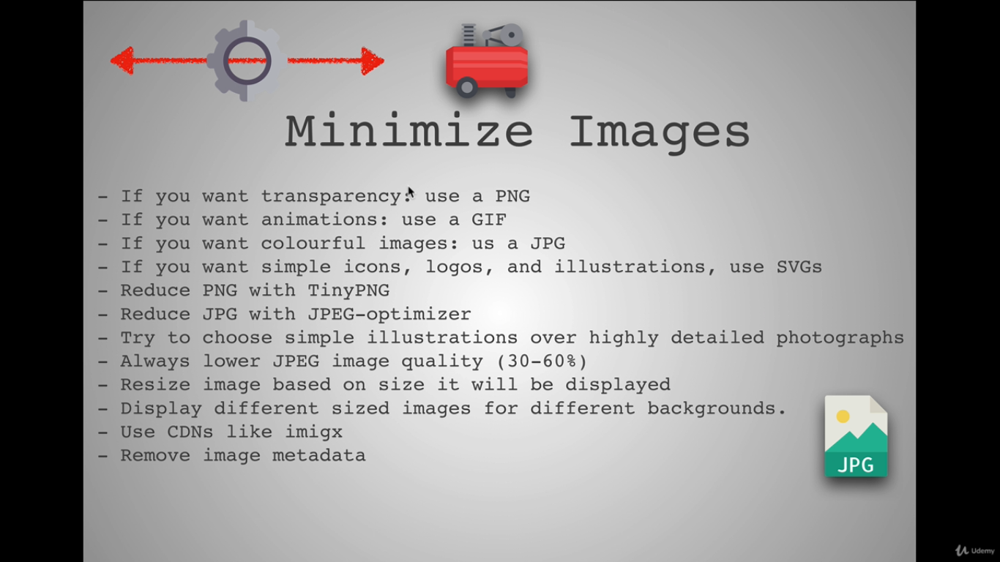

To compress png . Use
https://tinypng.com/

To compress jpg , use
http://jpeg-optimizer.com/

remove image metadata
https://www.verexif.com/en/

