Basics
1- There are 3 ways to use webpacks
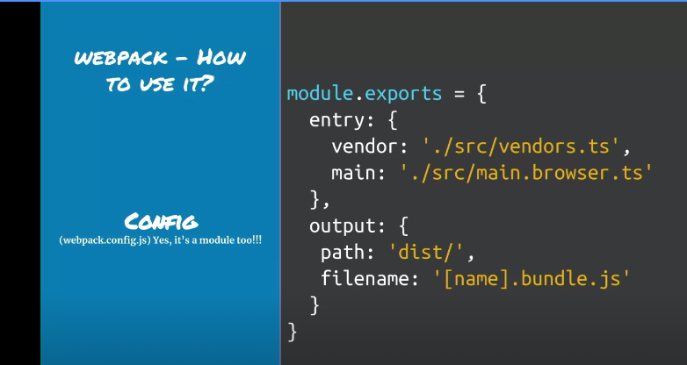

using config which is just an object that tells webpack what to do with code

2 – Using CLI

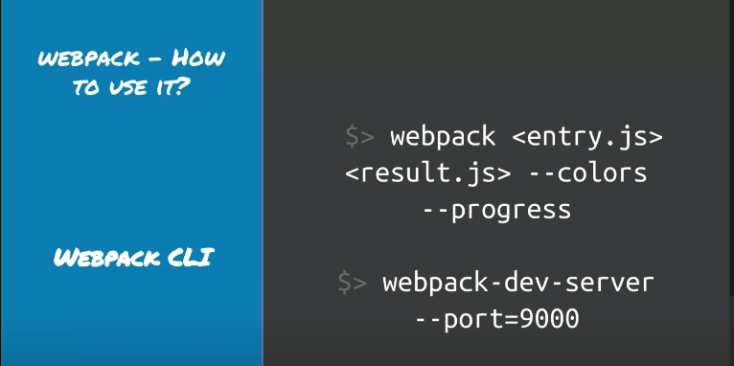

3 – Using node API
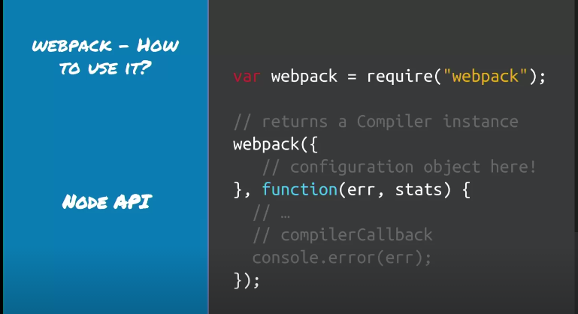

Scripts in npm and node

1) In package.json , we have scripts field , when we run npm i , we get nodemodules folder and inside it we have a bin folder which has binary executable of all packages we installed , these are available inside scripts field of package.json directly (they are hoisted)
so inside package.json
"scripts": {
"webpack": "webpack"
},

and run
npm run webpack

now webpack runs successfully without config file
coz webpack 4 default config is
input – src/index.js

There are 2 modes in webpack dev and prod
default is prod

"scripts": {
"webpack": "webpack",
"debug":"node --inspect --debug-brk ./node_modules/webpack/bin/webpack.js",
"dev": "npm run webpack -- --mode development",
"prod": "npm run webpack -- --mode production",
"prod:debug": "npm run debug -- --mode production",
"dev:debug": "npm run debug -- --mode development",
"debugthis": "node --inspect --inspect-brk ./src/index.js"
},

Now run npm run prod

now in our first folder , inside dist there is a main.js file which is op of above command .
We can run this file

npm

node ./dist/main.js

and we get op “nav”

Webpack has a watch mode so that we dont have to execute npm run prod on each changes

change script tag of dev to add watch flag

"dev": "npm run webpack -- --mode development --watch",

Second Folder

