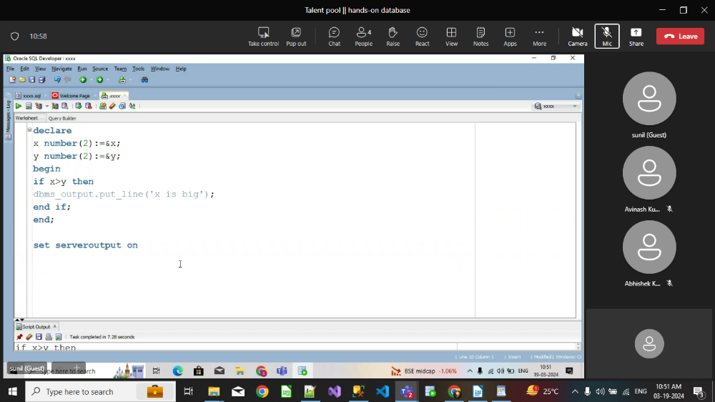
write a particular employee empno , ename, job, oldsal, newsal(sal>2000 10% of oldsal), deptno
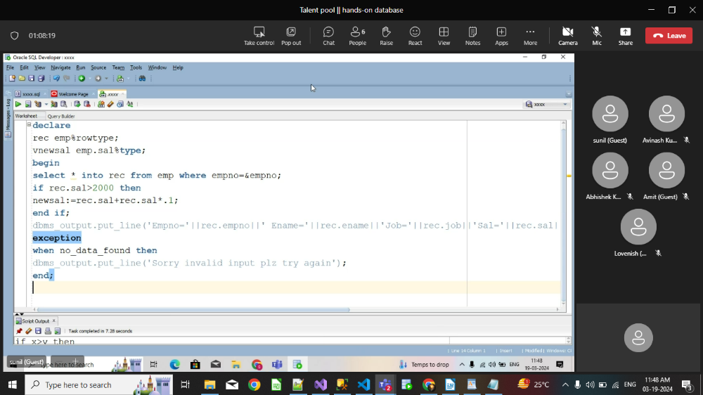

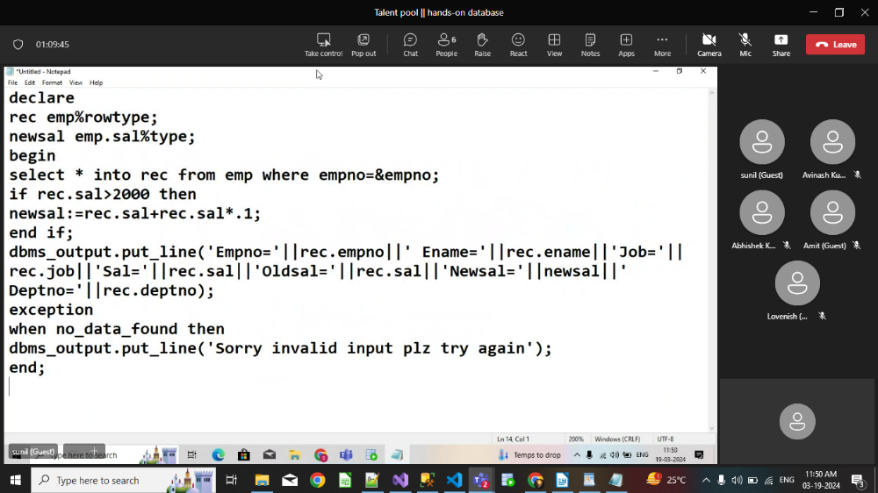
Q.write a pl/sql program to print empno, ename, job, deptno, oldsal
newsal (if manager then sal inc by 10% of basic sal)
newsal (if clerk then sal inc by 7% of basic sal)
newsal (if salesman then sal inc by 5% of basic sal)

