ESD FINAL PROJECT DOCUMENTATION

Smart Stylus Cam Pen

Team Taskforce141

Khushal 2022249

1. Introduction:

The Smart Stylus Crop Camera with Object Detection is an innovative project designed to automate the process of capturing images, cropping them intelligently based on object detection, and analyzing the detected objects within the cropped images. This system utilizes ultrasonic sensors, an ESP32-CAM module, an accelerometer+gyro (GY521), and OpenCV with a pre-trained YOLO model to achieve its functionality.

2. Methodology:

Ultrasonic Sensor Detection: Ultrasonic sensors use sound waves to detect the presence of objects within their range. In this project, the sensor is placed between the ESP32-CAM and the target area. It is being used to get the distance between ESP32-CAM and the object along with the angle (explained in rotation tracking) to get the object height on the button press

Formula used : Distance =Speed/TIME where speed is the speed of sound and time is measured using delays

Acceleration-based Trigger: An accelerometer measures acceleration forces, which in this project, serves as a trigger mechanism. When a button connected to the accelerometer is pressed, it captures the the starting angle. This initiates the image capture process.

The angle is measured using the following formula : Angle=Y = atan2(-a.acceleration.x, sqrt(pow(a.acceleration.y, 2) )) * 180 / M_PI ;

Image Capture: The ESP32-CAM module is responsible for capturing images. When triggered by the accelerometer, it captures an image of the scene along with the initial angle.

Rotation Tracking: While the button is held down, the accelerometer continuously tracks rotation. This allows the system to determine the change in angle from the initial position, aiding in precise image cropping.

Image Cropping: Using the initial angle and distance captured, the system calculates the height of the object in the image. This height information converted into pixels is then used to scale a square crop around the object, ensuring it occupies a significant portion of the cropped image.

Height in pixels: abs(resolution*math.tan(Object_height/2*185/360*math.pi))

Object Detection: The cropped image is then passed to OpenCV, a popular computer vision library. OpenCV utilizes a pre-trained YOLO (You Only Look Once) model to detect objects within the cropped image.

LED’s: To indicate Feedback of button press

Transmitting Captured Image and Data to Client:

After capturing the image and calculating the angles and distance, the ESP32 establishes a connection with the client (laptop) over WIFI.Utilizing the WebServer async library from Arduino, the ESP32 sets up a lightweight asynchronous web server.Upon receiving a request from the client, the ESP32 asynchronously sends the captured image along with the calculated angles and distance as a String list.The client (laptop) can then process this data for visualization, analysis, or further action.

#Only a single button is doing everything

3. System Architecture:

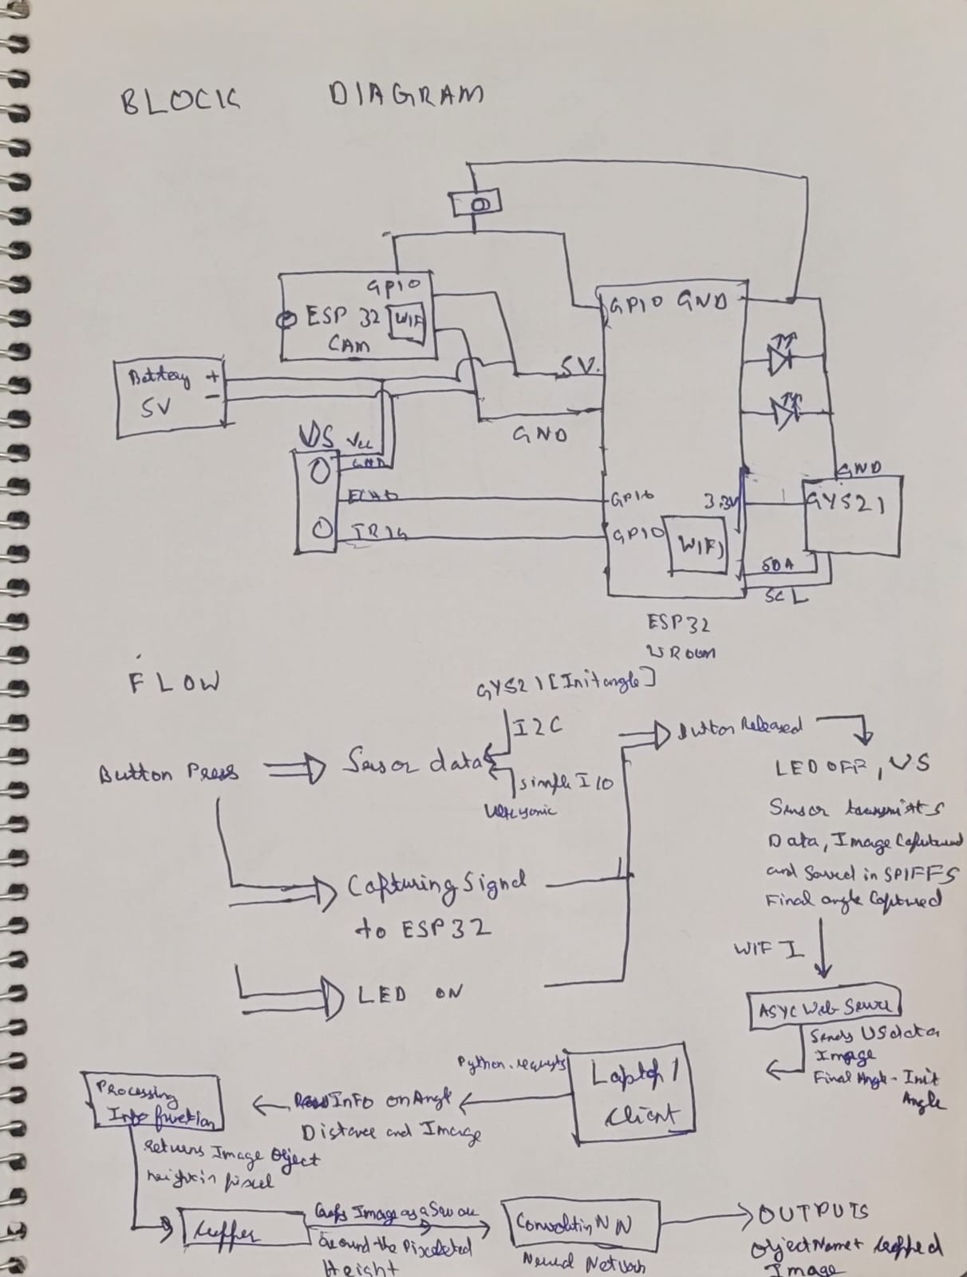

4. Implementation Details:

1. Hardware Setup:

Connect the accelerometer and ultrasonic sensor with an ESP32 board.

Ensure the button for triggering is connected to the GPIO pin.

Connect an LED to the ESP32 board, with its cathode connected to a GPIO pin and its anode connected to a resistor and then to the ground to indicate esp 32 button hold.

Connect an LED to indicate buffer time for transmission to other gpio pin

2. Software Setup:

Program the ESP32-CAM to capture images and transmit them.

Configure the ESP32 with the accelerometer and ultrasonic to capture distance and initial angle.

Implement rotation tracking algorithm.

Set up OpenCV with YOLO for object detection.

Utilize the WebServer async library from Arduino for transmitting data to the client.

5. Testing and Evaluation:

Functionality Testing:

Verify ultrasonic sensor detects objects accurately.

Test accelerometer-based triggering and rotation tracking.

Ensure ESP32-CAM captures images correctly.

Validate object detection accuracy with sample images.

Validate image cropping with respect to the field of view and

Performance Evaluation:

Measure the speed and accuracy of object detection.

Evaluate the consistency of image cropping and object detection.

6. Future Enhancements:

Real-Time Streaming: The addition of real-time streaming capabilities would allow users to monitor captured images remotely, enhancing the system's utility for surveillance and monitoring applications.

Improved Object Detection: Experimenting with different object detection algorithms or fine-tuning the parameters of the YOLO model could lead to improved accuracy and reliability in detecting objects within the images.

Integration with IoT Platforms: Integrating the system with IoT platforms would enable data logging, remote control, and integration with other smart devices, expanding its functionality and potential applications.

Enhanced User Interface: Developing a user-friendly interface would make the system easier to interact with and control, improving usability and accessibility for users with varying levels of technical expertise.

Conclusion:

The Smart Crop Camera with Object Detection system offers a novel approach to automating image capture, cropping, and object detection. By combining various sensors and technologies, it provides a versatile solution applicable in fields such as surveillance, agriculture, and automation. With further enhancements and optimizations, this system has the potential to become an indispensable tool for various applications requiring intelligent image analysis.