Q1: In training set, which features are available?

Variable | Definition | Key
pclass | Ticket class | 1 = 1st, 2 = 2nd, 3 = 3rd
sex | Sex
Age | Age in years
sibsp | # of siblings / spouses aboard the Titanic
parch | # of parents / children aboard the Titanic
ticket | Ticket number
fare | Passenger fare
cabin | Cabin number
embarked | Port of Embarkation | C = Cherbourg, Q = Queenstown, S = Southampton

Q2: In training set, which features are categorical?
Pclass, Sex, Embarked, cabin
Q3: In training set, which features are numerical (e.g., discrete, continuous, or time series based)?
age, sibsp, Parch, fare,
Q4: In training set, which features are mixed data types?
Ticket because ticket is alphanumerical and numerical at the same time.
Q5: In training set, which features contain blank, null or empty values? In test set, which features contain blank, null or empty values?
Training:
Age: 177
Cabin: 687
Embarked: 2
Testing:
Age: 177
Cabin: 687
Embarked: 2

Testing:
PassengerId 0
Pclass 0
Name 0
Sex 0
Age 86
SibSp 0
Parch 0
Ticket 0
Fare 1
Cabin 327
Embarked 0
Q6: In training set, what are the data types (e.g., integer, floats or strings ) for various features?
PassengerId: int
Pclass: int
Name: string
Sex: string
Age: int
SibSp: int
Parch: int
Ticket: string?
Fare: float
Cabin: string
Embarked: character
Q7: To understand the distribution of numerical feature values across the samples, please list the properties, including count, mean, std, min, 25% percentile, 50% percentile, 75% percentile, max, of numerical features?
count 714.000000
mean 29.699118
std 14.526497
min 0.420000
25% 20.125000
50% 28.000000
75% 38.000000
max 80.000000
Name: Age, dtype: float64

count 891.000000
mean 0.523008
std 1.102743
min 0.000000
25% 0.000000
50% 0.000000
75% 1.000000
max 8.000000
Name: SibSp, dtype: float64

count 891.000000
mean 0.381594
std 0.806057
min 0.000000
25% 0.000000
50% 0.000000
75% 0.000000
max 6.000000
Name: Parch, dtype: float64

count 891.000000
mean 32.204208
std 49.693429
min 0.000000
25% 7.910400
50% 14.454200
75% 31.000000
max 512.329200
Name: Fare, dtype: float64

Q8: To understand the distribution of categorical features, we define: count is the total number of categorical values per column; unique is the total number of unique categorical values per column; top is the most frequent categorical value; freq is the total number of the most frequent categorical value. Please list the properties, including count, unique, top, freq, of categorical features?

count 891
unique 2
top male
freq 577
Name: Sex

count 889
unique 3
top S
freq 644
Name: Embarked

count 891
unique 3
top 3
freq 491
Name: Pclass

count 204
unique 147
top G6
freq 4
Name: Cabin

Q9: Can you observe significant correlation (average survivied ratio>0.5) among the group of Pclass=1 and Survived? If Pclass has significant correlation with Survivied, we should include this feature in the predictive model. Based on your computation, will you include this feature in the
predictive model?

Pclass Survived PassengerId
1 0 80
1 136
2 0 97
1 87
3 0 372
1 119

Pclass 1 passngers had a survival rate of 63%.
Pclass 2 passengers had a survival rate of 47.3%
Pclass 3 passengers had a survival rate of 24.2%

Therefore, there does seem to be a significant correlation between Pclass and Survived, with survival trending downward with pclass value. We should definitely include this in the model.

Q10: Are Women (Sex=female) were more likely to have survived?

Sex Survived PassengerId
female 0 81
1 233
male
0 468
1 109

Women had a survival rate of 74.2%
Men had a survival rate of 18.9%.
So, women were more likely to have survived.

Q11: Let us start by understanding correlations between a numeric feature (Age) and our predictive goal (Survived). A histogram chart is useful for analyzing continuous numerical variables like Age where banding or ranges will help identify useful patterns. The histogram can indicate distribution of
samples using automatically defined bins or equally ranged bands. This helps us answer questions relating to specific bands (e.g., infants, old). Please plot the histogram plots between ages and Survived (Figure 1 is an example), and answer the following questions:
• Do infants (Age <=4) have high survival rate?
More infants survived than did not survive.
• Do oldest passengers (Age = 80) survive?
These passengers appear to have an equal rate of surviving and not surviving.
• Do large number of 15-25 year olds not survive?
This group has a comparatively equal rate of surviving and not surviving.
• Based on your analysis of the histograms:Should we consider Age in our model training? (If yes, then we should complete the Age feature for null values.)
I believe so. More infants survived than did not survive, and as age increases (40-50+) the number of non-survivors also increases.
• Should we should band age groups?
Yes. There are pretty clear divides in both histograms. I would say that the bands ought to be:
0-4
4-15
15-30
30-40
40-60
60-80+
Based on the visual distinction of areas in the histogram.
Histogram of age vs Survived = 1
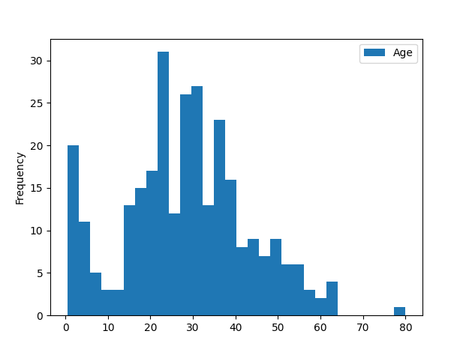

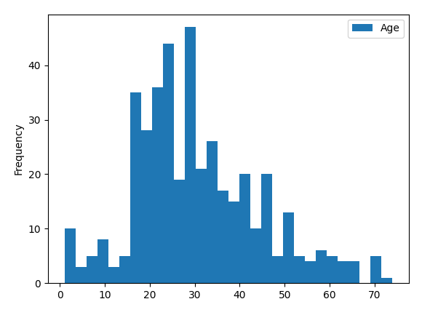
Histogram of Age vs Survived = 0

Q12: We can combine three features (age, Pclass, and survivied) for identifying correlations using a single plot. This can be done with numerical and categorical features which have numeric values. Please plot the histogram plot using python, and answer the following questions:

- Does Pclass=3 have most passengers, however most did not survive?
  - Pclass 3 had the most passengers, and most in fact did not survive.
- Do infant passengers in Pclass=2 and Pclass=3 mostly survive?
  - Yes
- Do most passengers in Pclass=1 survive?
  - Yes
- Does Pclass vary in terms of Age distribution of passengers?
  - Not considerably.
- Should we consider Pclass for model training?
  - Yes. It appears that Pclass does correlate with survival, in such that the the rate of survival goes: 1>2>3.

Pclass = 1
Survived = 0 Survived = 1
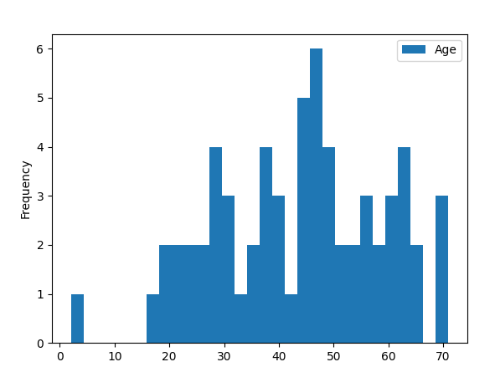
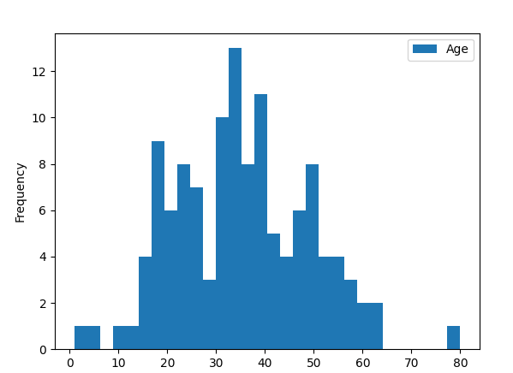

Pclass = 2
Survived = 0 Survived = 1
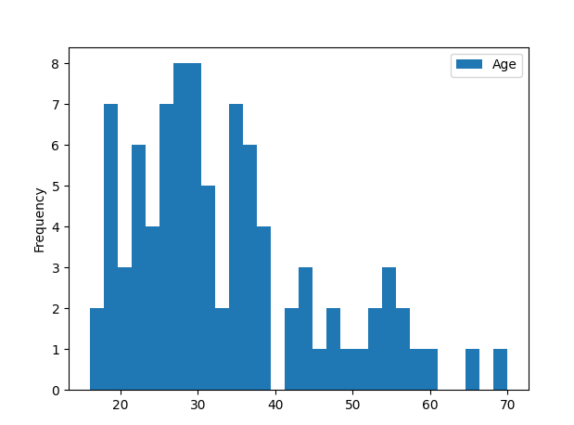
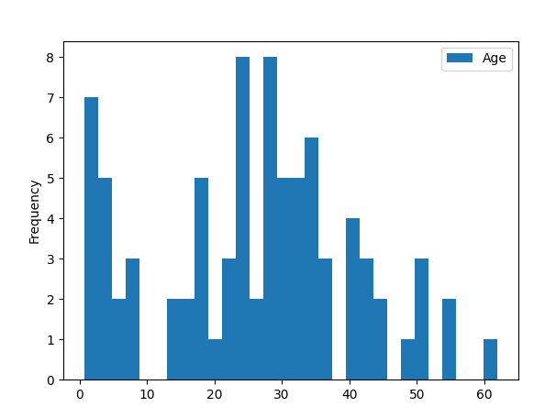

Pclass = 3
Survived = 0 Survived = 1
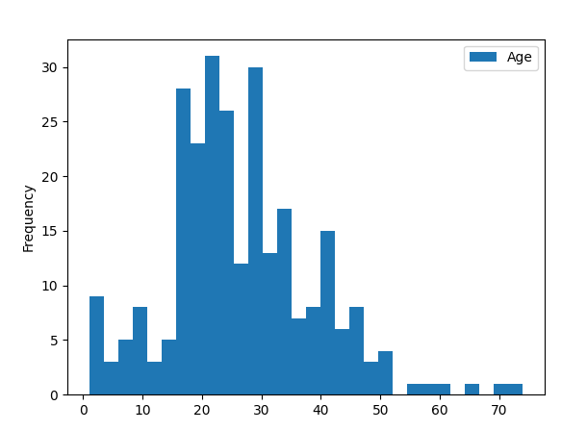
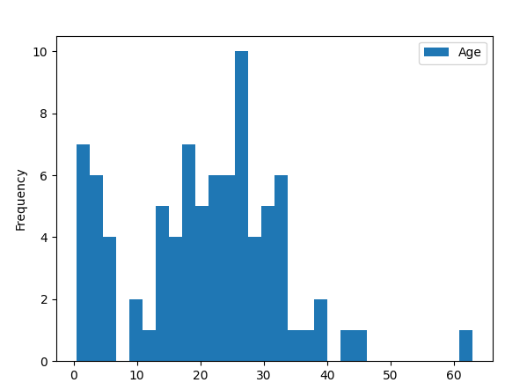

Q13: In training set, we want to correlate categorical features (with non-numeric values) and numeric features. We can consider correlating Embarked (Categorical non-numeric), Sex (Categorical non-numeric), Fare (Numeric continuous), with Survived (Categorical numeric). Please plot a figure to
illustrate the correlations of Embarked, Sex, Fare, and Survivied. Here is a sample plot (Figure 3):
Figure 3: a sample figure of the correlations of Embarked, Sex, Fare, and Survivied (notice that your plot might not be the same with the sample plot)
And answer the following questions:
• Do higher fare paying passengers have better survival?
• Should we consider banding fare feature?

Q14: In training set, what is the rate of duplicates for the Ticket feature? Is there a correlation between Ticket and survival? Should we drop the Ticket feature?
There are 210 duplicates in the ticket feature. Ticket number is honestly a useless feature, there is no correlation. It does not make sense for the ticket number to correlate to survivability in any way, it’s essentially a random number. Therefore, we should drop it.
Q15: In the training set, Is the Cabin feature complete? How many null values there are in the Cabin features of the combined dataset of training and test dataset? Should we drop the Cabin feature?

The cabin feature is not complete.
687/891 = 77.1% null values in the training data
327/418 = 78.2% null values in testing data.
I think we should drop this feature because over 75% of the data is missing from this column, as no replacement method that we use could be accurate that that rate.

Q16: In the training set, we can convert features which contain strings to numerical values. This is required by most model algorithms. Doing so will also help us in achieving the feature completing goal. In this question ,please convert Sex feature to a new feature called Gender where female=1
and male=0.

Q17: In the training set, we start estimating and completing features with missing or null values. We will first do this for the Age feature. We can consider three methods to complete a numerical continuous feature. A simple way is to generate random numbers between mean and standard deviation. More accurate way of guessing missing values is to use the K-Nearest Neighbor algorithm to select the top-K most similar data points, and then use the top-K most similar data points to impute the missing values of ages.

