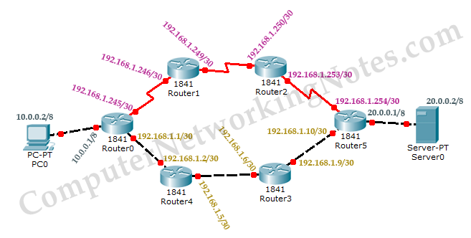

Router(config)#interface fastEthernet 0/0

Router(config-if)#ip address 10.0.0.1 255.0.0.0

Router(config-if)#no shutdown

Router(config-if)#exit

Router(config)#interface fastEthernet 0/1

Router(config-if)#ip address 192.168.1.1 255.255.255.252

Router(config-if)#no shutdown

Router(config-if)#exit

Router(config)#

Router# configure terminal

Enter configuration commands, one per line. End with CNTL/Z.

Router(config)#interface serial 0/0/0

Router(config-if)#ip address 192.168.1.245 255.255.255.252

Router(config-if)#clock rate 64000

Router(config-if)#bandwidth 64

Router(config-if)#no shutdown

Router(config-if)#exit

Router>enable

Router#configure terminal

Enter configuration commands, one per line. End with CNTL/Z.

Router(config)#interface serial 0/0/0

Router(config-if)#ip address 192.168.1.246 255.255.255.252

Router(config-if)#no shutdown

Router(config-if)#exit

Router(config)#interface serial 0/0/1

Router(config-if)#ip address 192.168.1.249 255.255.255.252

Router(config-if)#clock rate 64000

Router(config-if)#bandwidth 64

Router(config-if)#no shutdown

Router(config-if)#exit

Router>enable

Router#configure terminal

Enter configuration commands, one per line. End with CNTL/Z.

Router(config)#interface serial 0/0/1

Router(config-if)#ip address 192.168.1.250 255.255.255.252

Router(config-if)#no shutdown

Router(config-if)#exit

Router(config)#interface serial 0/0/0

Router(config-if)#ip address 192.168.1.253 255.255.255.252

Router(config-if)#clock rate 64000

Router(config-if)#bandwidth 64

Router(config-if)#no shutdown

Router(config-if)#exit

Router>enable

Router#configure terminal

Enter configuration commands, one per line. End with CNTL/Z.

Router(config)#interface fastEthernet 0/0

Router(config-if)#ip address 20.0.0.1 255.0.0.0

Router(config-if)#no shutdown

Router(config-if)#exit

Router(config)#interface fastEthernet 0/1

Router(config-if)#ip address 192.168.1.10 255.255.255.252

Router(config-if)#no shutdown

Router(config-if)#exit

Router(config)#

Router(config)#interface serial 0/0/0

Router(config-if)#ip address 192.168.1.254 255.255.255.252

Router(config-if)#no shutdown

Router(config-if)#exit

Router>enable

Router#configure terminal

Enter configuration commands, one per line. End with CNTL/Z.

Router(config)#interface fastEthernet 0/0

Router(config-if)#ip address 192.168.1.6 255.255.255.252

Router(config-if)#no shutdown

Router(config-if)#exit

Router(config)#interface fastEthernet 0/1

Router(config-if)# ip address 192.168.1.9 255.255.255.252

Router(config-if)#no shutdown

Router(config-if)#exit

Router(config)#

Router>enable

Router#configure terminal

Enter configuration commands, one per line. End with CNTL/Z.

Router(config)#interface fastEthernet 0/0

Router(config-if)#ip address 192.168.1.5 255.255.255.252

Router(config-if)#no shutdown

Router(config-if)#exit

Router(config)#interface fastEthernet 0/1

Router(config-if)# ip address 192.168.1.2 255.255.255.252

Router(config-if)#no shutdown

Router(config-if)#exit

Router(config)#

Router(config)# router eigrp autonomous_system_#

Router(config-router)# network IP_network_# [subnet_mask]

Router(config-router)# network 172.168.1.0 0.0.0.255

Router(config-router)# network 172.168.2.0 0.0.0.255

Router(config-router)# network 172.168.1.0 255.255.255.0

Router(config-router)# network 172.168.2.0 255.255.255.0

Router(config)#router eigrp 20

Router(config-router)#network 10.0.0.0 0.0.0.255

Router(config-router)#network 192.168.1.244 0.0.0.3

Router(config-router)#network 192.168.1.0 0.0.0.3

Router(config-router)#

Router(config)#router eigrp 20

Router(config-router)#network 192.168.1.244 0.0.0.3

Router(config-router)#

%DUAL-5-NBRCHANGE: IP-EIGRP 20: Neighbor 192.168.1.245 (Serial0/0/0) is up: new adjacency

Router(config-router)#network 192.168.1.248 0.0.0.3

Router(config-router)#

Router(config)#router eigrp 20

Router(config-router)#network 192.168.1.248 0.0.0.3

Router(config-router)#

%DUAL-5-NBRCHANGE: IP-EIGRP 20: Neighbor 192.168.1.249 (Serial0/0/1) is up: new adjacency

Router(config-router)#network 192.168.1.252 0.0.0.3

Router(config-router)#

Router(config)#router eigrp 20

Router(config-router)#network 20.0.0.0 255.0.0.0

Router(config-router)#network 192.168.1.252 255.255.255.252

Router(config-router)#

%DUAL-5-NBRCHANGE: IP-EIGRP 20: Neighbor 192.168.1.253 (Serial0/0/0) is up: new adjacency

Router(config-router)#network 192.168.1.8 255.255.255.252

Router(config-router)#

Router(config)#router eigrp 20

Router(config-router)#network 192.168.1.8 255.255.255.252

Router(config-router)#

%DUAL-5-NBRCHANGE: IP-EIGRP 20: Neighbor 192.168.1.10 (FastEthernet0/1) is up: new adjacency

Router(config-router)#network 192.168.1.4 255.255.255.252

Router(config-router)#

Router(config)#router eigrp 20

Router(config-router)#network 192.168.1.4 255.255.255.252

Router(config-router)#

%DUAL-5-NBRCHANGE: IP-EIGRP 20: Neighbor 192.168.1.6 (FastEthernet0/0) is up: new adjacency

Router(config-router)#network 192.168.1.0 255.255.255.252

Router(config-router)#

%DUAL-5-NBRCHANGE: IP-EIGRP 20: Neighbor 192.168.1.1 (FastEthernet0/1) is up: new adjacency

Router(config-router)#