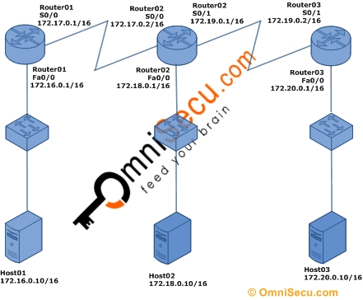

Router01>enable

Router01#configure terminal

Enter configuration commands, one per line. End with CNTL/Z.

Router01(config)#router ospf 1

Router01(config-router)#network 172.16.0.0 0.0.255.255 area 0

Router01(config-router)#network 172.17.0.0 0.0.255.255 area 0

Router01(config-router)#exit

Router01(config)#exit

Router01#

Router02>

Router02>enable

Router02#configure terminal

Enter configuration commands, one per line. End with CNTL/Z.

Router02(config)#router ospf 1

Router02(config-router)#network 172.17.0.0 0.0.255.255 area 0

Router02(config-router)#network 172.18.0.0 0.0.255.255 area 0

Router02(config-router)#network 172.19.0.0 0.0.255.255 area 0

Router02(config-router)#exit

Router02(config)#exit

Router03>enable

Router03#configure terminal

Enter configuration commands, one per line. End with CNTL/Z.

Router03(config)#router ospf 1

Router03(config-router)#network 172.19.0.0 0.0.255.255 area 0

Router03(config-router)#network 172.20.0.0 0.0.255.255 area 0

Router03(config-router)#exit

Router03(config)#exit

Router03#