TROUBLE-SHOOTING

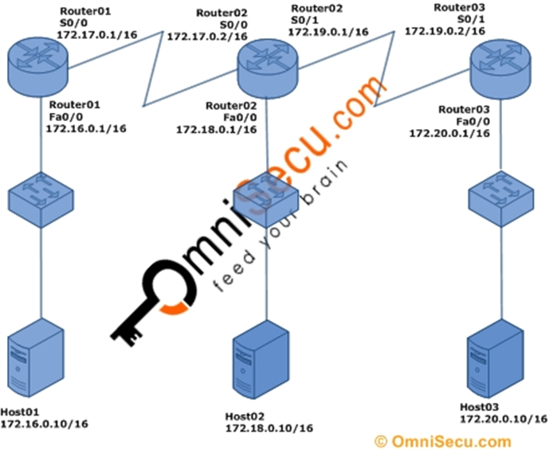

Router03>enable

Router03#show ip route

Codes: C - connected, S - static, I - IGRP, R - RIP, M - mobile, B - BGP

D - EIGRP, EX - EIGRP external, O - OSPF, IA - OSPF inter area

N1 - OSPF NSSA external type 1, N2 - OSPF NSSA external type 2

E1 - OSPF external type 1, E2 - OSPF external type 2, E - EGP

i - IS-IS, L1 - IS-IS level-1, L2 - IS-IS level-2, ia - IS-IS inter area

\* - candidate default, U - per-user static route, o - ODR

P - periodic downloaded static route

Gateway of last resort is not set

O 172.16.0.0/16 [110/129] via 172.19.0.1, 00:29:43, Serial0/1

O 172.17.0.0/16 [110/128] via 172.19.0.1, 00:29:43, Serial0/1

O 172.18.0.0/16 [110/65] via 172.19.0.1, 00:29:43, Serial0/1

C 172.19.0.0/16 is directly connected, Serial0/1

C 172.20.0.0/16 is directly connected, FastEthernet0/0

Router02>enable

Router02#show ip route

Codes: C - connected, S - static, I - IGRP, R - RIP, M - mobile, B - BGP

D - EIGRP, EX - EIGRP external, O - OSPF, IA - OSPF inter area

N1 - OSPF NSSA external type 1, N2 - OSPF NSSA external type 2

E1 - OSPF external type 1, E2 - OSPF external type 2, E - EGP

i - IS-IS, L1 - IS-IS level-1, L2 - IS-IS level-2, ia - IS-IS inter area

\* - candidate default, U - per-user static route, o - ODR

P - periodic downloaded static route

Gateway of last resort is not set

O 172.16.0.0/16 [110/65] via 172.17.0.1, 00:30:20, Serial0/0

C 172.17.0.0/16 is directly connected, Serial0/0

C 172.18.0.0/16 is directly connected, FastEthernet0/0

C 172.19.0.0/16 is directly connected, Serial0/1

O 172.20.0.0/16 [110/65] via 172.19.0.2, 00:28:08, Serial0/1