CM2104 - Computational Mathematics  
Coursework 1 – Drawing Ovals – C1722325

The MATLAB tool created can retrieve the dimensions and position of a rectangle and use its values to create an approximation of an ellipse using 4 quadrarcs and tangent continuity.

Task 1

The User is able to place rectangles on a canvas with arbitrary aspect ratio, position and orientation. These rectangles will define the shape of the quadrarcs.

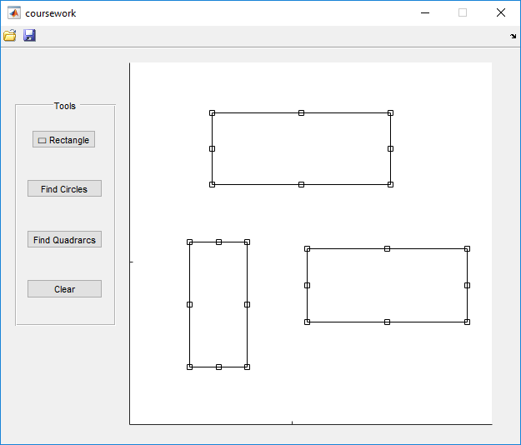

Task 2

The tool has the functionality to display the 4 circles that will be used in the presentation of each quadrarc.

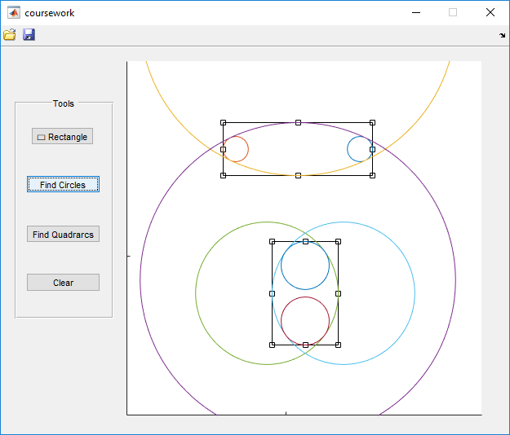

Task 3

The tool also has functionality to display each circular quadrarc that makes up the ellipse. They are displayed in different colours.

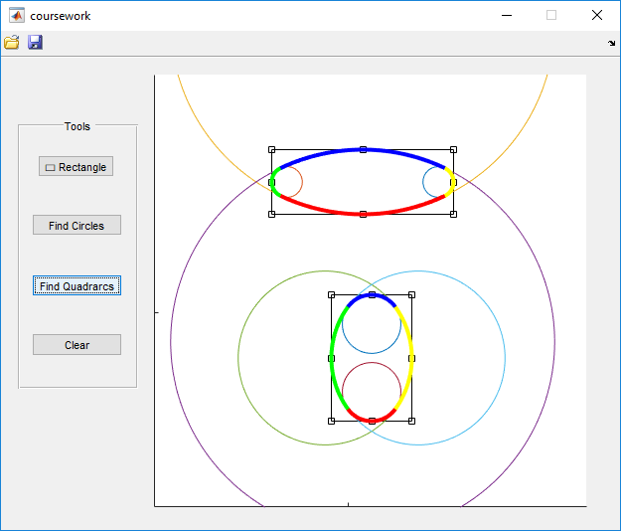

Additional Feature

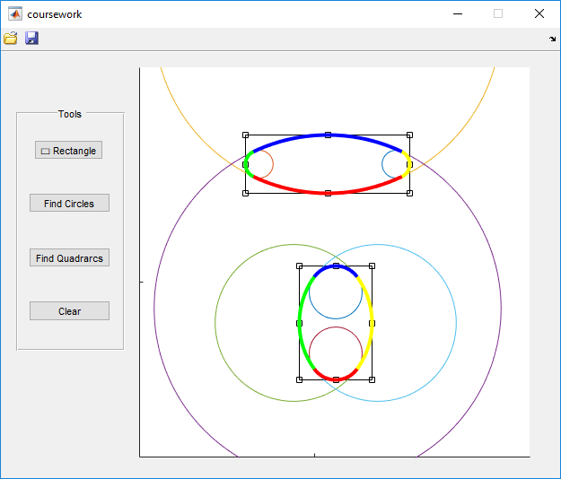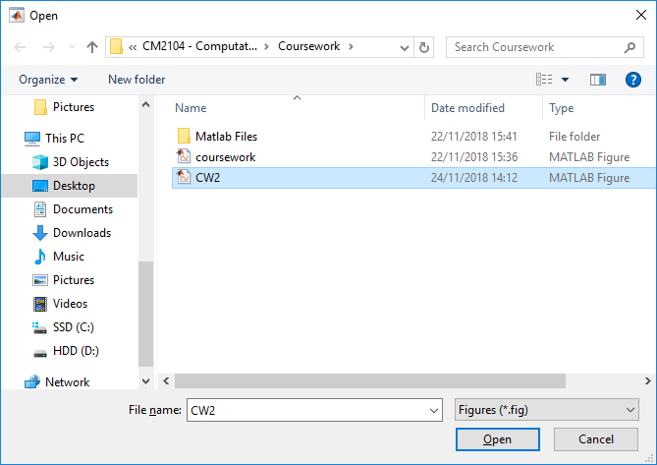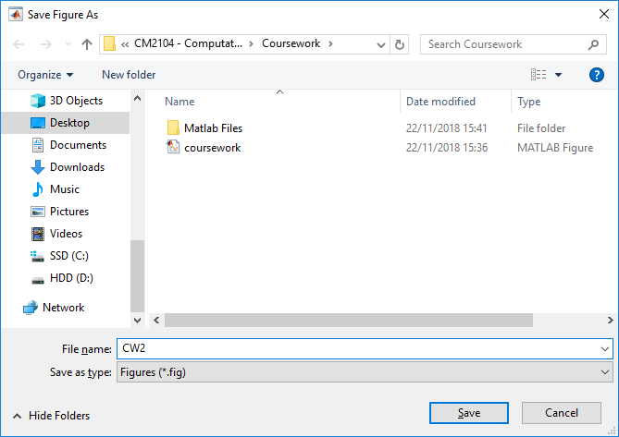The additional feature used is the ability for the User to Save and Load back the quadrarcs that have been constructed.

Programming Philosophy

* User is able to create a rectangle using the GUI button that uses an imrect function. The rectangle placed is then stored in an array and the array is stored in the handle.
* For the User to observe the 4 circles created by each rectangle he presses the button “Find Circles”. The button has a for loop that goes through all the rectangles in the array, finds their position and dimensions. These values are then used with the given equations to find the h and k. The centre of the rectangle, h, k, a and b are the main components used to plot the 4 circles.
* To find the quadrarcs that make up the ellipse the user can press the “Find Quadrarcs” button, which in turn that again for loops through all the rectangles. It finds the centre and radius of the 4 circles for that specific rectangle and it finds their point of intersections. It then plots the quadrarcs using the 2 points of intersections, the centre and radius of the circle the arc lies upon and creates the 4 quadrarcs in 4 different colours.
* The tool also has a “Clear” button for the user to press in order to clear the canvas from any existing rectangles and clear the handles containing their information.
* Additionally, 2 toolbar features where added using the Toolbar Editor in the GUIDE. These features give the ability for the user to save or load the figure and the quadrarcs that have been constructed.

Disclaimer

Although I have used simple programming statements like (for loop) and (if statement) MATLAB can rarely be buggy and show errors or one of the buttons not working. Please re-run the MATLAB file and it should run properly.

Possible bugs found

* Specific rectangle dimensions give an imaginary result in the atan2() function which raises an error.
* The “Find Quadrarcs” button may not do anything.
* The “Find Quadrarcs” button may not show all the quadrarcs that should have been plotted.

Solutions

* Usually clearing the axes and inserting another rectangle no new errors will arise
* If error is persistent close the figure and re-run the tool and it should work normally as intended.

These errors are not due to the code since I had run it on a large number of different scenarios. It is mostly on MATLAB’s inconsistency in the GUI implementation.