# JMeter Test Plan Setup For eBOSS

Apache JMeter is a pure Java application designed to load test client/server software (such as a web application). As an open source tool and it is popular among performance tester. It may be used to test performance both on static and dynamic resources.

We are using it for performance testing of eBoss application.

As per our initial discussion with Greg and Trish, we have decided 50 concurrent users (store managers) for 500 stores (4 lanes per store) can access the eBOSS web application during peak load.

JMeter shouldn’t be run all the time while eBOSS multi-hour, multi-day tests are running. It will run once depending on the test scenarios.

**3 Hour Test**

It will run once after 2hour and 20 minutes into the run.

**Multi-day test**

Run once a day when eBOSS is busy (not during ramping users in, or during quiet time)

# Test Script

**Test Plan**

eBOSS test plan contains ‘Http request Defaults’, that contains default server name or IP. Please change the IP, if you want to run the test plan against different eBOSS server.

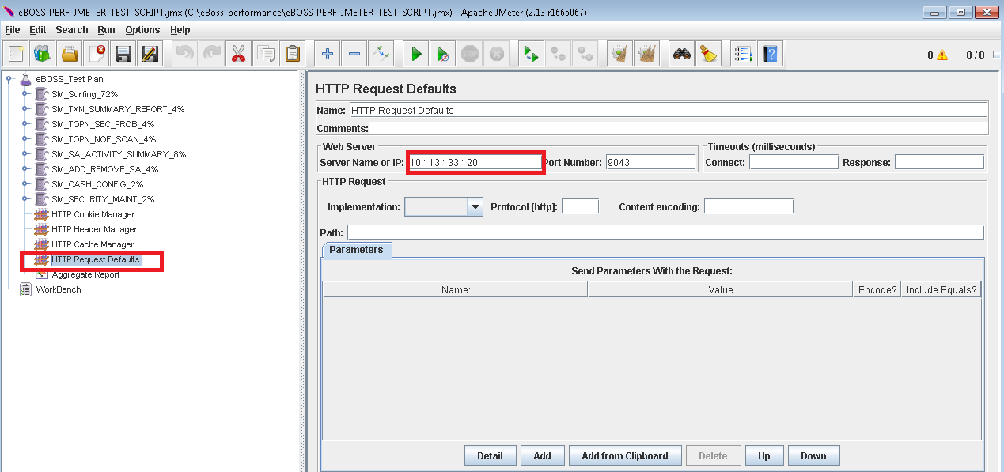

Test Plan contains Thread Group, each thread group represent set of store managers (there profile defined depending on their activities). All these thread group run concurrently.

We have divided these 50 concurrent users (store managers) in different set of activities to simulate a real scenario.

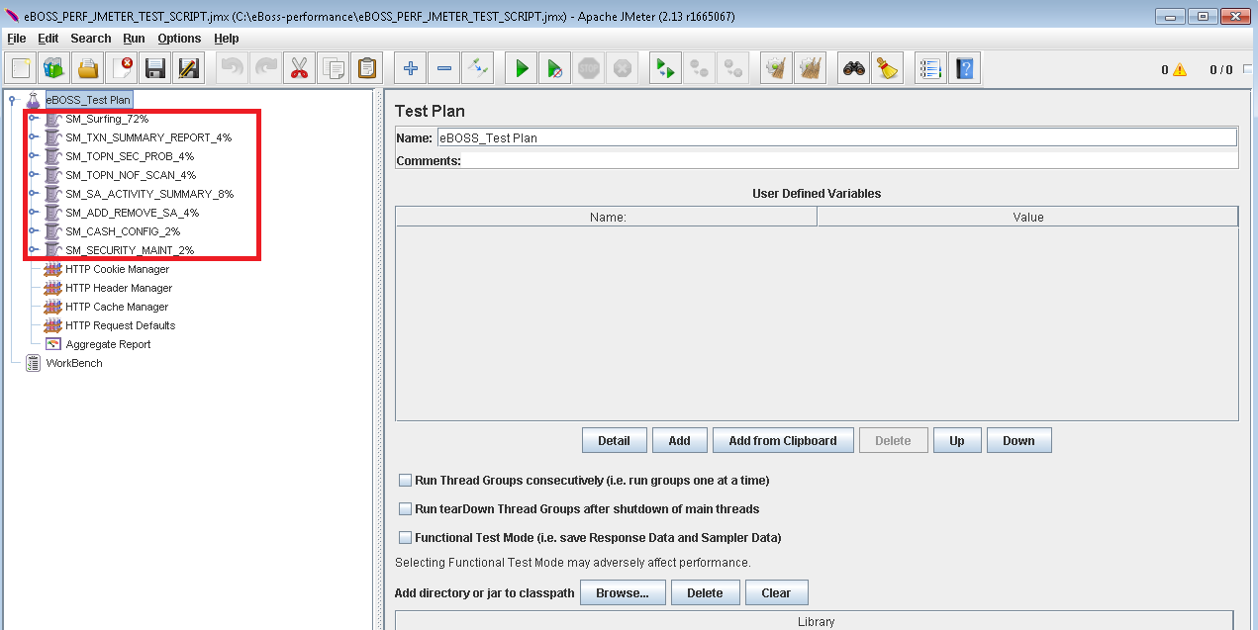

Below are the **Thread-Groups** with their ‘Http Request’.

1. **SM_Surfing_72%**: 36 Store-Managers are browsing on eBOSS application. Just going through each of the tab to get the information.

Store manager login to the eBOSS web application and browse to below tabs apart from ‘Quick Lookup’ and ‘Mobile Terminal’.

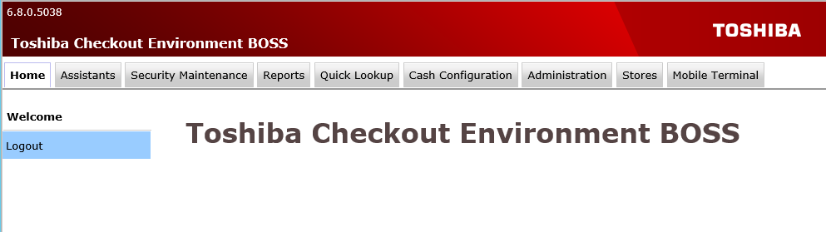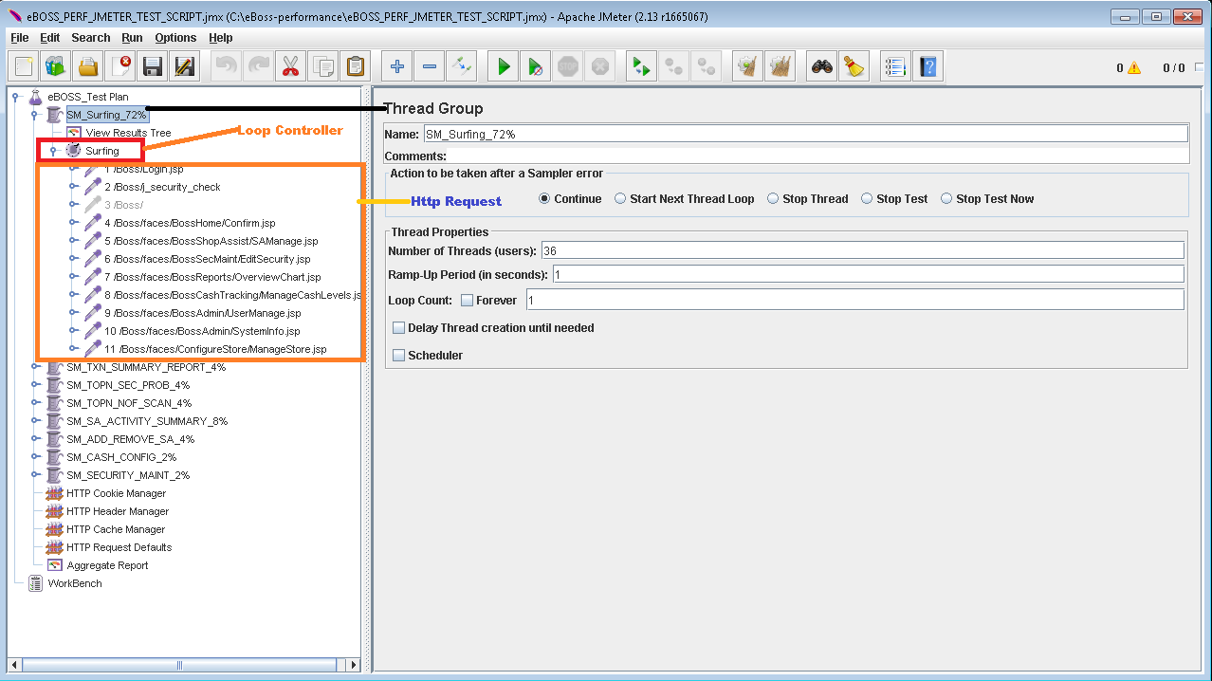

Each ‘Thead Group’ contains ‘Loop Controller’ and ‘Loop Controller’ contains ‘Http Request’. These Http Request are created with help of JMeter recoding. All the jsp pages are representing ‘Http Request’.

For recording the HTTP request I have followed the below link

<http://nadimsaker.blogspot.in/2015/06/jmeter-how-to-record-http-request-and.html>

1. **SM_TXN_SUMMARY_REPORT_4%:** 2 Store-Managers are going through ‘Utilization -Transaction Summary Report’. Looking report for past 2 week.

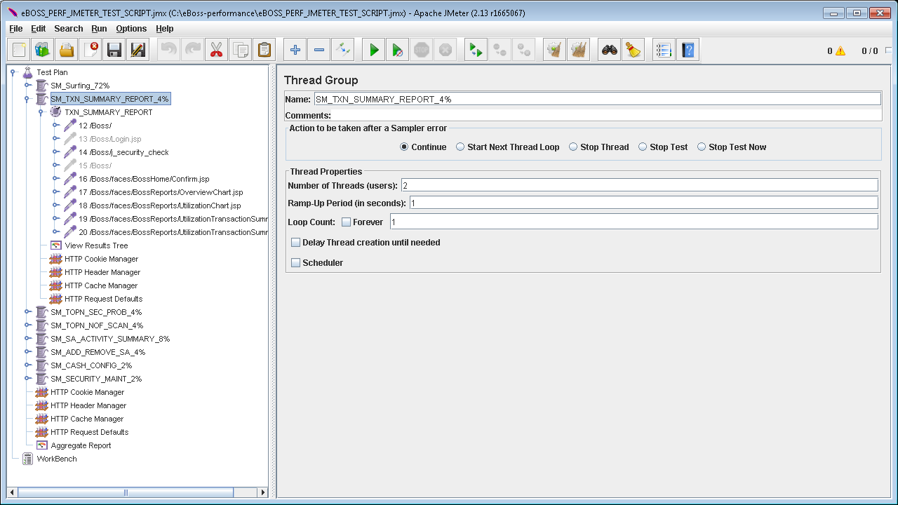

1. **SM_TOPN_SEC_PROB_4%:** 2 Store-Managers are going through ‘Top 25 – Security Problem Report’. Looking report for past 2 week.

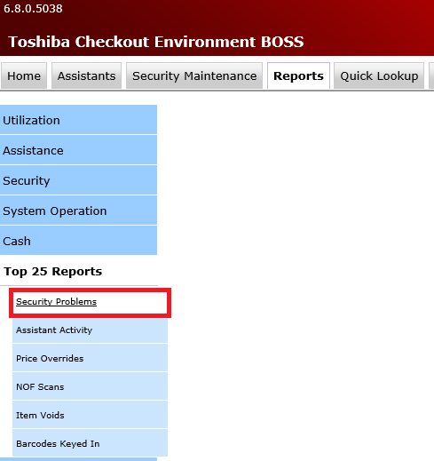

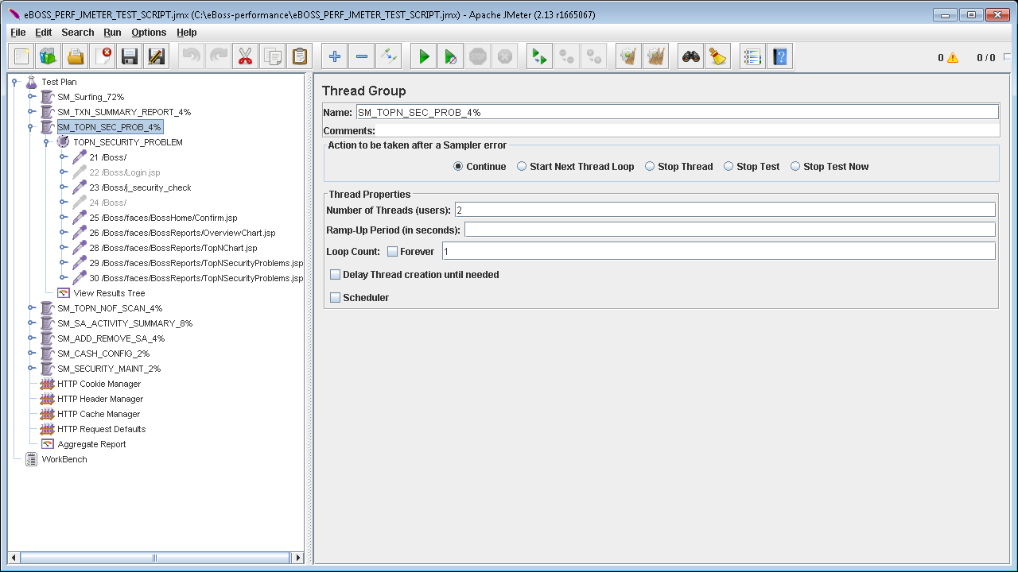

1. **SM_TOPN_NOF_SCAN_4%:** 2 Store-Managers are going through ‘Top 25 – NOF Scan Report’. Looking report for past 2 week.

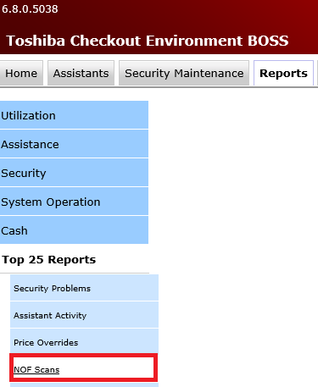

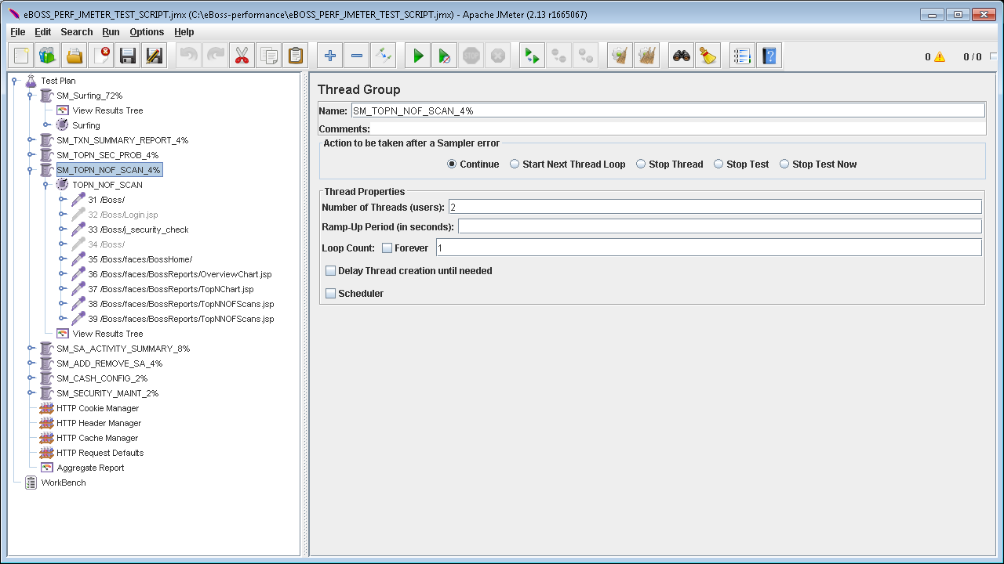

1. **SM_SA_Activity_SUMMARY_Report_8%:** 4 Store-Managers are going through ‘Assistance – SA Activity Summary Report’. Looking report for past 2 week.

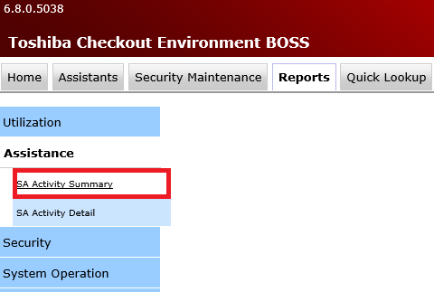

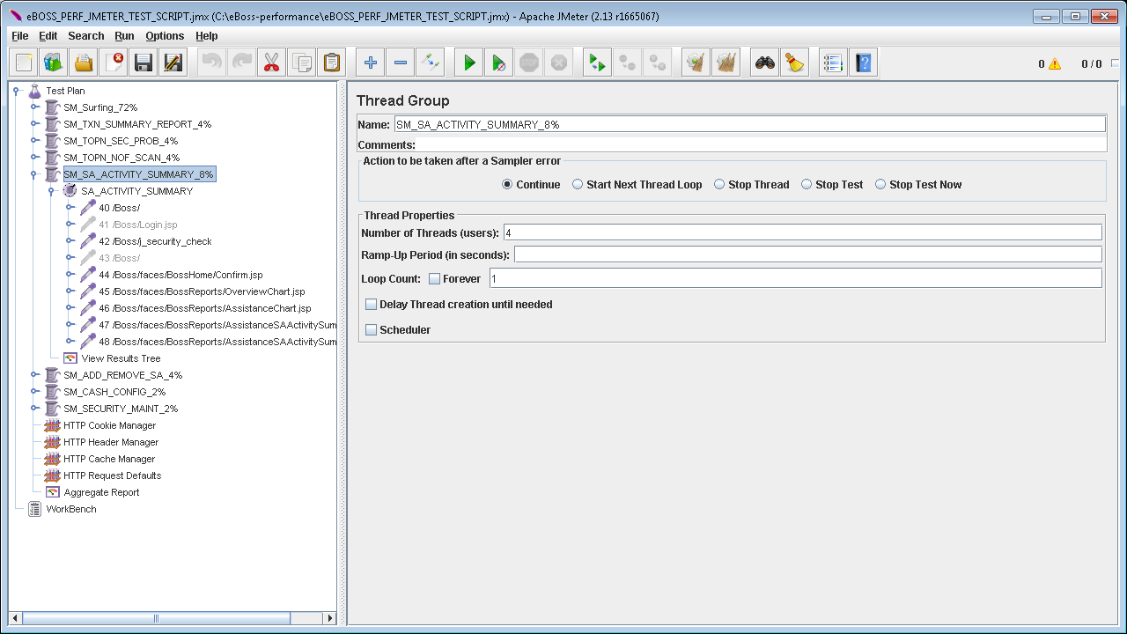

1. **SM_ADD_REMOVE_SA _4%:** 2 store managers will add and remove the shopper assistant**.**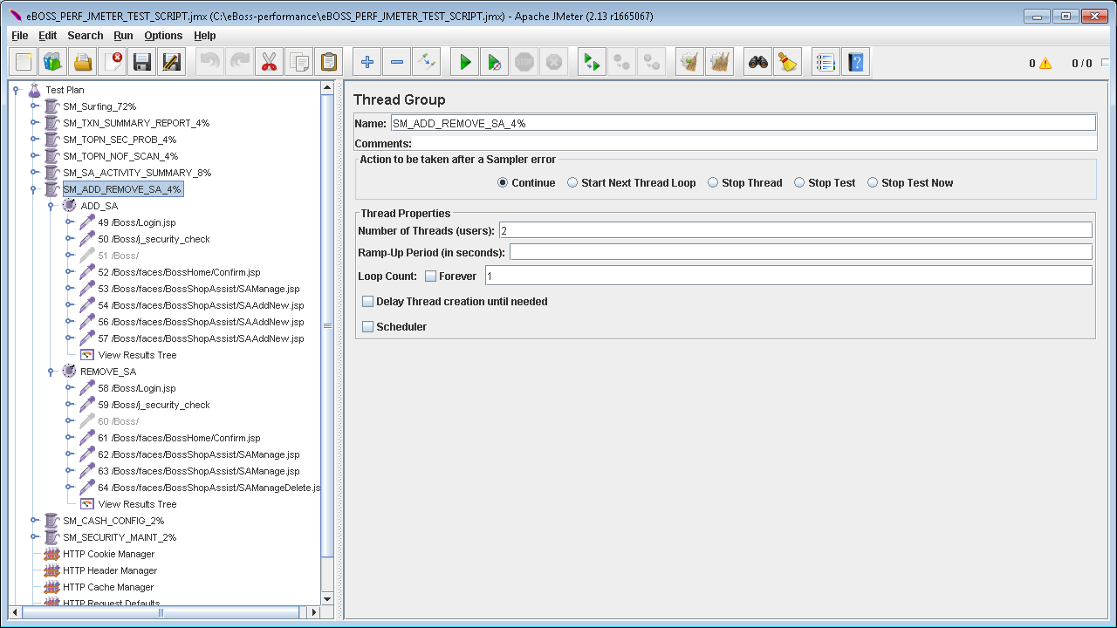
2. **SM_CASH_CONFIG_2%:** 1store manager will view the cash configuration and press the save button.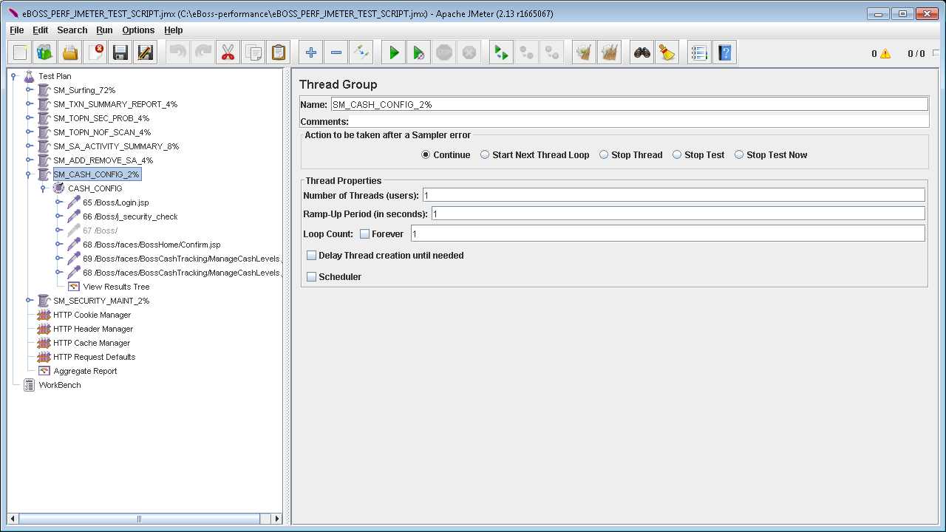
3. **SM_SECURITY_MAINT_2%:** 1store manager will view and edit the security maintenance for particular db_item_id.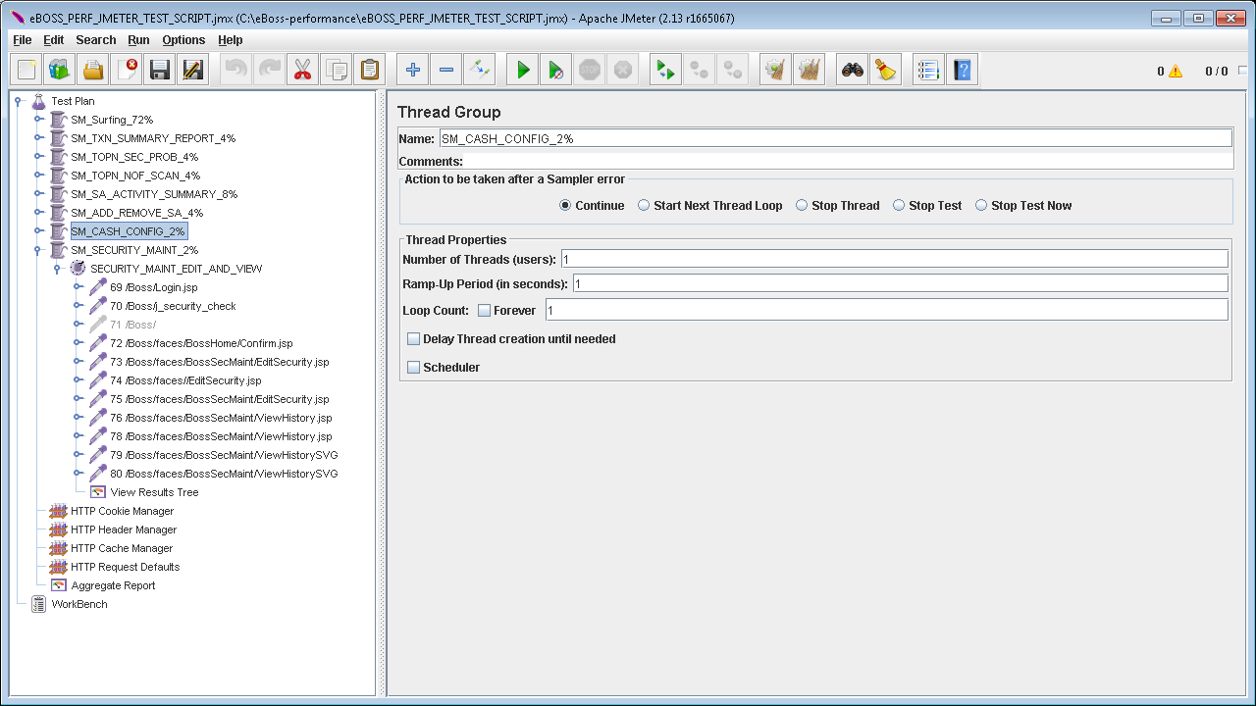

# How to run the script

Prerequisite

1. Install latest JMeter on C drive 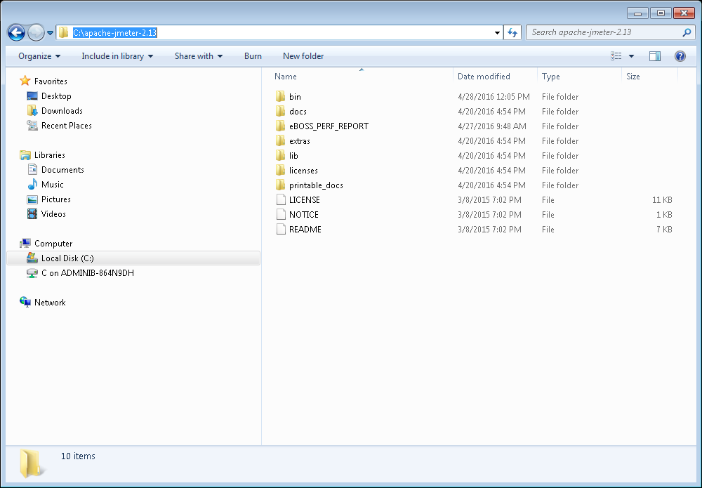
2. Install Java

jMeter requires a fully compliant JVM 6 or higher. Please Install java6 or higher and set the PATH environment variable accordingly.

1. Change the jMeter properties (C:\apache-jmeter-2.1.3\bin) file to generate output report in CSV format.



1. Please copy below scripts in same folder and run through command line.



This script will generate summary report as well as log file for each run.