2：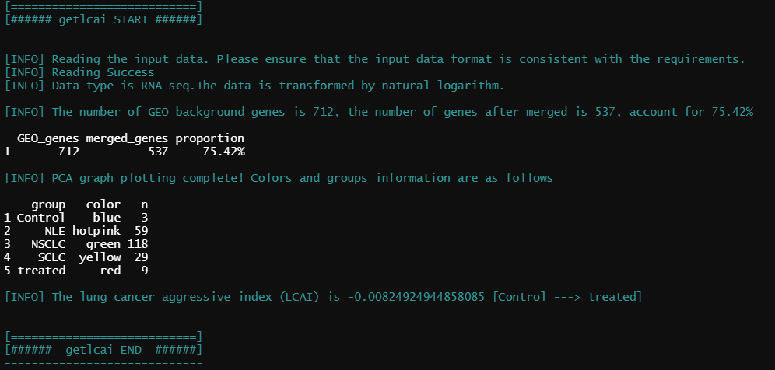

The number of GEO background genes is 712, the number of genes after merged is 537, account for 75.42%

The lung cancer aggressive index (LCAI) is -0.00824924944858085 [Control ---> treated]

