**Evaluation Only. Created with Aspose.Words. Copyright 2003-2014 Aspose Pty Ltd.**

This will turn into one embedded image

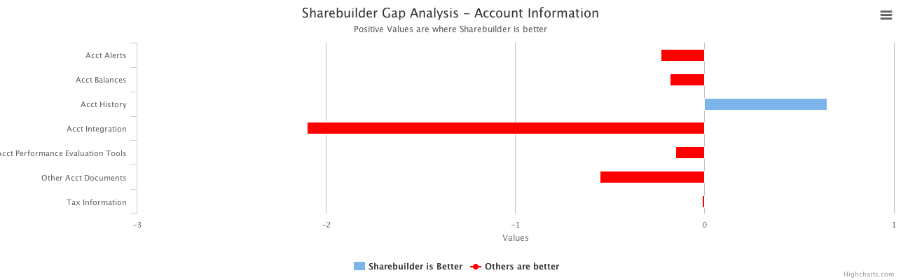

This will turn into another embedded image

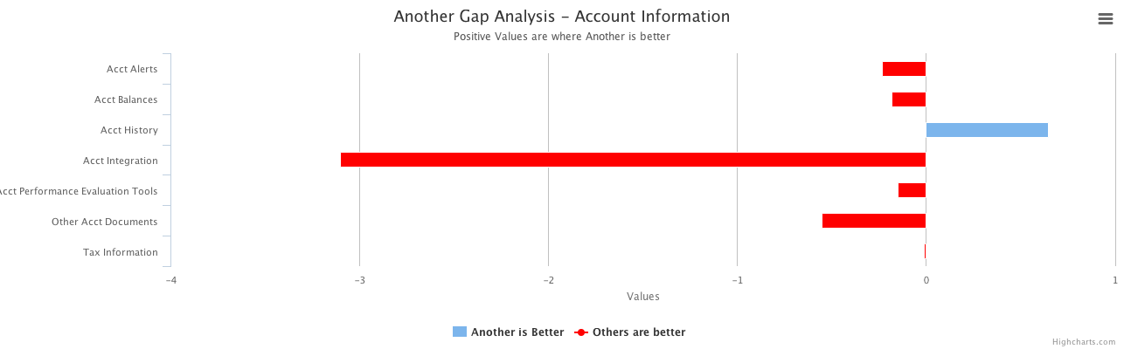

Window size: 1317 x 744  
Viewport size: 1317 x 635