**[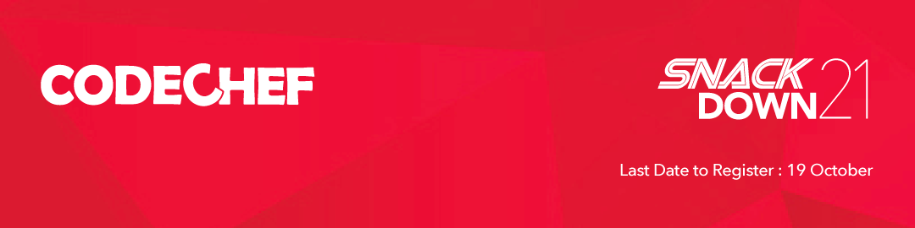](https://mail.codechef.com/l/ibi8MAnIqNCM4TjGrAHtsQ/62M3BTan5rcQqQn892oPxm4g/I8J0t2E8CHJ8GD763HmWI4qw)**



|  |  |
| --- | --- |
| |  | | --- | | We’re pleased to invite the student programmers to SnackDown 2021.  SnackDown is CodeChef’s biggest Annual Programming Challenge and one of the most popular global online events as well.  [Gennady Korotkewich](https://mail.codechef.com/l/ibi8MAnIqNCM4TjGrAHtsQ/0uTD7TQZIlF892rWm2hBtV892A/I8J0t2E8CHJ8GD763HmWI4qw) & [Borys Minaiev](https://mail.codechef.com/l/ibi8MAnIqNCM4TjGrAHtsQ/9yPwoA00u3pa68QSQiQJhw/I8J0t2E8CHJ8GD763HmWI4qw" \t "_blank), programmers from Saint Petersburg University, were the previous SnackDown champions. If you think your programmers can challenge them this year for the coveted SnackDown 2021 title, then do share the below details with your students.  [REGISTER HERE](https://mail.codechef.com/l/ibi8MAnIqNCM4TjGrAHtsQ/62M3BTan5rcQqQn892oPxm4g/I8J0t2E8CHJ8GD763HmWI4qw)  [SnackDown Prizes](https://mail.codechef.com/l/ibi8MAnIqNCM4TjGrAHtsQ/7ddC7rtFHYFFsT31FV892Ppg/I8J0t2E8CHJ8GD763HmWI4qw)  **The Dates to Remember:** Registrations are open now and will end on October 19. The first Online Qualifier Round will be from October 15th till the 19th. Online Round 1A will be held between 21st - 23rd October, and Online Round 1B will be held between 29th to 31st October. Online Pre-elimination will be on 21st November, and Online Elimination will be on 5th December. The Online Finale is scheduled to be held on 9th January 2022.  **Learn & Practice:** We have put together two Practice Contests to warm you up for SnackDown 2021. The practice contest for beginners is available in the below link, and the advanced practice contest will begin on September 20th. Click the link below and set reminder for the advanced contest now.  [PRACTICE CONTEST - BEGINNERS](https://mail.codechef.com/l/ibi8MAnIqNCM4TjGrAHtsQ/jPbNN763K892Fob1imWsNSJffQ/I8J0t2E8CHJ8GD763HmWI4qw)  [PRACTICE CONTEST - ADVANCED](https://mail.codechef.com/l/ibi8MAnIqNCM4TjGrAHtsQ/LzeY2mR4FXdbFem892ZhRf8Q/I8J0t2E8CHJ8GD763HmWI4qw)  Hope to see your University’s participation in this year’s SnackDown. Kindly reply to us as an acknowledgment of receiving this invitation.  Thanks & Regards   **Dr. Deepti Pillai   CodeChef For Colleges Team** LinkedIn: [https://www.linkedin.com/in/deepti-pillai-6b365314/](https://mail.codechef.com/l/ibi8MAnIqNCM4TjGrAHtsQ/xBQEK3LN6c9QyxcZCoV3mA/I8J0t2E8CHJ8GD763HmWI4qw) Diamond District, Ground Floor, Tower B, Domlur, Bengaluru, Karnataka | |