GoopOnTheGo

Team Project Report

  - CSD3156 Mobile and Cloud Computing
  - Spring 2026

Team Information
Edwin Lee Zirui (2301299)
Jeremy Lim Ting Jie (2301370)
Hurng Kai Rui (2301278)
Muhammad Nur Aqif Bin Abdemanaf (2301453)
Mohamed Ridhwan Bin Mohamed Afandi (2301367)

GitHub Repository | https://github.com/SquigglyOwl/GoopOnTheGo
App Demo Video
Presentation Video | https://youtu.be/QX3ov0hjPS4

Team Contributions
Member | Contributions
Edwin | Core game architecture, AR camera pipeline and colour detection CV algorithm, catch mechanic, evolution and fusion systems, Room database design and seeding, GPS habitat mapping, daily challenges, achievement system, login streak, Goopdex with persistent discovery, achievements header button, CI/CD pipeline, unit tests, Report, Video
Jeremy | UI overhaul - gradient header drawable, vector nav icons (scan, collection, map, back), card elevation and item layout polish across all screens, colour palette in colors.xml, light/night theme tokens; released all duplicates feature (v1.0) with DAO query and repository logic; moved release button from EvolutionActivity to CollectionActivity for better accessibility, Report
Kai Rui | Confirmation dialog before releasing a creature (with 3-second cooldown timer on the release button); display of caught location on CreatureDetailActivity (shows GPS coordinates or habitat zone name if GPS was unavailable), Report
Nur Aqif | Search bar on Collection screen - TextInputEditText with real-time Text Watcher filtering creatures by name and nickname (case-insensitive); sort dropdown positioned below search bar, Report
Ridhwan | Live creatures count on the Collection button in HomeActivity (e.g. "Collection (5)"); sort Collection dropdown (by name, rarity, date caught), Report

Table of Contents
GoopOnTheGo 1
Team Information 1
Team Contributions 2
1. Introduction & Game Overview 5
Core Game Loop 5
Creature System 5
Key Features Summary 5
2. Software Architecture 7
Architecture Diagram 7
Architectural Decisions 7
Navigation Flow 8
Activities Overview 9
3. Database Design 9
3.1 Entity-Relationship Overview 10
3.2 Table Definitions 11
3.3 Fusion Recipes 13
3.4 Notable Queries 13
3.5 Type Conversion 14
4. Mobile Features Implemented 14
4.1 Camera / Computer Vision 14
4.2 GPS Location Services 15
4.3 SQLite Database (Room ORM) 16
4.4 Canvas-Based 2D Graphics 17
4.5 Animations 17
4.6 Multi-Threading / Coroutines 17
5. Technical Implementation Details 18
5.1 Evolution System 18
5.2 Fusion System 20
5.3 Daily Challenge System 21
5.4 Daily Login Streak 22
5.5 Achievement System 23
5.6 Probabilistic Catch Mechanic 24
5.7 Creature Type System — GoopType.kt 25
5.8 Custom AR Overlay Graphics — AROverlayView.kt 25
5.9 Custom Habitat Map — HabitatMapView.kt 26
5.10 Geohashing for Habitat Zones — HabitatMapActivity.kt 26
6. Bonus: Computer Vision — Real-Time Colour-Based AR Spawning 27
Overview 28
Pipeline Architecture 28
Step 1 — Dominant Colour Extraction 28
Step 2 — Saturation Filter 29
Step 3 — RGB Channel Type Classification 29
Step 4 — Temporal Hold Timer 30
Step 5 — Spawn Selection 30
CV Summary 30
7. Software Engineering Practices 31
7.1 Version Control 31
7.2 CI/CD — GitHub Actions 31
7.3 Unit Testing 32
7.4 Code Structure & Style 32
8. Third-Party Libraries & Assets 33
9. AI Usage Declaration 34
10. Results & Evaluation 37
Features Delivered 37
Mobile Features Summary (Requirement: 3+) 37
Known Limitations 38
11. Links 40

1. Introduction & Game Overview
GoopOnTheGo is a location-based creature collection game for Android, inspired by Pokemon Go. Players scan their physical environment using the device camera to spawn and catch creatures called “Goops.” Each creature type is linked to a real-world colour signature detected via the camera in real time. Players build a collection, evolve creatures by merging duplicates, fuse two different types into hybrid creatures, and track progress through achievements and daily challenges.

Core Game Loop
Camera Scan → Colour Detected → Creature Spawns → Tap to Catch → Collect → Evolve / Fuse

Creature System
- 19 creatures (15 + 4) across 5 base types (Water, Fire, Nature, Electric, Shadow) and 4 hybrid fusion types
- 3-stage evolution chains - e.g. Droplet Goop → Aqua Goop → Tsunami Goop
- 4 fusion combinations producing hybrid creatures - e.g. Water + Fire = Steam Goop

Key Features Summary
Feature | Description
AR-style Camera Scanning | Real-time colour detection triggers creature spawns
Catch Mechanic | Tap creature within radius; rarity determines success rate
Creature Collection | Filterable inventory with nicknames and favourites
Evolution | Collect 3 identical creatures and merge them to evolve from either the Evolution screen or the Creature Detail screen
Fusion | Combine 2 compatible types into a hybrid creature
Habitat Map | GPS-based map showing nearby creature habitat zones
Daily Challenges | Time-limited objectives refreshed each midnight
Achievements | 10 persistent achievements across 5 categories
Login Streaks | Consecutive daily login tracking

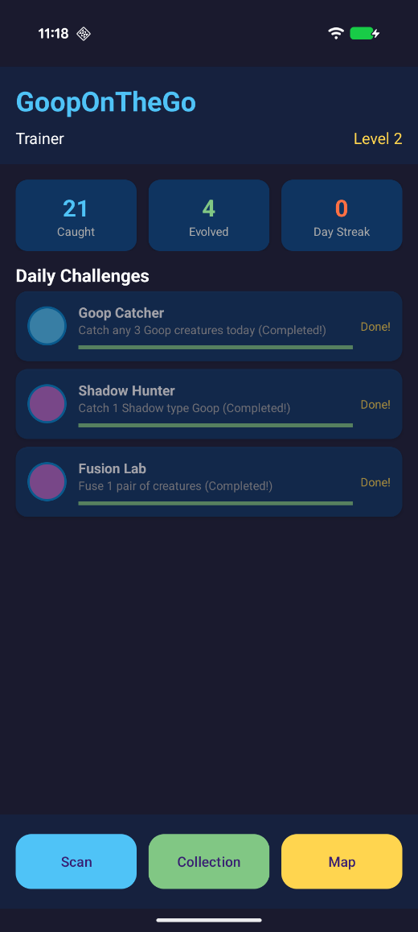
Figure 1: Home screen showing player stats and daily challenges

2. Software Architecture
The app follows an MVVM-adjacent architecture using the Repository pattern with Android Jetpack components.

Architecture Diagram
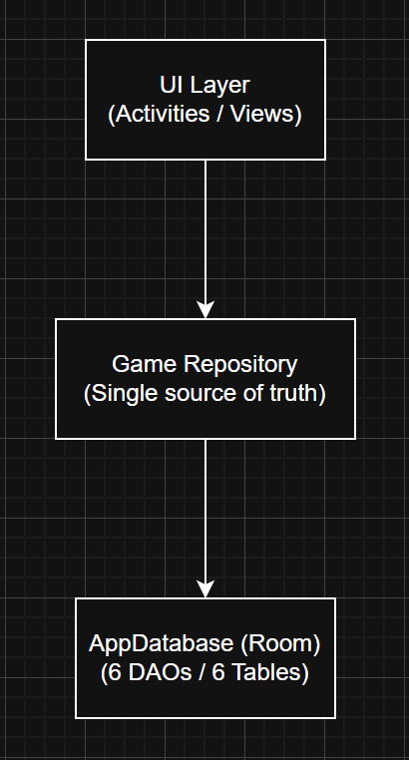

Architectural Decisions
Pattern | Implementation | Rationale
Repository Pattern | GameRepository.kt - centralises all data access and game logic | Keeps the UI separate from the data layer
Reactive Data | Kotlin Flow<> from Room DAOs | UI updates automatically when data changes, no polling needed
Coroutines | lifecycleScope.launch, Dispatchers.IO / Main | Database and camera work runs off the main thread
Singleton App | GoopApplication holds database and repository lazily | Shared across all screens
Custom Views | AROverlayView, HabitatMapView | Canvas drawing without a game engine
Application Entry: GoopApplication.kt initialises the Room database and GameRepository lazily, making them available to all Activities via (application as GoopApplication).repository.
Navigation Flow
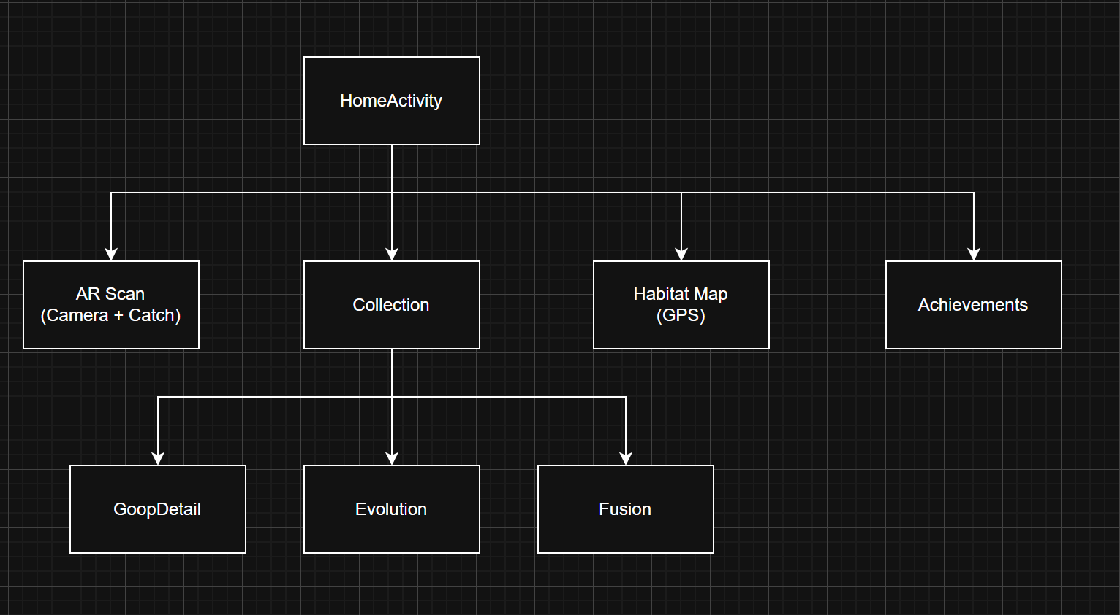

Activities Overview
Activity | Purpose
HomeActivity | Main hub - player stats, daily challenges, navigation
ARScanActivity | Camera preview, colour analysis, creature spawning, catch mechanic
CollectionActivity | RecyclerView grid (3 columns), type and favourite filtering
CreatureDetailActivity | Creature stats, nickname editing, evolve/release actions
EvolutionActivity | Lists creatures with 3+ copies ready to evolve; shows creature images in evolution preview card
FusionActivity | Two-slot selection for type fusion
HabitatMapActivity | Live GPS tracking, habitat zone detection
AchievementsActivity | Achievement list with progress bars
GoopdexActivity | Creature encyclopedia - silhouette for undiscovered, full image for discovered; live discovery counter (e.g. “7 / 19”); accessible from Collection screen

3. Database Design
The app uses Room ORM on top of SQLite with a database named gooponthego_database (schema version 2), with 6 entity tables.

3.1 Entity-Relationship Overview

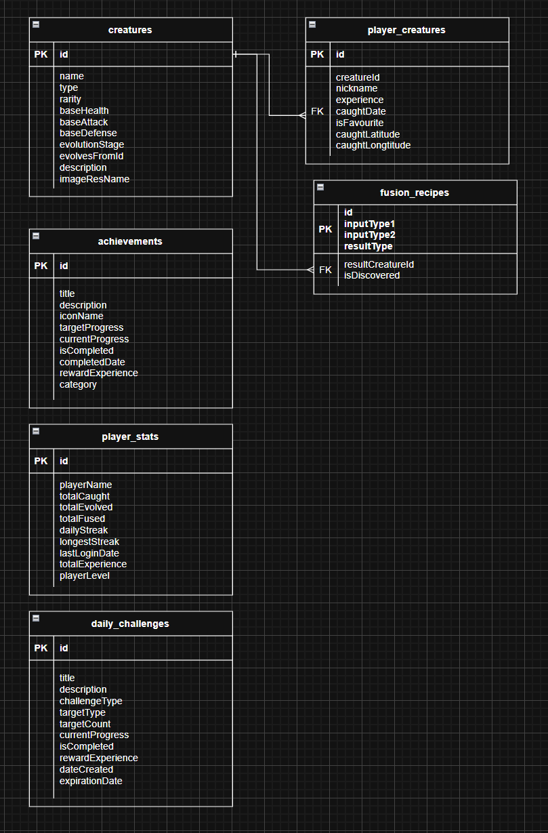

3.2 Table Definitions

creatures - Master creature list (19 rows seeded on first launch)
Column | Type | Constraints | Purpose
id | LONG | PK, autoGenerate | Unique creature ID
name | STRING | NOT NULL | Display name
type | STRING | NOT NULL | GoopType enum via TypeConverter
rarity | INT | NOT NULL | 1–5 (1 = common, 5 = legendary)
baseHealth | INT | NOT NULL | Base HP stat
baseAttack | INT | NOT NULL | Base attack
baseDefense | INT | NOT NULL | Base defense
evolutionStage | INT | NOT NULL | 1, 2, or 3
evolvesFromId | LONG | NULLABLE | Reference to parent form
evolvesToId | LONG | NULLABLE | Reference to next stage
description | STRING | NOT NULL | Dex entry text
imageResName | STRING | NULLABLE | Drawable resource name

player_creatures - Player’s caught creature instances
Column | Type | Constraints | Purpose
id | LONG | PK, autoGenerate | Unique instance ID
creatureId | LONG | FK → creatures.id, CASCADE DELETE | Base creature reference
nickname | STRING | NULLABLE | Player-assigned name
experience | INT | DEFAULT 0 | Accumulated XP
caughtDate | LONG | DEFAULT now | Epoch timestamp of capture
isFavorite | BOOLEAN | DEFAULT false | Favourite flag
caughtLatitude | DOUBLE | NULLABLE | GPS latitude at capture
caughtLongitude | DOUBLE | NULLABLE | GPS longitude at capture

player_stats - Singleton player progress (always id = 1)
Column | Type | Purpose
totalCaught / Evolved / Fused | INT | Cumulative event counters
dailyStreak / longestStreak | INT | Login streak tracking
lastLoginDate | LONG | For streak day-diff calculation
totalExperience | INT | Account-level XP
playerLevel | INT | Derived: (totalExperience / 1000) + 1

daily_challenges - Time-limited objectives (expire at midnight)
Column | Type | Purpose
challengeType | STRING (Enum) | CATCH_ANY, CATCH_TYPE, EVOLVE, FUSE, SCAN_LOCATIONS
targetType | STRING? | GoopType for type-specific challenges
targetCount / currentProgress | INT | Goal vs current progress
expirationDate | LONG | Next day 00:00:00 epoch
rewardExperience | INT | XP on completion

achievements - Persistent unlock system (10 seeded achievements)
Column | Type | Purpose
category | STRING (Enum) | COLLECTION, EVOLUTION, EXPLORATION, DAILY, SPECIAL
targetProgress / currentProgress | INT | Goal tracking
completedDate | LONG? | Null until completed
rewardExperience | INT | XP reward

fusion_recipes - 4 fusion combination rules
Column | Type | Purpose
inputType1 / inputType2 | STRING | GoopType ingredients
resultType | STRING | Output hybrid type
resultCreatureId | LONG | FK to resulting creature
isDiscovered | BOOLEAN | Revealed to player on first use

3.3 Fusion Recipes
Type 1 | Type 2 | Result
WATER | FIRE | STEAM
ELECTRIC | NATURE | LIGHTNING_PLANT
FIRE | NATURE | MAGMA
WATER | ELECTRIC | ICE

3.4 Notable Queries
Bidirectional Fusion Recipe Lookup (FusionRecipeDao):
SELECT * FROM fusion_recipes
WHERE (inputType1 = :type1 AND inputType2 = :type2)
OR (inputType1 = :type2 AND inputType2 = :type1)
This matches a recipe regardless of the order the two creature types are passed in.
Joined Collection Query (PlayerCreatureDao):
SELECT * FROM player_creatures
INNER JOIN creatures ON player_creatures.creatureId = creatures.id
Returns all player creatures with their full base creature data in a single transaction.

3.5 Type Conversion
Converters.kt provides Room with @TypeConverter functions to persist the GoopType enum as a String in SQLite and restore it on read.

4. Mobile Features Implemented
The app uses six advanced mobile features, more than the required minimum of three.

4.1 Camera / Computer Vision
Classes: ARScanActivity.kt, inner class ColorAnalyzer
CameraX ImageAnalysis with a single-thread ExecutorService processes camera frames continuously. A custom pixel-sampling and colour-classification algorithm detects the dominant environmental colour and maps it to a GoopType. A 2-second temporal hold filter prevents accidental spawns from transient colour changes. (Full algorithm documented in Section 6 - Bonus Component.)

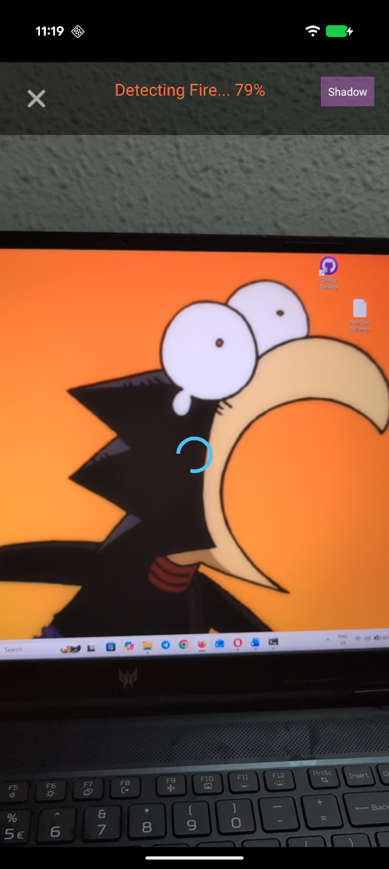  Figure 2: AR scanning screen detecting environmental colour - 2-second temporal hold timer in progress before creature spawn | 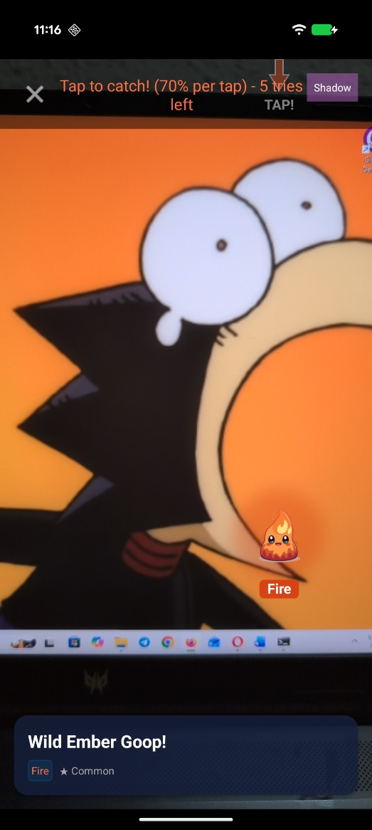  Figure 3: AR scanning screen showing a creature spawned via real-time colour detection

4.2 GPS Location Services
Class: HabitatMapActivity.kt
The Fused Location Provider (com.google.android.gms:play-services-location) tracks the player’s position with update interval of 5 seconds and minimum update interval of 2 seconds. Permissions: ACCESS_FINE_LOCATION and ACCESS_COARSE_LOCATION. GPS coordinates feed into the geohashing algorithm to determine the local habitat type, displayed on the custom canvas map.

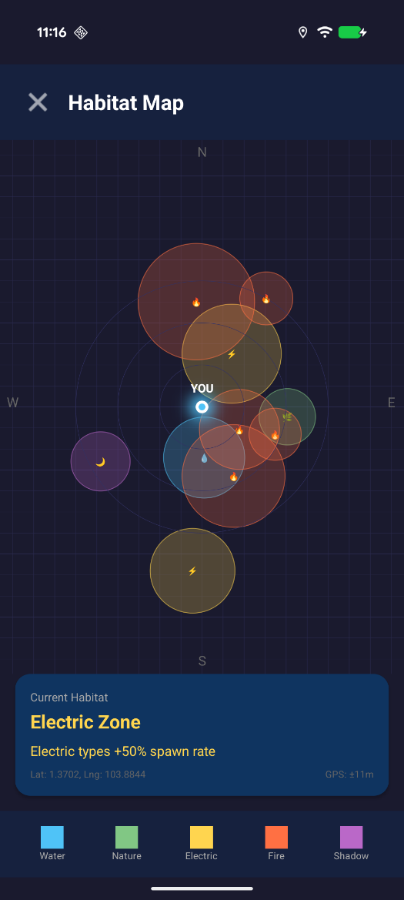
Figure 4: Habitat map showing GPS-tracked player position and habitat zones

4.3 SQLite Database (Room ORM)
Classes: AppDatabase.kt, 6 DAOs, GameRepository.kt
A full relational database with 6 tables, foreign key constraints, cascade deletion, type converters, and 23 queries across 6 DAOs. The database is auto-initialised with 19 creatures, 4 fusion recipes, and 10 achievements via RoomDatabase.Callback.

4.4 Canvas-Based 2D Graphics
Classes: AROverlayView.kt, HabitatMapView.kt
Two custom View subclasses render game graphics entirely via the Android Canvas API - no external game engine is used. AROverlayView renders animated creatures with procedural blob shapes, layered glow effects, and a directional catch arrow. HabitatMapView renders a live map with habitat zones, a player position marker, a grid background, and a compass.

4.5 Animations
Class: AROverlayView.kt
Two ValueAnimator instances drive continuous creature animations:
- Bounce: 1000 ms cycle, AccelerateDecelerateInterpolator, plus/minus 25 px vertical displacement, INFINITE / REVERSE repeat
- Glow pulse: 1500 ms cycle, 0–30 px BlurMaskFilter radius expansion, INFINITE / REVERSE repeat
Both animators call invalidate() on each frame to trigger canvas redraw.

4.6 Multi-Threading / Coroutines
All database operations run on Dispatchers.IO via Kotlin coroutines (lifecycleScope.launch). Camera frame analysis runs on a dedicated ExecutorService. Results are dispatched back to Dispatchers.Main for UI updates. The main thread is never blocked.

5. Technical Implementation Details

5.1 Evolution System
Evolution uses a merge-to-evolve mechanic. The player must own 3 identical base-stage creatures. All 3 copies are removed and one evolved creature is inserted. The evolved creature inherits the nickname of the original.
- Requirement: sameCreatures.size >= 3
- Action: delete instances[0..2], insert PlayerCreature(evolution.id)
- XP reward: 50 XP added to player_stats

Evolution can be triggered from two places in the app:
- CreatureDetailActivity - when viewing a specific Goop, a progress bar shows X/3 copies owned. The Evolve button enables automatically once 3 copies are collected.
- EvolutionActivity - a dedicated screen accessible from the Collection screen. It displays all creature types where the player owns 3 or more copies, showing the actual creature image alongside the evolved form in a preview card. Previously this screen used an XP-based filter which never surfaced any creatures; this was identified and fixed so the screen now correctly reflects the merge-to-evolve mechanic.

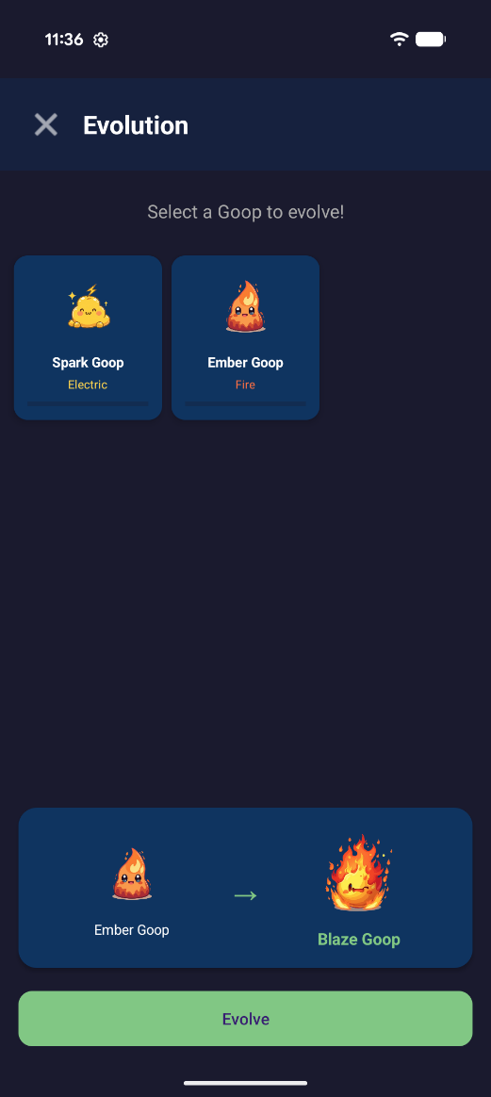  Figure 5: EvolutionActivity showing eligible creatures and evolution preview with creature images | 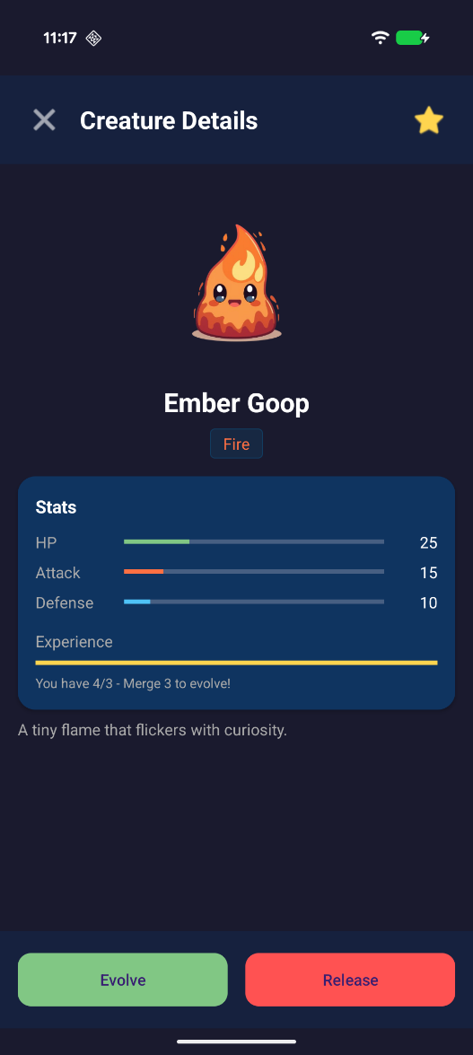  Figure 6: CreatureDetailActivity displaying X/3 evolution progress bar with Evolve button enabled

5.2 Fusion System
Two creatures of compatible types are selected by the player. FusionRecipeDao performs a bidirectional lookup for a matching recipe. Both source creatures are deleted and one hybrid creature is inserted with averaged experience. The recipe is flagged isDiscovered = true on first successful use.
- Fused XP = (experience1 + experience2) / 2
- XP reward: 75 XP added to player_stats

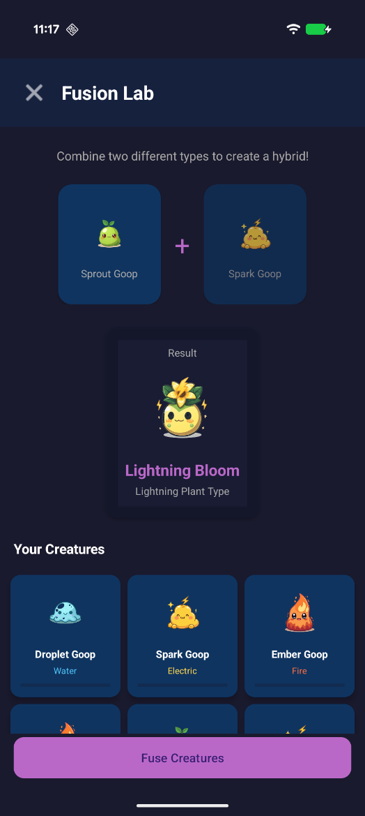
Figure 7: FusionActivity showing two compatible creature slots selected for fusion

5.3 Daily Challenge System
Challenges are generated fresh when no active (non-expired) challenges exist. Three challenges are created with expiration set to the next day at 00:00:00. Progress is updated by event hooks inside GameRepository that fire on catch / evolve / fuse actions.
Default Daily Challenges:
Title | Type | Target | Reward
Catch 3 Goops | CATCH_ANY | 3 | 50 XP
Water Hunter | CATCH_TYPE (WATER) | 2 | 75 XP
Evolution Time | EVOLVE | 1 | 100 XP

5.4 Daily Login Streak
The streak system compares Calendar.DAY_OF_YEAR and Calendar.YEAR between the last login timestamp and the current time:
- Same day: streak unchanged
- Next consecutive day: streak incremented by 1
- Gap of 2+ days: streak resets to 1
- Cross-year transitions handled by comparing both year and day-of-year fields

Figure 8: Home screen zoomed in on the daily challenges and daily login sections

5.5 Achievement System
10 achievements across 5 categories (COLLECTION, EVOLUTION, EXPLORATION, DAILY, SPECIAL). Progress is updated passively on game events and compared against targetProgress. Once isCompleted = true, progress stops updating. Completion awards rewardExperience XP.
Title | Category | Target | Reward
First Catch | COLLECTION | 1 catch | 50 XP
Collector | COLLECTION | 10 catches | 100 XP
Goop Master | COLLECTION | 50 catches | 500 XP
First Evolution | EVOLUTION | 1 evolution | 100 XP
Evolution Expert | EVOLUTION | 10 evolutions | 300 XP
Mad Scientist | EVOLUTION | 1 fusion | 150 XP
Explorer | EXPLORATION | 5 locations | 200 XP
Dedicated Trainer | DAILY | 7-day streak | 250 XP
Type Specialist | COLLECTION | 5 types caught | 300 XP
Challenge Champion | DAILY | 10 challenges | 200 XP

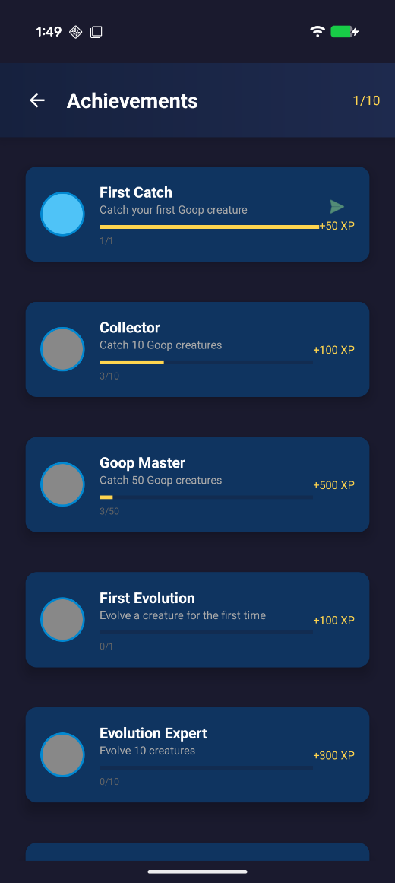

5.6 Probabilistic Catch Mechanic
Tap detection computes Euclidean distance from the touch point to the creature’s current animated position (accounting for live bounce offset). A tap within 90% of the creature radius triggers a catch attempt:
Rarity | Stars | Catch Rate
Common | 1 star | 70%
Uncommon | 2 stars | 55%
Rare | 3 stars | 40%
Epic | 4 stars | 25%
Legendary | 5 stars | 15%
Random.nextFloat() < catchRate determines success or failure.
Players have a maximum of 3 attempts before the creature escapes, making each throw meaningful.

5.7 Creature Type System - GoopType.kt
A Kotlin enum with 10 values, each carrying displayName, primaryColor, secondaryColor, and habitat. A companion object implements getFusionResult(type1, type2) using setOf() for order-independent matching.
Type | Primary Colour | Habitat
WATER | Blue (#4FC3F7) | Near water sources
FIRE | Red-orange (#FF7043) | Warm areas
NATURE | Green (#81C784) | Parks and plants
ELECTRIC | Yellow (#FFD54F) | Near electronics
SHADOW | Purple (#BA68C8) | Dark areas
STEAM | Grey (#B0BEC5) | Misty areas
LIGHTNING_PLANT | Yellow-green (#AED581) | Stormy gardens
MAGMA | Deep orange (#FF5722) | Volcanic regions
ICE | Light blue (#E1F5FE) | Cold areas
VOID | Dark indigo (#311B92) | Unknown

5.8 Custom AR Overlay Graphics - AROverlayView.kt
Procedural Blob Rendering uses a 12-point polygon with sine-wave radial distortion:
val angle = (i.toFloat() / 12) * 2 * PI
val wobble = sin(angle * 3 + System.currentTimeMillis() / 200.0) * 15f
val r = radius + wobble.toFloat()
val x = cx + (r * cos(angle)).toFloat()
val y = cy + (r * sin(angle)).toFloat()
- Wobble cycles at approximately 5 Hz (time / 200)
- 3rd-order angular frequency (angle × 3) creates 3 lobes of organic distortion
- Rendered with a drop shadow, primary filled path, and white highlight circle
- Glow effect uses BlurMaskFilter(glowRadius + 20f, BlurMaskFilter.Blur.NORMAL) drawn behind the creature

5.9 Custom Habitat Map - HabitatMapView.kt
Habitat Zone Generation uses random polar coordinates:
val angle = random.nextDouble() * 2 * PI
val distance = 100f + random.nextFloat() * 300f // 100–400 px from centre
val offsetX = (cos(angle) * distance).toFloat()
val offsetY = (sin(angle) * distance).toFloat()
val radius = 60f + random.nextFloat() * 80f // 60–140 px zone radius
8–12 zones are generated per session. Canvas layers drawn in order: dark grid background, habitat circles, range rings (100/200/300 px), player glow marker, compass labels.

5.10 Geohashing for Habitat Zones - HabitatMapActivity.kt
val latZone = (lat * 100).toInt() // 0.01 degree resolution = approx 1.1 km
val lngZone = (lng * 100).toInt()
val hash = abs(latZone + lngZone)
return when (hash % 10) {
0, 1 -> GoopType.WATER
2, 3 -> GoopType.NATURE
4, 5 -> GoopType.ELECTRIC
6, 7 -> GoopType.FIRE
else -> GoopType.SHADOW
}

5.11 Goopdex - Persistent Discovery System
The Goopdex (GoopdexActivity) shows all 19 creatures in a 3-column grid. Undiscovered creatures display a black silhouette with “???” for name and type. Discovered creatures show their full colour image, name, and type.
Discovery is saved as isDiscovered on the Creature entity - a flag that stays true once set. It gets set to true by GameRepository in three cases:
Event | Action
catchCreature() | Marks the caught creature’s base entry as discovered
evolveCreature() | Marks the evolved-stage creature as discovered when created
fuseCreatures() | Marks the fusion result creature as discovered when created
This means if a player catches Droplet Goop, evolves all 3 copies into Aqua Goop, and then fuses Aqua Goop away - Droplet Goop, Aqua Goop, and Steam Goop all remain shown in the Goopdex permanently, even though none are currently in the collection.
The silhouette effect is applied via a ColorMatrix that sets all RGB channels to zero while keeping the alpha channel, so the original image shape fills in as solid black.
The Goopdex is accessible from the Collection screen via the “Goopdex” button, and the header shows a live progress counter (e.g. “7 / 19”).
The hash is deterministic - the same real-world location always produces the same habitat type, so the same real-world area always maps to the same habitat type.

6. Bonus: Computer Vision - Real-Time Colour-Based AR Spawning
This section describes the custom CV component we built for the bonus criterion: “Complex implemented component with special algorithms, or other advanced features e.g. CG, ML, CV, VR, AR (mostly using a library or copying code from somewhere doesn’t count). This component should be clearly documented within the report.”

Overview
ARScanActivity.kt implements a real-time computer vision pipeline using CameraX ImageAnalysis to classify the player’s physical environment by dominant colour and map it to a creature type. The pixel sampling, saturation filtering, type classification rules, and temporal hold detection are all custom-implemented logic - no CV or ML library is used for the classification itself.

Pipeline Architecture
Camera Frame (CameraX ImageAnalysis, every 200 ms)
|
v
Bitmap Capture
|
v
Dominant Colour Extraction <-- Custom sparse pixel sampling
|
v
Saturation Filter <-- Reject achromatic surfaces
|
v
RGB Channel Classification <-- Map colour to GoopType
|
v
Temporal Hold Timer <-- 2-second sustained colour required
|
v
Creature Spawn Trigger <-- evolutionStage = 1 creatures only

Step 1 - Dominant Colour Extraction
The centre region of each camera frame is sampled. Every 4th pixel in both axes is read (1/16th of the region) to balance accuracy with CPU performance on the camera thread:
for (x in startX..endX step 4) {
for (y in startY..endY step 4) {
val pixel = bitmap.getPixel(x, y)
rSum += Color.red(pixel)
gSum += Color.green(pixel)
bSum += Color.blue(pixel)
count++
}
}
return Color.rgb(rSum / count, gSum / count, bSum / count)

Step 2 - Saturation Filter
Pixels with low RGB spread are rejected as achromatic. This prevents white walls, grey floors, or overcast skies from falsely triggering a spawn:
val max = maxOf(r, g, b)
val min = minOf(r, g, b)
if (max - min < 30) return null // Too grey / neutral - no type

Step 3 - RGB Channel Type Classification
return when {
b > r && b > g && b > 80 -> GoopType.WATER // Blue dominant
r > g && r > b && r > 80 -> GoopType.FIRE // Red dominant
g > r && g > b && g > 80 -> GoopType.NATURE // Green dominant
r > 120 && g > 120 && b < 100 -> GoopType.ELECTRIC // Yellow: R+G high, B low
r < 50 && g < 50 && b < 50 -> GoopType.SHADOW // Near-black
else -> null
}
The ELECTRIC case is the most notable: yellow is not a primary additive colour, so it is identified by requiring both red and green channels to exceed 120 with blue below 100 - a deliberate multi-channel rule rather than single-channel dominance.

Step 4 - Temporal Hold Timer
A single camera frame is unreliable due to lighting flicker and motion. A 2-second sustained colour hold is required before any spawn is triggered. If the detected type changes mid-scan, the timer resets, stopping false spawns when the detected colour changes briefly:
private var currentDetectedType: GoopType? = null
private var colorDetectionStartTime = 0L
private val COLOR_HOLD_TIME_MS = 2000L
if (detectedType == currentDetectedType) {
val elapsed = currentTimeMillis - colorDetectionStartTime
val progress = ((elapsed / 2000.0) * 100).toInt().coerceIn(0, 100)
// UI feedback: "Detecting Water... 47%"
if (elapsed >= COLOR_HOLD_TIME_MS) spawnCreatureOfType(detectedType)
} else {
currentDetectedType = detectedType
colorDetectionStartTime = currentTimeMillis // Reset on type change
}

Step 5 - Spawn Selection
Only base-stage creatures (evolutionStage = 1) can be wild-spawned via colour detection. Evolved and hybrid creatures are exclusive rewards for gameplay investment (merging, fusing):
SELECT * FROM creatures WHERE type = :type AND evolutionStage = 1

CV Summary
Aspect | Detail
Input | CameraX ImageAnalysis bitmap frames at 200 ms intervals
Sampling | Sparse centre-region sampling (1/16 pixel density)
Saturation filter | max(R,G,B) − min(R,G,B) < 30 rejects achromatic frames
Classification | 5-rule RGB channel comparison mapping to 5 GoopTypes
Temporal filter | 2-second same-type hold with real-time UI progress feedback
Output | spawnCreatureOfType(GoopType) → DB query → AR overlay render
Libraries used | CameraX for frame delivery only - classification is entirely custom code

7. Software Engineering Practices

7.1 Version Control
- 15 pull requests merged into master across branches: edwin, jeremy, kairui, aqif, Ridhwan, feature/unit-tests, report
- Feature branch workflow - each team member worked on a named branch and submitted a PR for review
- Commit history shows the project was built up step by step

7.2 CI/CD - GitHub Actions
A GitHub Actions workflow (.github/workflows/android-ci.yml) runs automatically on every push and pull request to master, main, and develop:
Step | Action
1 | Checkout code - actions/checkout@v4
2 | Set up JDK 17 (Temurin distribution)
3 | Configure Gradle - gradle/actions/setup-gradle@v4
4 | Build Debug APK - ./gradlew assembleDebug
5 | Run unit tests - ./gradlew testDebugUnitTest
6 | Upload APK artifact (14-day retention)
7 | Upload test result reports (14-day retention)
This keeps the main branch from breaking and makes sure all unit tests pass before any merge.

7.3 Unit Testing
Unit tests are present and merged into master via PR #1 (feature/unit-tests):
- CreatureTest - creature entity validation (stats, rarity bounds)
- GoopTypeTest - type system logic (fusion rules, getFusionResult correctness)
- PlayerStatsTest - player stats calculations (level formula, streak edge cases)
Tests run automatically in CI on every push.

7.4 Code Structure & Style
- Modular package structure: data/database/, data/repository/, ui/ar/, ui/map/, ui/collection/, ui/achievements/
- Separation of concerns: DAOs handle queries only; Repository handles business logic; Activities handle UI only
- Kotlin idioms: data classes, when expressions, extension functions, coroutines, Flow
- Code follows the Android Kotlin Style Guide (https://developer.android.com/kotlin/style-guide)
- KDoc and inline comments on key classes and algorithms

8. Third-Party Libraries & Assets
All third-party libraries are listed below as required. No library was used to implement the core classification logic of the CV algorithm.
Library | Purpose
androidx.room (runtime + ktx + compiler/KSP) | SQLite ORM - all data persistence
androidx.camera.camera2 | Camera hardware access
androidx.camera.lifecycle | Lifecycle-aware camera binding
androidx.camera.view | PreviewView UI component
com.google.android.gms:play-services-location | Fused GPS location provider
kotlinx.coroutines.android | Async / non-blocking operations
androidx.lifecycle.viewmodel.ktx | Lifecycle-aware ViewModel scope
androidx.lifecycle.livedata.ktx | LiveData
androidx.lifecycle.runtime.ktx | lifecycleScope coroutine support
androidx.recyclerview | Scrollable list and grid displays
com.google.android.material | Material Design UI components
androidx.cardview | Card layout containers
androidx.navigation.fragment.ktx | Fragment navigation
junit | Unit testing framework
androidx.test.espresso.core | UI instrumented testing
androidx.test.ext:junit | Android JUnit test runner
Build Configuration: Android API 24 (min) - 34 (target/compile), JVM target 17, KSP for Room code generation.
Assets: All creature names, types, and game designs are original. rawable assets are AI-generated, created for this project

9. AI Usage Declaration
AI tools were used during this project as declared below:
Phase | Tool | How It Was Used
Design | Claude (Anthropic) | Brainstorming the colour-detection approach for AR-style spawning without ARCore
UI / Asset Design | Claude (Anthropic) | Generating creature names, Goopdex descriptions, colour palette suggestions, and app UI layout advice
Implementation | Claude (Anthropic) | Assistance with Room DAO query syntax, CameraX ImageAnalysis setup, coroutine patterns
Debugging | Claude (Anthropic) | Diagnosing Room database migration version conflicts and camera thread management issues
Testing | Claude (Anthropic) | Writing unit test cases for GoopType fusion logic, player stats level formula, and streak edge cases
Report writing | Claude Code (Anthropic) | Structuring and drafting this report
Prompts used:
Design phase:
- "I want to build an AR creature spawning mechanic without using ARCore. Can I use the camera to detect colours in real time and use that to trigger spawns?"
- "What's a good way to structure a merge-to-evolve system like Dragon City in Android?"
“can you suggest 19 creature names for my game, based on 5 types: water fire nature electric and shadow, some should have 3 evolution stages like droplet → aqua → tsunami, need the names to sound cool”
“how should i design the catch mechanic, should success be based on rarity or should the player need to tap at the right time, also how many attempts before the creature escapes”
“what color palette should i use for a dark themed android mobile game where the creatures are glowing coloured blobs, i want it to look clean but still feel like a game”

Implementation phase:
- "My Room DAO isn't returning results when I join two tables. Here is my query:…. What is wrong?"
- "How do I set up CameraX ImageAnalysis to process frames on a background thread without blocking the UI?"
- "How do I use Kotlin Flow with Room so my RecyclerView updates automatically when the database changes?"
- "What's the correct way to use lifecycleScope and Dispatchers.IO together for database calls?"
“how do i request camera and location permissions at runtime in android, i already added them to the manifest but the app crashes on devices running android 6 and above”
“my recyclerview keeps showing the wrong creature image when i scroll, like the images are swapping around, how do i stop this”
“i want to let the player nickname their creature, how do i save that to the room database and update the display in the collection screen straight away”
“how do i make a custom view that draws a glowing circle on android canvas, i want a blur effect around the creature shape”

UI / Asset Design phase:
“give me pokedex style descriptions for these 19 creatures i made up, keep them short like 2 sentences, they should match the creature’s element type”
“how do i make a gradient header background in android using xml drawables, i want it to go from dark purple at the top to dark blue at the bottom”
“generate icon descriptions for nav bar buttons for a creature collecting game: scan, collection, map, i need them to feel game-like not generic”

Debugging phase:
- "I'm getting a Room migration error after adding a new column. My schema version is still 1. How do I fix this?"
- "My camera analyzer is running on the main thread and causing jank. How do I move it to a dedicated ExecutorService?"
“my evolution screen is always empty even when i have 3 of the same creature in my collection, the list just shows nothing, i think the filter is wrong but i cant figure out why”
“my login streak keeps resetting to 1 every time the app opens even if i opened it yesterday, the calendar comparison logic seems off”

Testing phase:
“how do i write a junit unit test for a kotlin function that takes two GoopType enum values and returns a fusion result, i want to test all 4 valid combos and some invalid ones”
“what should i be testing for a PlayerStats class, specifically the level calculation and the streak logic when the user opens the app 2 days in a row vs skipping a day”

Report writing phase:
- "Can you help me structure a technical report section explaining how my colour detection CV pipeline works?"
- "How should I document my database schema in a report - as a table or ER diagram?"
“can you help me write the CI/CD section of my report, we used github actions to build the apk and run tests on every push, how should i explain this in a technical report”
All AI suggestions were reviewed and tested by the team before being used. Final decisions and code were done by us.

10. Results & Evaluation

Features Delivered
Feature | Status
Camera colour detection (CV pipeline) | Complete
Colour to GoopType classification | Complete
Temporal hold filter (2 seconds) | Complete
Tap-to-catch with rarity probability | Complete
Creature escape timer (6 seconds) | Complete
Creature collection with filtering | Complete
Merge-to-evolve (3x same creature) | Complete
Fusion system (2-type hybrid, 4 recipes) | Complete
GPS habitat mapping | Complete
Geohashing for deterministic habitat zones | Complete
Daily challenges with midnight expiration | Complete
Login streak system (cross-year aware) | Complete
Achievement system (10 achievements, 5 categories) | Complete
Room database (6 tables, seeded on first launch) | Complete
GitHub Actions CI/CD pipeline | Complete
Unit tests (3 test classes) | Complete

Mobile Features Summary (Requirement: 3+)
Feature | API / Component
Camera | CameraX ImageAnalysis
GPS / Location | Fused Location Provider
Database | Room ORM (SQLite)
Canvas Graphics | Android Canvas API
Animation | ValueAnimator, BlurMaskFilter
Multi-threading | Kotlin Coroutines + ExecutorService
6 mobile features total

Known Limitations
- Colour detection is sensitive to lighting conditions - very dark or very bright environments may not trigger spawns reliably
- Habitat zone positions are randomly seeded each session - zones are not spatially persistent across app restarts
- All data is stored locally; no cloud sync or remote leaderboard is implemented

Future Work
- Persist habitat zone seeds to the database so zones remain consistent across app restarts
- Implement cloud sync via Firebase to enable cross-device progress and a global leaderboard
- Expand the fusion recipe system with more type combinations and rare hybrid creatures
- Add push notifications for daily challenge reminders and login streak alerts
- Introduce a trading system allowing players to exchange creatures with nearby players via Bluetooth or NFC
- Implement a turn-based battle system allowing players to pit their Goops against each other or against AI-controlled encounters

Reflections

What went well:
- The colour-based CV pipeline proved more effective than initially expected - the 2-second temporal hold filter significantly reduced false spawns and made the mechanic feel responsive and intentional
- Using Room with Kotlin Flow meant the UI updated automatically without manual polling, which simplified a lot of the collection and home screen logic
- The Repository pattern kept the codebase clean and made debugging easier since all data logic was centralised in one place

What was harder than expected:
- Colour detection is inherently sensitive to lighting - achieving consistent spawns across different real-world environments required significant tuning of the saturation filter and RGB thresholds
- Room database migrations caused repeated issues during development when new columns were added, requiring careful versioning to avoid data loss on reinstall
- The EvolutionActivity initially used an XP-based filter that never surfaced any creatures, identifying and fixing this bug required tracing the filter logic back through the repository layer

What we would do differently:
- We would persist habitat zone seeds to the database earlier in development, as the current session-based random seeding means zones reset on every app restart, which reduces the sense of a persistent game world.

11. Links
Resource | URL
Source Code (GitHub) | https://github.com/SquigglyOwl/GoopOnTheGo
App Demo Video | (paste demo video link)
Presentation Video | https://youtu.be/QX3ov0hjPS4

