## Master Mind Game Clone Overview

**Overview written by Peter Mitchell.**

**Revision Number 1.0**

Contents

1.1 Master Mind Game Clone Overview 1

1.2 Introduction 1

1.3 The Rules of Master Mind 1

1.4 High Level Discussion About Implementation 2

1.5 How the Core Game Works 3

1.6 Features You Could Add 4

## Introduction

This is NOT a graded piece of work! It is just an additional activity that anyone is free to try out if they are interested.

This document will explain the fundamentals of how the Master Mind game works. At this time, it will not walk through how to create it step by step. If you are looking for a more complex program example that expands on content in Java look at the RPG Text Game.

Finished version (MasterMind folder): <https://github.com/Squirrelbear/CP1Extras>

## The Rules of Master Mind

Master Mind has a simple set of rules to control the flow of play. The following summarises the rules.

* The game starts with one player hiding a puzzle combination made up of some number of possible colours with some length of puzzle.
* The other player’s goal is to guess what the combination is. This is done by guessing complete combinations to match the solution.
* After submitting combinations, the guessing player is told how many of the pattern is correct position and colour, and how many are the right colour, but in the wrong position.
* The game ends when either the guessing player correctly guesses the solution, or when the guessing player runs out of a maximum number of guesses.

## High Level Discussion About Implementation

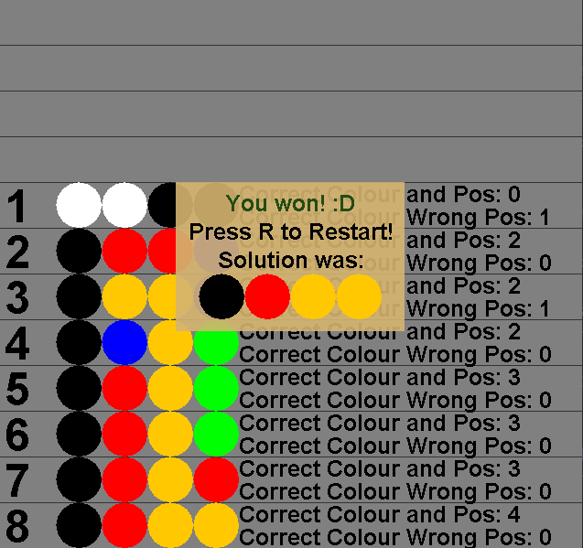

Implementation of this game is set up to have the “player” setting the solution controlled by the player to randomly create solutions. The player is playing it as a single player game where they are trying to guess correctly.

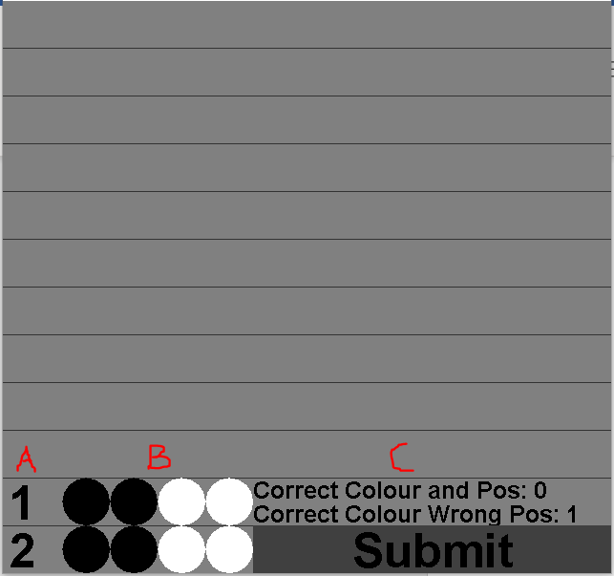

In the image above you can see labels A, B, and C. This shows how the interface is built where A is the attempt number, B is the puzzle combination, and C is the information about how close the attempt was. You can see from this image and the image further up that the new attempts are inserted at the bottom, and the submit button hides the result information for the current attempt. The submit button is hidden when the overlay showing the game is over appears. Only the bottom row is interactable where you can click on the colours with left or right mouse button to cycle them, and submit will validate your solution to tell you if it is correct as seen in C, or via a dialogue that appears to tell you it was won.

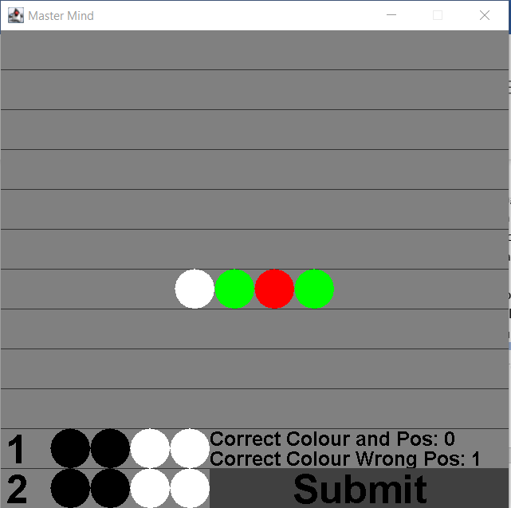

Pressing C will make a cheat activate to toggle viewing the solution. This would appear like above where it shows the solution in the same position it would be on the end dialogue. Pressing R at any time will make it restart the game and pressing Escape will exit the game.

## How the Core Game Works

The classes used to develop this include the following.

* Lowest level classes:
  + SimpleButton: A button that can be used to check for mouse clicks in a rectangle with optional drawn background. It is used for detecting clicks to change the combination.
  + SimpleTextButton: Extends the SimpleButton to add centred text. Used for the Submit button.
* Attempt panel classes:
  + AttemptPanel: Combines drawing of the attempt number, PuzzleCombination, and ResultPanel for a single line of the interface.
  + PuzzleCombination: Used to represent either the combination for an attempt, or the solution.
  + ResultPanel: Draws the text showing how many matches were found in the attempt.
* GamePanel classes:
  + GamePanel: Controls the game state while managing a list of AttemptPanel objects. When the game ends it will display the GameEndedPanel.
  + GameEndedPanel: A dialogue to show if the game was won or lost.
* Starting the game:
  + Game: Creates the JFrame and populates it with a GamePanel. Also passes information about keys that are pressed to the GamePanel.

You can view the code to browse how the different elements are implemented with full comments provided.

## Features You Could Add

The current implementation is very simple. It has many different things you can change. The following list summarises some of the things you could try changing.

* Change some of the properties to test how the game works with different settings. These constant variables can be changed to automatically update the game to change how it works.
  + PuzzleCombination.ID_TO_COLOUR  
    You can add or remove colours to add or remove how many different options there are for combinations. It is provided with 6 colours, but you could try seeing how the game changes if you were to have 2,3,4,5,7,8,9,10 different colours.
  + PuzzleCombination.COMBINATION_LENGTH  
    This is the number of elements in the puzzle. The default is 4, you could try with changing it to 5 or some other number.
  + GamePanel.MAXIMUM_ATTEMPTS

This is the number of attempts shown as the amount of space on screen. By default, this is 12, but you could try changing this to other amounts.

* + A note though on changing these variables. You will need to consider the impact of how many combinations it will require and make that proportional to the number of attempts. You also need to consider how much screen space is available. With the current implementation it sizes itself to show everything.

With the default settings you would for example have 6*6*6*6 = 1296 possible combinations. Or if you change the COMBINATION_LENGTH to 5 it would be 6*6*6*6*6 = 7776.

* Improve the visuals of the game. You could change the text result information to show as something more interesting like black circles for each of one and white for each of the other.
* Add a multiplayer mode where another player can set the combination while the guesser does not look at the screen. You could take this a step further by making this work in an online game, but that is a significant amount of work.
* Create an AI that can solve the puzzles by using a minmax type algorithm.
* Create a new rule or element for the game to add to the existing rules or change something about them to make the game unique.