## Match 3 Game Clone Overview

**Overview written by Peter Mitchell.**

**Revision Number 1.0**

Contents

1.1 Match 3 Game Clone Overview 1

1.2 Introduction 1

1.3 The Rules of Match 3 Game 1

1.4 High Level Discussion About Implementation 2

1.5 How the Core Game Works 3

1.6 How the Rest of the Interface Ties into the Game 7

1.7 Features You Could Add 7

## Introduction

This is NOT a graded piece of work! It is just an additional activity that anyone is free to try out if they are interested.

This document will explain the fundamentals of how the Match game works. At this time, it will not walk through how to create it step by step. If you are looking for a more complex program example that expands on content in Java look at the RPG Text Game.

Finished version (Match folder): <https://github.com/Squirrelbear/CP1Extras>

## The Rules of Match 3 Game

You have probably seen many match 3 type games. Games like Bejewelled or Candy Crush. The rules are very simple for the base game with the focus on matching similar objects or colours together. In this application it is developed using simple coloured circles. The rules of the game can be summarised with the following list.

* Starts with a grid of objects that are waiting to be matched.
* Selecting an object on the grid and then one adjacent (up/down/left/right) will swap the two cells if it creates a match from at least one moving. Cells do not swap under any other conditions.
* A match is considered any connected group of cells either horizontally or vertically where the same object appears 3 or more times in a row.
* When cells are matched, they are removed from the board and all cells fall from the top to fill the cells that were removed.
* New objects are filled in at the top to fill the gaps at the top after objects have fallen.
* Matches are continually resolved in the same way as described until there are no more matches.
* For every matched cell, the player is awarded a score.

## High Level Discussion About Implementation

It is certainly possible to add in fancy animations and nice graphics for this sort of game, but that is not really the focus of this example. Instead, this example is looking at how the matching is done to facilitate the core game mechanics. This game represents everything on a grid, and everything is updated in the grid instantly when matches happen. It would be possible to add animation of falling with a few extra steps that are briefly described in the features you could add section.

The game can be broken down into three separate parts. The core game representing the state information, the visual form of the state, and finally the parts that tie everything together and add minor additional content.

Core Game:

* Position: Used to represent positions with an x and y coordinates.
* MatchBoard: Stores the state of the 2d grid and provides methods to update the state of the board with all the matching behaviours.

Visual Representation:

* MatchPanel: Uses a MatchBoard and renders it to a panel. Takes the mouse input from the user to pass changes to the MatchBoard and changes the game state based on how the input is. Meaning it will start by waiting for selecting the first position for a swap, then a second. If the pair is a valid pair to swap it will perform the swap, or it will override and return to the earlier state. When a swap does occur, it will move to the last state where input is paused until all matches have been finished. The states with transitions are shown in the diagram below.

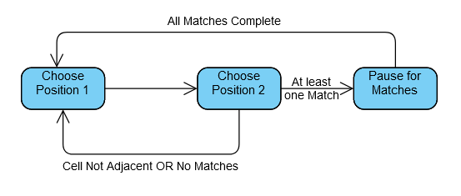

Other Parts:

* Game: Manages the JFrame, MatchPanel, and StatusPanel providing communication both ways via the restart() and notifyScoreUpdate() methods.
* StatusPanel: A panel with JLabels to show the score and buttons to restart and quit.

## How the Core Game Works

This section will focus on the MatchBoard and MatchPanel showing how the classes work by breaking down the functionality that is included. Position will be mostly ignored as it just ties in by representing a coordinate with x and y so does not warrant additional explanation. Starting with the MatchBoard that defines most of the core code used to implement the game.

The MatchBoard is simple in how it is designed for the start of the game. The board is just filled with random numbers in every cell for a given width and height with numbers ranging from 0 to whatever maxNums has been passed to the class. In this case it will be passed the length of a colours array from the MatchPanel so that each number will be used to show a colour. The methods defining the behaviour for the MatchBoard fall into two types. The methods related to all the swapping/matching, and everything else. Firstly, the methods that fall into the everything else include the following:

* setEnforceAdjacent(): This is not actually used, but it could be called to swap the enforceAdjacent variable to false. This would change the rules around swapping to allow the MatchBoard to swap any two cells. Note that if you were to implement this the rules would need to be added to MatchPanel to make this work as well.
* getCellValue(): Used to grab the int value stored for a given x,y position cell on the grid. Used for drawing all the cells.
* fillBoard(): Fills every cell on the board with a random number.

The methods that add in functionality related to the matching include the following methods.

* swapCells(): Does a swap of the values contained in the cells defined by pos1 and pos2. This does not check any validation, just does a swap. It is used to perform the actual swap, but also for testing if there are any matches in the getMatchesFromSwap() doing a temporary swap.
* getMatchesFromSwap(): Tests what would happen if the two cells defined by pos1 and pos2 were to be swapped. It performs a temporary swap and checks for all the matches, and then swaps the cells back. The list of what would change is passed back to be evaluated in the MatchPanel. Note that this only does a limited search on the row/columns localised to the swap.
* shuffleDownToFill(): Takes a list of all the positions that were marked as matches, moves down cells from the top to fill those gaps, and then returns a list of positions that are now empty at the top. The list of positions can then be filled in using a fillPositions() call.
* fillPositions(): Fills all the list of positions with new random numbers. This would be called normally to fill the cells after a shuffle down has happened.
* findAllMatches(): Searches the entire board on every row and every column for matches.
* getMatchesOnRow(): Searches a single row for all matches of 3 or more in a row and adds them to the list of matched elements.
* getMatchesOnColumn(): Does the same as getMatchesOnRow() except it searches a single column.
* shuffleDownToFill(): An alternate version of shuffleDownToFill that takes a single position and moves all the cells above that point down. This is called by the other version of shuffleDownToFill() that takes the list of points.
* getAffectedPositionsFromAffectedColumns(): Converts counts of how many cells were moved down for each column into positions at the top of each column. Used by the list version of shuffleDownToFill().

As you can see from reading through the list of methods all the functionality for getting the information needed for matches and performing the result of matching are provided in the MatchBoard class. It does not facilitate the actual interaction or selecting of points though. That all happens inside the MatchPanel. The MatchPanel translates the MatchBoards grid of numbers providing a set of colours that match 1 to 1 with the numbers. For example, 0 is blue, 1 is black, etc. The MatchPanel controls the MatchBoard by performing the selection of positions and directing it to perform the correct set of actions.

When the MatchPanel is created it will start itself with a MatchBoard that is fully randomised. You could make it begin matching right away at the start of the game with a few simple changes, but for the purpose of this version a stable board state is enforced before the player sees this. It means all matches are replaced with new random numbers until there is no longer any match on the board. This may take a few iterations, but it means the player starts with an action right away. A mouse listener is set to begin listening to change between states from selecting cells and the event timer for flowing through multiple stages of matching is configured, but not started. The remaining parts will split up the methods used to create the MatchPanel into similar types. Firstly, the methods used to draw the game, and then the methods used to provide interaction.

* paint(): Draws first the recently matched and recently filled from top cells marked with rectangles to create a visual cue and then draws all cells over the top. Additionally, as a helpful visual a + sign is drawn over the cell where pos1 has been set.
* drawAllCells(): Iterates through all the cells in the grid and uses the int values stored in those cells to look up the appropriate colour to draw a circle with from the colours array. This is done for the individual cells by calling drawCell().
* drawCell(): Does the individual part of the above where it sets the colour correctly and then fills in an oval to represent the element visually.
* drawRecentMatches(): As part of the code there is tracked a set of positions where recent matches occurred and where recent new cells were randomly added at the top. The most recent of these are given a filled rectangle behind them to indicate visually where changes are happening. This helps because there is no animation.
* drawSelectedPos1(): Draws a white + sign over the cell where pos1 is set. Used to make it stand out more, so the player knows they have set the first of two.
* drawGrid(): Not used, but will draw a grid of lines between all the cells.

The rest of the methods provide functional changes based on the interaction stemming either from the mouse clicks, or the restart button.

* mouseClicked(): This is the key method to how the game is changing between states. It will attempt to move between states by selecting a pos1 and pos2 for swapping cells. Once two valid cells are selected they are tested for swapping with attemptCellSwap(). Every time this method possibly made a change it will force a repaint() as well.
* restart(): Called from the Game object via the StatusPanel’s Restart button. It will reset the game state to a new stable board and reset the score.
* setPos1(): Sets the value of the pos1 to be used for swapping and then changes to the next state (choosing pos2).
* setPos2(): Sets the value of the pos1 to be used for swapping and then changes to the next state (pause for destroy).
* attemptCellSwap(): uses the getMatchesFromSwap() method in MatchBoard to first check if there are any matches. Then updates the score based on matches found. If there were any matches the actual swap is performed and then cells are shuffled down to fill the gaps before filling the positions at the top by using the different methods in MatchBoard. The matches and cells filled at the top are stored to be draw with drawRecentMatches().
* updateScore(): Increases score by an amount and then passes the new score to the StatusPanel via the Game object using notifyScoreUpdate().
* isValidPosition(): Checks if the mouse click position is a valid set of coordinates within the board.
* createStableBoardState(): Brute forces finding matches, then filling those matched positions with new random numbers until there are no more matches.
* configureTimer(): This method actually contains a method inside it. Most of the code is about setting up the actionPerformed to be nested inside the Timer. This method sets up the timer to trigger every 500ms and it will continue making itself repeat until there are no more matches. It will search the entire board for matches and do the same process of shuffling and filling as was done inside the mouseClicked() method.

There are a few other methods all related to the mouse that you will find down the bottom, but they were not important for this application.

You can view the next example that follows as an animation at:

<https://i.gyazo.com/2476cecb41f6e7109d8e6b6765ccb710.mp4>

Each step of the matches is shown and described for this example.

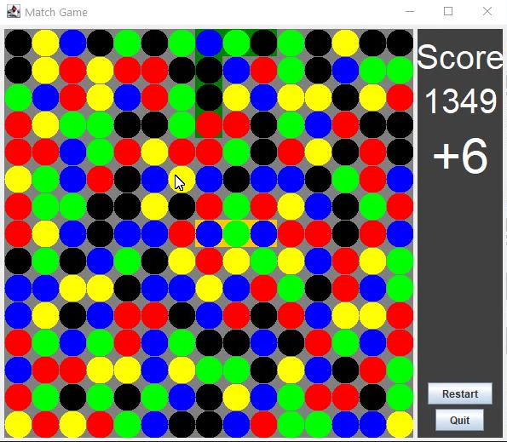 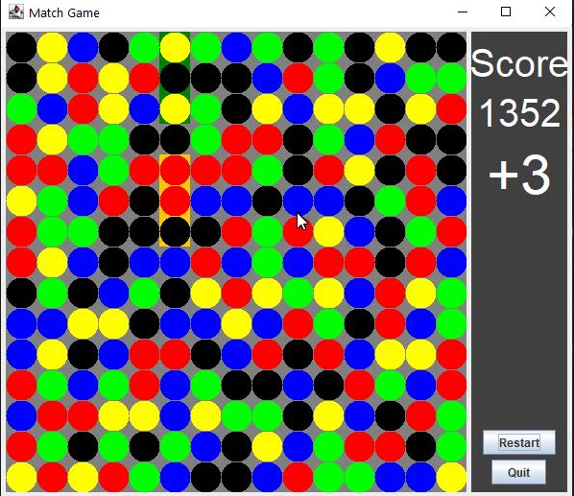

Above to the left you can see the mouse hovering over the yellow circle near the middle. The player in this example clicks the yellow circle and the blue circle to the left of it. This creates the 3 yellow in a row. You can see a slight orange background in the image on the right showing where the match occurred. And you will notice the cells moved down such that the red have now lined up to be a group of 4 on a row (and also a group of 4 black near the middle, and 3 black near the top). With also the green background at the top behind the yellow, black, yellow where the new random ones were filled in.

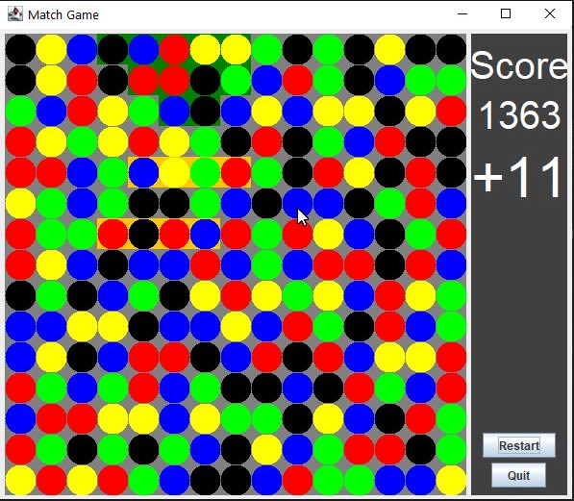 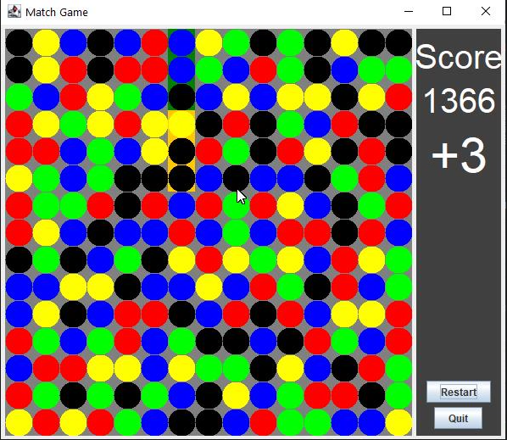

You can see in the next step in the above left image that the two groups of 4 (red/black) and one of 3 (black) were matched and everything fell down then extras filled in at the top. This formed another group of 3 matching as green near the middle. That is then matched on the right and you can see it creates another row of 3 matched black. That then leaves the image below where there are no matches, so it waits for more input.

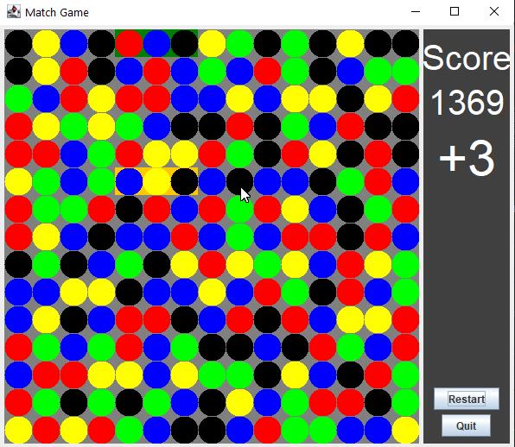

## How the Rest of the Interface Ties into the Game

Most of the functionality has been covered for the application now. The parts that remain are just the Game class and StatusPanel. The Game class was mostly responsible for just creating the JFrame and placing the MatchPanel and StatusPanel inside it. It only has two methods that allow a line of communicate between the MatchPanel and StatusPanel as listed below.

* notifyScoreUpdate(): Called when the score has increased by some amount. The new total score and the amount that it has changed are passed through this method to the StatusPanel from the MatchPanel.
* restart(): Called when the restart button is pressed in the StatusPanel, this tells the StatusPanel to reset its score, and for the MatchPanel to preform its restart which includes creating a freshly filled board.

The StatusPanel is there to provide buttons for restarting/quitting the game, and to show the score. It contains two labels, one to show the current total score, and one to show how much the score was increased by from the last match that occurred. The methods that can be found in the StatusPanel include the following.

* updateScore(): Takes the score that has been passed from the MatchPanel to the Game class and then down to this StatusPanel. It will swap out the values of the labels. If the amount of change in the score is 0 it will just remove the text showing how much the last match gave.
* actionPerformed(): Called when either button is pressed. It checks the button that was pressed and handles it appropriately. If it was the restart button it will call restart() in Game or if it was the quit button it will just exit the program.

## Features You Could Add

The following list shows some of the features or changes you could make to improve this base game.

* Improve visuals: Currently the visuals are very plain with just simple colours. You could swap the circles out for images and even perhaps mimic those used in other titles like Bejewelled with jewels or candy as in Candy Crush.
* Animate the cells falling: You could take the list of positions changed and add another timer for animation. You could transition the cells with an offset travelling between two points over a fixed period (should be less than or equal to the time between match checks).
* Add sounds: Every time you get a match a sound (or perhaps additional visual explosion) could go off.
* Add in special cells that can be used to apply special effects: For example, cells that when matched they clear out an entire column, row, or some area around where the match occurred.
* Animate the score panel’s change in score: Make it more eye catching for larger gains in score and perhaps you could change it to show multiple increases (perhaps last 3) and have them fade out over time.
* You could look at any of the other features in similar types of games and try to mimic them yourself.
* Come up with your own new feature or rule change to make the game more unique.