Download SimHub from here: http://www.simhubdash.com/

GUIDE: https://github.com/SHWotever/SimHub/wiki/Custom-serial-devices

1. On the left bar click 
2. Find and enable the “Custom Serial Devices” option



1. In the Update Message field click Edit and select NCalc
2. Add the following text in the field and click “ok”

'can.0.send='**+(([Rpms]>**5000**)**?1:0**)+**'?120/n'

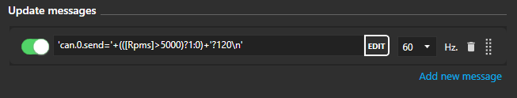

This will output 0 when < 5krpms and output a 1 when >5krpm send state over CAN0 to address 120