
Manual Testing

Date: 02/19/2024
Performed by: David Vilas Boas
Environment: Chrome Version 121.0.6167.184 (Official Build) (64-bit)

Link: https://opensource-demo.orangehrmlive.com/web/index.php/dashboard/index

TC01. "Admin" Clickable item and Hover Over function
Given the website is accessible with a valid user account
When the user logs in with the following valid credentials:
- Username: Admin
- Password: admin123
And clicks on “Login” button
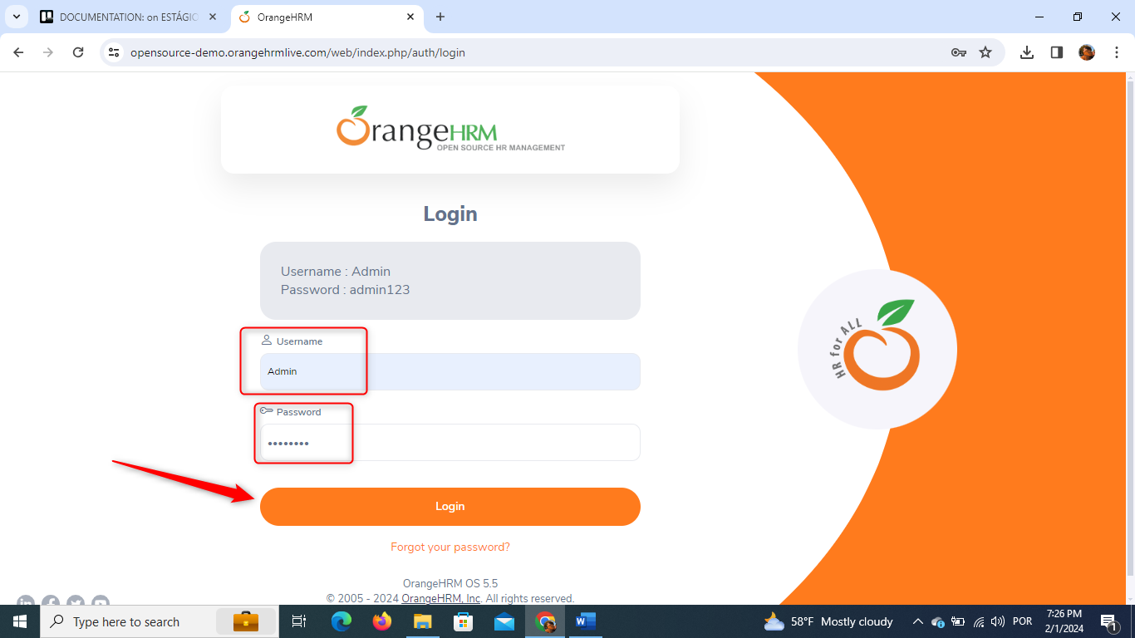
And the login should be successful, and the dashboard should be displayed
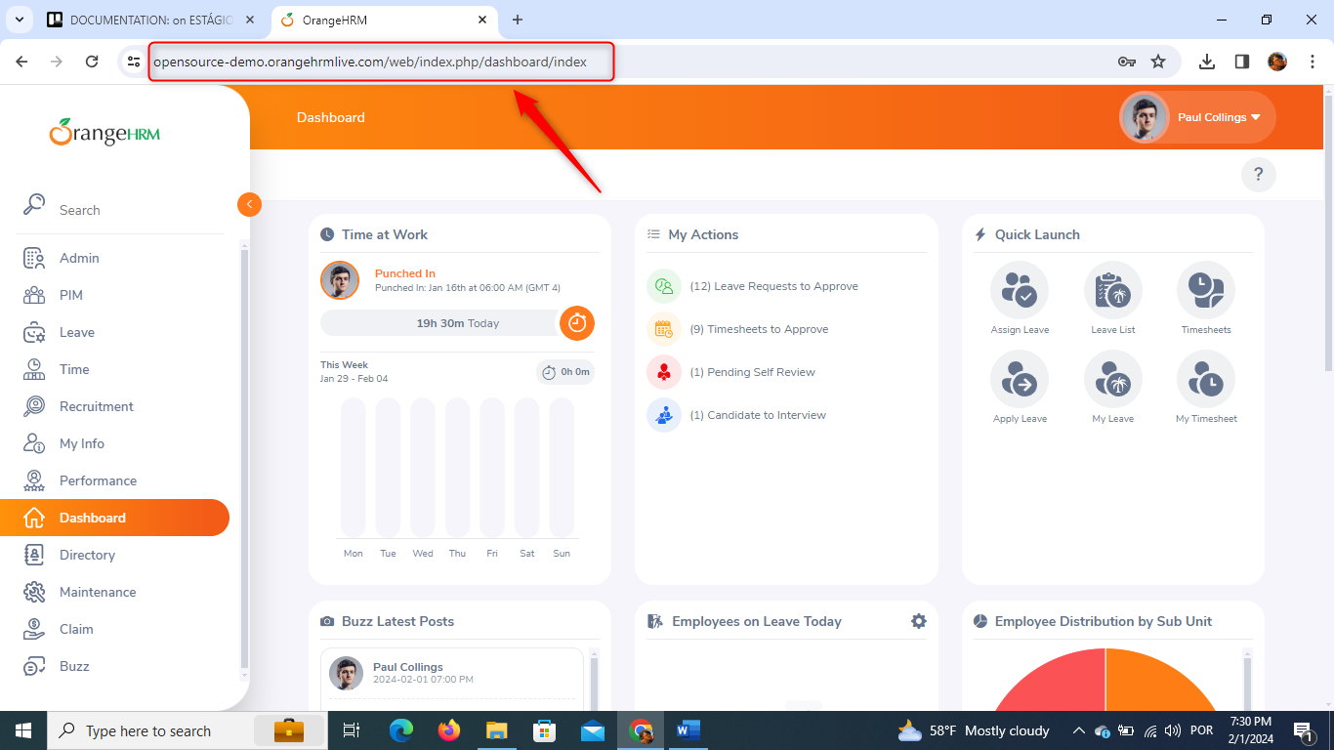
AND the main menu layer is open
AND I hover over the mouse's arrow the "Admin" item
THEN the "Admin" background gets a little darker and orangish meaning it's clickable
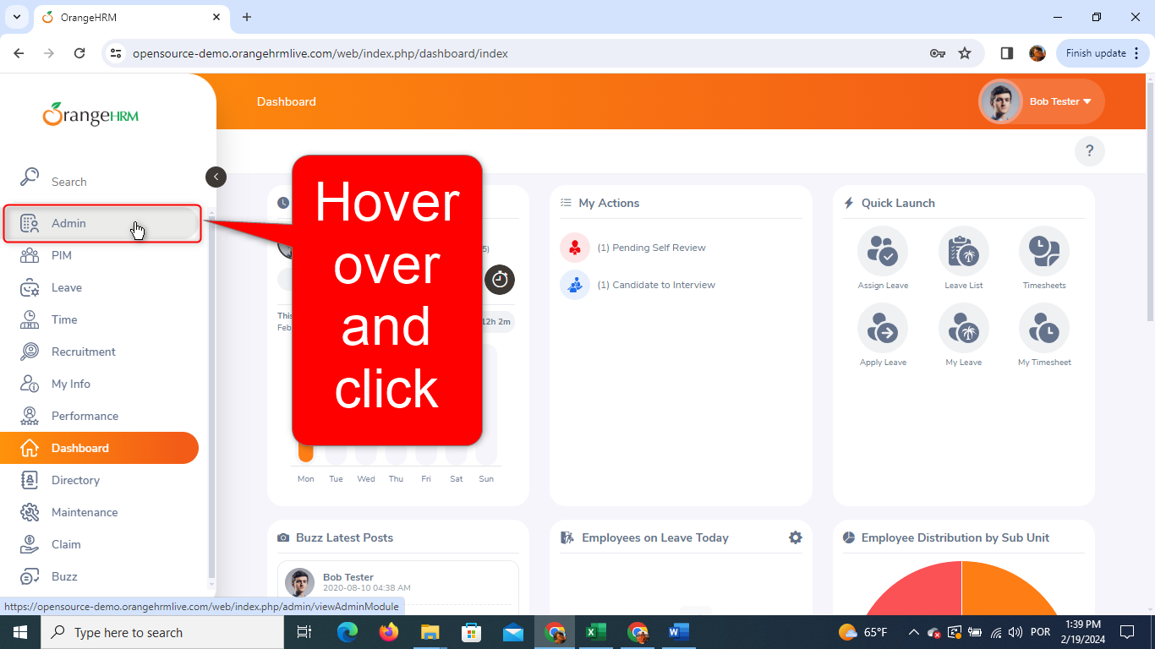
AND when it gets clicked, it triggers the "/web/index.php/admin/viewSystemUsers" page
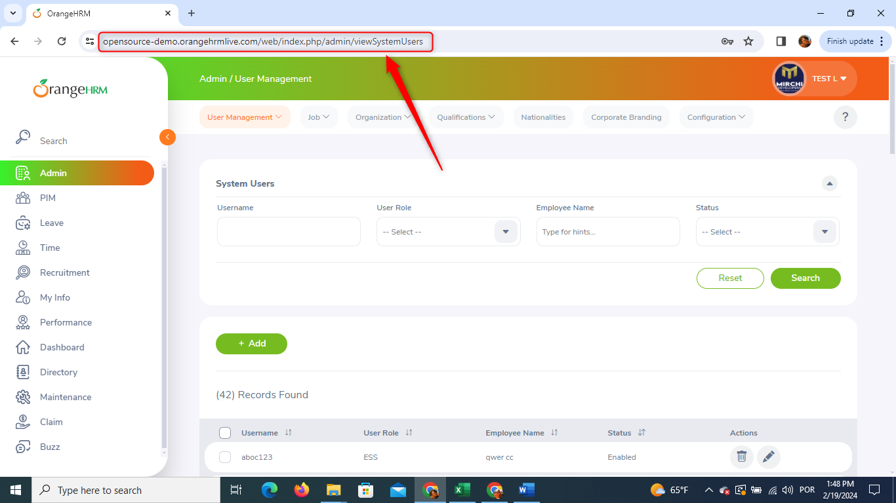
TC02. "Organization" Clickable item and Hover Over function
Given the website is accessible with a valid user account
And the user logs in with the following valid credentials:
- Username: Admin
- Password: admin123
And clicks on “Login” button
And the login should be successful, and the dashboard should be displayed
AND I'm on the "/web/index.php/admin/viewSystemUsers"
WHEN I hover over the mouse cursor on the "Organization" item
THEN the "Organization" background gets a little darker and orangish meaning it's clickable
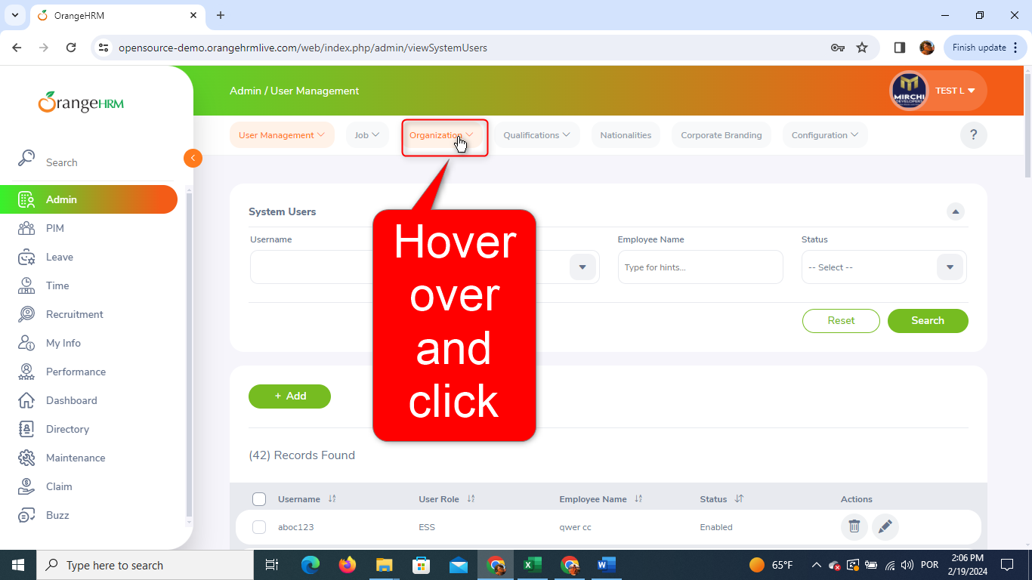
AND when it gets clicked, it triggers the dropdown menu with: "General Information", "Locations" and "Structure"
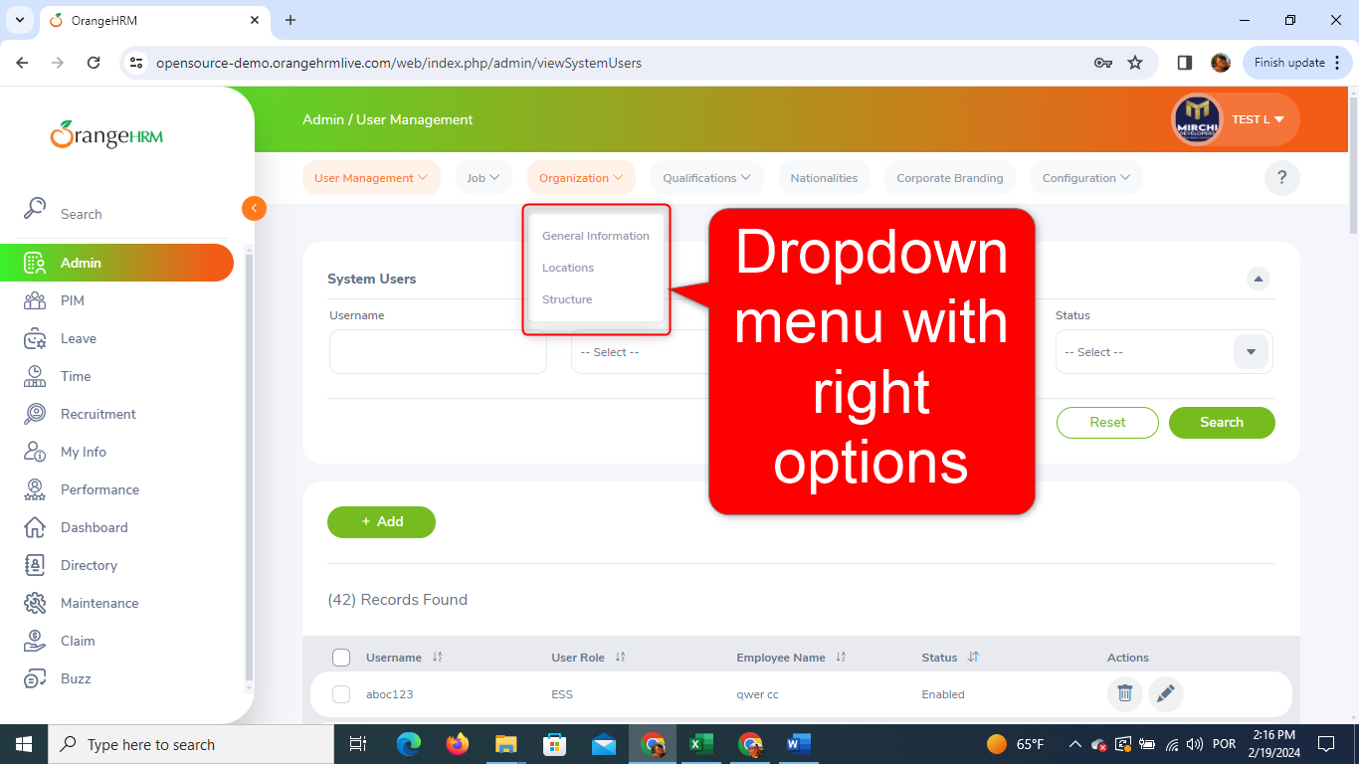
TC03. "Locations" Clickable item and Hover Over function
Given the website is accessible with a valid user account
And the user logs in with the following valid credentials:
- Username: Admin
- Password: admin123
And clicks on “Login” button
And the login should be successful, and the dashboard should be displayed
AND I'm on the "/web/index.php/admin/viewSystemUsers"
AND the "Organization" dropdown menu is open
WHEN I hover over the mouse's arrow on the "Locations" item
THEN the "Admin" background gets a little darker and grayish meaning it's clickable
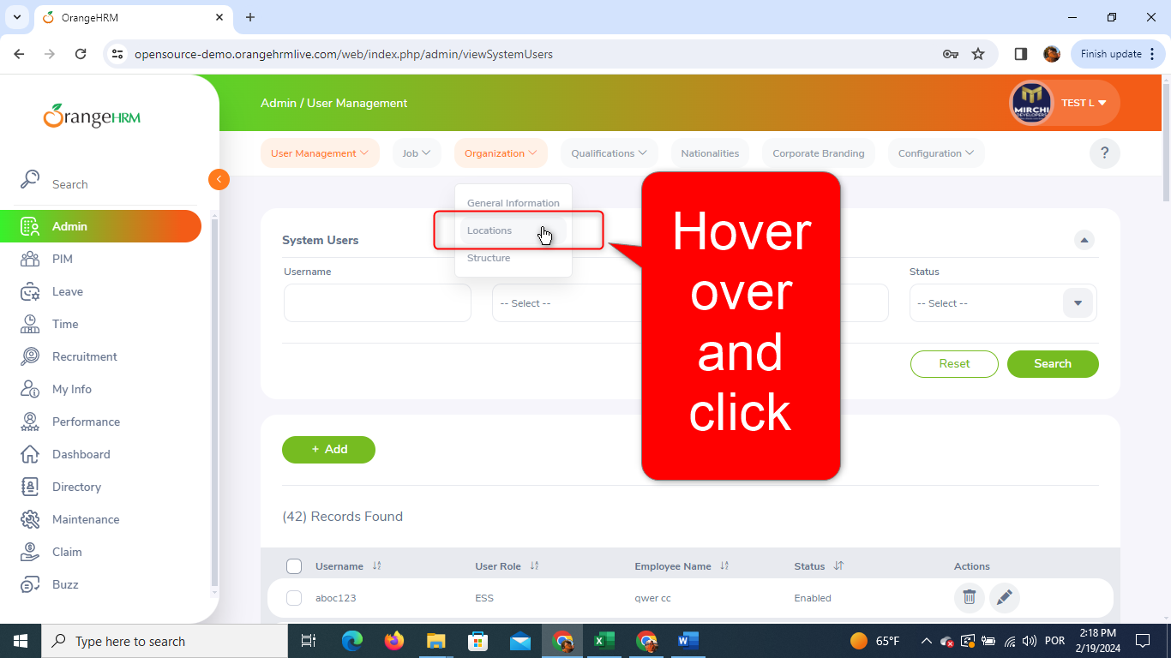
And when it gets clicked, it triggers the "/web/index.php/admin/viewLocations" page
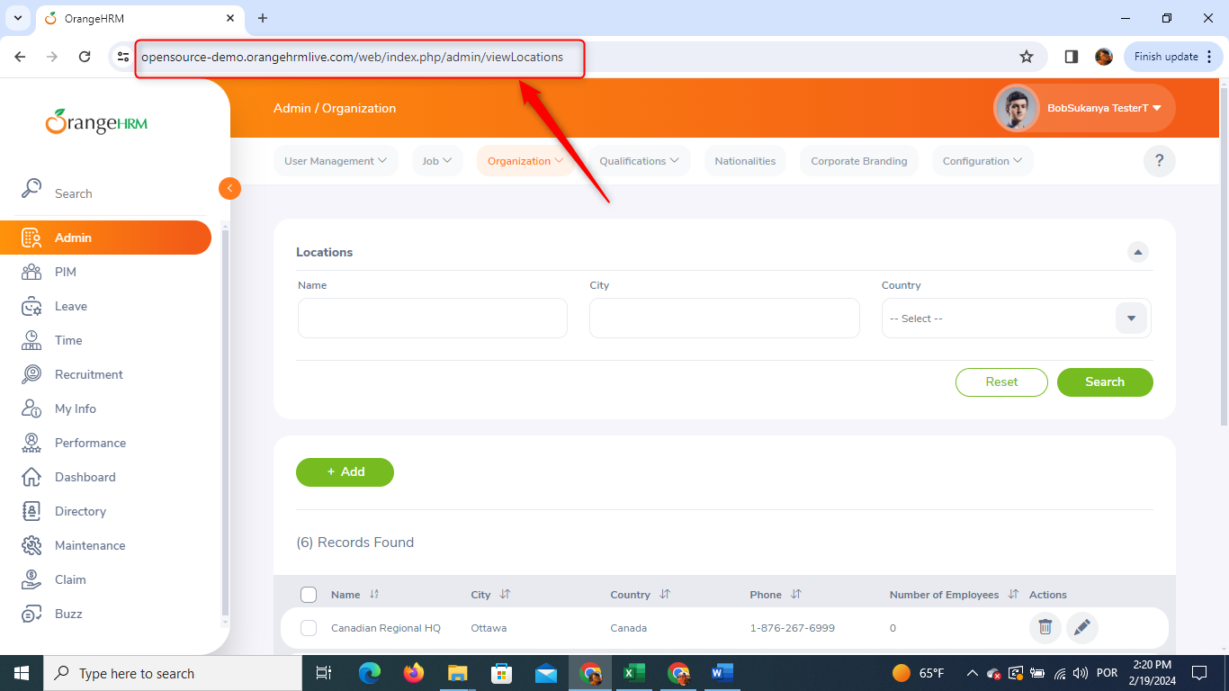
TC04. Adding User - Happy Path
Given the website is accessible with a valid user account
And the user logs in with the following valid credentials:
- Username: Admin
- Password: admin123
And clicks on “Login” button
And the login should be successful, and the dashboard should be displayed
AND I'm on the page "/web/index.php/admin/viewLocations"
AND I click on the "+ Add" button
AND the "+ Add" button is clickable
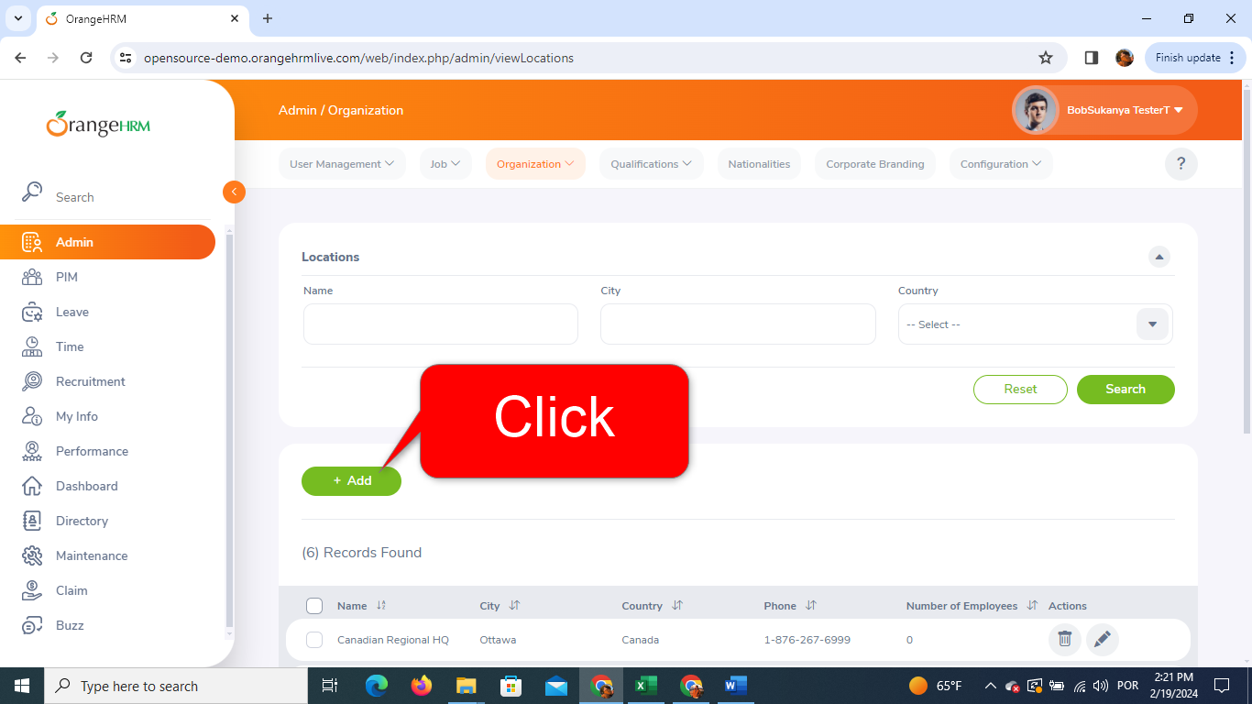
AND the button triggers the page "/web/index.php/admin/saveLocation"
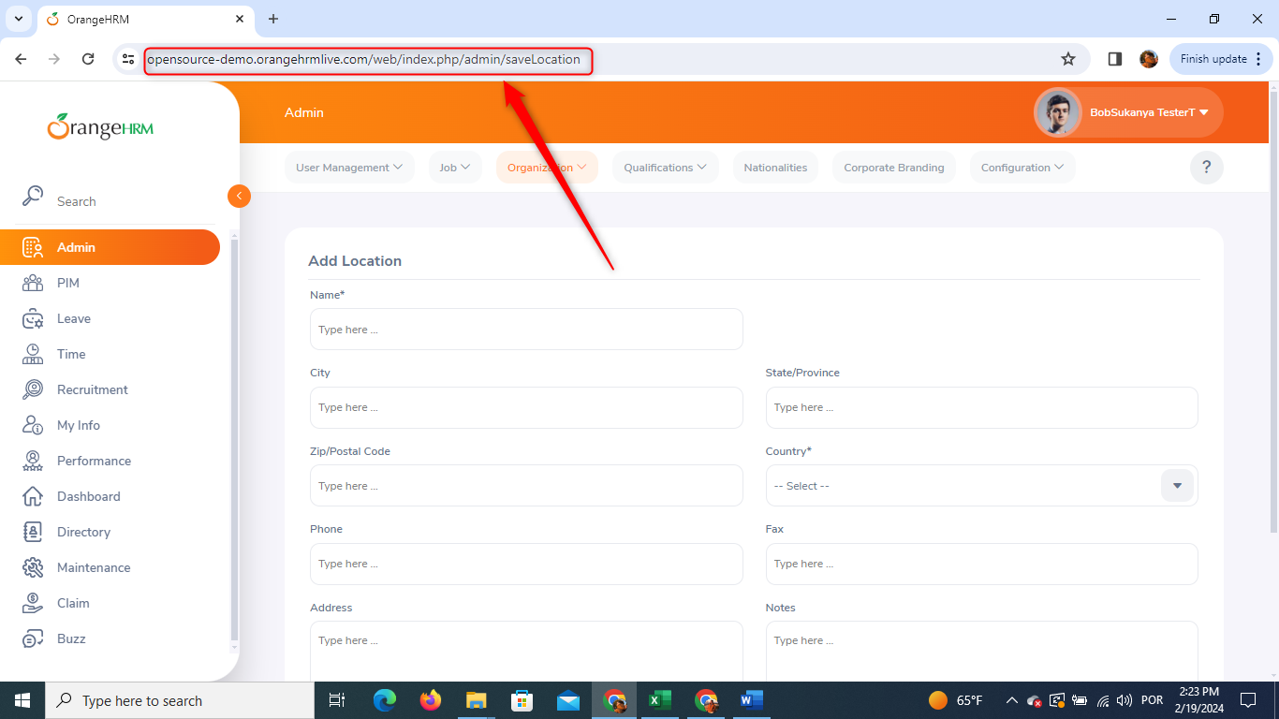
WHEN I insert the following data: Name - "TECH FIXE" & Country - "Brazil"
AND click on the "Save" button
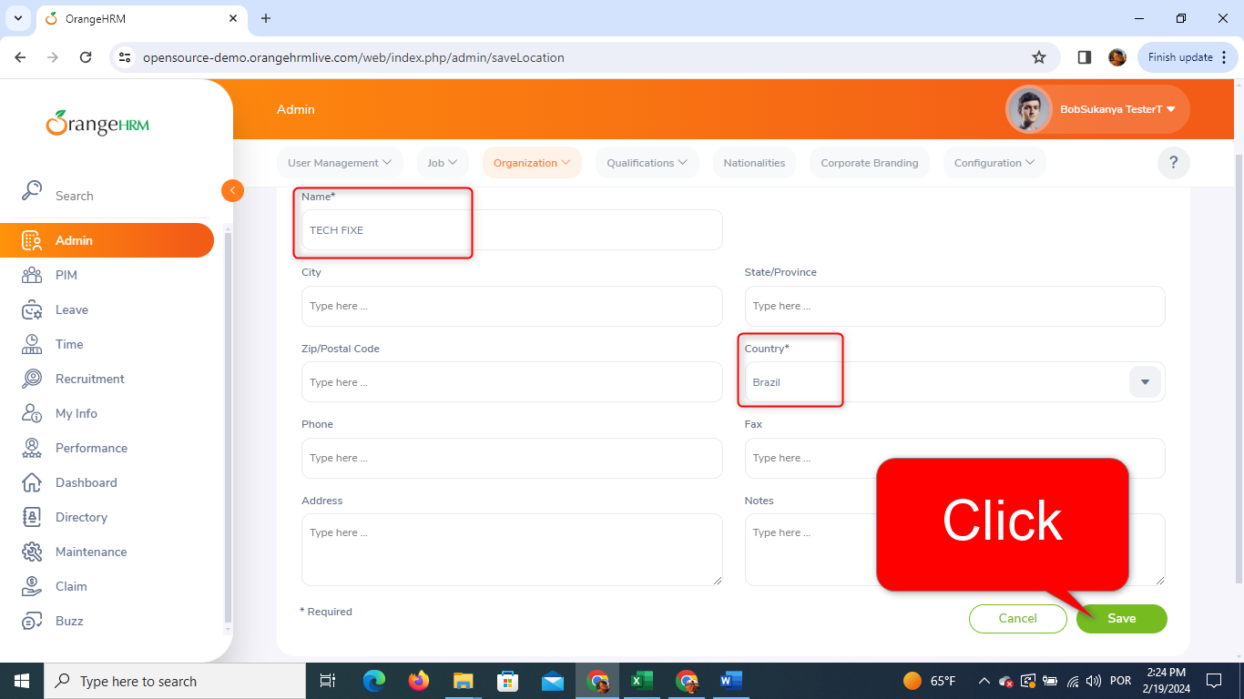
THEN I get back to the page "/web/index.php/admin/viewLocations"
AND the message "Saved" + "Successfully Saved" pops up
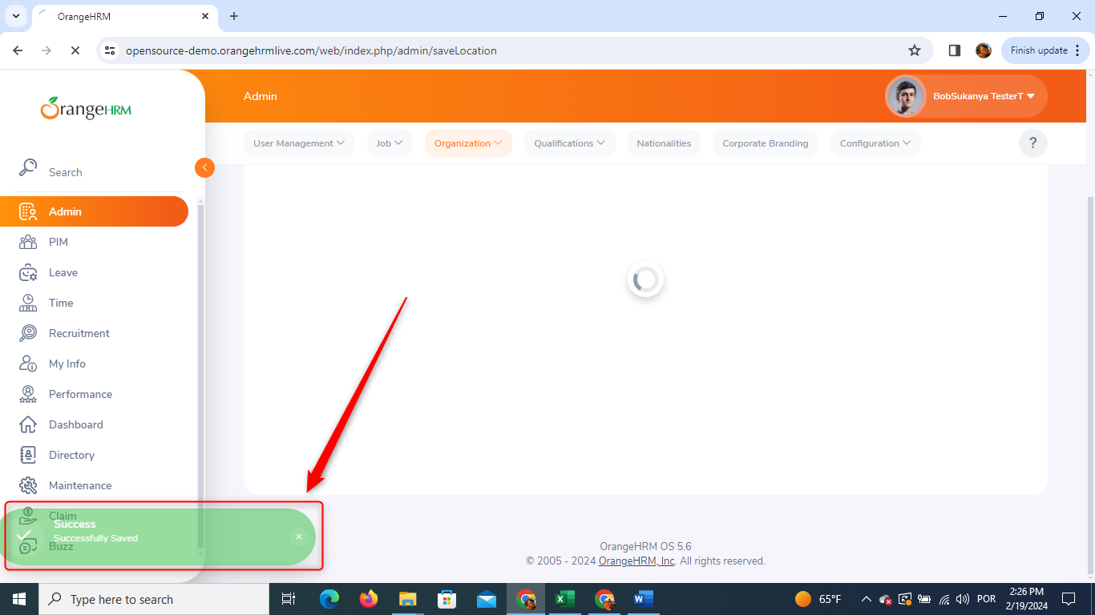
AND the data I provided are added to the "Records Found" table
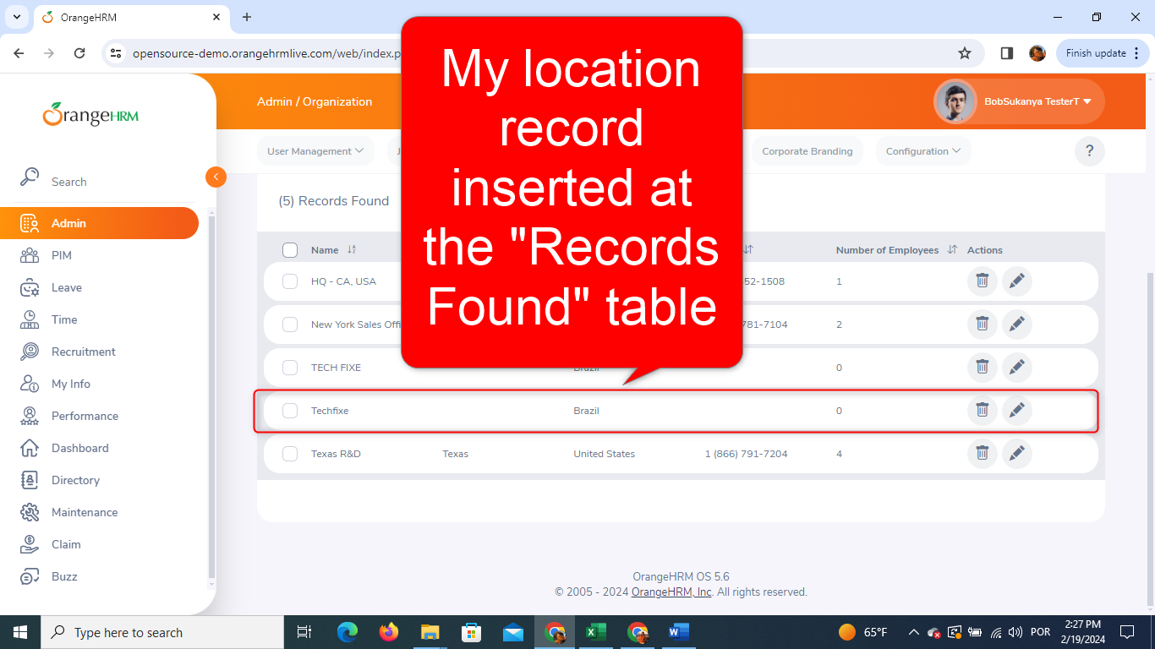
TC05. Searching User Data by Name
Given the website is accessible with a valid user account
And the user logs in with the following valid credentials:
- Username: Admin
- Password: admin123
And clicks on “Login” button
And the login should be successful, and the dashboard should be displayed
AND I'm on the page "/web/index.php/admin/viewLocations"
AND I have added already the User with Name "TECH FIXE"
WHEN I fill in with "TECH FIXE" the "Name" field placed at the "Locations" filter
AND click on the "Search" button
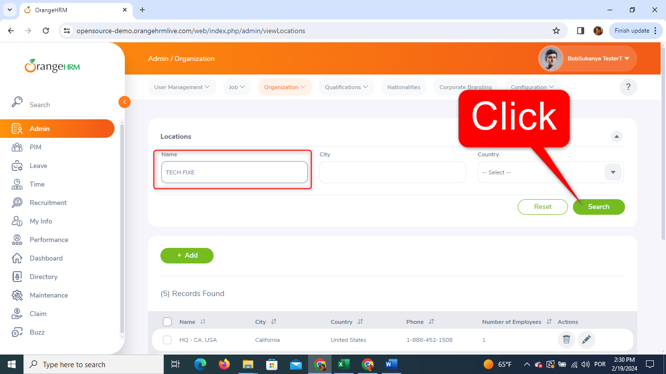
THEN all the user data I provided are displayed in the "Records Found" table at the bottom of the page "/web/index.php/admin/viewLocations"
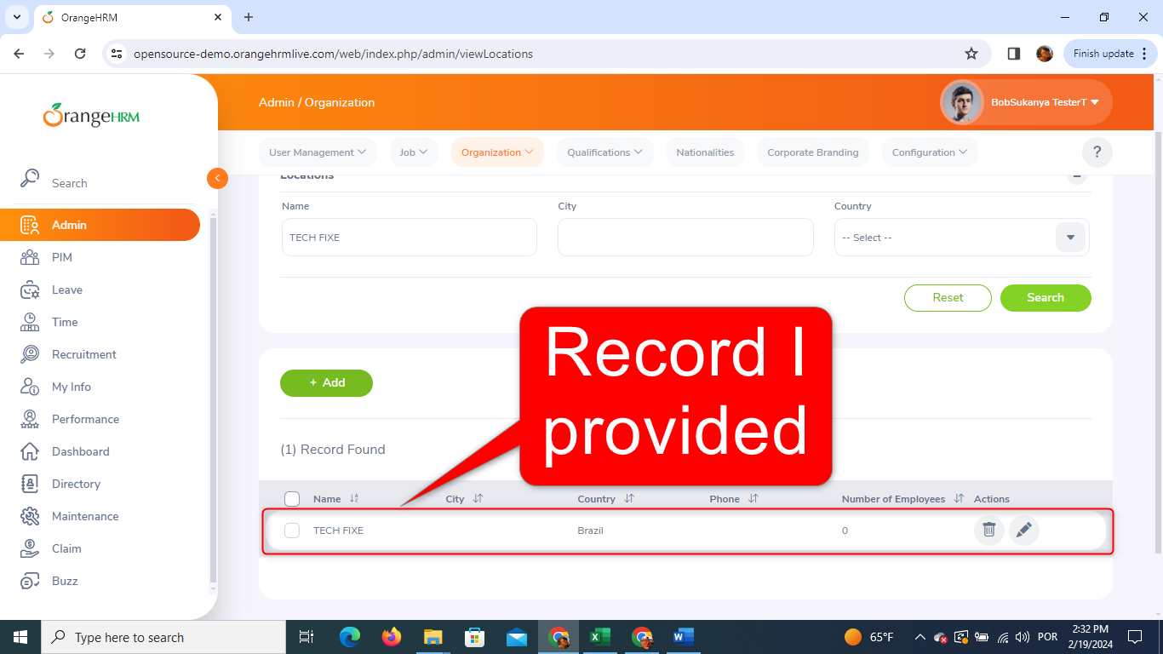
TC06. Searching User Data by Country
Given the website is accessible with a valid user account
And the user logs in with the following valid credentials:
- Username: Admin
- Password: admin123
And clicks on “Login” button
And the login should be successful, and the dashboard should be displayed
AND I'm on the page "/web/index.php/admin/viewLocations"
AND I have added already the User with Country "Brazil"
WHEN I select "Brazil" at the "Country" field placed at the "Locations" filter
AND click on the "Search" button
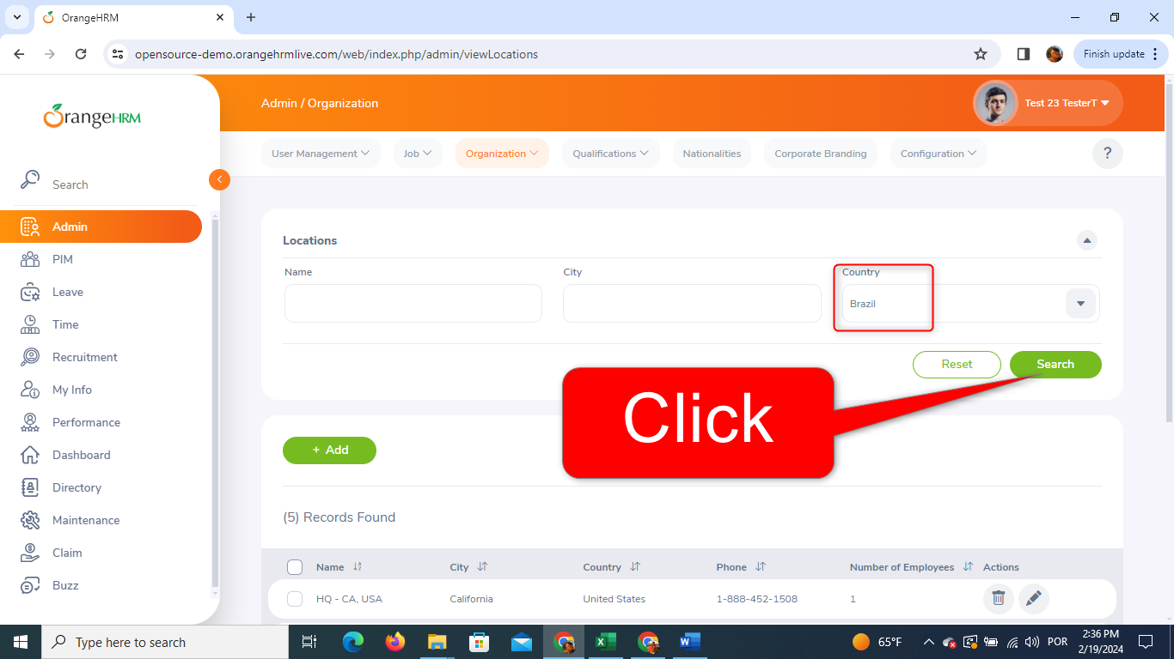
THEN all the user data I provided are displayed in the "Records Found" table at the bottom of the page "/web/index.php/admin/viewLocations"
TC07. Editing User Data
Given the website is accessible with a valid user account
And the user logs in with the following valid credentials:
- Username: Admin
- Password: admin123
And clicks on “Login” button
And the login should be successful, and the dashboard should be displayed
AND I'm on the page "/web/index.php/admin/viewLocations"
AND I find my user data on the "Records Found" table
AND I click on the pencil icon placed on the right side of my already inserted user data field, to edit it
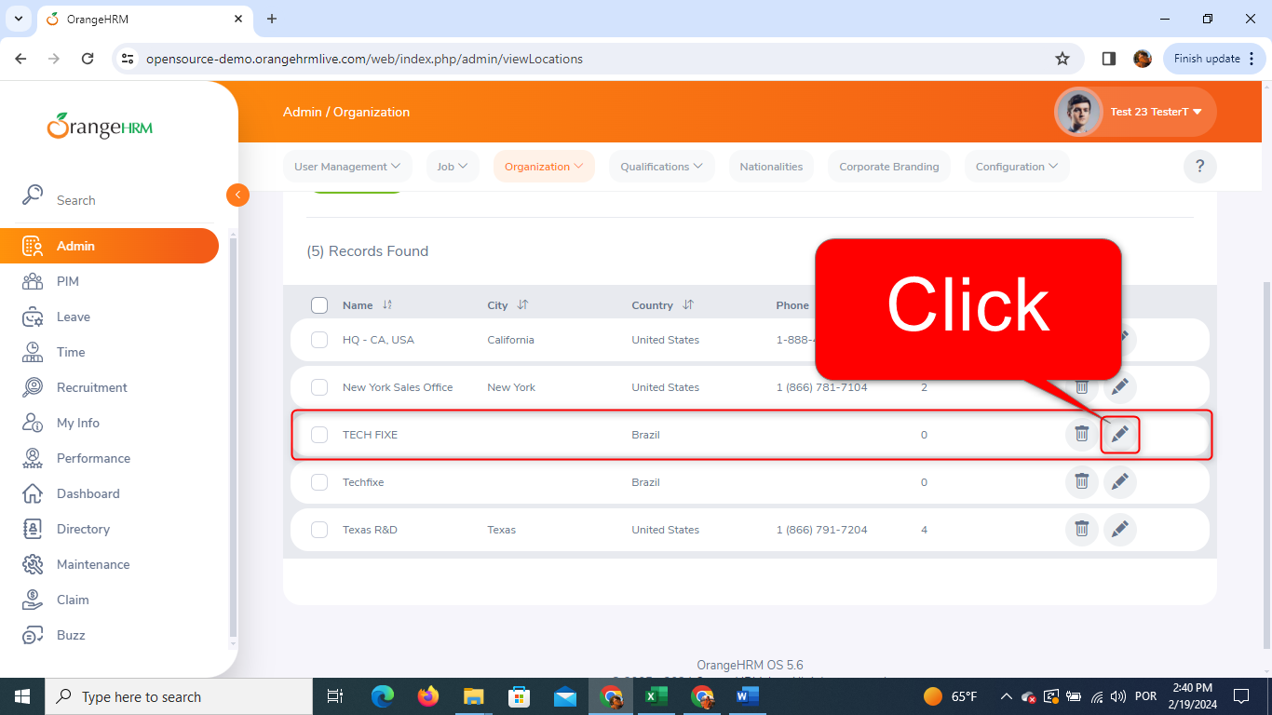
AND I'm directed to page "/web/index.php/admin/saveLocation"
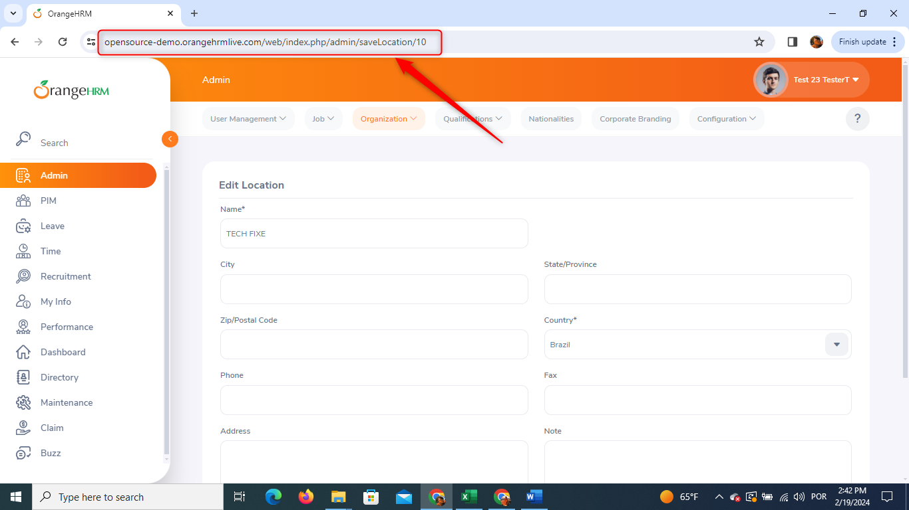
AND I switch the already inserted data with the following replacing data: Name - "TECH FIXE - EDIT" & Contry - "Portugal"
WHEN I click on the "Save" button
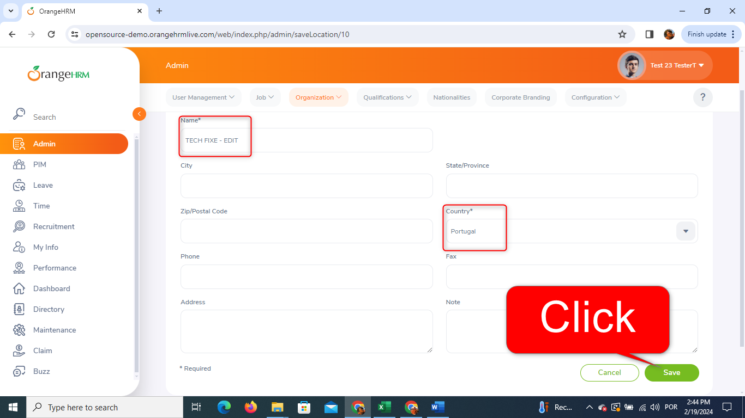
THEN I get back to the page "/web/index.php/admin/viewLocations"
AND the message "Saved" + "Successfully Updated" pops up
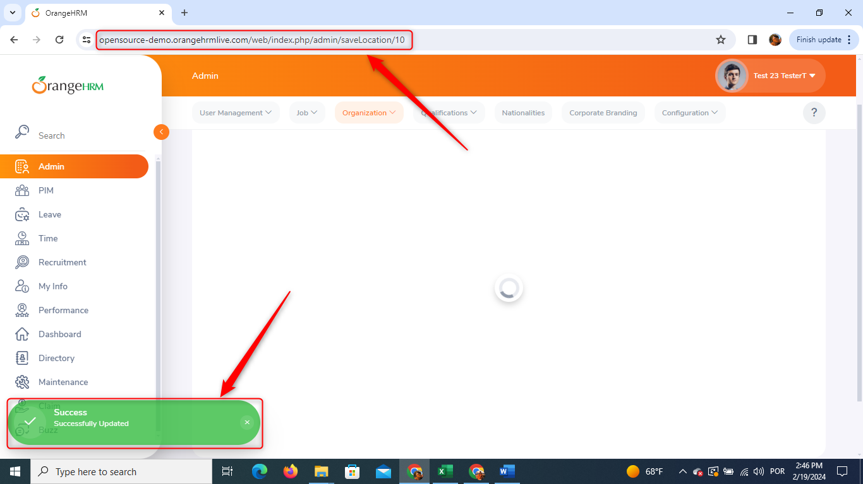
AND the data I provided are added to the "Records Found" table
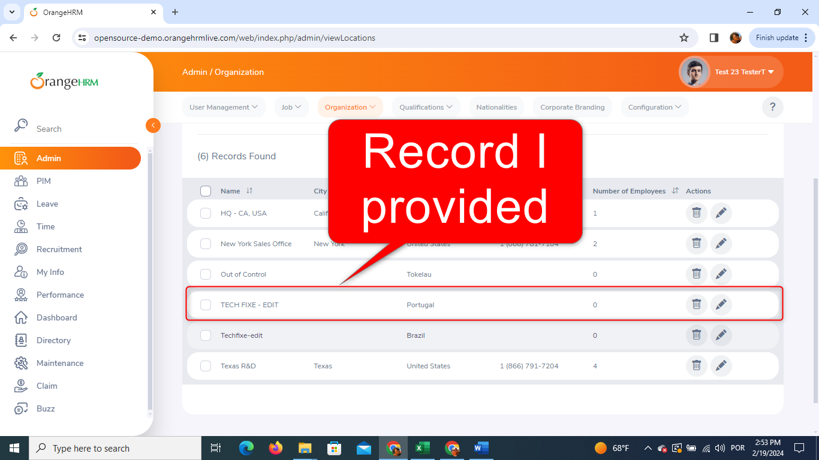
TC08. Searching Edited User Data by Name
Given the website is accessible with a valid user account
And the user logs in with the following valid credentials:
- Username: Admin
- Password: admin123
And clicks on “Login” button
And the login should be successful, and the dashboard should be displayed
AND I'm on the page "/web/index.php/admin/viewLocations"
AND I have added already the User with Name "TECH FIXE"
WHEN I fill in with "TECH FIXE - EDIT" the "Name" field placed at the "Locations" filter
AND click on the "Search" button
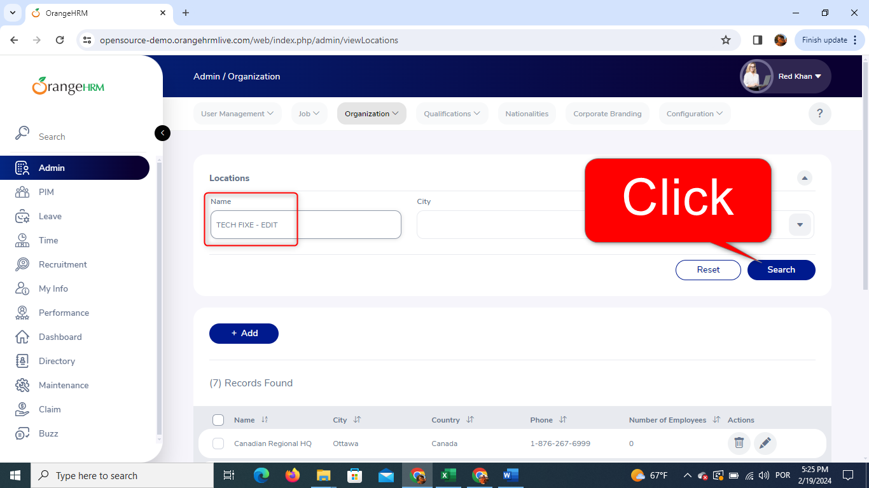
THEN all the user data I provided are displayed in the "Records Found" table at the bottom of the page "/web/index.php/admin/viewLocations"
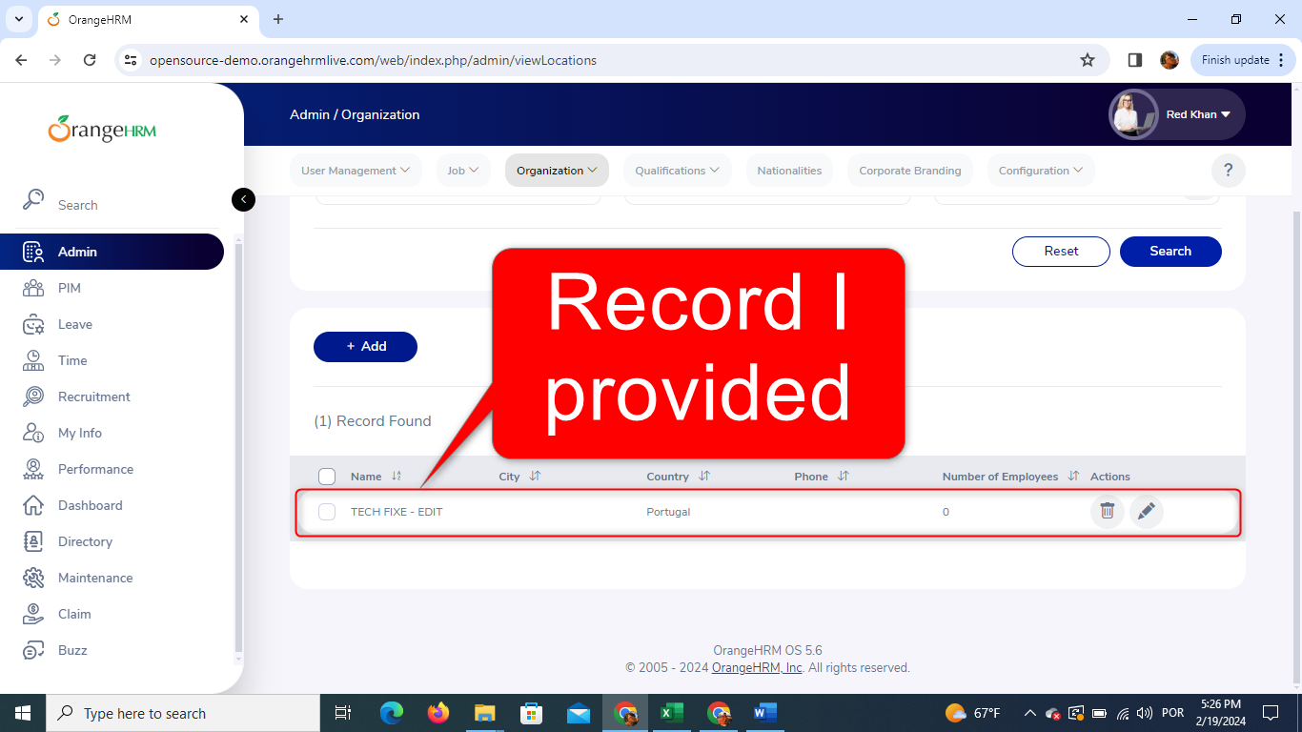
TC09. Searching Edited User Data by Country
Given the website is accessible with a valid user account
And the user logs in with the following valid credentials:
- Username: Admin
- Password: admin123
And clicks on “Login” button
And the login should be successful, and the dashboard should be displayed
AND I'm on the page "/web/index.php/admin/viewLocations"
AND I have added already the User with Name "TECH FIXE"
WHEN I select "Portugal" at the "Country" field placed at the "Locations" filter
AND click on the "Search" button
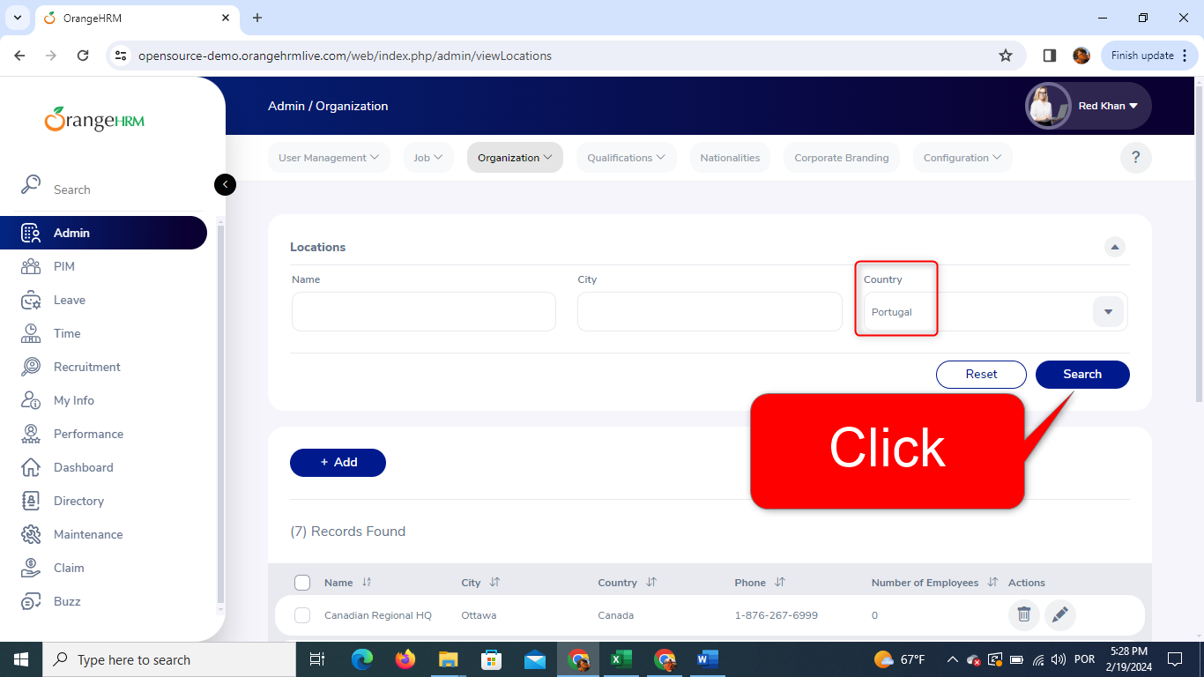
THEN all the user data I provided are displayed in the "Records Found" table at the bottom of the page "/web/index.php/admin/viewLocations"
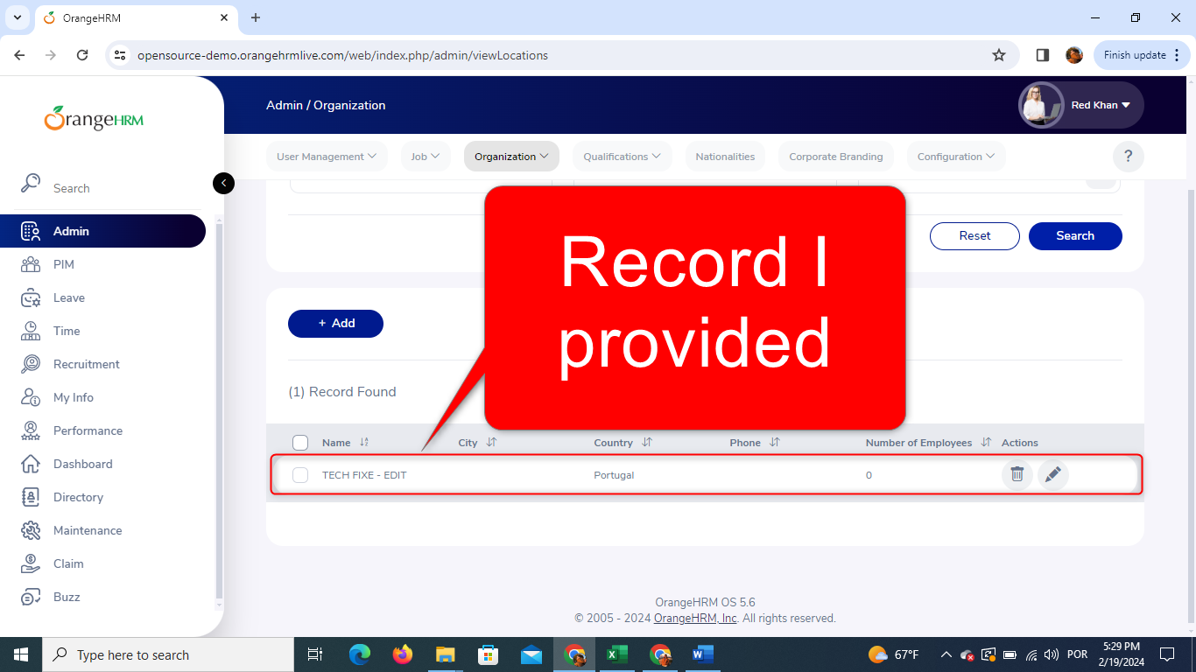
TC10. Deleting User Data through "Actions" Section
Given the website is accessible with a valid user account
And the user logs in with the following valid credentials:
- Username: Admin
- Password: admin123
And clicks on “Login” button
And the login should be successful, and the dashboard should be displayed
AND I'm on the page "/web/index.php/admin/viewLocations"
AND I find my user data on the "Records Found" table
AND I click on the waste bin icon placed on the right side of my already inserted user data field
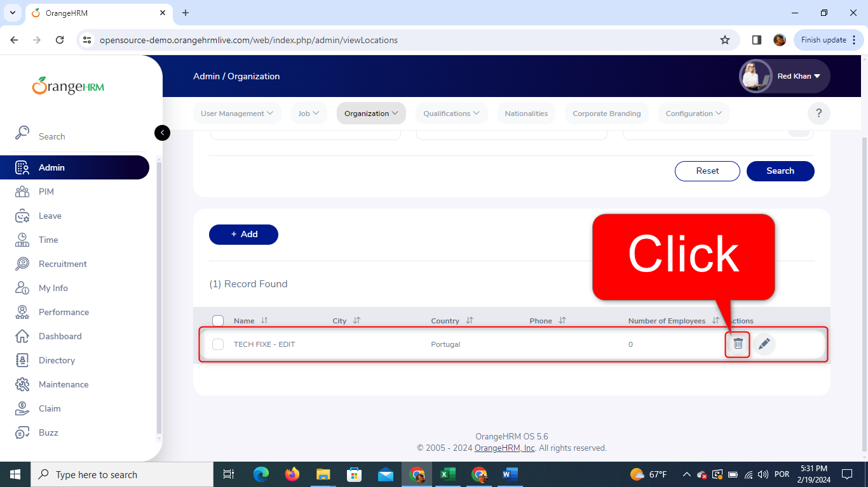
AND a message with the following highlighted question pops up "Are you Sure?"
WHEN I click on the button placed in the bottom right corner with the following message "Yes, Delete" at the pop-up message having the following highlighted question "Are you Sure?"
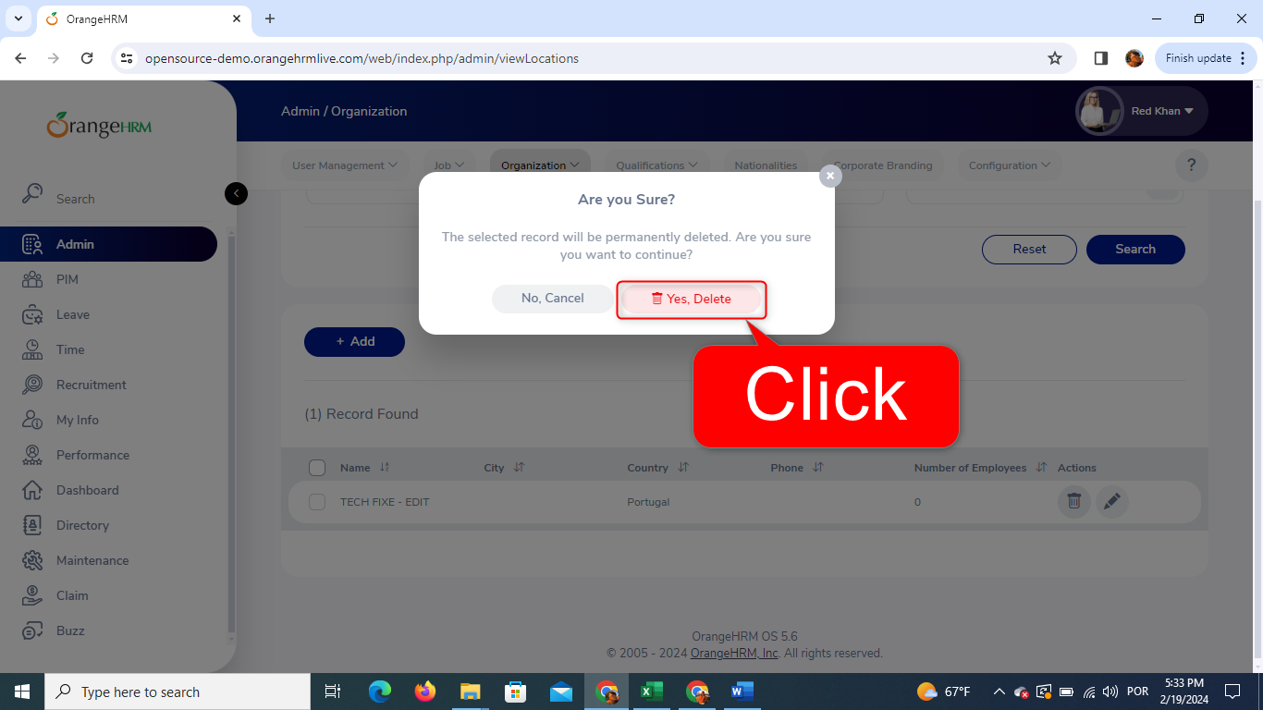
THEN the User Data I provided is no more there
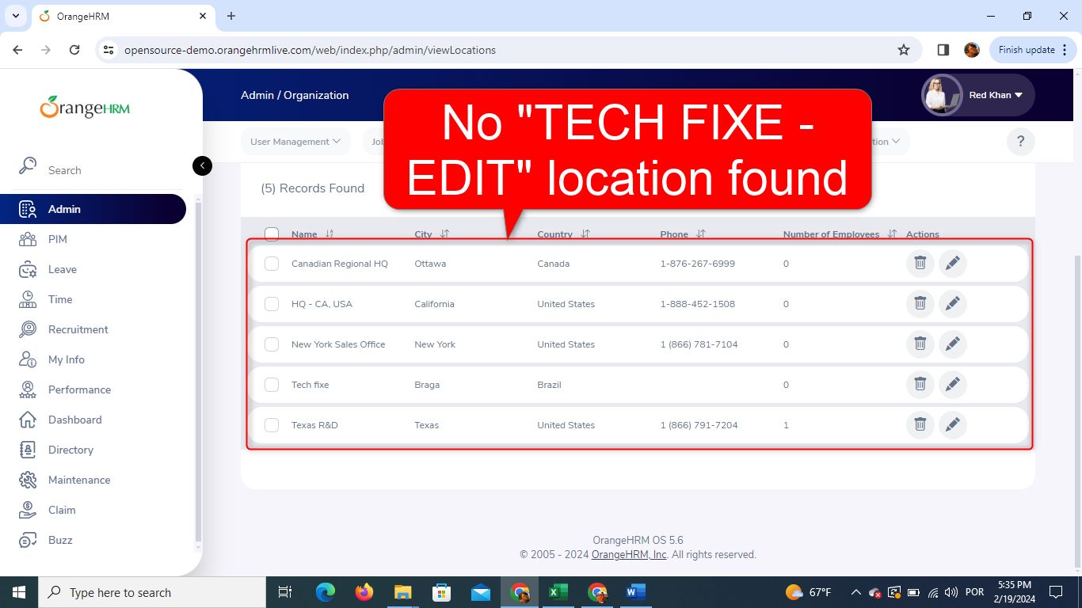
AND the following message pops up at the lower left corner
“Success Successfully Deleted”
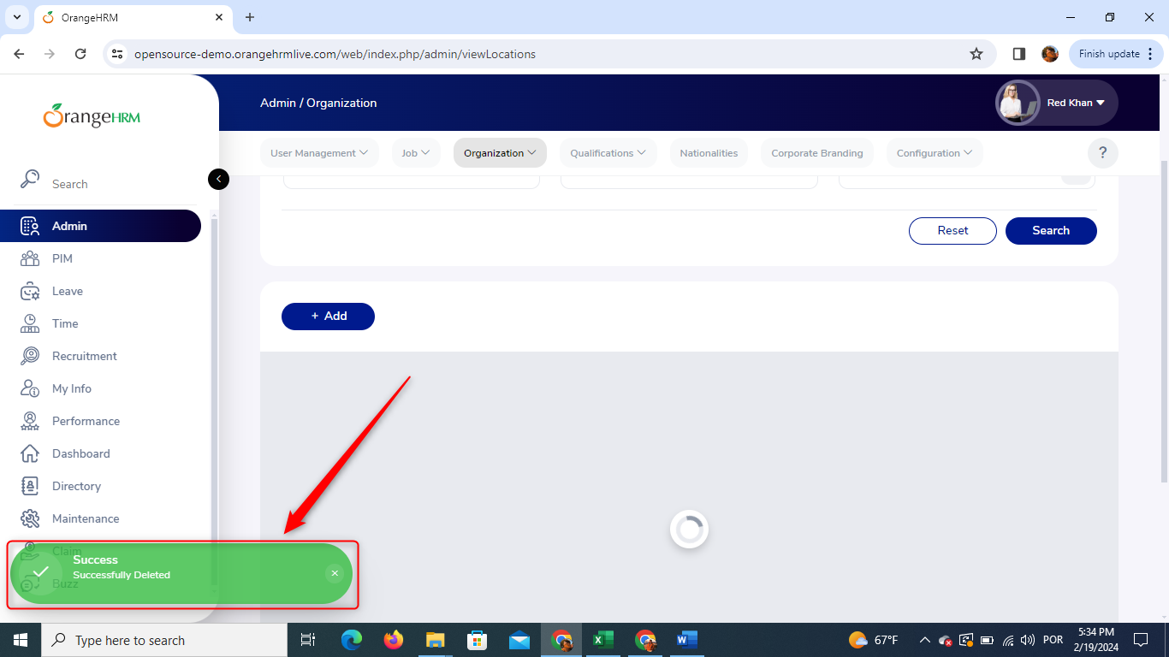
TC11. Deleting User Data through selecting "Record"
Given the website is accessible with a valid user account
And the user logs in with the following valid credentials:
- Username: Admin
- Password: admin123
And clicks on “Login” button
And the login should be successful, and the dashboard should be displayed
AND I'm on the page "/web/index.php/admin/viewLocations"
AND I find my user data on the "Records Found" table
AND I Select my already inserted user data by clicking on the checkbox placed on the left side of its field
AND I click on the “Delete Selected” button at the top of the “Records Found” table
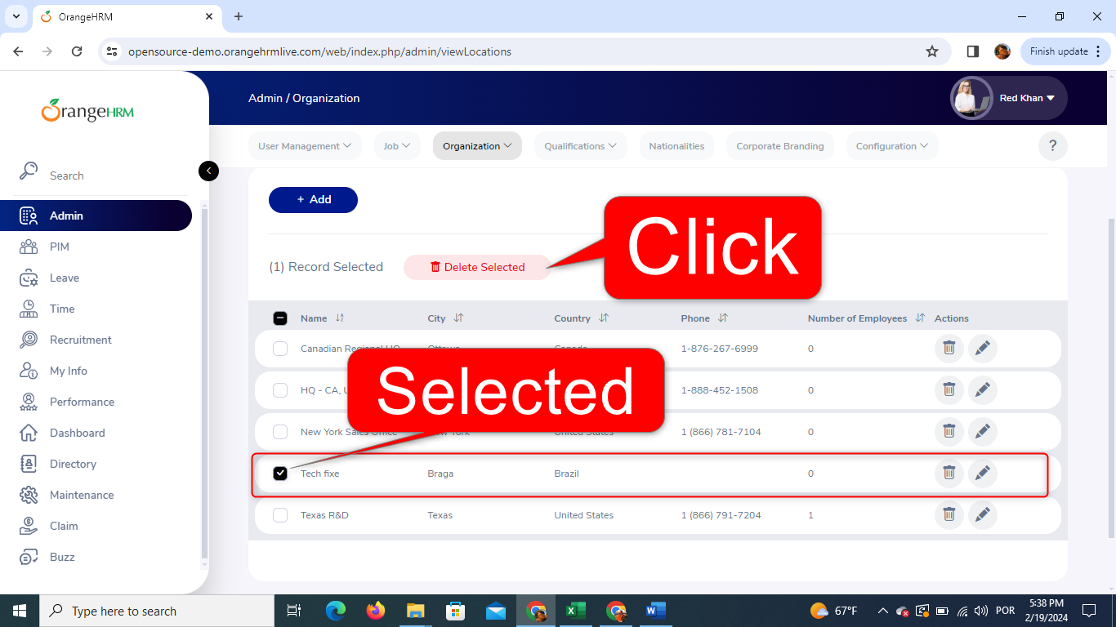
AND a message with the following highlighted question pops up "Are you Sure?"
WHEN I click on the button placed in the bottom right corner with the following message "Yes, Delete" at the pop-up message having the following highlighted question "Are you Sure?"
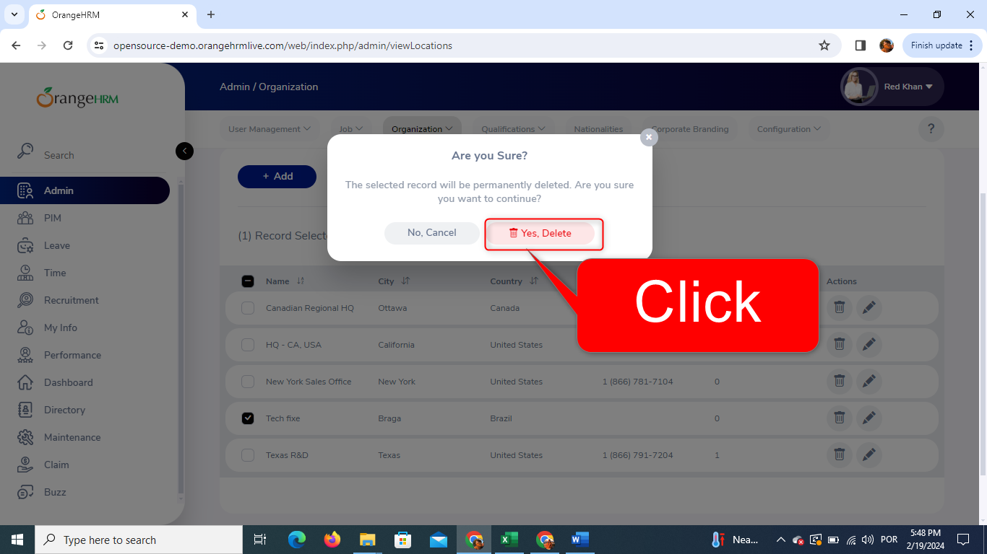
THEN the User Data I provided is no more there
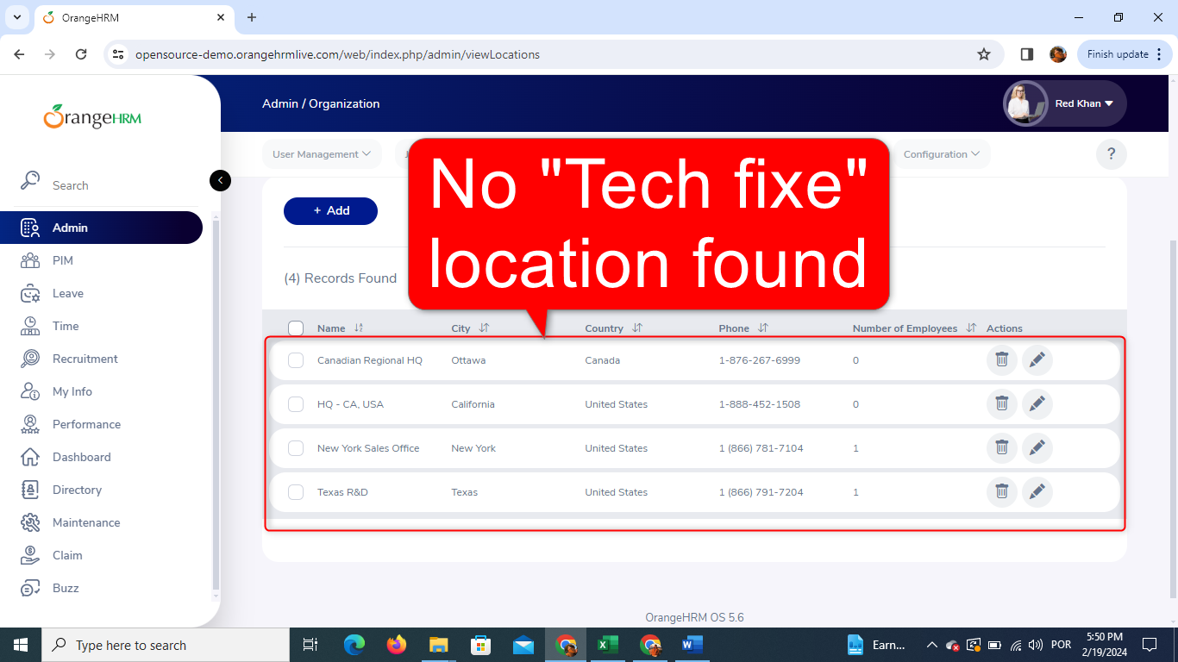
AND the following message pops up at the lower left corner
“Success Successfully Deleted”
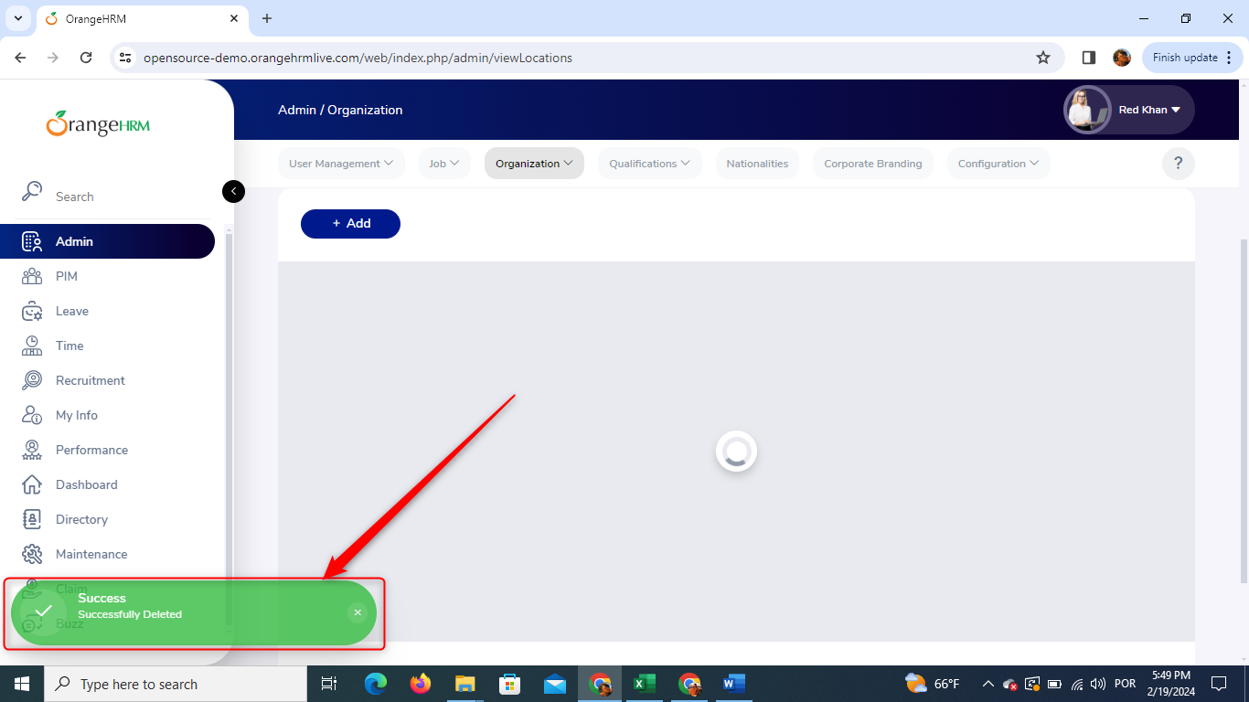
TC12. Non-Case-Sensitive Name searching Field
Given the website is accessible with a valid user account
And the user logs in with the following valid credentials:
- Username: Admin
- Password: admin123
And clicks on “Login” button
And the login should be successful, and the dashboard should be displayed
AND I'm on the page "/web/index.php/admin/viewLocations"
WHEN I type "tech fixe" in the "Name" field on the "Search" table
AND click on the "Search" button at the lower right corner of the "Search" table
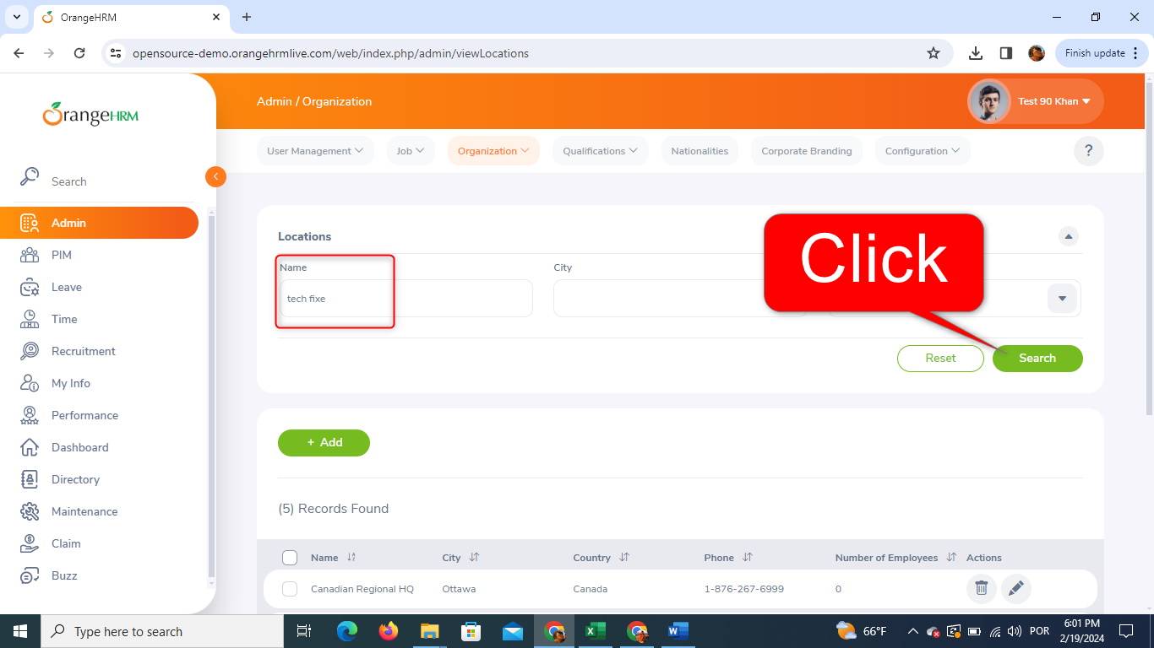
THEN all the User Data I provided with the Name "TECH FIXE" display on the "Record found" table
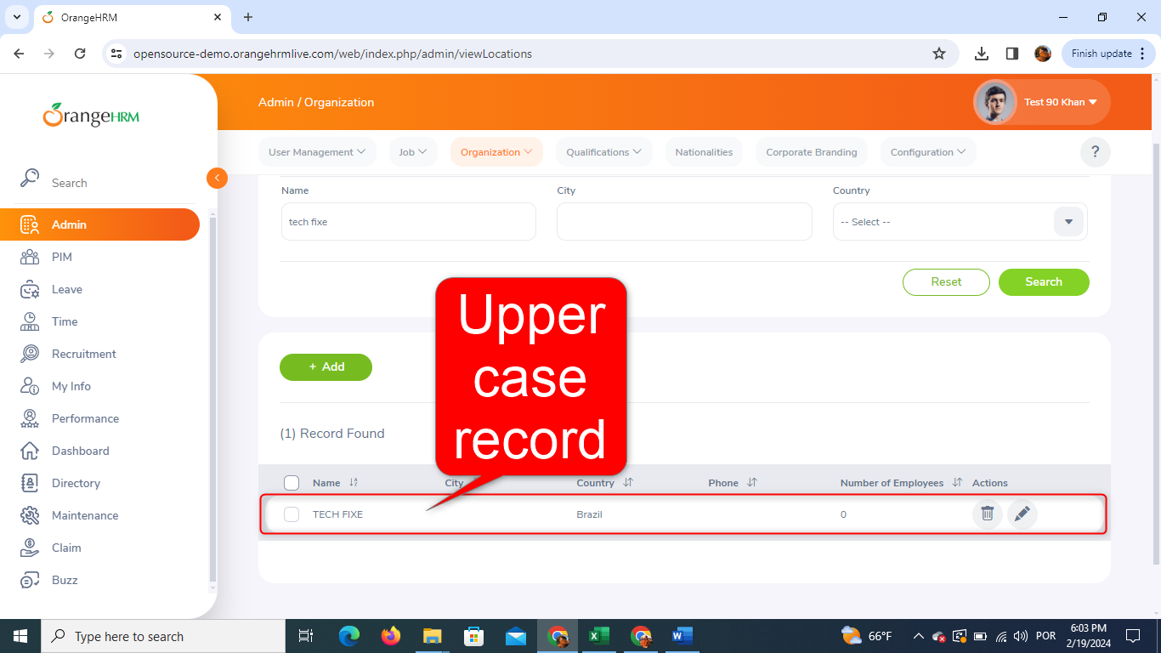
TC13. Blank Name field
Given the website is accessible with a valid user account
And the user logs in with the following valid credentials:
- Username: Admin
- Password: admin123
And clicks on “Login” button
And the login should be successful, and the dashboard should be displayed
AND I'm on the page "/web/index.php/admin/saveLocation"
WHEN I let the "Name*" field blank
AND I click on the "Save" button at the lower right corner of the page
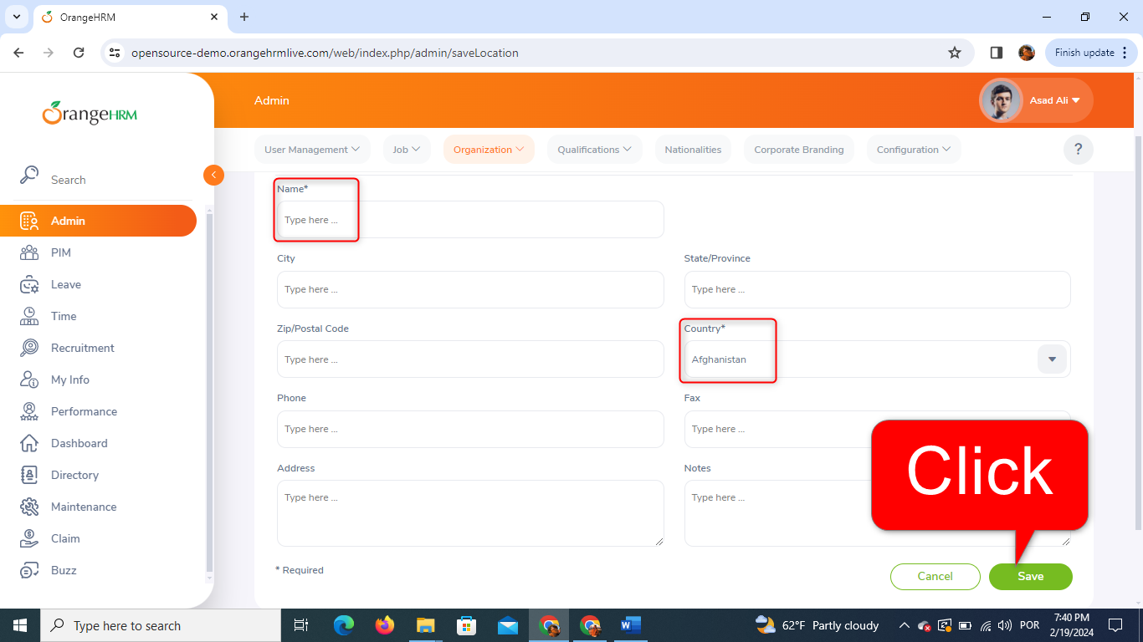
THEN the message "Required" shows up bellow the "Name*" field
AND the data I provided are not added to the "Records Found" table
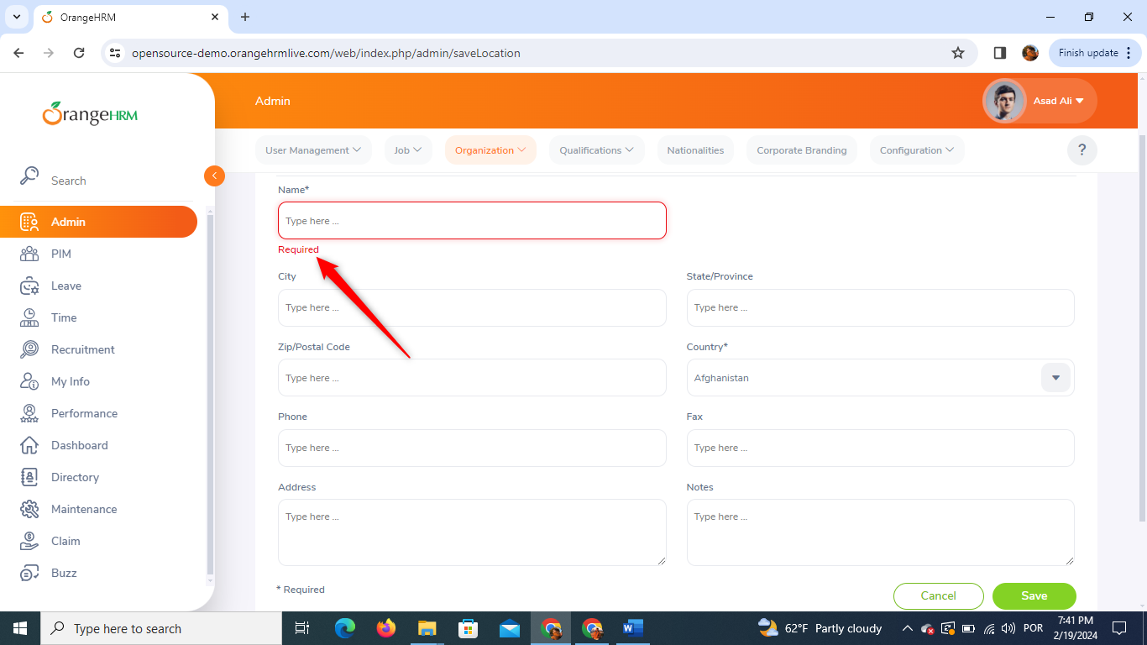
TC14. Special Characters Name field
Given the website is accessible with a valid user account
And the user logs in with the following valid credentials:
- Username: Admin
- Password: admin123
And clicks on “Login” button
And the login should be successful, and the dashboard should be displayed
AND I'm on the page "/web/index.php/admin/saveLocation"
WHEN I fill in with a valid Name and a "!" following the "Name" on the "Name*" field
AND I click on the "Save" button at the lower right corner of the page
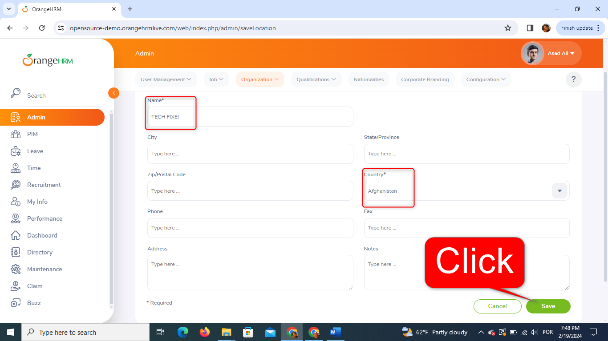
THEN I get back to the page "/web/index.php/admin/viewLocations"
AND the following message spans at the lower left corner of the page
“Success Successfully Saved”
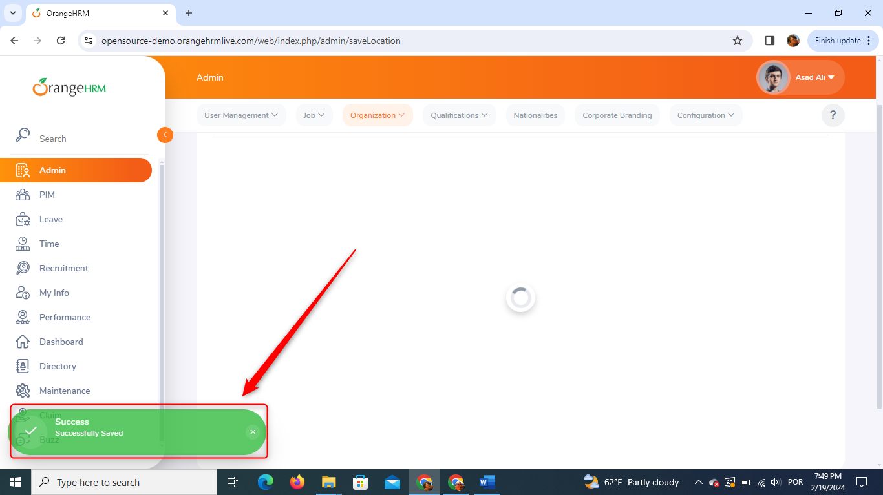
AND the data I provided are added to the "Records Found" table
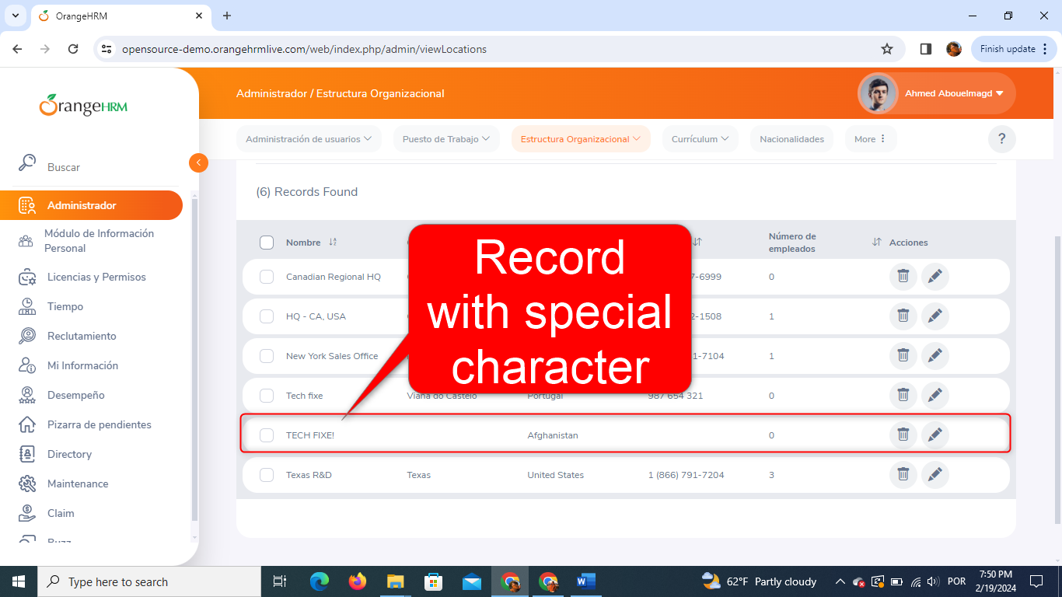
BUG DETECTED
TC15. Less than 3 letters in the Name field
Given the website is accessible with a valid user account
And the user logs in with the following valid credentials:
- Username: Admin
- Password: admin123
And clicks on “Login” button
And the login should be successful, and the dashboard should be displayed
AND I'm on the page "/web/index.php/admin/saveLocation"
WHEN I fill in the "Name*" field with "Hi"
AND I click on the "Save" button at the lower right corner of the page
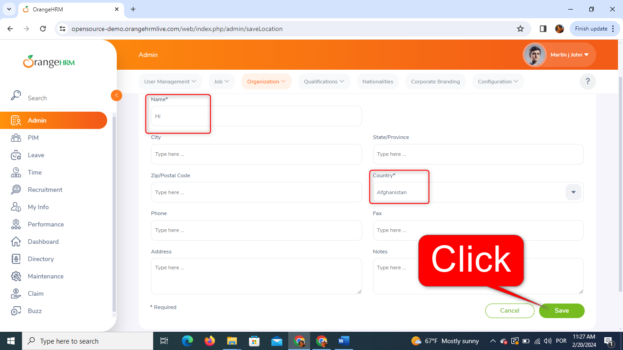
THEN I get back to the page "/web/index.php/admin/viewLocations"
AND the following message spans at the lower left corner of the page
“Success Successfully Saved”
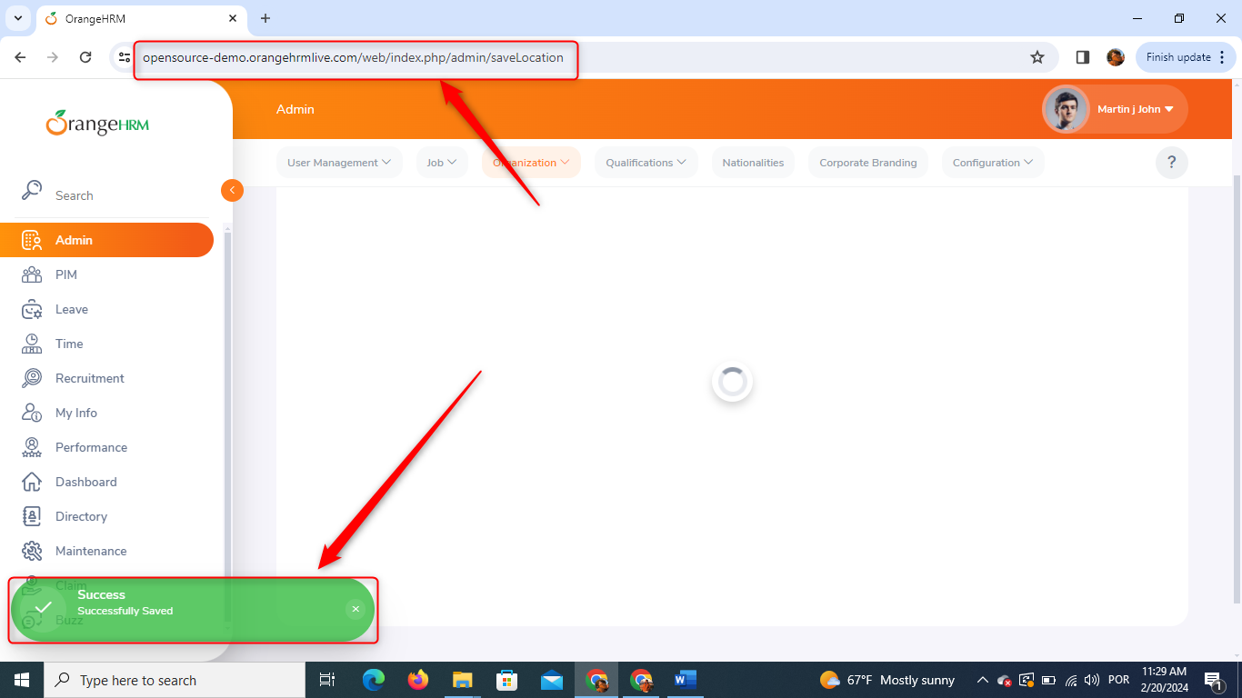
AND the data I provided are added to the "Records Found" table
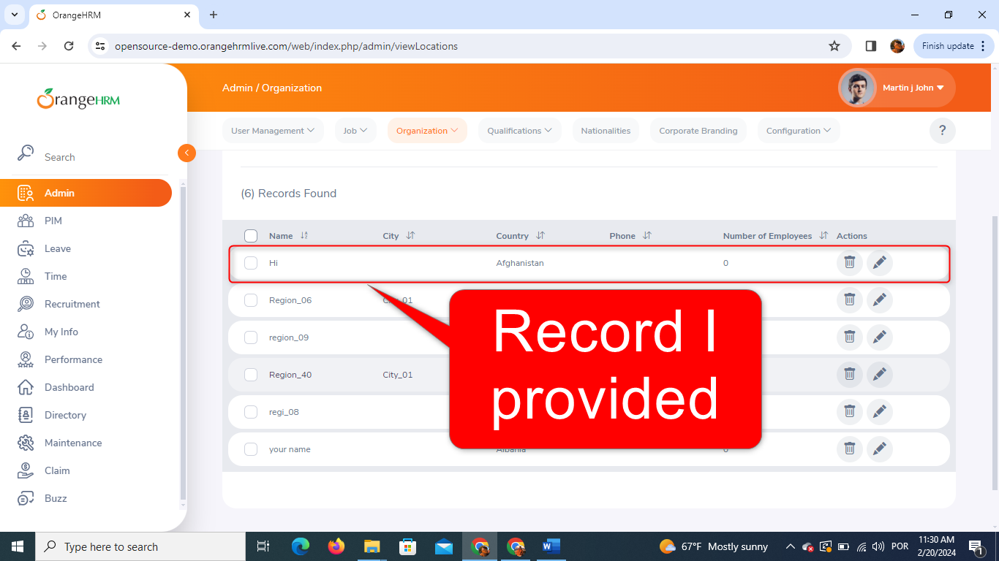
BUG DETECTED
TC16. Fill in the Name field with Numbers
Given the website is accessible with a valid user account
And the user logs in with the following valid credentials:
- Username: Admin
- Password: admin123
And clicks on “Login” button
And the login should be successful, and the dashboard should be displayed
AND I'm on the page "/web/index.php/admin/saveLocation"
WHEN I fill in the "Name*" field with "007"
AND I click on the "Save" button at the lower right corner of the page
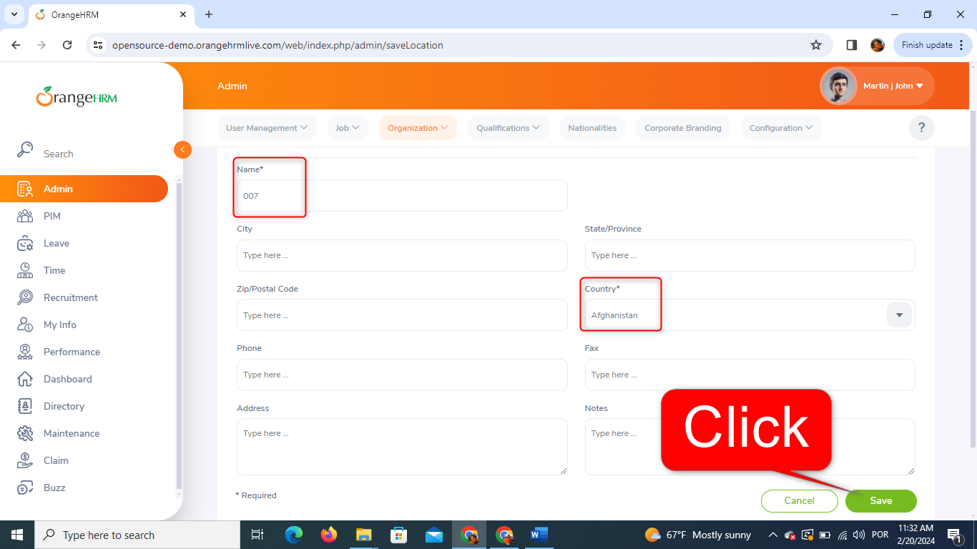
THEN I get back to the page "/web/index.php/admin/viewLocations"
AND the following message spans at the lower left corner of the page
“Success Successfully Saved”
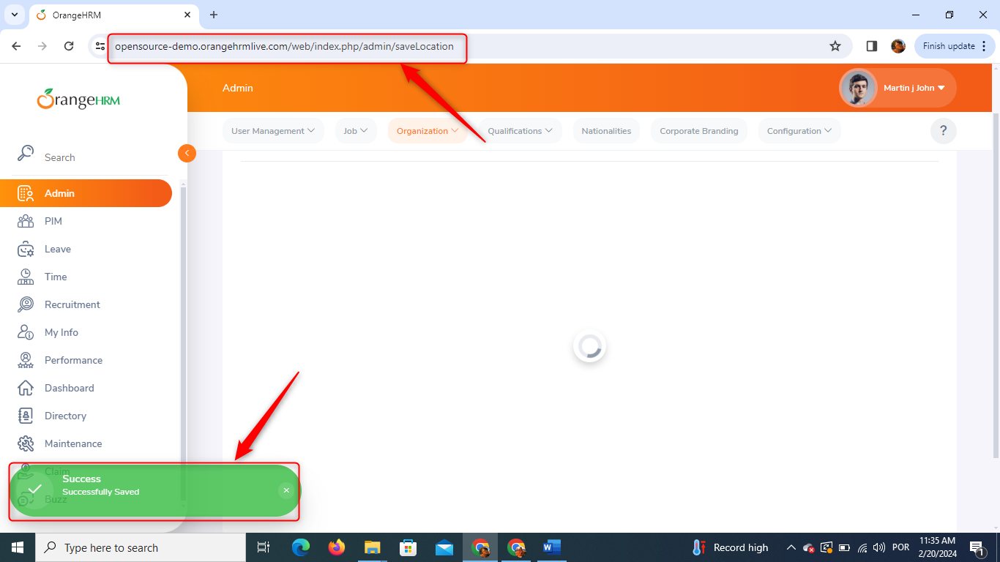
AND the data I provided are added to the "Records Found" table
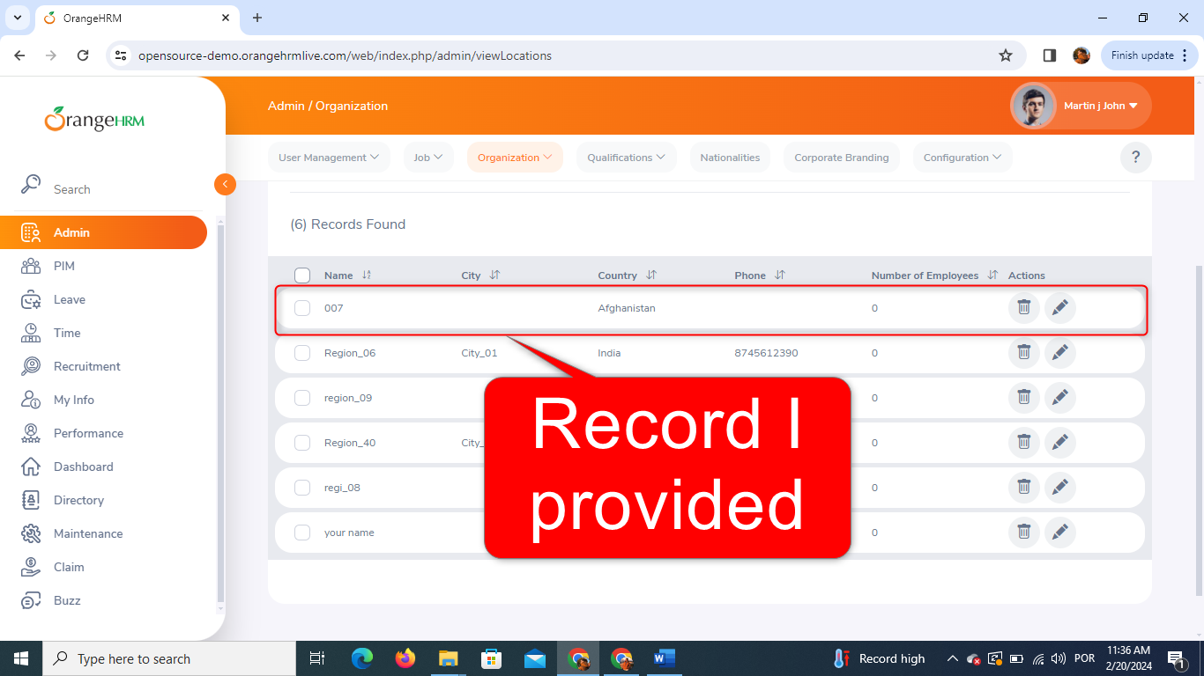
BUG DETECTED

