**CHAPTER I**

**THE PROBLEM AND ITS BACKGROUND**

**Introduction**

           A beauty salon is a facility offering male and female aesthetic treatments and cosmetic services. Everyone wants to look attractive, and beauty requires upkeep or improvement that a professional can best deliver. A beauty salon is made up of professional students who provide beauty services, have attended school to become specialists in the industry, can understand beauty concerns, provide advice and offer their customers useful beauty items. It gives everyone tranquility since it is a tiny refuge away from all that creates tension. Technology today is about the application of science to make a solution for any problems that people are encountering in their daily lives, it made lives much easier. Application software is considered as a technology, application software or app is a program that performs specific tasks to help the user.

Musil (2020) stated that technology is continuously changing or improving the lives of every person and there are some technologies and gadgets that changed not just the lives of people but also the world. It is not a secret at all that technology made people’s lives much easier in terms of connecting with other people with the use of the internet and devices, it is much easier to connect and communicate with other people without physical interaction. People are now living in this technological era, they like to browse everything on the internet, it is a good recommendation for a beauty salon to have their application. According to Vitez (2019), every small business owner should think about applying technology or having a system or software to make their business more effective and successful. Business owners can take advantage of the technology in saving and securing all the information of their customers. Through the help of technology, especially the electronic communication methods using devices like mobile phones, the customers of a business can give their feedback about the business, and customer’s feedback will allow the business to grow and to know what improvement they should do and what are their customers think about their business.

There is always a need for improvement to match the client's needs. Nowadays, digital marketing is very popular, because there are many potential clients online. Based on Barone (2020) digital marketing is a new way or a modern technique when it comes to reaching or approaching customers, it is about the use of the internet and devices to digitally market a specific product or business. Digital marketing is a good way to market a business, it allows the business owners or companies to directly reach a specific or potential customer and it also allows them to be able to connect with their customers in a more personal way (Storm, 2020). A salon application can increase the credibility of the salon because a business that has no web presence appears unreliable and obsolete. Having a digital presence allows the business to communicate with its customers and it will also provide the business a more strategic approach when it comes to marketing (Paun, 2020).

**Project Context**

Trendz Hair Salon and Wellness Center aims to provide quality services and convenient accommodations for their customers, they also provide beauty and wellness products and services. In regards to their goals, the developers want to develop a software application that will improve their manual transaction, keeping records, and manual reservations. The salon is located at Banga 1st, Plaridel, Bulacan, and the operating hours are from 9:00 am to 8:00 pm.

The salon has five employees who provide hair and nail services. All the employees and the owner take a part in recording transaction information manually. The daily transactions include recording payments, appointments, and customer information. The information recorded during daily transactio ns is needed as a reference record used during the analysis of service sales. The main problem of the salon is that they rely on the non-computerized system to record those transactions currently. It is not convenient for the owner and employees of the salon because the manual recording of every transaction is time-consuming, and when searching for information needed for reports, and if there are calculations that need to be done cannot be done fast. That is why a service appointment scheduling application will be very useful and will give convenience not just to the owner but as well as to the employees and customers of the salon.

**Purpose and Description**

The service appointment scheduling application will serve as a management system, and a management system is a way in which an organization manages the interrelated parts of its business to achieve its objectives, it is a very significant system in booking records, every booking's data must be managed well. The intention of developing a service appointment scheduling application for Trendz Hair Salon and Wellness Center is for the customer to easily schedule an appointment and for the owner and employees to manage the records of transactions, including the customer's information, payments, and appointments.

This is also an informative app that provides information about the salon. The software application will be used by the owner, employees, and customers of the salon. The results of the study entitled “Development of Service Appointment Scheduling Application for Trendz Hair Salon and Wellness Center” will be of great benefit to the following:

**Salon Owner/Admin.** This Service Appointment Scheduling Application will serve as a huge help to the owner in accessing and managing all the records of Trendz Hair Salon and Wellness Center. The app will make the data gathering/collection much easier in that way the owner could easily drive business decisions.

**Employees.** The app will give convenience to the employees of the salon. Using the appl the employees can have a proper schedule and they can monitor every appointments of their customers.

**Customers.** The app will also be beneficial to the customers of the salon. Booking an appointment could be done at their convenience. The system will provide information about the services of the salon, in that way the customers could view the service that they want to avail and they can also pick their preferred time even the stylist of their choice.

**Researchers.** The success of this study will be beneficial to the researchers because it will contribute to their knowledge and skills as developers and programmers.

**Future Researchers.** This study can serve as the basis of future researchers for their own version of Service Appointment Scheduling Application for Beauty Salon.

**General Objective**

This study aims to design and develop a service appointment scheduling application for Trendz Hair Salon and Wellness Center.

**Specific Objectives**

This study will have the following specific objectives:

1. To develop an application with flexible scheduling of appointment with hair consultation feature as preferred by the costumer.

2. To develop an application with notification system to prompt customers about their appointment schedule.

3. To manage and track the customers’ data using the admin account.

4. To provide an advanced reporting functions for generating business reports.

5. To manage all the services and products using inventory system.

6. To evaluate the developed Service Appointment Scheduling Application for Trendz Hair Salon and Wellness Center using an international standard quality assurance survey form.

**Scope and Delimitations of the Study**

The study involves the development of a scheduling application for Trendz Hair Salon and Wellness Center which will be used by the salon owner, employees, and customers. It is an application that will provide information for the customers about the operating hours, stylist schedule, and services of the salon.

The main purpose of the application is to give convenience to the owner, employees, and customers of the salon. Using this application, employees could save and delete records, and the app is also capable of finding the records that the owner or employee wants to search. This app will help the salon to have an organized customer record. It could provide reports for the owner of the salon and it will allow the customers to easily schedule an appointment, and will help the owner or admin of the salon to manage the inventory. The scheduling application will not include the point-of-sale system.

**CHAPTER II**

**REVIEW OF RELATED LITERATURE AND STUDIES**

            This chapter contains relevant theories, related literature, and related studies. The researchers gathered all the information that is presented in this chapter to help them overcome problems that they might encounter while developing the study. This will serve as a guide for the researchers in the study.

**Relevant Theories**

In this part of the chapter, the researchers include theories that are relevant to the study. The theories that are presented below will serve as a guide in developing the study.

**A Theory of Software Reliability and its Application** Musa (1975). This theory allows, in advance of a project, the estimation of the amount of testing in terms of execution time needed to reach a specified reliability goal. Execution time can be connected to calendar time, allowing the development of a schedule. To test the software reliability and its application, estimates of execution time and calendar time remaining until the reliability goal is achieved can be continually remade as testing continues. The current mean time to failure and the number of errors can estimate. The confidence intervals are developed and maximum likelihood estimation is employed.

**Customer Satisfaction Theory**. Thomassen (2003) as cited in the study of Mithas, Krishnan, & Fornell (2005) entitled "Effect of Information Technology Investments on Customer Satisfaction: Theory and Evidence". This study supports the Thomassen theory, which shows that satisfaction with customers is the customer's view that their experiences are compared with their expectations consciously or unconsciously. It is a psychological condition assessed by the expectations of the buyer. You can substantially boost the loyalty of your customers to your brand by knowing what those expectations are. The Mithas et al (2005) study attempted to examine the effects on customer satisfaction of IT investments. With an IT system in a company, customer satisfaction can be increased and, if customers are satisfied, the chances of success will be increased. Service Timetable Development Application for Trendz Hair Salon and Wellness Centre, which can boost customer happiness at the salon.

**Technology and Business Ethics Theory**. Davies (1997) Any technology can be a threat and cause harm to employees. Technology can be a source of exploitation and can expose some private and personal information of employees in a business or organization (Cordeiro, 1997). Before developing technology in a certain business, the ethics of business should always be considered. Many ethical challenges involve technology.

**Theories of Technological Innovation as Useful Tools for Corporate Strategy**. Butler (1988) The product-process concept, meta-learning concept, and concept of technological interdependence are the three theories of technology and innovation that are used to connect technology and innovation to strategic management. Technology can be a threat or opportunity and it can affect competitive advantage. Technological innovation is a good strategy as it will lead to more growth and prosperity.

**Related Literature**

In this part of the chapter, the researchers gather, read, analyze, and review related works of literature. The researchers shall include literature that is relevant, related, and necessary to the study.

**Appointment Scheduling Software**

Appointment schedulers are business tools that enable customers to make/create, reschedule or cancel an appointment (Esposito, 2020). Appointment scheduling apps let every business owner reduce their works and it will easily allow customers to schedule and update their appointments. It offers the ability to capture scheduling statistics. The appointment scheduling apps can avoid the double booking or overbooking of appointments and allows the management to make a specific appointment unavailable.

There are many benefits of having an appointment scheduling software especially for customers to have a better experience and to reduce their waiting time, it can also improve operational and staff efficiency. An appointment booking system can help businesses like salons to run smoothly in the current environment that we are facing now (Thamrin, 2020).

Technology is constantly improving so most of the business nowadays are adopting an online reservation system. An online reservation system is an app or software that may be installed or a website, that can used by the customer to book, reserve, or pay efficiently for their activities online. An online reservation can be the best way for the customer to save more time, they just need to fill-up the form and submit it. Now after that, the company will be received the information and customer can wait until their appointment. Online reservation systems can provide many benefits not only for the business but also for their customers. Nowadays, most people are increasingly becoming mobile users, so having an online reservation that can book or reserve them anytime and anywhere can have a positive impact on them and the company. It eases the convenience pain of the customers rather than booking manually (Small Business, 2017).

**Online Booking System**

Ching (2020) stated that an online booking system can have more benefits to the owner and customers. Like, customers can lessen their stress and saving more money by using an online booking system and it may result in a good bond or a healthy relationship between customers and the owner. Second is they can Email and SMS the customer. It is more efficient that they don't have to worry about whether customers remember their appointment. Third it easy to generate a report of how many customers they have already service and how much they earned in the recent months. According to a recent study, globally, online booking systems or software is consistently growing over the year. As estimated 15.1% will be the growth rate of it until 2024 and expecting to reach a more than hundred million market value soon. Almost 58% of the clients are using online booking software to take advantage because it is easy to use, they can save more money and less stress for them.

A Salon Online Booking Software is a tool or equipment to manage and automates the Salon operations effectively. The software will help the salon and its owner to manage customer information, online booking, appointment scheduling, payments, and billing. Using salon booking software the owner can keep an eye on its business from anywhere and anytime. Salon booking software will allow the customers to schedule an appointment any time of the day. It will enable the customers to know the available timeslot and book their preferred time. Surely, the salon booking software will increase customer satisfaction, they can also change or cancel their appointments prior and it will avoid the idea of no-shows. The said software also makes customer data tracking much easier. The salon should have its software for effective marketing (Jobs, 2020).

The name speaks for itself pretty much. A reservation system allows clients to reserve online with you. This means that you no longer need to make telephone calls or emails to find the time to spend, nor even the employees or managers. Recall the days of the manual check for an appointment slot? After that, you would let the customer know, and they would advise when time is available, etc. Further modifications required another call and repeatedly did the same process. This takes much administrative time to waste even with receptionists and dedicated workers and leads to lost clients. The online reservation systems are essentially user-friendly and user-friendly to the customer and are easy to use to reserve and pay for online appointments on your site. The entire process is done online, easily accessible, easy to fill, and with little involvement. This means no duplication or error in humans may happen, as this is entirely a digital procedure by using mobile phones, smartphones, or a computer desktop. Advanced software can let clients know that they can view this website on mobile. Suddenly, everywhere and anywhere, anybody can book. No more consumers were lost because of hours of business or busy fixed services or business. Customers will also be happy with the simple user-friendly approach to view all available options (WP Amelia Staff, 2020).

Unlike having a traditional booking, that might cause different problems and confusion on their businesses and customers that may cause the downfall of your business. Technology is changing our everyday lives. From booking most of the service today, we all do it by just simply touching our devices. And most of the businesses are adopting it. Nowadays, customers are expecting a flexible booking system for a salon that they can use 24/7. A study conducted shows that almost 70% of the customers of spas and salons prefer to book online (MIOSALON, 2019).

According to Gawlowski (2018) being an owner of a hair & beauty business, they need to devote themselves to that job. They need to supervise their business and evaluate everything. Good thing is that a business owner, specifically a salon owner can take advantage of management software that will help the owner to be successful in running the salon's business. A good salon management software will organize and manage everything for the owner, it will allow the owner to properly manage the salon's employees, salon's customers including their personal information, and appointments. The software could also have an automatic and ongoing creation of reports and statistics that can be easily accessed by the owner and come up with business decisions.

Online booking for a salon can reduce your problems in answering many phone calls and emails. Customers can make their appointment anytime and anywhere. So, having an online booking system can avoid those problems. Customers also missed their appointments that can cause problems like losing some revenue and a hassle for the hairdresser that is assigned to that appointment. An online booking can also reduce this kind of scenario. The system can send an email or SMS to a customer to remind them that they have an appointment at your salon on this day. Online payments are one of the advantages that give the customer satisfaction and convenience when they are scheduling their appointment to your salon using an online system. It also reduced the chance of missing their appointment and encourage them by offering a discount. You can also arrange the schedule of your hairdressers by using an online booking system. Customers and Hairdressers can both benefit from this. Some of the hairdressers are not available on a specific date they can also know when they have an appointment by adding an event to their calendar and also, some of the customers want to be serviced by a specific hairdresser (Bookly, n.d.).

**Inventory System**

Inventory management helps companies to know and be informed about the quantity of stock they need to order at a specific time. It helps the management to identify the number of stocks that are still available and ensure that there's always enough stock for their customers and the inventory system helps companies to have proper warning of a shortage. It limits the risk of stockouts and inaccurate records. Inventory management techniques use formulas and analysis. One of the techniques of managing inventory is batch tracking, this method groups similar items to track expiration dates (Jenkins, 2020).

Barry (2019) argued that a business inventory system is a strategic choice. Many companies today use the inventory management system to correctly preserve and manage all the data of a certain company's products. Inventory management systems contribute to product buy operations, analyze sales trends and availability online, and liquidate products for the wholesale, dealership, e-commerce, and production organizations. products for wholesalers and retailers are also supported. Knowing the legacy of the system and the installed user base of the organization is the key to choosing the proper system for a particular business.

**Related Studies**

In this part of the chapter, the researchers gather, read, analyze, and review related studies. The researchers shall include studies that are relevant, related, and necessary to the study.

Based on the project of Tamanna Sultana Eva (2020) entitled "Salon Care" an android based application will help people to have a great salon experience. Customers can easily make online appointments without being physically present in their desired salon. Aside from saving customer's time and energy, the app will also provide safety and security measurements. Using Salon Care Application, customers can have home services and they can also review the salon to their according. Every salon that has an app like Salon Care will increase customers satisfaction which is the goal of the most salon.

Maryani, Hendro Nindito & Hendra Alianto (2019) discovered that an online reservation system is appropriate for the salon, or barbershop since it reduces client waiting time in their "prototype development for online reservation systems of Barbershop and Salon Industry" research. Most of the students that go to a salon or barbershop are young people aged between 17 and 20 or between 21 and 30 years old. People around this age usually like internet surfing and using their devices like mobile phones. The development of an online reserving system will help to reduce the customer's waiting time. The same is true of designing a Term Planning application because it is particularly accessible for young people. This project examines and constructs an online reservation barbershop and showroom that fits the requirements of its users, owners, and customers. This strategy can help every barbershop and living room cut down waiting times on the other hand. The technique to analyze system requirements involves creating and distributing a list of questions via Google documents online and then evaluating them by partial correlations. The collected information is then examined to establish the need to build this system. The Online Reservation System is suitable for use to reduce customer waiting time (Maryani et.al, 2019).

Nowadays a lot of organizations are using management systems in their daily task, but there are still organizations and businesses that are using the non-computerized system. The non-computerized system can cause a greater task load when implemented unlike to computerized system that is more efficient and effective. It makes it easier for users because it has functions like searching, automatic calculation, and display of related information with minimal queries. Annie Chai & Chuah Chai Wen (n.d) developed Shears Inc. Salon Management System to act as an alternative to the non-computerized system implemented by Shears Inc. Salon. The objective of their study is to decrease the task load of owners and employees of Shears Inc. Salon. In the development of the system, they used the Software Development Life Cycle methodology, PHP programming language, and MySQL as the database server.

The study of Putra et. al (2020) entitled "Geographic Information System for Booking Beauty Salon and Barber Shop with an Android – Based ECRM Approach" aims to give convenience to the customers of Beauty Salon and Barber Shop in terms of finding the best beauty salon and barbershop that the customers may want to visit or to conveniently book an appointment. Their study gives solutions for scheduling appointments and transactions by using the e-CRM approach.

Developing software for the salon is a solution to improve business management. The software will serve as a huge help to the customers of the salon especially the employee of the salon. It will help the customers to schedule their appointments and it will help the employees to organize data or information that is necessary to a salon (Thanki, 2019).

Akshay et. al (2019) developed an Online Appointment Booking System for salons/parlors, hospitals, and architecture. The system is a web-based application and an open-source SDK for hybrid mobile application development. They used CSS, HTML, and JavaScript in developing the Online Appointment Booking System and they also make use of firebase for the database of the system. The system makes booking appointments much easier.

The study entitled "Digital Salon System" of Mudasir Ijaz (n.d) stated that the purpose of technology is to make life much easier. The study developed an online salon appointment system to reduce the waiting time of every customer of the salon. It is not a secret at all that almost everything is becoming digitalized, it's a good way for businesses like the salon to have a digital system to be competitive and keep up with the flow of the modern industry.

The result of the study of Will et.al (2020) shows that technologies have relevance in business. Integrating a technology or system in a business helps the business to enhance their operations and it helps them market their product. It is very important to make an improvement in a business and promote innovation and technology is one of the best ways to do that.

Many businesses are now using a digital platform to gain a strategic advantage. According to many studies, every business or organization should lead its way in the digital world to help them survive and be able to adapt to our continuously changing world. They should know where to invest in digital capabilities and how they can improve their business operations digitally.

The study of Moghavvemi et. al (2012) explained the effect of IT innovation on competitive advantage. Their study also presents the impact of government policy in motivating organizations and businesses to adopt IT innovation. IT innovation will help business organizations in the objective of meeting competition and enhancing their business performance.

**CHAPTER III**

**TECHNICAL BACKGROUND**

This chapter presents the technical background employed in developing a Service Appointment Scheduling Application for Trendz Hair Salon and Wellness Center. It includes the software development methodology, requirements analysis, and documentation, design of software, systems, product, and/or processes to complete the development of the Service Appointment Scheduling Application.

**Software Development Methodology**

For society and many companies, software development has gained importance with the majority engaging in substantial resources. You employ several methods to develop software to increase income while reducing running costs. This encourages software engineers to offer flexible and effective policies, such as agile techniques, to support the production of software of high quality. The technique impacts software development, given that it delivers high-quality products. It has an excellent influence on developers to dedicate their efforts to achieving the aims of the project. (Eman Altameem, 2015).

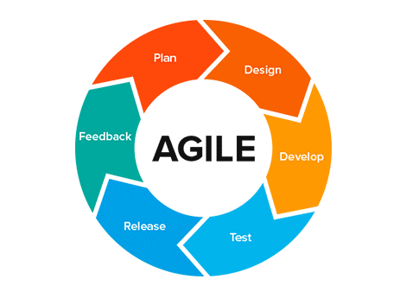

**Figure 1. Agile Software Development Life Cycle**

            The Agile technique is in line with the Agile Manifesto for Software Development's values and principles. This principle states that requirements, plans, and outcomes are examined regularly; teams have a natural system for adjusting swiftly to change. And it gives different benefits for the team that is working on their software. It also increases the chance of finishing the project early.

**Planning Phase:** In this phase, researchers are planning on how they can collect data from their client like the history of the business, services they are offering, and problems that they encounter today. Researchers are also planning on how they can integrate some solutions to their problem using the application that they will develop. Aside from that, researchers are planning on how they can save their time to lessen the time and the stress they may feel while doing the system.

**Requirement and Analysis Phase:** This phase is the initial phase of the development process wherein the researchers determined the user's requirements for the product. The researcher considered the functional requirements of the study. This is also the phase where the researchers analyzed the needs of the end-users to make sure that the system that will be developed will meet their expectations and will meet the required functions to be acceptable by the users. The requirements developed in this phase serve as a foundation for the remaining phases for the development of the system.

*Table 1. Software Requirements*

|  |  |
| --- | --- |
| **Software Requirement** | **Recommended Requirements** |
| Operating System | Android 7.0 (Nougat) & Windows 7 |

*Table 2. Hardware Requirements*

|  |  |
| --- | --- |
| **Hardware Requirement** | **Recommended Requirements** |
| Processor | Snapdragon 865 |
| Random Access Memory (RAM) | 3 GB RAM |
| Storage Space | 2 GB Space |

**Design Phase:** In this phase of software development, the researchers have established systems flowcharts, business relationships, and the anticipated system design. The goal of this stage is the complete and detailed system design requirements so that researchers can already start the development stage once the design phase is completed and approved. This stage will provide a guide to the system's development.

**Development Phase:** In this phase of Agile SDLC, coding and changing design documentations into actual software is regarded as the backbone of the entire process. This stage aims to design the system's user interface and build the system's expected functions for the Trendz Hair Salon and Wellness Centre. The programming language used by developers is java and Android Studio is the Integrated Development Environment (IDE).

**Testing Phase:** The testing phase will involve the end-users to evaluate and test the developed system. The participants of the study including the end-users, 4th-year CICT college students, and CICT faculty members will take part in testing and evaluating the system. The researcher will monitor the participants and they shall document the bugs and errors that will encounter in testing the system.

**Deployment Phase:** This is the final phase of the Software Development Life Cycle. After passing the testing phase, the product will put into production. The system will be distributed to the end-users which are the Trendz Hair Salon and Wellness Center owner, employees, and customers.

**Review Phase:** This phase plays an important role in every Software Development Life Cycle. The review phase will determine if the study has met its objectives.

**Conceptual Framework**

To be able to achieve the general objective of the study which is to develop a Service Appointment Scheduling Application for Trendz Hair Salon and Wellness Center, the researcher constructed a conceptual framework based on the flow of the whole study. The conceptual framework is based on the Input-Process-Output diagram to be easily understood by the readers.

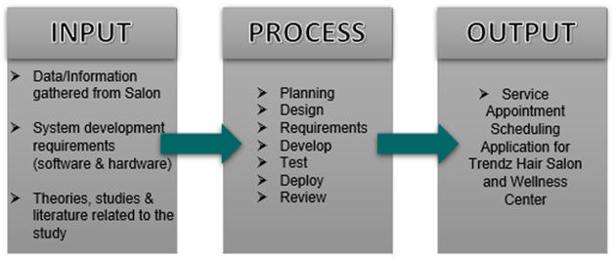

**Figure 2. Paradigm of the Study**

**Input Phase**

The first frame is the Input phase that involves the data or information gathered from Trendz Hair Salon and Wellness Center and the references that are needed in developing the system such as articles, books, thesis, and interviews with the client. This phase will also include all the requirements that are necessary for developing the system such as the user requirements, software requirements, and hardware requirements.

**Process Phase**

The second frame is the Process phase. The researchers adopted the Agile System Development Life Cycle (SDLC) Model. It consists of seven phases including the Planning, Design, Requirements, Develop, Test, Deploy and Review phase. The Agile SDLC Model will be used by the researcher in developing the system.

**Output Phase**

The final phase is the Output phase. The researchers shall finish the process of developing the system. The output of the study shall be the Service Appointment Scheduling Application for Trendz Hair Salon and Wellness Center that will be used by the owner of the salon as well as the employees and customers of the salon.

**Requirements Analysis and Documentation**

In this part of the chapter, user requirements, system requirements, and interface requirements will be discussed. User requirements are the features of the system that is required by the client which is the Trendz Hair Salon and Wellness Center.

**User Requirements**

1. To design a web and mobile based appointment scheduling application for Trendz Hair Salon and Wellness Center.
2. To develop an application with the following features:

a.    Hair Consultation

b.    Flexible Scheduling

c.    Time-Slot Optimization

d.    Multi-Channel Notification System

e.    Customer Data Tracking

f.     Advanced Reporting Functions

g. Inventory System

**System/Technical Requirements**

General Requirements:

* Use of database(s)
* Report Generation
* Calendar
* E-consultation module
* Organization/category of topics or information

**Interface Requirements**

* 1. Login & signup form for the end users
  2. Image of services
  3. Message box for the inquiries or feedback of customers
  4. Calendar to show the date and time of appointment

**Testing**

The researchers will determine the acceptability of the system using the 5-point Likert scale. The system will be evaluated based on the standards set by ISO/IEC 25010 or Square-System and Software Quality Model and based on different criteria applicable to the application including the functional suitability, usability, reliability, security, and maintainability. The numerical rating and descriptive equivalent of the Likert scale will be used for interpretation are as follows: 5 for Strongly Agree; 4 for Agree; 3 for Moderately Agree; 2 for Disagree; and 1 for Strongly Agree.

The weighted scores and their equivalent description will be used to analyze the computed mean of each criterion, as shown in the mean value score below.

Weighted Scores

5

4

3

2

1

Ranges

4.60 – 5.0

3.60 – 4.59

2.60 – 3.59

1.60 – 2.59

1.0 – 1.59

Descriptive Rating

Strongly Agree

Agree

Moderately Agree

Disagree

Strongly Disagree

It shows the different weighted scores and corresponding descriptive ratings. It displays the reference table in obtaining the mean value scores of the respondents chosen by the researchers who will evaluate the system "Service Appointment Scheduling Application for Trendz Hair Salon and Wellness Center ". The result of the conducted survey will use as a guide to determine the acceptability of the system and guide to improving the quality of the system.

The researchers employed a stratified random sample method, which divides the overall population into smaller groups or strata to complete the sampling procedure. The researchers used this method. Stratified random sampling enables scientists to obtain the best sample population of the whole population investigated (Hayes, 2020). Table 3 shows the respondents of the study, consisting of five (5) CICT faculty members of Bulacan State University, and five (5) IT professionals.

Table 3 displays the frequency and percentage distribution of the evaluators that will evaluate the Service Appointment Scheduling Application for Trendz Hair Salon and Wellness Center and the said respondents will be chosen by the researchers.

**Table 3**

**Evaluators of the Developed Application**

|  |  |  |
| --- | --- | --- |
| **Evaluators** | **Frequency** | **Percentage** |
| CICT Faculty Members | 5 | 50% |
| IT professionals | 5 | 50% |
| **Total** | **10** | **100%** |

**Design of Software, Systems, Product, and/or Processes**

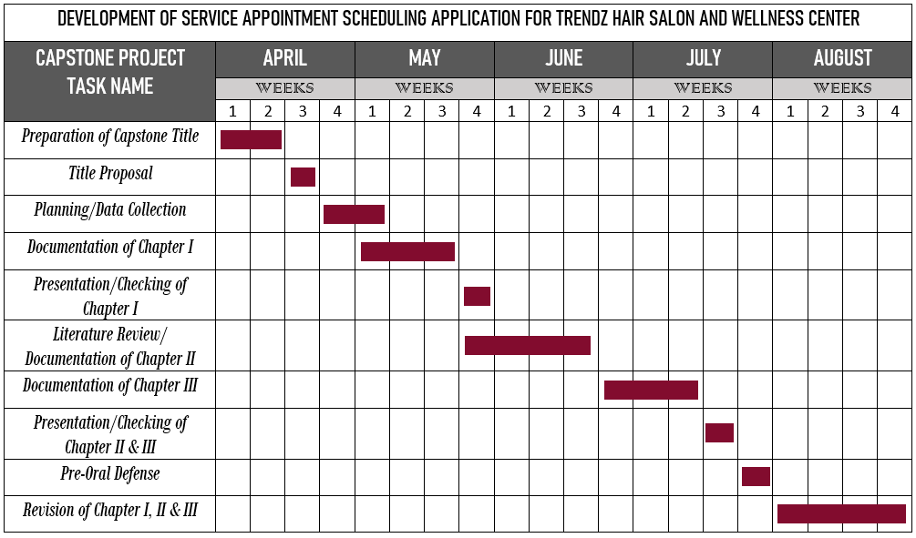

**Figure 3. Gantt Chart Timeline (Capstone Project 1)**

Figure 3 shows the Gantt chart or the project timeline that was developed by the proponents or researchers during their Capstone Project 1 from April until August. The researchers prepared their capstone title during the first week of April and the researchers started the documentation of Chapter I in May. Literature review and documentation of Chapter II were done in June and the researchers finished Chapter III in July every chapter of the documentation was presented to and checked by the researchers’ capstone project coordinator. The pre-oral defense was held in the last week of July and the revision of the manuscript are done during August.

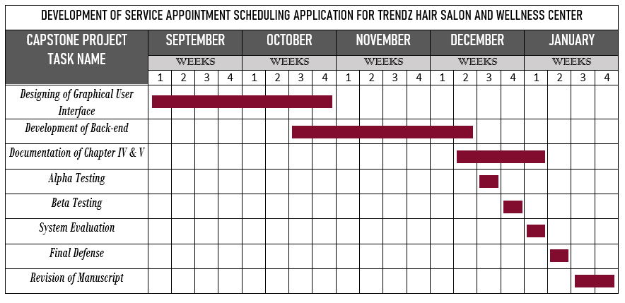

**Figure 4. Gantt Chart Timeline (Capstone Project 2)**

Figure 4 presents the Gantt chart or the project timeline of the researchers from September to January or during their Capstone Project 2. The researchers developed the design of the graphical user interface of the system during September and October, In the same month of October the researchers started the development of the system’s functions or the back-end. Alpha and beta testing were implemented during the documentation of Chapters IV and V in December, while system evaluation was done in the first week of January. The second week of January was the final defense of the Capstone Project and after that is the revision of the manuscript.

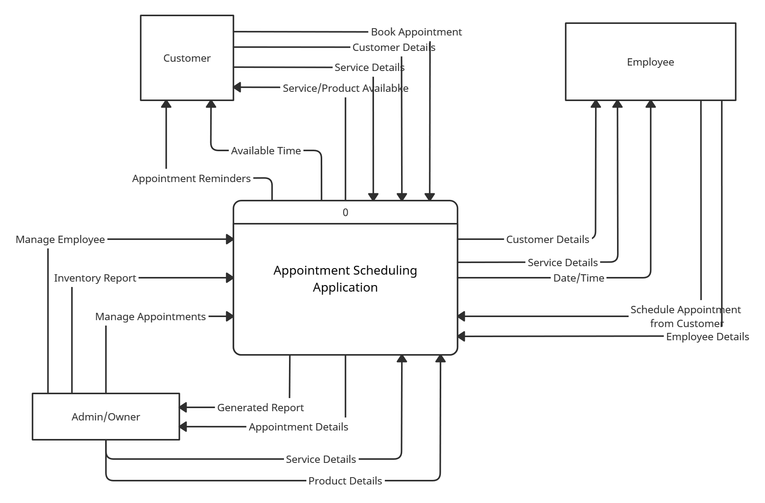

**Figure 5. Context Diagram**

Figure 5 is the Context Diagram of the Scheduling Appointment Application. There are three entities, the customer, employee, and the admin/salon owner. The customer entity will provide its details to the app and the customer is also the one who will book an appointment using the app. While the employee entity will schedule an appointment with the customer and employee should also provide details about them. And lastly, the admin entity, admin will be the one who is responsible for managing the employees, managing inventory, and managing appointments that will be made by the customers using the scheduling appointment application.

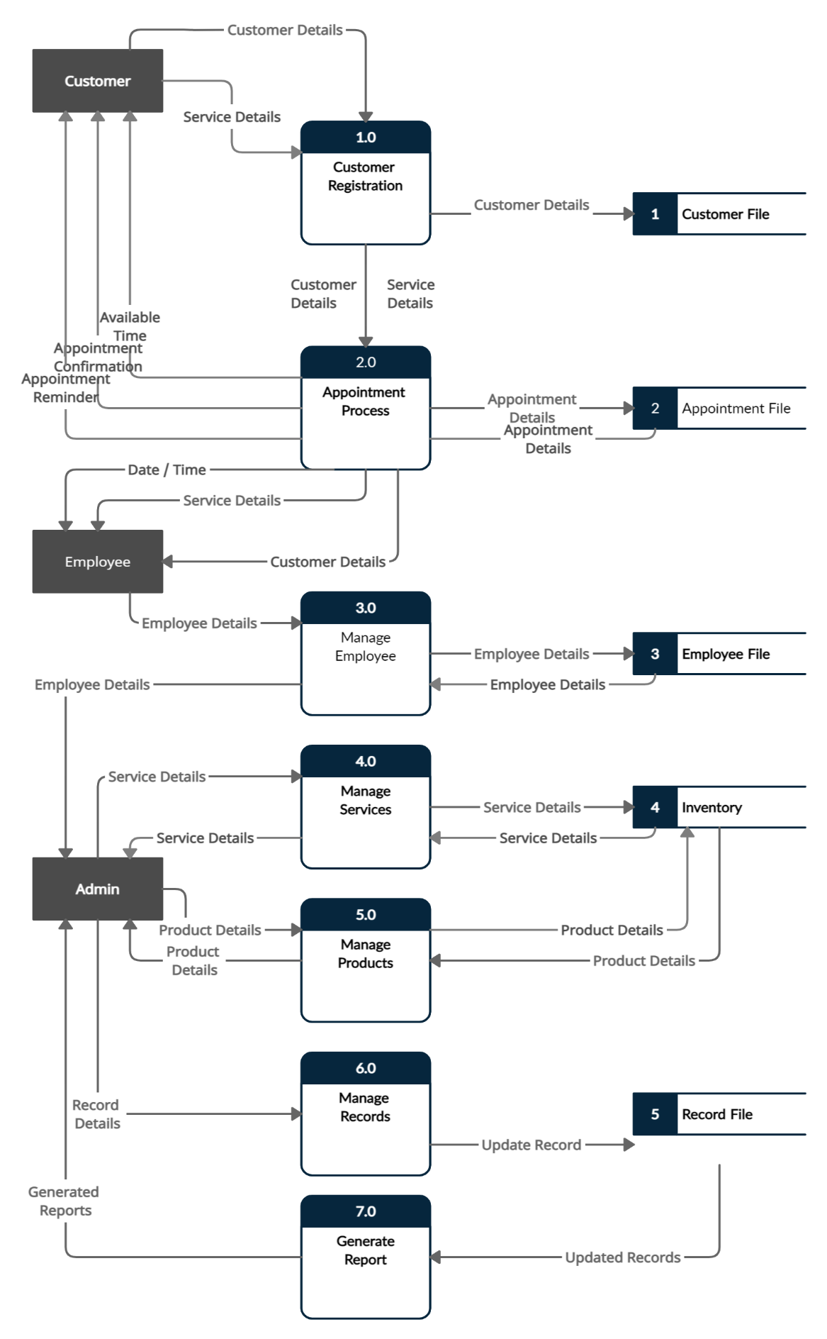

**Figure 6. Dataflow Diagram**

Figure 6 shows the Dataflow Diagram of the application. The first process is the customer registration, in this process, the customer should provide personal details like their full name, email address, and contact number, and customer details will be saved to the customer database, it will be useful if the admin or the owner of the salon wants to track the data or information of their customers. Under the appointment process are all the necessary information for the appointment details including the service details, customer details, employee details, and the date and time of the appointment provided by the customer and employee, and every appointment detail will be saved to the database. And every employee detail will also be saved in the database that will be managed by the admin, and the admin is also the one who will manage the inventory that will also save in the database.

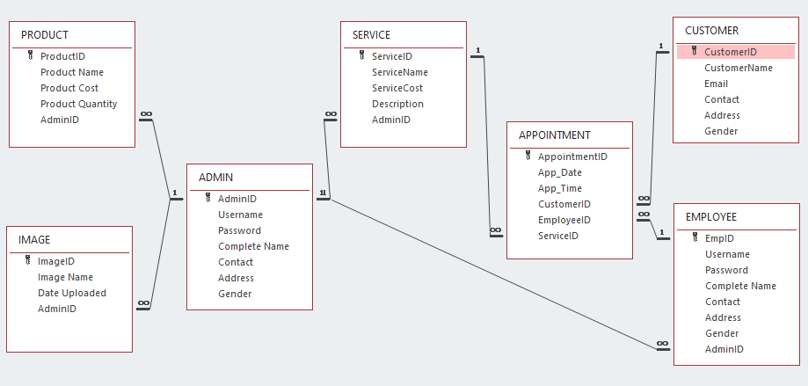

**Figure 7. Entity Relationship Diagram**

Figure 7 shows the Entity Relationship Diagram and there are seven (7) tables overall in the Entity Relationship Diagram. The first table is the PRODUCT table with ProductID as its primary key, the second table is the ADMIN table with AdminID as its PK, the third table is SERVICE table and its primary key is ServiceID, next is the APPOINTMENT table with AppointmentID as the PK, next is the CUSTOMER table with CustomerID as its PK, EMPLOYEE table with EmpID as its PK and lastly the IMAGE table with ImageID as the PK.

**System Flowchart**

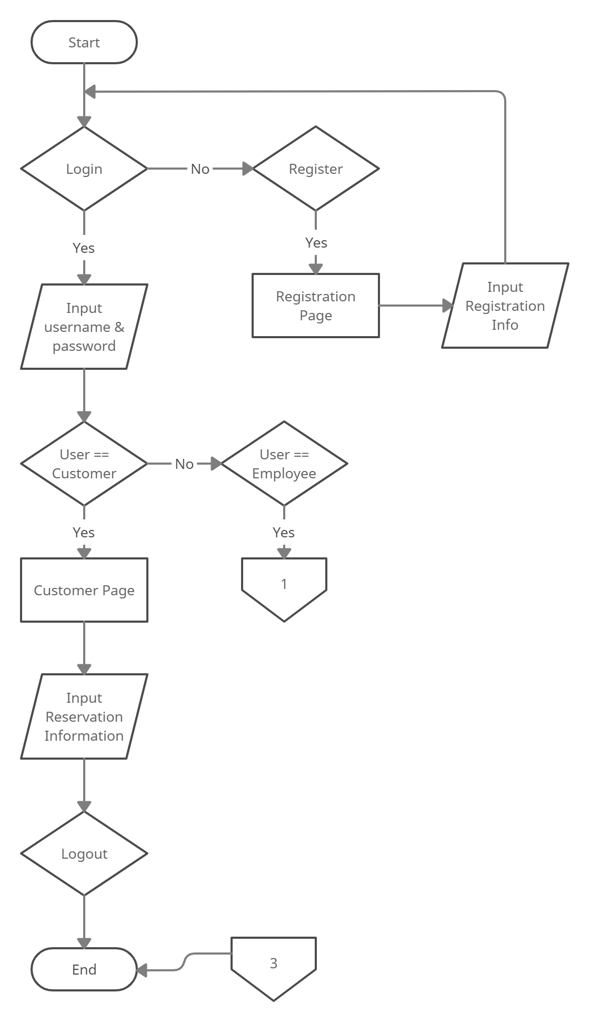

**Figure 8. Customer Flowchart**

Figure 8 is the customer flowchart, it shows the flow of how the customer will use the application, the users can either log in if they already have an account or they can register and if the user chooses to register, the user will go to the registration page and they will be asked to input registration information like username and password. After that, they can now log in and the user must input username and password if the user is equaled to the employee account the app will bring the user to the employee page, if the user is equaled to admin account user will go to the admin page but if the user is equaled to customer account the app will bring the user to the customer page, under this page user can make a reservation or schedule an appointment by providing reservation information.

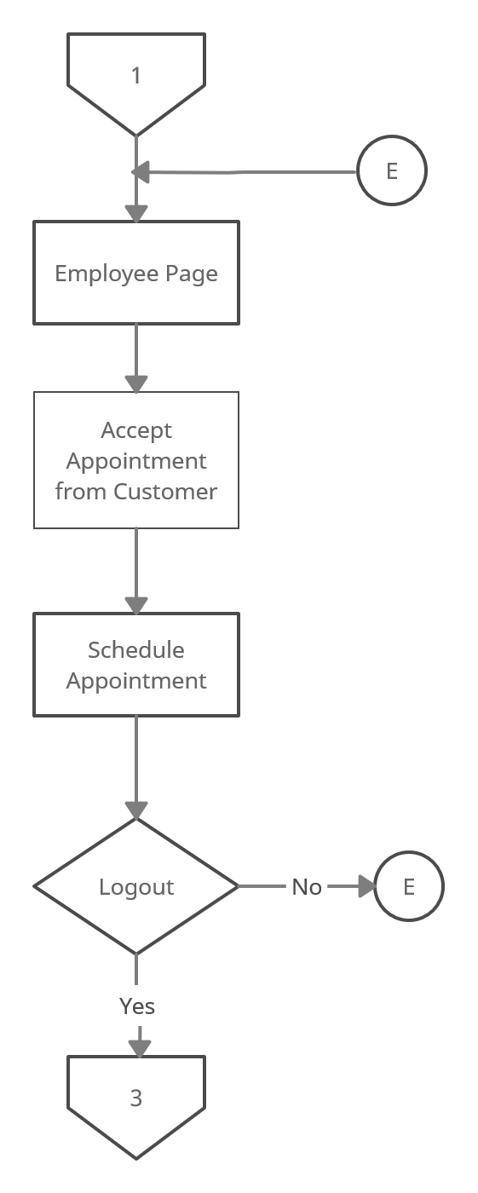

**Figure 9. Employee Flowchart**

Figure 9 is the employee flowchart, it shows the employee page where the employee can accept an appointment from a customer and the employee can add that appointment to his/her schedule.

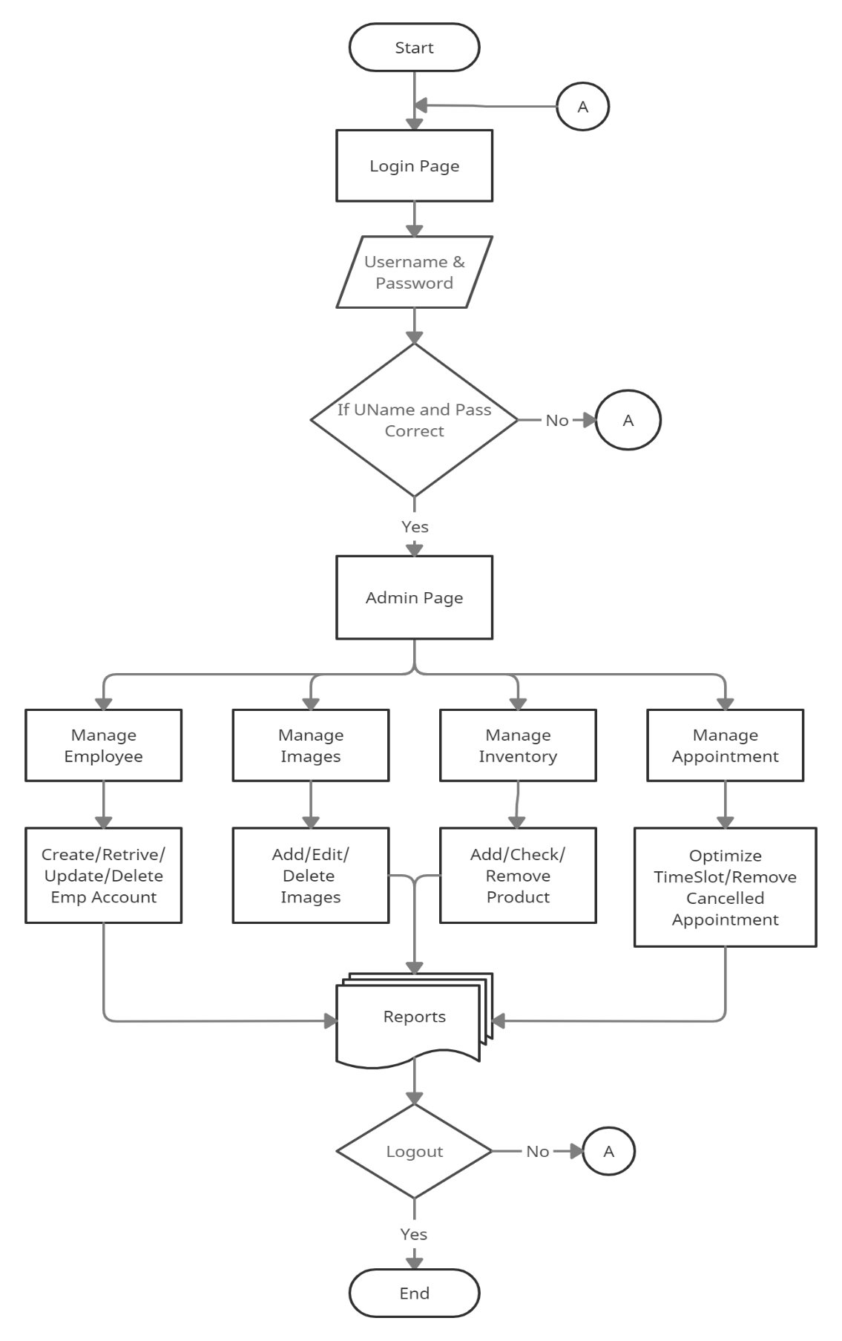

**Figure 10. Admin Flowchart**

Figure 10 is the admin flowchart that shows the flow of how the user as admin will use the application. Under the admin page, the admin can manage employee account, admin can create, retrieve, update or delete an employee account, admin can track data or information of the customer, admin also has the access to manage the inventory, admin can add product, check the quantity of product or remove a product using the app. Admin also has the access to manage the appointment and optimize the time slot of the salon and remove every canceled appointment so that the specific time slot will be available to other customers and admin can have access to all the necessary business reports generated by the app.

**Prototype Design of Service Appointment Scheduling Application for Trendz Hair Salon and Wellness Center**

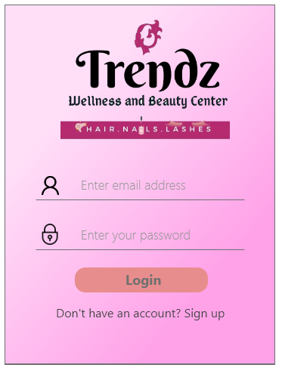

**Figure 11. Prototype Login Page of the App**

Figure 11 is the Login Page of the App where the Customer and Employee can input their email address/username and password to log in to their account.

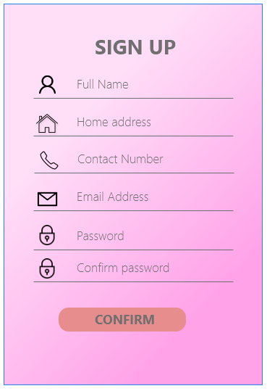

**Figure 12. Prototype Signup Page of the App**

This is the signup page of the app that will enable the salon’s customer to create an account by filling up the necessary information.



**Figure 13. Prototype Customer Homepage**

Customer Homepage is the page where the customer can access all the menus of the app.

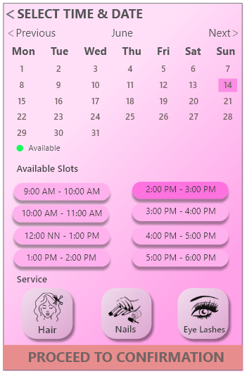

**Figure 14. Prototype Book Now Section**

Figure 14 is the Book Now section where the customer can choose their preferred date and time with the available slots and they could choose the services they want to avail themselves of.

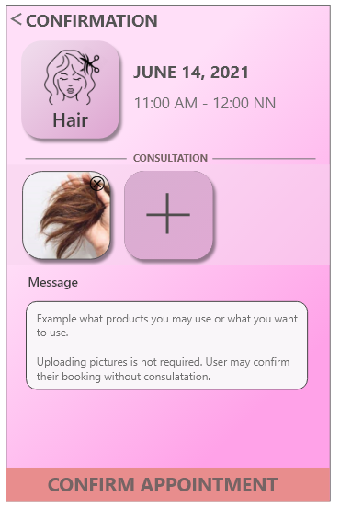

**Figure 15. Prototype Confirmation Section**

Figure 15 is the Confirmation Section where the customer should confirm the appointment for it to process.

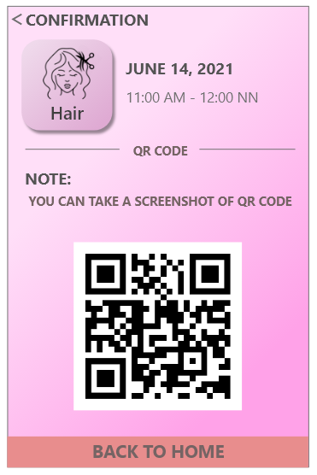

**Figure 16. Prototype Customer QR Code**

The customer QR Code in figure 16 is the QR code that the customer could use and present to the salon on the day of their appointment.

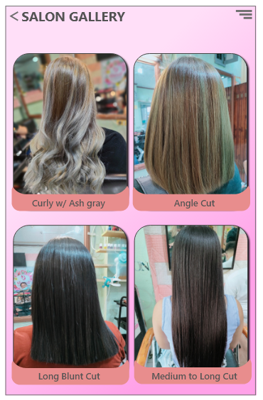

**Figure 17. Prototype Gallery Section**

Figure 17 is the Gallery Section, this section shows the gallery of the salon where the customer could see and have an idea about the services of the salon.



**Figure 18. Prototype Customer Dashboard**

Figure 18 is the Customer Dashboard that displays the necessary information/notification about the salon.

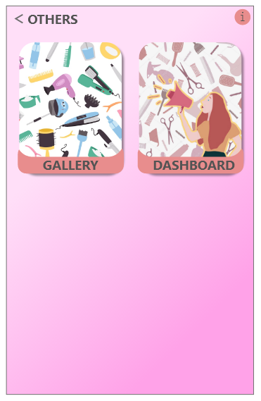

**Figure 19. Prototype Others Section**

Figure 19 is the Others Section where the customer could easily access other menus or pages like gallery and dashboard.

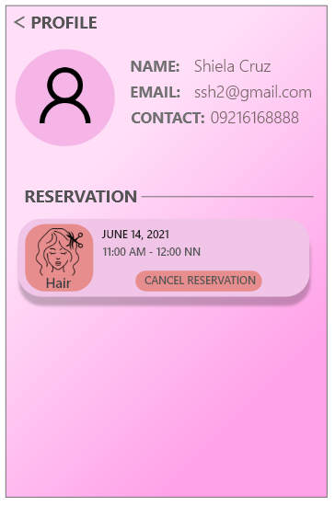

**Figure 20. Prototype Customer Profile Section**

Figure 20 is the Customer Profile Section that displays the profile and personal information of the customer, it also shows the reservation information of the customer.

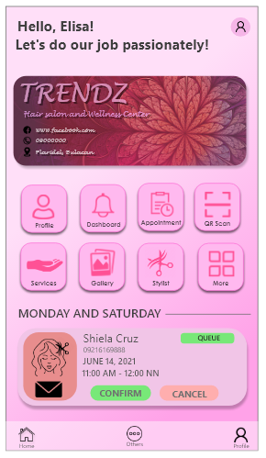

**Figure 21. Prototype Employee Homepage**

Figure 21 is the Employee Homepage on where the employee can access all the menus of the app.

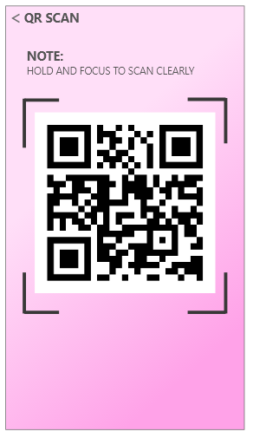

**Figure 22. Prototype Employee QR Code**

Figure 22 is the Employee QR Code that can be used by the employee of the salon to use as their identification.

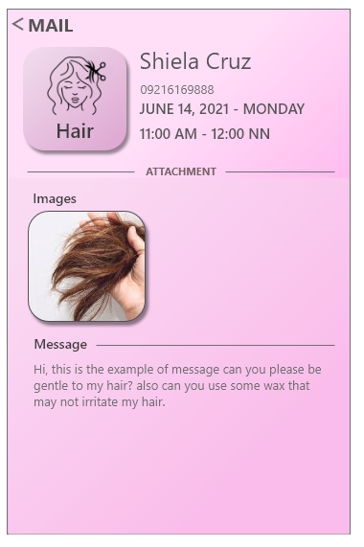

**Figure 23. Prototype Employee Mail Section**

Figure 23 is the Employee Mail Section where the employee could receive and read emails/messages from customers.

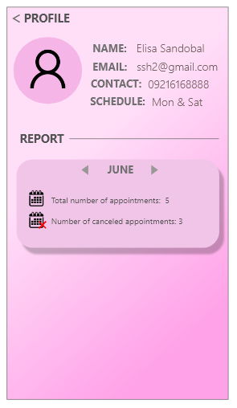

**Figure 24. Prototype Employee Profile Section**

Figure 24 is the Employee Profile Section that displays the profile and personal information of the employee, it also shows the report of the employee's appointment.

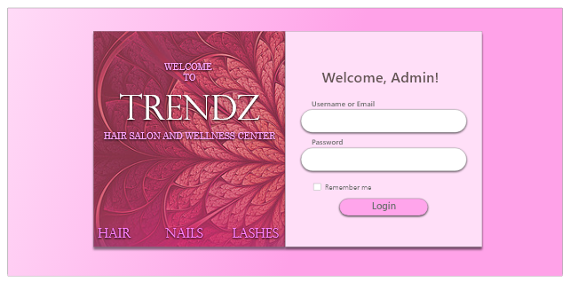

**Figure 25. Prototype Login Page of the Website**

Figure 25 is the Login Page of the Website where the admin must input the correct username and password to log in to their account.

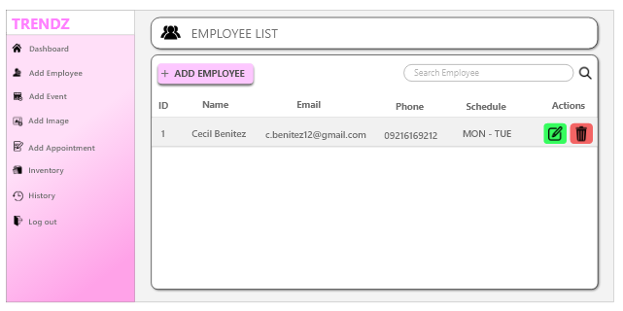

**Figure 26. Prototype Add Employee Page**

Figure 26 is the Add Employee Page where the Admin can add an employee account, or delete an employee account.

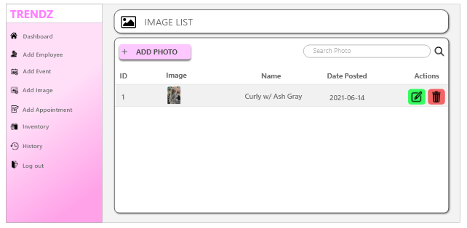

**Figure 27. Prototype Add Image Page**

Add Image Page is the page where the Admin can manage the images on the app, Admin can change, add, or remove an image.

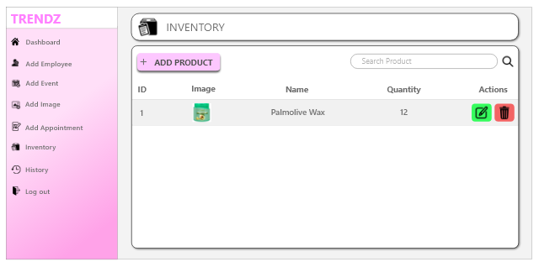

**Figure 28. Prototype Inventory Page**

This Inventory Page is the page where the Admin can manage the inventory of the salon, Admin can easily add products, edit the product or remove the product from the list.

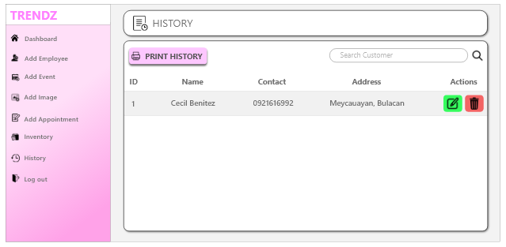

**Figure 29. Prototype History Page**

Figure 29 shows the History Page of the salon, Admin has the access to view all the appointments of the salon, and Admin can print it as a report.

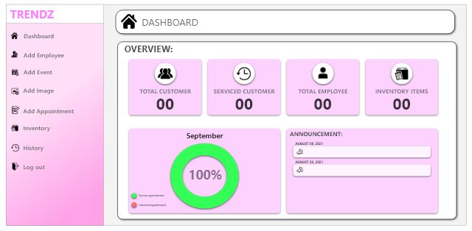

**Figure 30. Prototype Admin Dashboard**

Figure 30 is the Admin Dashboard, this is used for the Admin to have an overview of all the details of the salon.

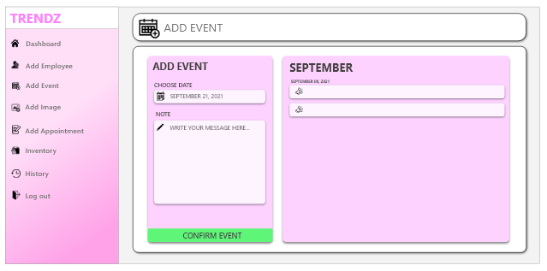

**Figure 31. Prototype Add Event Page**

On this page Admin can add an event, Admin can create an event or set a date on when the salon will offer special promos for the customer.

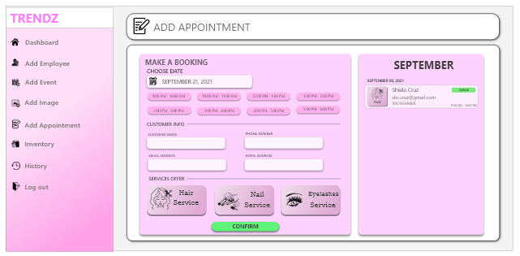

**Figure 32. Prototype Add Appointment Page**

Figure 32 is the Add Appointment Page where the Admin can add the appointment of the customer.

**BIBLIOGRAPHY**

1. **Books**

Mitev, Nathalie. (2000). Toward Social Construcivist Understandings of IS Success and Failure: Introducing a New Computerized Reservation System. *ICIS Proceedings. 9*. Retrieved from [*https://aisel.aisnet.org/cgi/viewcontent.cgi?article=1102&context=icis2000*](https://aisel.aisnet.org/cgi/viewcontent.cgi?article=1102&context=icis2000)

Musa, John D. (1975). A Theory of Software Reliability and its Application. *pp. 312-327, Vol. 1* Retrieved from [*https://scholar.google.com/scholar?hl=en&as_sdt=0%2C5&q=theory+of+software&btnG=#d=gs_qabs&u=%23p%3DNuN5oEyYrSoJ*](https://scholar.google.com/scholar?hl=en&as_sdt=0%2C5&q=theory+of+software&btnG=#d=gs_qabs&u=%23p%3DNuN5oEyYrSoJ)

Will A., Gossel B., & Windscheid J. (2020). Eyes on tech! Media entrepreneurship and the relevance of technology in business models. Retrieved from, [*https://books.google.com.ph/books?hl=en&lr=&id=bIDWDwAAQBAJ&oi=fnd&pg=PT166&dq=relevance+of+technology+in+business&ots=DXQuOe8gjg&sig=ViMlc-eUUwp9y1NwR1IL_bUDEzY&redir_esc=y#v=onepage&q=relevance%20of%20technology%20in%20business&f=false*](https://books.google.com.ph/books?hl=en&lr=&id=bIDWDwAAQBAJ&oi=fnd&pg=PT166&dq=relevance+of+technology+in+business&ots=DXQuOe8gjg&sig=ViMlc-eUUwp9y1NwR1IL_bUDEzY&redir_esc=y#v=onepage&q=relevance%20of%20technology%20in%20business&f=false)

1. **Journals**

Annie Chai & Chuah Chai Wen (2017). Shears Inc. Management System. *International Journal on Informatics Visualization 1 (4-2), 246-249, 2017*. Retrieved from, [*http://joiv.org/index.php/joiv/article/view/72*](http://joiv.org/index.php/joiv/article/view/72)

Butler, J.E. (1988). Theories of Technological Innovation as Useful Tools for Corporate Strategy. *Strategic Management Journal, vol. 9, no. 1, Wiley, 1988, pp. 15-29.* Retrieved from, [*https://www.jstor.org/stable/2485999?fbclid=IwAR1ZkEri5ThNrzlclkjhipYw1miEnuC9DPWyOVokaR_jHKWa0qRQUWuFAzU*](https://www.jstor.org/stable/2485999?fbclid=IwAR1ZkEri5ThNrzlclkjhipYw1miEnuC9DPWyOVokaR_jHKWa0qRQUWuFAzU)

Kadek Dharma Krisna Putra, Nyoman Piarsa2, Made Sukarsa (May 2020). Geographic Information System for Booking Beauty Salon and Barber Shop with an Android-Based ECRM Approach. *Scientific Journal of Informatics vol 7, no. 1 p-ISSN 2407-7658.* Retrieved from, [*https://pdfs.semanticscholar.org/8b37/2e0452d2521620bdb233202203884de04389.pdf*](https://pdfs.semanticscholar.org/8b37/2e0452d2521620bdb233202203884de04389.pdf)

1. **Published Master’s Theses/Undergraduate Theses and/or**

**Capstone Project**

Eva, Tamanna Sultana (December 31, 2020). Salon Care. *Id-171-35-1826 Daffodil International University.* Retrieved from [*http://dspace.daffodilvarsity.edu.bd:8080/handle/123456789/5682*](http://dspace.daffodilvarsity.edu.bd:8080/handle/123456789/5682)

Mithas S., Krishnan M.S. & Fornell C. (2005). Effect of Information Technology Investments on Customer Satisfaction: Theory and Evidence. *Ross School of Business Working Paper Series Working Paper No. 971*. Retrieved from [*https://deepblue.lib.umich.edu/bitstream/handle/2027.42/39170/971.pdf?sequence=1&isAllowed=yv*](https://deepblue.lib.umich.edu/bitstream/handle/2027.42/39170/971.pdf?sequence=1&isAllowed=yv)

1. **Unpublished Theses/Undergraduate Theses and/or**

**Capstone Project**

Moghavvemi S., Fatemeh Hakimian, Tengku Mohd Faziharudean Tenk Feissal (2012). Competitive advantages through IT innovation adoption by SMEs. Retrieved from, [*https://papers.ssrn.com/sol3/papers.cfm?abstract_id=2383134*](https://papers.ssrn.com/sol3/papers.cfm?abstract_id=2383134)

Mudasir Ijaz (2020). Digital Salon System. Retrieved from, [*http://dspace.cuilahore.edu.pk/xmlui/handle/123456789/1937*](http://dspace.cuilahore.edu.pk/xmlui/handle/123456789/1937)

1. **Publications**

Akshay V., Kumar A., Alagappan R.M., and Gnanavel S. (2019). Bookazor-an Online appointment Booking System. *International Conference on Vision Towards Emerging Trends in Communication and Networking (ViTECoN), 2019, pp. 1-6, doi: 10.1109/ViTECoN.2019.8899460. Published by IEEE.* Retrieved from, [*https://ieeexplore.ieee.org/abstract/document/8899460*](https://ieeexplore.ieee.org/abstract/document/8899460)

[Maryani](https://ieeexplore.ieee.org/author/37087011321), [Nindito H.](https://ieeexplore.ieee.org/author/37086121734) & [Alianto](https://ieeexplore.ieee.org/author/37087012575) H. (2019).  Prototype Development for Online Reservation System in Barbershop and Salon Industry. *Published by International Conference on Information Management and Technology (ICIMTech), 2019, pp. 58-61, doi: 10.1109/ICIMTech.2019.8843836.* Retrieved from [*https://ieeexplore.ieee.org/abstract/document/8843836/figures#figures*](https://ieeexplore.ieee.org/abstract/document/8843836/figures#figures)

1. **Electronic References**

# Barone, Adam (December 30, 2020). Digital Marketing Definitions & Examples. Retrieved from, [*https://www.investopedia.com/terms/d/digital-marketing.asp*](https://www.investopedia.com/terms/d/digital-marketing.asp)

# Barry, Brian (August 5, 2019). Top 6 Features to Look for In an Inventory Management System. Retrieved from *https://www.fcbco.com/blog/top-6-features-to-look-for-in-an-inventory-management-system*

Bookly. (n.d.). Main reasons to use online booking system in the hairdressing salon. Retrieved from [*https://www.booking-wp-plugin.com/main-reasons-use-online-booking-system-hairdressing-salon/*](https://www.booking-wp-plugin.com/main-reasons-use-online-booking-system-hairdressing-salon/)

Ching, Julia. (October 7, 2020). Online Booking: 8 Reasons Why We need to use in the Salon. Retrieved from [*https://salonist.io/blog/online-booking-system/*](https://salonist.io/blog/online-booking-system/)

Esposito, Emily (August 14, 2020). The best appointment scheduling and booking software. Retrieved from [*https://zapier.com/blog/best-appointment-scheduling-apps/*](https://zapier.com/blog/best-appointment-scheduling-apps/)

Gawlowski, Slawmir (2018). Benefits and advantages that salon software brings to owners. Retrieved from [*https://www.versum.com/m/blog/the-benefits-salon-software-brings-owners/*](https://www.versum.com/m/blog/the-benefits-salon-software-brings-owners/)

Jenkins, Abby (September 18, 2020). What is Inventory Management? Benefits, Types, & Techniques. Retrieved from [*https://www.netsuite.com/portal/resource/articles/inventory-management/inventory-management.shtml*](https://www.netsuite.com/portal/resource/articles/inventory-management/inventory-management.shtml)

Jobs, Sophie (2020). 10 Essential Benefits of Salon Booking Software | Salonist blog. Retrieved from [*https://salonist.io/blog/benefits-of-salon-booking-software/*](https://salonist.io/blog/benefits-of-salon-booking-software/)

Look Upgrade (December 10, 2018). The purpose of Beauty Salon in the Philippines. Retrieved from, [*https://lookupgrade.com/en/blog/english-the-purpose-of-beauty-salon-in-the-philippines/?fbclid=IwAR1kq_xXA7o2tmGFAKLS0xmEIzxUmnp6vHbHP4ectHFaxnat_vY91kbU2ZM*](https://lookupgrade.com/en/blog/english-the-purpose-of-beauty-salon-in-the-philippines/?fbclid=IwAR1kq_xXA7o2tmGFAKLS0xmEIzxUmnp6vHbHP4ectHFaxnat_vY91kbU2ZM)

Miosalon. (April 25, 2019). Surprising Benefits of Online Booking for Salons, when done right! Retrieved from [*https://www.miosalon.com/blog/surprising-benefits-of-online-booking-for-salons-when-done-right/*](https://www.miosalon.com/blog/surprising-benefits-of-online-booking-for-salons-when-done-right/)

# Paun, Goran (July 2, 2020).Building A Brand: Why A Strong Digital Presence Matters. Retrieved from, [*https://www.forbes.com/sites/forbesagencycouncil/2020/07/02/building-a-brand-why-a-strong-digital-presence-matters/?sh=6f567a3249f2*](https://www.forbes.com/sites/forbesagencycouncil/2020/07/02/building-a-brand-why-a-strong-digital-presence-matters/?sh=6f567a3249f2)

Small Business. (August 18, 2017). The Growing Impact of Online Reservation Systems. Retrieved from [*https://www.bookeo.com/news/2017/08/growing-impact-online-reservation-systems/*](https://www.bookeo.com/news/2017/08/growing-impact-online-reservation-systems/)

# Storm, Macy (April 13, 2020. The Benefits of Digital Marketing: 6 Advantages of Online Advertising. Retrieved from, [*https://www.webfx.com/blog/marketing/benefits-of-digital-marketing/*](https://www.webfx.com/blog/marketing/benefits-of-digital-marketing/)

# Thamrin, Dixie (June 03, 2020). Appointment scheduling solution: What you need to know. Retrieved from *https://www.qmatic.com/blog/appointment-scheduling-solution-what-how-and-why*

WP Amelia Staff (2020). What Is an Online Booking System? (Reservation System Definition) Retrieved from [*https://wpamelia.com/online-booking-system/?fbclid=IwAR36DoXPC2yqt6bHPaM-yfeG6Ng4dvlQoWWv1HNhDAxI79iDGFINIdBuoOg*](https://wpamelia.com/online-booking-system/?fbclid=IwAR36DoXPC2yqt6bHPaM-yfeG6Ng4dvlQoWWv1HNhDAxI79iDGFINIdBuoOg)

**APPENDICES**

**Appendix A**

**Evaluation Instrument**

Republic of the Philippines

**BULACAN STATE UNIVERSITY**

City of Malolos, Bulacan

A. Evaluator’s Profile

Name: (Optional)

Occupation:

B. Software Evaluation

Instruction:

The proponents are currently conducting a capstone project entitled “**Development of Service Appointment Scheduling Application for Trendz Hair Salon and Wellness Center**” in partial fulfillment of the requirements for the degree of Bachelor of Science in Information Technology.

In this regard, kindly evaluate the developed application by using the given scale below and placing a checkmark (√ ) under its corresponding numerical rating.

|  |  |  |
| --- | --- | --- |
| Scale | Range | Descriptive Interpretation |
| 5 | 4.60 – 5.00 | Strongly Agree |
| 4 | 3.60 – 4.59 | Agree |
| 3 | 2.60 – 3.59 | Moderately Agree |
| 2 | 1.60 – 2.59 | Disagree |
| 1 | 0 – 1. 59 | Strongly Disagree |

|  |  |  |  |  |  |
| --- | --- | --- | --- | --- | --- |
| **CHARACTERISTICS** | **Responses** | | | | |
| **5** | **4** | **3** | **2** | **1** |
| **Functional Suitability** |  |  |  |  |  |
| 1. *Functional Completeness.* The set of functions of the developed application covers all the specified tasks and user objectives. |  |  |  |  |  |
| 1. *Functional Correctness.* The functions of the developed application provide the correct results with the needed degree of precision. |  |  |  |  |  |
| 1. *Functional Appropriateness.* The functions of the developed application facilitate the accomplishment of specified tasks and objectives. |  |  |  |  |  |
| **Usability** |  |  |  |  |  |
| 1. *Appropriateness Recognizability.* Users can recognize whether the developed application is appropriate for their needs. |  |  |  |  |  |
| 1. *Learnability*. The developed application enables the user to learn how to use it with effectiveness, efficiency in emergency situations. |  |  |  |  |  |
| 1. *Operability*. The developed application is easy to operate, control and appropriate to use. |  |  |  |  |  |
| 1. *User error protection*. The developed application protects users against making errors. |  |  |  |  |  |
| 1. *User Interface Aesthetics.* The user interface of the developed application enables pleasing and satisfying interaction for the user. |  |  |  |  |  |
| 1. *Accessibility*. The developed application can be used by people with the widest range of characteristics and capabilities to achieve a specified goal in a specified context of use. |  |  |  |  |  |
| **Reliability** |  |  |  |  |  |
| 1. *Maturity*. The developed application meets needs for reliability under normal operation. |  |  |  |  |  |
| 1. *Availability*. The developed application is operational and accessible when required for use. |  |  |  |  |  |
| 1. *Fault Tolerance.* The developed application operates as intended despite the presence of hardware or software faults. |  |  |  |  |  |
| 1. *Recoverability*. In the event of an interruption or a failure, the developed application can recover the data directly affected and re-establish the desired state of the system. |  |  |  |  |  |
| **Security** |  |  |  |  |  |
| 1. *Confidentiality*. The developed application ensures that data are accessible only to those authorized to have access. |  |  |  |  |  |
| 1. *Integrity*. The developed application prevents unauthorized access to, or modification of, computer programs or data. |  |  |  |  |  |
| 1. *Non-reputation.* Actions or events can be proven to have taken place, so that the events or actions cannot be repudiated later. |  |  |  |  |  |
| 1. *Accountability*. The actions of an entity can be traced uniquely to the entity. |  |  |  |  |  |
| 1. *Authenticity*. The identity of a subject or resource can be proved to be the one claimed. |  |  |  |  |  |
| **Maintainability** |  |  |  |  |  |
| 1. *Modularity*. The developed application is composed of discrete components such that a change to one component has minimal impact on other components. |  |  |  |  |  |
| 1. *Reusability*. An asset can be used in more than one system, or in building other assets. |  |  |  |  |  |
| 1. *Analyzability*. It is possible to assess the impact on the developed application of an intended change to one or more of its parts, or to diagnose the developed application for deficiencies or causes of failures, or to identify parts to be modified. |  |  |  |  |  |
| 1. *Modifiability*. The developed application can be effectively and efficiently modified without introducing defects or degrading existing product quality. |  |  |  |  |  |
| 1. *Testability*. Test criteria can be established for the developed application and tests can be performed to determine whether those criteria have been met. |  |  |  |  |  |

Comments/Suggestions:

Thank you!

Sincerely,



*Capstone Project Team*

**Philip James L. Dalagan**

Project Team Leader

Team Members: **Mark Ponce F. Bascal, Darryl P. Hipolito, Ryan R. Pacifico, Deniel Ryan C. Sugay, and Rica Mae P. Valenzuela**

*(BSIT 4J-g1&g2)*

**Appendix B**

**Communication Letters**

**Request Letter for Panel**

Dear Sir/Madam,

Our group would like to request you to be one of the panel members of the capstone project entitled **“DEVELOPMENT OF SERVICE APPOINTMENT SCHEDULING APPLICATION FOR TRENDZ HAIR SALON AND WELLNESS CENTER”** of these students: **Mark Ponce F. Bascal, Philip James L. Dalagan, Darryl P. Hipolito, Ryan R. Pacifico, Deniel Ryan C. Sugay, and Rica Mae P. Valenzuela,** who are BSIT 3rd year students in our College.

Part of the Capstone project development is the commitment of the panel member to ensure that the students will develop a skill-based project conforming the appropriate standard of a capstone project to qualify for graduation at BulSU.

The Panel member’s commitment are:

1. validate the endorsement of the project paper adviser;
2. evaluate the deliverables;
3. recommend a verdict; and
4. consider the requests of the project paper adviser and/or the proponents.
5. sign necessary documents needed by the group like the Final Evaluation form and Approval Sheet which indicates the successful completion of the final project by the group. Your signature is a crucial endorsement that confirms that the project meets or exceeds the standards of excellence expected of BSIT students.

Your support in this academic endeavor is highly appreciated. Thank you and God bless!

*Yours Truly,*

**Philip James L. Dalagan**

Project Team Leader

Members: **Mark Ponce F. Bascal, Darryl P. Hipolito, Ryan R. Pacifico, Deniel Ryan C. Sugay, and Rica Mae P. Valenzuela**

BSIT 3JG1

*Noted by:*

**Eunice B. Custodio, Ph.D., DIT**

Capstone Project Coordinator

**Request Letter for Technical Adviser**

Dear Sir/Madam,

The undersigned would like to request you to be the technical adviser of the capstone project entitled **“Development of Service Appointment Scheduling Application for Trendz Hair Salon and Wellness Center”** of these students: **Mark Ponce F. Bascal, Philip James L. Dalagan, Darryl P. Hipolito, Ryan R. Pacifico, Deniel Ryan C. Sugay, and Rica Mae P. Valenzuela,** who are BSIT 3rd year students in our College.

Part of the Capstone project development is the commitment of the adviser to ensure that the students will develop a skill-based project conforming the appropriate standard of a capstone project to qualify for graduation at BulSU.

The Adviser’s commitments are:

1. have a high interest in the project;
2. guide the group in the research and development process by providing timely advices;
3. attend the group’s project presentations and provide feedbacks that will ensure success;
4. review and correct the project paper – its contents, grammar, and completeness, together with the group and prepare comments before its submission to the Research Methodology instructor/Capstone Project Coordinator;
5. allocate regular consultation hours to the group; and
6. promote the value of hard work, communication, and integrity throughout the development of the project by encouraging the group to work on their own research.
7. sign necessary documents needed by the group like the Endorsement Form for Pre and Final defense, as well as the Approval Sheet which indicates the successful completion of the final project by the group. Your signature is a crucial endorsement that confirms that the project meets or exceeds the standards of excellence expected of BSIT students.

Your support in this academic endeavor is highly appreciated. Thank you and God bless!



**Eunice B. Custodio,**  **Ph.D., DIT**

Capstone Project Coordinator



*Capstone Project Team*

**Philip James L. Dalagan**

Project Team Leader

Members: **Mark Ponce F. Bascal, Darryl P. Hipolito, Ryan R. Pacifico, Deniel Ryan C. Sugay, and Rica Mae P. Valenzuela**

BSIT 3JG1

I agree to the terms outlined above.

**JOHN MICHAEL CALIZON, MSIT**

Technical Adviser

**Request Letter for Trendz Hair Salon and Wellness Center**

To whom it may concern,

In partial fulfillment of our requirements for our subject Capstone and Research I, we 3rd year students of BSIT 3J in Bulacan State University would like to ask for permission to conduct a research study entitled “Development of Service Appointment Scheduling Application for Beauty Salon”.

In connection with this, we would like to ask your permission to allow us to use the salon’s business name, owner’s name, products and services name etc. in our research study. Rest assured that the data we will gather will remain confidential and to be used in academic purpose only.

Your kind consideration for our request will be a great help to finish the requirement as compliance for our subject. Your approval to use the said information will be greatly appreciated.

Sincerely,



*Capstone Project Team*

**Philip James L. Dalagan**

Project Team Leader

Team Members: **Mark Ponce F. Bascal, Darryl P. Hipolito, Ryan R. Pacifico, Deniel Ryan C. Sugay, and Rica Mae P. Valenzuela**

*(BSIT 3J-g1&g2)*

**Request Letter for the Evaluators**

Bulacan State University  
College of Information and Communications Technology  
City of Malolos, Bulacan

Dear Sir/Ma’am:

The undersigned are presently developing a capstone project entitled **“DEVELOPMENT OF SERVICE APPOINTMENT SCHEDULING APPLICATION FOR TRENDZ HAIR SALON AND WELLNESS CENTER”**, which is in partial fulfillment of the requirements for the degree Bachelor of Science in Information Technology, major in Web and Mobile Development.

The team is already done with the development phase and is presently working with the testing and evaluation of the developed application.

In this regard, we would like to ask your assistance in this endeavor, by evaluating our developed capstone project. Attached herewith is the executive summary of the project development (project objectives, scope and delimitations, software/hardware specifications etc.) The Google survey forms intended for your responses after using and evaluating the developed project will be sent to your email.

Hoping for your most kind support for the completion of this capstone project. Thank you and God bless!

Sincerely,



*Capstone Project Team*

**Philip James L. Dalagan**

Project Team Leader

Team Members: **Mark Ponce F. Bascal, Darryl P. Hipolito, Ryan R. Pacifico, Deniel Ryan C. Sugay, and Rica Mae P. Valenzuela**

*(BSIT 4J-g1&g2)*

**Eunice B. Custodio, PhD, DIT**

Capstone Project Coordinator

**Appendix C**

**Curriculum Vitae**



**Valenzuela, Rica Mae P.**

Purok4 Blk08 Lot20 Lalangan, Plaridel, Bulacan

[valenzuela.ricamae.p.1958@gmail.com](mailto:valenzuela.ricamae.p.1958@gmail.com)

CAREER OBJECTIVE: Currently taking Information and Communication Technology seeking for a task or job that is related to my field to help me gain more knowledge and develop my skills. I want to have an experience in a work field and improve my well-being.

CORE QUALIFICATIONS

* Willing to learn new things and willing to listen with others opinion.
* Hardworking and dedicated in doing things.
* Trustworthy in the assigned tasks.

EDUCATIONAL ATTAINMENT

Tertiary: Bulacan State University (2018-present)

Senior High: Next Generation Technological College (2016-2018)

Junior High: Dr. Felipe de Jesus National High School (2012-2016)

Primary: Lalangan Elementary School (2006-2012)

PERSONAL INFFORMATION

Gender: Female

Birthday: October 15,2000

Age: 20

Civil Status: Single

Nationality: Filipino

Religion: Roman Catholic

**Darryl P. Hipolito**

Flotante St, Panginay, Balagtas, Bulacan

[Darrylhipolito@gmail.com](mailto:Darrylhipolito@gmail.com%20%20%20%20%20%20%20%20%20%20%20%20%20%20%20%20%20%20%20%20%20%20%20%20%20%20%20%20%20%20%20%20%20%20%20%20%20%20%20%20%20%20%20%20%20%20%20%20%20%20%20%20%20%20%20%20)

Career Objective: Currently taking BS Information Technology seeking for a task or job that can help me gain experience and knowledge in the field, and to have a wide knowledge about IT fields especially in Programming.

Educational Attainment:

**Tertiary**:   
Bulacan State University (2018-present)  
Senior Immaculate conception institution [Grade 11- 12] (2016-2018)  
Junior Romeo Acuna Santos Memorial High School [Grade 9-10] (2014-2016)  
Dr. Yanga’s Colleges inc. [Grade 7- 8] (2012-2014)  
**Primary**: Sulok Elementary School [Grade 1-6] (2006-2012)   
**Skills:**

* Excellent interpersonal abilities
* Computer Literate

**Personal Information:**  
Gender: Male  
Birthday: August 27, 1999  
Age: 21  
Civil Status: Single  
Religion: Roman: Iglesia ni cristo  
Nationality: Filipino  
Father: Romeo D.O. Hipolito  
Mother: Daisy P. Hipolito

**Character Reference:**

Mrs. Annabelle Uy  
SHS OIC  
Immaculate Conception Institute  
0906 576 3805  
  
  
I hereby certify that the information stated above is true and correct.

________________________

Darryl Pavia Hipolito

**Ryan R. Pacifico**

San Marcos Calumpit, Bulacan

[pacifico.ryan.r.1114@gmail.com](mailto:pacifico.ryan.r.1114@gmail.com%20%20%20%20%20%20%20%20%20%20%20%20%20%20%20%20%20%20%20%20%20%20%20%20%20%20%20%20%20%20%20%20%20%20%20%20%20%20%20%20%20%20%20%20%20%20%20%20%20%20%20%20%20%20%20%20)

Career Objective: I am seeking opportunities to join a company that can help me in enhancing my skills, strengthening my knowledge, and realizing my potential. I am willing to explore a wide variety of opportunities that can help me gain perspective.

Educational Attainment:

**Tertiary**:   
Bulacan State University (2018-present)  
La Consolacion University Philippines [Grade 11- 12] (2016-2018)  
Calumipt National High School [Grade 7-10] (2012-2016)  
  
**Primary**: San Marcos Elementary School [Grade 1-6] (2006-2012)

**Skills:**

* Resourceful
* Computer Literate
* Creative
* Analytical Abilities

**Personal Information:**  
Gender: Male  
Birthday: July 25, 2000  
Age: 20  
Civil Status: Single  
Religion: Roman: Catholic  
Nationality: Filipino  
Father: Rosalito N. Pacifico  
Mother: Jacqueline R. Pacifico

I hereby certify that the information stated above is true and correct.

________________________

Ryan Regalado Pacifico

**Mark Ponce F. Bascal**

Purok 4, Tabang, Guiguinto, Bulacan

[bascal.markponce.f.1015@gmail.com](mailto:bascal.markponce.f.1015@gmail.com)

**Objectives :**

To pursue a career that would allow me to explore and enhance myself socially, mentally, and spiritually.  
To be given a chance to work and harmonious camaraderie with others through role that the company would entrust me with an end view upholding with the company vision of success.

**Personal Data**

Date of Birth : September 08, 2000  
Gender : Male  
Age : 17 y/o  
Religion : Roman Catholic  
Father’s name : Ponciano N. BascalM  
other’s name: Maricel C. Francisco  
**Skills:**Hard-workingCan easily adopt the environmentPassionate **Educational Backgrounds**

Bulacan State University (2018 – Present)

**Senior High School**Calumpit National High School (2016 – 2018)

**Junior High School**Calumpit National High School (2016 – 2017)   
Guiguinto National Vocational High School (2012 – 2016)

**Primary**Tabang Elementary School (2006 – 2012)

**I hereby that information above is true and correct to the best of my knowledge and capabilities**

**___________________**

**Mark Ponce F. Bascal**

**Dalagan, Philip James L.**

Santol, Balagtas, Bulacan

[philipjamesdalagan03@gmail.com](mailto:philipjamesdalagan03@gmail.com%20%20%20%20%20%20%20%20%20%20%20%20%20%20%20%20%20%20%20%20%20%20%20%20%20%20%20%20%20%20%20%20%20%20%20%20%20%20%20%20%20%20%20%20%20%20%20%20%20%20%20%20%20%20%20%20)

Career Objective: I'm looking for a task or work that will allow me to develop skills and knowledge in the area. Also, helping my self to expand my knowledge in the world of technology.

Educational Attainment:

**Tertiary**:   
Bulacan State University (2018-present)  
Dr. Yanga’s Colleges Inc. [Grade 11- 12] (2016-2018)  
Christian Academy of Pandi [Grade 7-10] (2012-2016)  
**Primary**: Tugatog Elementary School [Grade 1-6] (2006-2012)   
**Skills:**

* Excellent interpersonal abilities
* Computer Literate

**Personal Information:**  
Gender: Male  
Birthday: May 03, 2000  
Age: 21  
Civil Status: Single  
Religion: Roman: Catholic  
Nationality: Filipino  
Father: Jojo G. Dalagan  
Mother: Hedeliza L. Dalagan

**Character Reference:**  
Earl John Dalagan  
Tech Support 09430963455

I hereby certify that the information stated above is true and correct.

________________________

Dalagan, Philip James Libiran

**Sugay, Deniel Ryan C,**

Pritil, Guiguinto, Bulacan

[denielryan0@gmail.com](mailto:denielryan0@gmail.com%20%20%20%20%20%20%20%20%20%20%20%20%20%20%20%20%20%20%20%20%20%20%20%20%20%20%20%20%20%20%20%20%20%20%20%20%20%20%20%20%20%20%20%20%20%20%20%20%20%20%20%20%20%20%20%20)

To secure a challenging position in a reputable organization to expand my learnings, knowledge, and skills.

Educational Attainment:

**Tertiary**:   
Bulacan State University (2018-present)  
Guiguinto National Vocational High School [Grade 7-12] (2012-2018)  
**Primary**: Pritil Elementary School [Grade 1-6] (2006-2012)

**Personal Information:**  
Gender: Male  
Birthday: May 07, 2000  
Age: 21  
Civil Status: Single  
Religion: Roman: Catholic  
Nationality: Filipino  
Father: Arlan V. Sugay  
Mother: Editha C. Sugay

**Character Reference:**  
Enrique Rigor P. Flores Jr.  
  
  
   
  
  
  
I hereby certify that the information stated above is true and correct.

________________________

Sugay, Deniel Ryan Capulong

CERTIFICATE OF ANTI-PLAGIARISM

This is to certify that the document detailed below has been evaluated by plagiarism similarity checking software. The content was found plagiarism free which is below the permissible limit.

|  |  |  |  |
| --- | --- | --- | --- |
| Document Type: | **Capstone Project** | | |
| Document Title: | **“DEVELOPMENT OF SERVICE APPOINTMENT**  **SCHEDULING APPLICATION FOR TRENDZ HAIR SALON**  **AND WELLNESS CENTER"** | | |
| Author: | **MARK PONCE F. BASCAL**  **PHILIP JAMES L. DALAGAN**  **JAMES BRYAN D. ESCARLAN**  **DARRYL P. HIPOLITO**  **RYAN R. PACIFICO**  **RICA MAE P. VALENZUELA** | | |
| Plagiarism Quantity: | | | 4% Duplicate |
| Date: | | | Sunday, July 04, 2021 |
| Statistics: | | | 279 words Plagiarized / 6644 Words |
| Sources | | | More than 34 Sources Identified |
| Remarks | | | Low Plagiarism Detected - Your Document needs Optional Improvement. |

*Scanned by:*



**iFairtrade Consumer Trading**

Philippines 3000

Visit us in our fb page: https://www.facebook.com/ifairtrade

Email us at:

ifairtradeconsumer@gmail.com

