Assessment Title | Assessment 1 - Gather Operating System Information

Competency Details
Unit code/s and title/s | ICTNWK428 Create scripts for networking
Qualification code/s and title/s | ICT30524 Certificate III in Telecommunications Technology  ICT40120 Certificate IV in Information Technology  ICT41219 Certificate IV in Telecommunications Engineering Technology
Business unit/Work group | Culinary, Business and Arts / IT Studies

Instructions
Method/s of assessment | Product – Script creation  Questioning (Oral) – Confirm Requirements  Observation (Presentation) – Video of explanation of code
Overview of assessment | This is a practical task and will require you to code, test and document in the PowerShell language.  You will also have a meeting with your IT Team Leader to confirm requirements of tasks to be done.  The following pages will define the specific tasks you need to complete.
Task/s to be assessed | This assessment is where you will identify ways in which operating system’s information can be collated and display by running a PowerShell script.  You will be required to complete the following:  - Confirm requirements with your lecturer.  - Implement an abbreviated Software Development Lifecyle (SDLC) by addressing: Planning, Design, Development, Testing, Deployment and Maintenance for script development.  - Create a script based on client requirements using PowerShell.
Time allowed | The submission dates for each assessment are provided in the Study Schedule in the Home section in Learn
Location of assessment | Assessment can be completed anywhere with access to the resources required. (see Resources Required section below)
Decision making rules | To receive a satisfactory outcome for this assessment you must complete all parts correctly.
Assessment conditions | This assessment must be undertaken where the conditions replicate noise levels and interruptions that people typically experience working in the ICT industry.  This is an unsupervised assessment and you may access any required resources.  This is not group work and must be completed as an individual.
Resources required | You will need the following:  - Access to Learn with Internet access  - Learn resources  - Browser e.g. Edge, Chrome, Firefox  - VMWare for running virtual machines  - Virtual Machines for Microsoft Server 2022 and Microsoft Windows 2011.  (Downloaded from the IT Studies NAS)  - Word processing software such as Microsoft Word.  - ITWorks_PowerShell_Coding_Standards  - ITWorks_Best_Practices_For_Version_Control  You can complete this assignment on their own computers or laptops if they are able to run virtual machines by enabling virtualization in their own computer or laptops.
Result notification and reassessment information | You will be provided feedback and the result for your assignment on TAFESA Learn. You will be and given the chance to resubmit with required corrections only once.  Refer to the TAFE SA Assessment Policy for more information
Unit and Assessment Outline | The Unit and Assessment Outline will provide detailed information relating to:  - Recognition of Prior Learning  - Special Consideration  - Reasonable Adjustments  - Academic misconduct (plagiarism or cheating)

Background

You have been employed by the ITWorks organisation as a junior script programmer. Your job is to develop a script in PowerShell that ITWorks can use for clients to obtain Operating System information to help when fixing issues or wanting additional information about a client’s computer and/or Operating System.

Assessment part 1

Your manager at ITWorks has provided a structured outline for a script that will gather information from clients’ computers, in accordance with the ITWorks_PowerShell_Coding_Standards. You are required to follow this outline precisely to ensure the script meets company expectations.
To ensure proper progress and adherence to standards, you must complete all phases of the script development lifecycle - Planning & Requirement, Design & Development, Testing, Deployment & Maintenance.

Planning & Requirement Phase

Describe what your script is intended to do and clearly outline the steps it will follow to meet the specified requirements in a short paragraph (max 250 words) - Use dot points where possible.
The PowerShell script is designed to serve as a diagnostic tool for ITWorks, enabling support staff to quickly gather critical operating system and Hardware information from client machines. By automating the retrieval of this data, the script will streamline troubleshooting processes and system context.
First Step
Intialise an Interactive Menu: Launch a continuous loop that displays a console menu for user.
Second Step
Handle User Input : Validate the user input.
Third Step
Execute Modular Functions: Map each menu selection to a dedicated PowerShell function that performs a single task and return the result.
Forth Step
Process “Get All” Requests: If the user select this option, it will invoke a function that aggregates the data from all individual functions and outputs it in a formatted list.
Fifth Step
Implementing Error Handling: Utilize TRY and CATCH block within every function to ensure a stable execution.
Sixth Step
Terminate: Keep the menu active until user explicitly selects quit the application.

Design Phase

2.1 Design

Create pseudocode of your script to illustrates each step of the script’s execution and include it in Word document and name it OSInfo_documention_yourname.docx for submission. Please see below for an example.
2.2 Design Meeting

Upon finishing the Planning & Requirement Phase and the Design Phase, must organise a meeting with your manager (to be played by your lecturer) t show your manager how you plan to create your script but also to show them your pseudocode and the steps your script will follow to complete the required tasks.
During this meeting ensure you address the following:
- Ensure clear communications with questioning and listening techniques
  - prepare at least 1 open question that relates to the scenario before the meeting.
- Seek feedback of you work from your manager.
- Respond to any question your manager may ask

Example of pseudocode for a basic program that calculates a user’s age based on the year they were born:
START
PROMPT user for birth year
READ birthYear
GET currentYear
CALCULATE age = currentYear - birthYear
DISPLAY "Your age is " + age
END

2.3 Development

Following your recent meeting with your manager at ITWorks, you are required to develop a script that meets the following specifications:

- The script needs to be created in a Microsoft Windows environment (use the Microsoft Server 2022 Virtual Machine), therefore needs to be created using the native scripting language PowerShell.
- The script must display the information it gathers from client computers by presenting a menu on the screen for the user to select from.

Your script must gather the following information from clients’ computer:

      - Operating system currently been used.
      - Windows remote service status.
      - Computer manufacturer and Model.
      - Computer name.
      - Computer domain name.
      - Computer’s trusted hosts.
      - Operating system architecture (32 bit or 64 bit)
      - Get all the above information
      - Quit

- You need to create an algorithm (use a WHILE or FOR loop) to allow a user to select from a menu. The script should include the ability to quit the menu by selecting a ‘9’. If a ‘9’ is not selected, the script must keep on waiting for a selection from the user.

Ensure that if the user selects a character or value that is not within the menu selection range, then the script should prompt the user to input a correct menu selection within the allowable range, i.e 1-9.

- Each selection made should call upon a PowerShell function and the called function should only do 1 task and return the result of that task.
- If a user selects ‘Get all the above information’, the code should call another function that gathers all the information listed and displays it in a list format.
- All functions should use a TRY and CATCH block to ensure correct error handling.
- All script code must include comments that explain its functionality.
- You must use Git and Github to keep version control of code and add your Github repository link to the OSInfo_documention_yourname.docx file you will be submitting. Make sure you lecturer has read access to your repository.

Follow the ITWorks_Best_Practices_For_Version_Control procedure to implement and use Git and Github.

- Put the final version of your code in a PowerShell file and name it: os_information_yourname.ps1
git hub link
SrKoffe/001227297_Powershell: OS_Information
- 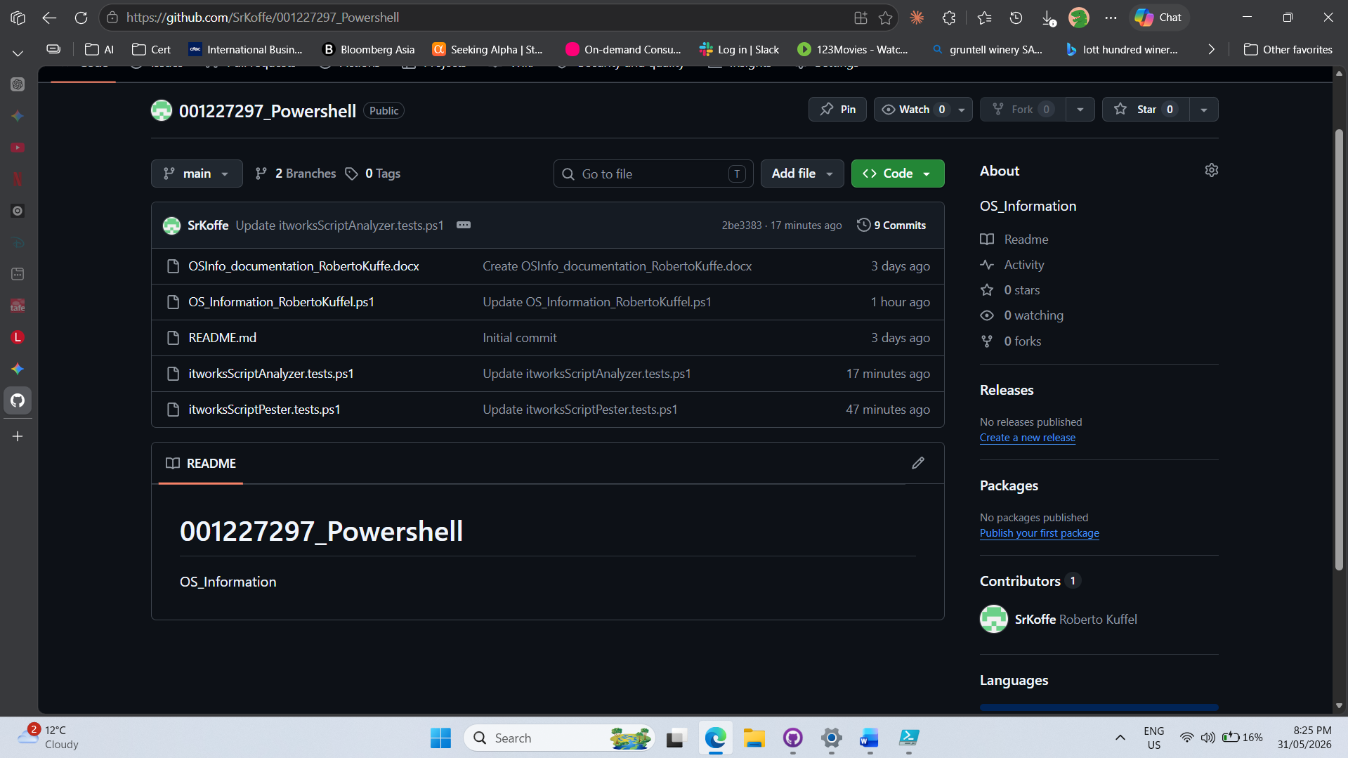
SUDOCODE
START

BEGIN
INITIALIZE userChoice = 0
END BEGIN

PROCESS
WHILE userChoice is NOT equal to 9 DO
DISPLAY "--- ITWorks OS Information Gatherer ---"
DISPLAY "1. Get Operating System"
DISPLAY "2. Get Windows Remote Service Status"
DISPLAY "3. Get Computer Manufacturer and Model"
DISPLAY "4. Get Computer Name"
DISPLAY "5. Get Computer Domain Name"
DISPLAY "6. Get Trusted Hosts"
DISPLAY "7. Get Operating System Architecture"
DISPLAY "8. Get all the above information"
DISPLAY "9. Quit"

PROMPT user to "Enter a selection (1-9):"
READ userChoice

IF userChoice is between 1 and 9 THEN
TRY
SWITCH userChoice
CASE 1:
CALL function Get-OSVersion
CASE 2:
CALL function Get-RemoteServiceStatus
CASE 3:
CALL function Get-PCModel
CASE 4:
CALL function Get-PCName
CASE 5:
CALL function Get-DomainName
CASE 6:
CALL function Get-TrustedHosts
CASE 7:
CALL function Get-OSArch
CASE 8:
CALL function Get-AllInfo
CASE 9:
DISPLAY "Exiting script..."
END SWITCH
CATCH
DISPLAY "An error occurred while attempting to retrieve the information. Please check system permissions."
END TRY
ELSE
DISPLAY "Invalid input. Please enter a correct menu selection between 1 and 9."
END IF

END WHILE
END PROCESS

END
Script Testing Phase

You must run various test of your code’s functionality and input, more specifically, you must run tests on values that are not within the scope of expected user input. This should be done for every function you create within your script.

An example of test cases for the function getTrustedHost are below:

# Define the function for context
function Get-TrustedHosts {
param([string]$Hosts)

if ([string]::IsNullOrWhiteSpace($Hosts)) {
return $null
}
return $Hosts -split ','
}

# Test Scenarios
Describe "Get-TrustedHosts Null Value Tests" {
Context "When input is null" {
It "Should return null" {
$result = Get-TrustedHosts -Hosts $null
$result | Should -Be $null
}
}

Context "When input is empty string" {
It "Should return null" {
$result = Get-TrustedHosts -Hosts ""
$result | Should -Be $null
}
}

Context "When input is whitespace" {
It "Should return null" {
$result = Get-TrustedHosts -Hosts " "
$result | Should -Be $null
}
}

Context "When input has valid hosts" {
It "Should return array of hosts" {
$result = Get-TrustedHosts -Hosts "host1,host2"
$result | Should -Contain "host1"
$result | Should -Contain "host2"
}
}
}

You need to record a video in Yuja of running the following testing modules and upload the link to Learn:
I had an issue with my yuja that I cant upload the video on web environment, or even the video isn’t save at my pc. So I took a screenshot of both results. The videos still uploading endlessly
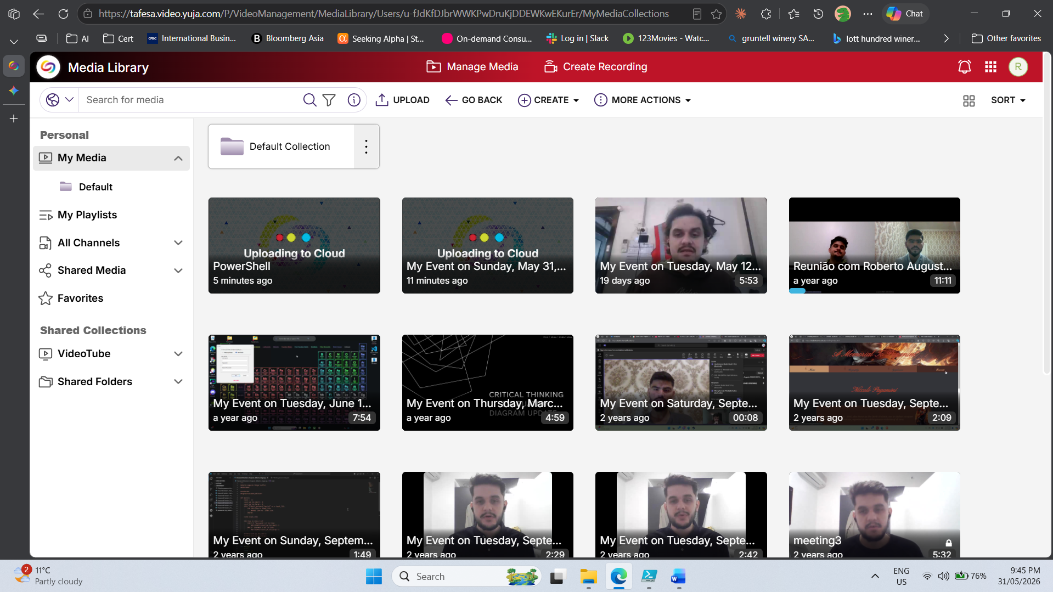
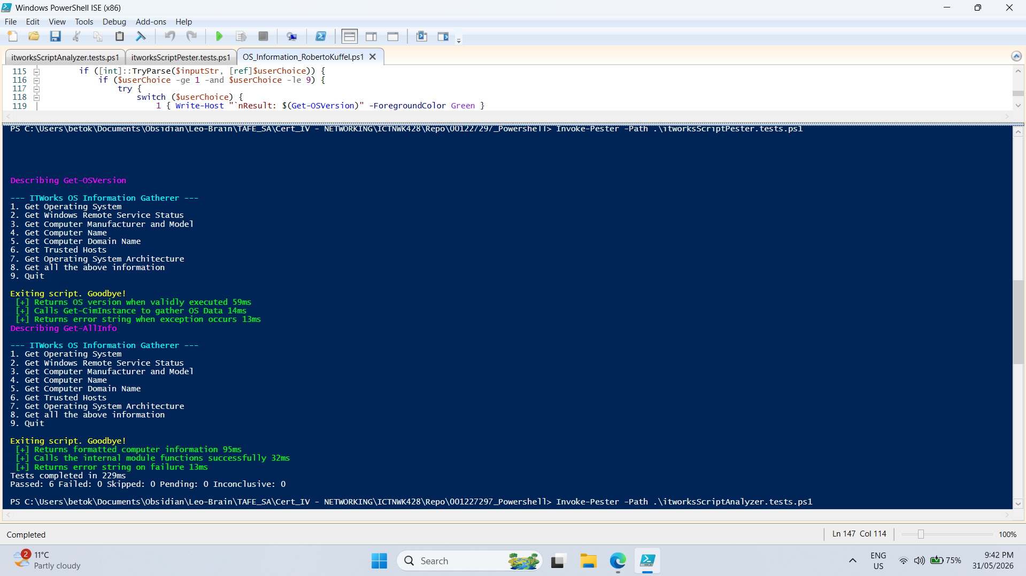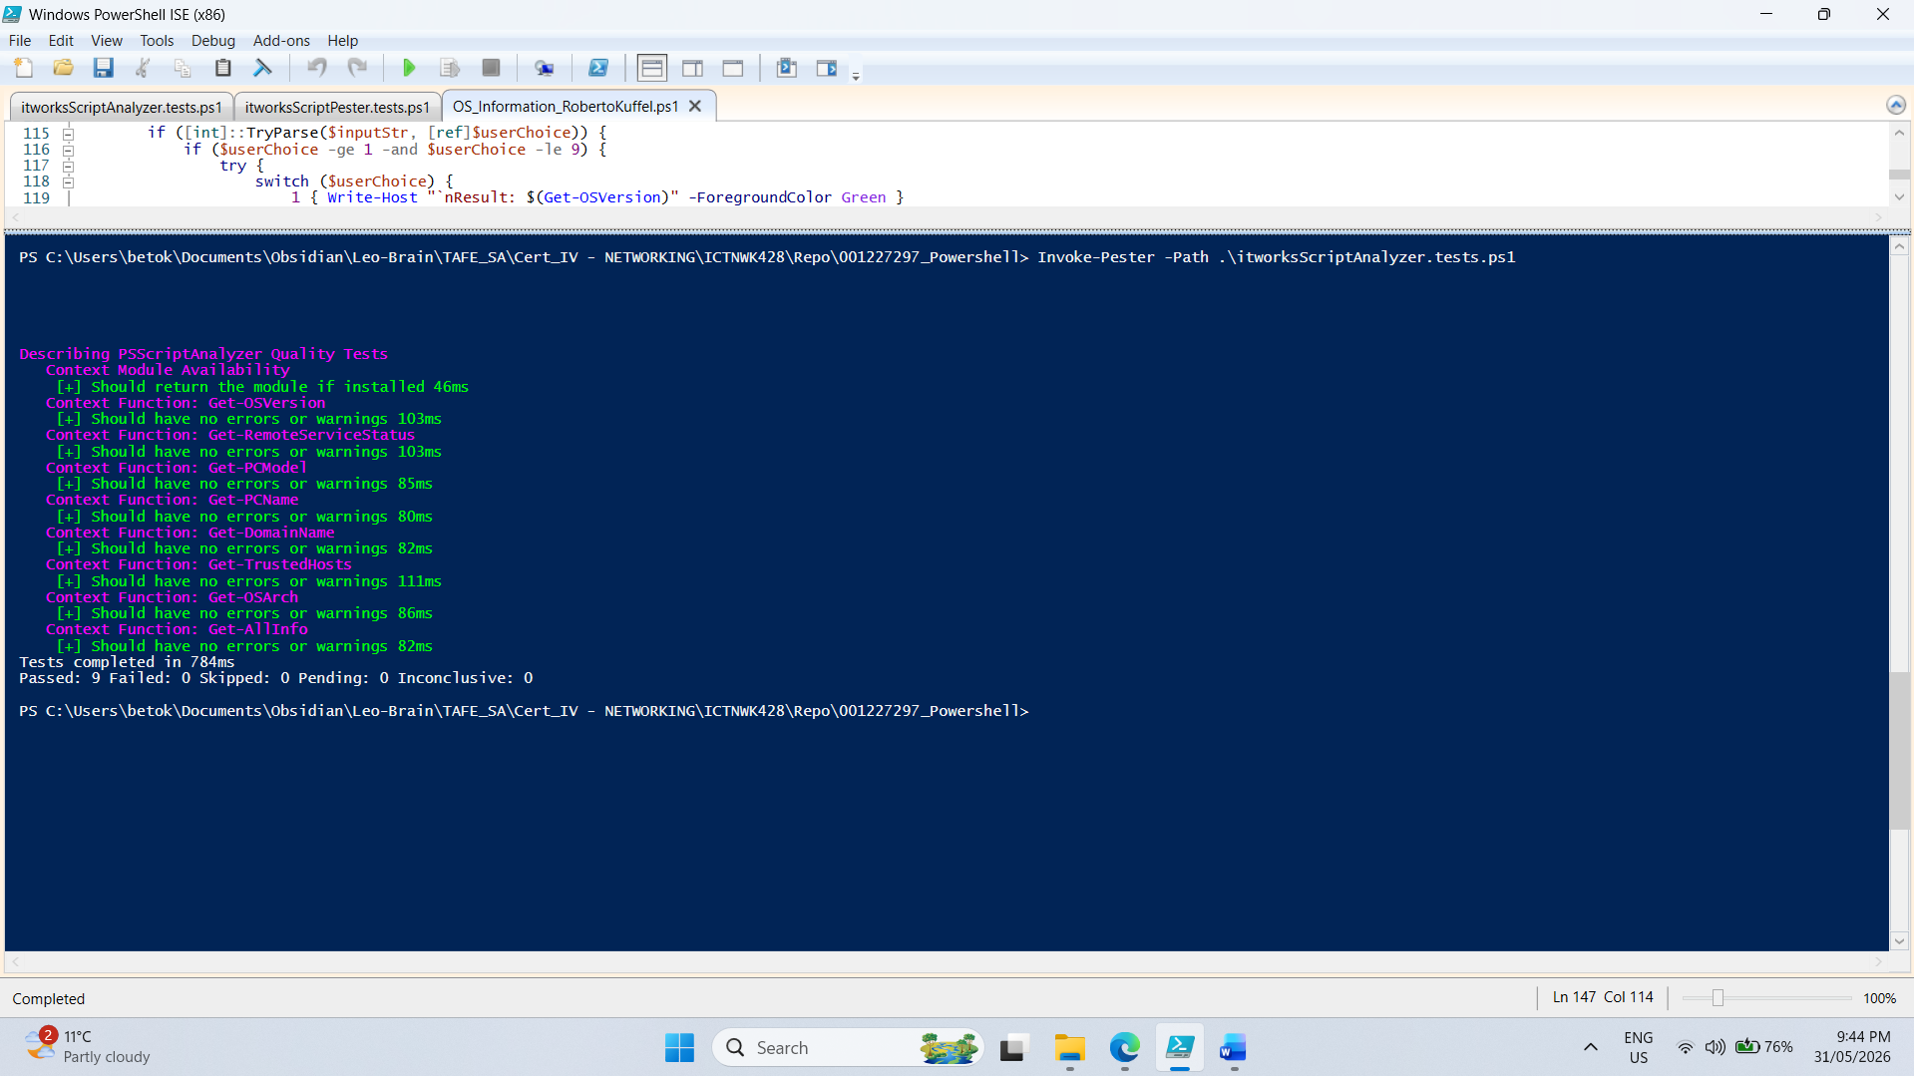

- PSScriptAnalyzer by importing and implementing the module itworksScriptAnalyzer.tests.ps1
- Pester by importing and implementing the module itworksScriptPester.tests.ps1

Deployment & Maintenance Phase

4.1 Deployment

You must be able to run your script in at least one of the following methods and provide a screenshot of the output:

- Using the Microsoft Windows Command-line
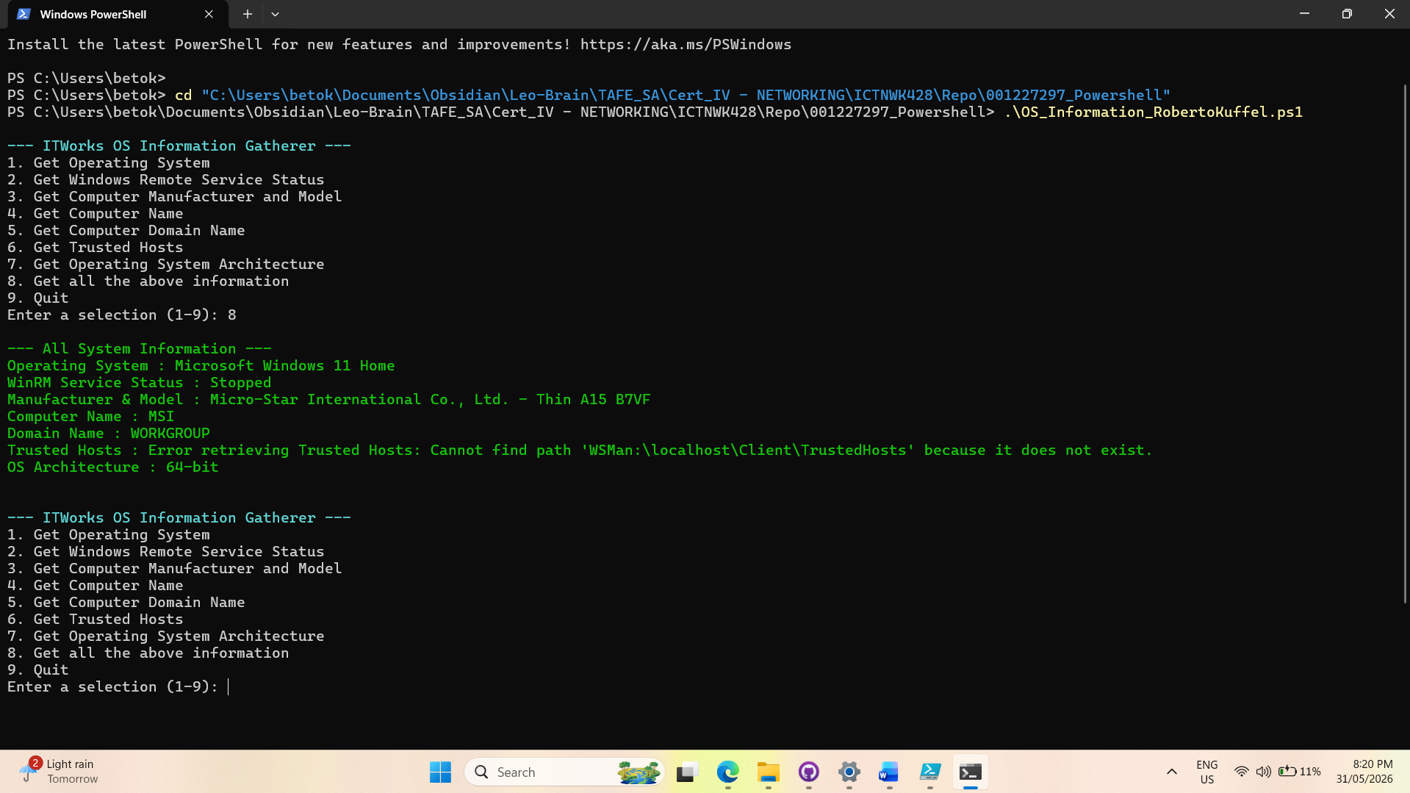
- Using the Microsoft Windows PowerShell ISE
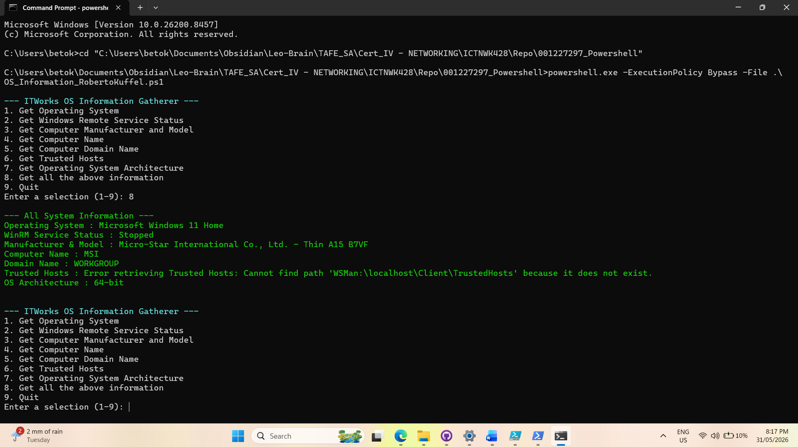

4.2 Maintenance

Make a list of at least 3 aspects of your script that will require an update in future. For example, you may choose to implement version control in future for your script. Add this to your OSInfo_documention_yourname.docx file created in 2.1 Design phase.
4.2 Maintenance (Future Updates)
- Saving Results to a File: Right now, the script only shows the computer's information on the screen. In the future, it should be updated to automatically save this data into a document or spreadsheet so the IT team can keep a permanent record.
- Checking Other Computers (Remote Access): The script currently only gathers information from the computer it is actively running on. A future update should allow it to scan other computers across the company network so we don't have to walk over to each desk physically.
- Keeping an Error History (Logging): If the script runs into a problem, it just shows an error message on the screen and forgets about it when closed. We need to update it so it secretly saves a history of these errors in a background file, making it easier to figure out what went wrong later.

Summary of files to upload to Learn.

Please collate the following documents in a zip file and upload the created zip to Learn for marking.

- The os_information_yourname.ps1 file with all required functions.
- The Word document OSInfo_documention_yourname.docx

