SmartHalo power state diagram

# Acronyms and abbreviations

* LED: Light-Emitting Diode
* TBT: Turn by turn display mode
* CROW: As the crow flies display mode
* GC: Goal completion
* BT X: Bluetooth connection
* BT D: Bluetooth disconnect
* SA Ride: Standalone ride (no phone)

# State diagram

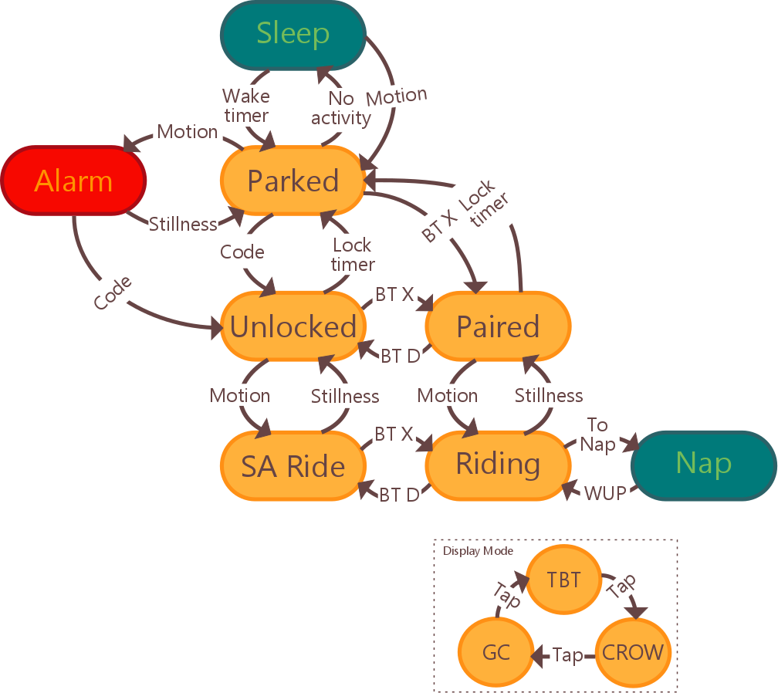

Figure : SmartHalo power state diagram

# States description:

|  |  |  |  |
| --- | --- | --- | --- |
| State | Condition | Output | Power saving |
| Sleep | Bicycle still for extended period of time | N/A | Everything OFF except Accelerometer |
| Parked | Bicycle still awaiting connection/motion | N/A | Everything ON except LEDs and LED drivers |
| Alarm | Bicycle motion/shock > Alarm trigger | RED LEDs Halo, Alarm sound | Everything ON |
| Unlocked | Bicycle still, unlock code entered | Green LEDs Halo | Everything ON |
| Paired | Bicycle still, Bluetooth connection | Display mode (TBT, CROW, FIT) | Everything ON |
| SA Ride | Bicycle moving, no Bluetooth connection | N/A | Everything ON except LEDs and LED drivers |
| Riding | Bicycle moving, Bluetooth connection | Display mode (TBT, CROW, FIT) | Everything ON |
| Nap | Bicycle moving, Bluetooth connection | N/A | Accelerometer and BT On |

1: Green states are low power states. Red state is the Alarm state

# Signal description:

|  |  |  |  |  |
| --- | --- | --- | --- | --- |
| Signal | Description | Motion | BT X | Value |
| Wake timer | SmartHalo will periodically wake up upon expiration of this time to check for incoming BT X |  |  | 600s |
| No activity | No motion or BT X detected |  |  | 15s |
| Motion | Bicycle motion |  | DC | Acceleration > 20 mg |
|  | Bicycle motion/shock > Alarm trigger (time > alarm timer) |  | DC | Acceleration > 15 mg  Alarm Timer > 10s |
| Stillness | Bicycle still > Parked timer |  | DC | Acceleration < 20 mg Time > 120s |
| Lock timer | Bicycle still, no Bluetooth connection > Lock timer |  |  | 300s |
| Code | Tap code to unlock the SmartHalo |  |  | User-specific |
| BT X | Bluetooth connection | DC |  |  |
| BT D | Bluetooth disconnect | DC |  |  |
| Idle timer | Idle time to automatically put SmartHalo to sleep |  |  | 300s |
| To Nap | Control signal from phone to put SmartHalo to temporary sleep during a ride (e.g. long stretch) |  |  |  |
| WUP | Control signal from phone to wake SmartHalo from temporary sleep |  |  |  |
| Tap | User input to switch display mode | DC | DC |  |

2: DC = Don't care