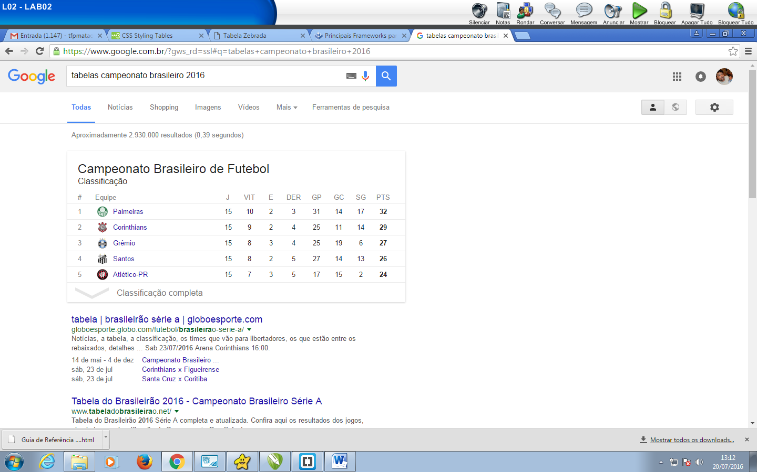

**<table border="1">**

**<tr>**

**<td>#</td>**  
**<td>Equipe</td>**  
**<td>J</td>**

**<td>VIT</td>**

**<td>E</td>**  
**<td>DER</td>**  
**<td>GP</td>**

**<td>GC</td>**

**<td>SG</td>**  
**<td>PTS</td>**

**</tr>**

**<tr>**

**<td>#</td>**  
**<td>Matonense</td>**  
**<td>0</td>**

**<td>0</td>**

**<td>0</td>**  
**<td>0</td>**  
**<td>0</td>**

**<td>0</td>**

**<td>0</td>**  
**<td>0</td>**

**</tr>**

**</table>**

https://tympanus.net/Tutorials/ItemSlider/