SmartShop – Online Product Store

Acknowledgement
This project was completed with academic guidance, technical support, and continuous feedback throughout the development process. We sincerely acknowledge all contributors who helped in planning, implementation, and testing. Their suggestions played an important role in improving system quality, usability, and requirement compliance.

Abstract
SmartShop is a dynamic single-page e-commerce web application developed using HTML5, Tailwind CSS, JavaScript DOM, Fetch API, and JSON data handling. The system allows users to browse products, add/remove items from cart, apply coupons, manage wallet balance, and complete a simulated checkout flow with real-time updates. Product data is fetched from a public API, and customer reviews are loaded from a local JSON source. The application also includes advanced interactive features such as search, sorting, category filtering, dark/light mode, wishlist, contact form validation, FAQ accordion, and back-to-top functionality.

Introduction
SmartShop was designed to simulate a modern online product store while demonstrating practical frontend engineering skills. The project focuses on dynamic user interaction, responsive UI design, client-side business logic, and integration of multiple foundational web technologies into one cohesive application.

Objectives
- Build a responsive and interactive e-commerce web interface.
- Fetch product data dynamically from a public API.
- Implement cart operations with real-time pricing updates.
- Integrate coupon logic and delivery/shipping calculations.
- Implement wallet-based balance checks during checkout.
- Demonstrate effective use of DOM manipulation and local storage.
- Deliver a complete, presentation-ready software project aligned with requirement specifications.

Tools & Technologies Used
- HTML5 – semantic structure and content layout
- Tailwind CSS (CDN) – responsive styling using utility classes
- JavaScript (Vanilla) – state management, event handling, business logic
- DOM API – dynamic rendering and interaction updates
- Fetch API – remote product data retrieval
- JSON – review data source and API payload handling
- localStorage – persistence for cart, wishlist, balance, theme, coupon state
- Static Deployment Config – production-ready static routing setup

Requirement Analysis
The implemented system satisfies the major functional requirements: responsive sticky navbar, sliding banner (auto/manual), dynamic product rendering from public API, real-time cart calculations, review carousel from JSON, user balance handling, and additional mandatory features.

Features & Functionalities
- Product listing from API with image, title, price, rating
- Cart management (add, remove, quantity control)
- Dynamic subtotal, delivery, shipping, discount, grand total
- Coupon application with validation logic
- Wallet-aware checkout with insufficient balance warning
- Review carousel with auto/manual controls
- Search, sorting, category filter, wishlist, dark/light mode
- Contact form validation, newsletter validation, FAQ, back-to-top

System Design / Workflow
- Initialize UI and persisted state from localStorage.
- Fetch product data and render product cards dynamically.
- Capture user actions through DOM events and delegated handlers.
- Recompute cart totals and wallet constraints in real time.
- Render updated UI state without page reload.
- Complete checkout only when sufficient balance is available.

API Integration Explanation
Product data is fetched from a public API endpoint using asynchronous Fetch API calls. Category-based filtering uses category-specific endpoints. Review content is loaded from a local JSON file, with fallback data to preserve UX in case of retrieval failure.

DOM Manipulation & JavaScript Features
The project applies DOM manipulation for dynamic rendering of products, cart items, wishlist entries, review cards, and interactive sections. JavaScript handles event delegation, conditional visibility, validation feedback, and all runtime updates to totals, counters, and balance display.

User Balance System
A fixed starting balance is maintained for the user. The system dynamically updates balance after add-money actions and checkout operations. If grand total exceeds available balance, a warning is shown and checkout remains disabled until balance is sufficient.

Additional Feature Explanation
Beyond baseline requirements, the system includes search and filter, sorting options, wishlist management, and dark/light mode. These additions enhance usability and demonstrate broader JavaScript DOM proficiency.

Testing & Output Screenshots
Testing covered API loading behavior, cart and coupon calculations, balance validation logic, responsive layout behavior, and form validations. Insert project screenshots under figure captions in final submission.
- Figure 1: Home page with sticky navigation and hero slider
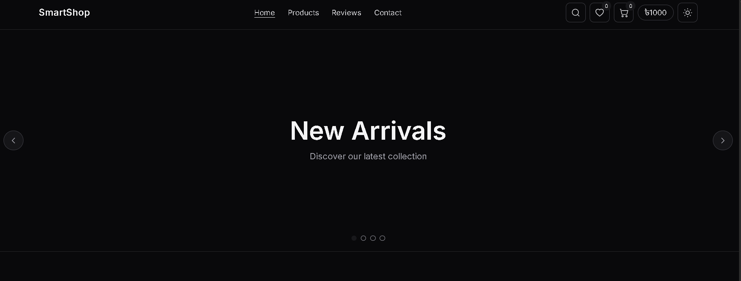
- Figure 2: Product section after API fetch
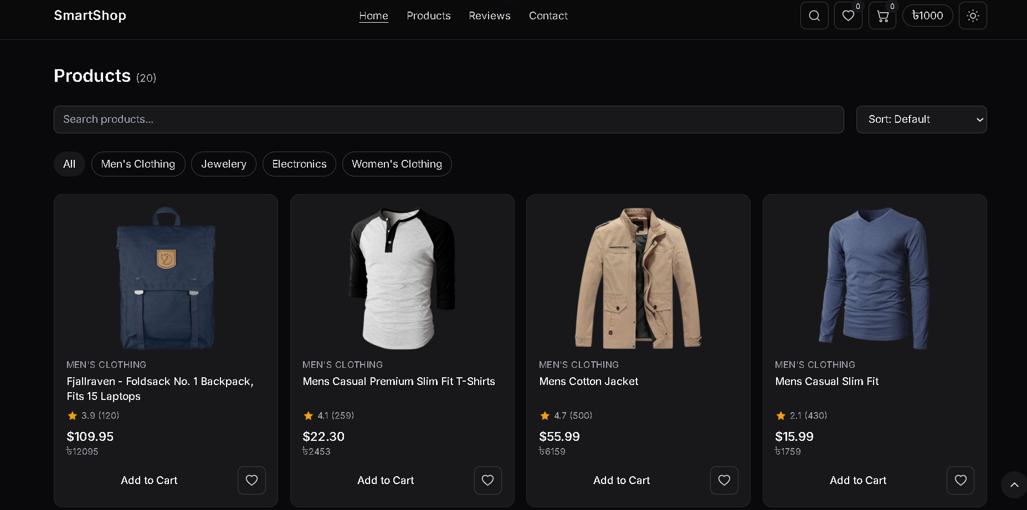
- Figure 3: Search/filter/sort interaction
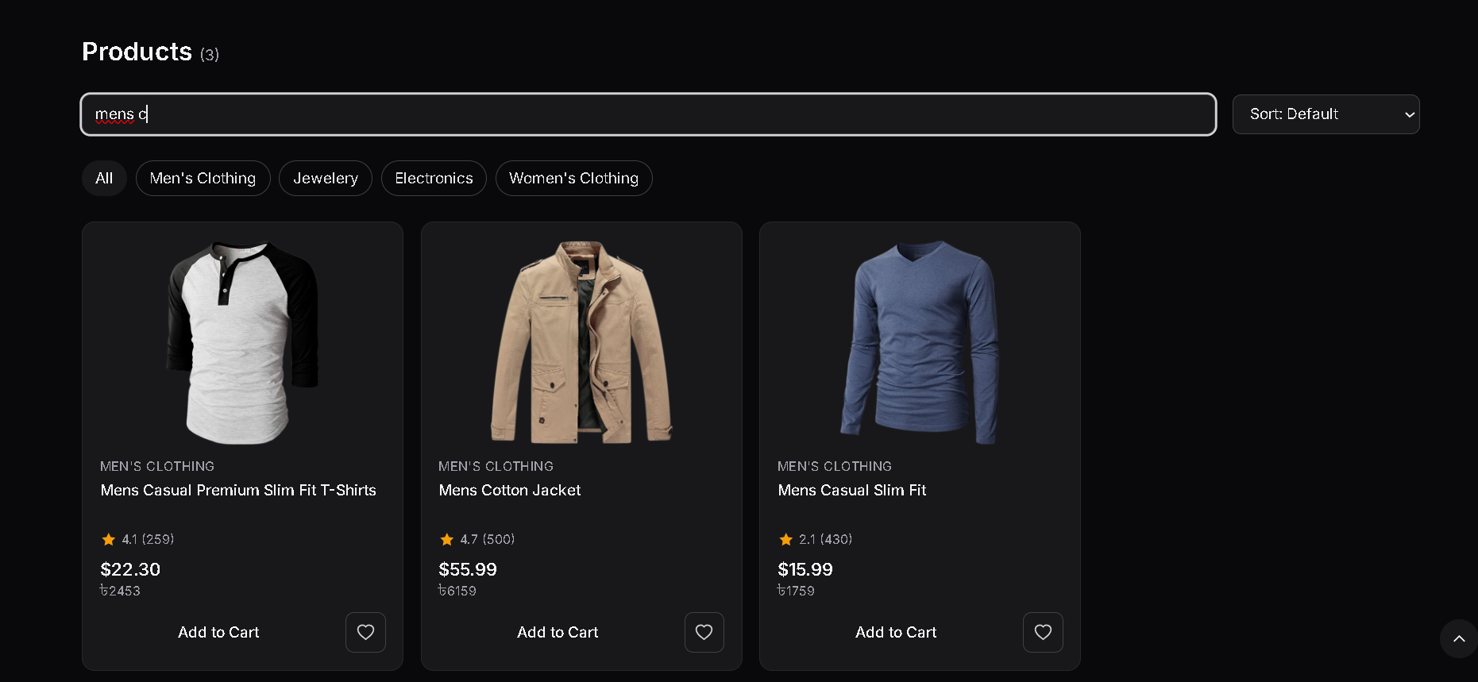
- Figure 4: Cart drawer with pricing breakdown
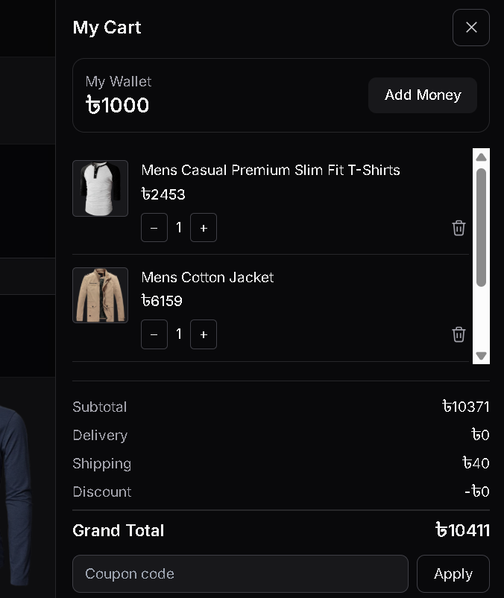
- Figure 5: Coupon application result
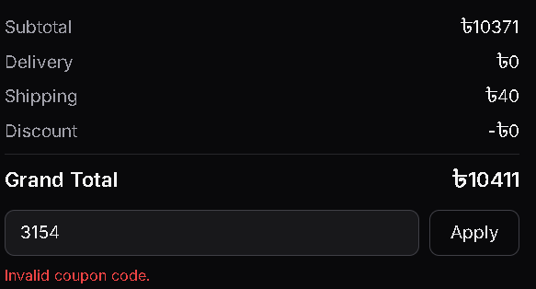
- Figure 6: Insufficient balance warning state
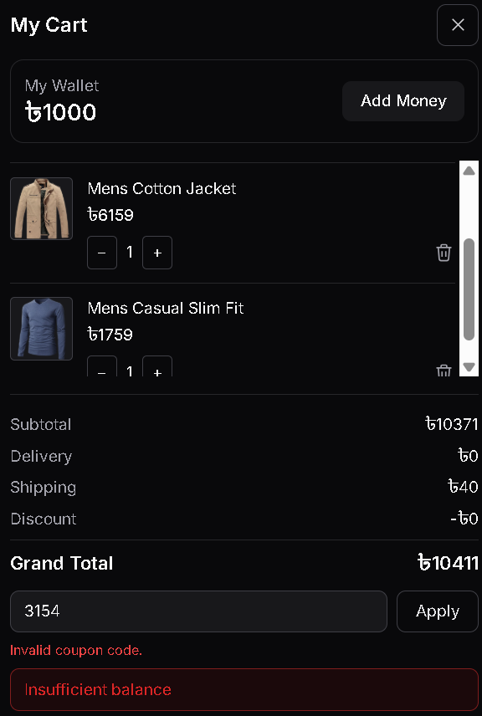
- Figure 7: Add money and updated balance
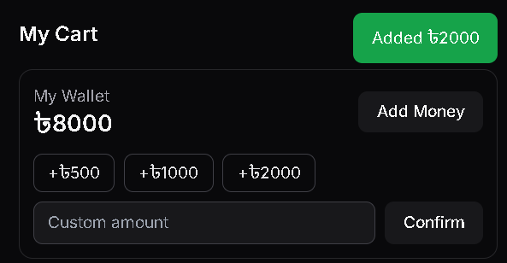
- Figure 8: Contact form validation/success output

- Figure 9: Footer with FAQ and back-to-top
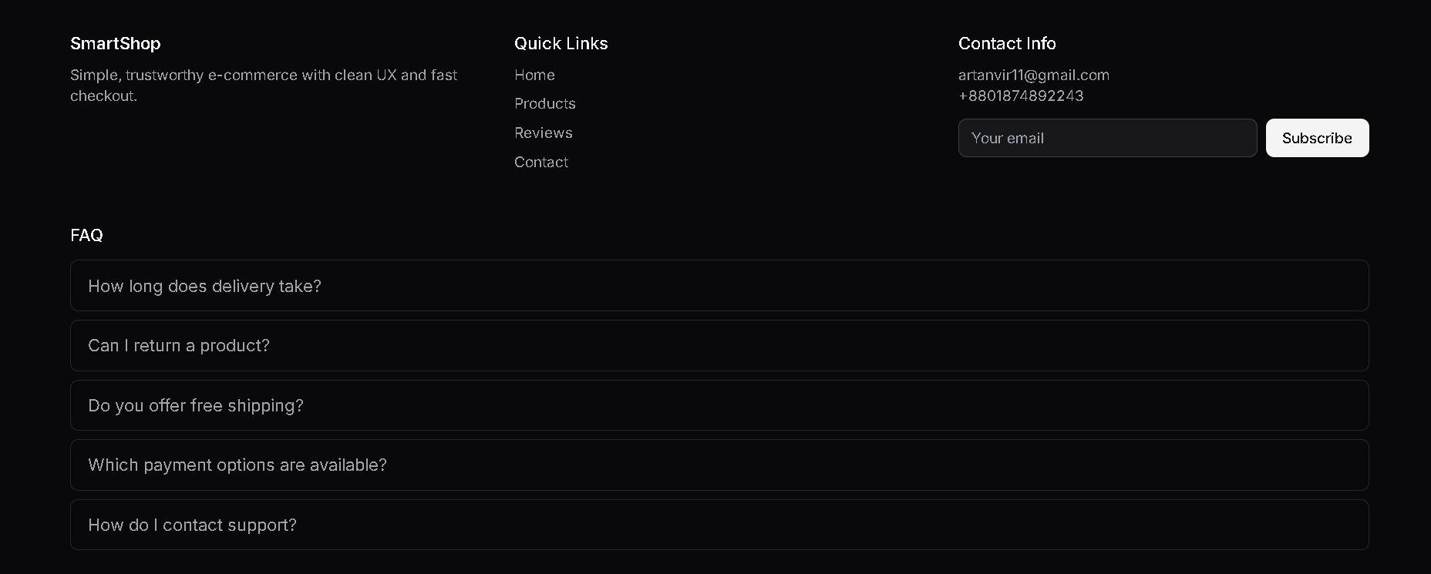

Challenges & Solutions
Challenge: Managing many interactive states in one-page architecture. Solution: Centralized state and segmented render functions.
Challenge: Maintaining accurate cart math. Solution: Single reusable total-calculation routine.
Challenge: Preserving user state after reload. Solution: localStorage persistence integration.
Challenge: API/network failures. Solution: Error messaging, retry flow, and fallback review data.

Conclusion
SmartShop demonstrates successful integration of foundational web technologies into a complete interactive e-commerce system. The project fulfills core requirement expectations with strong functional coverage and a polished user experience.

Future Improvements
- Refactor JavaScript into modules for maintainability.
- Enhance accessibility and keyboard navigation support.
- Add automated tests for cart and validation logic.
- Extend with login/order history simulation.
- Integrate backend services for production-grade persistence.

