**RAJSHAHI UNIVERSITY OF ENGINEERING & TECHNOLOGY**

**SESSIONAL TASK-07**

COURSE NAME: SESSIONAL BASED ON CSE-2201

COURSE CODE: CSE-2102

**SUBMITTED TO-**

**BIPRODIP PAL**

Assistant Professor

Department of Computer Science & Engineering

Rajshahi University of Engineering & Technology

**SUBMITTED BY-**

**SRABONTI DEB**

Roll- 1803163

Section-C

Department of Computer Science & Engineering

Rajshahi University of Engineering & Technology

SUBMISSION DATE – 3 JULY, 2021

# Problem Statement: Comparison of bubble sort & counting sort algorithms.

**Code for Bubble Sort Algorithm:**

#include<bits/stdc++.h>

using namespace std;

int main()

{

int cnt,n,i,j,temp,counter;

long long ar[10000],num;

ofstream input;

input.open("input.txt");

for (cnt=1;cnt<=2000;cnt++)

{

n=rand()%2000+1;

input<<n<<endl;

}

input.close();

ifstream file;

file.open("input.txt");

if(file)

{

while(file>>num)

{

ar[n++]=(num);

}

}

else

cout<<"file can't open"<<endl;

int counter1=2;

for(i=0; i<n; i++)

{

counter+=2;

for(j=1; j<n-i; j++)

{

counter+=2;

if(ar[j]>ar[j+1])

{

temp=ar[j];

ar[j]=ar[j+1];

ar[j+1]=temp;

counter=4;

}

}

}

counter+=2;

cout<<"Time required for bubble sort: "<<counter<<endl;

}

**Output:**

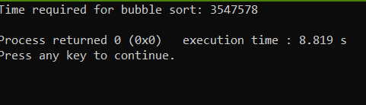

**Code for Counting Sort Algorithm:**

#include<bits/stdc++.h>

using namespace std;

int main()

{

int cnt,n,i;

long long ar[10000],ar1[10000],num;

ofstream input;

input.open("input.txt");

for (cnt=1;cnt<=2000;cnt++)

{

n=rand()%2000+1;

input<<n<<endl;

}

input.close();

ifstream file;

file.open("input.txt");

if(file)

{

while(file>>num)

{

ar[n++]=(num);

}

}

else

cout<<"file can't open"<<endl;

long long maximum=*max_element(ar,ar+n),b[maximum+5];

memset(b,0,sizeof(b));

memset(ar1,0,sizeof(ar1));

for(i=0; i<n; i++)

{

b[ar[i]]++;

}

for(i=1; i<=maximum; i++)

{

b[i]=b[i-1]+b[i];

}

int counter=1;

for(i=n-1; i>=0; i--)

{

ar1[b[ar[i]] - 1] = ar[i];

b[ar[i]]--;

counter+=4;

}

counter+=1;

cout<<"Time required for counting sort: "<<counter<<endl;

}

**Output:**

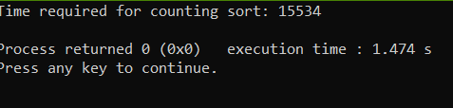

**Graph:**

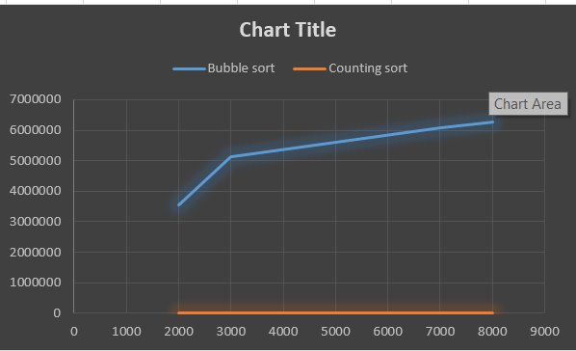

**Discussion:**

We know that the complexity of counting sort is O(n) and bubble sort is O($n^{2}$).That means the complexity of counting sort is less than that of bubble sort.We can prove this by the executed output and graph (shown above).In a nutshell,we can say that counting sort is more efficient than bubble sort.

.