**RAJSHAHI UNIVERSITY OF ENGINEERING & TECHNOLOGY**

**LAB REPORT**

**COURSE NAME**: SESSIONAL BASED ON CSE-3205

**COURSE CODE**: CSE-3206

**SUBMITTED TO-**

TASMIA JANNAT

LECTURER

Department of Computer Science & Engineering

Rajshahi University of Engineering & Technology

**SUBMITTED BY-**

SRABONTI DEB

Roll-1803163

Section - C

Department of Computer Science & Engineering

Rajshahi University of Engineering & Technology

**Submission date:** 22 december,2022

**Task-1:**

Last octate of the IP address of “Name PC” should be the last 3 digits of your roll number (Static Host).

For example, if roll: 1803121 then IP address of “Name PC” can be like 192.168.100.121

**Solution:**

IP ADDRESS for “Name PC” is given as 192.168.100.163

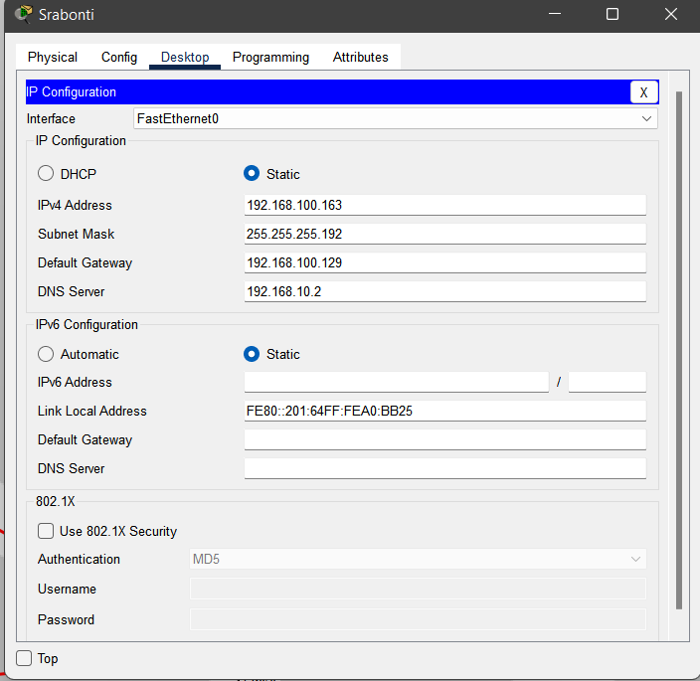

**Task-2:**

Use Dynamic Routing for the connection.

**Solution:**

**Router 0 Gig 0/0:**

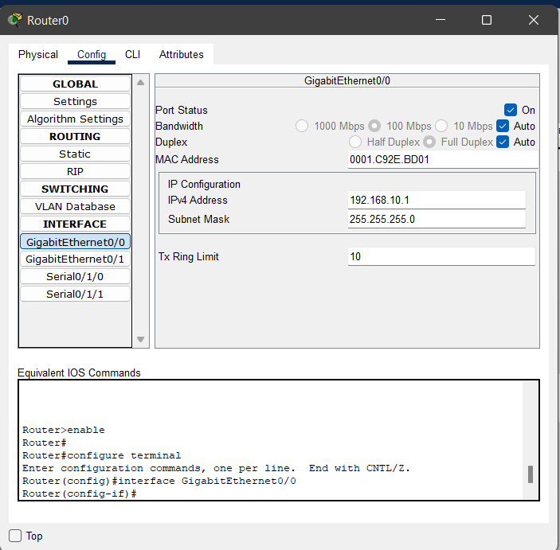

**Router 0 Serial 0/1/0:**

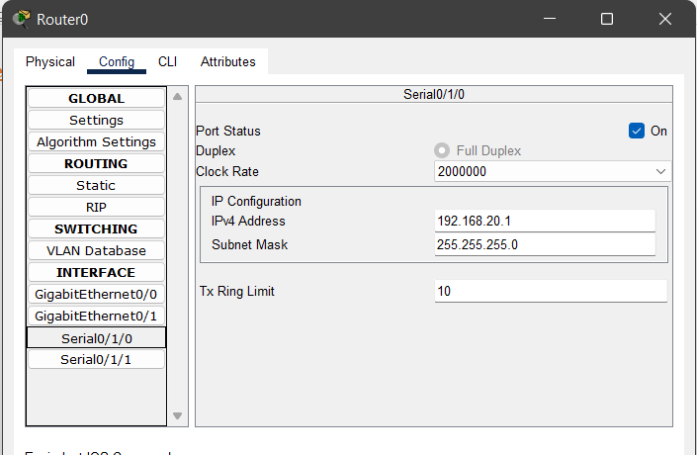

**Router 0 Serial 0/1/1:**

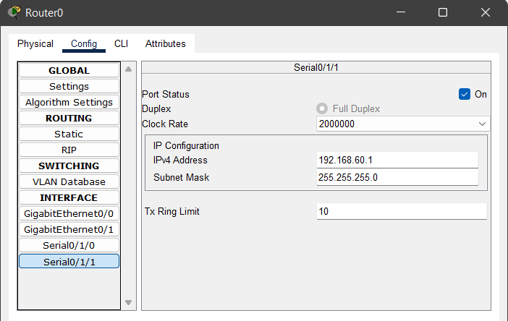

**Router 1 FastEthernet 0/0:**

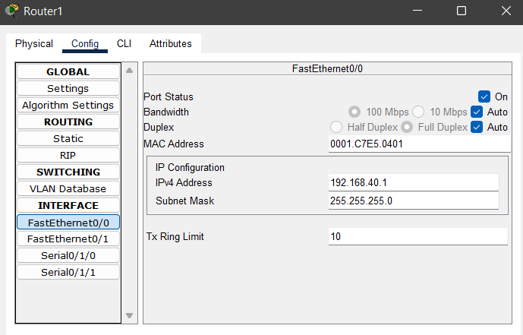

**Router 1 Serial 0/1/0:**

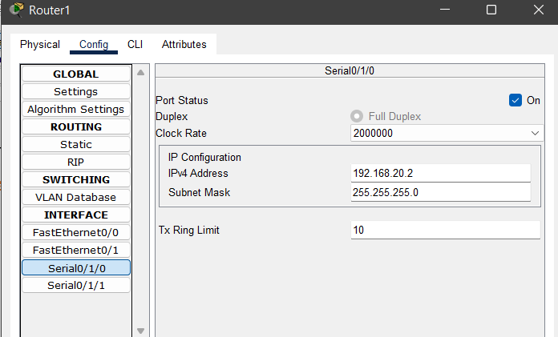

**Router 1 Serial 0/1/1:**

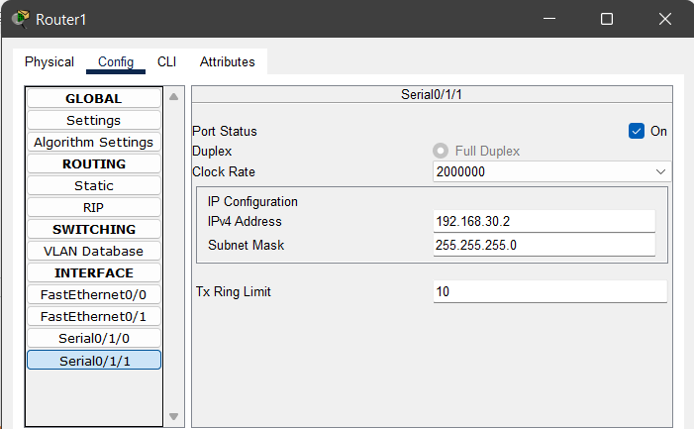

**Router 2 FastEthernet 0/0:**

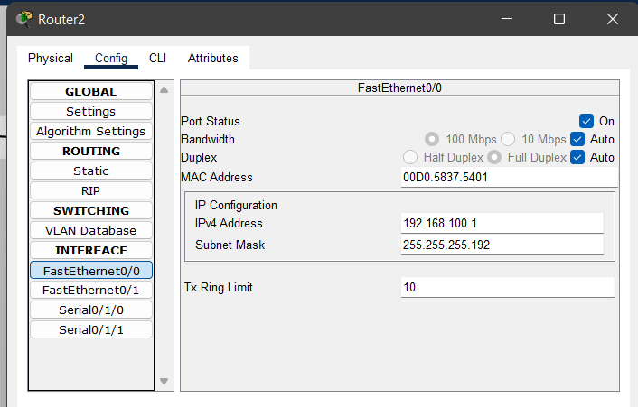

**Router 2 FastEthernet 0/1:**

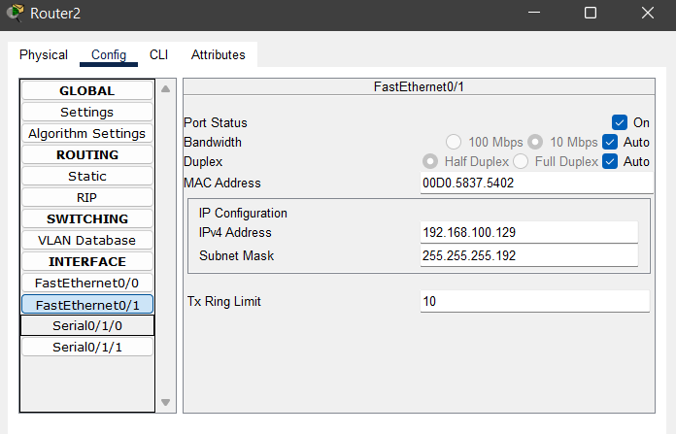

**Router 2 Serial 0/1/0:**

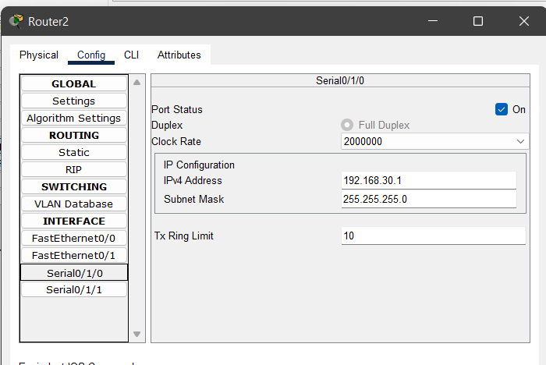

**Router 2 Serial 0/1/1:**

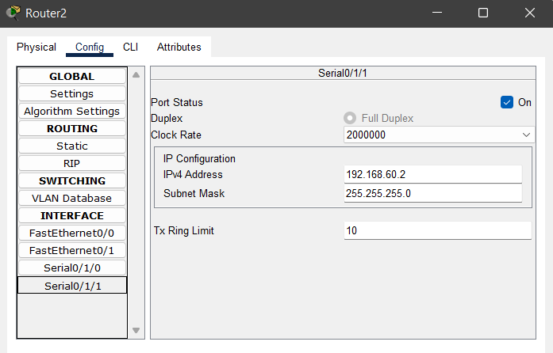

For each router all network addresses has been added in the RIP which ensures Dynamic Routing:

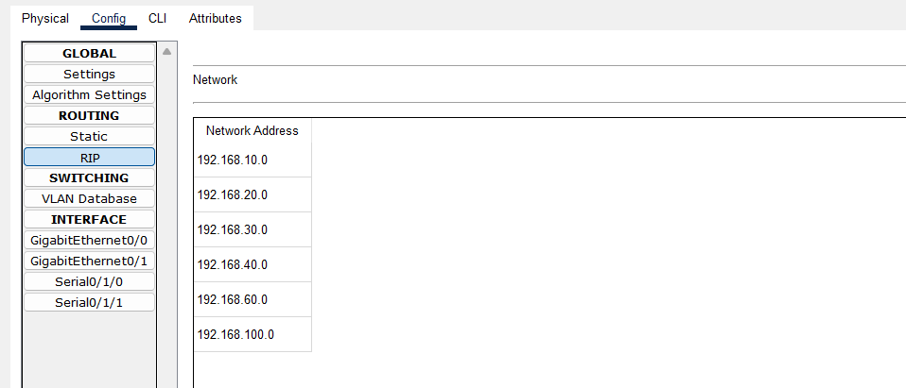

**Task-3:**

Assign the DNS name to “Name PC” as your Name.

**Solution:**

Name of the PC and IP ADDRESS has been added to the server in DNS section of **server0**:

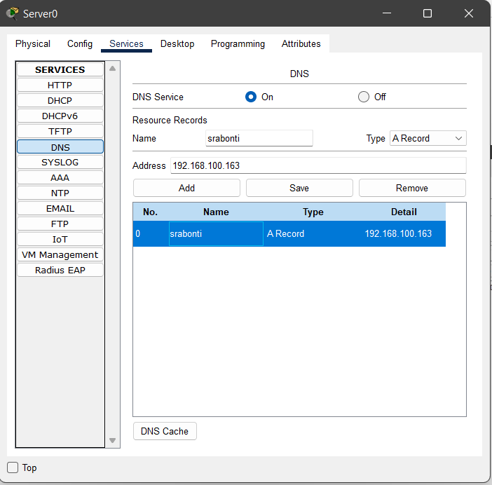

After pinging to “Name PC”:

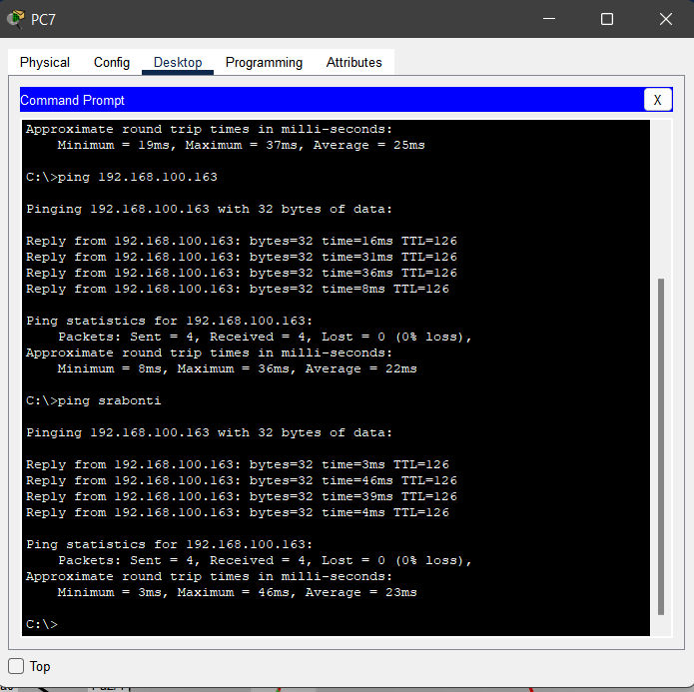

**Task-4:**

Assign IP addresses to all the host by DHCP except “Name PC”.

**Solution:**

Pool name and DHCP details has been added for each LAN.

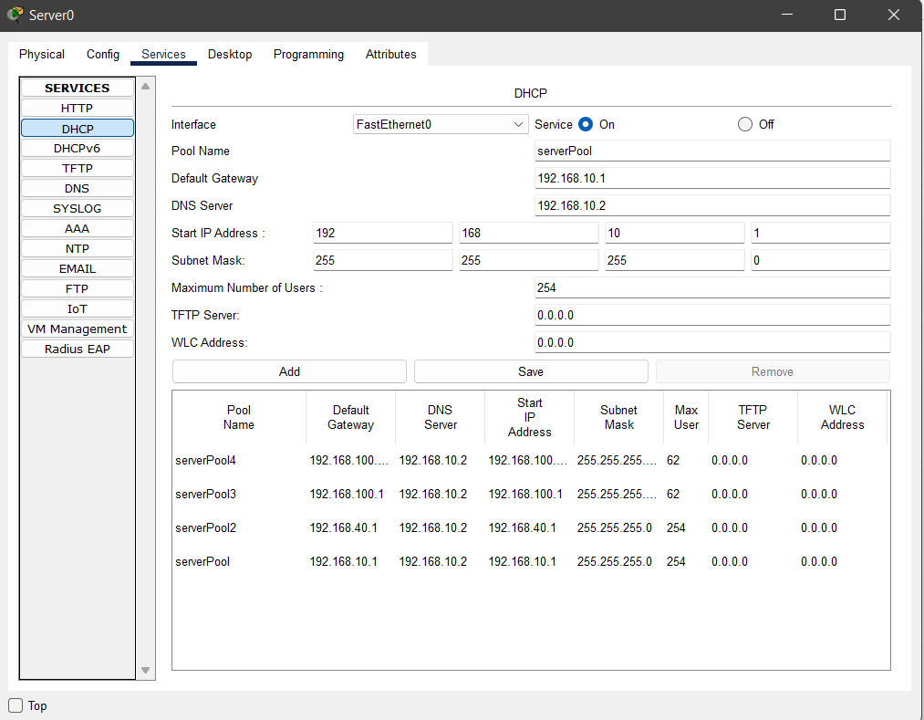

**Router 0 Terminal:**

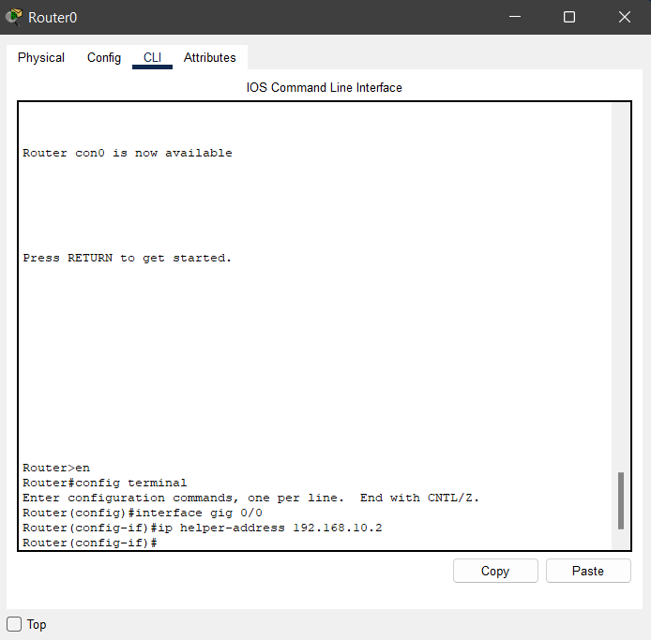

**Router 1 Terminal:**

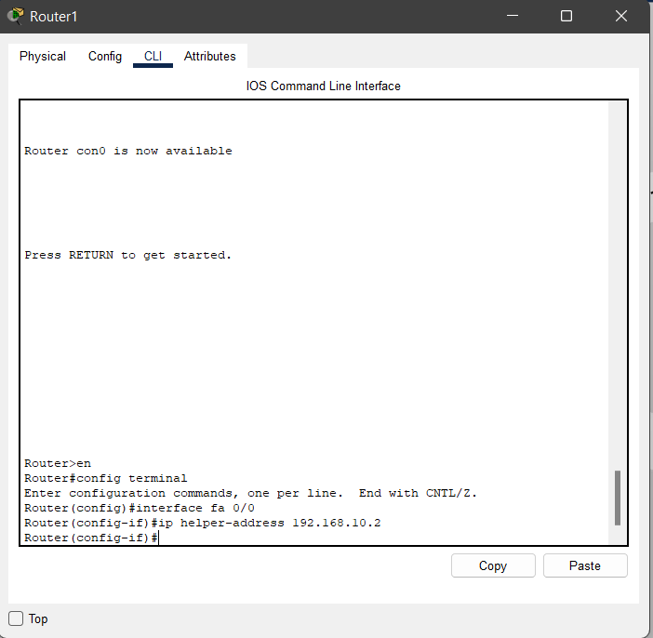

**Router 2 Terminal:**

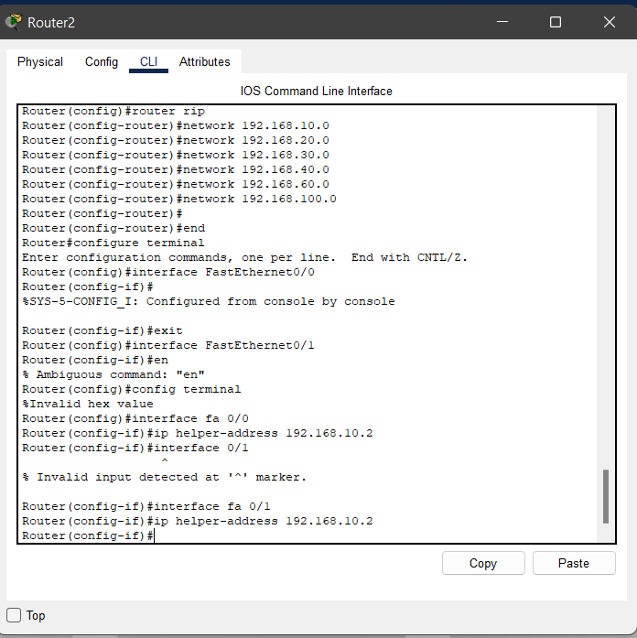

After adding pool name and details of each LAN in DHCP, IP ADDRESS that has been assigned to all host by DHCP:

**PC1:**

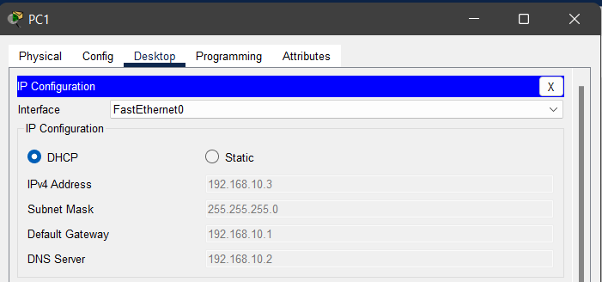

**PC6:**

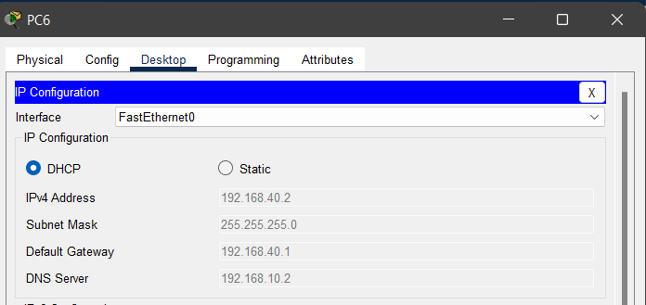

**PC7:**

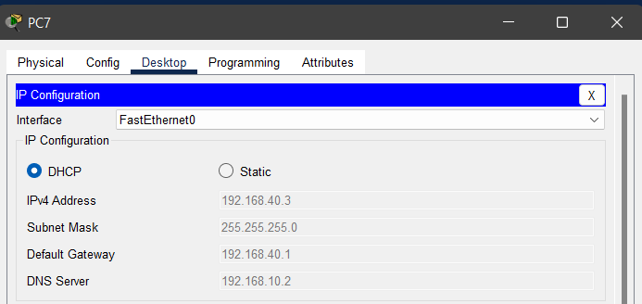

**PC3:**

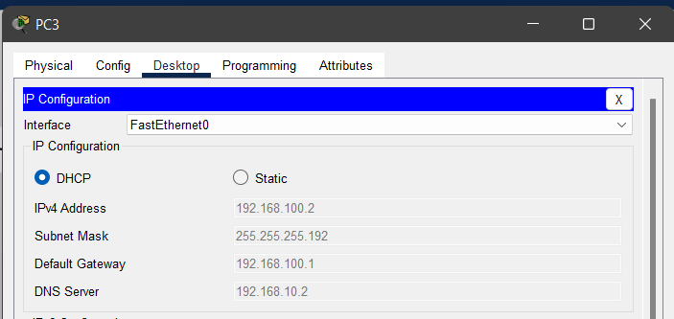

**Laptop0:**

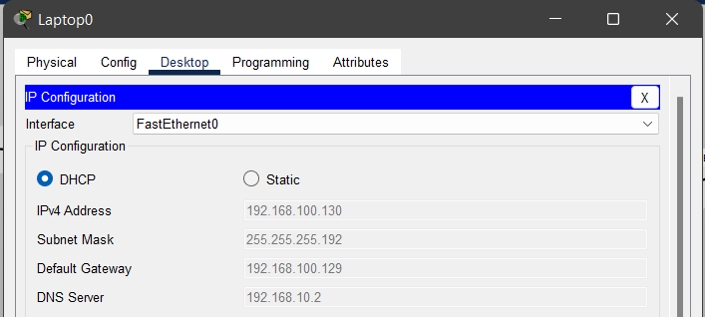

**Cables Description:**

|  |  |  |
| --- | --- | --- |
| **Connections** | **Cables used** | **Justification for using this cable** |
| 1. **Router to Router** | Serial DCE/DTE | For connecting two routers via their serial ports, we use Serial DCE/DTE cable. |
| 1. **Router to each switch** 2. **Router to each repeater** 3. **Switch to each host** 4. **Hub to each Host** | Copper Straight Through | They are used to connect two different type of network device that allows one end to communicate at any time. |
| 1. **Router to host** 2. **Repeater to switch** 3. **Switch to Bridge** 4. **Bridge to Hub** | Copper Cross Over | This cable is nearly same as the Copper Straight Through Cable. Only difference is it supports two way communication. |

**Connection check:**

