**Name: SRAGVIN KUMAR**

**MIS: 112315097**

**SECTION: A**

**GROUP: 3**

**SUBJECT: PYTHON**

# **QUESTION 1:**

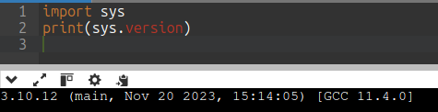

# **QUESTION 2:**

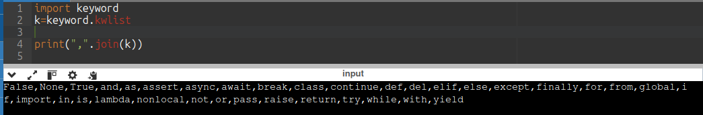

# **QUESTION 3:**

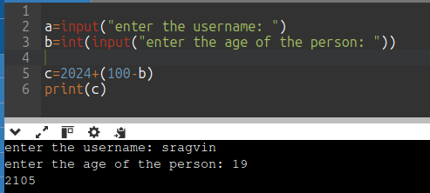

# **QUESTION 4:**

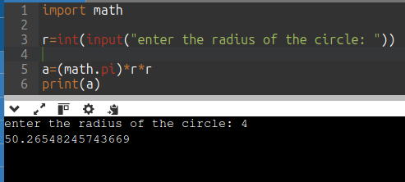

# **QUESTION 5:**

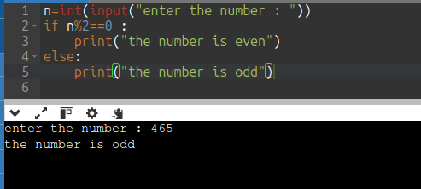

# **QUESTION 6:**

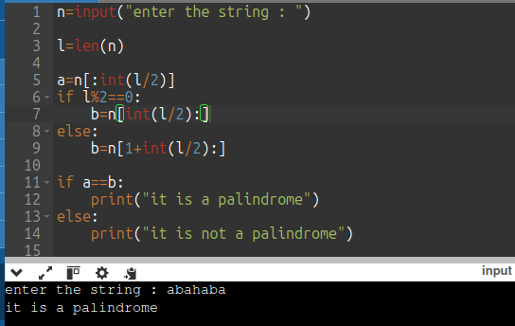

# **QUESTION 7:**

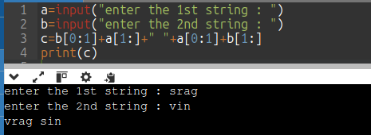

# **QUESTION 8:**

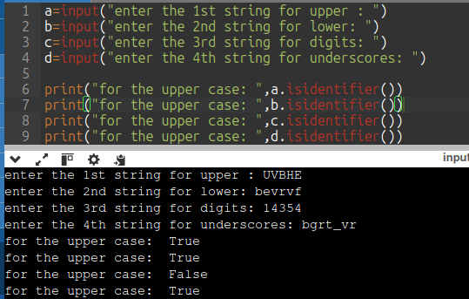

# **QUESTION 9:**

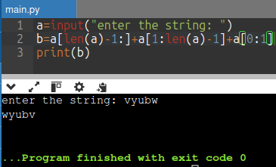

# **QUESTION 10:**

