

ASSIGNMENT-2

# PYTHON

# **NAME : MADA SRAGVIN KUMAR**

# **MIS NO : 112315097**

# **GROUP : 3**

**YEAR : 2**

**SECTION : A**

# **1**

a=int(input("enter the number: "))

if a%2==0:

print("the given number is even")

else:

print("the given number is odd")

# **Output:**

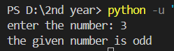

# **2**

for i in range(2,11):

a=1/i

print(a,end=" ")

# **Output:**

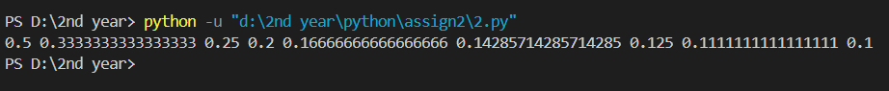

# **3**

a=int(input("enter the number: "))

while a>=0 :

print(a,end=" ")

a=a-1

# **Output:**



# **4**

from datetime import datetime, timedelta

now_utc = datetime.utcnow()

ist_offset = timedelta(hours=5, minutes=30)

now_ist = now_utc + ist_offset

day_of_week = now_ist.strftime('%A')

print(f"Current Date and Time: {day_of_week} {now_ist.strftime('%B %d %I:%M:%S %Y ')} IST")

# **Output:**

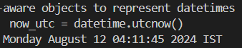

# **5**

a=int(input("enter the number: "))

b=int(input("enter the number: "))

c=int(input("enter the number: "))

if(a>b and a>c):

print("a is teh largest number")

elif(b>a and b>c):

print("b is teh largest number")

else:

print("c is the largest number")

# **Output:**

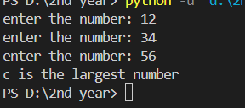

# **6**

a=input("enter the tempeture units : ")

if(a=="celsius"):

c=int(input("enter teh temperature: "))

f=((9*c)/5)+32

print(f"the temperature in farenhiet is {f}")

elif(a=="farenhiet"):

f=int(input("enter the tmeprature:"))

c=((f-32)/9)*5

print(f"the temperature in celsius is {c}")

else:

print("no such units to be printed")

# **Output:**

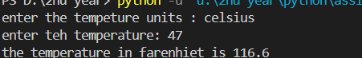

# **7**

print("2 is a prime number")

for i in range(2,21):

for j in range(2,i):

if i%j==0:

break

if j==i-1:

print(f"{i} is a prime number")

# **Output:**

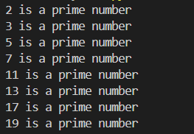

# **8**

a=int(input("enter the length of the side 1: "))

b=int(input("enter the length of the side 2: "))

c=int(input("enter the length of the side 3: "))

if(a>b and a>c):

lon=a

si1=b

si2=c

print("a is the largest number")

elif(b>a and b>c):

lon=b

si1=a

si2=c

print("b is the largest number")

else:

lon=c

si1=b

si2=a

print("c is the largest number")

if(lon*lon==si1*si1+si2*si2):

print("the triangle is a right angled triangle")

else:

print("this triangle is not a right angled triangle")

# **Output:**

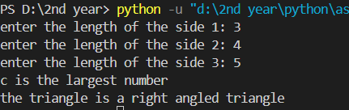

# **9**

a=int(input("enter the marks for test 1: "))

b=int(input("enter the marks for test 2: "))

c=int(input("enter the marks for test 3: "))

if(a<b and a<c):

m1=b

m2=c

print("a is the smallest number")

elif(b<a and b<c):

m1=a

m2=c

print("b is the smallest number")

else:

m1=b

m2=a

print("c is the smallest number")

avg=(m1+m2)/2

print(f"the avg marks for the best marks of 2 tests are: {avg}")

# **Output:**

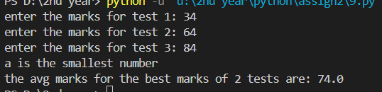

# **10**

num=input("enter the number :")

count=0

n=len(num)//2

for a in range (n):

if(num[len(num)-1-a]==num[a]):

count=count+1

if(count==n):

print("the number is palindrome")

else:

print("the number is not palindrome")

counted_digits = []

for digit in num:

if digit not in counted_digits:

counted_digits.append(digit)

count = num.count(digit)

print(f"{digit} appears {count} times")

# **Output:**

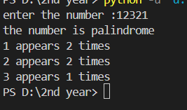

# **11**

a = input("Enter a sentence: ")

b = len(a.split())

c = 0

d = 0

e = 0

for char in a:

if char.isdigit():

c += 1

elif char.isupper():

d += 1

elif char.islower():

e += 1

print(f"This sentence has {b} words")

print(f"This sentence has {c} digits")

print(f"this sentence has {d} upper case letter")

print(f"this sentence has {e} lower case letter")

Output:

