Test 1: Pass
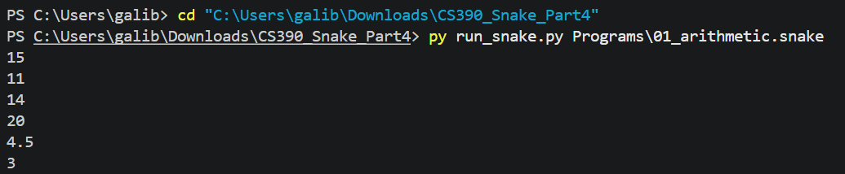
Test 2: Pass
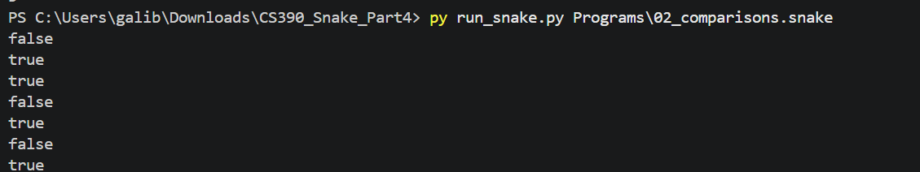
Test 3: Pass
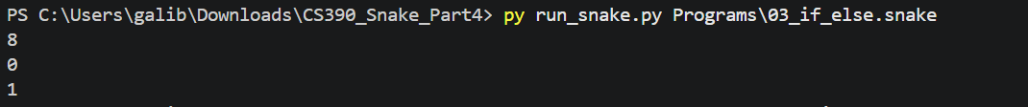
Test 4: Pass
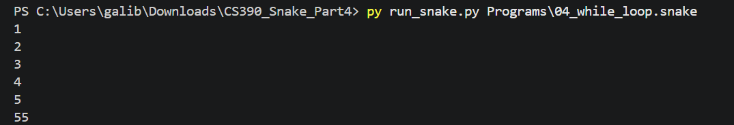
Test 5: Pass
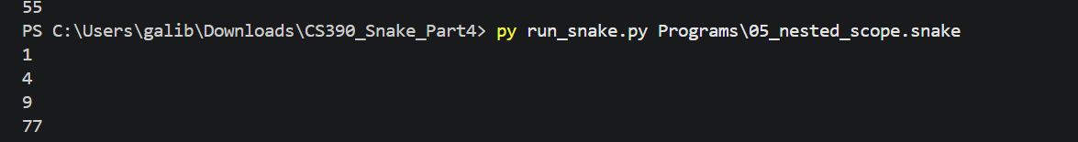
Test 6: Pass

Test 7: Pass
Test 8: Pass
Test 9:

