## GrainPalette - A Deep Learning Odyssey In Rice Type Classification Through Transfer Learning System Required:

Windows 8 machine Install with two web browser Bandwidth of 30mbps

The Rice Type Identification AI model provides a solution for farmers and agriculture enthusiasts to identify various types of rice grains quickly and accurately. By uploading an image of a rice grain and clicking the submit button, users receive predictions for the probable type of rice, enabling informed decisions on cultivation practices such as water and fertilizer requirements. Built using Convolutional Neural Networks (CNN) and employing transfer learning with MobileNetv4, this model offers reliable classification of up to five different types of rice, catering to the needs of farmers, agriculture

scientists, home growers, and gardeners.

## Scenarios:

**Farmers' Crop Planning:** Farmers can use the Rice Type Identification AI model to plan their crop cultivation strategies effectively. Before planting, they can upload images of rice grains from their

seed stock to determine the specific types of rice they possess. Based on the predictions provided by the model, farmers can adjust their agricultural practices such as irrigation schedules, fertilization methods, and pest management strategies tailored to the requirements of each rice variety.

**Research and Agricultural Extension Services:** Agriculture scientists and extension workers utilize the AI model to assist farmers in identifying rice varieties accurately. During field visits or research trials, they can capture images of rice grains and input them into the model to obtain rapid classifications. This facilitates data collection for research studies, variety testing, and extension programs,

ultimately enhancing productivity and sustainability in rice cultivation.

**Home Gardening and Education:** Home growers and gardening enthusiasts leverage the AI model to learn about different rice varieties and enhance their gardening skills. By uploading images of rice grains from seed packets or harvested crops, they can explore the diversity of rice types and

understand their unique characteristics. This fosters learning and appreciation for agricultural biodiversity, promoting sustainable practices in home gardening and education initiatives.

## A picture containing text, diagram, screenshot, font Description automatically generatedTechnical Architecture:

**Project Objectives**

By the end of this project, you’ll understand:

* Preprocessing of images and augmentation of images.
* Applying Transfer learning algorithms on the dataset.
* How deep neural networks detect the disease.
* You will be able to know how to find the accuracy of the model.
* You will be able to Build web applications using the Flask framework.

## Project Flow

* The user interacts with the UI (User Interface) to choose the image.
* The chosen image analyzed by the model which is integrated with flask application.
* The MobileNet Model analyzes the image, then the prediction is showcased on the Flask UI. To accomplish this, we must complete all the activities and tasks listed below
* Data Collection.
  + Create a Train and Test path.
* Data Pre-processing.
* Import the required library
* Configure ImageDataGenerator class
* ApplyImageDataGenerator functionality to Trainset and Test set
* Model Building
  + Pre-trained CNN model as a Feature Extractor
  + Adding Dense Layer
  + Configure the Learning Process
  + Train the model
  + Save the Model
  + Test the model
* Application Building
  + Create an HTML file
  + Build Python Code

## Project Structure

Create a Project folder which contains files as shown below

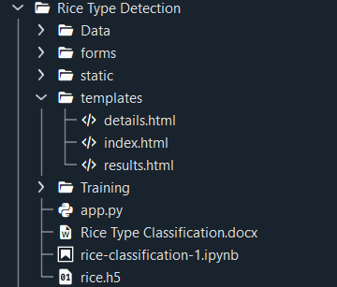

* Static folder contains css files
* Template folder contains all 3 HTML pages.
* Data folder contains Training and Validation images
* Training file consist of train.ipynb , rice.h5 model

# 1: Data Collection

* There are many popular open sources for collecting the data. Eg: kaggle.com, UCI repository, etc.
* ​

## 1: Download the dataset

* Collect images of Tomato Leaves. Images are then organized into subdirectories based on their respective names as shown in the project structure.
* In this project, we have collected images of 10 types of Tomato Leaf images like Heatly, Spider Mites, Yellow leaf curl, etc. and they are saved in the respective sub directories with their respective names.
* You can download the dataset used in this project using the below link
* Dataset: <https://www.kaggle.com/datasets/muratkokludataset/rice-image-dataset>
* ​
* Note: For better accuracy train on more images
* ​
* We are going to build our training model on Kaggle as they provide accelerators like GPUs and TPUs.
* ​
* Note: The Google Drive notebook will also be provided in the GitHub link mentioned at the end of the project
* ​
* A new Kaggle Notebook should be created under the dataset link provided.
* 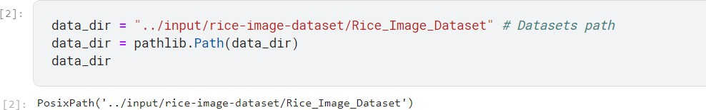This notebook will directly link to the Kaggle Dataset.

# 2: Splitting Data on Classes

* 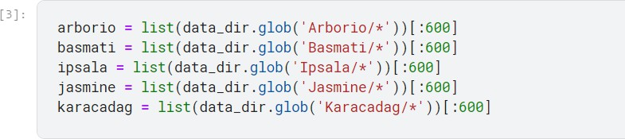Inside the data folder there are several folders for different classes.
* ​

# 1: Importing the libraries

* Import the necessary libraries as shown in the image
* .

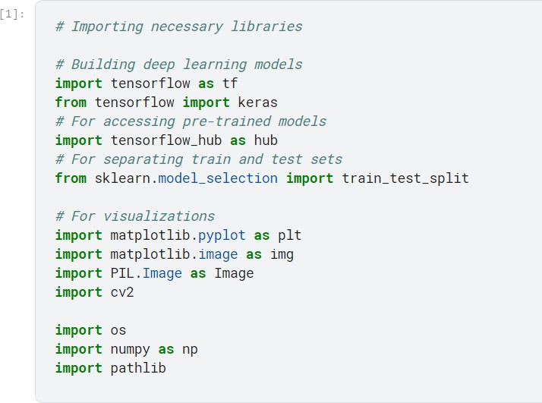

* ​

# 2: Changing size of the images:

* Since the input dimensions of the MobileNet are (224,224,3). We have to resize our images in the same way.
* ​
* Currently the size of images is (250,250,3).

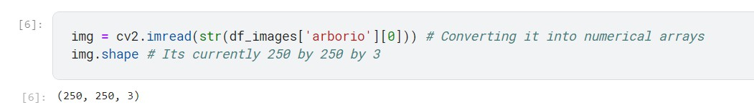

•

# 3: Link images to different classes

* Here we have 5 classes and the images need to be labelled with appropriate classes.

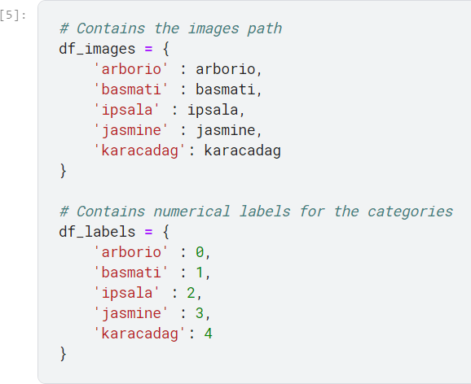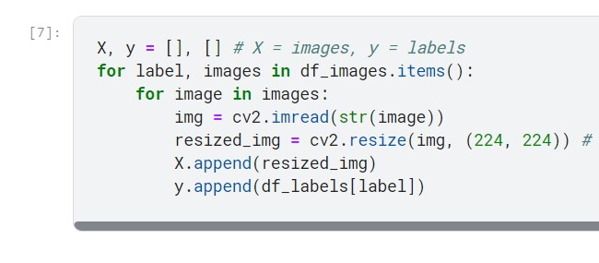

•

•

•

# 4: Splitting Data in Train set , Validation and Test set

* We will split the data in training, validation and testing sets.
* ​
* ​

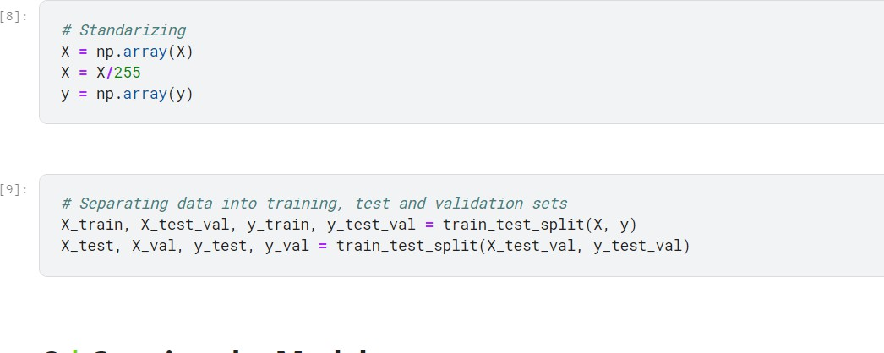

•

* **5: Preview of images**

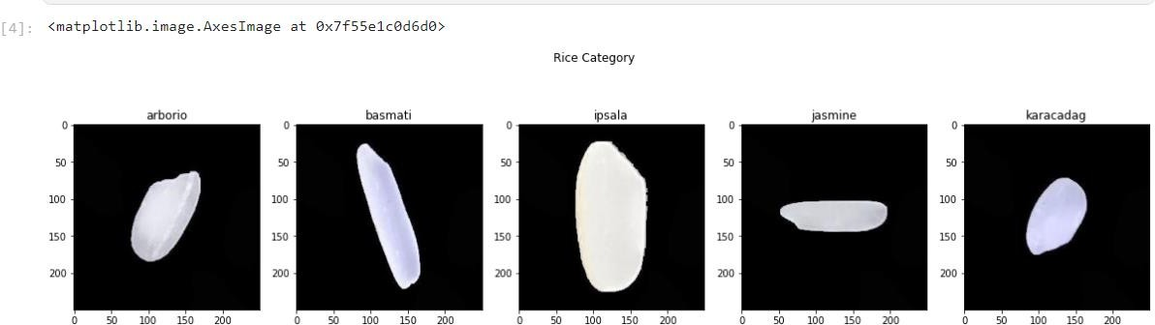

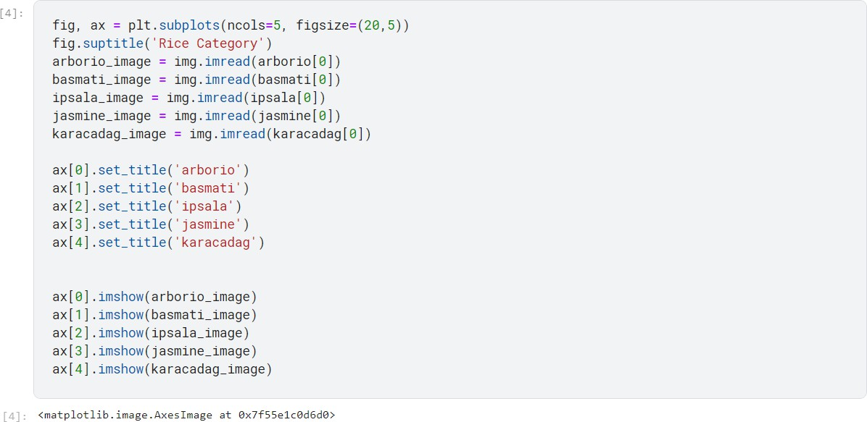

•

•

* ​
* Here we can see that there are 5 different classes, we can see their names above the images. We can see that each disease can be seen directly from the image.

# 3: Model Building

* Now it's time to build our model. Let’s use the pre-trained model which is MobileNetv4, one of the convolution neural net (CNN) architecture which is considered as a very good model for Image classification.

# 1: Pre-trained CNN model as a Feature Extractor

* For one of the models, we will use it as a simple feature extractor by freezing all the convolution blocks to make sure their weights don’t get updated after each epoch as we train our own model.
* Here, we have considered images of dimension (224, 224, 3).
* Also, we have assigned trainable = False because we are using convolution layer for features extraction and wants to train fully connected layer for our images classification.

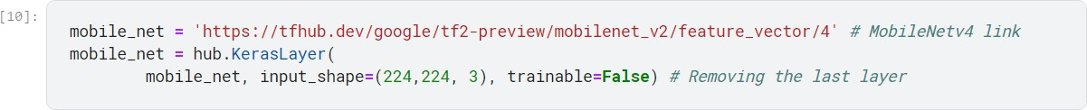

* ​

# 2: Adding Dense Layer

* A dense layer is a deeply connected neural network layer. It is the most common and frequently used layer.
* Let us create a model object named model with inputs as mobile_net and output as dense layer.

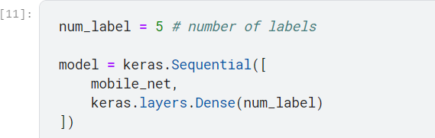

•

•

* The number of neurons in the Dense layer is the same as the number of classes in the training set. The neurons in the last Dense layer, use softmax activation to convert their outputs into respective probabilities.
* Understanding the model is a very important phase to properly use it for training and prediction purposes. Keras provides a simple method, summary to get the full information about the model and its layers.
* ​
* 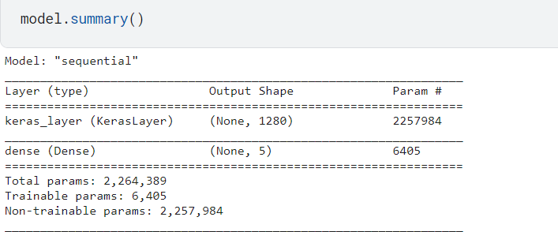​

# 3: Configure the Learning Process

* The compilation is the final step in creating a model. Once the compilation is done, we can move on to the training phase. The loss function is used to find errors or deviations in the learning process. Keras requires a loss function during the model compilation process.
* Optimization is an important process that optimizes the input weights by comparing the prediction and the loss function. Here we are using adam optimizer
* 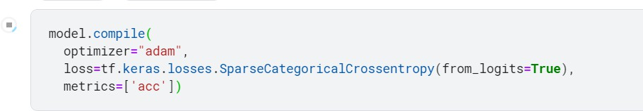Metrics are used to evaluate the performance of your model. It is similar to the loss function, but not used in the training process
* ​

## 4: Train the model

* Now, let us train our model with our image dataset. The model is trained for 10 epochs and after every epoch, the current model state is saved if the model has the least loss

encountered till that time. We can see that the training loss decreases in almost every epoch.

* fit functions used to train a deep learning neural network
* ​
* Arguments:
* Epochs: an integer and number of epochs we want to train our model for.
* validation_data can be either:
* - an inputs and targets list
* - a generator
* - an inputs, targets, and sample_weights list which can be used to evaluate
* the loss and metrics for any model after any epoch has ended
* ​

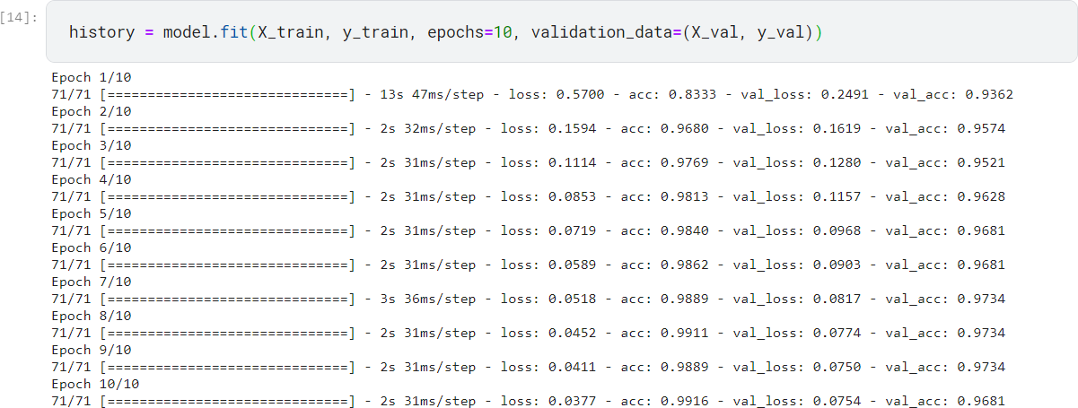

* ​

# 5: Testing the Model

* Model testing is the process of evaluating the performance of a deep learning model on a dataset that it has not seen before. It is a crucial step in the development of any machine learning model, as it helps to determine how well the model can generalize to new data.
* The accuracy and loss can be visualized to check the correlation between the epochs and loss or epochs and accuracy.

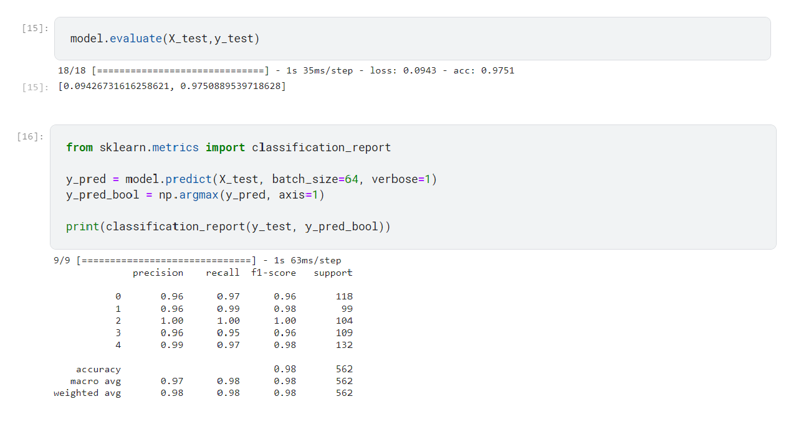

•

* ​
* **6: Visualizing Accuracy and Loss**

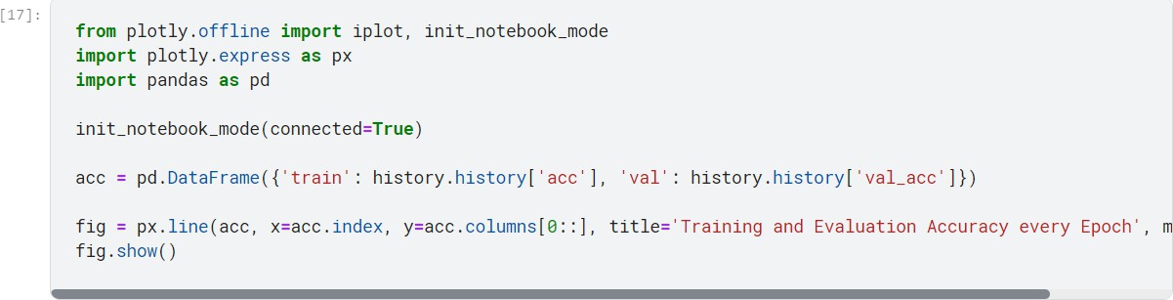

* ​
* Here we will take a image of basmati rice and check what our model predicts for the same.

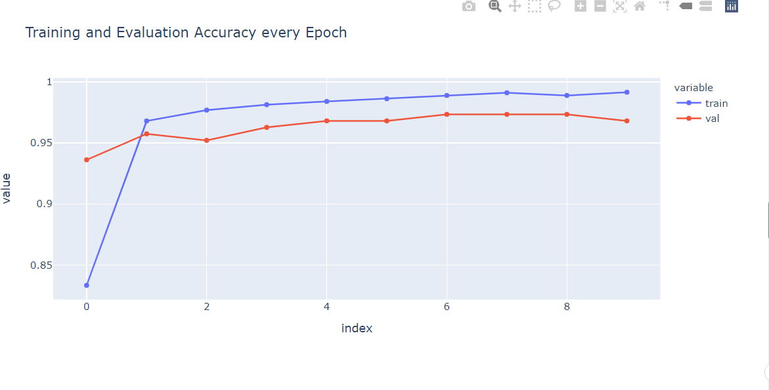

* ​
* **7: Testing the Model:**
* ​
* ​

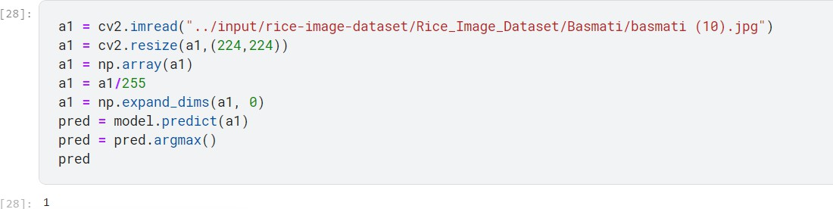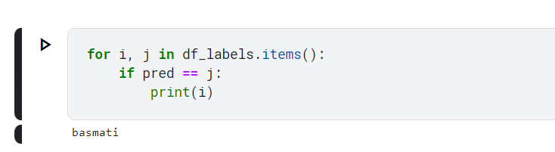

•

* As we can see our model has predicted the rice to be Basmati rice, means our model is giving correct predictions.

# Save the Model

* The model is saved as rice.h5
* A .h5 file is a data file saved in the hdf5 format. It contains multidimensional arrays of scientific data.



* ​

## 5: Application Building

* In this section, we will be building a web application that is integrated to the model we built.

A UI is provided for the user where they have to upload the image for predictions. The entered image is given to the saved model and prediction is showcased on the UI.

* This section has the following tasks
* Building HTML Pages
* Building server side script

## 1: Building Html Pages:

* For this project create 3 HTML files namely
* Index.html
* Details.html
* Results.html
* ​
* Let’s see how our index.html page looks like:
* 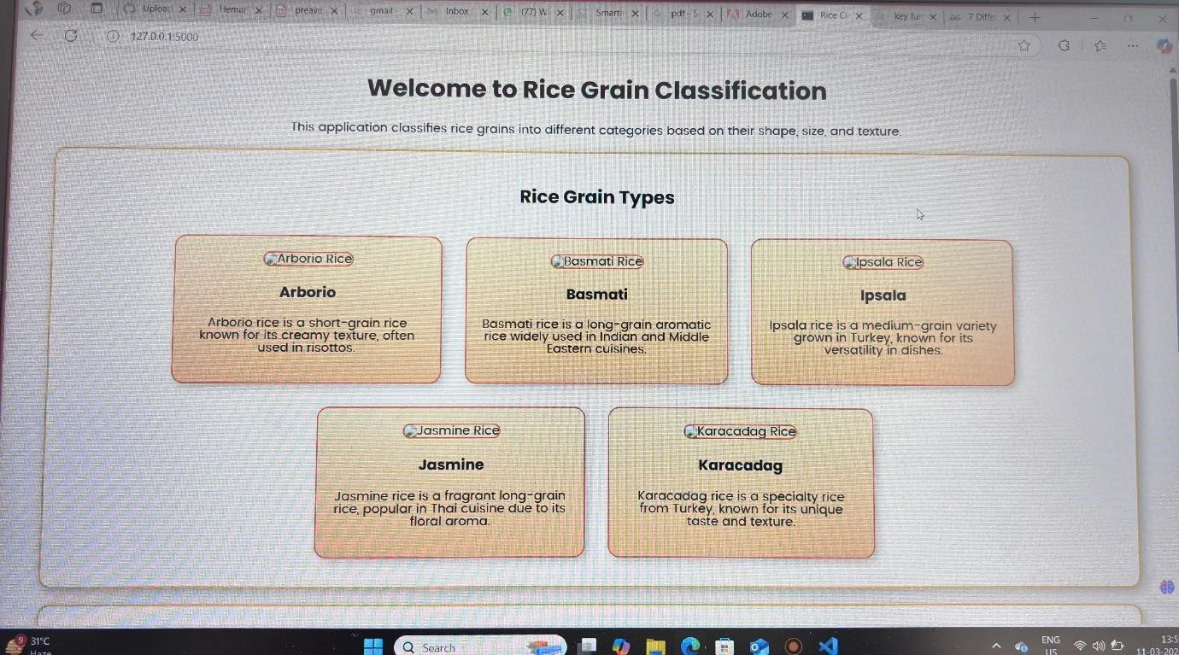
* All the sections below are included in the index.html page.
* 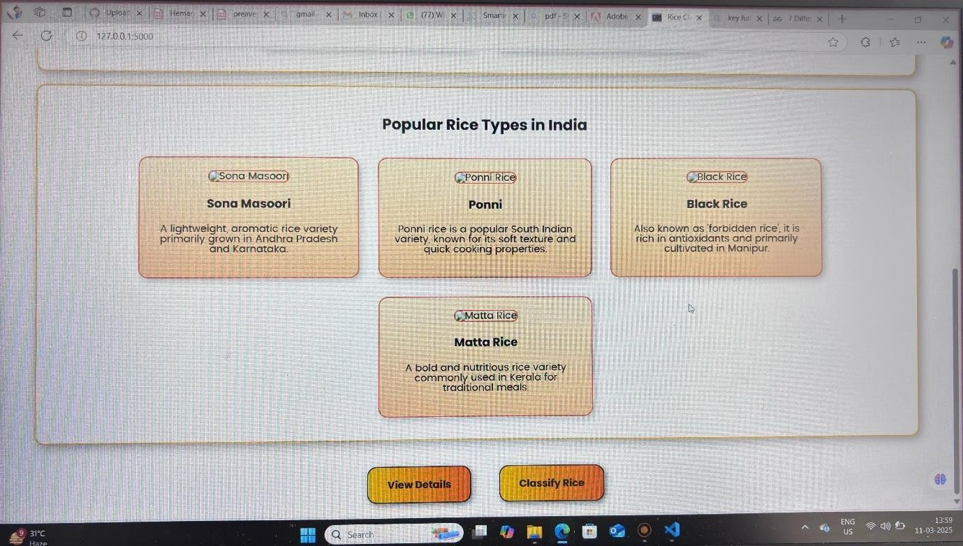
* When you click on the predict button, it will display the below page. You can test the model by

passing a image

# 2: Build Python code:

* mport the libraries
* ​

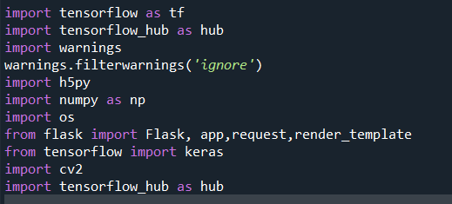

•

•

* Loading the saved model and initializing the flask app
* ​



* ​
* ​
* ​
* Render HTML pages:
* ​
* 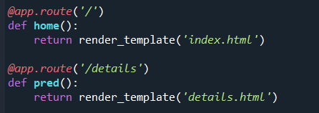
* ​
* Once we uploaded the file into the app, then verifying the file uploaded properly or not. Here we will be using declared constructor to route to the HTML page which we have created earlier.
* ​
* In the above example, ‘/’ URL is bound with index.html function. Hence, when the home page of the web server is opened in browser, the html page will be rendered. Whenever you enter the values from the html page the values can be retrieved using POST Method.
* ​
* ​

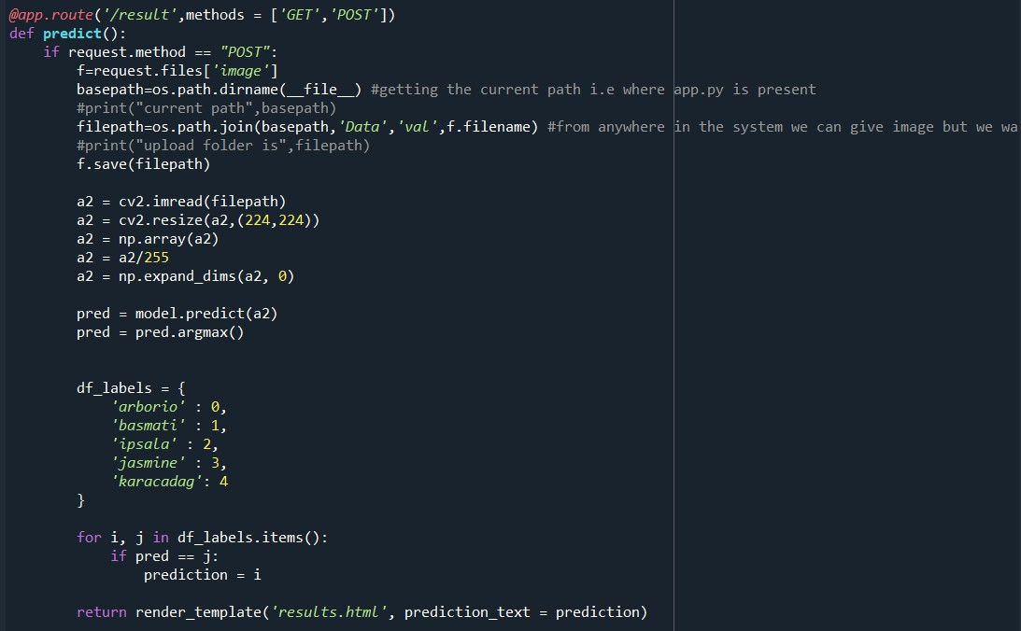

* ​
* ​
* ​
* ​
* Here we are routing our app to predict function. This function retrieves all the values from the HTML page using Post request. That is stored in variable image and then converted into an array. This array is passed to the model.predict() function. This function returns the prediction. And this prediction value will rendered to the text that we have mentioned in the result.html page earlier.
* ​
* Main Function:
* ​
* 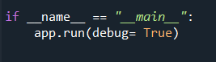

## 3: Run the application

* Open the Anaconda prompt from the start menu.
* Navigate to the folder where your Python script is.
* Now type the “python app.py” command.
* Navigate to the localhost where you can view your web page.
* Click on the predict button from the top right corner, enter the inputs, click on the submit button, and see the result/prediction on the web.
* ​
* 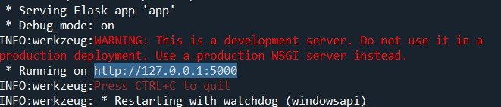
* ​
* The home page looks like this. When you click on the button “Predict”, you’ll be redirected to the predict section
* Input 1
* 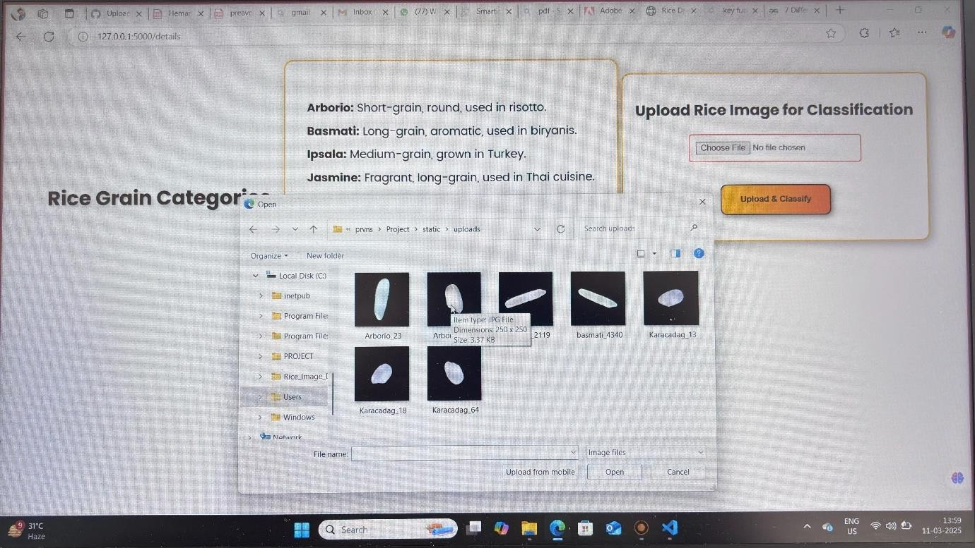

Output 1

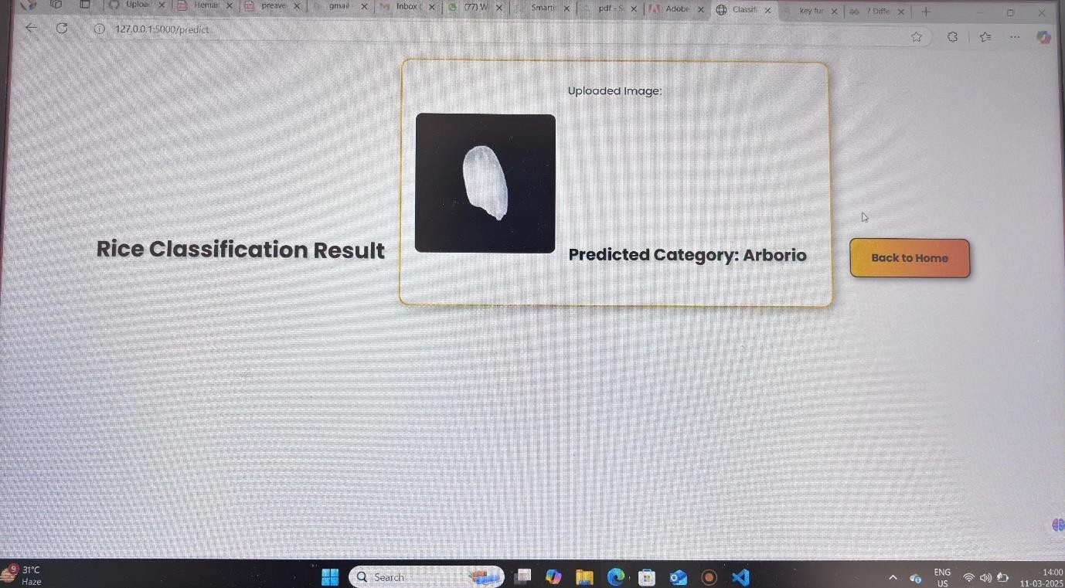

Input 2

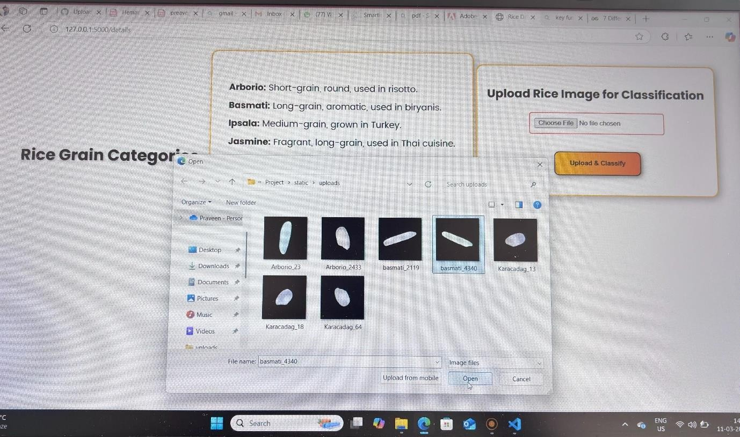

Output 2

