Low Frequency Function Generator

CB.EN.U4ECE21243 Pujiita Srieya Bolisetty
CB.EN.U4ECE21244 Puppala Sravan
CB.EN.U4ECE21256 Sivaraju Venkata Sai Karthik

in partial fulfillment of the requirements for the course
19ECE384 – Open Lab


Department of Electronics and Communication Engineering, Amrita School of Engineering,
Amrita Vishwa Vidyapeetham, Coimbatore – 641112

June 2024

- Motivation: The inspiration for developing a multifunctional signal generator stems from the critical need for versatile and precise signal sources in various scientific and engineering applications. Whether in educational settings, research labs, or industrial environments, having a single device that can produce sine, square, triangle, and pulse waveforms with adjustable amplitude and frequency significantly enhances experimentation and prototyping efficiency. This project aims to bridge the gap between affordability and functionality, providing an accessible yet powerful tool to support a wide range of electronic and signal processing projects.
- Problem Statement: To develop a multifunctional signal generator capable of producing various waveform outputs, including sine, square, triangle, and pulse waves. This versatile device allows users to customize both the amplitude and frequency of the generated signals, making it suitable for a wide range of applications such as testing and troubleshooting electronic circuits, designing and analyzing audio equipment, and educational purposes in laboratories.
The signal generator will incorporate user-friendly controls for adjusting the amplitude and frequency within predefined ranges. These ranges will be selected to cover typical values required in most practical scenarios, ensuring the device's applicability in different fields. The amplitude adjustment will enable users to set the desired voltage level of the output signal, while the frequency adjustment will allow the selection of the signal's oscillation rate.
Specifications:
  - Types of Waveforms: Sine, square, triangle, and pulse
  - Power supply: 13V
  - Minimum Frequency: 10 Hz
  - Maximum Frequency: 100Hz
  - Minimum Amplitude: 2V peak-to-peak
  - Maximum Amplitude: 16V peak-to-peak (adjustable with amplitude control)
  - Adjustable Duty Cycle:
  - 6 Pin Push Switch: Accepting 12V and 13V DC

- Design Procedure:
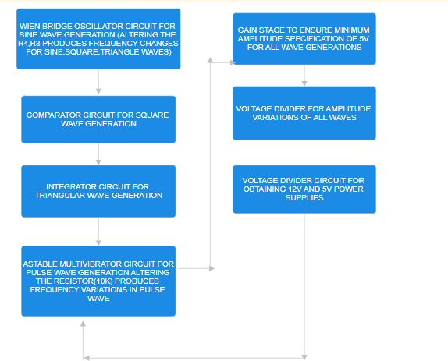
- Budget:

COMPONENT | QUANTITY | COST
IC555 Timer | 1 | ₹ 5
Op-amp ua741 | 6 | ₹ 60
6 Pin Push Switch | 5 | ₹ 25
Potentiometer-10k | 1 | ₹ 10
Potentiometer-47k | 3 | ₹ 30
Breadboard | 1 | ₹ 100
 | Total | ₹ 230
- Circuit Diagram / Board Layout / Schematic:
- Sine Wave:
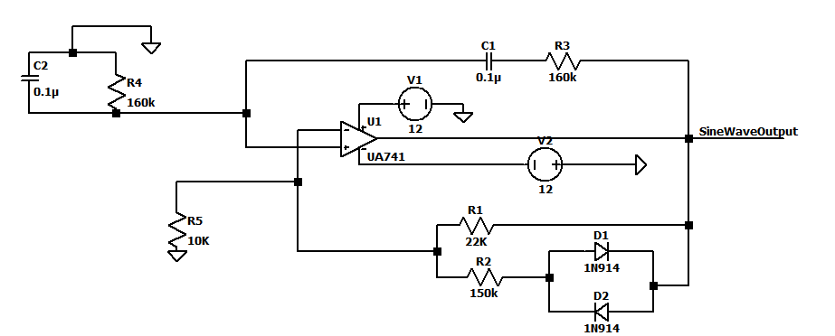

- Square Wave:

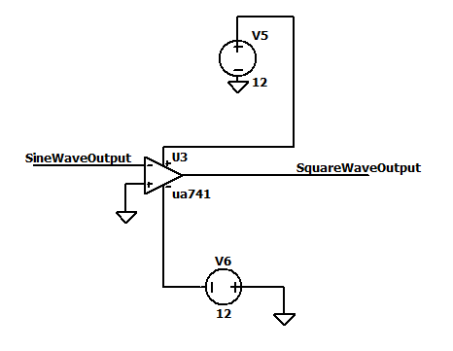

- Triangle wave:

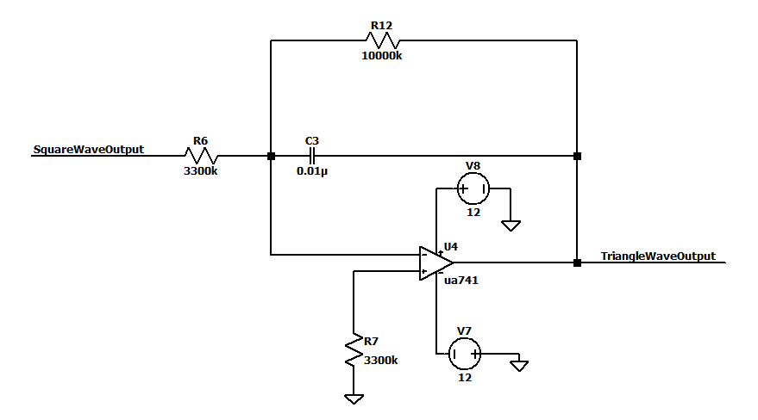

- Pulse Wave:
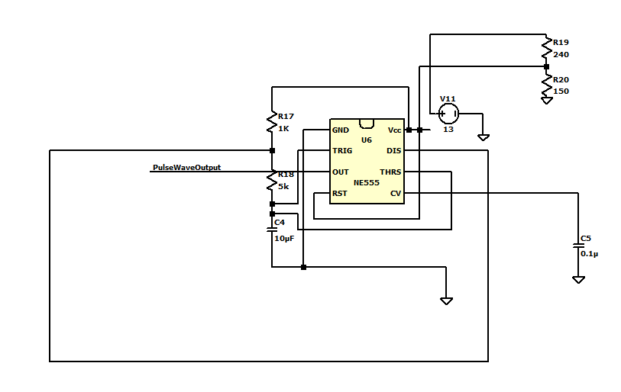

- Gain Stage:
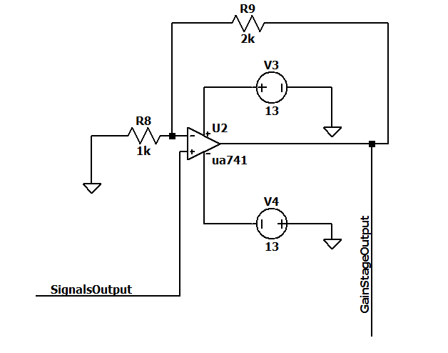

- Voltage Divider for amplitude variations:
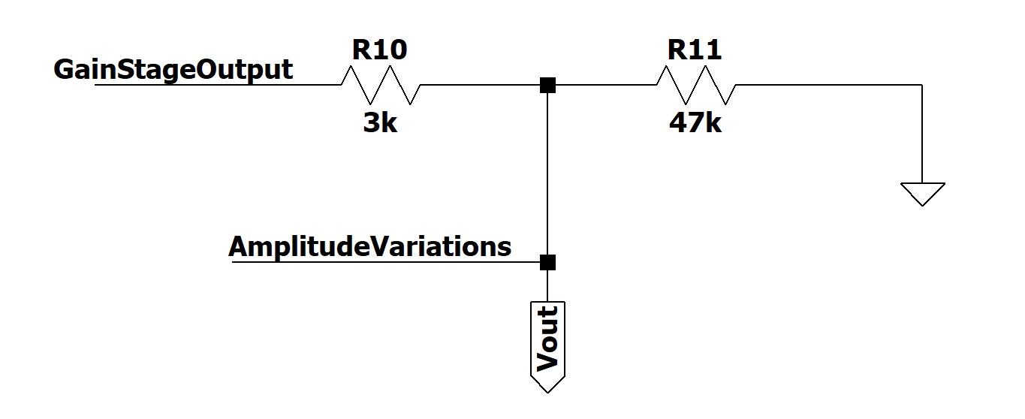
- Circuit Diagram:
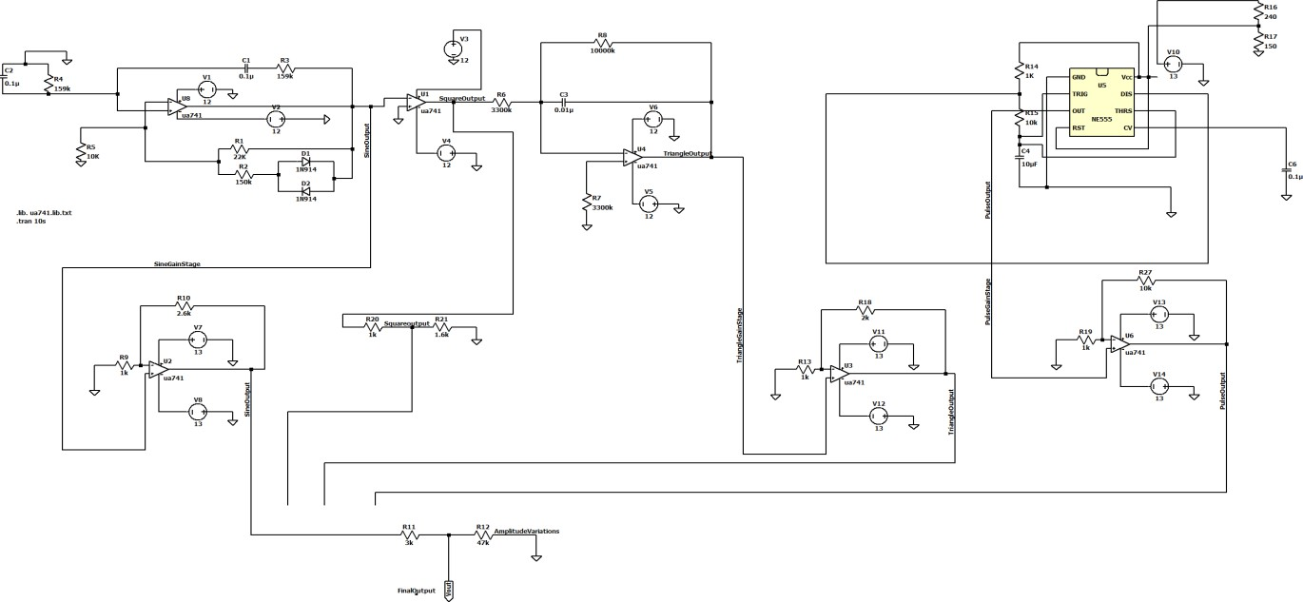
- Simulation Results / Discussion:
The LTspice simulation of the multifunctional signal generator demonstrates precise control over sine, square, triangle, and pulse waveforms. The sine wave output shows smooth, continuous oscillations, while the square wave features distinct high and low states with sharp transitions. The triangle wave exhibits linear rise and fall slopes, and the pulse wave allows adjustable duty cycles. Adjusting amplitude and frequency in the simulation scales the waveforms and changes the cycles per second, respectively.

Simulation results for minimum frequency of 10Hz are below:
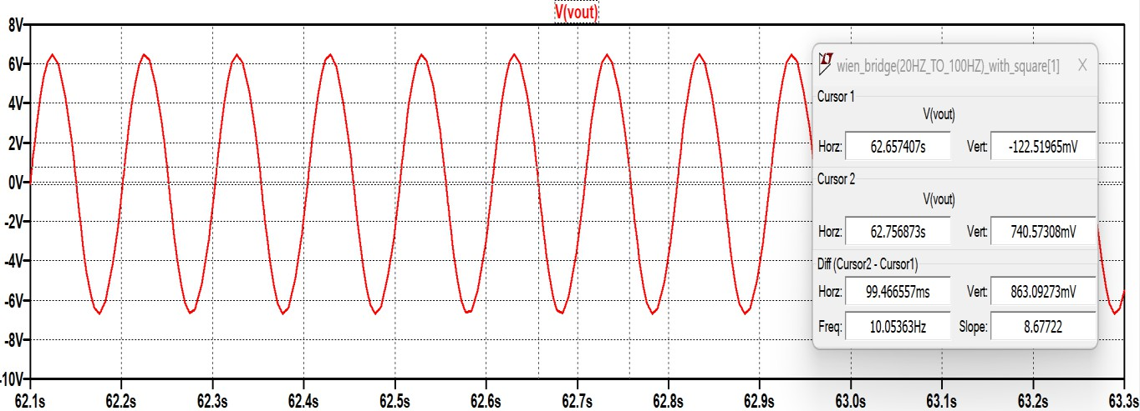

Fig. 1 Sine Wave Output
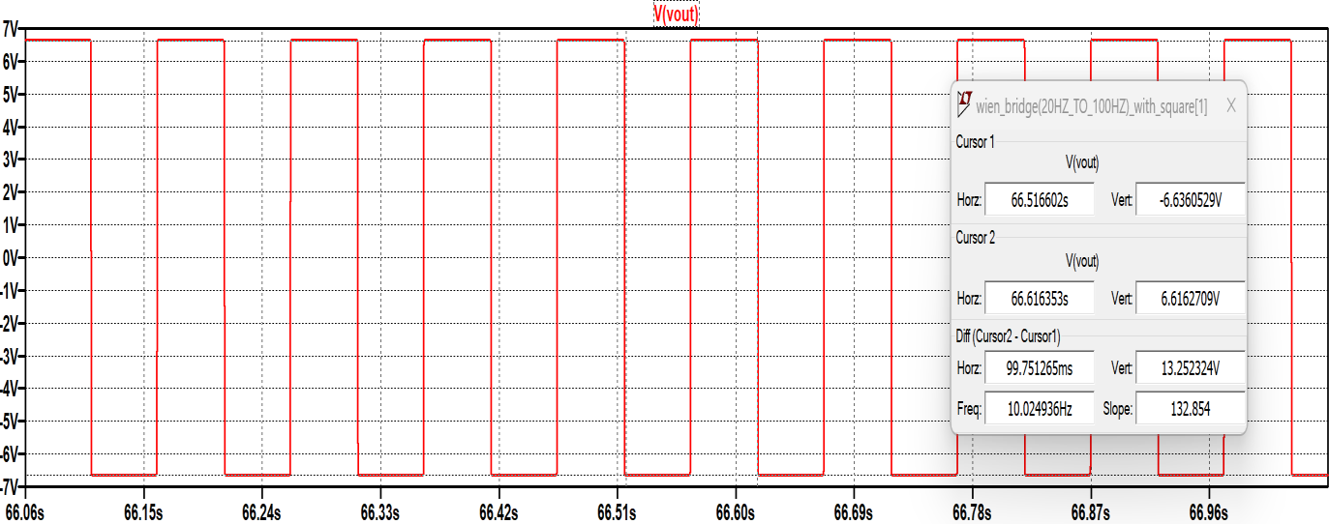
Fig. 2 Square Wave Output

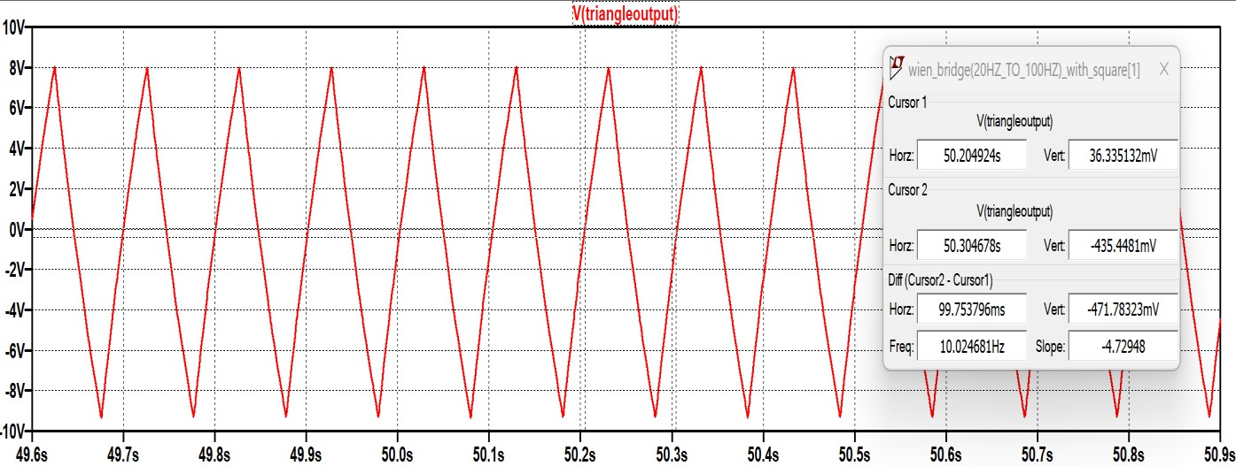
Fig. 3 Triangle Wave Output

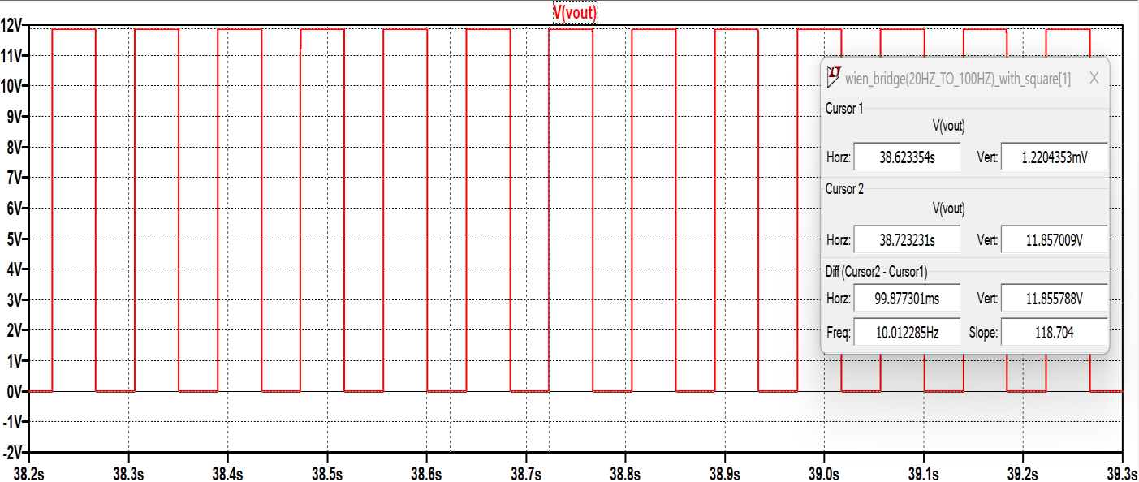
Fig. 4 Pulse Wave Output

- Implementation / Prototytping results:
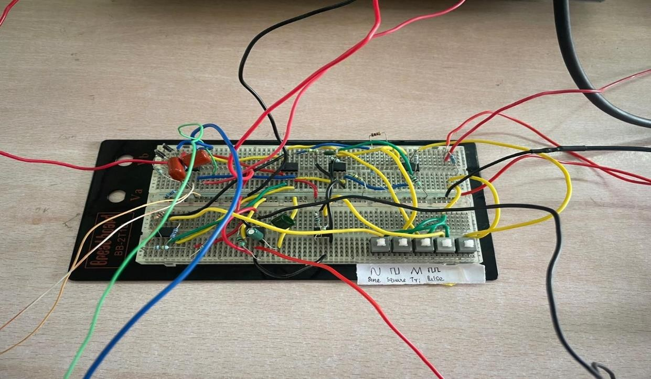
Fig. 4 Hardware Circuit
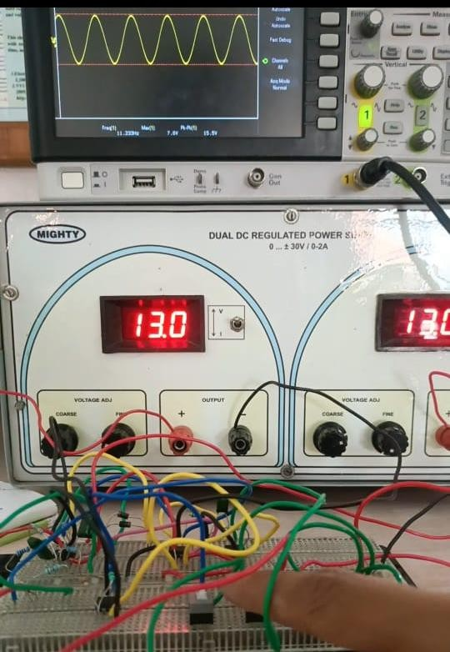

Fig. 5 Sine Wave Output

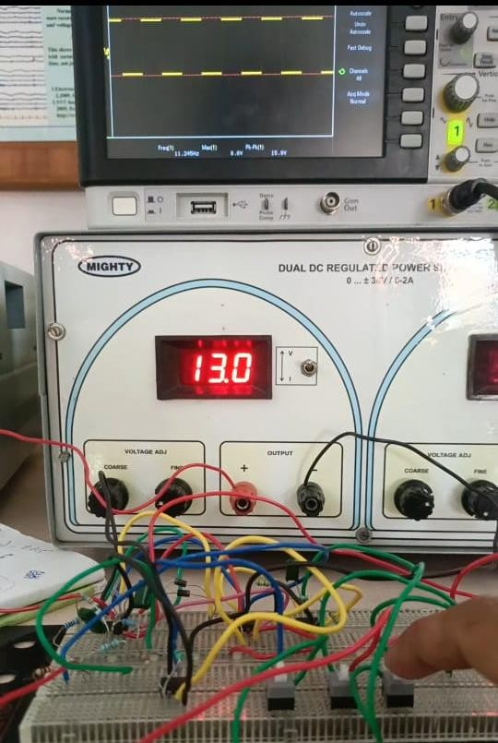

Fig. 6 Square Wave Output
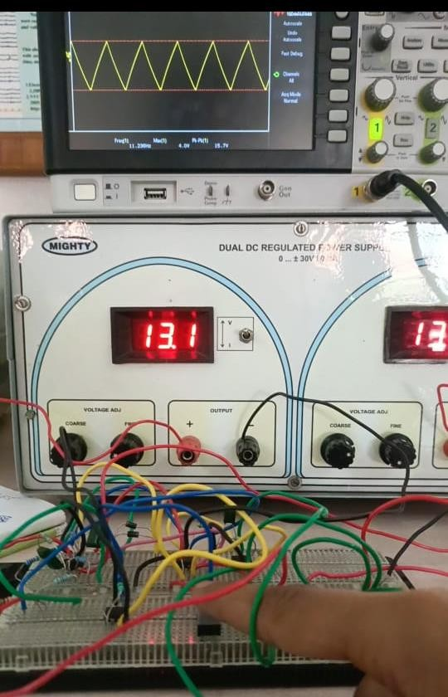
Fig. 7 Triangle Wave Output

- Discussion & Conclusions: Our low frequency function generator yields the required wave upon the switch pressing labelled with corresponding wave and amplitude can be altered ( a minimum of 5V(p-p) is guaranteed by utilizing gain stages. The results could have been even more better if variable capacitor has been utilized as the potentiometer tuning in wien bridge stage for frequency variations is causing amplitude variations which could be resolved upon usage of variable capacitors which would provide a standard amplitude for a particular frequency.

