Appendix:
Installation Instruction:

Installation Manual

The Project “COURSE MANAGEMENT SYSTEM” can be run on a personal computer using the software’s TOMCAT, MYSQL, and JAVA with the versions JDK1.5. TOMCAT 5.5, MYSQL 5.1 Installation steps for those software are given in this manual.

Setting up Tomcat Server as Windows Service

Tomcat Server Installation is easy with the following steps.
The server installation process (setupserver.bat) automatically starts tomcat installation which brings up wizard screens shown below.
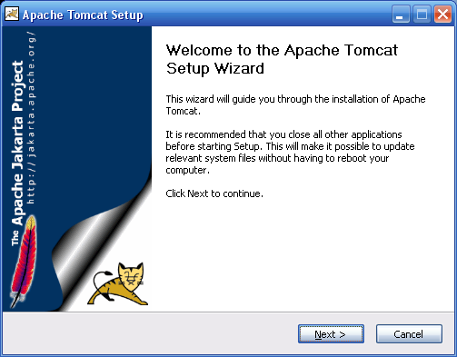

Click Next on the first screen as shown above:
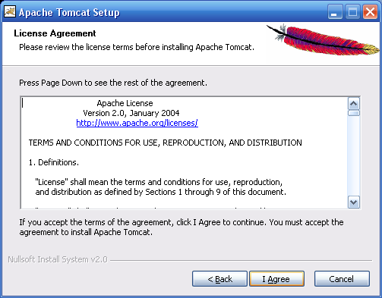
Click on I Agree button:
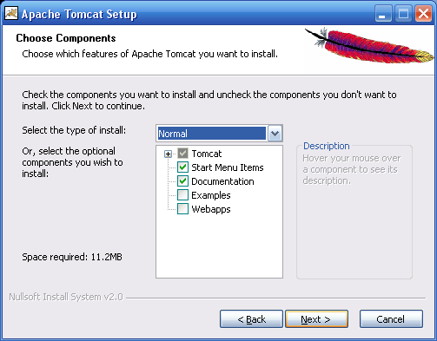
Click Next button
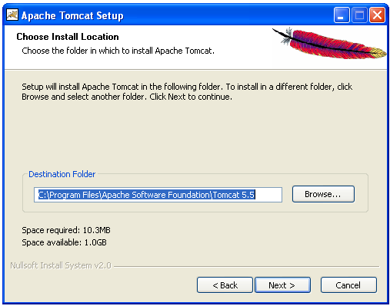
Choose the directory to install Tomcat by browse option then click on next button.
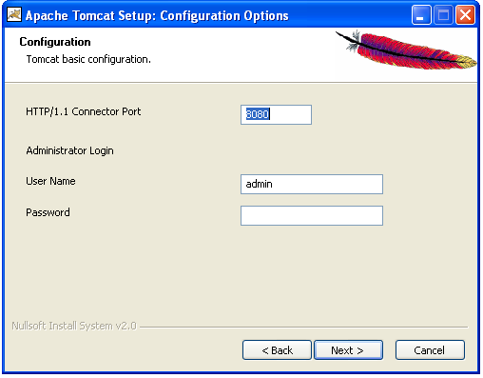
Here we can choose our desired port no user name and password then click on next button.but defaultly port is 8080 for tomcat.

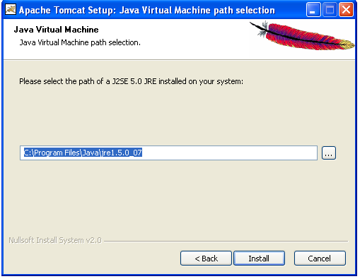
Click on next button
Installation starts
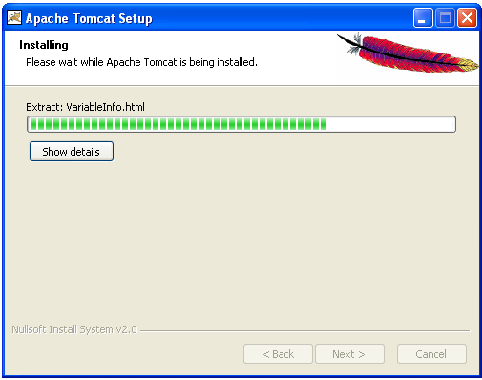
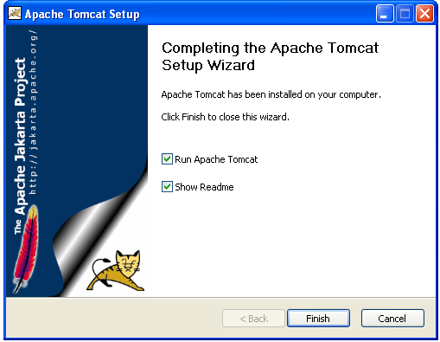
Click on finish button .

Setting up MySql as Windows Service
Below are the steps to install MySql server as windows service. Installtion can be done easily with the followng steps.First start installing by clicking setup.exe
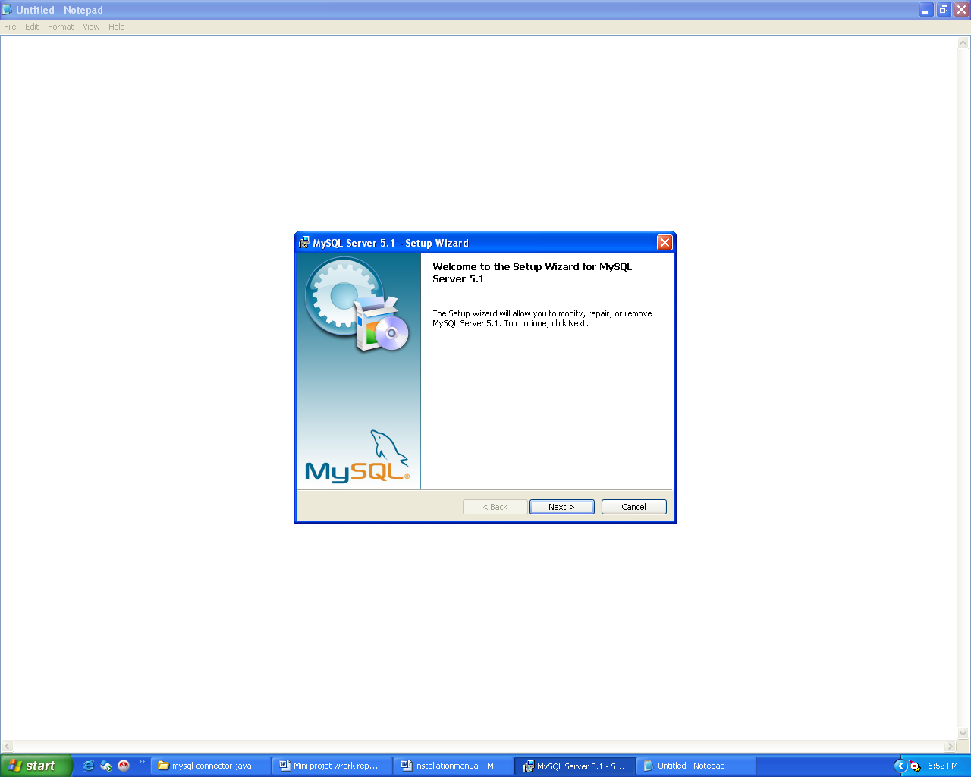
Below is the screen to come after clicking setup.exe
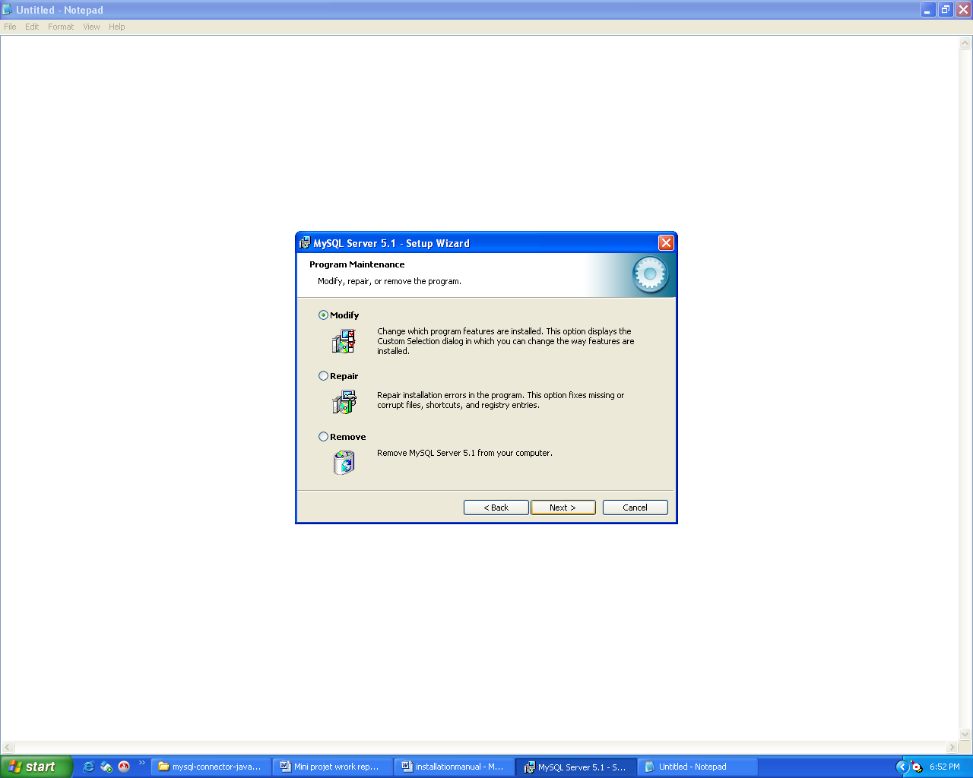
Click Next button on screen
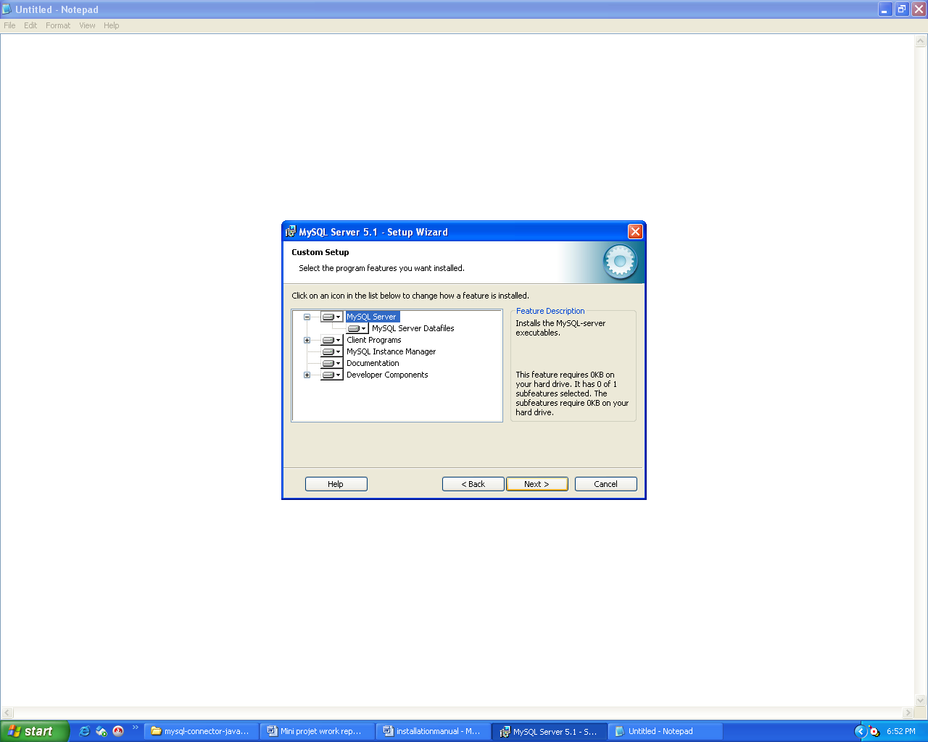
Again Click Next button on screen:
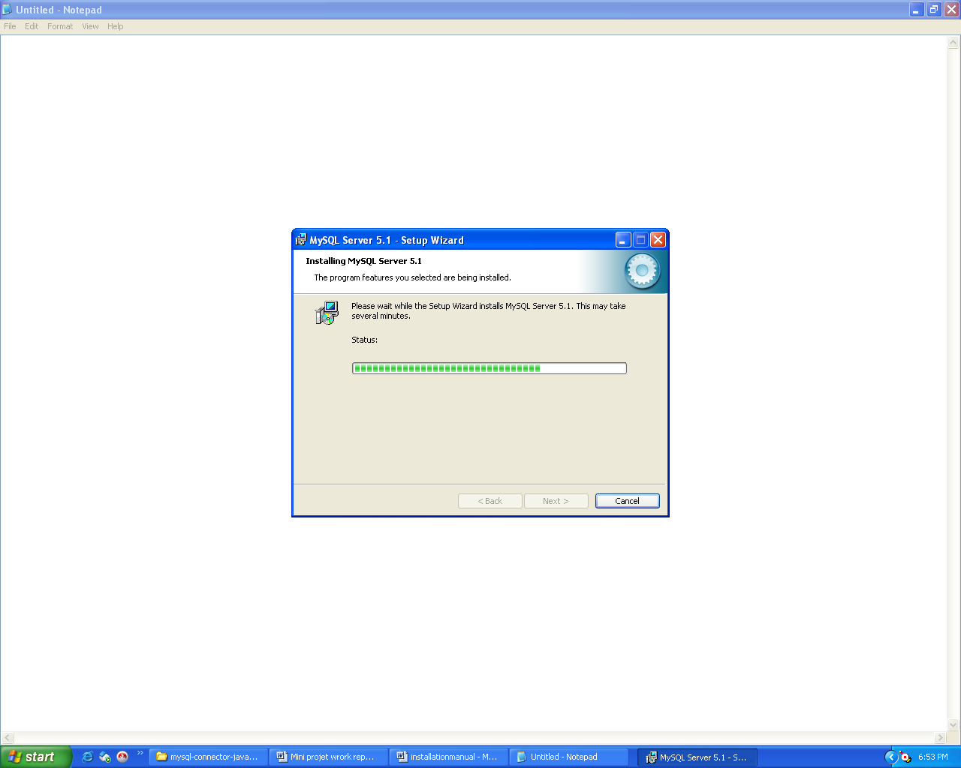
Here, Installation Starts.
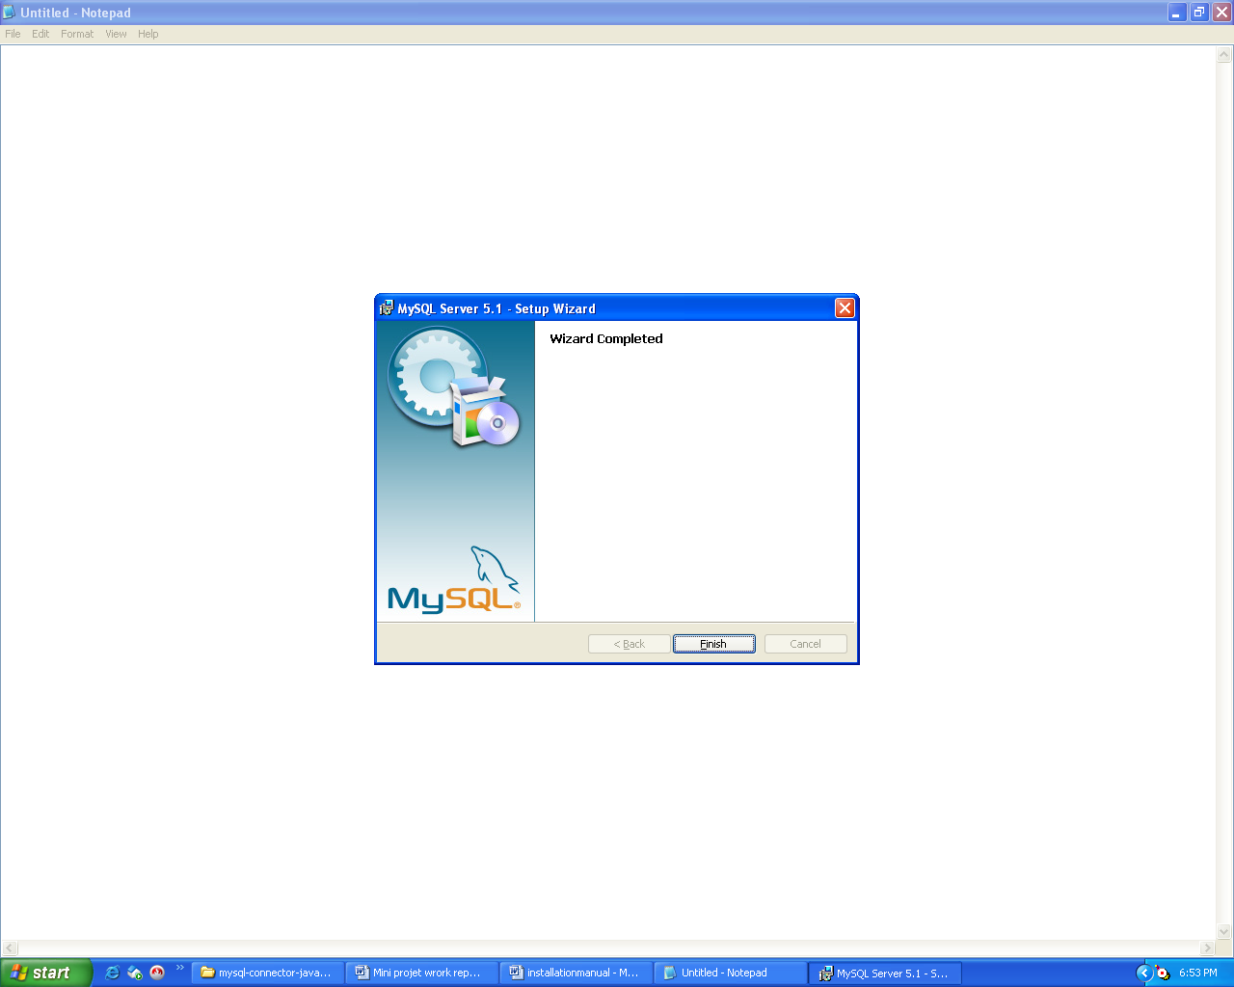
Installation Completed
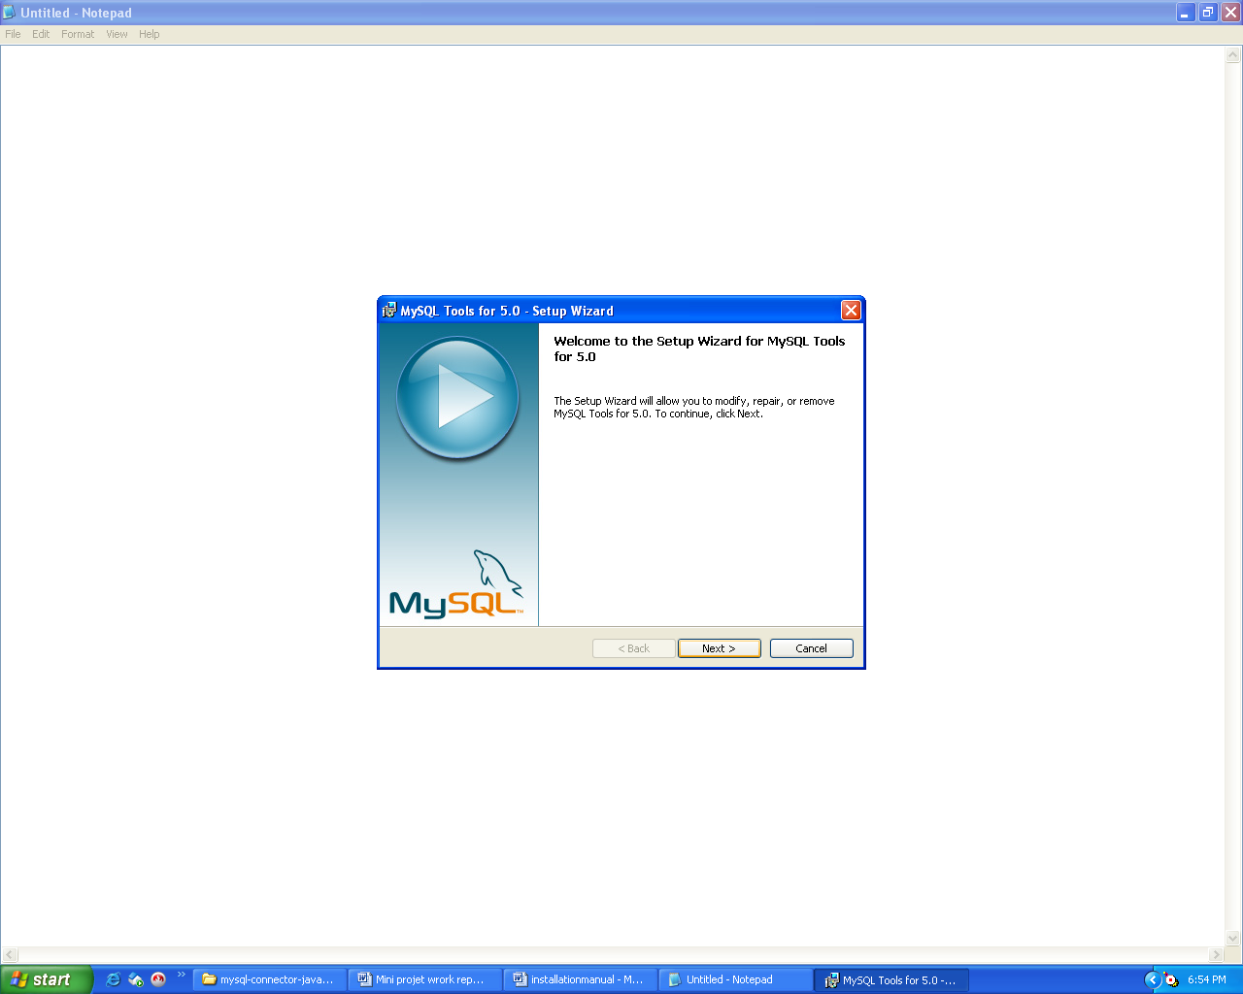
Click Next to Install Tomcat5.0 tools
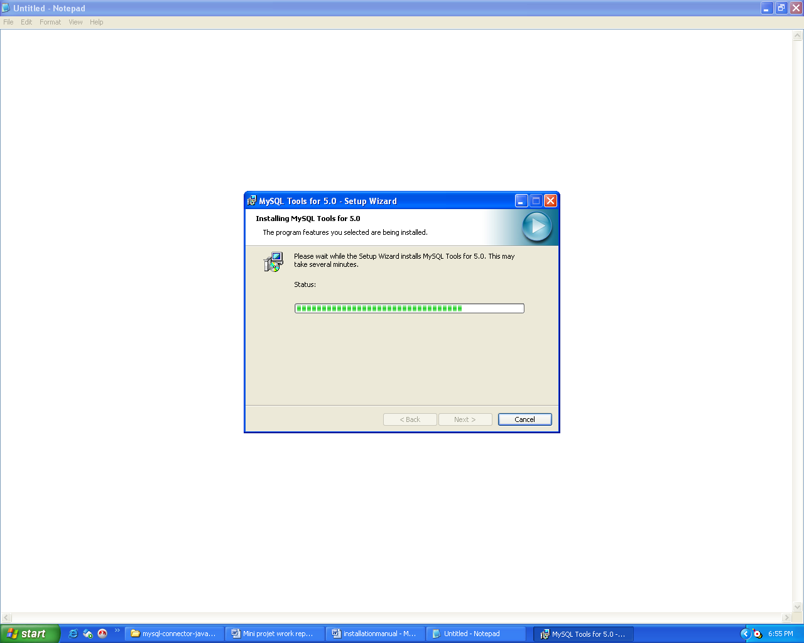
Click on Finish button.
Installation of Jdk
Step-1: Double-Click on file “jdk-1_5_0-windows-i586.exe” and then we can observe the following screen.
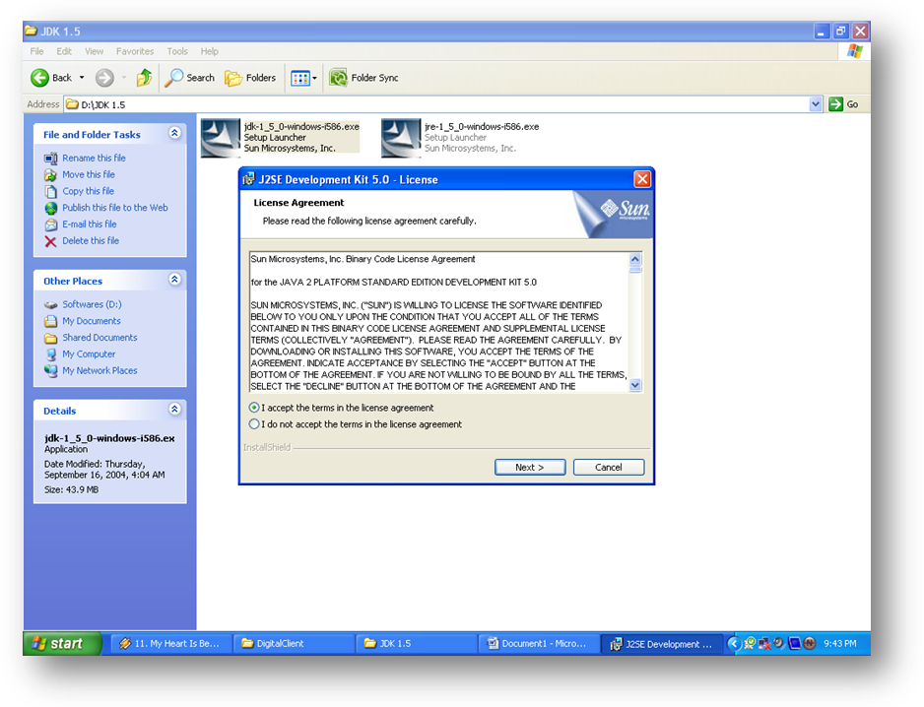
`Step-2: Then select the options of JDK 5.0 and their screen shots as follows:
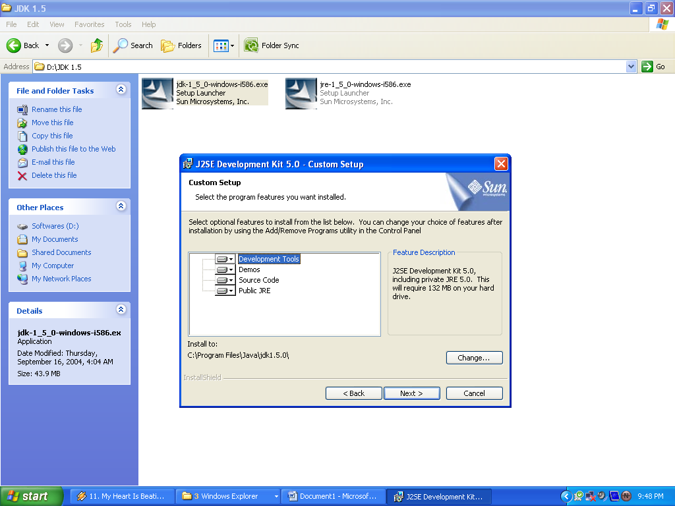
Step – 3: It will implicitly invoke the required Java Runtime Environment 5.0 – Custom Setup as shown below:
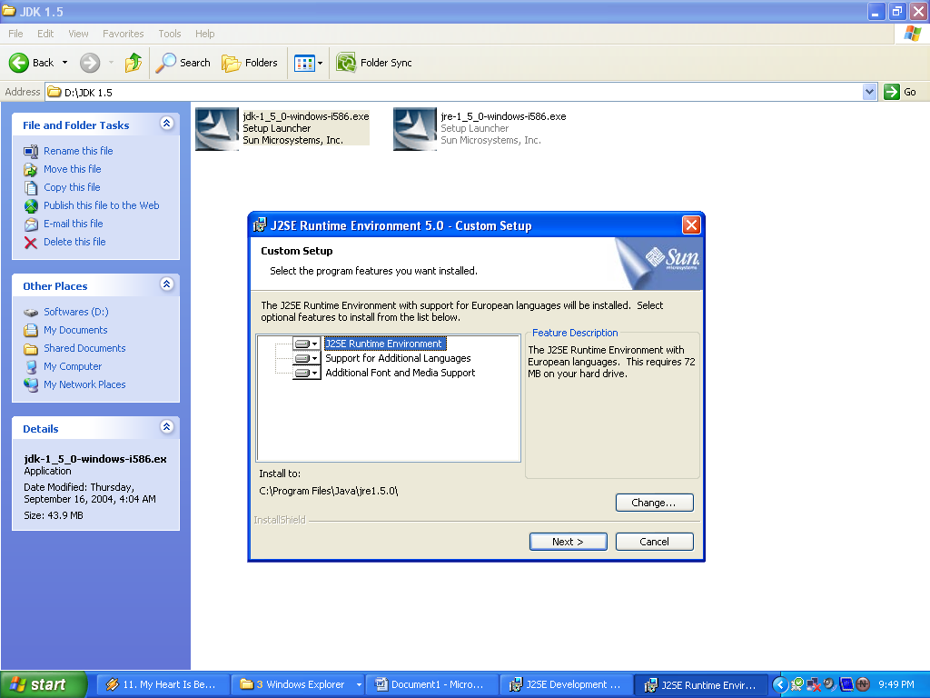
Jdk 1.5 is installed in the system

User Manual:

Installation:
Make sure that the system meets the software and hardware requirements.
Server Side Installation:
Deploy the content of the folder course into the webapps folder of the web server.
For example : <tomcat-home>\webapps\
Then we have to place some jar files in
- Java environment as we are using mysql as backend, so to make connection between jdk and mysql we have to place mysql-connector-java-5.1.11-stable-bin.jar (provided in jars folder in this cd)into C:\Program Files\Java\jre1.6.0_07\lib\ext.
- Jars which are needed for our application they are also provided in jars folder they should be placed in C:\Tomcat 5.5\common\lib.
Client Side Installation:
- Being the web-based system make sure that internet explorer installed on the system.
- Access the application using http://<server-ip>:8080
- Enter tomcat-manager.
- Access course application.
Paths to be Set:
- CATALINA_HOME
C:\Program Files\Apache Software Foundation\Tomcat 5.5;
- JAVA_HOME
C:\Program Files\Java\jdk1.6.0_12;
- classpath
C:\Program Files\Apache Software Foundation\Tomcat 5.5\common\lib\servlet-api.jar;

Glossary:
DBMS Data Base Management Systems.
DML Data Manipulation Language.
HTML Hyper Text Markup Language.
J2EE Java 2 Enterprise Edition.
JDBC Java Data Base Connectivity.
JVM Java Virtual Machine.
ODBC Open Data Base Connectivity.
SQL Structured Query Language.
UML Unified Modeling Language

