Navigate to below deployed Azure URL
https://smartanalyzer20240317170508.azurewebsites.net/

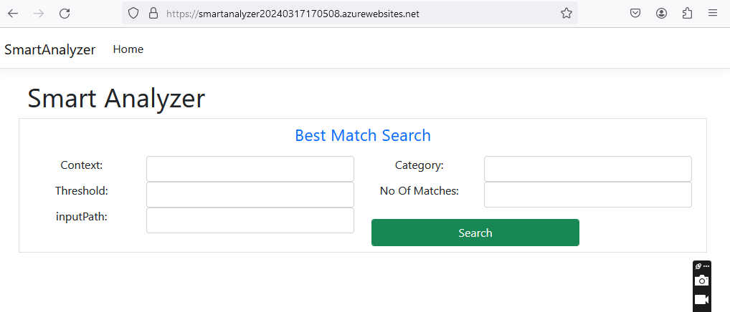

Currently we have created our own Blob storage as we are seeing error while connecting with existing Azure Blob Storage, data might be retrieved from our newly created Blob Storage.
Blob Storage details :
