## Design

### Structural Diagrams

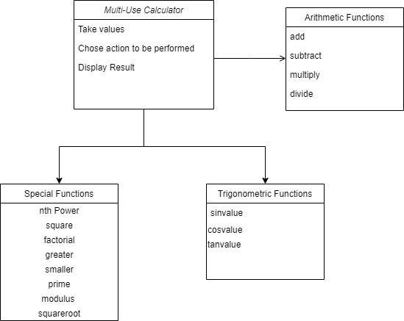

Fig 1 Class Diagram of multiuse calculator

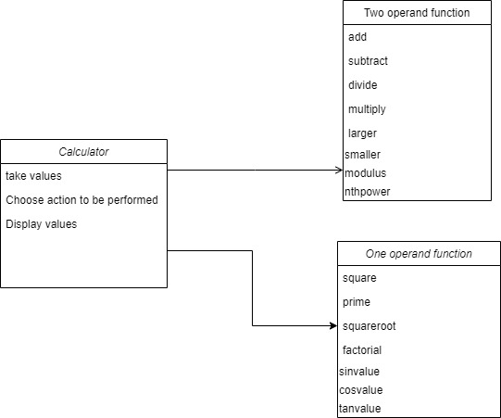

Fig 2 Component Diagram

### Behavioral Diagrams

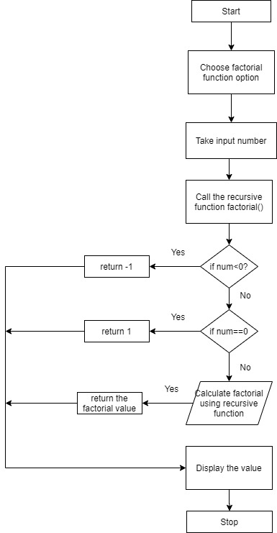

Fig 3 Flow chart to calculate factorial of a number

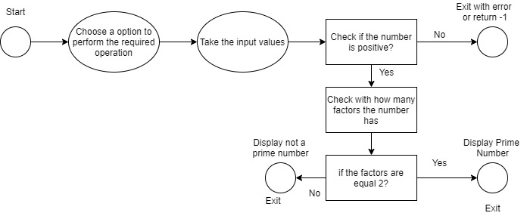

Fig 4 State diagram to find the prime number