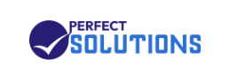
PERFECT SOLUTIONS
Unleashing IT Talent
Business Requirements
Document (BRD)
AurborBloom HRMS Implementation

Document Code | PS-BRD-2026-001
Version | 1.0
Date | May 07, 2026
Classification | Confidential — Internal Use
Prepared By | AurborBloom Product & Implementation Team

1. Document Control
Version | Date | Author | Reviewer | Description of Change
0.1 | 2026-01-15 | AurborBloom PM | Perfect Solutions HR | Initial draft
0.5 | 2026-01-22 | Implementation Lead | PS IT Director | Internal review
1.0 | 2026-05-07 | AurborBloom PM | PS Steering Committee | Approved baseline

1.1 Distribution List
Name / Role | Organization | Purpose
Director, IT Services | Perfect Solutions | Approver
Head of Human Resources | Perfect Solutions | Approver
Chief Financial Officer | Perfect Solutions | Reviewer
Engineering Manager | Perfect Solutions | Reviewer
Implementation Lead | AurborBloom | Owner
Product Manager | AurborBloom | Author

2. Executive Summary
Perfect Solutions is a mid-sized IT Services and Software Development firm headquartered in the United States, operating with a workforce of approximately 51–250 employees distributed across engineering, sales, marketing, finance, human resources, and general operations. As the company scales its delivery footprint and onboards increasingly distributed talent, it has identified the need to consolidate its people-operations stack onto a single, multi-tenant SaaS platform — AurborBloom HRMS.
This Business Requirements Document (BRD) captures the consolidated set of business goals, stakeholder expectations, success metrics, scope boundaries, and business-level requirements that must be satisfied by the AurborBloom HRMS deployment for Perfect Solutions. It serves as the contractual foundation upon which the Functional Requirements Document (FRD), system design, and acceptance test cases will be built.
Key Outcome Targets — reduce HR administrative effort by 60%, eliminate spreadsheet-driven tracking, achieve 99.9% platform availability, and deliver a measurable improvement in employee experience within two quarters of go-live.
2.1 Business Drivers
- Rapid headcount growth has outstripped existing spreadsheet- and email-based HR processes.
- Multiple disconnected tools (separate apps for leave, attendance, helpdesk, calendar) cause data drift and reconciliation overhead.
- Compliance and audit readiness demand a centralized, immutable record of HR transactions.
- Distributed teams require a single, branded portal accessible from any device.
- Leadership requires real-time, role-based dashboards for workforce decisions.

3. Company Overview — Perfect Solutions
Attribute | Value
Legal Name | Perfect Solutions
Industry | IT Services & Software Development
Company Size | Medium (51 – 250 employees)
Primary Markets | United States, with offshore engineering presence
Brand Tagline | Unleashing IT Talent
Primary Brand Color | #1E3A8A (Deep Corporate Blue)
Secondary Brand Color | #3B82F6 (Action Blue)
Public Website | www.perfectgroupus.com
HRMS Tenant Slug | perfectsolutions
Custom Domain | hr.perfectsolutions.com
Departments In Scope | Engineering, Sales, Marketing, Finance, Human Resources, General
3.1 Strategic Context
Perfect Solutions positions itself as a high-velocity IT talent firm. The HR function is therefore not a back-office cost center but a competitive differentiator: speed of hiring, accuracy of billing for time-and-materials engagements, and employee retention all flow directly through HR systems. The HRMS is therefore treated as a Tier-1 business system with stringent uptime, security, and reporting requirements.
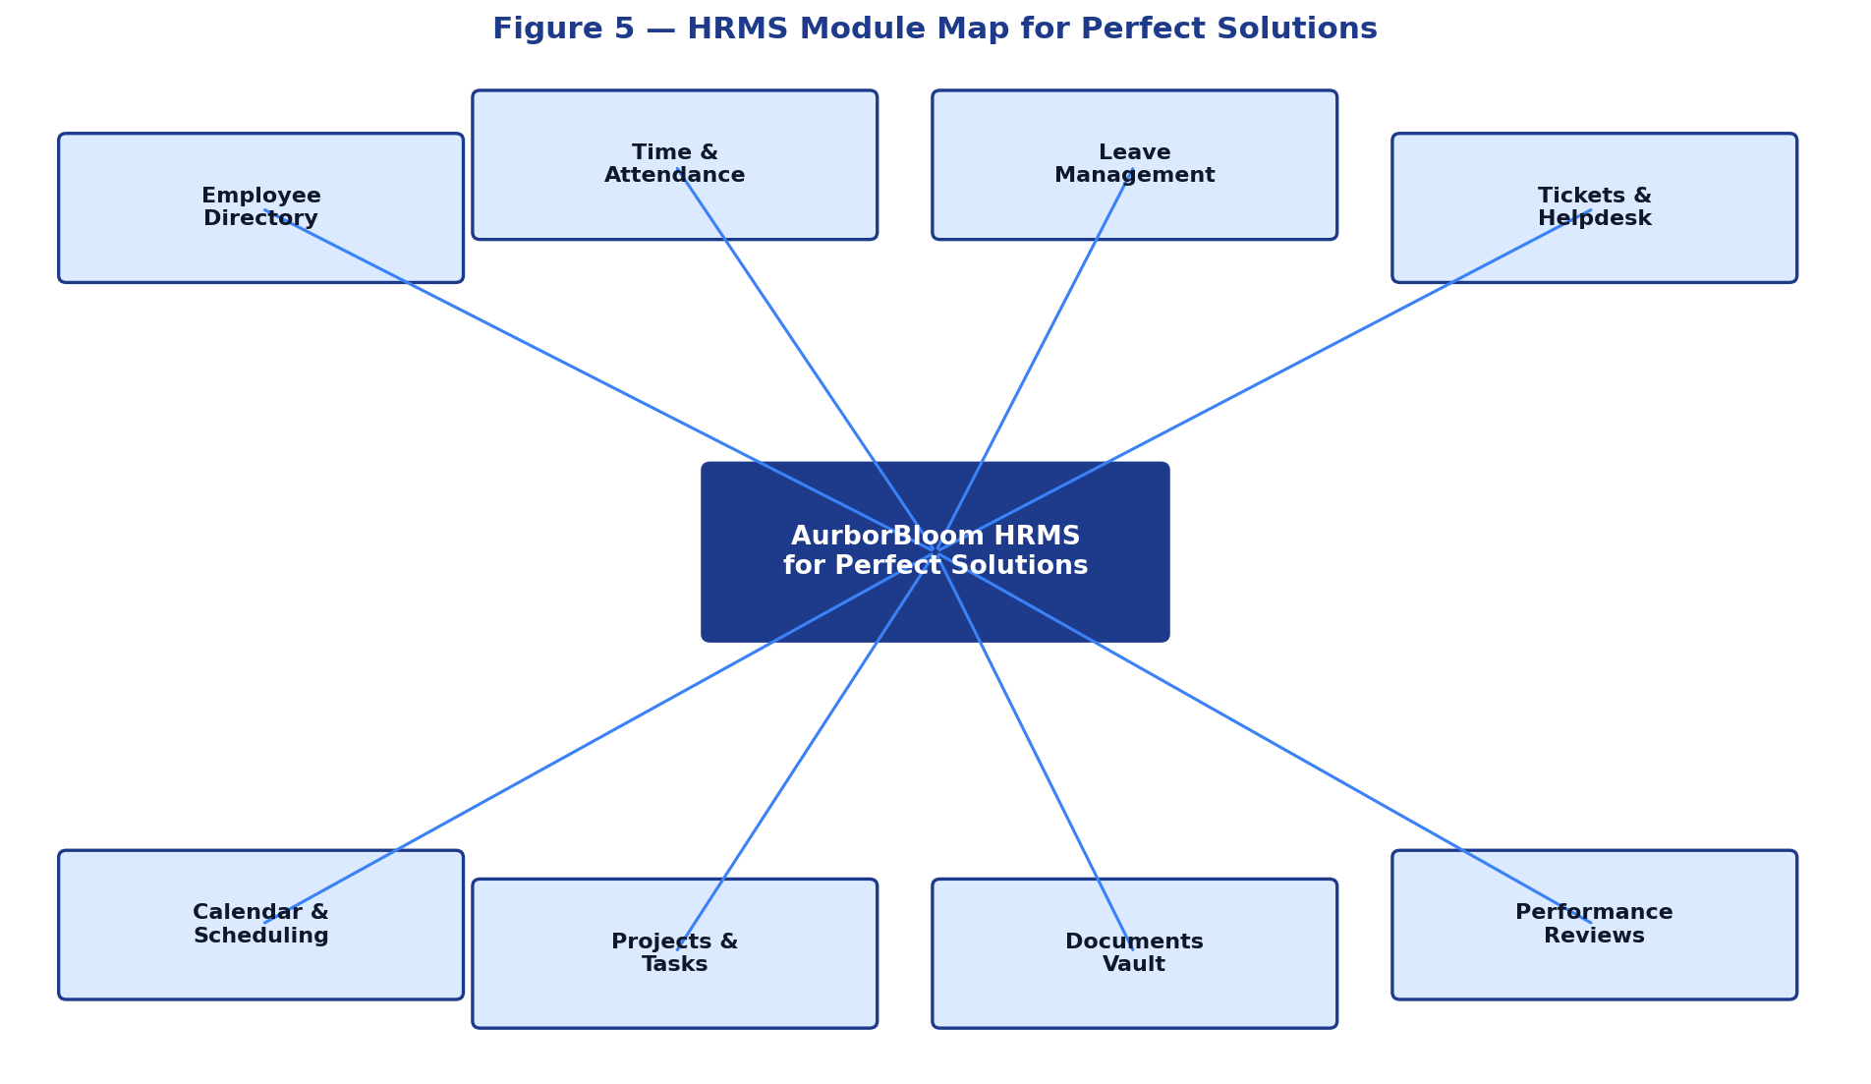
Figure 5 — HRMS Module Map for Perfect Solutions

4. Stakeholders & User Personas
The following stakeholder map identifies the primary actors who will interact with, sponsor, govern, or be impacted by the AurborBloom HRMS deployment for Perfect Solutions.
Stakeholder | Role | Influence | Interest | Engagement Strategy
Director, IT Services | Executive Sponsor | High | High | Steering committee, monthly review
Head of Human Resources | Business Owner | High | High | Weekly working group
CFO | Financial Approver | High | Medium | Budget gates, ROI checkpoints
Engineering Manager | Power User | Medium | High | Pilot user, feedback loop
HR Operations Lead | Day-to-day Owner | Medium | High | UAT, training champion
IT Security Officer | Risk Approver | High | Medium | Security review at each phase
Employees (all) | End Users | Low | High | Onboarding sessions, in-app guides
Managers (all departments) | Approvers | Medium | High | Train-the-trainer model
External Auditor | Compliance Reviewer | Medium | Low | Read-only access at audit time
4.1 Detailed User Personas
Priya — HR Operations Lead
Role: Manages onboarding, leave approvals, policy enforcement, audit responses.
Pain Points: Manual data entry, chasing managers for approvals, reconciling spreadsheets, generating monthly reports.
Desired Outcome: A single dashboard with pending approvals, automated reminders, and one-click report exports.

Daniel — Engineering Manager
Role: Approves time, leave, and ticket escalations for an engineering team of ~25.
Pain Points: Switching between tools, no real-time visibility into team capacity, approval requests buried in email.
Desired Outcome: Mobile-friendly approval queue, team capacity heatmap, project allocation visibility.

Anita — Software Engineer
Role: Logs hours, requests leave, raises IT helpdesk tickets, downloads payslips.
Pain Points: Forgetting to log time, unclear leave balance, no visibility into ticket status.
Desired Outcome: Friction-free time entry, instant leave balance, ticket status notifications.

Marcus — CFO
Role: Approves payroll, monitors workforce cost, reviews compliance posture.
Pain Points: Late or inconsistent reports, lack of trend visibility, manual reconciliation with payroll vendor.
Desired Outcome: Executive dashboard with cost-per-department, trend charts, exportable payroll registers.

Sophia — IT Security Officer
Role: Owns access governance, data classification, audit response.
Pain Points: No central audit log, ambiguous role definitions, password sprawl.
Desired Outcome: Immutable audit trail, granular RBAC, SSO/2FA, encryption at rest and in transit.

5. Business Goals & Success Metrics
The following SMART business objectives have been agreed by the Perfect Solutions steering committee. Each objective is paired with a measurable Key Performance Indicator (KPI) and a target value to be achieved within two quarters of go-live (T+6 months).
# | Business Goal | KPI | Baseline | Target (T+6m)
BG-01 | Centralize all HR data into a single platform | % of HR processes on AurborBloom | 0% | ≥ 95%
BG-02 | Automate attendance and timesheet capture | Manual time-entry corrections / month | ~120 | < 15
BG-03 | Reduce leave processing cycle time | Avg. days from request to decision | 3.2 days | < 1 day
BG-04 | Improve internal support responsiveness | Avg. ticket first-response time | 8 hours | < 2 hours
BG-05 | Increase employee self-service adoption | % of leave/timesheet actions performed by employees themselves | 30% | ≥ 90%
BG-06 | Ensure audit-ready records | Audit findings related to HR data | — | Zero material findings
BG-07 | Strengthen brand experience | Employee NPS for HR tools | +12 | ≥ +45
BG-08 | Reduce HR operational cost | HR admin hours / 100 employees / month | 180 | ≤ 70
BG-09 | Achieve enterprise-grade availability | Platform uptime (rolling 30 days) | — | ≥ 99.9%
BG-10 | Enable data-driven workforce planning | Adoption of analytics dashboards by managers | — | ≥ 80% MAU

6. Scope of the Engagement
6.1 In Scope
- Multi-tenant deployment of AurborBloom HRMS for the perfectsolutions tenant.
- White-label branding: logo, primary/secondary colors, custom domain (hr.perfectsolutions.com), email sender identity, browser tab title.
- Modules: Authentication & RBAC, Employee Directory, Time & Attendance, Leave Management, Tickets / Helpdesk, Calendar & Scheduling, Projects & Tasks, Document Vault, Performance Reviews, Reports & Analytics, In-app Chat.
- Department configuration: General, Engineering, HR, Sales, Marketing, Finance.
- Leave types configured: Vacation, Sick, Personal, Unpaid.
- Role-based access control with at minimum: Super Admin, Tenant Admin, HR Manager, People Manager, Employee.
- Secure invite-only signup flow tied to tenant-specific admin invite codes.
- Data migration from existing spreadsheets for active employees and current leave balances.
- End-user training (admins, managers, employees) and operations runbook.
- Hypercare period of 30 days post go-live.
6.2 Out of Scope (Phase 1)
- Full payroll calculation and statutory tax filing (handled by external payroll provider; AurborBloom will export payroll-ready data).
- Recruitment / Applicant Tracking System (ATS) — to be evaluated in Phase 2.
- Learning Management System (LMS) integration — Phase 2.
- Biometric hardware integration — Phase 2.
- Mobile native applications (iOS/Android) — Phase 2 (mobile web is in scope).
- Migration of historical (> 24 months) leave and timesheet data.
6.3 Assumptions
- Perfect Solutions will provide a single point of contact (SPOC) empowered to make functional decisions.
- Perfect Solutions will provide cleansed master data (employees, departments, managers) prior to migration.
- DNS access for hr.perfectsolutions.com will be granted for CNAME verification.
- Standard business hours support (9×5) is acceptable post hypercare; 24×7 is a Phase 2 consideration.
- All users will access the system using modern evergreen browsers (Chrome, Edge, Safari, Firefox — latest two versions).
- English is the only language required at go-live.
6.4 Constraints
- Go-live must occur before the start of the next fiscal year planning cycle.
- Data residency: all production data stored in regions compliant with US data protection regulations.
- Maximum allowable scheduled downtime is one 2-hour window per month, executed outside business hours.
- Implementation budget is fixed; scope changes require formal change-control approval.

7. Business Processes — Current vs Future State
The table below summarizes the most impactful HR processes that will transition from a manual or semi-digital current state to a fully automated future state on AurborBloom HRMS.
Process | Current State (As-Is) | Future State (To-Be) | Expected Benefit
Employee Onboarding | Email-driven, paper forms, manual asset assignment. | Digital onboarding workflow, pre-arrival document collection, automatic account provisioning. | Onboarding cycle reduced from 5 days to 1 day.
Time Tracking | Spreadsheets emailed weekly to managers. | In-app daily/weekly entry, manager approvals, project tagging, exception alerts. | Billing accuracy +15%; overtime visibility same-day.
Leave Requests | Email + spreadsheet ledger maintained by HR. | Self-service request, real-time balance, automated routing, calendar sync. | Cycle time < 1 day; zero balance disputes.
IT Helpdesk | Shared mailbox; no SLA tracking. | Ticketing module with categories, SLAs, comments, attachments, satisfaction rating. | First response < 2h; CSAT measurable.
Performance Reviews | Annual, paper-based, Q4-only. | Continuous feedback, quarterly check-ins, OKR tracking. | Higher engagement, retention insight.
Audit Response | Manual data pull from multiple sources. | Single export with immutable audit log. | Audit prep time reduced ~70%.
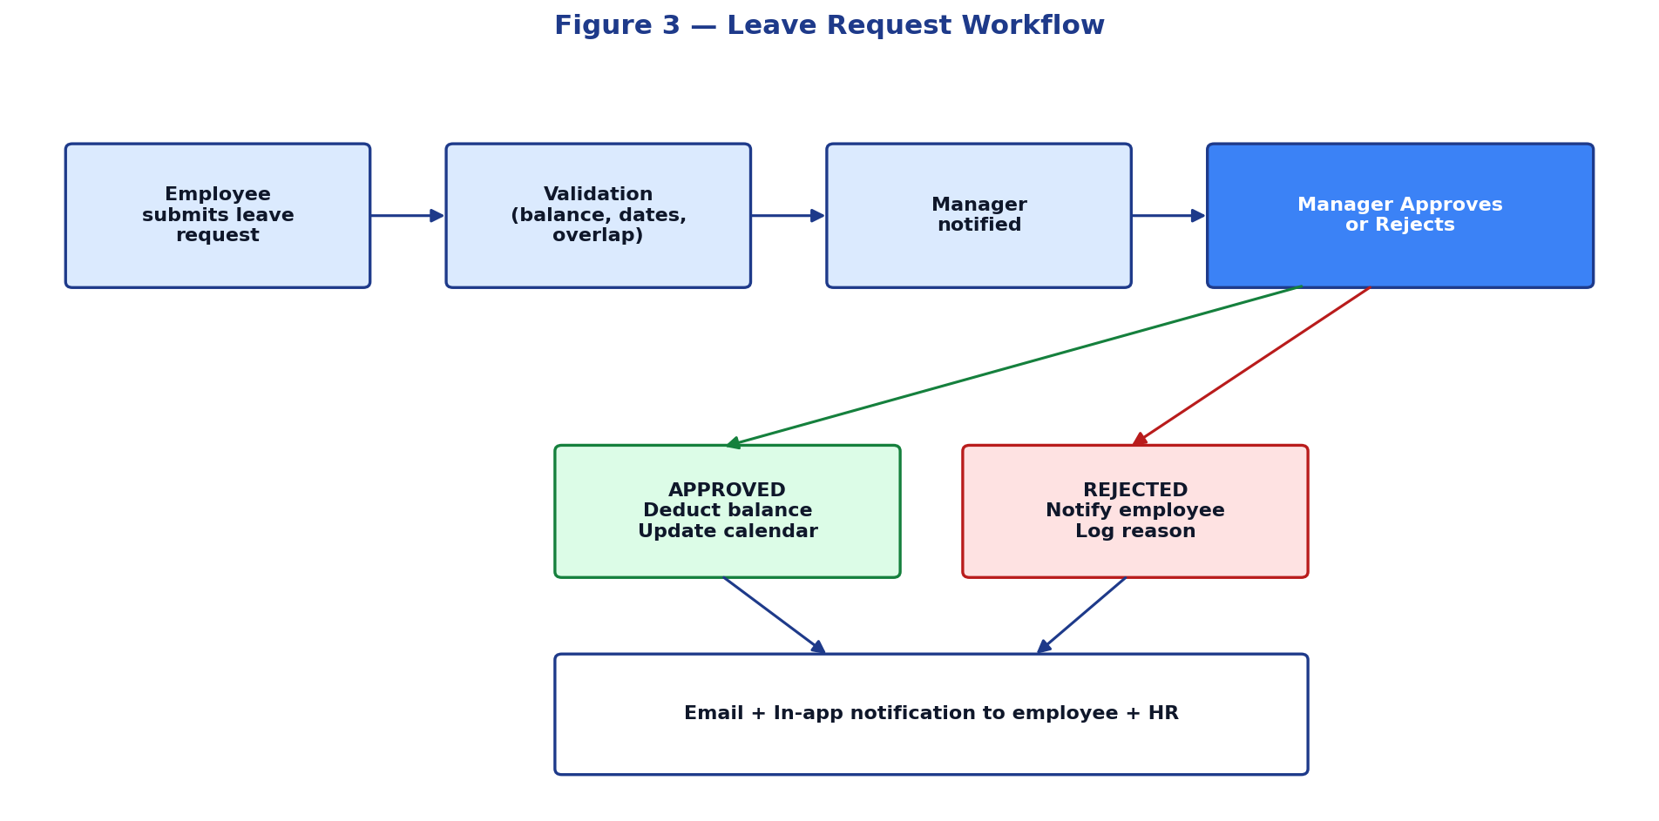
Figure 3 — Future-state Leave Request Workflow

8. Business Requirements
Each business requirement is uniquely identified (BR-NNN), categorized, prioritized using MoSCoW, and traced to the corresponding business goal. Functional decomposition is provided in the companion FRD (PS-FRD-2026-001).
ID | Category | Requirement | Priority | Goal
BR-001 | Branding | The platform must display Perfect Solutions branding (logo, colors, tab title, custom domain) consistently across every page and outbound email. | Must | BG-07
BR-002 | Access | Only invited users with a valid tenant-specific admin invite code may sign up as administrators. | Must | BG-06
BR-003 | Access | All users must authenticate before accessing any non-public route. | Must | BG-06
BR-004 | Access | The system shall enforce role-based access control with at minimum five roles. | Must | BG-06
BR-005 | Employees | HR shall be able to create, update, deactivate, and search employee records. | Must | BG-01
BR-006 | Time | Employees shall log time daily/weekly with project tagging and submit for manager approval. | Must | BG-02
BR-007 | Time | Managers shall approve, reject, or request changes on submitted timesheets. | Must | BG-02
BR-008 | Leave | Employees shall view current leave balance and submit leave requests. | Must | BG-03
BR-009 | Leave | Managers shall approve/reject leave with automated notifications. | Must | BG-03
BR-010 | Leave | The system shall prevent overlapping or balance-exceeding leave requests. | Must | BG-03
BR-011 | Tickets | Employees shall raise support tickets categorized by department. | Must | BG-04
BR-012 | Tickets | Tickets shall track SLA against configured targets. | Should | BG-04
BR-013 | Calendar | Approved leaves and company events shall surface in a unified calendar. | Must | BG-05
BR-014 | Documents | Employees shall securely access pay slips, policies, and personal documents. | Must | BG-01
BR-015 | Reports | HR and Finance shall export workforce, attendance, and leave reports in CSV/Excel. | Must | BG-10
BR-016 | Reports | Leadership shall view real-time dashboards by department, role, and project. | Should | BG-10
BR-017 | Notifications | All approval-driven workflows shall produce in-app and email notifications. | Must | BG-03
BR-018 | Audit | Every state-changing action shall be recorded in an immutable audit log retained ≥ 7 years. | Must | BG-06
BR-019 | Security | Passwords shall be hashed using a modern adaptive algorithm; PII encrypted at rest. | Must | BG-06
BR-020 | Security | Failed login attempts shall be rate-limited and lock accounts after 5 consecutive failures. | Must | BG-06
BR-021 | Availability | The platform shall maintain ≥ 99.9% monthly uptime. | Must | BG-09
BR-022 | Performance | 95% of API requests shall return in under 500 ms under normal load. | Should | BG-09
BR-023 | Usability | The UI shall be fully responsive and meet WCAG 2.1 AA accessibility. | Should | BG-07
BR-024 | Self-service | Employees shall accomplish all routine HR actions without HR intervention. | Must | BG-05
BR-025 | Integrations | The platform shall expose REST APIs for payroll, SSO, and BI tools. | Should | BG-08
BR-026 | Compliance | The platform shall provide data export and deletion capabilities to satisfy data subject rights. | Must | BG-06
BR-027 | Localization | Time zones shall default to America/New_York with per-employee override. | Should | BG-07
BR-028 | Mobile | All employee-facing flows shall be usable on mobile browsers (≥ 360 px width). | Must | BG-07
BR-029 | Tenant Isolation | No data of any other tenant shall be accessible from the perfectsolutions tenant. | Must | BG-06
BR-030 | Disaster Recovery | RPO ≤ 1 hour, RTO ≤ 4 hours. | Must | BG-09

9. Risk Analysis & Mitigation
Risks are scored on Likelihood (L) and Impact (I) on a 1–5 scale. Risk Score = L × I. Risks scoring ≥ 12 are tracked weekly by the steering committee.
ID | Risk | L | I | Score | Mitigation | Owner
R-01 | Resistance to change from long-tenured employees | 3 | 4 | 12 | Change-management plan, executive sponsorship, hands-on training. | HR Lead
R-02 | Master-data quality issues delay migration | 4 | 4 | 16 | Data-cleansing sprint and phased migration with rollback. | PMO
R-03 | DNS / CNAME setup delays custom domain go-live | 2 | 3 | 6 | Pre-validate DNS access early; fallback to *.aurborbloom.com. | IT
R-04 | Security incident exposes PII | 2 | 5 | 10 | Encryption at rest + in transit, RBAC, audit log, SOC monitoring. | InfoSec
R-05 | Vendor LLM costs exceed budget | 3 | 2 | 6 | Universal Key with budget alerts; cap monthly spend per feature. | Finance
R-06 | Browser compatibility regressions | 3 | 2 | 6 | Automated cross-browser test suite in CI. | Engineering
R-07 | Insufficient mobile experience reduces adoption | 3 | 4 | 12 | Mobile-first design review for every employee flow. | Product
R-08 | Unplanned downtime during peak hours | 2 | 5 | 10 | Blue-green deploys, off-hours maintenance windows, SRE on-call. | DevOps
R-09 | Cross-tenant data leakage | 1 | 5 | 5 | Tenant-scoped queries, automated isolation tests in CI. | Engineering
R-10 | Audit failure due to incomplete logging | 2 | 5 | 10 | Immutable append-only audit log with periodic verification. | Compliance

10. Regulatory & Compliance Considerations
- U.S. labor recordkeeping (Fair Labor Standards Act): time records retained for ≥ 3 years; payroll-ready exports.
- U.S. state-specific paid-sick-leave rules: leave types configurable per policy.
- Data privacy: explicit consent capture, right to access and delete, breach notification within 72 hours.
- SOC 2 Type II posture: annual third-party assessment of security, availability, confidentiality.
- Internal IT policies: SSO-readiness, password complexity, session timeout (≤ 30 minutes idle).
11. Glossary
Term | Definition
BRD | Business Requirements Document
FRD | Functional Requirements Document
HRMS | Human Resource Management System
MoSCoW | Prioritization framework: Must / Should / Could / Won't
RBAC | Role-Based Access Control
RPO | Recovery Point Objective — max acceptable data loss measured in time
RTO | Recovery Time Objective — max acceptable downtime to restore service
SLA | Service Level Agreement
SPOC | Single Point Of Contact
SaaS | Software as a Service
Tenant | Isolated logical instance within the multi-tenant SaaS platform
UAT | User Acceptance Testing
WCAG | Web Content Accessibility Guidelines

12. Approval & Sign-off
The undersigned acknowledge that this Business Requirements Document represents the agreed-upon business needs of Perfect Solutions for the AurborBloom HRMS implementation. Material changes to this document shall be processed via formal change control.

Role | Name | Signature | Date
Executive Sponsor | Director, IT Services — Perfect Solutions | _____________________ | __________
Business Owner | Head of Human Resources — Perfect Solutions | _____________________ | __________
Financial Approver | Chief Financial Officer — Perfect Solutions | _____________________ | __________
Implementation Lead | AurborBloom Delivery | _____________________ | __________
Product Manager | AurborBloom Product | _____________________ | __________

