
PERFECT SOLUTIONS
Unleashing IT Talent
Functional Requirements
Document (FRD)
AurborBloom HRMS Implementation

Document Code | PS-FRD-2026-001
Version | 1.0
Date | May 07, 2026
Classification | Confidential — Internal Use
Prepared By | AurborBloom Product & Implementation Team

1. Document Control
Version | Date | Author | Reviewer | Description of Change
0.1 | 2026-01-18 | AurborBloom Lead Engineer | AurborBloom PM | Initial draft from BRD baseline
0.5 | 2026-01-26 | AurborBloom Lead Engineer | PS Engineering Manager | Tech review
1.0 | 2026-05-07 | AurborBloom PM | PS Steering Committee | Approved baseline
1.1 Reference Documents
- PS-BRD-2026-001 — Perfect Solutions Business Requirements Document, v1.0
- AurborBloom Platform Architecture Specification (Internal)
- AurborBloom Security & Compliance Whitepaper (Internal)
- Perfect Solutions Brand Guidelines (Internal)

2. Introduction
2.1 Purpose
This Functional Requirements Document (FRD) translates the business requirements captured in the BRD into discrete, testable functional specifications for the AurborBloom HRMS platform as it will be deployed for Perfect Solutions. Each requirement is uniquely identified, mapped back to one or more business requirements, and accompanied by acceptance criteria that form the basis of UAT.
2.2 Intended Audience
- Perfect Solutions IT and Engineering teams (technical reviewers)
- Perfect Solutions HR Operations (process validators)
- AurborBloom delivery, engineering, and QA teams (implementers)
- Internal and external auditors (compliance reviewers)
2.3 Document Conventions
- Functional requirements are prefixed FR-NNN.
- Non-functional requirements are prefixed NFR-NNN.
- Use cases are prefixed UC-NNN. User stories are prefixed US-NNN.
- Priority follows MoSCoW: Must / Should / Could / Won't.
- Wherever a requirement traces back to a BRD requirement, the BR-NNN identifier is provided.

3. System Overview
AurborBloom is a multi-tenant SaaS HRMS comprising a React single-page application, a FastAPI backend, and a MongoDB persistence tier, all deployed on Kubernetes. For Perfect Solutions the platform is delivered as a fully white-labeled tenant identified by the slug 'perfectsolutions', accessible at the custom domain hr.perfectsolutions.com. The figure below depicts the overall architecture.
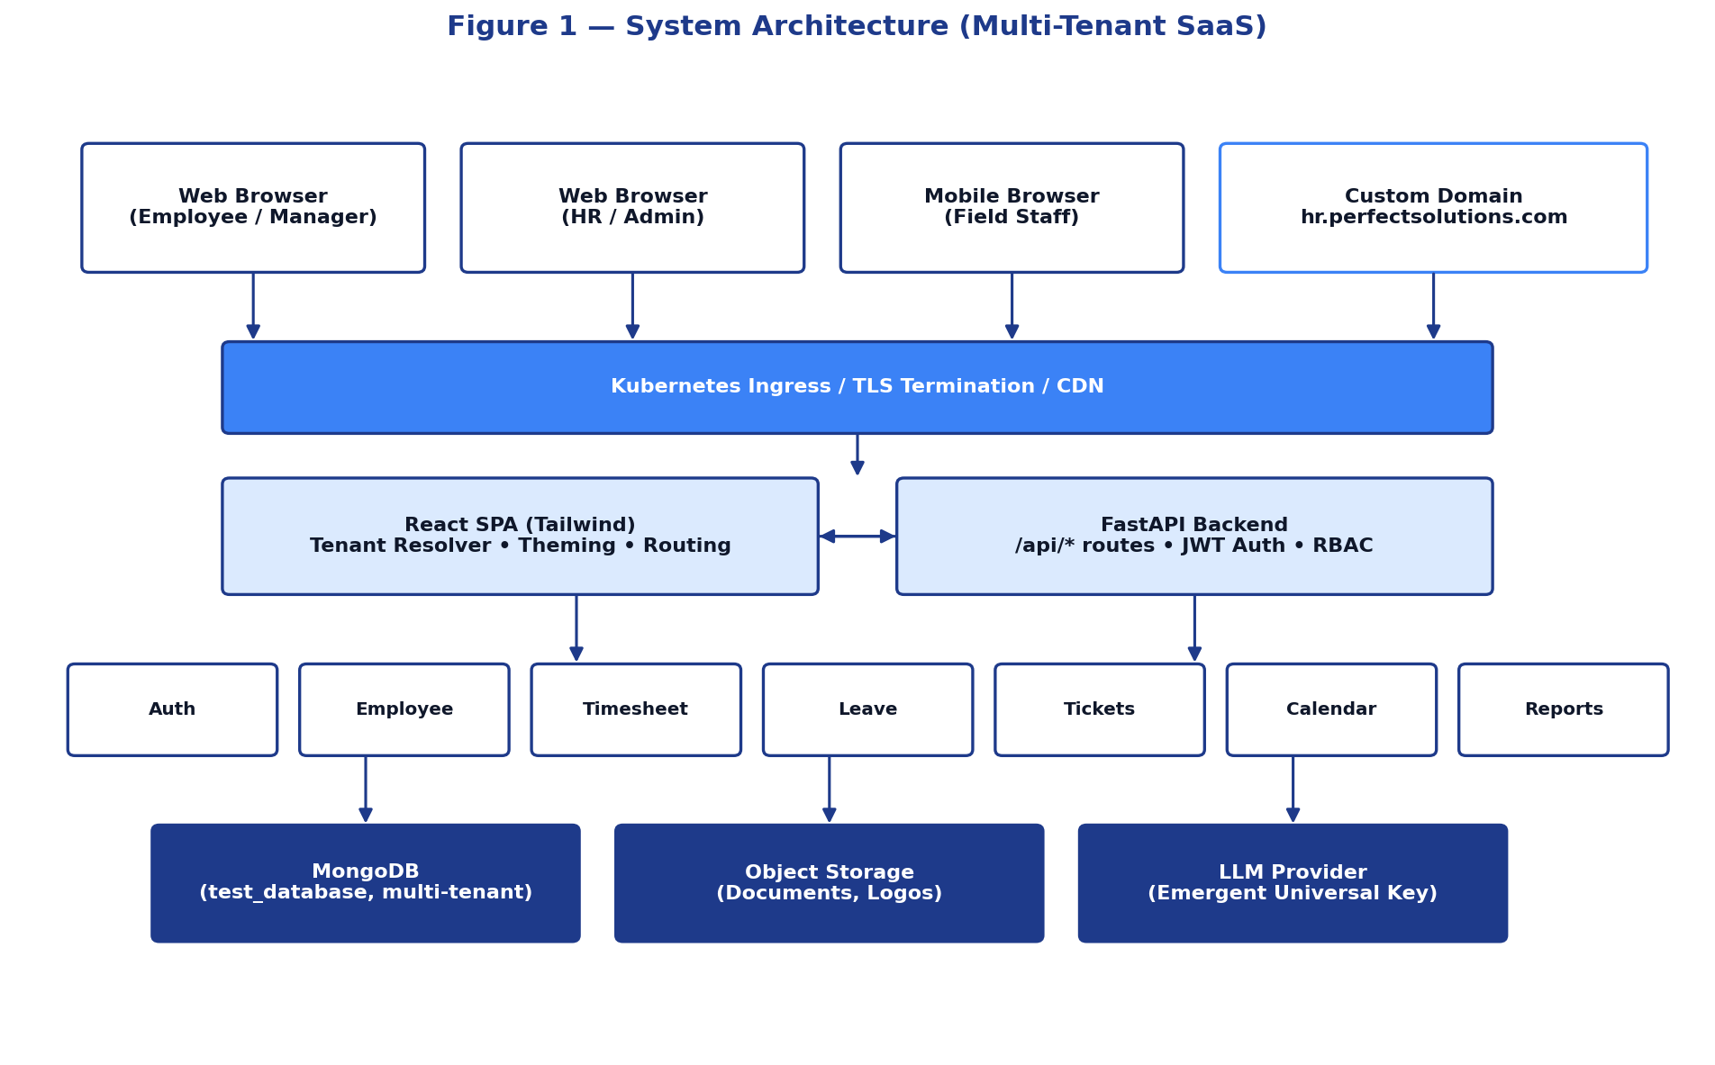
Figure 1 — System Architecture (Multi-Tenant SaaS)
3.1 Technology Stack
Layer | Technology | Purpose
Frontend | React 18, TailwindCSS, react-router-dom, Framer Motion | User interface, animations, routing
State | React Context API, hooks | Auth context, tenant context, theming
Backend | FastAPI (Python 3.11), Pydantic v2 | REST API, validation, OpenAPI
Database | MongoDB (test_database) | Tenant-scoped persistence
Auth | JWT (HS256), bcrypt password hashing | Stateless authentication
AI | Emergent Universal Key (Claude / GPT / Gemini) | AI assistant inside HRMS
PDF | ReportLab | Server-side document generation
Calendar | react-big-calendar | Calendar UX
Hosting | Kubernetes (Emergent Platform) | Orchestration, ingress, TLS
3.2 Tenant Resolution & White-Labeling
- Tenant resolution can occur via slug path (/perfectsolutions/...) or custom domain (hr.perfectsolutions.com).
- On page load the frontend calls GET /api/tenants/by-slug/{slug} or GET /api/tenants/by-domain to fetch tenant metadata.
- Tenant metadata drives logo, primary/secondary colors, browser tab title, and feature flags.
- All API calls implicitly carry tenant context via the JWT 'tenant_id' claim; cross-tenant access is rejected at the route layer.

4. User Roles & Permission Matrix
Roles below are scoped to the Perfect Solutions tenant. The Super Admin role exists at the platform level and is reserved for AurborBloom operations.
Capability | Super Admin | Tenant Admin | HR Manager | People Manager | Employee
Manage tenants & branding | YES | — | — | — | —
Create/Edit Employees | — | YES | YES | — | —
Approve Timesheet | — | YES | YES | YES (team) | —
Approve Leave | — | YES | YES | YES (team) | —
Submit Timesheet / Leave | — | YES | YES | YES | YES
Raise Tickets | — | YES | YES | YES | YES
Resolve Tickets | — | YES | YES | YES (assigned) | —
View All Reports | YES | YES | YES | Team only | Self only
Configure Departments / Leave Types | — | YES | YES | — | —
Audit Log Access | YES | YES | Read-only | — | —

5. Functional Modules
5.1 Authentication & Onboarding
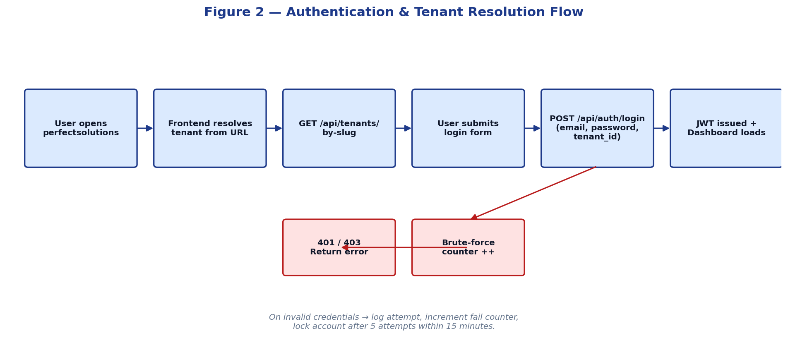
Figure 2 — Authentication & Tenant Resolution Flow
FR ID | Functional Requirement | Priority | Trace
FR-001 | The system shall allow new admins to sign up only when supplied with a valid tenant-specific admin invite code. | Must | BR-002
FR-002 | The system shall validate the invite code against the tenants collection and reject invalid or expired codes with a 'Invalid admin invite code' message. | Must | BR-002
FR-003 | The system shall hash passwords using bcrypt with a work factor ≥ 12. | Must | BR-019
FR-004 | The system shall issue a JWT containing user_id, tenant_id, role, and expiry on successful login. | Must | BR-003
FR-005 | The system shall lock an account after 5 consecutive failed login attempts within 15 minutes; lock duration is 30 minutes. | Must | BR-020
FR-006 | The system shall allow password reset through a one-time tokenized link sent to the registered email. | Should | BR-019
FR-007 | The system shall expire idle sessions after 30 minutes of inactivity. | Must | BR-019
FR-008 | The system shall display Perfect Solutions branding (logo, colors, tab title) on all auth pages. | Must | BR-001
5.1.1 Use Case — UC-001 Admin Self-Onboarding
Field | Detail
Actor | Prospective Tenant Admin at Perfect Solutions
Pre-condition | Valid admin invite code received via secure channel.
Trigger | User navigates to hr.perfectsolutions.com/signup
Main Flow | 1. User enters name, email, password, and admin code.  2. System validates code against perfectsolutions tenant.  3. System creates user with role TENANT_ADMIN.  4. JWT issued; user redirected to admin dashboard.
Alternate Flow A1 | Invite code invalid → display error and abort signup.
Alternate Flow A2 | Email already registered → prompt to log in instead.
Post-condition | User account created, audit log entry written.
Acceptance | Given a valid admin code, when the user submits the signup form with valid data, then the account is created and the dashboard loads within 2 seconds.
5.2 Employee Management
FR ID | Functional Requirement | Priority | Trace
FR-010 | HR shall create an employee record with name, email, department, role, manager, and join date. | Must | BR-005
FR-011 | HR shall edit any employee field except immutable identifiers. | Must | BR-005
FR-012 | HR shall deactivate (soft-delete) an employee; deactivated users cannot log in. | Must | BR-005
FR-013 | HR shall search and filter employees by name, department, manager, status. | Should | BR-005
FR-014 | Employees shall view and update their own profile photo, contact, and emergency contact. | Must | BR-024
FR-015 | The system shall enforce uniqueness of email within a tenant. | Must | BR-005
FR-016 | Department list shall be tenant-configurable; default values for Perfect Solutions are: General, Engineering, HR, Sales, Marketing, Finance. | Must | BR-005
5.3 Time & Attendance
FR ID | Functional Requirement | Priority | Trace
FR-020 | Employees shall log time entries per day with project, task, and hours. | Must | BR-006
FR-021 | Employees shall save drafts and submit timesheets weekly. | Must | BR-006
FR-022 | Managers shall approve, reject (with reason), or request changes on a timesheet. | Must | BR-007
FR-023 | The system shall flag timesheets > 60 hours/week as exceptions. | Should | BR-006
FR-024 | Approved timesheets shall be locked from edits except by HR. | Must | BR-007
FR-025 | The system shall produce a weekly utilization report per project. | Should | BR-015
FR-026 | Time entries shall be exportable in CSV/Excel. | Must | BR-015
5.4 Leave Management
FR ID | Functional Requirement | Priority | Trace
FR-030 | Employees shall view current leave balance per leave type. | Must | BR-008
FR-031 | Employees shall submit leave requests with type, start, end, and reason. | Must | BR-008
FR-032 | The system shall reject requests that exceed available balance or overlap existing approved leave. | Must | BR-010
FR-033 | Managers shall approve or reject requests with optional comments. | Must | BR-009
FR-034 | Approved leave shall automatically deduct balance and add a calendar entry visible to the team. | Must | BR-013
FR-035 | The system shall send email + in-app notifications on submit, approval, rejection. | Must | BR-017
FR-036 | HR shall configure leave types, accrual rules, and carry-over policies per leave type. | Must | BR-008
FR-037 | Default leave types for Perfect Solutions: Vacation, Sick, Personal, Unpaid. | Must | BR-008
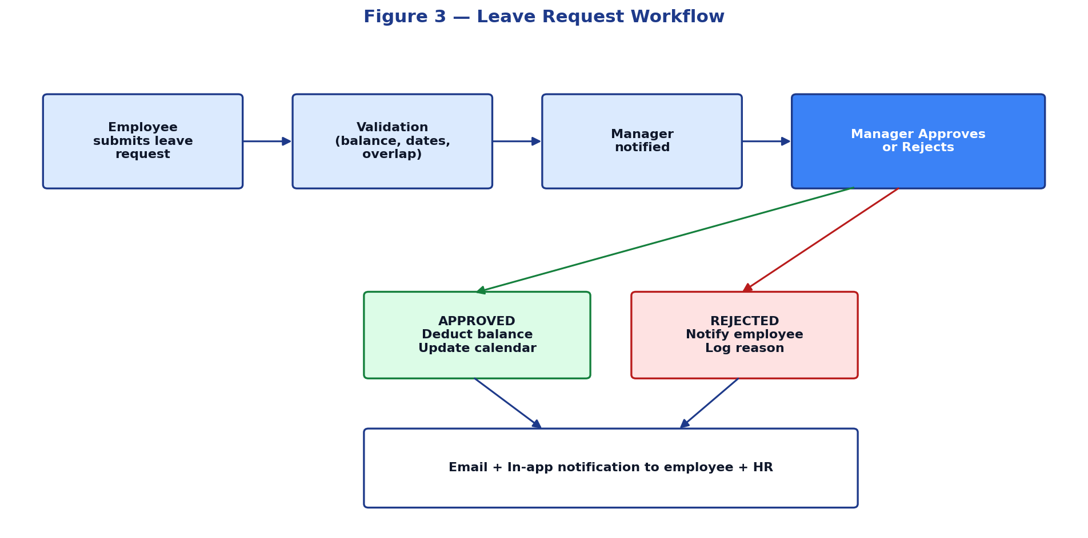
Figure 3 — Leave Workflow (re-shown for module context)
5.5 Tickets / Helpdesk
FR ID | Functional Requirement | Priority | Trace
FR-040 | Employees shall raise a ticket with subject, description, category, priority, and attachments. | Must | BR-011
FR-041 | Tickets shall be auto-routed by category to the corresponding department's queue. | Must | BR-011
FR-042 | Agents shall comment, change status, reassign, and close tickets. | Must | BR-011
FR-043 | Each ticket shall track first-response and resolution SLA, and visually warn when at risk. | Should | BR-012
FR-044 | Requesters shall receive notifications on status change and may reopen within 7 days of closure. | Must | BR-017
FR-045 | The system shall support a basic chat-style threaded conversation per ticket (polling-based). | Must | BR-011
5.6 Calendar & Scheduling
FR ID | Functional Requirement | Priority | Trace
FR-050 | The system shall display a unified calendar combining approved leaves, company events, and personal events. | Must | BR-013
FR-051 | Users shall create personal and team events with title, start, end, attendees. | Must | BR-013
FR-052 | Managers shall view team availability heatmap by week. | Should | BR-016
FR-053 | Calendar shall offer Day, Week, Month, and Agenda views. | Must | BR-013
5.7 Document Vault
FR ID | Functional Requirement | Priority | Trace
FR-060 | Employees shall download personal documents such as offer letters, payslips, policy acknowledgments. | Must | BR-014
FR-061 | HR shall upload company-wide policy documents available to all employees. | Must | BR-014
FR-062 | All documents shall be stored encrypted at rest and accessible only to authorized roles. | Must | BR-019
FR-063 | Document downloads shall be audit-logged. | Must | BR-018
5.8 Performance Reviews
FR ID | Functional Requirement | Priority | Trace
FR-070 | Managers shall create review cycles with self, peer, and manager assessments. | Should | BG-07
FR-071 | Employees shall set quarterly goals (OKRs) and update progress. | Should | BG-07
FR-072 | HR shall view aggregate performance trends by department. | Could | BG-10
5.9 Reports & Analytics
FR ID | Functional Requirement | Priority | Trace
FR-080 | The system shall provide standard reports: Headcount, Attendance, Leave Utilization, Ticket SLA, Project Utilization. | Must | BR-015
FR-081 | Reports shall be filterable by date range, department, and project. | Must | BR-015
FR-082 | Reports shall be exportable as CSV and Excel. | Must | BR-015
FR-083 | Dashboards shall refresh in near real-time (< 1 minute lag). | Should | BR-016

6. User Stories with Acceptance Criteria
ID | User Story | Acceptance Criteria
US-01 | As an Employee, I want to submit a leave request from my phone so that I do not need to be at my desk. | Given I am authenticated on a mobile browser, when I open Leave → New Request, then I can submit a request and receive a confirmation toast within 2 seconds.
US-02 | As a Manager, I want a single approval queue so that I do not switch contexts between leave, time, and tickets. | Given I have pending approvals across modules, when I open My Approvals, then I see a unified list ordered by SLA risk.
US-03 | As HR, I want to bulk import employees from a spreadsheet so that I avoid manual entry during onboarding waves. | Given a CSV in the standard template, when I upload it, then validated rows are imported and errors are downloadable as a per-row report.
US-04 | As an Admin, I want browser tab titles to display 'Perfect Solutions — HR Portal' so that brand identity is preserved. | Given any page on hr.perfectsolutions.com, then the tab title contains 'Perfect Solutions' and never the generic AurborBloom string.
US-05 | As an Auditor, I want to download an immutable audit log for any date range so that I can reconcile changes. | Given Auditor role, when I request the export, then a CSV with timestamp, actor, action, before/after states is produced.
US-06 | As an Employee, I want to see my real-time leave balance before I submit a request so that I avoid rejections. | Given my leave page, when I select a leave type and dates, then the projected remaining balance is shown live.
US-07 | As a Manager, I want to be notified within 1 minute of an SLA-at-risk ticket on my queue. | Given a ticket within 80% of its SLA window, when polling fires, then the agent receives an in-app warning and an email.
US-08 | As HR, I want to configure leave types per policy so that I can adapt to state-specific sick-leave laws. | Given Tenant Admin role, when I edit leave types, then changes apply prospectively without affecting historical balances.

7. Data Model
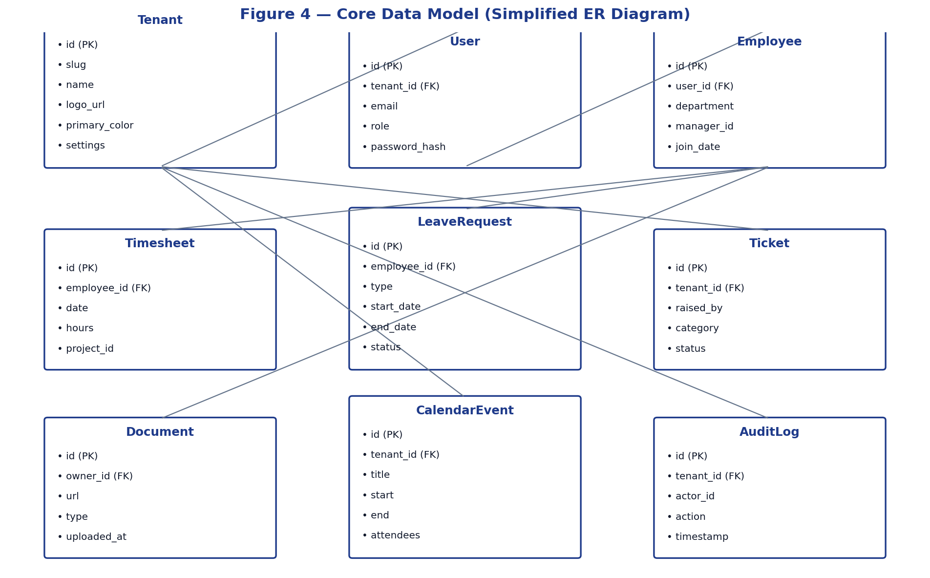
Figure 4 — Core Data Model (Simplified ER Diagram)
All collections are tenant-scoped: every persisted document carries an indexed tenant_id field. Backend queries automatically constrain by the JWT-resolved tenant_id; integration tests verify that no API call may return another tenant's data.
7.1 Key Collections
Collection | Cardinality | Indexes | Notes
tenants | 1 per company | slug (unique), custom_domain (unique sparse) | Stores branding, settings, invite code
users | 1..N per tenant | tenant_id+email (unique) | Auth + role
employees | 1..1 with users | tenant_id, manager_id | Profile data
timesheets | Many | tenant_id+employee_id+date | Locked after approval
leave_requests | Many | tenant_id+employee_id, status | Approval workflow
tickets | Many | tenant_id+status, assigned_to | SLA-tracked
calendar_events | Many | tenant_id+start | Includes leave-derived events
documents | Many | tenant_id+owner_id | Encrypted at rest
audit_logs | Many (append-only) | tenant_id+timestamp | Immutable

8. API Surface (Representative)
All backend endpoints are prefixed with /api and require a valid JWT (except the explicitly public ones). Tenant context is derived from the JWT's tenant_id claim. The list below is representative, not exhaustive; the full OpenAPI specification is generated by FastAPI at /api/docs.
Method | Endpoint | Purpose | Auth
POST | /api/auth/signup | Tenant admin sign-up with invite code | Public
POST | /api/auth/login | Login, returns JWT | Public
GET | /api/tenants/by-slug/{slug} | Resolve tenant by slug | Public
GET | /api/tenants/by-domain | Resolve tenant by custom domain | Public
GET | /api/employees | List tenant employees | Authenticated
POST | /api/employees | Create employee | Tenant Admin / HR
GET | /api/timesheets | List timesheets (filtered) | Authenticated
POST | /api/timesheets | Create / submit timesheet | Employee+
POST | /api/timesheets/{id}/approve | Approve timesheet | Manager+
GET | /api/leave/balance | Get leave balance | Authenticated
POST | /api/leave/request | Submit leave request | Employee+
POST | /api/leave/{id}/approve | Approve leave | Manager+
POST | /api/tickets | Create ticket | Authenticated
GET | /api/tickets/{id} | Get ticket detail incl. comments | Authenticated
GET | /api/calendar/events | List events for visible range | Authenticated
GET | /api/reports/{type} | Generate report (CSV/JSON) | HR / Admin
GET | /api/audit-logs | Read-only audit log | Admin / Auditor

9. Non-Functional Requirements
NFR ID | Category | Requirement | Target
NFR-001 | Performance | API response under normal load | p95 < 500 ms; p99 < 1.2 s
NFR-002 | Performance | Time-to-interactive (TTI) on dashboard | < 2.5 s on 4G
NFR-003 | Availability | Monthly uptime (excluding planned maintenance) | ≥ 99.9%
NFR-004 | Scalability | Concurrent active users supported per tenant | ≥ 1,000
NFR-005 | Scalability | Records per collection without performance degradation | ≥ 10 million
NFR-006 | Security | Password hashing | bcrypt (cost ≥ 12)
NFR-007 | Security | Transport encryption | TLS 1.2+ enforced
NFR-008 | Security | Storage encryption | AES-256 at rest for PII fields
NFR-009 | Security | Tenant isolation | 100% — verified by automated tests
NFR-010 | Privacy | Data subject access response time | ≤ 30 days
NFR-011 | Reliability | RPO (Recovery Point Objective) | ≤ 1 hour
NFR-012 | Reliability | RTO (Recovery Time Objective) | ≤ 4 hours
NFR-013 | Usability | Accessibility | WCAG 2.1 AA
NFR-014 | Compatibility | Supported browsers | Latest 2 versions of Chrome, Edge, Firefox, Safari
NFR-015 | Mobile | Responsive layout breakpoints | ≥ 360 px width
NFR-016 | Audit | Audit log retention | ≥ 7 years
NFR-017 | Maintainability | Backend test coverage | ≥ 80% for routes & services
NFR-018 | Observability | Structured logging + metrics + traces | 100% of API endpoints
NFR-019 | Localization | Default time zone | America/New_York with override
NFR-020 | Compliance | Audit-ready evidence collection | Available within 5 business days

10. Functional Risk Analysis
ID | Risk | Probability | Impact | Mitigation
FRK-01 | Race condition on leave balance during concurrent submissions | Medium | High | Optimistic concurrency check on balance, server-side authoritative deduction in single transaction.
FRK-02 | Browser tab title regressions when tenant context changes | Medium | Low | Centralized useBrowserTitle hook keyed on tenant resolution.
FRK-03 | Custom domain CNAME misconfiguration | Medium | Medium | Pre-flight DNS check + admin-visible verification status.
FRK-04 | Incomplete role enforcement on new endpoints | Medium | High | RBAC decorator pattern enforced via lint rule + integration tests.
FRK-05 | MongoDB ObjectId leakage in API responses | Low | Medium | Pydantic response models, _id excluded by default, contract tests.
FRK-06 | Duplicate /auth/signup routes leading to inconsistent validation | Confirmed | Medium | Refactor server.py to remove duplicate; consolidate into routes/auth.py.
FRK-07 | Email deliverability for notifications | Medium | Medium | Use authenticated SMTP/Resend with SPF, DKIM, DMARC.

11. Traceability Matrix (BR → FR → UC / US)
Every business requirement from the BRD is satisfied by one or more functional requirements, validated by use cases or user stories, and ultimately verified by acceptance test cases.
Business Req. | Functional Req. | Use Cases / Stories | Test Method
BR-001 Branding | FR-008 | UC-001, US-04 | Visual + automated regression
BR-002 Invite-only signup | FR-001, FR-002 | UC-001 | Functional + negative tests
BR-003 Auth required | FR-004, FR-007 | UC-001 | API + UI session tests
BR-004 RBAC | FR-001..FR-008, role matrix | UC-001 | Role permutation tests
BR-005 Employee CRUD | FR-010..FR-016 | US-03 | CRUD test suite
BR-006/7 Time | FR-020..FR-026 | US-02 | Workflow + approval tests
BR-008..10 Leave | FR-030..FR-037 | US-01, US-06, US-08 | Workflow + balance tests
BR-011/12 Tickets | FR-040..FR-045 | US-07 | SLA + workflow tests
BR-013 Calendar | FR-050..FR-053 | US-01 | Cross-module integration
BR-014 Documents | FR-060..FR-063 | — | Permission + audit tests
BR-015/16 Reports | FR-080..FR-083 | — | Snapshot + export tests
BR-017 Notifications | FR-035, FR-044 | US-07 | Email + in-app tests
BR-018 Audit | FR-063 + audit_logs | US-05 | Append-only verification
BR-019/20 Security | FR-003..FR-005, NFR-006..009 | — | Pen test + automated checks
BR-021 Availability | NFR-003 | — | Synthetic monitoring
BR-022 Performance | NFR-001, NFR-002 | — | Load test
BR-023 Accessibility | NFR-013 | — | Axe / Lighthouse audit
BR-024 Self-service | FR-014, FR-031, FR-040 | US-01 | End-to-end flow tests
BR-025 Integrations | API surface | — | Contract tests
BR-026 Privacy | NFR-010 | US-05 | DSAR drill
BR-027 Localization | NFR-019 | — | TZ regression tests
BR-028 Mobile | NFR-015 | US-01 | Mobile viewport tests
BR-029 Tenant isolation | NFR-009 | — | Cross-tenant fuzz tests
BR-030 DR | NFR-011, NFR-012 | — | DR drill

12. UAT Strategy & Exit Criteria
- Three UAT cycles: smoke, full regression, and pre-prod soak.
- Test data set includes 50 sample employees, 5 managers, 3 departments to start.
- Defect severity classes: S1 Blocker, S2 Major, S3 Minor, S4 Cosmetic.
- Exit criteria: Zero S1, zero S2, < 5 S3 open at sign-off.
- Performance gate: NFR-001/002 met under 2× expected load.
- Security gate: Pen test report with zero High findings outstanding.
13. Glossary
Term | Definition
FR / NFR | Functional / Non-Functional Requirement
JWT | JSON Web Token — signed, stateless auth token
MoSCoW | Must / Should / Could / Won't priority framework
RBAC | Role-Based Access Control
SLA | Service Level Agreement
UAT | User Acceptance Testing
WCAG | Web Content Accessibility Guidelines
RPO/RTO | Recovery Point / Time Objectives
DSAR | Data Subject Access Request

14. Approval & Sign-off
By signing below, the parties acknowledge that this Functional Requirements Document accurately translates the business needs into implementable functional and non-functional specifications.
Role | Name | Signature | Date
Engineering Manager | Perfect Solutions | _____________________ | __________
IT Security Officer | Perfect Solutions | _____________________ | __________
Head of HR Operations | Perfect Solutions | _____________________ | __________
Lead Engineer | AurborBloom Engineering | _____________________ | __________
Product Manager | AurborBloom Product | _____________________ | __________

