CAPSTONE PROJECT REPORT: RentAPlace
Developer: Sunkara Sravan Kumar Reddy
Project Date: March 2026
Github Repo Link : https://github.com/Sravan94-git/RentAPlace

1. Executive Summary
RentAPlace is a full-stack property management system designed to connect property owners and renters through a secure and role-based digital platform. The system enables property owners to list luxury villas and allows renters to search and reserve properties seamlessly. The application is built using Angular 19 for the frontend and .NET 9 Web API for the backend, ensuring scalability, performance, and modern UI/UX.

2. Flowchart Description
The system workflow begins with user authentication where users can either log in or register. After successful authentication, a role decision mechanism identifies whether the user is an Owner or a Renter. Owners can add new properties, which are validated before being stored in the database. If invalid data is detected, an error is displayed and the user can retry. Renters can search available properties and proceed with booking. If a property is unavailable, the system displays a booking error. Successful bookings lead to reservation creation and updates in relevant database tables. All actions are logged for authentication and auditing purposes.
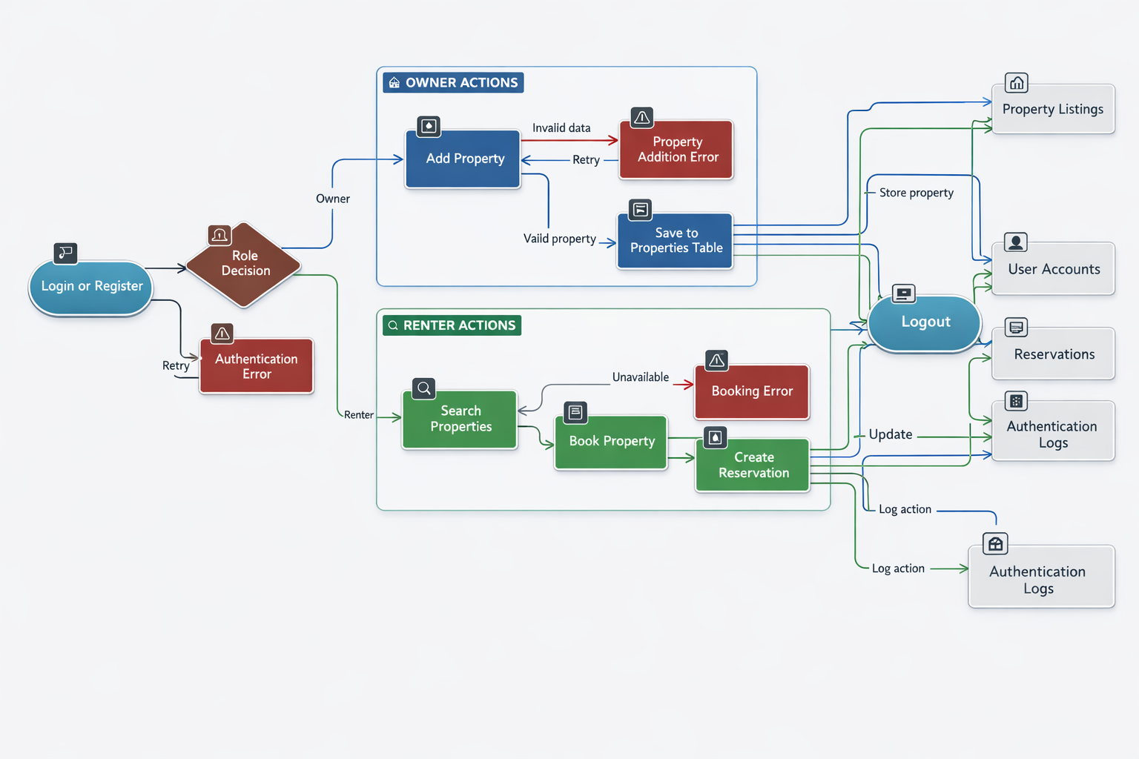

3. ER Diagram Description
The database follows a relational model with four primary entities: Users, Properties, Reservations, and Messages. A one-to-many relationship exists between Users and Properties, where one owner can list multiple properties. Reservations link renters to specific properties, capturing booking details such as check-in and check-out dates. Messages enable communication between users. Foreign key constraints and DeleteBehavior.Restrict are used to maintain data integrity and prevent accidental deletion of related records.
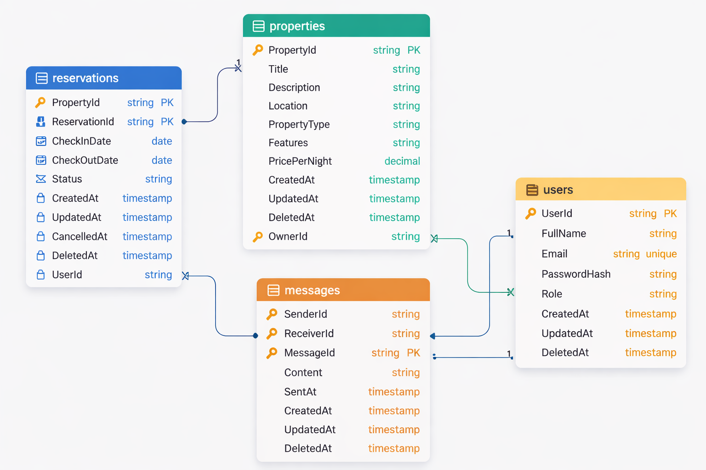

4. Back-End Architecture (.NET Web API)
The backend is designed as a RESTful API using .NET 9. Security is implemented through JWT-based authentication and BCrypt password hashing. Role-Based Access Control ensures that only authorized owners can manage property listings. Entity Framework Core is used for ORM mapping and database migrations.

5. Front-End Implementation (Angular)
The frontend is built using Angular standalone components with Tailwind CSS for responsive design. Key features include route protection using AuthGuard, automatic JWT attachment using AuthInterceptor, and session persistence via localStorage. SSR compatibility is ensured by platform checks before accessing browser APIs.

6. CRUD Operations
Owners can create, read, update, and delete property listings. Renters can view and book available properties. All database operations are verified using Entity Framework Core and SQL Server.

7. Conclusion
RentAPlace demonstrates a scalable and secure full-stack implementation integrating modern web technologies. The system ensures efficient property management, seamless booking experience, and robust authentication mechanisms.

