1. Create a project using angular-cli

Add one more module into the project. This module which you are adding should be generated using ng command. Add one directive to the module. Again, the directive has to be generated using ng. Host the directive on a paragraph element. Background color of the para should become blue when mouseenter event occurs on that element and no background color when mouseleave event occurs.

1. Create Navigation menu as shown below. Show the chosen option as shown below.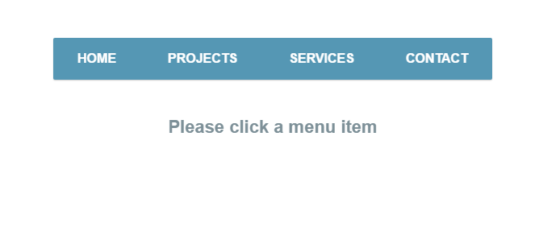

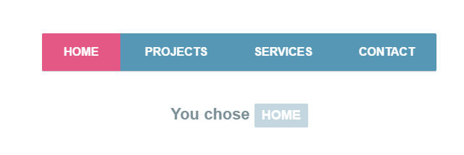

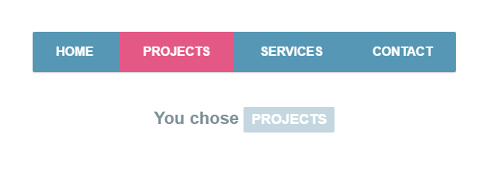

1. Create a SPA using Angular routing. Home page having 3 links home, contact and about. Create routing configuration to display content of different page depending on the user’s choice. Use the lazy loading concept. Do not load all modules at the beginning.
2. Using Animations, animate an element in and out of the view. Let element leave after a slight delay. When the element is entering and leaving the view, let the opacity of the element change. If elements enter the view in the order A,B,C then they should leave in the order C,B,A