|  |  |
| --- | --- |
| Use Case Name | Credit Card – Eligibility Validator |
| Domain | Banking |
| Complexity | Low |

Table of Contents

1. Business Objective 3

2. Functionality 3

3. Services for Customer 3

4. Scope and Limitations 3

5. Design Considerations / Assumptions: 3

6. UI Screens / Pages 5

a. Landing Page (index page) 5

b. Eligible Page 8

c. Not-Eligible Page 9

d. Invalid Page 10

7. Important Input: 10

8. Application Flow 11

# Business Objective

Before applying for a credit card with the Bank, a User might want to know his/her eligibility for the same. The **Credit Card- Eligibility Validator application** helps a potential credit card customer to find out his/her eligibility before applying for a credit card. The application would require the potential User to just entry his/her PAN card number and based on the credit score associated with every PAN card, the eligibility status is displayed to the User.

Below are the Functionalities the User is enabled with.

* Check Credit Card Eligibility

# Functionality

This application will provide a facility to the User to check their eligibility to apply for a credit card. In the main landing page of the application, the customer is expected to enter the PAN card number and once submitted, the User will be given the appropriate output.

# Services for Customer

This service provides the potential customer to check his/her eligibility for a credit card before applying for one.

# Scope and Limitations

Credit Card Validation internally uses only the credit score associated with a PAN card number as the only criteria/parameter for deciding whether the User is Eligible/Not-Eligible

# Design Considerations / Assumptions:

1. You can store the data in HttpSession or Cache or in-memory database
2. The solution for this needs to be implemented using Spring, Hibernate, Maven and Java 8 (if applicable).
3. For this application, please use any in-memory database of your choice as your persistence option (As this solution requires you to implement it in Spring and Hibernate, you should use an in-memory database and DO NOT use any local collections like Map, List for the same)
4. Use some sample PAN Card Numbers and associated credit scores as follows:

|  |  |
| --- | --- |
| PAN Number | Credit Score |
| AXSSP1122H | 3.10 |
| APPSA3355P | 8.50 |
| APPXA2244X | 9.50 |
| AXVPS7766V | 1.50 |
| ASXPS2121S | 5.10 |

1. The credit score is a double value and it could range of 0.00 to 10.00.
2. [http://host:port/contextroot/{path}](http://host:port/contextroot/%7bpath%7d)

In the above URL**,** *contextroot* isthe Context root of the application. You can use any value for contextroot in your local environment during development but do not hardcode it in the application source code, as the system will replace it with the dynamically generated name as context root and deploy in the application server to validate the functional test cases using selenium web driver api. In case if you are not using the context root (say for example, dot net core and nodejs applications may not really have the context root), it will be replaced with blank.

For example:

Java: <http://localhost:8080/onlinebanking/login>

NodeJS & Dotnet: <http://localhost:5001/login>

1. Do not refer any third-party libraries (CSS/JS libraries) directly from internet in the code, instead download them and use as local reference.
2. Variable **Identifier** of HTML should be id/name for input types, id for <div> and anchor text for <a> tags. It should be followed strictly.
3. Do not hard code port number and context root anywhere in the code

# UI Screens / Pages

**Please read the below points carefully before you start the development of the use case.**

Each page should have the following:

* Title of the page
* All the input elements to capture the user input
* Buttons/Links for any action like submit, cancel etc.,
* The colors that appear in the sample screen-shots of the views below are only indicative. You can chose to ignore using background colors for pages as it is **Optional** and in no way effects the functionality or evaluation of the application.
* **All the HTML elements should have id or name attribute**
* **Element id or name should be unique and is case sensitive. If you use different names, the automated functional test cases will fail.**
* Success or Error message to be displayed should be wrapped in a <div> tag with the documented id/name. Please note the div id name is case sensitive.
* **Please use the success / error messages documented as is, otherwise the automated functional test cases will fail.**
* **Please use the** **design considerations / assumptions section** **to configure the master data like user credentials, initial amount, account number etc., without which the functional tests will fail.**

## Landing Page (index page)

This page is the landing page that the User sees when he/she accesses the application.

User should be able to enter the PAN Number which is a mandatory field and click on the “check” button to submit the details and see the eligibility details.

An error message should be displayed when the mandatory field is missing. On successful submit, it should display the User, one of the below response pages.

* **‘Eligible’** page : That displays the message that the User is “Eligible” for a Credit Card
* **‘NotEligible’** page: That displays the message that the User is “Not-Eligible” for a Credit Card
* **‘Invalid’** page: That gets displayed if the PAN Number entered is Wrong/Invalid.

**http://host:port/contextroot/index.html**

|  |  |  |  |  |  |
| --- | --- | --- | --- | --- | --- |
| **Field / Page attribute** | **HTML Element Type** | **Required** | **Identifier** | **Validation Message** | **Remarks** |
| URL |  |  | [*http://host:port/contextroot/*](http://host:port/contextroot/)  *(or)*  [*http://* *host:port/contextroot /index.html*](http://localhost:8080/creditcard/index.html) | | |
| Title of the page |  |  | CreditCard-Home Page | | |
| Enter PAN Number | Label |  |  |  |  |
| PAN Number | Text Box | Yes | id=panNo” |  | Apply “required” HTML5 attribute for this input to ensure that the entry is mandatory.  Since the PAN Number should be exactly 10 character alpha-numeric value, you can apply an appropriate pattern validation in HTML5 and if validation fails, along with the default auto-generated browser message, append a user defined validation message “**10 character alpha numeric**” to it. |
| Check | Submit |  | Id=”submit” |  | Click on the ‘Check’ button should validate that the PAN Number is entered Mandatorily and as per the pattern expected.  Once the above 2 requirements are validated  Then it should be submitted to the server side program that would validate the PAN Numbers entered against the credit scores and displays the appropriate response page. |

Sample page looks like below:

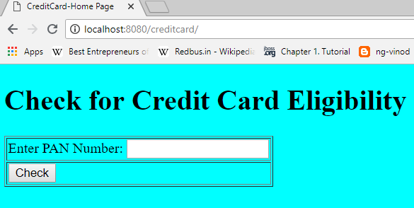

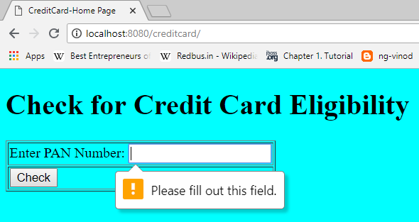

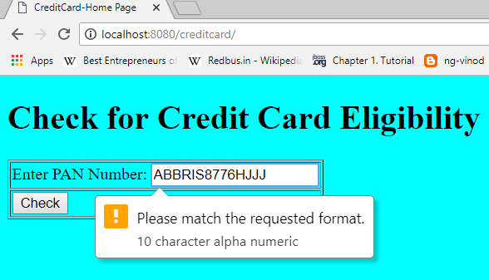

## Eligible Page

If the credit score associated with the entered PAN Number is >= 5, then it should show the Eligible Page

|  |  |  |  |  |  |  |  |
| --- | --- | --- | --- | --- | --- | --- | --- |
| **Field / Page attribute** | **HTML Element Type** | **Required** | **Identifier** | **Message** | | | **Remarks** |
| URL |  |  | *http://* *host:port/contextroot /checkEligibility* | | | | |
| Title of the page |  |  | CreditCard-Eligible | | | | |
| msg | div | yes | Id=”msg” | | Congratulations!!! You are eligible for a credit card |  | |

Sample page looks like below.

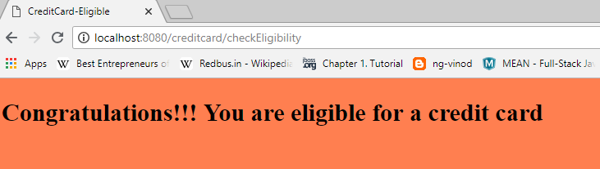

## Not-Eligible Page

If the credit score associated with the entered PAN Number is < 5, then it should show the Not Eligible Page

|  |  |  |  |  |  |  |
| --- | --- | --- | --- | --- | --- | --- |
| **Field / Page attribute** | **HTML Element Type** | **Required** | **Identifier** | | **Message** | **Remarks** |
| URL |  |  | *http://* *host:port/contextroot /checkEligibility* | | | |
| Title of the page |  |  | CreditCard-Not Eligible | | | |
| msg | Div | yes | Id=”msg” | Sorry!!! You are not eligible for a credit card | |  |

Sample Page looks like below:

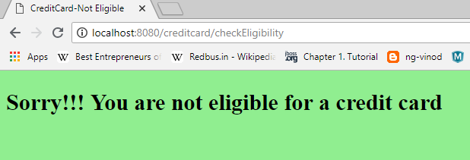

## Invalid Page

If the PAN Number entered is Not Available in the list , then the Invalid Page should be displayed the page should also have a link to allow the User to go back to the index page

|  |  |  |  |  |  |
| --- | --- | --- | --- | --- | --- |
| **Field / Page attribute** | **HTML Element Type** | **Required** | **Identifier** | **Message** | **Remarks** |
| URL |  |  |  | *http://* *host:port/contextroot/checkEligibility* | |
| Title of the Page |  |  | CreditCard-Invalid |  |  |
| msg | Div | Yes | Id=”msg” | Invalid PAN Entry !!! |  |
| Enter Again | Link / a href | Yes | Id=”index” |  | Click on this link should display the home page |

Sample Page looks like the below:

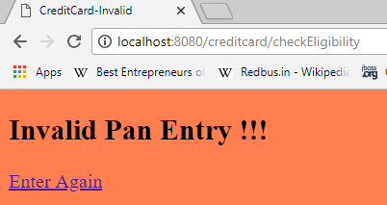

## Important Input:

The program should work per as our earlier discussions even if the PAN Number is entered in Lower/Upper case.

Sample Page where the PAN Number is entered in lower case:

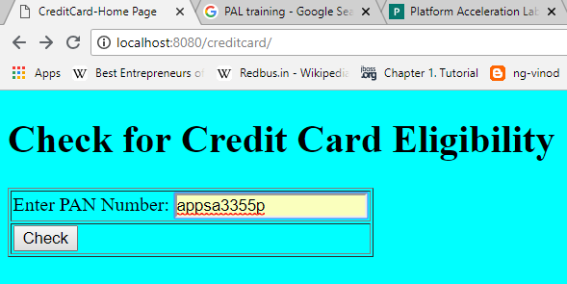

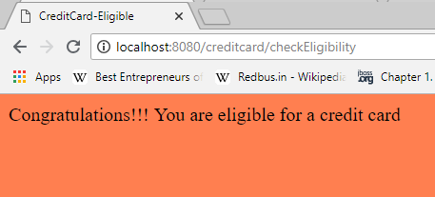

# Application Flow

|  |  |  |
| --- | --- | --- |
| **Current Page** | **Action** | **Next / Landing Page** |
| Index | Submit – Success | Eligible Page if Credit Score >=5 |
| Index | Submit – Success | Not Eligible Page if Credit Score <5 |
| index | Submit – Success | Invalid Page if PAN Card is Not found in the list |
| Invalid Page | Click on link | Index page |