**EXPERIMENT - 4**

Name:- Sravan Chittupalli

VJTI ID: 181060018

**AIM**

1. Design an 8086-assembly language program to compute the factorial of a positive integer ‘n’ using a recursive procedure. Integer n is a byte integer.

**SOFTWARE**

* EMU8086 emulator

**ALGORITHM**

1. Input the Number whose factorial is to be found into variable called ‘number’.
2. Insert 0001 in AX (Condition for MUL Instruction) and 0000 in DX
3. Decrement number
4. Call recur_func till number is not equal to zero
5. Copy the content of AX to ‘result’ variable.
6. Stop Execution

**CODE**

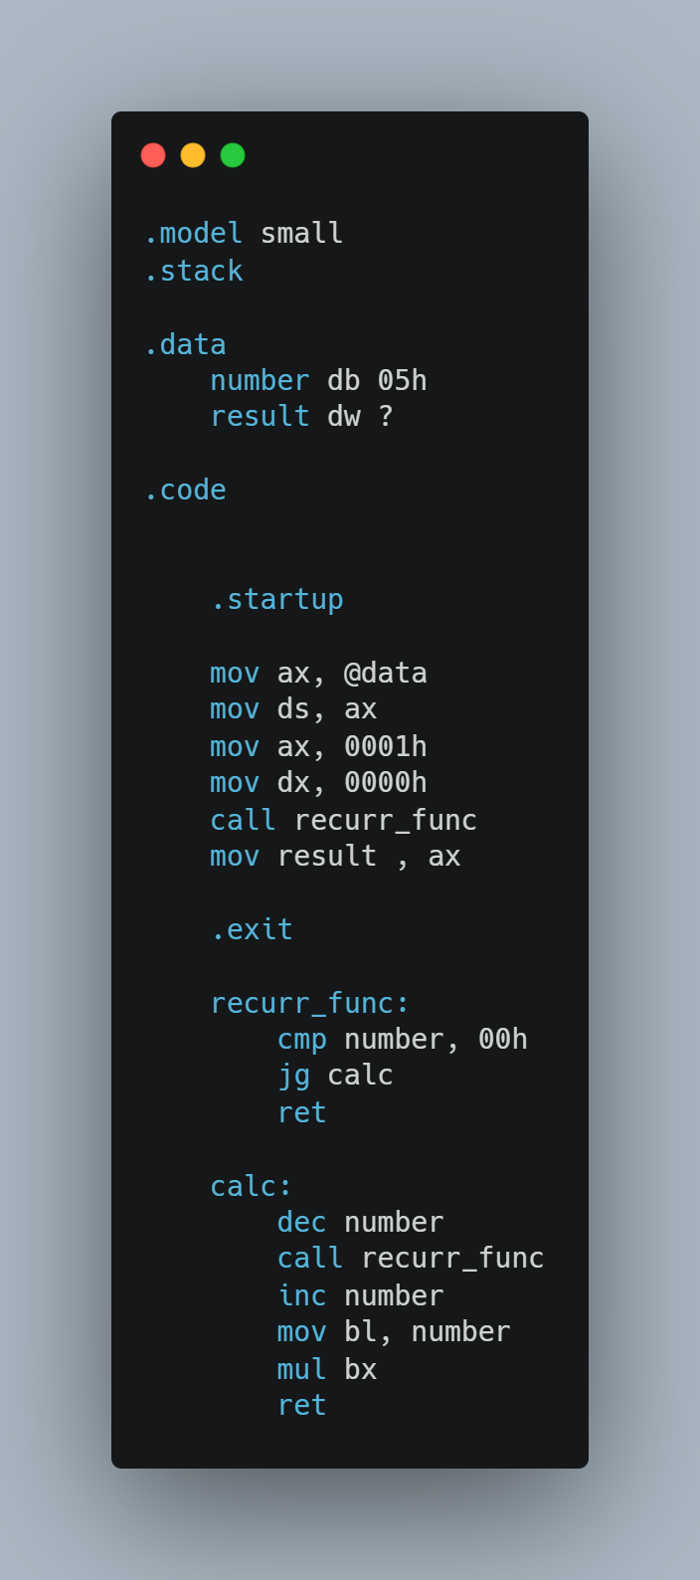

* **INPUT**

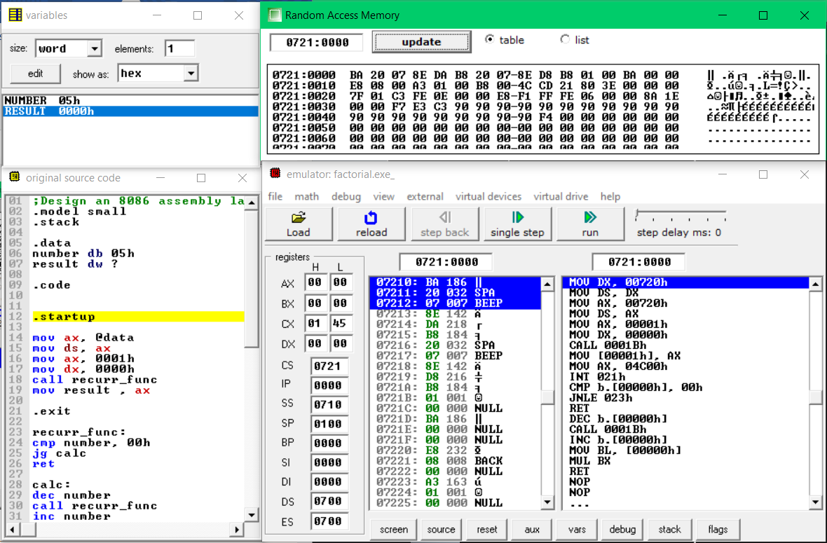

* **OUTPUT**

**5! = (120)10 = (78)16**

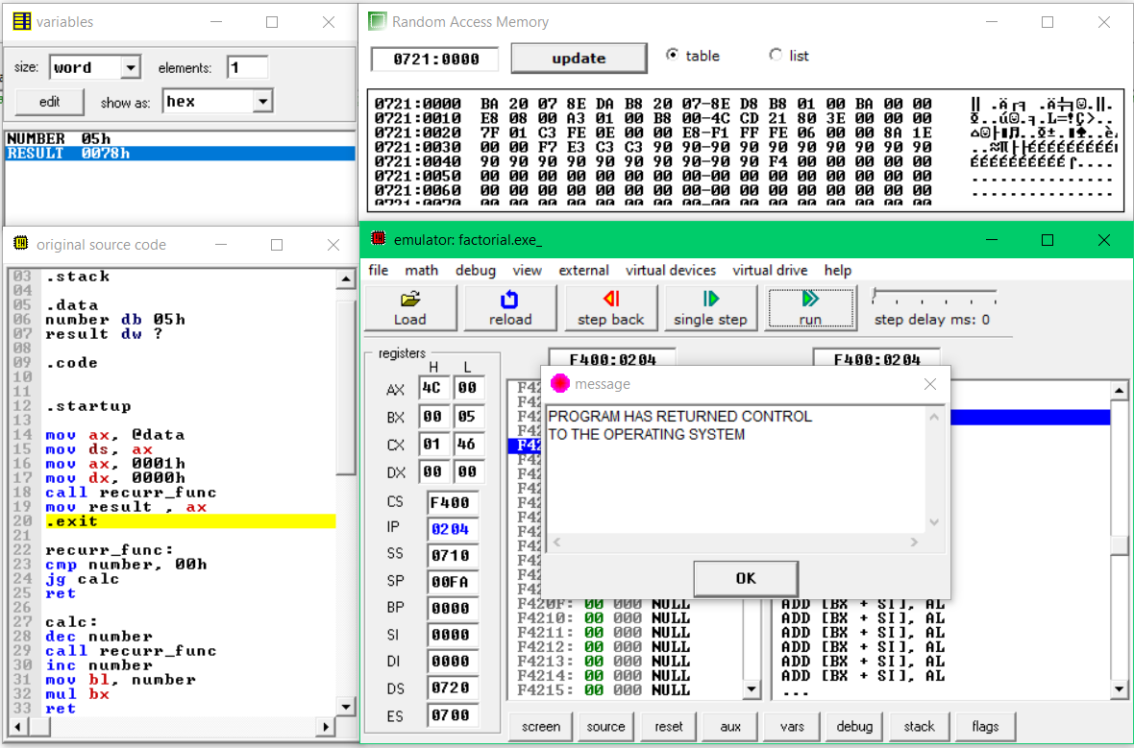

**CONCLUSION**

In this program we have learnt how to implement recursion in assembly language. Recursion is a fast method to solve problems but takes a lot of memory