

**CERTIFICATE**

This is to certify that the project report titled **“LOAN ELIGIBILITY PREDICTION”** is being submitted by **M. Nithin Reddy (207Z1A05A9), N. Varshitha (207Z1A05C0)** and  **K. Sriharshavardhan (207Z1A0583)** in Partial fulfillment for the award of **Bachelor of Technology in Computer Science & Engineering** is a record bonafide work carried out by them. The results embodied in this report have not been submitted to any other University for the award of any degree.

.

**Internal Guide Head of the Department**

(Mrs.M.Deepthi) (Dr.K. Rameshwaraiah)

Submitted for the University Examination held on…………………………….

**External Examiner**

**DECLARATION**

We M. Nithin Reddy, N. Varshitha and K. Sriharshavardhan the students of **Bachelor of Technology in Computer Science and Engineering, Nalla Narasimha Reddy Education Society’s Group of Institutions**, Hyderabad, Telangana, hereby declare that the work presented in this project work entitled **LOAN ELIGIBILITY PREDICTION** is the outcome of our own bonafide work and is correct to the best of our knowledge and this work has been undertaken taking care of engineering ethics. It contains no material previously published or written by another person nor material which has been accepted for the award of any other degree or diploma of the university or other institute of higher learning.

M. NITHIN REDDY 207Z1A05A9

N. VARSHITHA 207Z1A05C0

K. SRIHARSHAVARDHAN 207Z1A0583

**Date:**

**Signature:**

**ACKNOWLEDGEMENT**

We express our sincere gratitude to our guide **Mrs.M.Deepthi** Assistant Professor in Department of Computer Science and Engineering, NNRESGI, who motivated throughout the period of the project and also for her valuable and intellectual suggestions, guidance, and constant encouragement right throughout our work.

We would like to express our profound gratitude to our minor project In-charge **Mrs. V.Rani Sailaja**, Assistant Professor in Department of Computer Science and Engineering, NNRESGI, for her support and guidance in completing our project and for giving us this opportunity to present the project work.

We profoundly express thanks to **Dr.K.Rameshwaraiah,** Professor & Head, Department of Computer Science and Engineering, NNRESGI, for his cooperation and encouragement in completing the project successfully.

We wish to express our sincere thanks to **Dr.G. Janardhana Raja,** Dean School of Engineering, NNRESGI, for providing the facilities for completion of the project.

We wish to express our sincere thanks to **Dr**.**C.V. Krishna Reddy,** Director, NNRESGI, for providing the facilities for completion of the project.

Finally, we would like to thank overall major-project coordinator, **members of Project Review Committee (PRC),** all the faculty members and supporting staff, Department of Computer Science and Engineering, NNRESGI, for extending their help in all circumstances.

By

M. NITHIN REDDY 207Z1A05A9

N. VARSHITHA 207Z1A05C0

K. SRIHARSHAVARDHAN 207Z1A0583

**ABSTRACT**

Technology has boosted the existence of human kind the quality of life they live. Every day we are planning to create something new and different. We have a solution for every other problem we have machines to support our lives and make us somewhat complete in the banking sector candidate gets proofs/ backup before approval of the loan amount. The application approved or not approved depends upon the historical data of the candidate by the system. Every day lots of people applying for the loan in the banking sector but Bank would have limited funds. In this case, the right prediction would be very beneficial using some classes-function algorithm. An example the logistic regression, random forest classifier, support vector machine classifier, etc. A Bank's profit and loss depend on the amount of the loans that is whether the Client or customer is paying back the loan. Recovery of loans is the most important for the banking sector. The improvement process plays an important role in the banking sector. The historical data of candidates was used to build a machine learning model using different classification algorithms. The main objective of this paper is to predict whether a new applicant granted the loan or not using machine learning models trained on the historical data set.

***Keywords: loan prediction, K-Nearest Neighbour, cross entropy, semi automation, loan eligibility prediction system, Machine Learning***

**CONTENTS**

|  |  |
| --- | --- |
| **Title** | **Page No.** |
| **Certificate** | **i** |
| **Declaration** | **ii** |
| **Acknowledgement** | **iii** |
| **Abstract** | **iv** |
| **List Of Figures** | **vii** |
| **List Of Tables** | **viii** |
| **List Of Abbreviations** | **ix** |
| 1. **INTRODUCTION** | **1** |
| 1.1 Motivation | 1 |
| 1.2 Problem Statement | 2 |
| 1.3 Objective Of Project | 2 |
| 1.4 Limitation Of Project  1.5 Size Of Dataset  1.6 Processing Time  1.7 Real life Scenarios are different from theory | 2  2  3  3 |
| 1. **LITERATURE SURVEY** | **4** |
| 2.1 Introduction  2.2 Review of Literature Survey | 4  4 |
| 2.3 Existing System | 6 |
| 2.4 Constraints Of Existing System  2.5 Proposed System  2.6 Advantages | 7  7  7 |
| 1. **SYSTEM ANALYSIS** | **8** |
| 3.1 Introduction | 8 |
| 3.2 Software requirements | 9 |
| 3.3 Hardware requirements | 9 |
| 3.4 Content Diagram of Project | 10 |
| 1. **SYSTEM DESIGN** | **11** |
| 4.1 Introduction | 11 |
| 4.2 UML Diagrams | 15 |
| 4.3 Characteristics of UML  4.4 Behavioral Model  4.5 Data flow diagram | 16  17  17 |
| 4.6 Usecase Diagram | 19 |
| 4.7 Class Diagram | 20 |
| 4.8 Sequence Diagram  4.9 Activity Diagram | 21  22 |
|  |  |

1. **IMPLEMENTATION 23**
   1. Introduction 23
   2. KNN Features 23
   3. Methods Of Implementation 28
   4. Modules 28
2. **CODING & RESULTS 30**

6.1 Dependences 30

6.2 Data Collection 31

6.3 Data Cleaning & Preprocessing 31

6.4 Data Analysis & Visualization 33

6.5 Encoding 35

6.6 Model Training 35

6.7 Model Evaluation 36

6.8 Save The Model 37

6.9 Output Screens 39

1. **TESTING 41** 7.1 Introduction 41
   1. Types of Tests 41

7.3 Test Cases 42

**8. CONCLUSION AND FUTURE ENHANCEMENTS 44**

8.1 Project Conclusion 44

8.2 Future Enhancements 44

**9. REFERENCES 45**

9.1 Journals 45

9.2 Textbooks 45

9.3 Website 46

**List of Figures**

**S. No. Figure No Figure Name Page No.**

|  |  |  |
| --- | --- | --- |
| 1. 3.4 | Architecture of project | 10 |
| 2. 4.5 | Dataflow diagram | 18 |
| 3. 4.6 | Use case diagram | 19 |
| 4. 4.7 | Class diagram | 20 |
| 5. 4.8 | Sequence diagram | 21 |
| 6. 4.9 | Activity diagram | 22 |
| 7. 6.9.1 | Login page | 39 |
| 8. 6.9.2 | Register Page | 39 |
| 9. 6.9.3 | Register Page | 40 |
| 10. 6.9.4 | Prediction of Result | 40 |

**List of Tables**

**S. No. Table No Table Name Page No.**

1. 7.3 Testcases 42

**List ofAbbreviations**

|  |  |  |
| --- | --- | --- |
| **S.No.** | **Synonym** | **Abbreviation** |
| 1. | MOOC | Massive Open Online Courses |
| 2. | cMOOC | Connectivist Massive Open Online Courses |
| 3. | xMOOC | Extended Massive Open Online Courses |
| 4. | FAM | Factor Analysis Model |
| 5. | ITS | Intelligent Tutoring System |
| 6. | LA | Learning Analytics |
| 7. | TMA | Tutor Marked Assessment |
| 8. | CMA | Computer Marked Assessment |
| 9. | OULAD | Open University Learning Analytics Dataset |
| 10. | RFE | Recursive Feature Elimination |
| 11. | UML | Unified Modeling Language |
| 12. | KNN | K-Nearest Neighbor |

1. **INTRODUCTION**

Chronic Kidney Disease (CKD) is a critical health issue demanding early detection for effective intervention. Machine learning, with its data-driven approach, holds promise for CKD prediction. By analyzing diverse datasets including medical records, lab results, and patient information, machine learning models can accurately identify individuals at risk of developing CKD. These models enable proactive healthcare interventions, improving patient outcomes and reducing the burden on healthcare systems. The development of a machine learning system for CKD prediction represents a cutting-edge approach in healthcare, offering the potential to enhance early detection and personalized treatment, ultimately mitigating the impact of this chronic condition.

* 1. **MOTIVATION**

Machine learning models are revolutionizing chronic kidney disease (CKD) prediction by analyzing diverse patient data, including clinical records and lab results. Early CKD detection is essential for timely intervention and personalized treatments, potentially preventing the disease's progression to severe stages. This not only improves patient outcomes but also has economic implications, reducing the financial burden of late-stage CKD treatments. Machine learning allows for tailored treatment plans, considering individual risk factors and medical history, resulting in more effective care. Furthermore, it contributes to medical research by identifying CKD risk factors and progression, potentially leading to innovative therapies. These models can integrate with telemedicine and remote monitoring, enabling continuous tracking of at-risk patients and supporting public health efforts to minimize the societal impact of CKD.

* 1. **PROBLEM STATEMENT**

Chronic Kidney Disease (CKD) is a global healthcare challenge characterized by insidious progression with often asymptomatic early stages. Timely detection of at-risk individuals and efficient screening methods are essential. Factors like diabetes, hypertension, and lifestyle habits contribute to susceptibility. Improving diagnostic accuracy, addressing false results, and considering patient-specific factors are key issues. Managing CKD requires effective treatment, optimized medication regimens, and patient engagement. Educating patients, promoting self-management, and enhancing treatment plan adherence are integral. CKD imposes a substantial burden on healthcare systems, necessitating cost-effective management and resource allocation. This multifaceted problem requires comprehensive solutions to improve CKD detection, management, and healthcare system efficiency.

* 1. **OBJECTIVES OF PROJECT**

This project aims to develop a machine learning model to enhance chronic kidney disease (CKD) diagnosis, addressing limitations in current clinical criteria. By utilizing patient data and a variety of machine learning algorithms, including decision trees and deep learning, the model seeks to accurately predict CKD presence and assess its severity. With access to extensive patient records, including clinical history, laboratory results, and demographics, the model will enable early CKD detection, supporting personalized treatment plans. Ethical considerations for data privacy and fairness will be a priority, and practical integration within clinical settings is a key objective, ensuring user-friendliness for healthcare professionals. This project's primary goal is to advance CKD diagnosis and management for improved patient outcomes.

* 1. **LIMITATIONS OF PROJECT**

**1.4.1 DATA QUALITY**

Machine learning models rely heavily on the quality of the data they are trained on. Inaccurate, incomplete, or biased data can lead to suboptimal predictions. In healthcare, data quality is crucial, and inaccuracies in electronic health records or missing data can impact the performance of the CKD prediction model.

**1.4.2 DATA IMBALANCE**

CKD is relatively rare in the general population compared to non-CKD cases. This class imbalance can make it challenging for machine learning models to learn and generalize from the data, potentially leading to skewed results.

**1.4.3 FEATURE ENGINEERING**

Feature selection and engineering are critical in building effective machine learning models for CKD prediction. Selecting the right set of features can be challenging, and feature engineering may require domain expertise

**1.4.4 LIMITED TRAINING DATA**

In some cases, the available data for training machine learning models may be limited. This can make it difficult to build robust and accurate models, especially in rare subtypes of CKD.

**1.4.5 INTERPRETABLE MODELS**

Many machine learning algorithms, particularly deep learning models, are considered black-box models. Interpreting their predictions can be difficult, which is a significant concern in healthcare where clinicians need to understand and trust the models' decisions.

**SIZE OF DATA SET**

The size of a chronic kidney disease (CKD) dataset used for machine learning applications varies but typically ranges from a few thousand to tens of thousands of patient records. The dataset includes patient information, clinical data, laboratory results, demographics, and CKD diagnosis labels. The dataset's size depends on factors like model complexity, the number of features considered, and desired prediction accuracy. Larger, diverse, and representative datasets are preferred to enhance model performance and generalizability. Regular updates and expansion of the dataset can improve predictive capabilities as more patient data becomes available, aiding in the development of more accurate CKD prediction models.

**REAL LIFE SCENARIOS ARE DIFFERENT FORM THEORY**

In real-life scenarios related to chronic kidney disease (CKD), challenges such as data quality issues, biases in healthcare access, patient compliance variations, evolving medical guidelines, integration of predictive models into clinical practice, privacy concerns, resource limitations, and the presence of multiple health conditions all pose significant complexities that differ from idealized theoretical situations. These real-world challenges necessitate robust, adaptable, and ethical approaches to CKD prediction and management. Machine learning models must account for the intricacies of healthcare systems, diverse patient populations, and evolving clinical practices, ensuring that they are not only accurate but also relevant and practical for improving CKD outcomes.

1. **LITERATURE SURVEY**
   1. **INTRODUCTION**

A literature survey is a body of text that aims to review the critical points of current knowledge on and/or methodological approaches to a particular topic. It is secondary sources and discuss published information in a particular subject area and sometimes information in a particular subject area within a certain time period. Its ultimate goal is to bring the reader up to date with current literature on a topic and forms the basis for another goal, such as future research that may be needed in the area and precedes a research proposal and may be just a simple summary of sources. Usually, it has an organizational pattern and combines both summary and synthesis.

* 1. **EXISTING SYSTEM**

Many healthcare systems use the Modification of Diet in Renal Disease (MDRD) or Chronic Kidney Disease Epidemiology Collaboration (CKD-EPI) equations to estimate the Glomerular Filtration Rate (eGFR) from serum creatinine levels. A low eGFR is an indicator of kidney dysfunction and a risk factor for CKD.

* Clinical Decision Support Systems (CDSS) These systems are designed to assist healthcare professionals in diagnosing and managing CKD. They provide recommendations and alerts based on patient data, guideline adherence, and best practices for CKD care.
* Some healthcare institutions have developed risk assessment tools that calculate a patient's risk of developing CKD based on demographic, clinical, and laboratory data. These tools are often used to identify individuals who may need more thorough screening.

**CONSTRAINTS OF EXISTING SYSTEM**

* + Dependence on eGFR equations may result in inaccuracies in CKD diagnosis.
  + Data quality and standardization are essential for reliable eGFR calculations.
  + Risk assessment tools may lack generalizability and adaptation to evolving risk factors.
  + Adherence to CKD care guidelines can vary among healthcare professionals.
  + Integration and resource challenges may hinder CDSS implementation.
  + Patient engagement and education are often overlooked in CKD management.
  + Privacy and security concerns necessitate robust data protection measures.
  + Existing systems may not effectively predict early-stage CKD.
  1. **PROPOSED SYSTEM**

The proposed system aims to create a sophisticated machine learning model for the accurate and efficient prediction of Chronic Kidney Disease (CKD). This model will significantly enhance the early detection of CKD, facilitate precise risk assessment, and enable personalized treatment plans, thereby improving patient outcomes and ultimately reducing the economic burden on healthcare systems.

In contrast to traditional diagnostic tests, this approach offers a substantial advantage by harnessing the power of machine learning. By analyzing multiple datasets, the model can provide a more precise and reliable report, allowing healthcare professionals to make more informed decisions.

The utilization of machine learning algorithms, such as Random Forest, exemplifies the innovative approach of this system. These algorithms can effectively analyze vast and diverse datasets, including clinical records, lab results, and patient demographics, to identify patterns and early indicators of CKD that may go unnoticed using conventional methods.

By implementing this advanced machine learning system, the healthcare industry can potentially revolutionize CKD diagnosis and management. The model's interpretability ensures that healthcare professionals can understand and trust its recommendations, fostering better clinical decision-making. Overall, the proposed system represents a significant step forward in the battle against CKD, offering promise for improved patient care and more efficient allocation of healthcare resources.

**ADVANTAGES**

* Early detection for timely intervention.
* Precision and accuracy in diagnosis.
* Efficient resource allocation and cost reduction.

1. **SYSTEM ANALYSIS**

It is a process of collecting and interpreting facts, identifying the problems, and decomposition of a system into its components. System analysis is conducted for the purpose of studying a system or its parts in order to identify its objectives. It is a problem-solving technique that improves the system and ensures that all the components of the system work efficiently to accomplish their purpose. Analysis specifies what the system should do.

* 1. **INTRODUCTION**

In this phase the requirements are gathered and analyzed. User’s requirements are gathered in this phase. This phase is the main focus of the users and their interaction with the system.

* What is being done?
* How is it being done?
* Who is doing it?
* When is he doing it?
* Why is it being done?
* How can it be improved?

These general questions are answered during a requirement gathering phase. After requirement gathering these requirements are analyzed for their validity and the possibility of incorporating the requirements in the system to be development is also studied.

* 1. **SOFTWARE REQUIREMENTS**

The requirement can be defined as a high-level abstract statement or a detailed mathematical functional specification of a system's services, functions, and constraints. They are depictions of the characteristics and functionalities of the target system. Requirements denote the expectations of users from the software product.

The requirement should be open to interpretation and detailed enough to understand. It is essential to know about software requirements because it minimizes the developer's time and effort and the development cost.

* Operating System : Above windows 7
* Coding Language : Python.
* Framework : Flask.
* Designing : HTML.
* Tool : Jupyter Notebook
  1. **HARDWARE REQUIREMENTS**

The hardware requirements are the requirements of a hardware device. Most hardware only has operating system requirements or compatibility. For example, a printer may be compatible with Windows XP but not compatible with newer versions of Windows like Windows 10, Linux, or the Apple mac OS.

If a hardware device is not compatible with your computer, it is up to the manufacturer to release drivers. Unfortunately, many manufacturers only release updated drivers to fix problems with older drivers and often do not release drivers for newer operating systems or alternative operating systems. If a hardware device doesn't have drivers for your operating system, the only solution may be to get a more up-to-date replacement device.

* Processor : Pentium–IV/III
* RAM : 2GB (min)
* Hard Disk : 512 Mb (min)

**3.4 CONTENT DIAGRAM OF PROJECT**



Data Processing



Test dataset



CKD Dataset

***Figure 3.4 Architecture of project***



Training dataset



Classification ML Algorithm



Model



1. **SYSTEM DESIGN**
   1. **INTRODUCTION**

Software design is the process by which an agent creates a specification of a software artifact, intended to accomplish goals, using a set of primitive components and subject to constraints. Software design may refer to either all the activity involved in conceptualizing, framing, implementing, commissioning, and ultimately modifying complex systems or the activity following requirements specification and before programming, as in a stylized software engineering process. “Software design usually involves problem solving and planning a software solution. This includes both a low-level component design and a high-level, architecture design. Design is the first step in the development phase for any techniques and principles for the purpose of defining a device, a processor system insufficient detail to permit its physical realization.

Once the software requirements have been analyzed and specified the software design involves four technical activities – design, coding, implementation and testing that are required to build and verify the software.

The design activities are of main importance in this phase, because in this activity, decisions ultimately affecting the success of the software implementation and its ease of maintenance are made. These decisions have the final bearing upon reliability and maintainability of the system. Design is the only way to accurately translate the customer’s requirements into finished software or a system.

* **Actor:** An actor is a model element that interacts with a system.



* **Use Case:** A use case describes a function that a system performs to achieve the user’s goal
* **Use case system:** A system of a use case defines and represents boundaries of a business, software system, physical system or device, subsystem, component or even single class in relation to the requirements gathering and analysis.

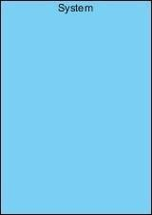

* **Associations:** A line between actors and use cases. It describes which actors are associated with which use cases.
* 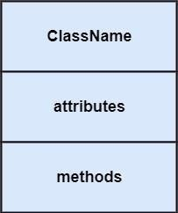**Class:** A class represents an object or a set of objects that share a common structure and behavior.
* 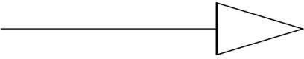**Generalization:** A generalization is a relationship between a parent class and a child class. In this, the child class is inherited from the parent class.
* **Composition:** It portrays the dependency between the parent and its child.

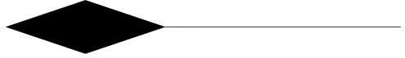

* **Control Flow:** The control flow determines the flow within an activity.



* **Decision Box:** It makes sure that the control flow or object flow will follow Only one path.

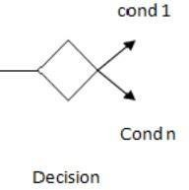

* **Initial State:** It depicts the initial stage or beginning of these two factions.



* 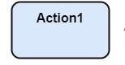**Action:** An action is a named element that is the fundamental unit of an executable functionality.
* **Join:** Join nodes are used to support concurrent activities converging into one.

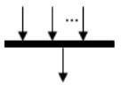

* **Call Message:** It depicts workflow or activity over time using messages passed from element to element.

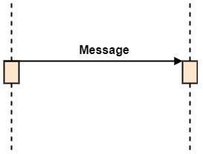

* **Activation:** It is represented by a thin rectangle on the life line. It describes that time period in which an operation is performed by an element.

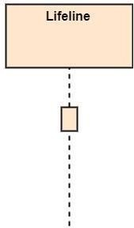

* **Life Line:** Life Line represents the objects that participates in an interaction.

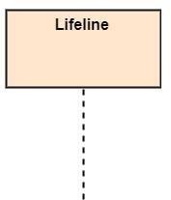

* **Final State:** It is the stage where all the control flows and object flow end.



* **<<Include>>**:

<<Include>>relationshiprepresentsbehaviorthatisfactoredoutoftheusecase.



* 1. **UML DIAGRAMS**

UML stands for Unified Modeling Language which is used in object- oriented software engineering. It is a standard language for specifying, visualizing, constructing, and documenting the artifacts of the software systems. UML is different from other common programming languages like C++, Java, and COBOL etc. It is pictorial language used to make software blueprints.

Although typically used in software engineering it is a rich language that can be used to model an application structure, behavior and even business processes. There are 8 UML diagram types to help us model this behavior.

**CHARACTERISTICS OF UML**

The UML has the following features:

* + - It is a generalized modeling language.
    - It is distinct from other programming languages like C++, Python, etc.
    - It is interrelated to object-oriented analysis and design.
    - It is used to visualize the workflow of the system.
    - It is a pictorial language, used to generate powerful modeling artifacts.

UML is linked with object-oriented design and analysis. UML makes the use of elements and forms associations between them to form diagrams. Diagrams in UML can be broadly classified as:

There are two types of UML modeling:

* Structural Modeling
* Behavioral Modeling

**STRUCTURAL MODELING**

Structural model represents the framework for the system and this framework is the place where all other components exist. Hence, the class diagram, component diagram and deployment diagrams are part of structural modeling. They all represent the elements and the mechanism to assemble them. The structural model never describes the dynamic behavior of the system. Class diagram is the most widely used structural diagram.

Structural Modeling captures the static features of a system. They consist of the following:

1. Classes diagrams
2. Objects diagrams
3. Deployment diagrams
4. Package diagrams
5. Composite structure diagram
6. Component diagram

**BEHAVIOURAL MODELING**

Behavioral model describes the interaction in the system. It represents the interaction among the structural diagrams. Behavioral modeling shows the dynamic nature of the system. They consist of the following:

1. Activity diagrams
2. Interaction diagrams
3. Use case diagrams

All the above show the dynamic sequence of flow in a system.

* 1. **DATA FLOW DIAGRAM**

A data flow diagram (DFD) is a visual representation of the information flow through a process or system. DFDs help you better understand process or system operations to discover potential problems, improve efficiency, and develop better processes. They range from simple overviews to complex, granular displays of a process or system. There are two types of DFDs — logical and physical. Logical diagrams display the theoretical process of moving information through a system, like where the data comes from, where it goes, how it changes, and where it ends up. Physical diagrams show you the practical process of moving information through a system. It can show how your system’s specific software, hardware, files, employees, and customers influence the flow of information.

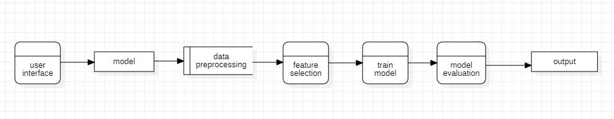

***Figure4.3 Data flow diagram***

* 1. **USE CASE DIAGRAM**

A UML use case diagram is the primary form of system/software requirements for a new software program underdeveloped. In the Unified Modeling Language (UML), a use case diagram can summarize the details of your system's users (also known as actors) and their interactions with the system. To build one, you'll use a set of specialized symbols and connectors. It is useful in the following situations: Scenarios in which your system or application interacts with people, organizations, or external systems, Goals that your system or application helps those entities (known as actors) achieve, the scope of your system. Use cases specify the expected behavior (what), and not the exact method of making it happens (how).

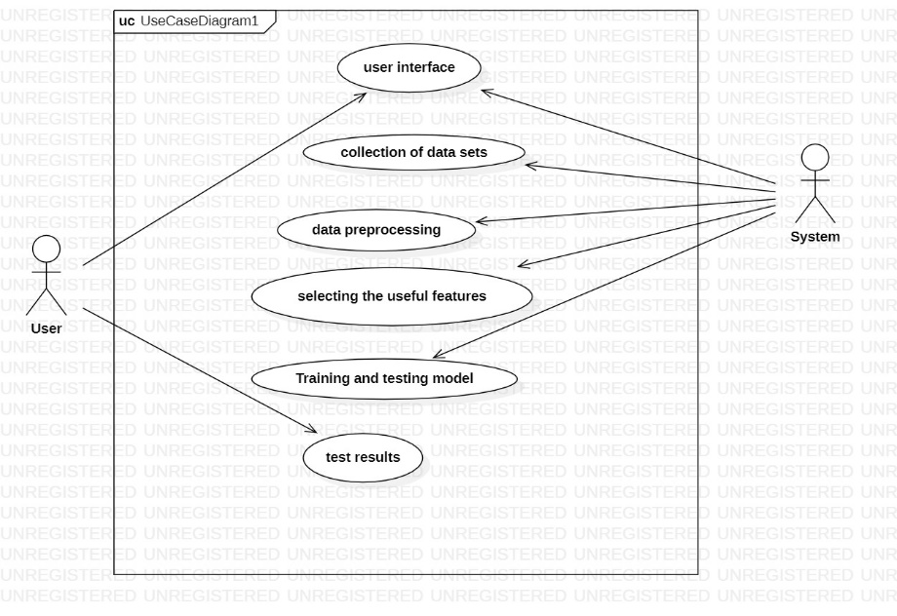

***Figure 4.4: Use case Diagram***

* 1. **CLASS DIAGRAM**

Class diagram is a static diagram. It represents the static view of an application. The class diagram is not only used for visualizing, describing, and documenting different aspects of a system but also for constructing executable code of the software application. The class diagram describes the attributes and operations of a class and also the constraints imposed on the system. The class diagrams are widely used in the modeling of object-oriented systems because they are the only UML diagrams, which can be mapped directly with object-oriented languages. The class diagram shows a collection of classes, interfaces, associations, collaborations, and constraints. It is also known as a structural diagram.

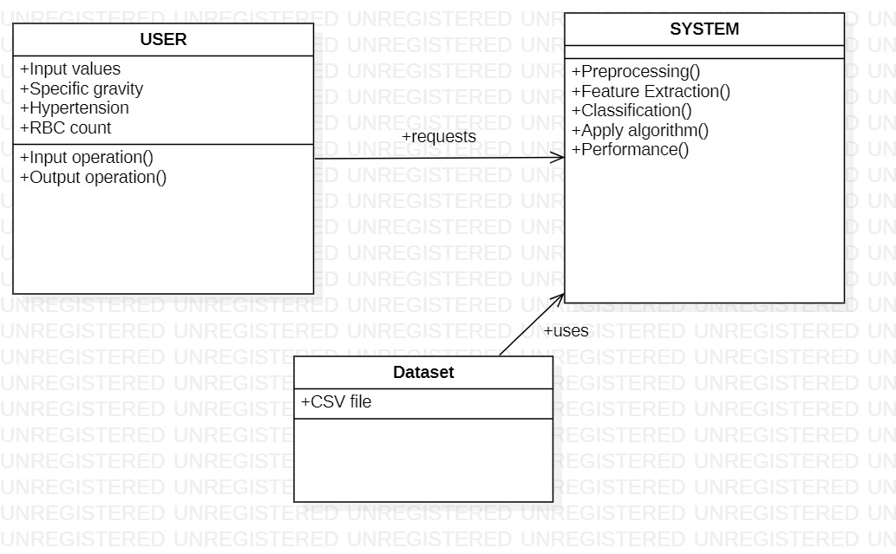

***Figure 4.5 Class Diagram***

* 1. **SEQUENCE DIAGRAM**

UML Sequence Diagrams are interaction diagrams that detail how operations are carried out. They capture the interaction between objects in the context of collaboration. A sequence diagram is a type of interaction diagram because it describes how and in what order a group of objects works together. These diagrams are used by software developers and business professionals to understand requirements for a new system or to document an existing process. Sequence diagrams are sometimes known as event diagrams or event scenarios.

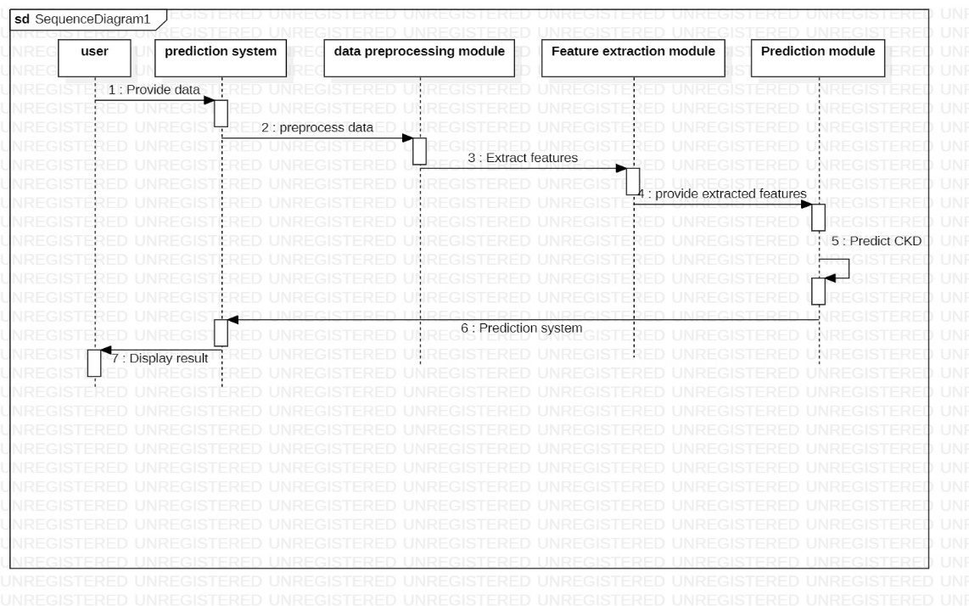

***Figure 4.6 Sequence Diagram***

* 1. **ACTIVITY DIAGRAM**

The Unified Modeling Language includes several subsets of diagrams, including structure diagrams, interaction diagrams, and behavior diagrams. Activity diagrams, along with use case and state machine diagrams are considered behavior diagrams because they describe what must happen in the system being modeled. Activity diagram is basically a flowchart to represent the flow from one activity to another activity. The activity can be described as an operation of the system. The control flow is drawn from one operation to another. This flow can be sequential, branched, or concurrent. Activity diagrams deal with all type of flow control by using different elements such as fork, join, etc.

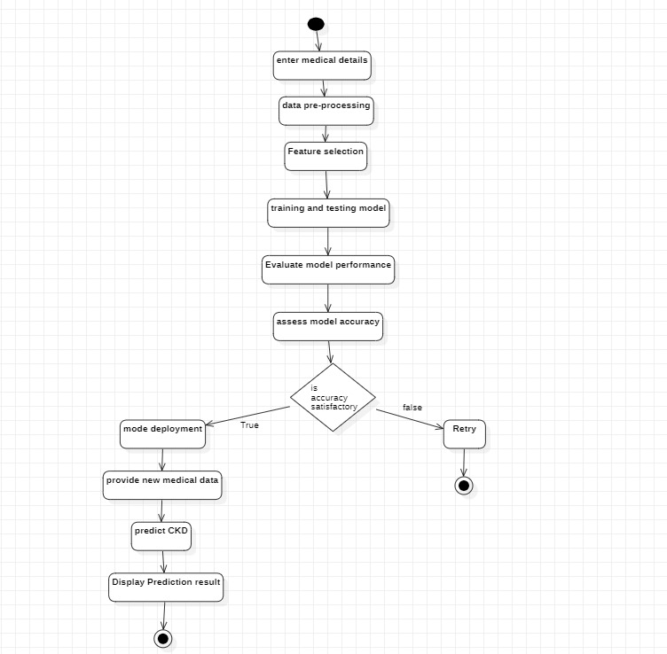

***Figure 4.7 Activity Diagram***

**5. IMPLEMENTATION**

* 1. **INRODUCTION**

Implementation is the stage where the theoretical design is turned into a working system. The most crucial stage in achieving a new successful system is giving confidence on the new system for the users that it will work efficiently and effectively. Function is an essential way of developing a software. Functions are used for writing the code which is to be repeated several times. For example, if we need same code, then we must have to write that code again and again. So, in order to remove this, we use functions.

The system can be implemented only after thorough requirement analysis and designing of the proposed system.

It involves careful planning, investigation of the current system and its constraints on implementation, design of methods to achieve the change over an evaluation of change over methods apart from planning.

**RANDOM FOREST**

Random Forest is an ensemble learning method based on decision tree algorithms. It creates a "forest" of decision trees, each trained on a subset of the data with bootstrapping, and selects random subsets of features for each tree. This approach reduces overfitting, enhances model generalization, and improves predictive accuracy by combining the results of multiple decision trees through voting or averaging. The aggregation of predictions from various trees results in a robust and versatile algorithm capable of handling both classification and regression tasks. Random Forest is renowned for its ability to handle high-dimensional data, identify feature importance, and provide insights into the underlying data structure, making it a popular choice in machine learning for diverse applications.

**RANDOM FOREST FEATURES**

* **Ensemble Learning**: Random Forest is an ensemble learning technique that combines the predictions of multiple decision trees to improve the overall model's performance and reduce overfitting.
* **Decision Trees**: Decision trees are the base learners in a Random Forest. Each tree is constructed based on a random subset of the training data.
* **Bootstrap Aggregating (Bagging)**: Random Forest uses a bootstrapping technique to create multiple subsets of the original training data, ensuring diversity in the data used for each tree.
* **Random Feature Selection**: It selects a random subset of features for each tree to promote feature diversity and improve model generalization.
* **Voting or Averaging**: For classification tasks, Random Forest combines tree predictions through majority voting. For regression tasks, it averages the predictions.
* **Out-of-Bag (OOB) Error** OOB error estimation is a technique used in Random Forest to assess the model's performance by evaluating how well it predicts data that was not included in the training set of a specific tree.
* **Feature Importance**: Random Forest provides a measure of feature importance, which indicates the contribution of each feature in making predictions. It is useful for feature selection and understanding the model's behavior.
* **Hyperparameter Tuning**: Like any other machine learning algorithm, Random Forest has hyperparameters that can be tuned to optimize the model's performance, such as the number of trees, tree depth, and feature selection criteria.
* **Overfitting Prevention**: Random Forest's ensemble approach helps prevent overfitting, making it a robust choice for a wide range of datasets.
* **Parallelization**: Random Forest can be parallelized, allowing for faster training on multi-core processors and distributed computing environments.
* **Scalability**: It is suitable for both small and large datasets due to its ability to handle high-dimensional data effectively.
* **Practical Applications**: Random Forest is widely used in various domains, including classification, regression, anomaly detection, and feature selection.

**WHY DO WE NEED RANDOM FOREST?**

1. **Improved Accuracy**: Random Forest delivers high predictive accuracy by combining multiple decision trees, reducing overfitting and capturing complex relationships in data.
2. **Robustness**: It can handle noisy data, high-dimensional datasets, and outliers effectively, making it suitable for a wide range of real-world applications.
3. **Versatility**: Random Forest is a versatile and widely applicable algorithm, used for classification, regression, feature selection, and more across various domains, making it an essential tool in machine learning.

**STEPS TO IMPLEMENT THE RANDOM FOREST ALGORITHM**

1. **Data collection and preprocessing**: Gather and clean the dataset.
2. **Data splitting for training and testing**: Divide data into subsets for model development and evaluation.
3. **Ensemble training of decision trees**: Build multiple decision trees with random feature selection.
4. **Predictions through majority vote or averaging**: Combine tree predictions for classification or regression.
5. **Model evaluation with metrics**: Assess model performance using relevant evaluation criteria.
6. **Hyperparameter tuning via cross-validation**: Optimize model settings for improved performance.
7. **Analyzing feature importance**: Determine the significance of each feature in making predictions.
8. **Deployment for real-world use**: Implement the model in practical applications.
9. **Continuous monitoring and maintenance**: Regularly update and assess the model's performance.

**ADVANTAGES OF RANDOM FOREST ALGORITHM**

* High Predictive Accuracy: Random Forest consistently delivers high predictive accuracy for both classification and regression tasks. By aggregating multiple decision trees, it reduces overfitting and captures complex relationships within the data, resulting in more reliable predictions.
* Robustness to Noisy Data: Random Forest is robust and resilient in the presence of noisy or unclean data, as the ensemble approach mitigates the impact of outliers and irrelevant variables. This makes it well-suited for real-world datasets that may have inconsistencies.
* Feature Importance: It provides a measure of feature importance, allowing data scientists and domain experts to identify which features have the most significant impact on the model's predictions. This feature is valuable for feature selection and understanding the underlying data.
* Versatility and Generalization: Random Forest can handle a wide range of data types and is versatile across various domains. It can be applied to classification, regression, anomaly detection, and feature selection, making it a go-to choice for diverse machine learning applications.
  1. **METHOD OF IMPLEMENTATION**

Implementation is the stage of the project when the theoretical design is turned out into a working system. Thus, it can be the most critical stage in achieving a successful new system and in giving the user confidence that the new system will work and be effective. The implementation stage involves careful planning, investigation of the existing system and its constraints on implementation, designing of methods to achieve changeover and evaluation of changeover methods

**5.3 MODULES**

**5.3.1 CHRONIC KIDNEY DATA**

The "Chronic Kidney Data" module plays a pivotal role in our project, serving as the foundational cornerstone upon which we build an effective and accurate model for predicting and managing chronic kidney disease (CKD). This module involves the meticulous collection and curation of a dataset specifically tailored to CKD, encompassing a comprehensive array of patient attributes, clinical records, laboratory results, and demographic characteristics. These data elements provide a holistic view of the patients' health and clinical history, essential for developing a robust predictive model. The dataset represents the real-world complexity of CKD cases, reflecting the diverse range of factors contributing to the disease's onset and progression. Quality assurance is paramount in this stage, as data integrity and completeness are vital for subsequent phases.

**5.3.2 MISSING VALUES PREPROCESSING**

The "Missing Values and Preprocessing" module is a pivotal step in ensuring the quality and readiness of the CKD dataset for machine learning. It begins by addressing the issue of missing data, a common challenge in real-world healthcare datasets. Missing values can hinder the performance of predictive models, necessitating careful handling. Techniques such as imputation or removal of incomplete data entries are employed to mitigate this issue.

Additionally, preprocessing involves a series of data transformations to prepare the dataset for machine learning. This may include data normalization to bring all features to a common scale, feature scaling to adjust the range of values, and encoding categorical variables to convert them into a numerical format. These steps ensure that the data is consistent and that machine learning algorithms can operate effectively.

Ultimately, the goal of this module is to produce a clean and well-structured dataset, free from inconsistencies and missing values, setting the stage for model development and accurate predictions.

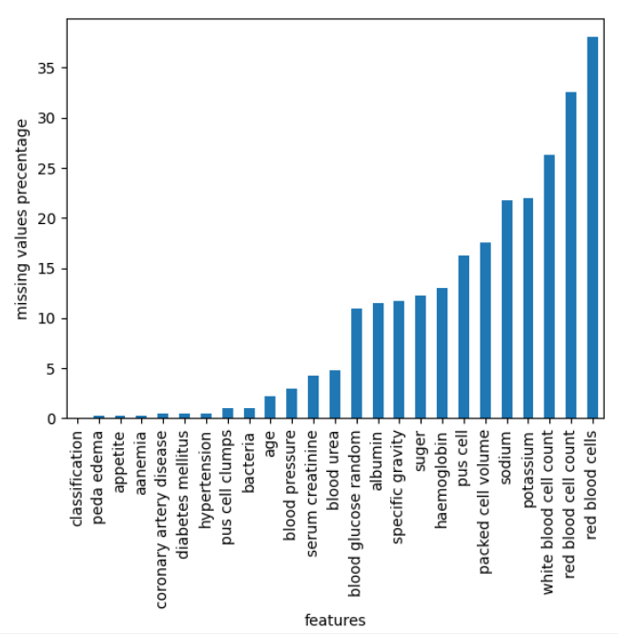

***Figure 5.2.1 Missing Values Preprocessing***

**5.3.3 FEATURE SELECTION**

The "Feature Selection" module is a critical phase in our endeavor to build an effective Chronic Kidney Disease (CKD) prediction model. With the dataset prepared, we turn our attention to identifying the most influential attributes or features for CKD prediction. Not all variables are equally informative, and selecting the right subset of features can enhance model efficiency and interpretability. This module involves various techniques to pinpoint the most relevant features, including correlation analysis, feature importance scores, and dimensionality reduction methods like Principal Component Analysis (PCA).

By reducing the dimensionality of the dataset to only the most informative attributes, we enhance the model's generalization and reduce computational complexity. This process is not only about enhancing predictive accuracy but also about understanding the key factors contributing to CKD. It ensures that the model is focused on the most pertinent variables, providing a more interpretable and efficient solution for healthcare professionals.

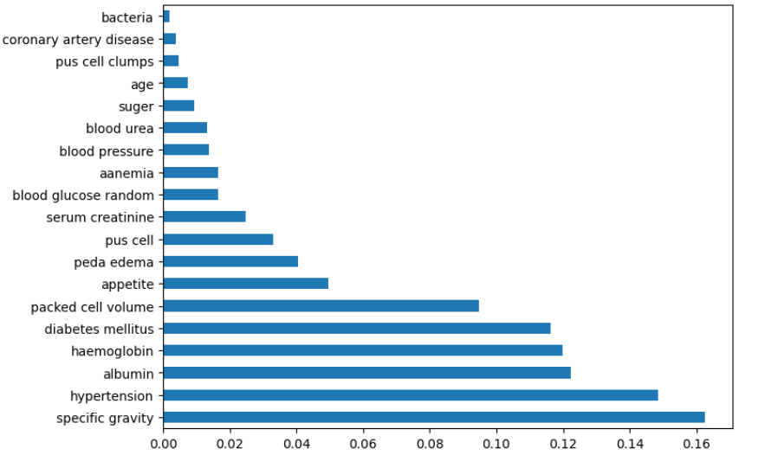

***Figure 5.2.2 Feature Selection***

**5.3.4 TRAINING AND TESTING DATASET**

In the "Training and Testing Dataset" module, we create a division of our preprocessed CKD dataset into two key subsets: the training set and the testing set. This separation is essential to assess the performance and generalization capabilities of our CKD prediction model accurately.

The training dataset is the primary component used to develop and train the CKD prediction model. It contains a significant portion of the data, and the model learns patterns, relationships, and characteristics from this subset.

In contrast, the testing dataset is designed to evaluate the model's performance on new, unseen data. By using this distinct dataset, we can determine how well the model generalizes to real-world scenarios and assess its ability to make accurate predictions on previously unencountered cases.

Additionally, for more complex models or when hyperparameter tuning is required, a validation set may be utilized for intermediate testing and fine-tuning of the model.

The careful division of the dataset into these subsets ensures that the model's performance assessment is comprehensive, reliable, and applicable to practical CKD diagnosis and management scenarios.

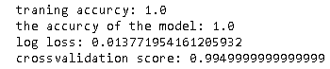

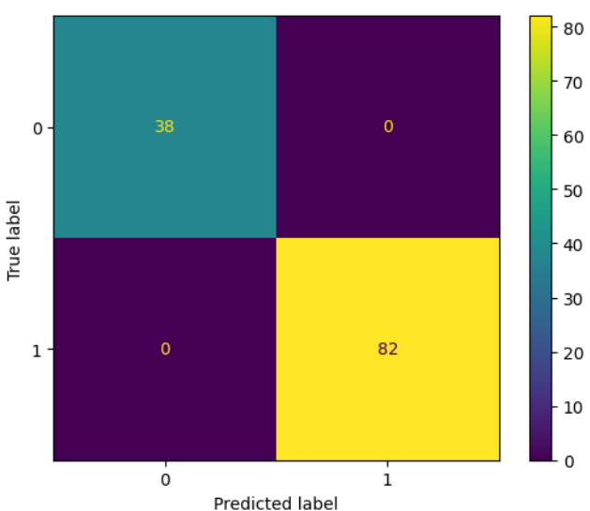

***Figure 5.2.3 Training and Testing***

**5.3.5 MODEL TRAINING AND EVALUVATION**

The "Model Training and Evaluation" module is a critical phase where we leverage machine learning techniques to build our Chronic Kidney Disease (CKD) prediction model. This module involves the selection of an appropriate algorithm, such as Random Forest or Gradient Boosting, to train the model. The training process employs the training dataset to fit the model to the data, enabling it to learn patterns and relationships.

Once the model is trained, we proceed to the evaluation step, which is essential for assessing its performance. For classification tasks, metrics like accuracy, precision, recall, and F1 score are used, while regression tasks may employ metrics such as mean squared error (MSE) or R-squared. This comprehensive evaluation process ensures that the model's predictions are accurate and reliable.

By iteratively fine-tuning the model and assessing its performance, we aim to create a highly effective CKD prediction tool. This module is the bridge that translates data into actionable insights, ultimately contributing to improved CKD diagnosis and management.

* 1. **EXPLANATION OF KEY FUNCTIONS**

**PYTHON**

Python is a high-level, interpreted, interactive and object-oriented scripting language. Python is designed to be highly readable. It uses English keywords frequently where as other languages use punctuation, and it has fewer syntactical constructions than other languages.

* **Python is Interpreted:** Python is processed at runtime by the interpreter. You do not need to compile your program before executing it. This is similar to PERL and PHP.
* **Python is Interactive:** You can actually sit at a Python prompt and interact with the interpreter directly to write your programs.
* **Python is Object-Oriented:** Python supports Object-Oriented style or technique of programming that encapsulates code within objects.
* **Python is a Beginner's Language:** Python is a great language for the beginner level. Programmers and supports the development of a wide range of applications from simple text processing to WWW browsers to games.

**FLASK**

Flask is a micro web framework written in Python. It is designed simple, lightweight, and easy to use, making it an excellent choice for building web applications, particularly for small to medium-sized projects. Flask follows the WSGI (Web Server Gateway Interface) standard and is known for its minimalistic design, giving developers the flexibility to add the components they need.

1. **Routing:**

Flask allows you to define URL routes and associate them with Python functions. When a user accesses a specific URL, the associated function, known as a view function, is executed to handle the request.

1. **Templates:**

Flask integrates with Jinja2, a popular templating engine. You can use templates to generate HTML content dynamically, making it easy to create web pages with dynamic data. Templates allow you to separate your application logic from your presentation.

1. **Request Handling:**

Flask provides request and response objects to handle incoming requests and send responses. You can access request data, form parameters, and more using the `request` object.

1. **View Functions:**

View functions are Python functions that define what happens when a particular URL is accessed. They can return HTML content, JSON data, or any other response.

1. **Templates:**

Flask integrates with Jinja2, a popular templating engine. You can use templates to generate HTML content dynamically, making it easy to create web pages with dynamic data. Templates allow you to separate your application logic from your presentation.

1. **Request Handling:**

Flask provides request and response objects to handle incoming requests and send responses. You can access request data, form parameters, and more using the `request` object.

1. **View Functions:**

View functions are Python functions that define what happens when a particular URL is accessed. They can return HTML content, JSON data, or any other response.

1. **URL Variables:**

Flask allows you to define variable parts in routes, which can be passed as parameters to view functions. For example, a URL like “/user/123”.

1. **Static Files:**

You can serve static files like CSS, JavaScript, and images by placing them in a folder named `static`. Flask provides the `url_for` function to generate URLs for these static files in your templates.

1. **Error Handling:**

Flask makes it easy to handle different types of errors and exceptions by defining error handlers. You can create functions to handle specific HTTP error codes.

1. **Middleware:**

Flask allows you to use middleware to process requests and responses globally across your application. Middleware functions can perform tasks like authentication, logging, and more.

1. **Extensions:**

Flask offers a wide range of extensions to add functionality to your application. These extensions cover areas such as database integration (e.g., Flask- SQL Alchemy), user authentication (e.g., Flask-Login), and form handling (e.g., Flask-WTF).

1. **Session Management and Cookies:**

You can easily work with sessions and cookies to manage user data and maintain state between requests.

1. **RESTful APIs:**

Flask is commonly used to build RESTful APIs, thanks to its simplicity and the ability to return JSON responses easily.

1. **Testing:**

Flask provides tools for unit testing and client simulation to test your application's functionality and routes.

1. **Deployment:**

To deploy a Flask application in production, it is common to use a production-ready server like Gunicorn or uWSGI, and to configure a web server like Nginx or Apache to serve the application.

**5.5 SOURCE CODE**

**Main.py**

import numpy as np

import matplotlib.pyplot as plt

import numpy as np

import seaborn as sns

import pandas as pd

from sklearn.metrics import ConfusionMatrixDisplay

from sklearn.metrics import accuracy_score, confusion_matrix, classification_report

from sklearn.metrics import classification_report

from sklearn import metrics

from sklearn.metrics import log_loss

from sklearn.metrics import f1_score

from sklearn.ensemble import RandomForestClassifier

import joblib

pd.pandas.set_option('display.max_columns', None)

dataset = pd.read_csv("Kidney_data.csv")

dataset.shape

dataset.head()

dataset = dataset.drop('id', axis=1)

dataset.info()

missingvalues=dataset.isnull().sum().sort_values()*100/len(dataset)

missingvalues.to_frame

missingvalues.plot(kind='bar')

plt.ylabel('missing values precentage')

plt.xlabel('features')

plt.show()

dataset=dataset.drop(['sodium','potassium','white blood cell count','red blood cell count','red blood cells'],axis=1)

dataset.head()

dataset.shape

dataset.describe()

dataset.columns

#for pc

print(dataset['pus cell'].value_counts())

dataset['pus cell'] = dataset['pus cell'].replace(to_replace = {'normal' : 0, 'abnormal' : 1})

#for pcc

dataset['pus cell clumps'].value_counts()

dataset['pus cell clumps'] = dataset['pus cell clumps'].replace(to_replace = {'notpresent':0,'present':1})

#for ba

print(dataset['bacteria'].value_counts())

dataset['bacteria'] = dataset['bacteria'].replace(to_replace = {'notpresent':0,'present':1})

#hnt

print(dataset['hypertension'].value_counts())

dataset['hypertension'] = dataset['hypertension'].replace(to_replace = {'yes' : 1, 'no' : 0})

#dm

print(dataset['diabetes mellitus'].value_counts())

dataset['diabetes mellitus'] = dataset['diabetes mellitus'].replace(to_replace = {'\tyes':'yes', ' yes':'yes', '\tno':'no'})

dataset['diabetes mellitus'] = dataset['diabetes mellitus'].replace(to_replace = {'yes' : 1, 'no' : 0})

#cad

print(dataset['coronary artery disease'].value_counts())

dataset['coronary artery disease'] = dataset['coronary artery disease'].replace(to_replace = {'\tno':'no',})

dataset['coronary artery disease'] = dataset['coronary artery disease'].replace(to_replace = {'yes' : 1, 'no' : 0})

#appet

print(dataset['appetite'].unique())

dataset['appetite'] = dataset['appetite'].replace(to_replace={'good':1,'poor':0,'no':np.nan})

#pe

print(dataset['peda edema'].value_counts())

dataset['peda edema'] = dataset['peda edema'].replace(to_replace = {'yes' : 1, 'no' : 0})

#ane

print(dataset['aanemia'].value_counts())

dataset['aanemia'] = dataset['aanemia'].replace(to_replace = {'yes' : 1, 'no' : 0})

#class

dataset['classification'] = dataset['classification'].replace(to_replace={'ckd\t':'ckd','notckd\t':'notckd'})

dataset['classification'] = dataset['classification'].replace(to_replace = {'ckd' : 1, 'notckd' : 0})

print(dataset['classification'].value_counts())

dataset['packed cell volume'] = pd.to_numeric(dataset['packed cell volume'], errors='coerce')

feature=[['age', 'blood pressure', 'specific gravity', 'albumin', 'suger',

'pus cell', 'pus cell clumps', 'bacteria', 'blood glucose random',

'blood urea', 'serum creatinine', 'haemoglobin', 'packed cell volume',

'hypertension', 'diabetes mellitus', 'coronary artery disease',

'appetite', 'peda edema', 'aanemia', 'classification']]

for feature in feature:

dataset[feature] = dataset[feature].fillna(dataset[feature].median())

dataset.head()

sns.countplot(x=dataset['classification'])

plt.figure(figsize=(24,14))

sns.heatmap(dataset.corr(), annot=True, cmap='YlGnBu')

plt.show()

X = dataset.iloc[:, :-1]

y= dataset.iloc[:, -1]

from sklearn.ensemble import ExtraTreesClassifier

import matplotlib.pyplot as plt

model=ExtraTreesClassifier()

model.fit(X,y)

plt.figure(figsize=(8,6))

ranked_features=pd.Series(model.feature_importances_,index=X.columns)

ranked_features.nlargest(24).plot(kind='barh')

plt.show()

ranked_features.nlargest(8).index

sns.kdeplot(data=dataset,x='serum creatinine',hue='classification')

#hypertension

#dm

#albumin

#aanemia

#haemoglobin

#specific gravity

##############################

#packed cell volume

#serum creatinine

#pus cell

X = dataset[['specific gravity', 'hypertension', 'haemoglobin', 'diabetes mellitus', 'albumin','serum creatinine','aanemia','pus cell']]

X.head()

from sklearn.model_selection import train_test_split

X_train,X_test,y_train,y_test = train_test_split(X,y, test_size=0.3)

print(X_train.shape)

print(X_test.shape)

RandomForest = RandomForestClassifier()

RandomForest = RandomForest.fit(X_train,y_train)

predict=(RandomForest.predict(X_test))

print("traning accurcy:", RandomForest.score(X_train,y_train))

print("the accurcy of the model:", accuracy_score(y_test,predict))

print("log loss:",log_loss(y_test,RandomForest.predict_proba(X_test)))

from sklearn.metrics import ConfusionMatrixDisplay

z=confusion_matrix(y_test,predict)

cm=ConfusionMatrixDisplay(confusion_matrix=z,display_labels=RandomForest.classes_)

cm.plot()

plt.show()

from sklearn.model_selection import cross_val_score

print(cross_val_score(RandomForest, X, y, cv=15).mean())

from sklearn.neighbors import KNeighborsClassifier

neigh = KNeighborsClassifier(n_neighbors=15)

neigh.fit(X, y)

print(cross_val_score(neigh, X, y, cv=15).mean())

cv=cross_val_score(neigh, X, y, cv=10)

plt.plot(cv)

print(np.mean(cv))

from sklearn.linear_model import LogisticRegression

lr=LogisticRegression()

lr.fit(X,y)

print(cross_val_score(lr, X, y, cv=10).mean())

from sklearn.svm import SVC

svm=SVC()

svm.fit(X,y)

print(cross_val_score(svm, X, y, cv=10).mean())

#specific gravity,hypertension,haemoglobin,diabetes mellitus,albumin,aanemia,pus cell

input=(1.020,0.0,15.7,0.0,0.0,0.0,0.0,0.5)

inputnp=np.array(input)

inputreshape=inputnp.reshape(1,-1)

outter=RandomForest.predict(inputreshape)

if (outter[0]==0):

print('NO CKD ')

else:

print('CKD')

**App.py(FLASK)**

from flask import Flask, render_template, request, Response

import numpy as np

import pandas as pd

from sklearn.ensemble import RandomForestClassifier

from sklearn.preprocessing import StandardScaler

import joblib

import os

from reportlab.pdfgen import canvas

app = Flask(__name__)

def load_model():

model = joblib.load('ckd.pkl')

return model

model = load_model()

@app.route('/')

def home():

return render_template('index.html')

@app.route('/predict', methods=['POST'])

def predict():

try:

# Extract input data from the form

specific_gravity = float(request.form['specific_gravity'])

hypertension = int(request.form['hypertension'])

haemoglobin = float(request.form['haemoglobin'])

diabetes_mellitus = int(request.form['diabetes_mellitus'])

albumin = float(request.form['albumin'])

serum_creatinine = float(request.form['serum_creatinine'])

aanemia = int(request.form['aanemia'])

pus_cell = int(request.form['pus_cell'])

# Prepare the input data for prediction

input_data = np.array([[specific_gravity, hypertension, haemoglobin, diabetes_mellitus,

albumin, serum_creatinine, aanemia, pus_cell]])

# Perform data preprocessing if needed (e.g., scaling)

# scaler = StandardScaler() # Use the same scaler used during training

# input_data = scaler.transform(input_data)

# Make predictions using the loaded model

prediction_result = model.predict(input_data)

# Convert the prediction result (1 for CKD, 0 for Not CKD) into a human-readable format

result_text = "CKD" if prediction_result == 1 else "Not CKD"

# Render the 'result.html' template with the prediction result and input values

return render_template('result.html',

prediction_result=result_text,

specific_gravity=specific_gravity,

hypertension=hypertension,

haemoglobin=haemoglobin,

diabetes_mellitus=diabetes_mellitus,

albumin=albumin,

serum_creatinine=serum_creatinine,

aanemia=aanemia,

pus_cell=pus_cell)

except Exception as e:

error_message = "An error occurred: " + str(e)

return render_template('error.html', error_message=error_message)

def generate_pdf():

pdf = FPDF()

pdf.add_page()

pdf.set_font("Arial", size=12)

# CKD Ranges

pdf.cell(200, 10, txt="CKD Ranges:", ln=True, align='L')

pdf.multi_cell(0, 10, "Specific Gravity: 1.005 to 1.030\n"

"Hypertension: 90mm Hg to 140mm Hg\n"

"Hemoglobin: 12.0 to 15.5 g/dL\n"

"Diabetes Mellitus: above 126mg/dL\n"

"Albumin: above 30mg/dL\n"

"Serum Creatinine: above 5.0 mg/dL (adults)\n"

"Anemia: below 60mg/dL\n"

"Pus Cell: above 8 pus cells", align='L')

# Prediction Result

prediction_result = request.args.get('prediction_result', 'None')

pdf.cell(200, 10, txt="\nPrediction Result:", ln=True, align='L')

pdf.multi_cell(0, 10, f"Result: {prediction_result}", align='L')

# Output the PDF content to a temporary buffer

pdf_buffer = pdf.output(dest='S')

# Specify the PDF file path

pdf_file = "CKD_Prediction_Report.pdf"

# Write the PDF content from the buffer to the file

with open(pdf_file, 'wb') as f:

f.write(pdf_buffer)

return pdf_file

@app.route('/generate_report_pdf_route', methods=['GET'])

def generate_report_pdf_route():

try:

pdf_file = generate_pdf()

def generate():

with open(pdf_file, 'rb') as f:

pdf_data = f.read()

yield pdf_data

response = Response(generate(), content_type='application/pdf')

response.headers['Content-Disposition'] = 'attachment; filename=CKD_Prediction_Report.pdf'

return response

except Exception as e:

error_message = "An error occurred while generating the PDF report: " + str(e)

return render_template('error.html', error_message=error_message)

if __name__ == '__main__':

app.run(debug=True)

**Index.html**

<!DOCTYPE html>

<html lang="en">

<head>

<meta charset="UTF-8">

<meta name="viewport" content="width=device-width, initial-scale=1.0">

<title>CKD Prediction</title>

<link rel="stylesheet" href="{{ url_for('static', filename='styles.css') }}">

<style>

body {

font-family: Arial, sans-serif;

}

.container {

max-width: 400px;

margin: 0 auto;

padding: 20px;

border-radius: 10px;

box-shadow: 0 0 10px rgba(0, 0, 0, 0.884);

}

h1 {

text-align: center;

color: #000000;

}

.form-group {

margin-bottom: 20px;

}

label {

display: block;

font-weight: bold;

margin-bottom: 5px;

}

input[type="text"],

input[type="number"] {

width: 100%;

padding: 10px;

border: 1px solid #ccc;

border-radius: 5px;

font-size: 16px;

}

input[type="submit"] {

background-color: #007bff;

color: #fff;

padding: 10px 20px;

border: none;

border-radius: 5px;

font-size: 18px;

cursor: pointer;

transition: background-color 0.3s ease-in-out;

}

input[type="submit"]:hover {

background-color: #0056b3;

}

.scrollable-table {

max-height: 400px;

overflow-y: scroll;

}

.scrollable-table::-webkit-scrollbar {

width: 0.001rem;

}

</style>

</head>

<body>

<div class="container">

<h1>Chronic Kidney Disease Prediction</h1>

<div class="scrollable-table">

<form action="/predict" method="POST">

<div class="form-group">

<label for="specific_gravity">Specific Gravity:</label>

<input type="text" name="specific_gravity" id="specific_gravity" required>

</div>

<div class="form-group">

<label for="hypertension">Hypertension:</label>

<input type="text" name="hypertension" id="hypertension" required>

</div>

<div class="form-group">

<label for="haemoglobin">Haemoglobin:</label>

<input type="text" id="haemoglobin" name="haemoglobin" required>

</div>

<div class="form-group">

<label for="diabetes_mellitus">Diabetes Mellitus (0 for No, 1 for Yes):</label>

<input type="number" id="diabetes_mellitus" name="diabetes_mellitus" required>

</div>

<div class="form-group">

<label for="albumin">Albumin:</label>

<input type="text" id="albumin" name="albumin" required>

</div>

<div class="form-group">

<label for="serum_creatinine">Serum Creatinine:</label>

<input type="text" id="serum_creatinine" name="serum_creatinine" required>

</div>

<div class="form-group">

<label for="aanemia">Aanemia (0 for No, 1 for Yes):</label>

<input type="number" id="aanemia" name="aanemia" required>

</div>

<div class="form-group">

<label for="pus_cell">Pus Cell (0 for No, 1 for Yes):</label>

<input type="number" id="pus_cell" name="pus_cell" required>

</div>

<div class="form-group">

<input type="submit" value="Predict">

</div>

</form>

</div>

</div>

</body>

</html>

**Styles.css**

@keyframes fadeIn {

from { opacity: 0; }

to { opacity: 1; }

}

@keyframes slideInUp {

from { transform: translateY(100px); }

to { transform: translateY(0); }

}

.container {

max-width: 600px;

margin: 0 auto;

text-align: center;

padding: 20px;

border-radius: 10px;

box-shadow: 0 0 10px rgba(0, 0, 0, 0.2);

animation: fadeIn 1s ease-in-out;

}

.form-group {

margin-bottom: 20px;

animation: slideInUp 1s ease-in-out;

}

.result {

font-size: 24px;

font-weight: bold;

margin-top: 200px;

animation: slideInUp 1s ease-in-out;

color: #3498db;

}

body {

font-family: Arial, sans-serif;

margin: 20;

padding: 100;

background-image: url('wallpaperflare.com_wallpaper (1).jpg');

background-size: cover;

background-repeat: no-repeat;

background-attachment: fixed;

background-position: center center;

animation: movingBackground 30s infinite linear;

color: rgb(0, 0, 0);

display: flex;

flex-direction: column;

justify-content: center;

align-items: center;

height: 100vh;

}

@keyframes movingBackground {

0% {

background-position: 0 0;

}

100% {

background-position: 100% 100%;

}

}

footer {

position: absolute;

bottom: 0;

left: 0;

padding: 1em;

background-color: rgb(0, 0, 0);

color: white;

font-size: 14px;

}

**5.6 Output Screens**

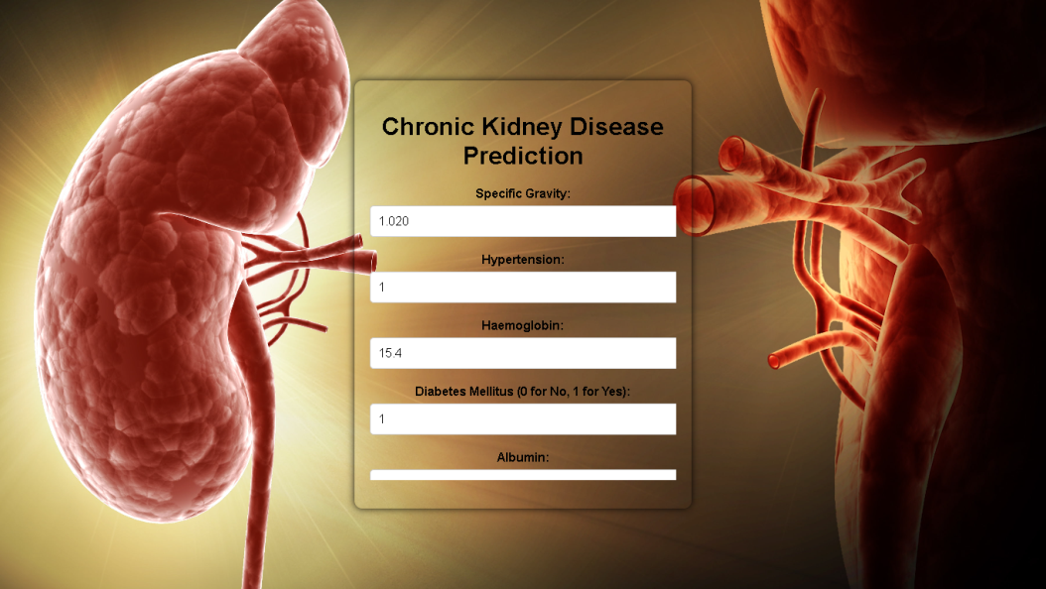

***Figure5.4.1: Prediction Input***

The above screenshot shows the Chronic Kidney Disease Prediction Input.

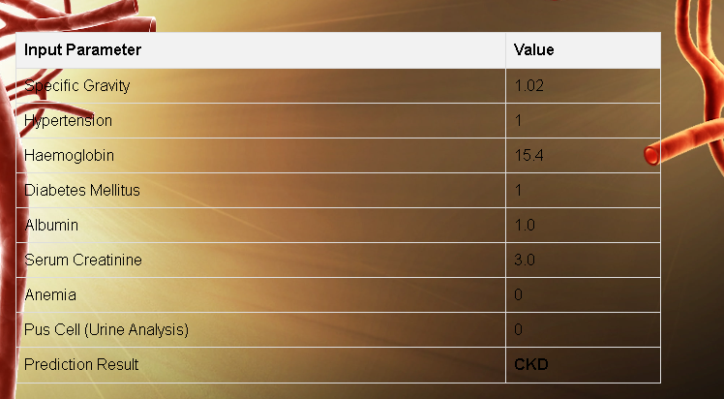

***Figure5.4.2: Prediction Result***

The above screenshot shows Chronic Kidney Disease Prediction Result.

* 1. **TESTING**
  2. **INTRODUCTION TO TESTING**

Software testing is a process, to evaluate the functionality of a software application with an intent to find whether the developed software met the specified requirements or not and to identify the defects to ensure that the product is defect free to produce the quality product.

* 1. **TYPES OF TESTS**

1. **Application Testing:**

It is defined as a software testing type, conducted through scripts with the motive of finding errors in software. It deals with tests for the entire application. It helps to enhance the quality of your applications while reducing costs, maximizing ROI, and saving development time.

1. **System Testing:**

It is a level of testing that validates the complete and fully integrated software product. The purpose of a system test is to evaluate the end-to-end system specifications. Usually, the software is only one element of a larger computer-based system.

1. **GUI Testing:**

GUI Testing is a software testing type that checks the Graphical User Interface of the Software. The purpose of Graphical User Interface (GUI) Testing is to ensure the functionalities of software application work as per specifications by checking screens and controls like menus, buttons, icons, etc.

1. **Security Testing:**

Security Testing is a type of Software Testing that uncovers vulnerabilities of the system and determines that the data and resources of the system

are protected from possible intruders. It ensures that the software system and application are free from any threats or risks that can cause a loss. Software Testing is a method to check whether the actual software product matches expected requirements and to ensure that software product is Defect free. It involves execution of software/system components using manual or automated tools to evaluate one or more properties of interest.

* 1. **TEST CASES**

Test case writing is a major activity and considered as one of the most important parts of software testing. It is used by the testing team, development team as well as the management. If there is no documentation for an application, we can use the test case as a baseline document.

***Table6.1*** *Test Cases for Chronic Kidney Disease.*

|  |  |  |  |  |  |
| --- | --- | --- | --- | --- | --- |
| **TEST CASE**  **ID** | **TEST CASE DESCRIPTION** | **TEST DATA** | **EXPECTED RESULT** | **ACTUAL RESULT** | **STATUS** |
| Test Case No 1. | Check Home Screen Launching from the IDE. | Go to site [http://127.0.0.1](http://127.0.0.1/)  :5000/. | Opens the Web Browser, when we click on URL. | As Expected. | Pass |
| Test Case No 2. | . Data Preprocessing Test. | Raw CKD dataset. | Dataset is cleaned and ready for feature selection. | As Expected. | Pass |
| Test Case No 3. | Feature Selection Test. | Preprocessed CKD dataset. | Select relevant features for CKD prediction. | As Expected. | Pass |
| **TEST CASE**  **ID** | **TEST CASE DESCRIPTION** | **TEST DATA** | **EXPECTED RESULT** | **ACTUAL RESULT** | **STATUS** |
| Test Case No 4. | Training and Testing Dataset Split Test. | Preprocessed CKD dataset. | Training set contains 70%, testing set 30%. | As Expected. | Pass |
| Test Case No 5. | Model Training Test. | Training dataset. | Model trained without errors. | As Expected. | Pass |
| Test Case No 6. | Evaluation Metrics Test. | Predictions and actual CKD status. | Display accuracy, precision, recall, F1-score, etc. | As Expected. | Pass |
| Test Case No 7. | User Interface Test. | UI for data input and result display. | User can input data, view predictions, and info. | As. Expected. | Pass |
| Test Case No 8. | Performance Test. | Prediction request. | Response time within acceptable limits. | As Expected. | Pass |
| Test Case No 9. | Security Test. | Data handling and storage procedures. | Data is securely handled and protected. | As Expected. | Pass |
| Test Case No 10. | Integration Test. | External systems or databases used. | Integration with external systems is seamless. | As Expected. | Pass |

1. **CONCLUSION**

**7.1 PROJECT CONCLUSION**

In conclusion, this project has been a significant step in leveraging machine learning techniques to predict chronic kidney disease (CKD) with a high degree of accuracy and reliability. The journey began with data collection, cleaning, and preprocessing, followed by an in-depth exploratory analysis of the dataset. We then employed various machine learning algorithms to build predictive models for CKD. After rigorous evaluation and comparison, the XGBoost model emerged as the top-performing algorithm, with a notable AUC score and recall rate.

Our primary objective was to develop a model that minimizes False Negatives since failing to predict CKD when it is present can have serious health implications. We prioritized recall over precision, given the importance of early detection in managing CKD. The chosen model, XGBoost, demonstrated a low False Negative count, making it a safer choice for real-world applications.

This project showcases the potential of machine learning in healthcare, as it provides a non-invasive and efficient way to predict CKD. The model's performance metrics, coupled with its computational efficiency, make it well-suited for deployment in a web application, where users can assess their risk of CKD conveniently. It's worth noting that XGBoost also outperformed Adaboost in terms of speed, making it a practical choice for real-time applications.

In summary, the CKD prediction model built in this project offers a promising solution for early detection and intervention, potentially improving the lives of individuals at risk of this debilitating condition. Further refinements and validation are essential before clinical deployment, but the results obtained thus far are encouraging and lay the foundation for future advancements in the field of healthcare predictive analytics.

* 1. **FUTURE ENHANCEMENT**

Future enhancements for the chronic kidney disease (CKD) prediction project encompass several key aspects. Firstly, the integration of more extensive and diverse data sources, including a wider array of patient attributes and longitudinal health data, can bolster prediction accuracy. Advanced feature engineering and hyperparameter tuning should continue to be explored, along with potential ensemble models to refine the model's performance.

Enhancing model interpretability using methods like SHAP values and LIME will improve user trust and acceptance. Real-time monitoring for continuous risk assessment and early intervention is crucial. Rigorous validation, including cross-validation and external validation, is necessary to ensure the model's reliability and generalizability.

Collaboration with healthcare professionals, integration with electronic health records, mobile application development, and a user-friendly interface are essential for practical deployment. Ethical considerations, data security, and compliance with healthcare regulations should remain a focus. Continuous updates and educational resources can empower users, ultimately contributing to better CKD prediction and prevention.

**8. REFERENCES**

* 1. **JOURNALS**

1. Khamparia, A.; Saini, G.; Pandey, B.; Tiwari, S.; Gupta, D.; Khanna, A. KDSAE: Chronic kidney disease classification with multimedia data learning using deep stacked autoencoder network. *Multimed. Tools Appl.* **2020**, *79*, 35425–35440
2. Van Gastel, M.D.; Edwards, M.E.; Torres, V.E.; Erickson, B.J.; Gansevoort, R.T.; Kline, T.L. Automatic measurement of kidney and liver volumes from MR images of patients affected by autosomal dominant polycystic kidney disease. *J. Am. Soc. Nephrol.* **2019**, *30*, 1514–1522.
3. Suresh, C.; Pani, B.C.; Swatisri, C.; Priya, R.; Rohith, R. A Neural Network based Model for Predicting Chronic Kidney Diseases. In Proceedings of the 2020 Second International Conference on Inventive Research in Computing Applications (ICIRCA), Coimbatore, India, 15–17 July 2020.
   1. **TEXT BOOKS**
4. An Early Prediction Model for Chronic Kidney Disease
5. Chronic Kidney Disease Diagnosis System using Sequential Backward Feature Selection and Artificial Neural Network
6. Machine Learning and AI for Healthcare
   1. **WEBSITES**
      * en.wikipedia.org/wiki/Machine learning
      * [www.geeksforgeeks.org](http://www.geeksforgeeks.org/)
      * [www.tutorialspoint.com](http://www.tutorialspoint.com/)
      * [https://chat.openai.com](https://chat.openai.com/)
      * <https://www.mdpi.com/1999-4893/15/9/308>