LuminTrack
Product Overview
One place for the entire recruiting pipeline — from a job coming in, to a consultant placed and billing.

What this is: an internal recruitment tracking system that replaces the current mix of Excel sheets, Word documents, and email threads with a single, always-current system of record — covering jobs, candidates, submissions, interviews, and placements, plus live reporting on how the team and the business are performing.
What LuminTrack is
LuminTrack tracks every stage of the recruiting process in one system, and keeps the numbers current automatically. Three types of user work in it:
Role | What they do in LuminTrack
Recruiter | Work assigned jobs, submit candidates, track interviews, see their own numbers.
Team Lead | Set the commercial terms on requirements, oversee a team, see rates and margins.
Manager / Admin | Full visibility across the org — every job, placement, margin, and report; manage settings.

What it replaces
Before (today) | After (LuminTrack)
Candidate details spread across spreadsheets | One searchable talent pool with résumés & documents attached
Job requirements re-typed by hand | Jobs import automatically from the vendor portal
Submission status tracked in email | A live pipeline everyone can see
Rates and margins calculated manually | Calculated automatically, with warnings when something's off
"How is the team doing?" = a spreadsheet someone builds | Live dashboards and reports, updated continuously
Deleted = gone forever | Nothing is truly lost — trash, backups, and a full history

The big picture — how the work flows
Recruiting is a pipeline. Work moves left to right, and each stage feeds the next automatically:
Job → Requirement → Submission → Interviews → Placement
A job comes in → a team lead sets the deal terms → a recruiter submits a candidate → the candidate interviews → if they join, a placement is created and billing begins. The key idea: enter information once, and it flows everywhere. When a candidate is marked Joined, the placement is created on its own, the candidate's status updates, and the dashboard and reports change — with no duplicate data entry.
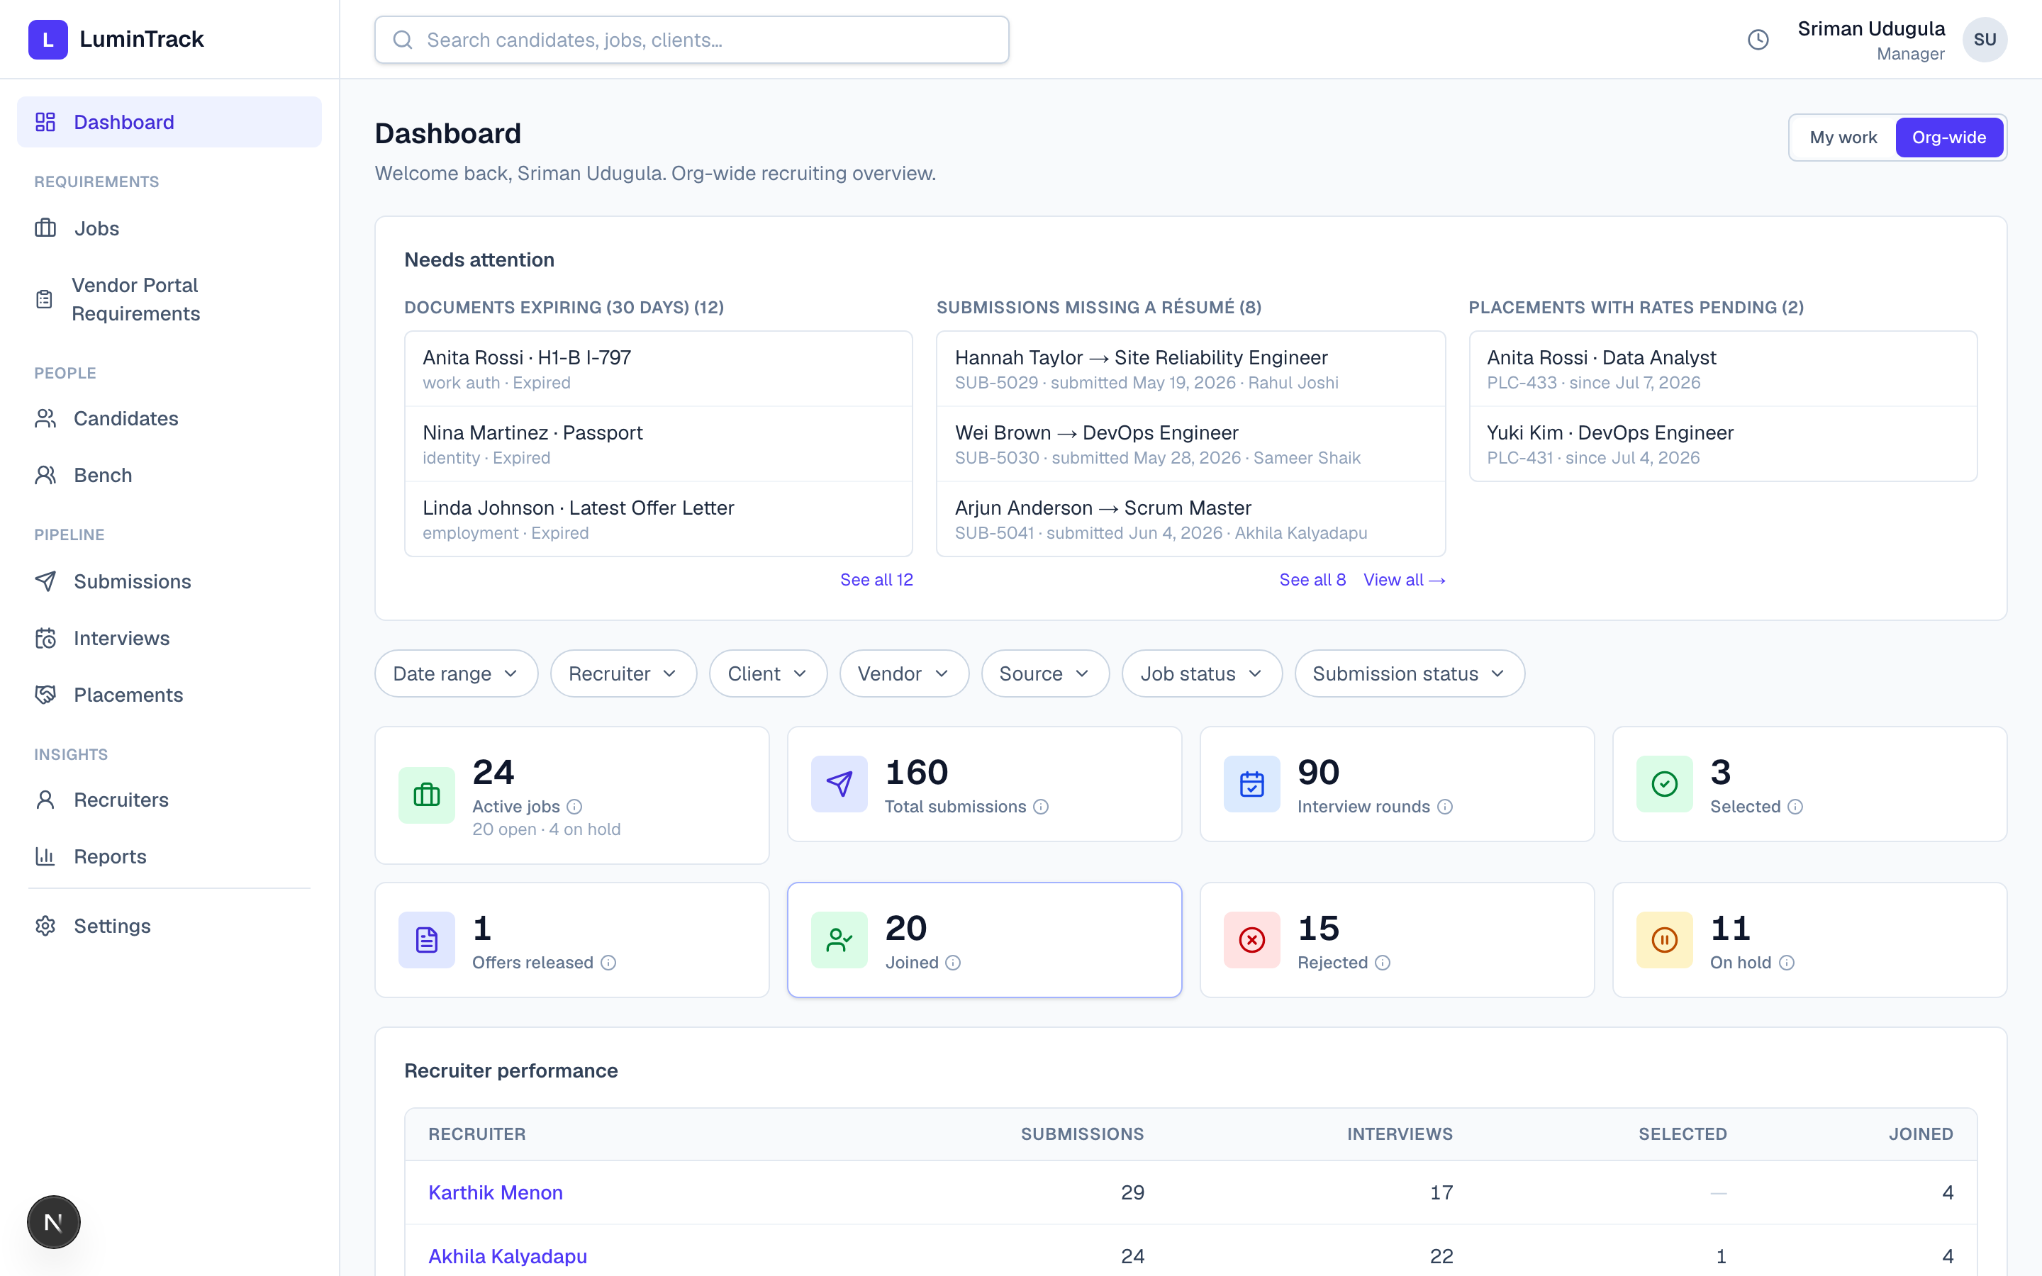
The Dashboard — the daily glance: headline numbers and a “Needs attention” panel.
Core concepts (the vocabulary)
Term | Plain meaning
Job | An order to be filled — a client or vendor needs a role staffed.
Requirement | The commercial plan for a job — what we'll bill, what we'll pay, the engagement type.
Candidate | A person in our talent pool, with résumés and documents.
Bench | The consultants we are actively marketing right now.
Submission | A candidate formally put forward for a specific job (the performance record).
Interview | A scheduled round the candidate goes through.
Placement | A candidate who got the role and started — where revenue begins.

Feature catalogue
Each area below lists what it does and why it matters to the business.
1. Dashboard — the daily glance
- What: the first screen everyone sees — headline numbers plus a “Needs attention” panel (stale submissions, documents about to expire, placements with rates pending).
- Personalised: a Me / Org switch — recruiters see their own work; managers see the whole team.
- Why it matters: everyone starts the day knowing exactly what needs action.
2. Jobs — the orders
- What: every job the team is working, with status, client, vendor, location, and positions.
- Automatic import: jobs flow in automatically from the vendor portal (iLabor) — no re-typing.
- Why it matters: one clean, current list of all demand instead of scattered spreadsheets.
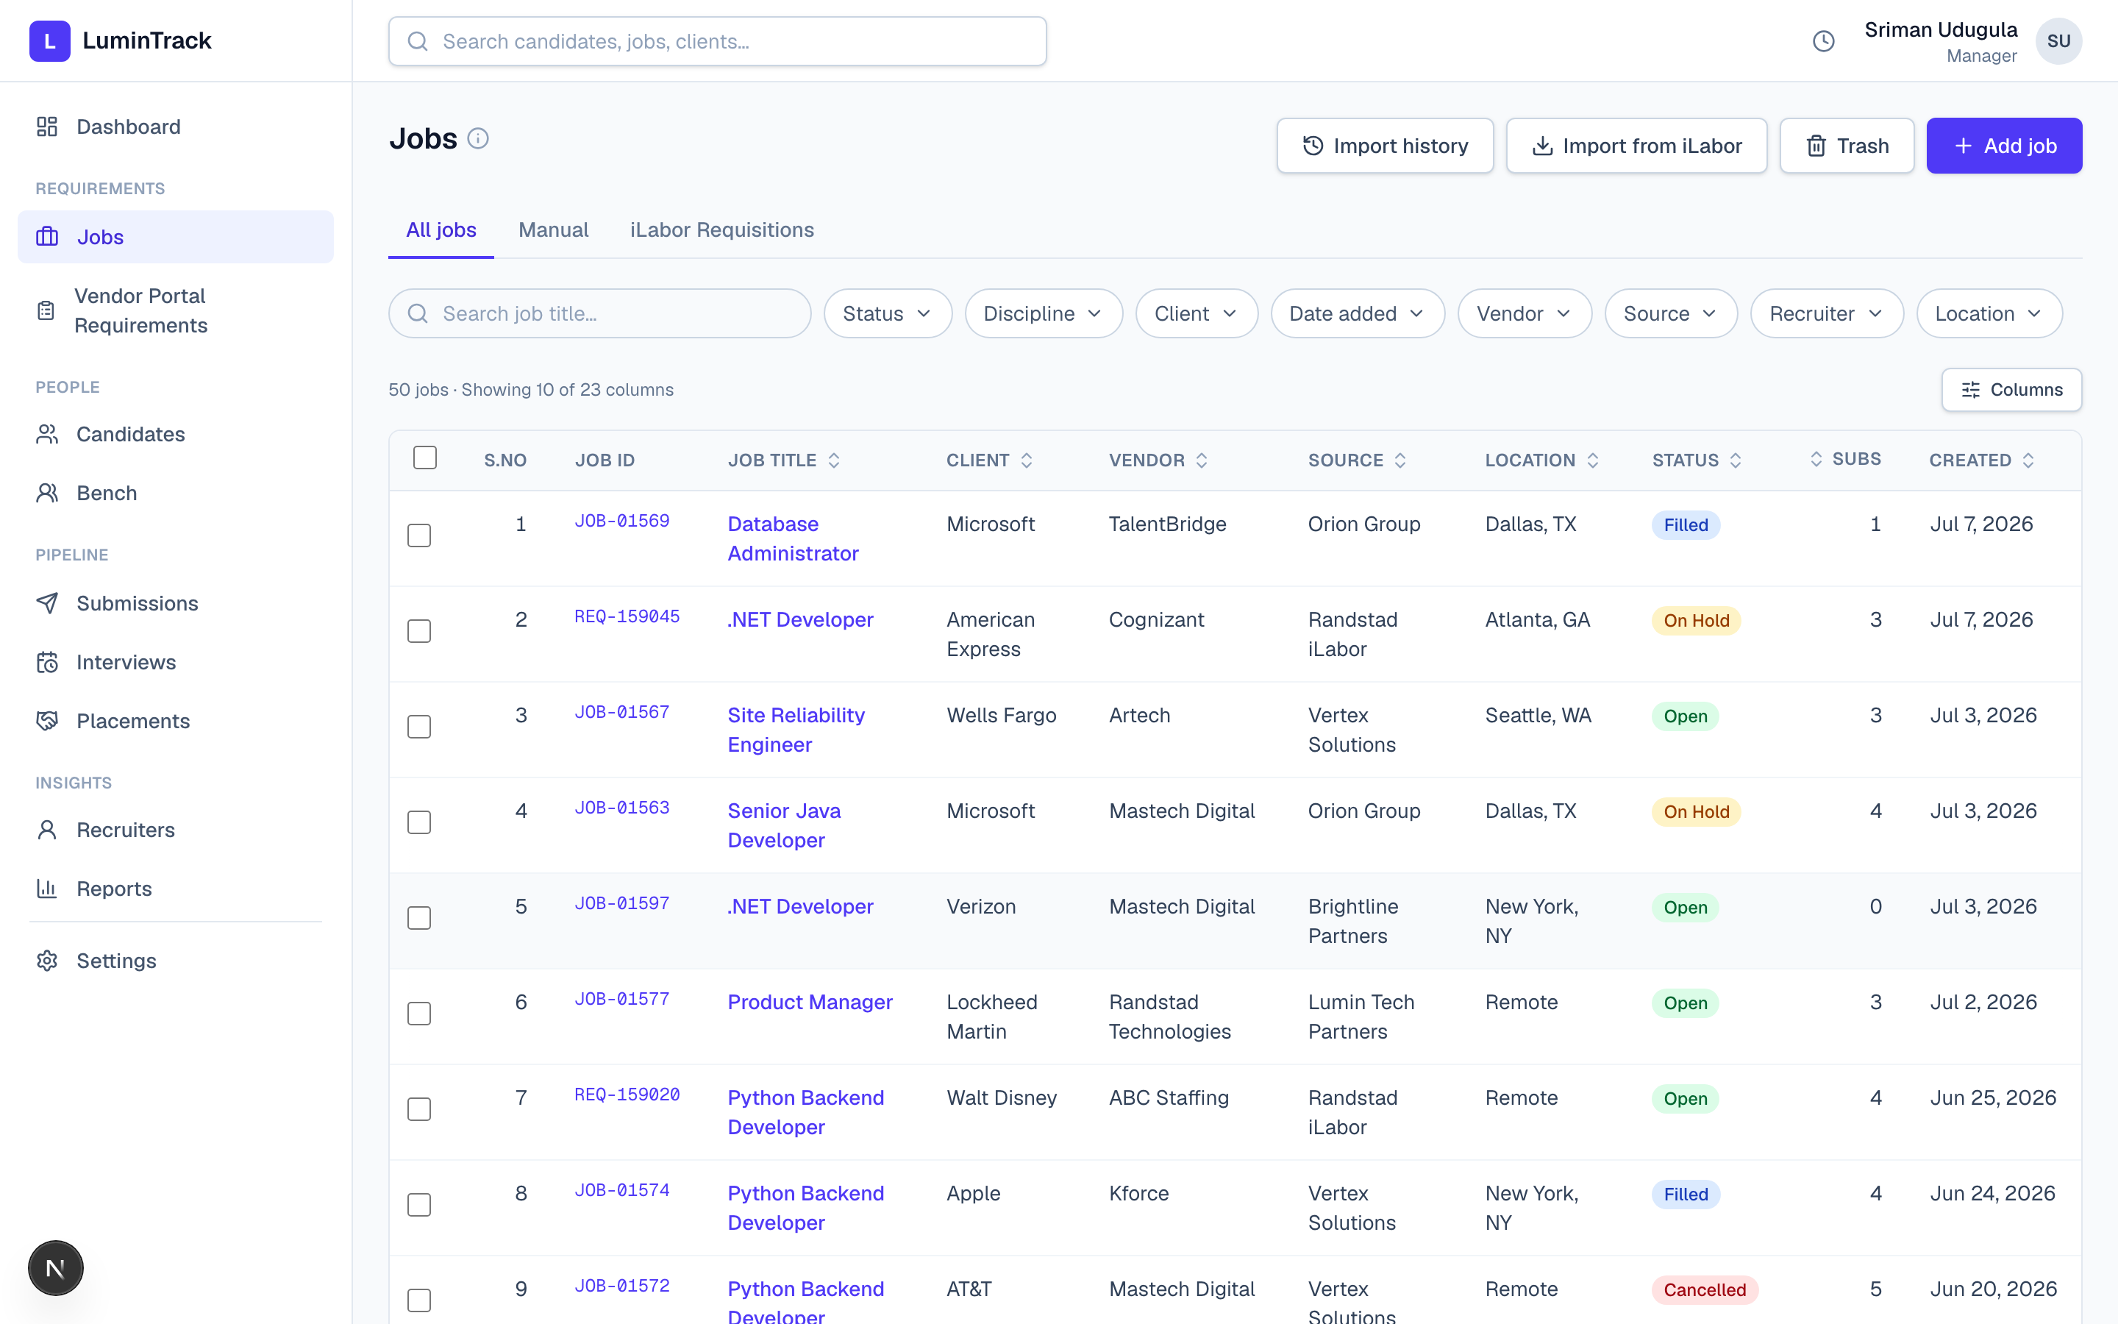
Jobs — a single, filterable list of every open order, with source and status.
3. Requirements — the deal terms
- What: before anyone is submitted, a team lead captures the commercial terms (bill rate, pay rate, engagement). One click turns a requirement into a submission with the terms pre-filled.
- Why it matters: pricing is decided deliberately, up front — not guessed at later.
4. Candidates — the talent pool
- What: a searchable database of people, each with status, skills, experience, and work authorisation.
- Résumés: multiple labelled résumés per candidate with an inline preview.
- Documents & compliance: issue/expiry dates with colour-coded warnings, and a flag for anything expiring within 30 days — so a work permit never lapses unnoticed. Sensitive documents are manager-only.
- Why it matters: the right person, the right résumé, and compliant paperwork — all in one place.
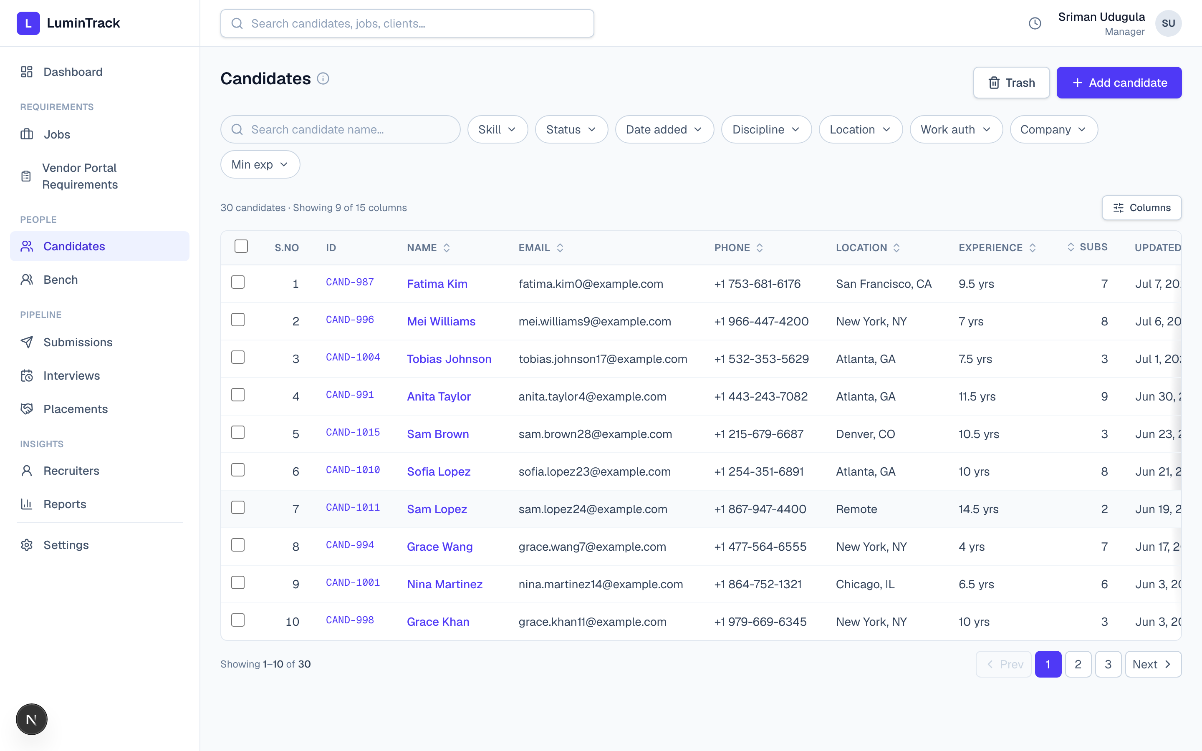
Candidates — the searchable talent pool.
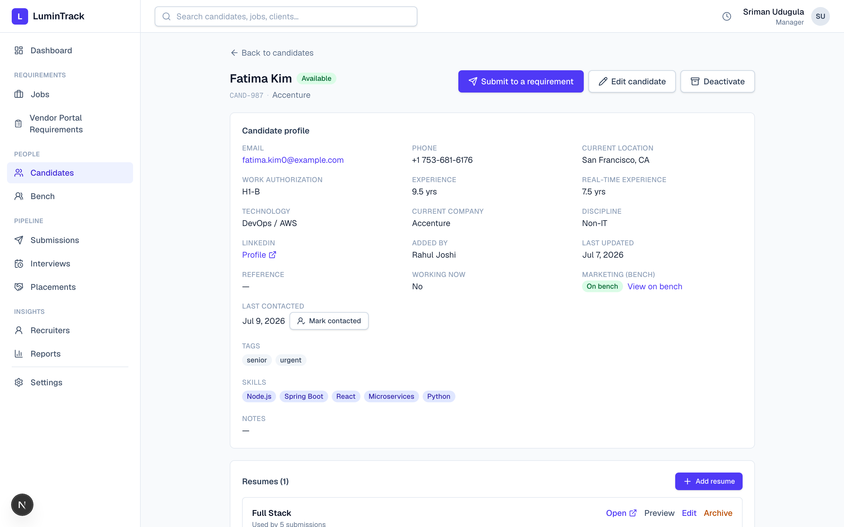
A candidate record — profile, work authorisation, skills, and the résumé library.
5. Bench — who we're marketing now
- What: the roster of consultants being actively marketed, grouped by priority, each with a clear marketing status and a marketing-details card.
- Why it matters: the bench-sales effort is organised and visible, not living in one person's head.
6. Submissions — the heart of the pipeline
- What: when a candidate is put forward for a job, it's tracked here through clear stages (Submitted → Interview → Selected → Offer → Joined). Every submission has a full history.
- Guardrails: a duplicate warning, a live rate check (warns if pay exceeds bill), and assignment/claim so recruiters work the right jobs.
- Why it matters: the single source of truth for what's in flight — and the guardrails stop costly mistakes before they happen.
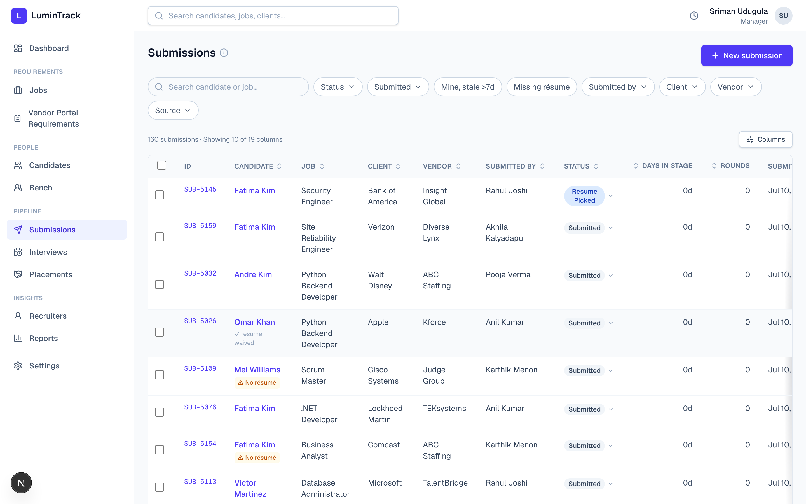
Submissions — the live pipeline, with stage, days-in-stage, and status at a glance.
7. Interviews — the rounds
- What: a consolidated list of every scheduled round — who, when, the result, and a one-click Join link.
- Why it matters: nobody misses a round, and outcomes are captured cleanly.
8. Placements — where we make money
- What: the moment a submission becomes Joined, a placement is created automatically, carrying the rates over. It tracks margin, handles extensions, and records end-of-placement details (including a replacement).
- Why it matters: revenue and margin are tracked accurately with zero double entry.
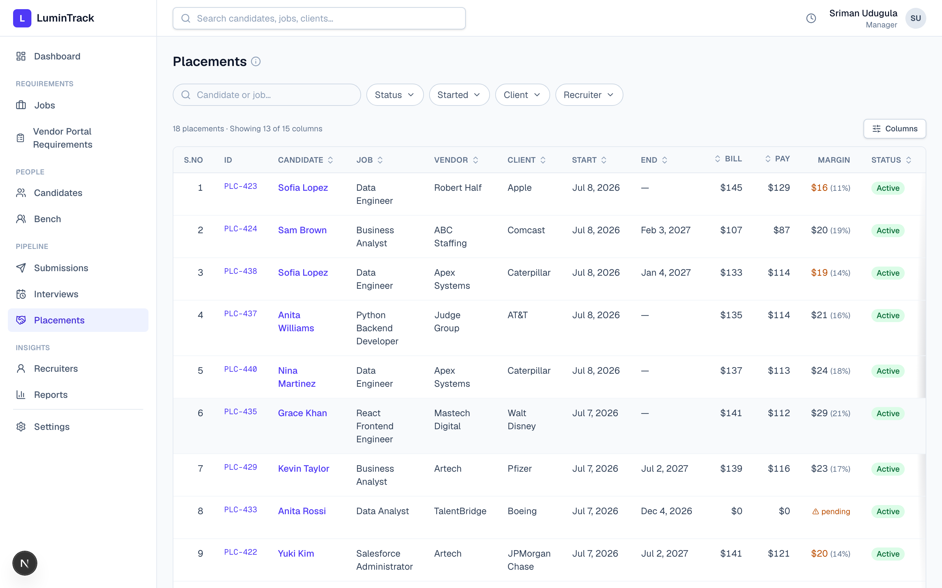
Placements — active engagements with bill/pay rates and margin.
9. Reports & Recruiters — how are we doing?
- Reports: the funnel and conversion rates, time-to-fill, time in each stage, projected margin, and a monthly performance scorecard by recruiter and team.
- Recruiters: a per-person performance leaderboard.
- Why it matters: answers “is the team productive, and is the business healthy?” live, every day.
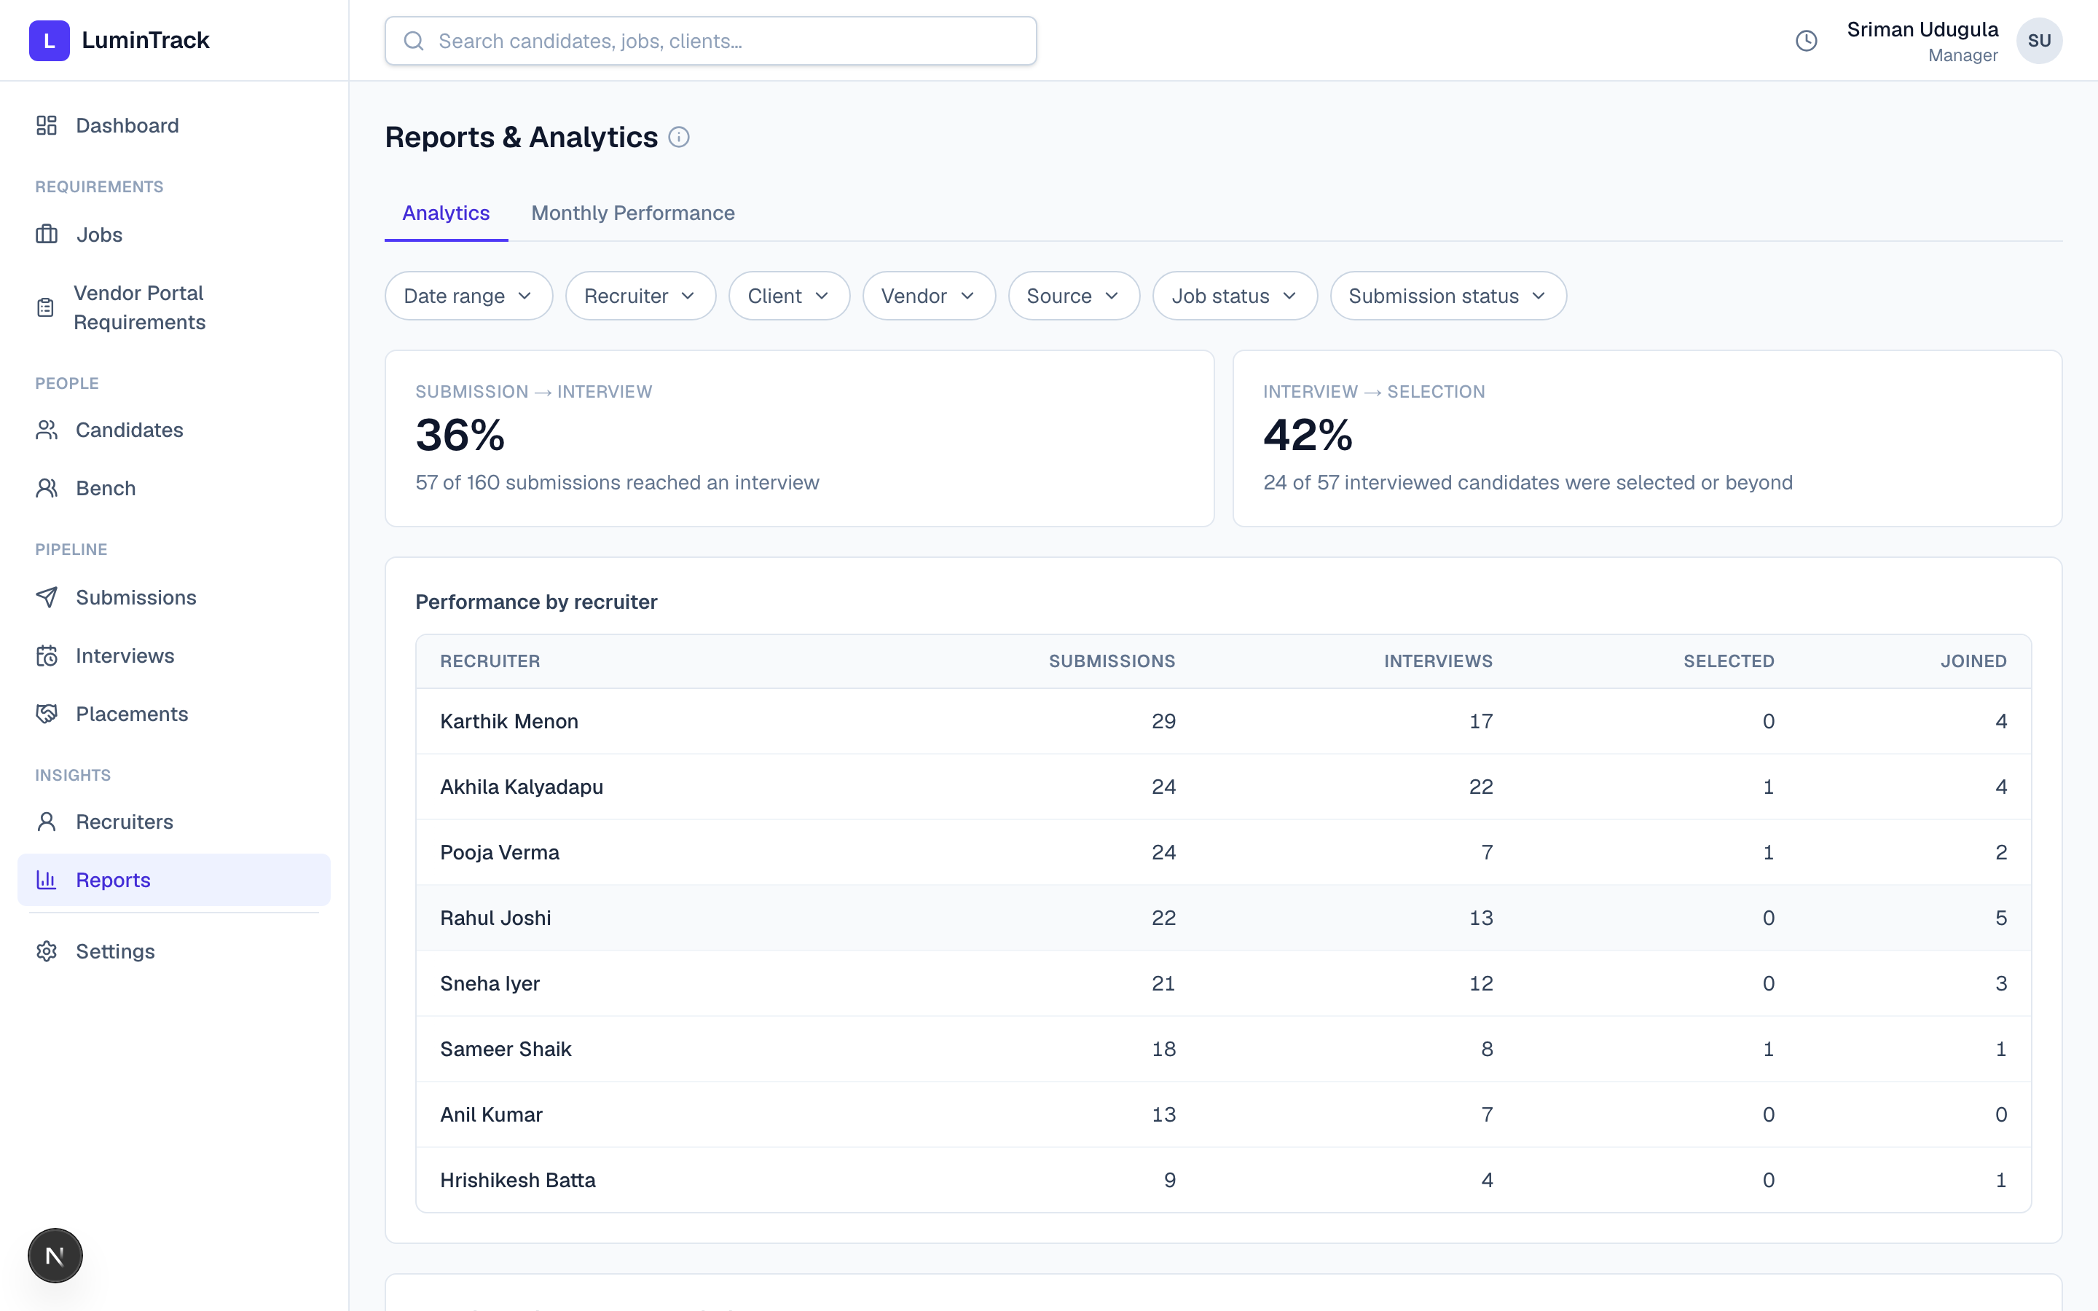
Reports — conversion rates and per-recruiter performance, without a spreadsheet.
10. Settings — administration
- What: manage clients, vendors, and sources; maintain a shared glossary; and export all data to Excel or a full backup with one click. A recycle bin holds anything deleted.
- Why it matters: the business stays in control of its own data — and it's never locked in.
End-to-end process flows
Flow A — a job becomes a placement (the happy path)
- Job arrives — imported from the vendor portal (or added by hand).
- Requirement set — a team lead enters the bill/pay/engagement terms.
- Candidate submitted — a recruiter creates the submission (duplicate & rate checks run).
- Interviews — rounds are scheduled and results recorded.
- Selected → Offer — status advances through the pipeline.
- Joined — a placement is created automatically and billing begins.
- Everything updates — dashboard, reports, and the candidate's status all reflect it instantly.
Flow B — marketing a bench consultant
- Consultant added to the Bench — marketing details and priority set.
- Actively marketed — status shows On bench, visible to the team.
- Submitted to a matching job — becomes a normal submission in the pipeline.
- Placed — bench status flips to Placed automatically.
- Placement ends — the consultant can be re-marketed with one click.
Flow C — when things don't go straight through
- Duplicate caught: the system warns before a candidate is double-submitted to the same job.
- Rejected / Backed out: captured with a reason, so the funnel reflects reality.
- Replacement needed: when a placement ends early, a replacement is selected and linked to the original.
- Nothing is lost: retiring a job or candidate moves it to trash, then to a recoverable backup.
How the money works (kept simple)
Money flows down a chain, and we keep the difference in the middle:
Client rate ≥ Bill rate ≥ Pay rate
In one sentence: we receive the bill rate, we pay the consultant the pay rate, and the difference is our margin. LuminTrack calculates margin automatically on every placement, and warns the moment a deal is structured to lose money (pay rate above bill rate).
Roles & access
LuminTrack has three roles. Managers and team leads share the same full-access tier; recruiters get the focused day-to-day view. Everyone signs in to the same system — it simply shows each person what they should see, and nothing more.
Capability | Manager | Team Lead | Recruiter
Create jobs; edit basic job details & status | ✓ | ✓ | ✓
Submit candidates & manage their own submissions | ✓ | ✓ | ✓
Manage candidates, notes, and interviews | ✓ | ✓ | ✓
Turn a requirement into a submission | ✓ | ✓ | ✓
View bench marketing details | ✓ | ✓ | ✓
Set / edit job rates & assign recruiters to jobs | ✓ | ✓ | —
Set requirement terms (bill & pay rates, engagement) | ✓ | ✓ | convert only
See rates & margins across placements and reports | ✓ | ✓ | own only
Re-assign a submission to a different recruiter | ✓ | ✓ | —
View sensitive documents (identity, work auth) | ✓ | ✓ | —
Manage clients, vendors & sources | ✓ | ✓ | —
Manage user accounts | ✓ | ✓ | —
Export data (Excel / full backup) | ✓ | ✓ | —
View the full audit history | ✓ | ✓ | —
Import jobs from the vendor portal | ✓ | ✓ | —

In one line: managers and team leads see and control everything — including the money numbers and administration; recruiters do the day-to-day work and see rates only on their own submissions.
Data safety
- Full audit history. Every meaningful change is recorded — who did what, and when.
- Nothing truly disappears. Deletions go to trash and then to a recoverable backup.
- Your data, exportable anytime. One click to a clean Excel file or a complete backup.
In summary
LuminTrack takes a process spread across five tools and puts it in one place that:
- Captures the whole pipeline — job → requirement → submission → interview → placement.
- Updates itself — enter once, and it flows to the dashboard, reports, and every linked record.
- Prevents mistakes — duplicate, rate, and expiry warnings built in.
- Shows the business in real time — productivity and profitability, without spreadsheets.
- Keeps the team in control — role-based access, full history, recoverable data, easy export.
One source of truth. Live numbers. Fewer things falling through the cracks.

