LuminTrack
Application Walkthrough & Open Questions
Internal recruitment & bench-sales tracking dashboard
Prepared June 22, 2026

What LuminTrack does
LuminTrack replaces the manual Excel/Word process for tracking recruitment. It follows a candidate from an open requirement all the way through submission, interviews, offer, and an active placement — keeping every status change, note, rate, and document in one auditable system, and rolling it all up into dashboards and a weekly performance scorecard.
At a glance, the application covers:
- Jobs / requirements — including bulk-imported Randstad iLabor requisitions.
- A Vendor Portal planning layer — scope a requirement's commercial terms before submitting.
- Candidates — profiles, a résumé library, and compliance documents with expiry alerts.
- Bench — the consultants we are actively marketing right now.
- Submissions — submit a candidate to a job and move them through the pipeline.
- Interviews — every scheduled round in one place.
- Placements — consultants currently working, with bill/pay rates and margin.
- Reports — analytics plus a monthly per-recruiter performance scorecard.
- Roles & access — admins, team leads, and recruiters, with rate visibility controls.
The walkthrough below follows the real flow a recruiter and manager use, screen by screen.

How the process flows
1. Dashboard — the command center
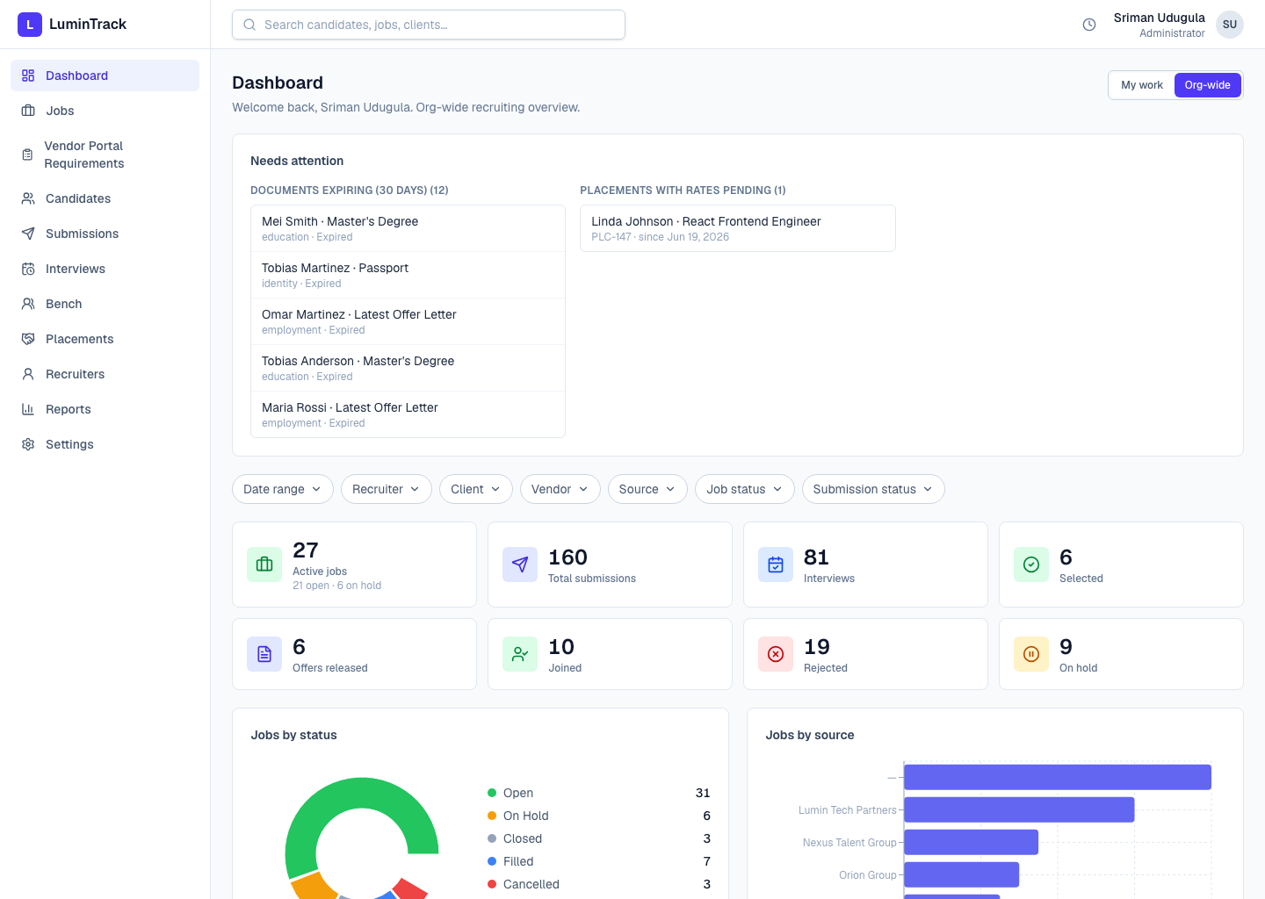
The landing screen. A “Needs attention” panel surfaces expiring documents and placements with rates still pending; KPI cards summarise active jobs, submissions, interviews, and outcomes; charts break jobs down by status and source. Admins see an org-wide view; recruiters default to “My work.”
2. Jobs / Requirements
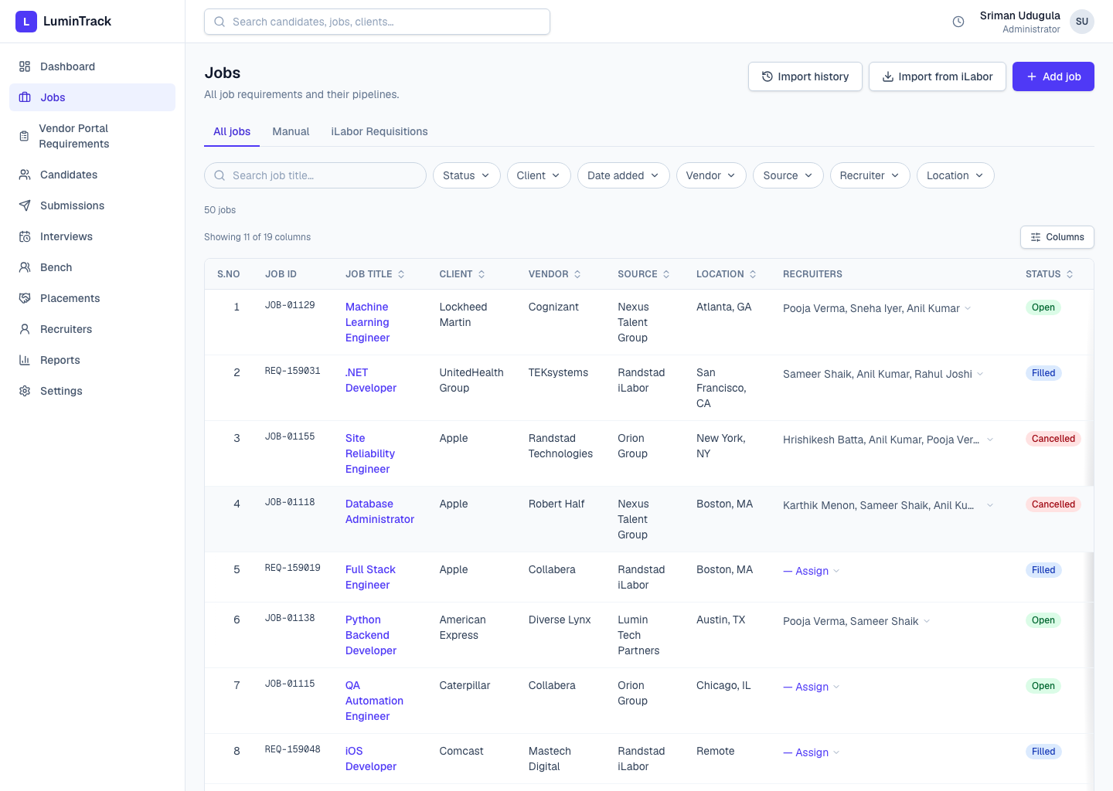
Every open requirement we are working, manual or imported from the Randstad iLabor vendor portal. The list is filterable, sortable, and paginated, with display IDs (JOB-xxxxx / REQ-xxxxxx).
3. Job detail
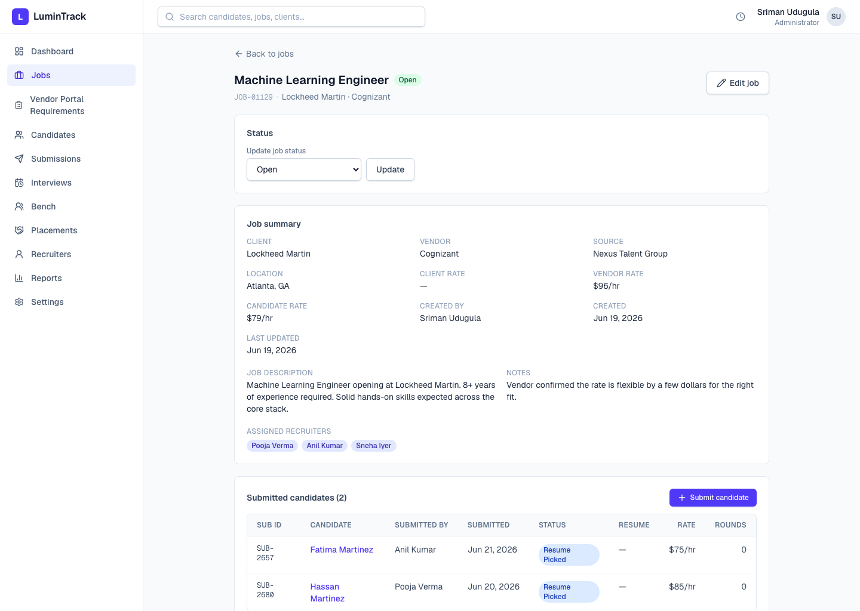
A single requirement: client, vendor, source, rates, assigned recruiters, the job description, and the table of candidates already submitted. Recruiters submit a candidate directly from here.
4. Vendor Portal Requirements (planning layer)
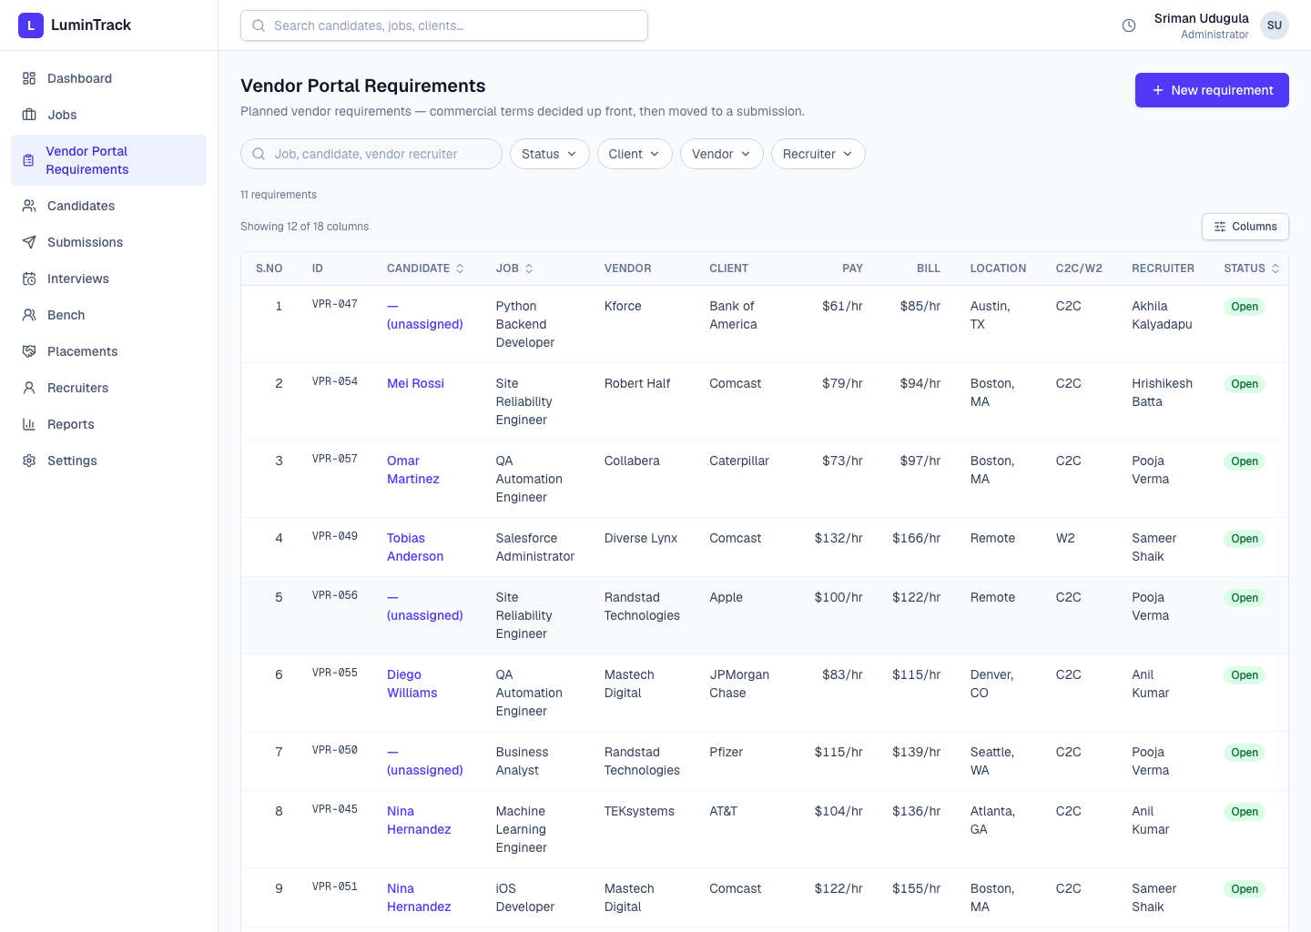
A pre-submission planning step. A team lead scopes a requirement's commercial terms; a recruiter later “moves it to a submission,” which pre-fills and creates the real submission. These plans are intentionally kept out of submission analytics.
5. Candidates
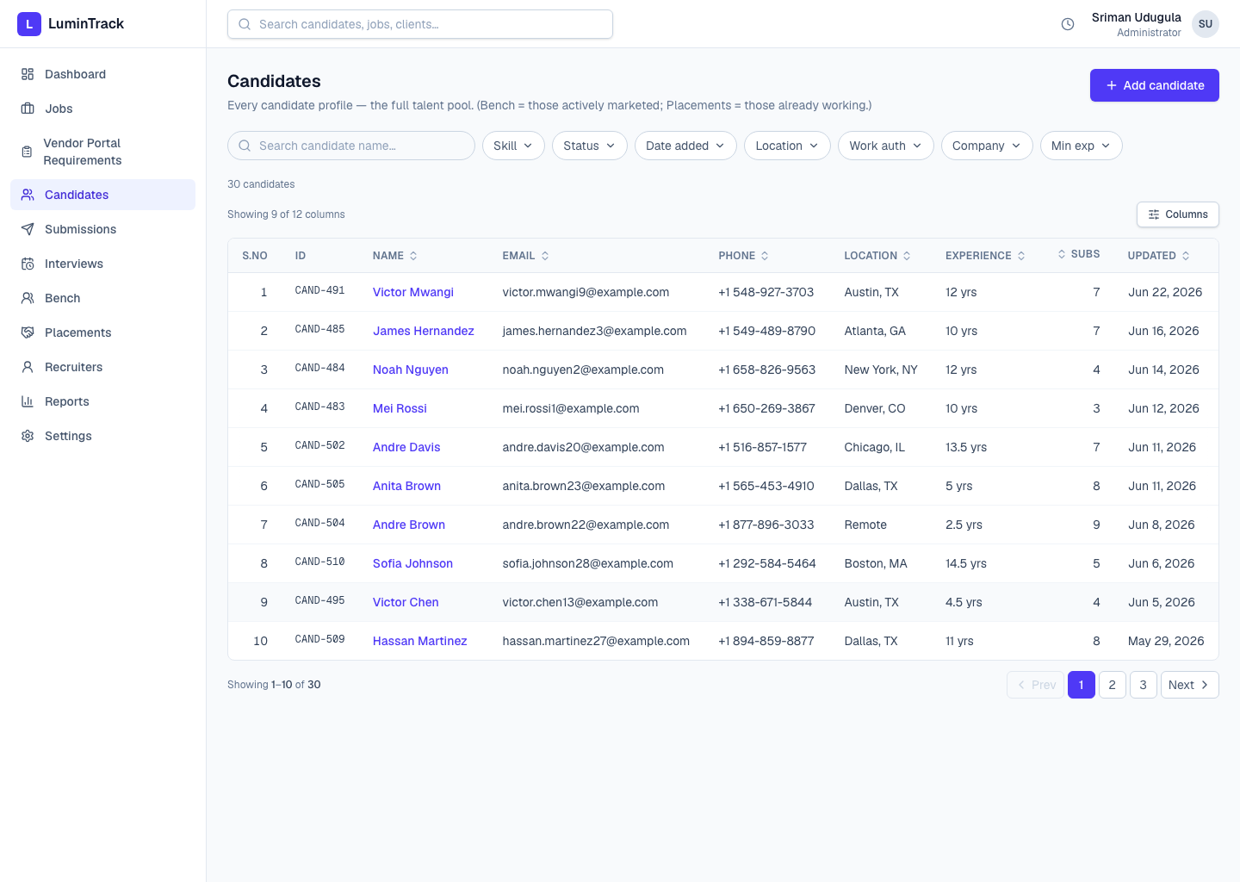
The full candidate pool — everyone we know, regardless of whether they are currently being marketed. Searchable, with status, skills, source, and last-contacted tracking.
6. Candidate detail
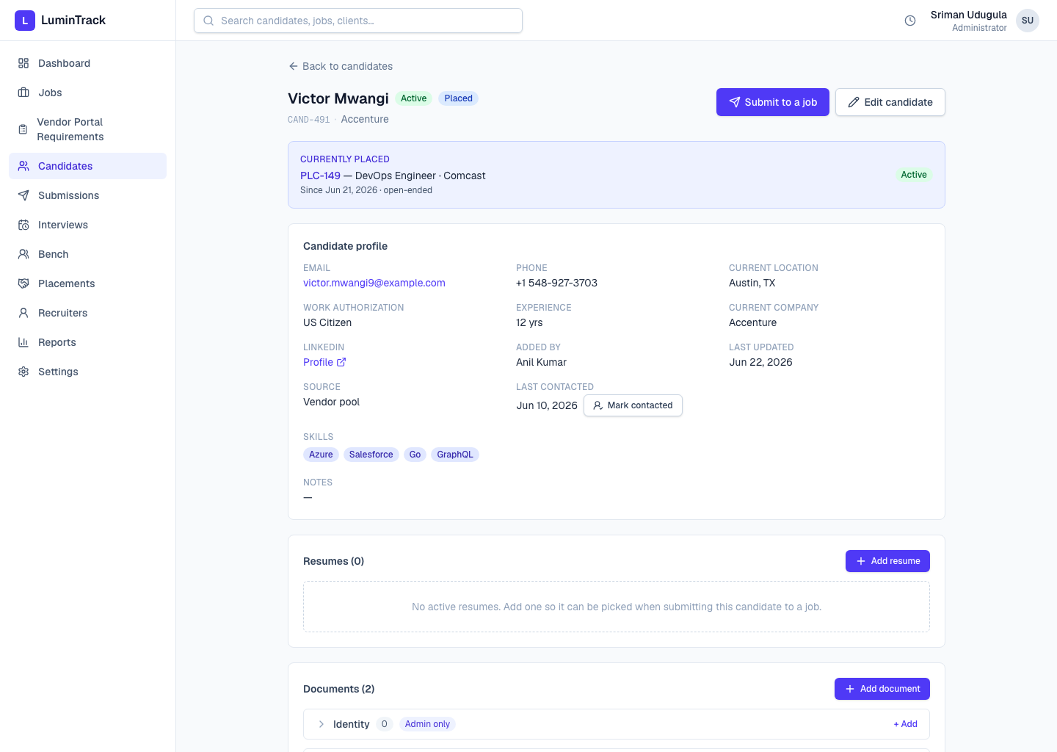
One candidate's profile: a résumé library (multiple labelled Google Drive résumés), compliance documents with expiry colour-coding, submission history grouped by job, and an interview history.
7. Bench
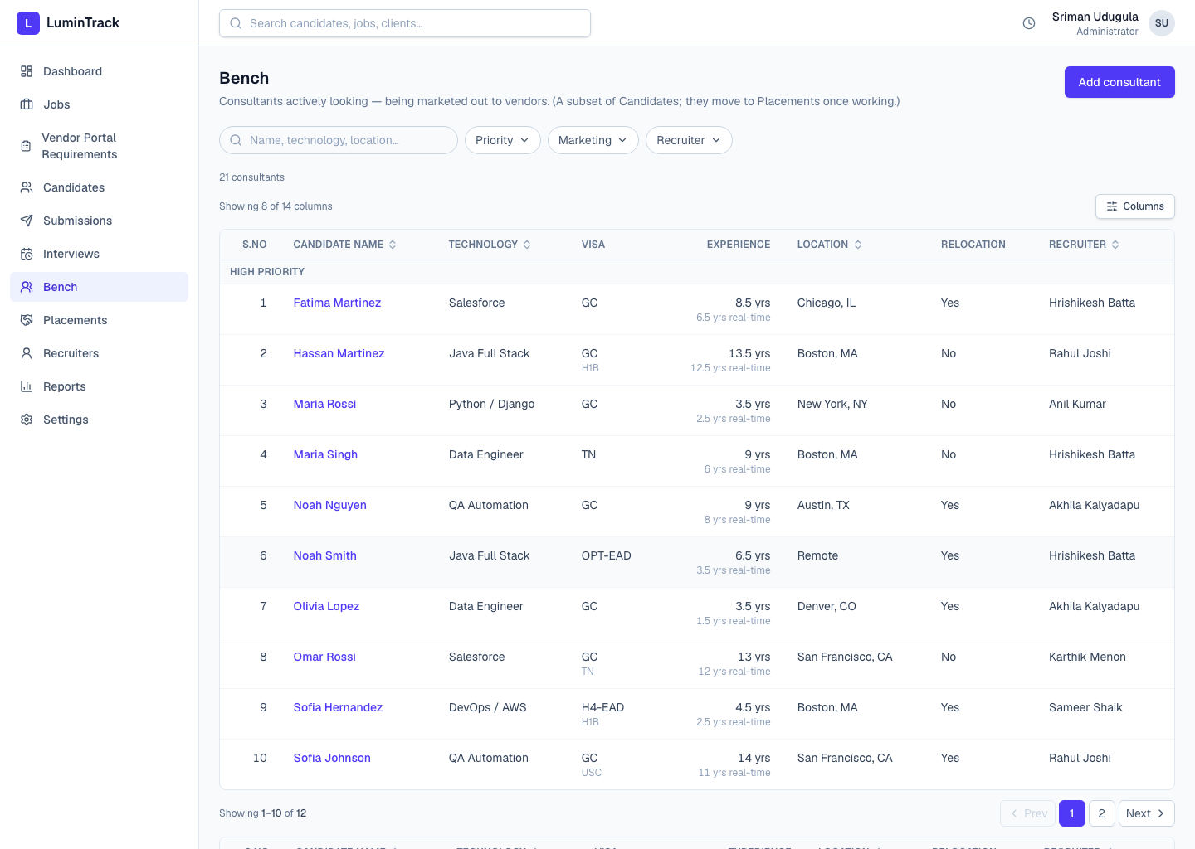
The consultants we are actively marketing right now, grouped by priority. A candidate is “on the bench” while their marketing status is active; they roll off automatically when placed.
8. New submission — the core action
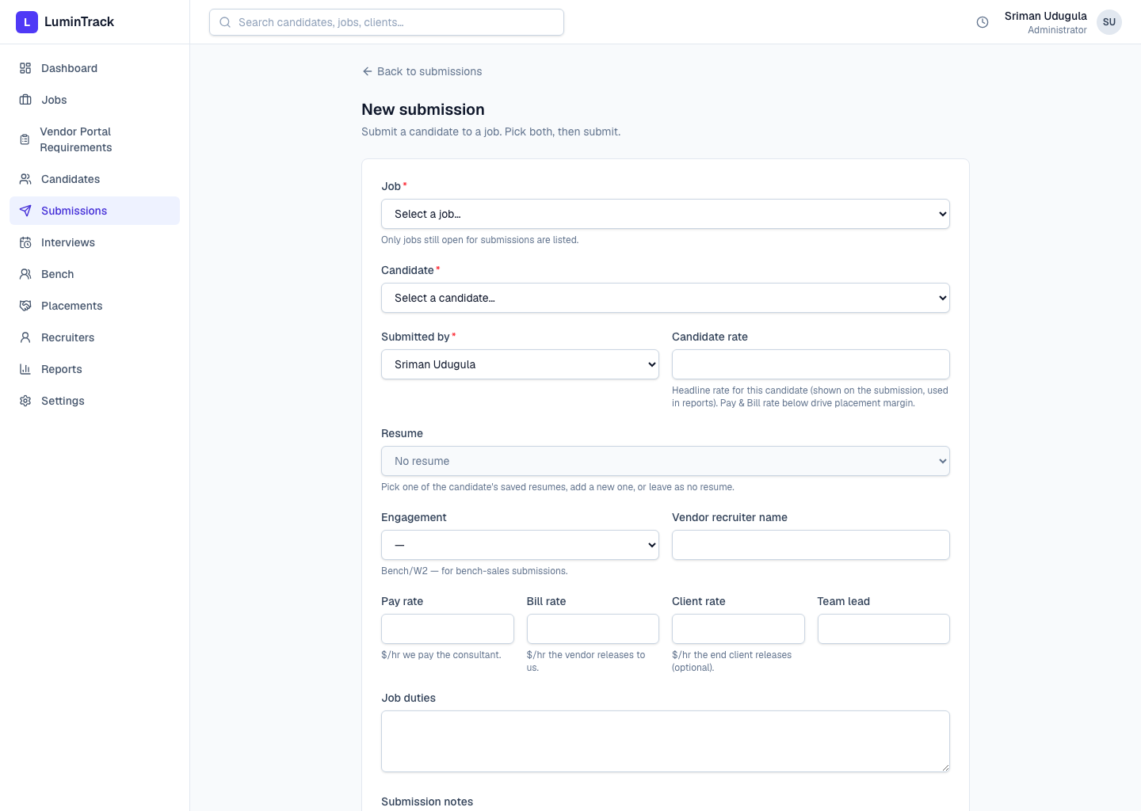
Submitting a candidate to a job. One form drives all three entry points (from a job, from a candidate, or globally). It captures the résumé used, engagement, and the rate chain — Pay, Bill, Client, and the headline Candidate rate.
9. Rate guardrail (built-in check)
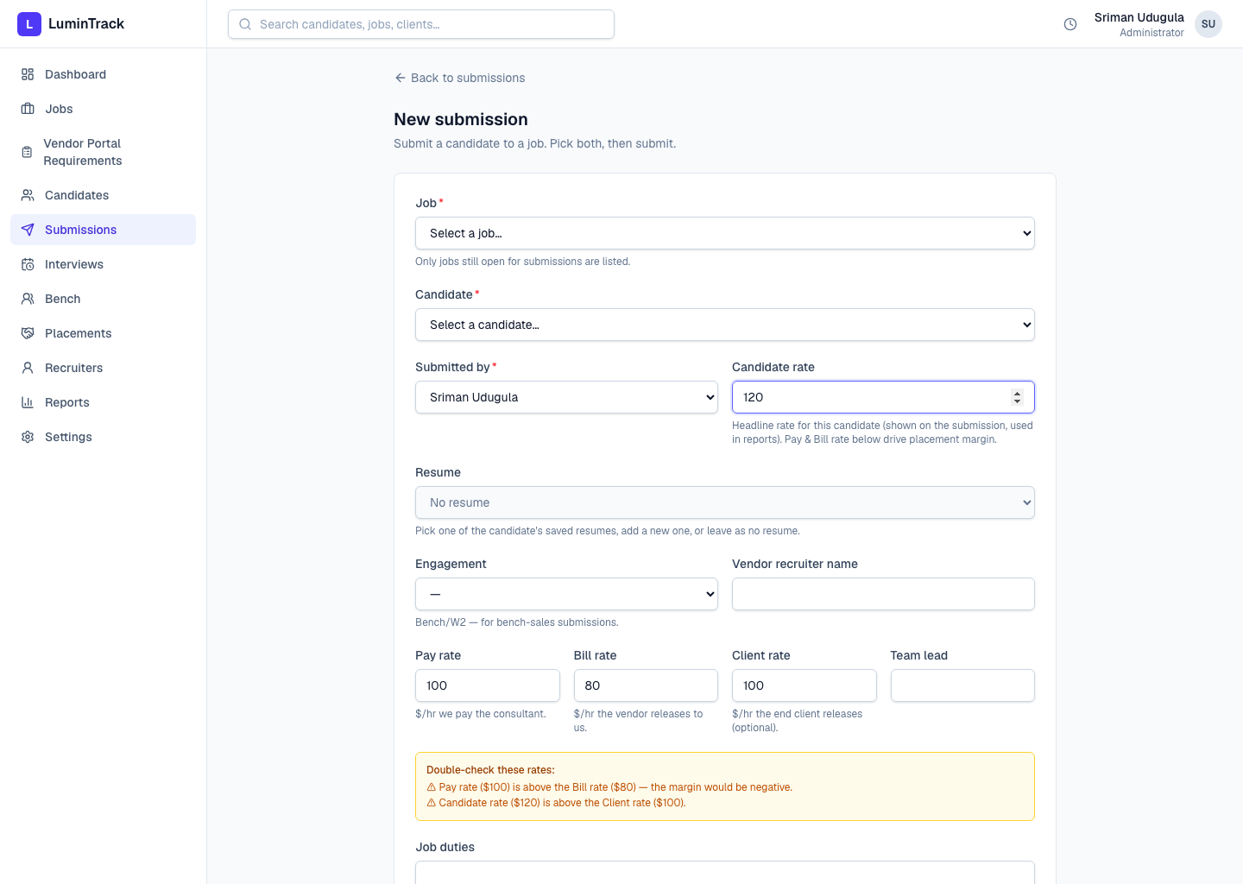
As rates are typed, the form warns — without blocking — when they break the expected chain: pay above bill (negative margin), or candidate/bill above the client rate. This is the guardrail tied to Question 4 below.
10. Submission detail & pipeline
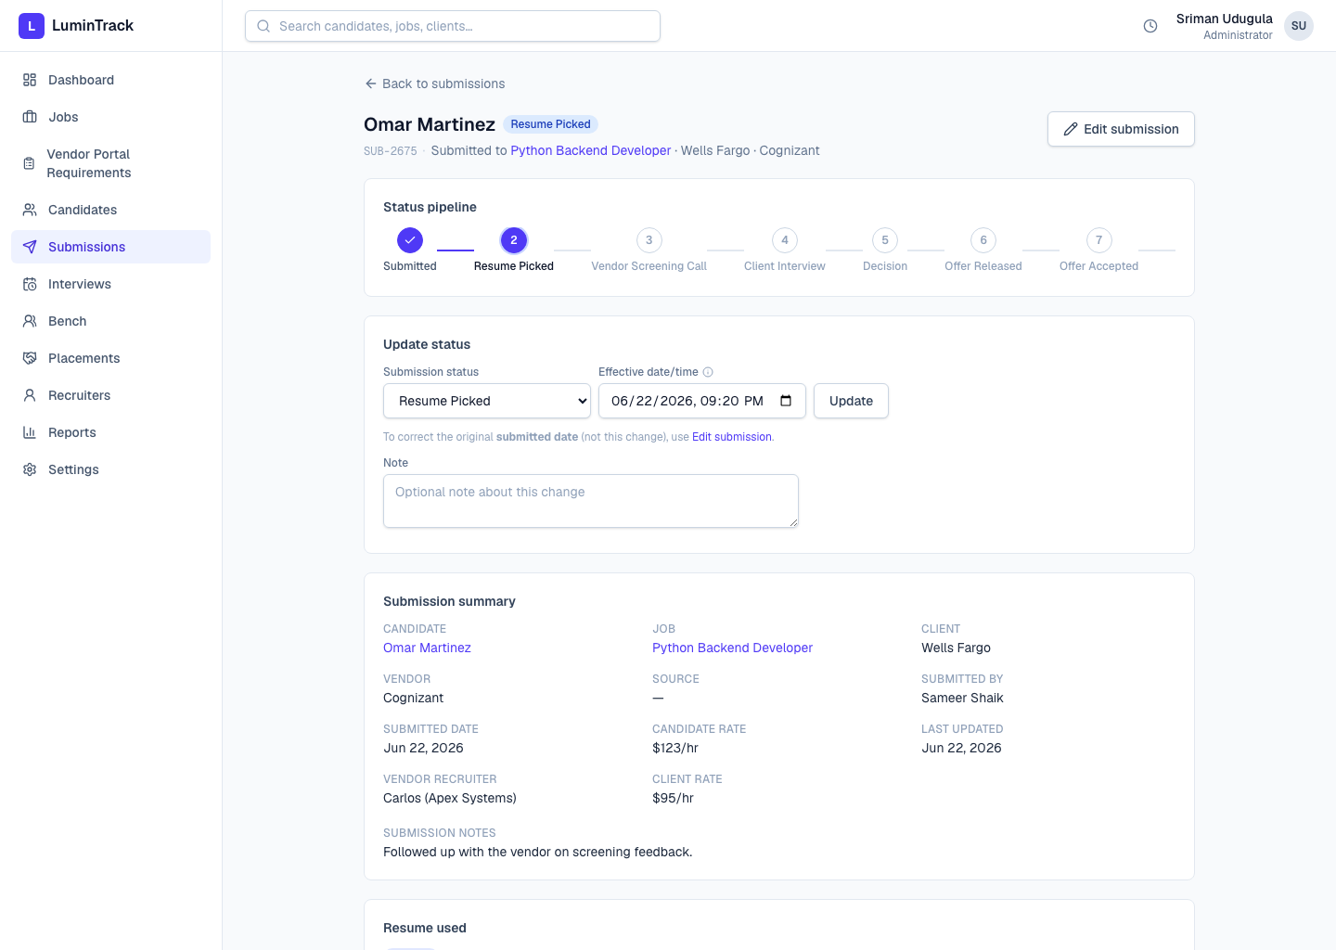
The submission's status pipeline (Submitted → Resume Picked → Screening → Client Interview → Decision → Offer Released → Offer Accepted → Joined), an update-status form that captures the real-world event date and a reason, the résumé used, interview rounds, notes, and a full activity timeline.
11. Interviews
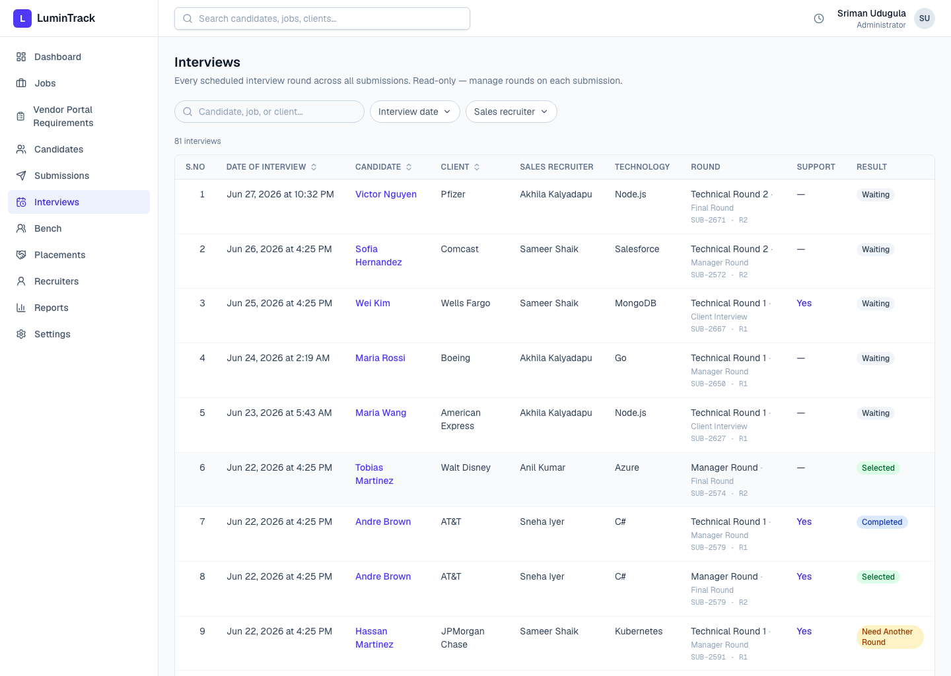
A read-only roll-up of every scheduled interview round across all submissions, linking back to the candidate and submission.
12. Placements
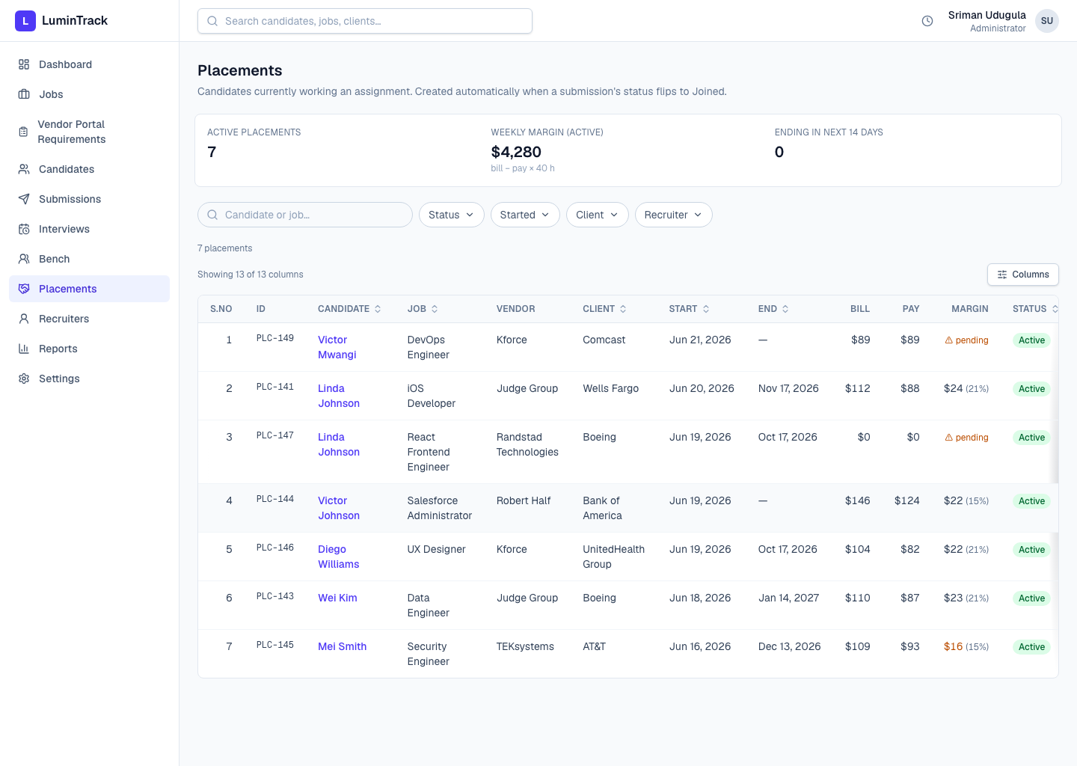
When a submission is marked “Joined,” a placement is created automatically. This list shows everyone currently working an assignment, with a summary strip (active count, weekly margin, ending soon).
13. Placement detail
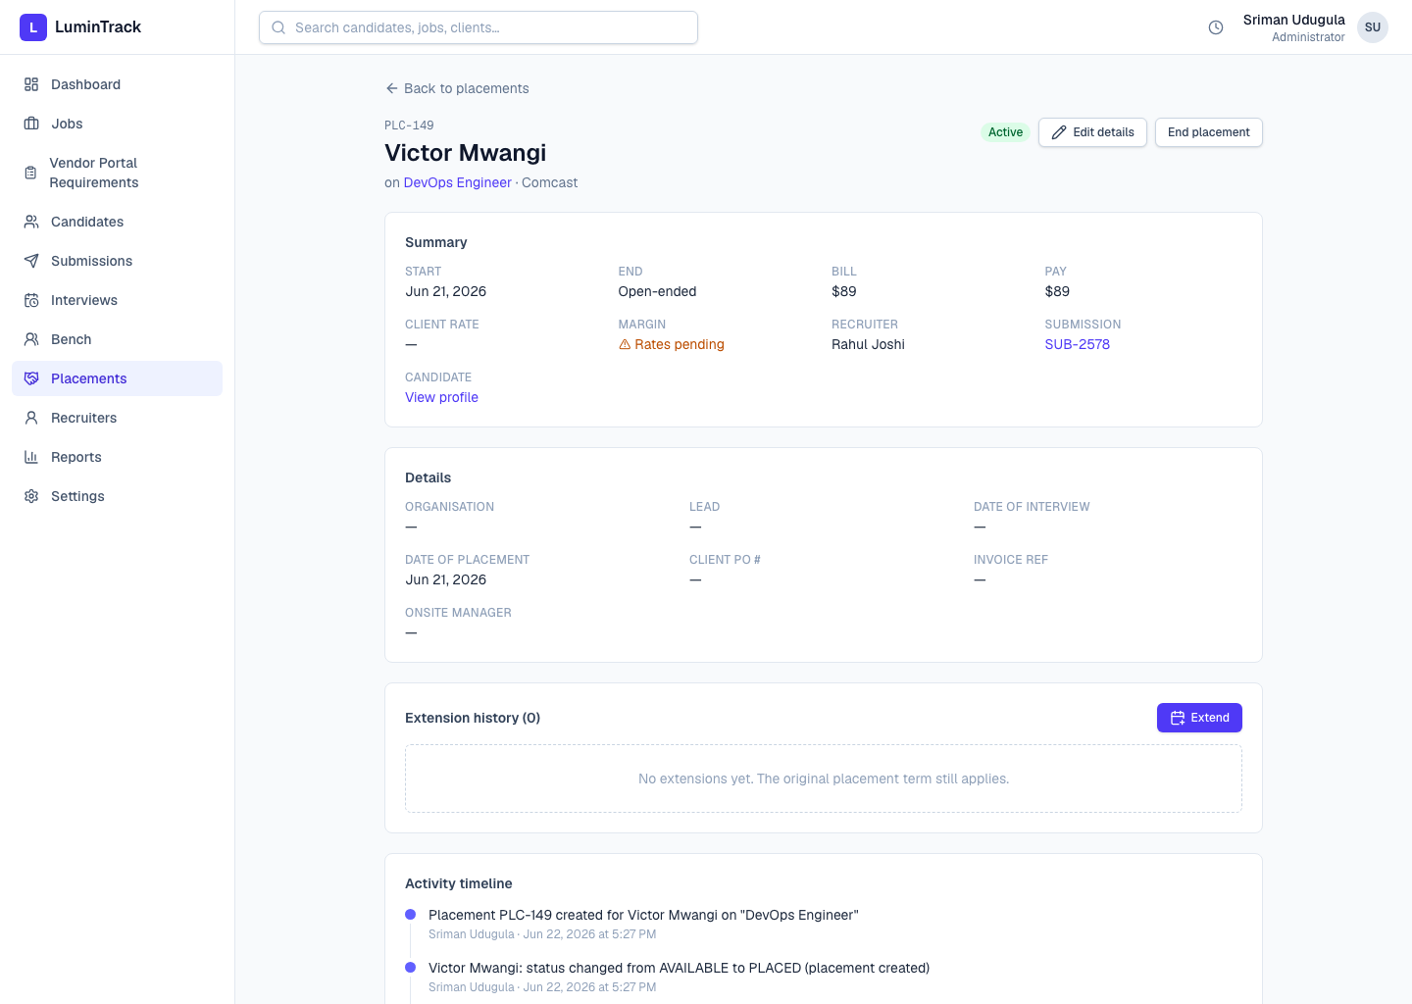
A single placement: start/end, bill & pay rates and margin, client rate, extensions, end-of-placement handling with an optional replacement, and a compliance banner for expiring documents. Rates are visible only to admins and the recruiter of record.
14. Reports — Analytics
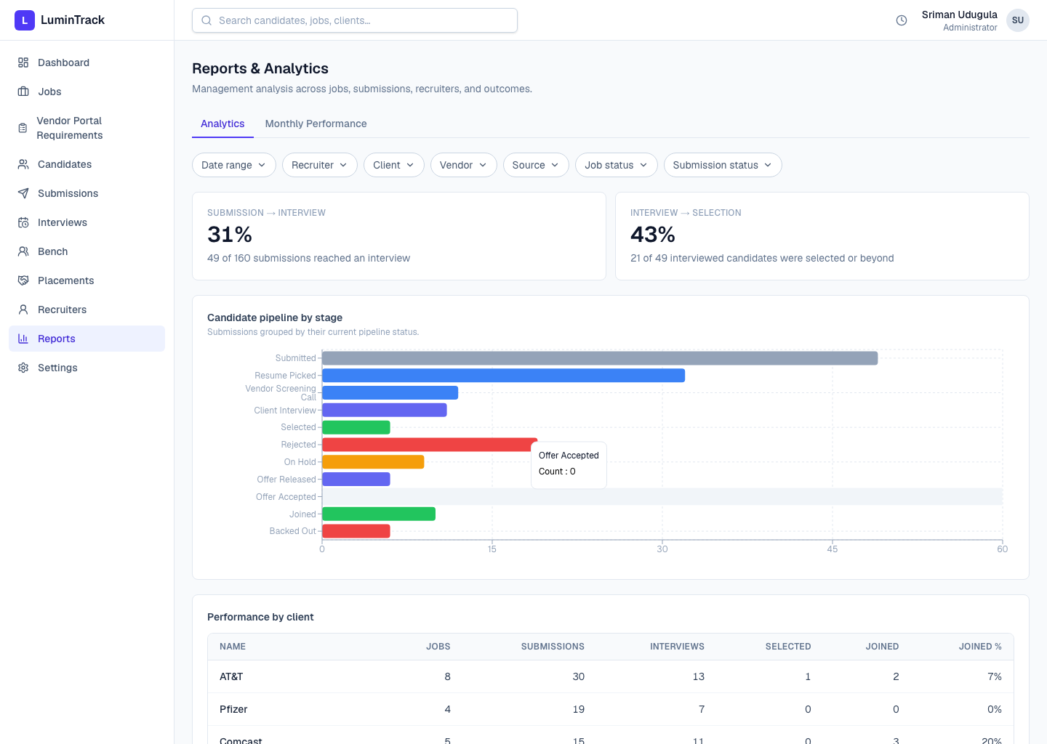
Management analytics across jobs, submissions, recruiters, and outcomes — funnel velocity, time-to-fill, aging, and revenue/margin projections.
15. Monthly Performance scorecard
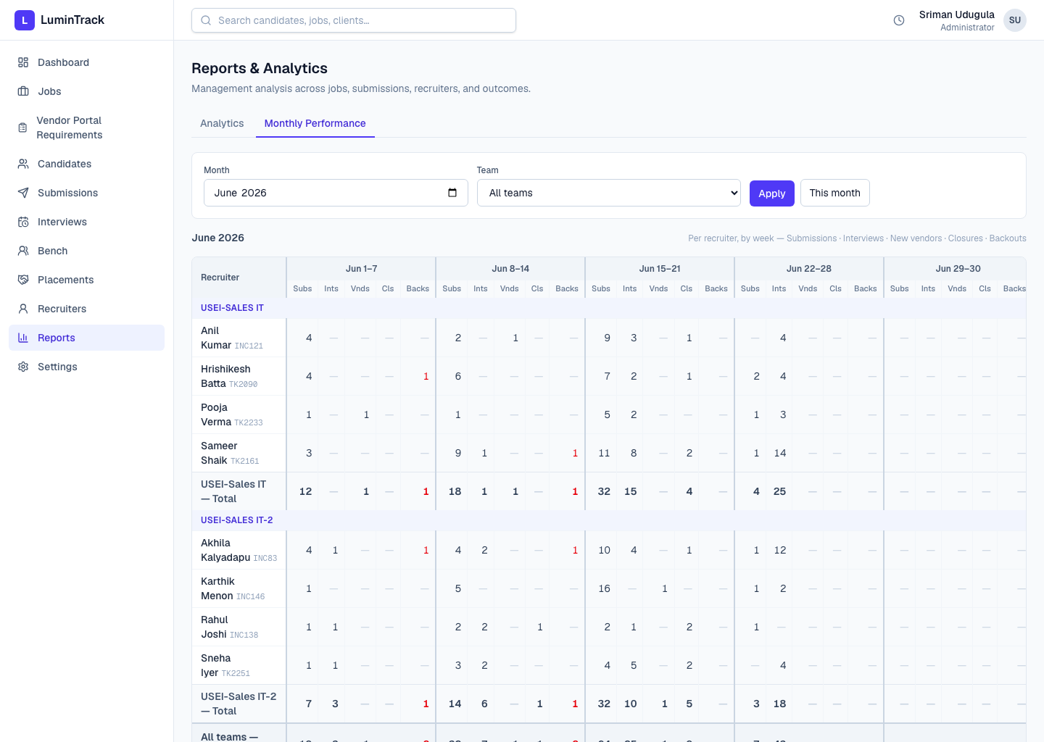
A per-recruiter weekly grid for a chosen month: submissions, interviews, new vendors, closures, and back-outs, with team and grand totals. “New vendors” is the metric in Question 5 below.
16. Recruiters
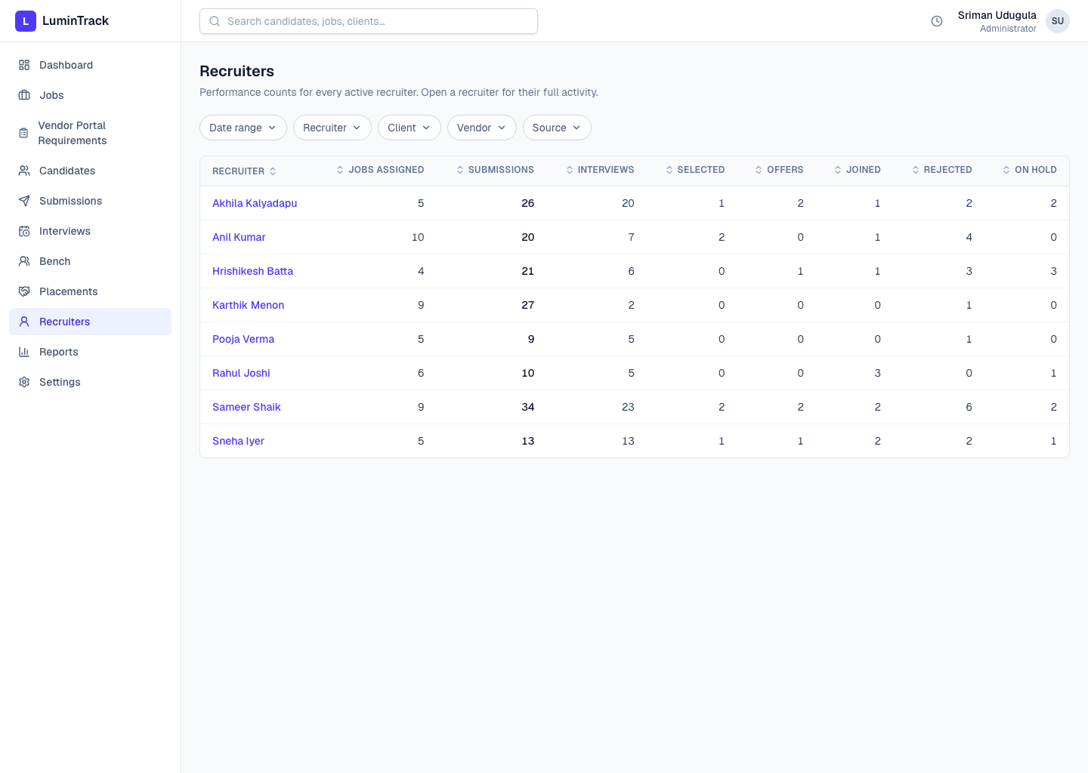
Per-recruiter performance — submissions, interviews, selections, and joins — with drill-down into each recruiter's pipeline.
17. Settings
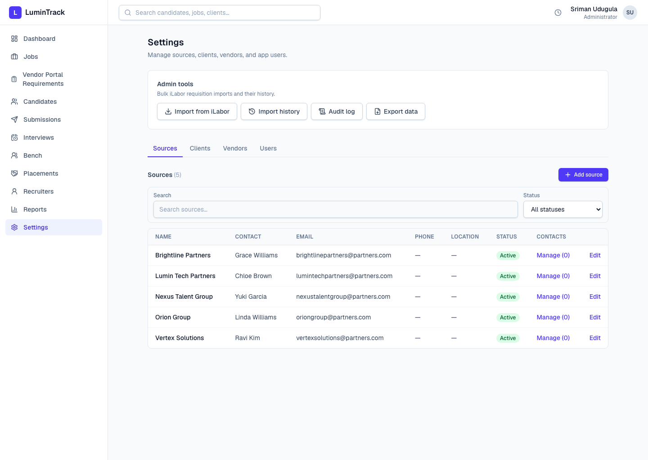
Reference data — sources, clients, vendors, and team members. Editable by admins; recruiters see it read-only. Admin tools (data export, audit log) live here too.

Questions to clarify
A few things we modelled on our best understanding and would like you to confirm or correct. Nothing here blocks the demo — but your answers will lock down the rate model and the scorecard.

Rates
- Rate chain — Do we have the three rates right? We model Client rate (what the end client releases) ≥ Bill / Vendor rate (what the vendor releases to us) ≥ Pay rate (what we pay the consultant). Is that correct, and is there ever a fourth party or extra markup?
- Candidate rate vs Pay rate — Today there is a legacy “Candidate rate” (a single headline number) AND a separate “Pay rate.” Are these the same thing? Can we retire/merge “Candidate rate” into “Pay rate,” or do they mean different things to you?
- Client rate disclosure — Is the end-client rate usually known to us, or is it often hidden by the vendor? (This decides whether we can check margins against it.)
- Guardrail strictness — We now show a non-blocking warning when pay is above bill, or candidate/bill is above the client rate (screen 9). Should this stay a soft warning, or become a hard block that requires a written override reason?

Metrics
- “New vendors” definition — We count a new vendor the first time anyone at the company submits to that vendor, credited to whoever made that first submission (company-wide, not per-recruiter). Is that the intended meaning?
- Missing scorecard metrics — Are there weekly numbers you track that the scorecard does not yet show (for example offers, no-shows, redeployments)?

Process & definitions
- Candidates vs Bench vs Placements — We treat Candidates = everyone, Bench = those actively being marketed, Placements = those currently working. Does that match how you think about them?
- Vendor Portal planning layer — A team lead scopes a requirement's terms, then a recruiter moves it to a submission (screen 4). Does this match how your team plans before submitting?
- Two active placements — Can one consultant be on two active placements at the same time? (We assumed yes — please confirm so the analytics handle it.)
- Documents & compliance — We track candidate documents with a 30-day expiry alert. Are there specific document types or compliance rules we should enforce or add?

Access & visibility
- Settings access — Sources, clients, vendors, and users are admin-only to edit; recruiters see them read-only. Is that the right split?
- Margin visibility — Bill, pay, and margin are visible only to admins and the submitting recruiter. Should team leads also see margins for their whole team?
Anything we got wrong, just tell us and we'll adjust before or right after the demo.

