# Retail Marketing Data Analysis:

## 1. Excel Tasks (Data Exploration)

### Task 1: Create a Statistical Summary for Numerical Features

* Identify and select numerical columns like Income, Year_Birth, MntWines, Recency.
* Use Excel’s **Quick Analysis → Totals** or **Formulas → More Functions → Statistical** for summary stats: Average, Median, Min, Max, Standard Deviation.
* This gives a numeric overview necessary for understanding customer demographics and spend.

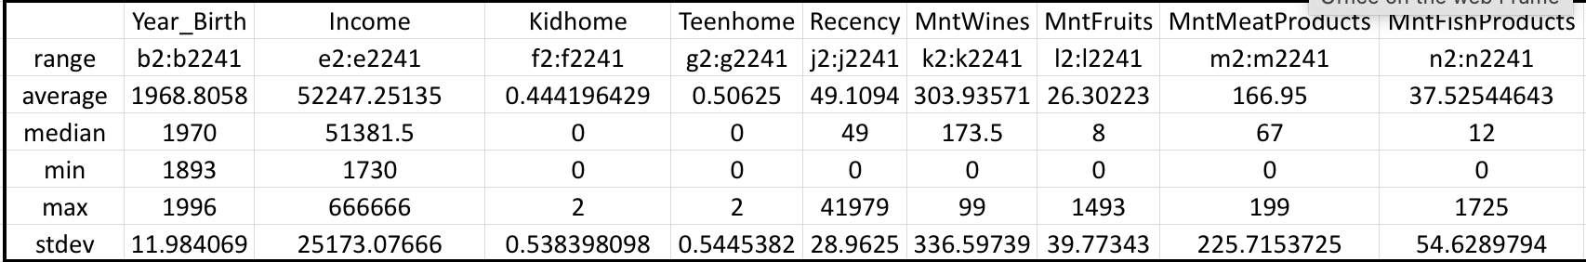 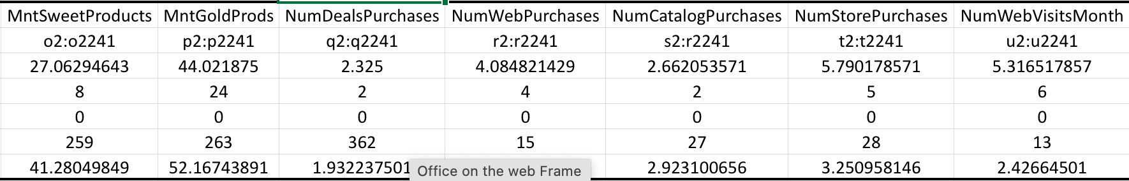 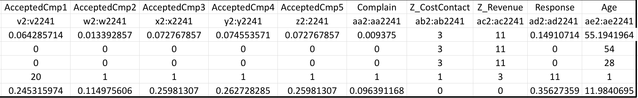

### Task 2: Line Chart of Number of Enrolments by Year

* Extract the registration year from Dt_Customer (handle mixed date formats with Excel formulas).
* Create a pivot or summary table counting customers per enrolment year.
* Plot a line chart showing how customer enrolment varies over time.

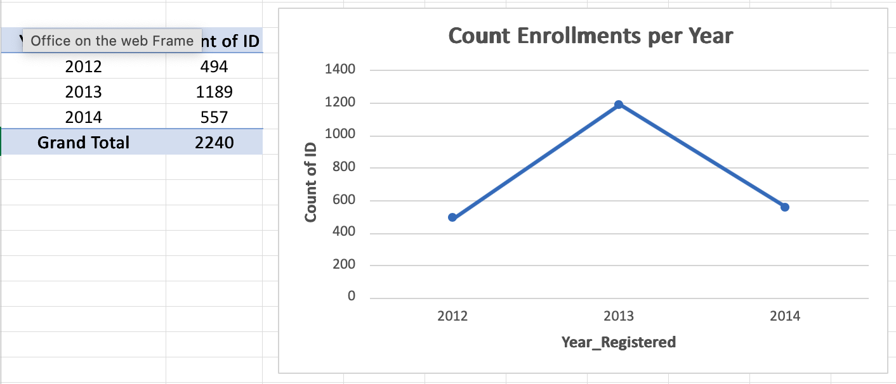

Screenshot 2025-08-14 at 10.51.37.png

### Task 3: Cross-tabulation of Response and Education

* Use Pivot Table to cross-tabulate how campaign response correlates with education levels.
* Helps understand demographic segments more/less responsive.

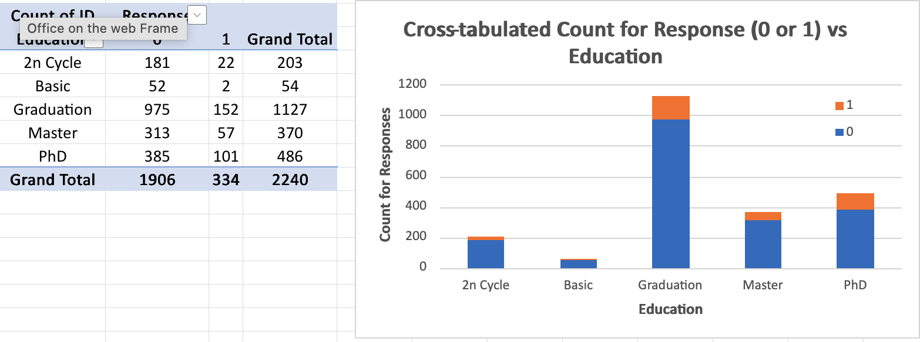

Screenshot 2025-08-14 at 10.52.00.png

### Task 4: Boxplot for Income Analysis

* Create a boxplot for the Income variable to visualize distribution and identify outliers.
* This shows income range and spread within your customer base.

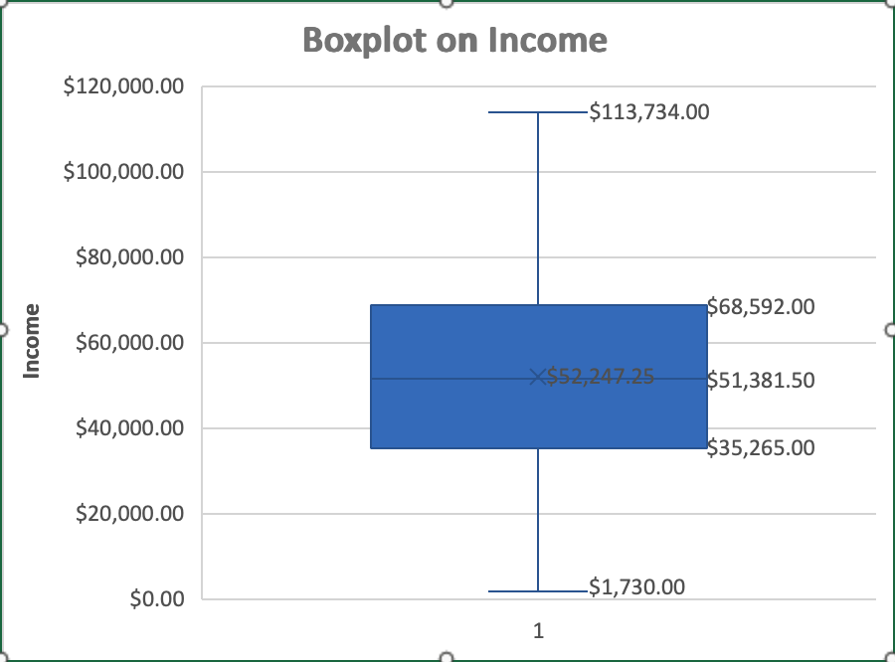

Screenshot 2025-08-14 at 10.52.59.png

### Task 5: Calculate Age and Create a Histogram

* Derive Age from Year_Birth or convert dates correctly.
* Use Excel’s histogram chart to visualize the age distribution.
* Useful for identifying predominant age groups.

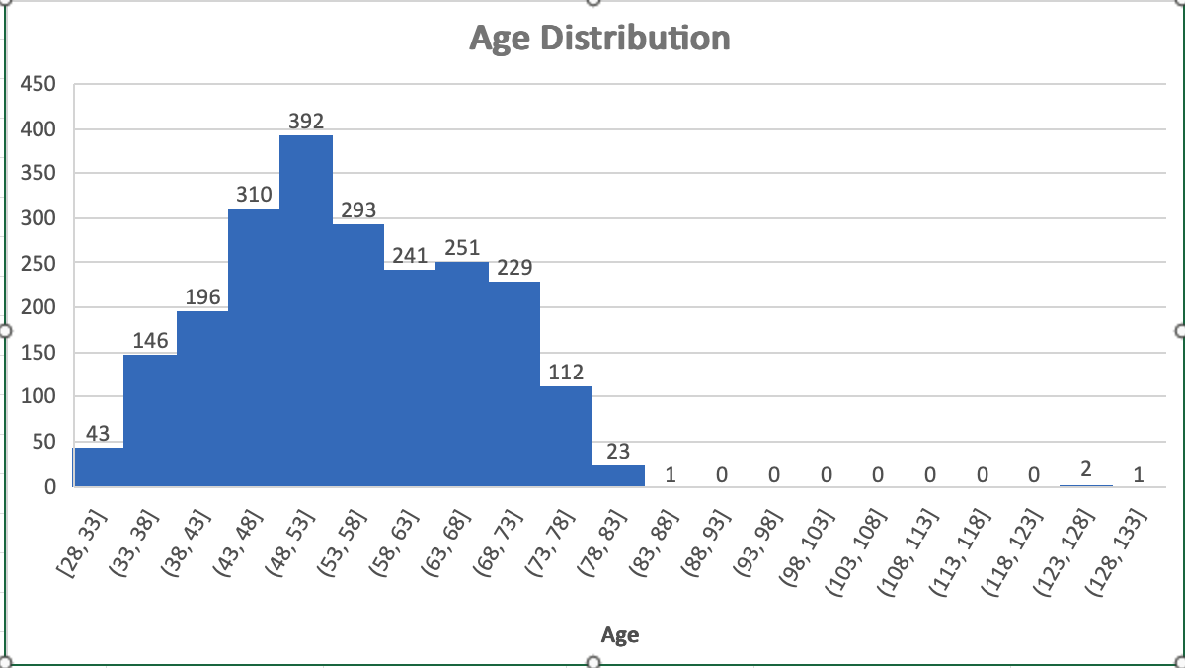

Screenshot 2025-08-14 at 10.53.32.png

### Task 6: Visualize Response vs Marital_Status (Bar Chart Suggested)

* Create a bar chart showing counts or percentages of responses by marital status groups.
* Reveals how marital status might influence campaign engagement.
* 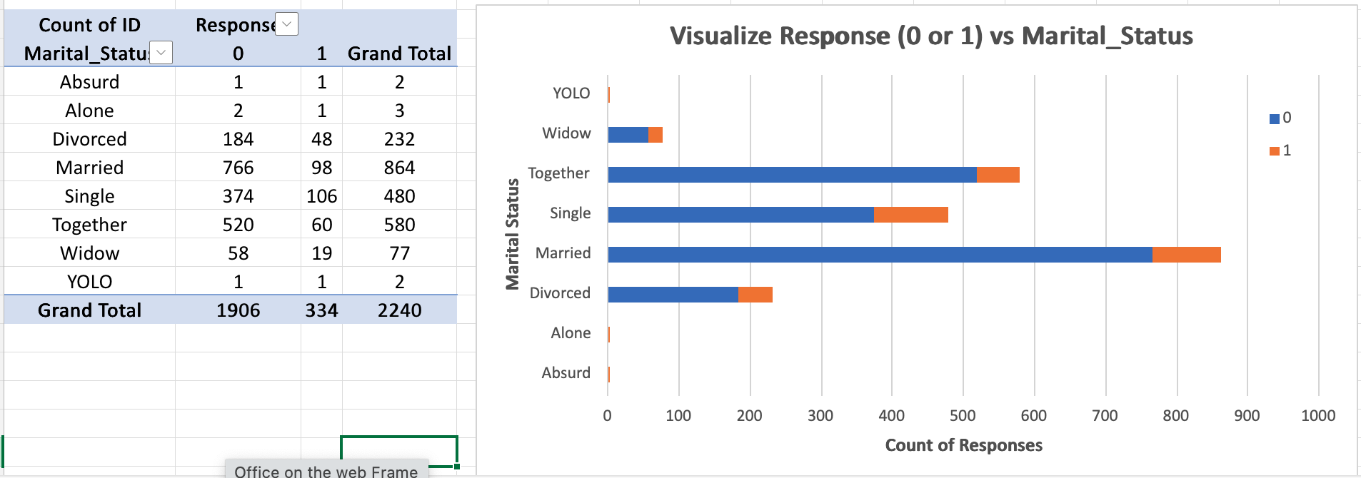
* Screenshot 2025-08-14 at 10.54.01.png

## 2. SQL Tasks (Schema Creation + Pre - processing)

### 1. Create Schema and Tables

* Create schema/database: retail_data.
* Create a **staging table** with all columns as text (VARCHAR) to accept raw CSV import, avoiding errors due to mixed formats or missing values.
* Create final table marketing_campaign with typed columns matching CSV headers, including proper numeric types and a DATE column for Dt_Customer.
* Include Age and Age_Group columns for demographic analysis.

### 2. Data Import and Conversion

* Import raw CSV data into the staging table.
* Use a SQL INSERT INTO statement from staging to final table:
  + Convert income and numeric string fields to numbers, replacing blanks with NULL.
  + Parse Dt_Customer from mixed formats (e.g. dd-mm-yyyy and mm/dd/yyyy) using STR_TO_DATE.
  + Use provided Age or calculate from Year_Birth.
  + Assign Age_Group categories based on Age.

### 3. Key Queries for Data Analysis

#### Total Customer Encounters

SELECT COUNT(*) AS total_customers FROM marketing_campaign;

Screenshot 2025-08-14 at 11.14.29.png

Screenshot 2025-08-14 at 11.14.29.png

#### Top 10 Purchased Product Categories (Total Spending)

SELECT 'MntWines' AS category, SUM(MntWines) AS total_spent FROM marketing_campaign  
UNION ALL  
SELECT 'MntFruits', SUM(MntFruits) FROM marketing_campaign  
UNION ALL  
SELECT 'MntMeatProducts', SUM(MntMeatProducts) FROM marketing_campaign  
UNION ALL  
SELECT 'MntFishProducts', SUM(MntFishProducts) FROM marketing_campaign  
UNION ALL  
SELECT 'MntSweetProducts', SUM(MntSweetProducts) FROM marketing_campaign  
UNION ALL  
SELECT 'MntGoldProds', SUM(MntGoldProds) FROM marketing_campaign  
ORDER BY total_spent DESC;

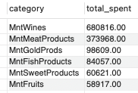

Screenshot 2025-08-14 at 11.15.05.png

#### Count of Each Response Value

SELECT Response, COUNT(*) AS total_customers  
FROM marketing_campaign  
GROUP BY Response;

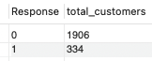

Screenshot 2025-08-14 at 11.15.32.png

#### Education vs Marital Status Distribution

SELECT Education, Marital_Status, COUNT(*) AS customer_count  
FROM marketing_campaign  
GROUP BY Education, Marital_Status  
ORDER BY Education, Marital_Status;

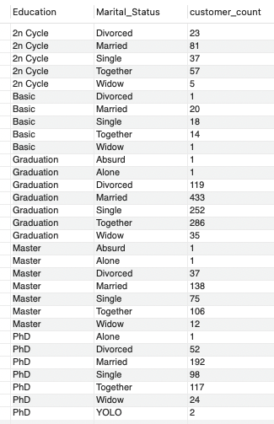

Screenshot 2025-08-14 at 11.16.08.png

#### Average Income of Customers Who Responded

SELECT AVG(Income) AS avg_income_responders  
FROM marketing_campaign  
WHERE Response = 1 AND Income IS NOT NULL;

Screenshot 2025-08-14 at 11.16.55.png

Screenshot 2025-08-14 at 11.16.55.png

#### Total Campaigns Accepted Per Campaign (AcceptedCmp1 to AcceptedCmp5)

SELECT  
 SUM(AcceptedCmp1) AS Accepted_Cmp1,  
 SUM(AcceptedCmp2) AS Accepted_Cmp2,  
 SUM(AcceptedCmp3) AS Accepted_Cmp3,  
 SUM(AcceptedCmp4) AS Accepted_Cmp4,  
 SUM(AcceptedCmp5) AS Accepted_Cmp5  
FROM marketing_campaign;

Screenshot 2025-08-14 at 11.17.21.png

Screenshot 2025-08-14 at 11.17.21.png

#### Distribution of Responses to the Last Campaign

SELECT Response, COUNT(*) AS total_customers,  
ROUND(COUNT(*) * 100.0 / (SELECT COUNT(*) FROM marketing_campaign), 2) AS pct_of_total  
FROM marketing_campaign  
GROUP BY Response;

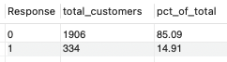

Screenshot 2025-08-14 at 11.17.45.png

#### Average Number of Children (Kidhome) and Teenagers (Teenhome)

SELECT ROUND(AVG(Kidhome), 2) AS avg_kids, ROUND(AVG(Teenhome), 2) AS avg_teens  
FROM marketing_campaign;

Screenshot 2025-08-14 at 11.18.04.png

Screenshot 2025-08-14 at 11.18.04.png

#### Derive Age_Group (if not assigned during import)

UPDATE marketing_campaign  
SET Age_Group = CASE   
 WHEN Age BETWEEN 18 AND 30 THEN '18-30'  
 WHEN Age BETWEEN 31 AND 45 THEN '31-45'  
 WHEN Age BETWEEN 46 AND 60 THEN '46-60'  
 WHEN Age > 60 THEN '60+'  
 ELSE 'Unknown' END;

#### Average Visits Per Month by Age_Group

SELECT Age_Group, ROUND(AVG(NumWebVisitsMonth), 2) AS avg_web_visits  
FROM marketing_campaign  
GROUP BY Age_Group  
ORDER BY Age_Group;

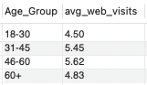

Screenshot 2025-08-14 at 11.18.43.png

## 3. Python/Jupyter Tasks: Exploratory Data Analysis (EDA)

### **A. Environment Setup & Directory Structure**

import os  
# Define directory to store all generated plot images  
plot_dir = 'eda_plots'  
# Create the directory if it doesn't already exist  
if not os.path.exists(plot_dir):  
 os.makedirs(plot_dir)  
print(f"Plots will save to: {plot_dir}")

### **B. Library Import and Data Ingestion**

# Standard data analysis libraries  
import pandas as pd  
import matplotlib.pyplot as plt  
import seaborn as sns  
from scipy.stats import chi2_contingency  
import matplotlib.lines as mlines  
  
# Set global Seaborn plotting style for visual consistency  
sns.set(style="whitegrid", palette="muted", font_scale=1.1)  
  
# Load data from CSV into DataFrame  
df = pd.read_csv('marketing_campaign.csv')

### **C. Data Cleaning and Feature Engineering**

# Convert join date column to datetime (handles day-first format)  
df['Dt_Customer'] = pd.to_datetime(df['Dt_Customer'], dayfirst=True)  
  
# Merge rare/odd marital status values into 'Other' for clean analysis  
df['Marital_Status'] = df['Marital_Status'].replace({'YOLO':'Other', 'Absurd':'Other', 'Alone':'Other'})  
  
# Remove rows with unreasonably high Age (>100 years) or Income (>200,000) as outliers  
df = df[df['Age'] <= 100]  
df = df[df['Income'] <= 200000]  
  
# Drop columns that have the same value everywhere (no analytical value)  
if 'Z_CostContact' in df.columns: df = df.drop(columns=['Z_CostContact'])  
if 'Z_Revenue' in df.columns: df = df.drop(columns=['Z_Revenue'])  
  
# Bin Age into categorical groups for demographic profiling  
df['Age_Group'] = pd.cut(  
 df['Age'],  
 bins=,  
 labels=['18-30', '31-45', '46-60', '60+']  
)

### **D. Descriptive Statistics and Feature Diagnostics**

# Display key descriptive statistics (mean, std, median, min, max) for numeric columns  
display(df.describe().T[['mean', 'std', '50%', 'min', 'max']])  
  
# Visual summary: horizontal boxplot of numeric data (outliers hidden for readability)  
plt.figure(figsize=(14,6))  
sns.boxplot(data=df.select_dtypes(['number']), orient='h', showfliers=False)  
plt.title('Numeric Feature Distributions')  
plt.savefig(f'{plot_dir}/Numeric Feature Distributions.png', bbox_inches='tight')  
plt.show()

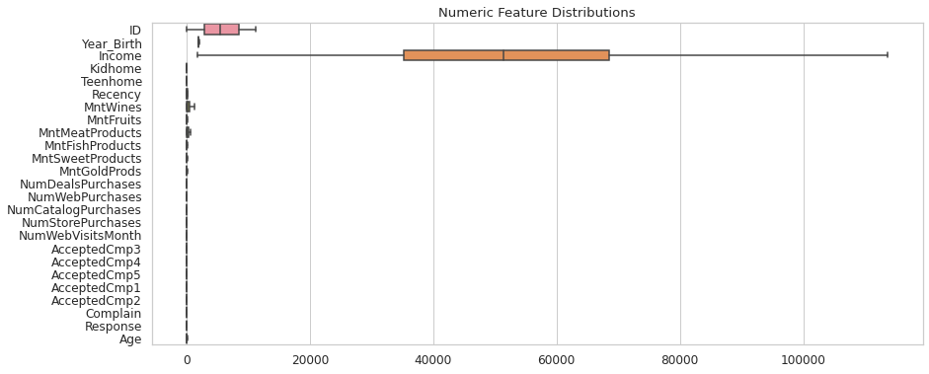

Numeric Feature Distributions.png

### **E. Uni-variate Analysis (Annotated)**

# Plot histograms (with KDE) for each selected numeric feature, with central tendency and tail annotated  
for col in ['Income', 'MntWines', 'MntFruits', 'MntMeatProducts',  
 'MntFishProducts', 'MntSweetProducts', 'MntGoldProds',  
 'Recency', 'Kidhome', 'Teenhome', 'Age']:  
 plt.figure(figsize=(7,3))  
 ax = sns.histplot(df[col].dropna(), kde=True, bins=30, color='cornflowerblue')  
 plt.title(f'Distribution of {col}')  
 plt.xlabel(col)  
 plt.ylabel('Count')  
 # Annotate central measures and high-end tail  
 plt.axvline(df[col].mean(), color='orange', linestyle='--', label=f"Mean: {df[col].mean():.0f}")  
 plt.axvline(df[col].median(), color='green', linestyle=':', label=f"Median: {df[col].median():.0f}")  
 q99 = df[col].quantile(0.99)  
 if q99 < df[col].max():  
 plt.axvline(q99, color='red', linestyle='-.', label=f"99th %ile: {q99:.0f}")  
 plt.legend()  
 plt.savefig(f'{plot_dir}/Distribution of {col}.png', bbox_inches='tight')  
 plt.show()

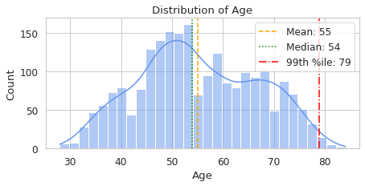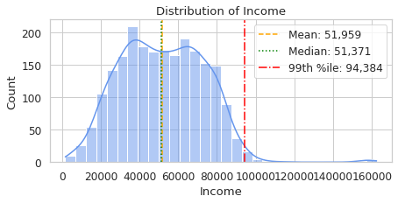 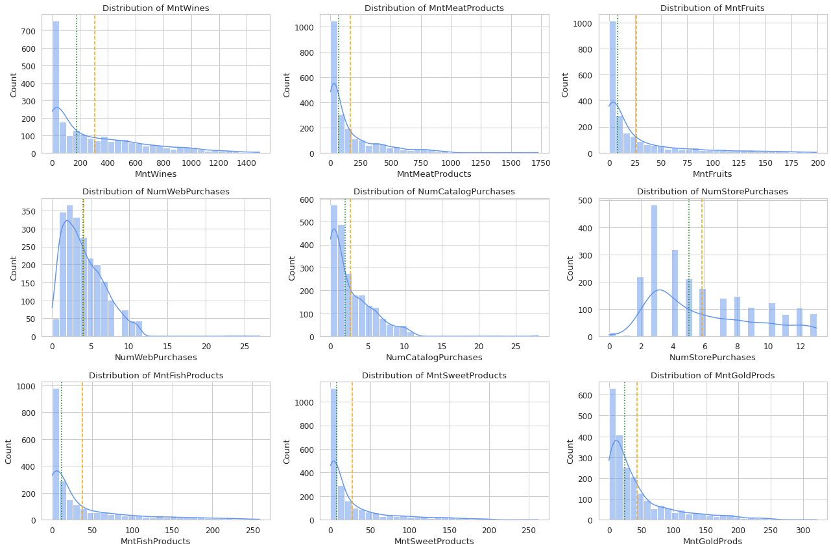

### **F. Combined Multi-panel Categorical Plots**

#### Demographic Counts

# Display counts for Education, Marital_Status, Age_Group in three side-by-side barplots  
fig, axes = plt.subplots(1, 3, figsize=(18, 5))  
for ax, col in zip(axes, ['Education', 'Marital_Status', 'Age_Group']):  
 g = sns.countplot(x=col, data=df, ax=ax)  
 ax.set_title(f'Count of {col}')  
 for c in g.containers:  
 g.bar_label(c, fmt='%d') # Show bar value on top  
 ax.set_ylabel('Count')  
 ax.tick_params(axis='x', rotation=30)  
plt.tight_layout()  
plt.savefig(f'{plot_dir}/Demographics_Distribution.png', bbox_inches='tight')  
plt.show()

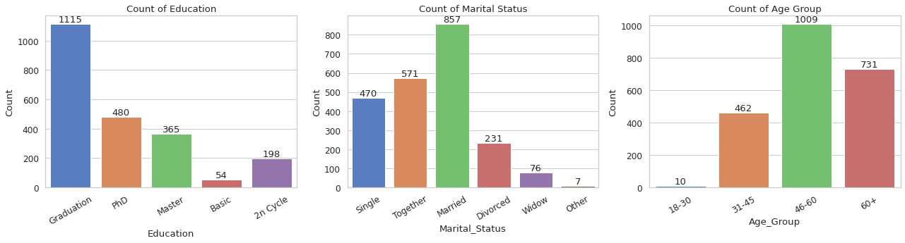

Demographics_Distribution.png

#### Campaign Response (Count + Stacked Bars)

fig, axes = plt.subplots(1, 3, figsize=(21, 5))  
  
# Campaign response (leftmost panel)  
g = sns.countplot(x='Response', data=df, ax=axes, palette='Set2')  
axes.set_title('Count of Campaign Response')  
for c in g.containers: g.bar_label(c, fmt='%d')  
  
# Stacked Bar: Response by Education (middle panel)  
edu_resp = pd.crosstab(df['Education'], df['Response'], normalize='index') * 100  
ax2 = edu_resp.plot(kind='bar', stacked=True, colormap='coolwarm', ax=axes)  
axes.set_ylabel('Percentage')  
axes.set_title('Response Rate (%) by Education')  
for container in ax2.containers:  
 ax2.bar_label(container, fmt='%.1f', label_type='center')  
axes.legend(title='Response')  
  
# Stacked Bar: Response by Marital Status (rightmost panel)  
ms_resp = pd.crosstab(df['Marital_Status'], df['Response'], normalize='index') * 100  
ax3 = ms_resp.plot(kind='bar', stacked=True, colormap='crest', ax=axes)  
axes.set_ylabel('Percentage')  
axes.set_title('Response Rate (%) by Marital Status')  
for container in ax3.containers:  
 ax3.bar_label(container, fmt='%.1f', label_type='center')  
axes.legend(title='Response')  
  
plt.tight_layout()  
plt.savefig(f'{plot_dir}/Campaign_Response_Distributions.png', bbox_inches='tight')  
plt.show()

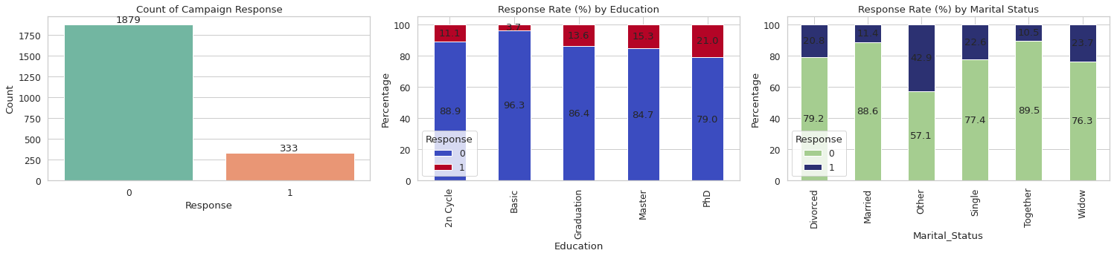

Campaign_Response_Distributions.png

### **G. Numeric Features by Response (Box plots with Median/Mean Lines)**

# Compare Income, MntWines, Recency by response group with boxplots,  
# overlaying group medians (red dashed) and means (blue dash-dot)  
fig, axes = plt.subplots(1, 3, figsize=(18, 5))  
for i, col in enumerate(['Income', 'MntWines', 'Recency']):  
 ax = sns.boxplot(x='Response', y=col, data=df, showfliers=False, palette='Set1', ax=axes[i])  
 ax.set_title(f'{col} by Campaign Response')  
 med = df.groupby('Response')[col].median()  
 mean = df.groupby('Response')[col].mean()  
 # Overlay median and mean lines for each response group  
 for j, resp in enumerate(sorted(df['Response'].unique())):  
 ax.plot([j-0.2, j+0.2], [med[resp]]*2, color='red', linestyle='--', lw=2, label='Median' if (i==0 and j==0) else "")  
 ax.plot([j-0.2, j+0.2], [mean[resp]]*2, color='blue', linestyle='-.', lw=2, label='Mean' if (i==0 and j==0) else "")  
 if i == 0: ax.legend()  
plt.tight_layout()  
plt.savefig(f'{plot_dir}/Numeric_Features_by_Response.png', bbox_inches='tight')  
plt.show()

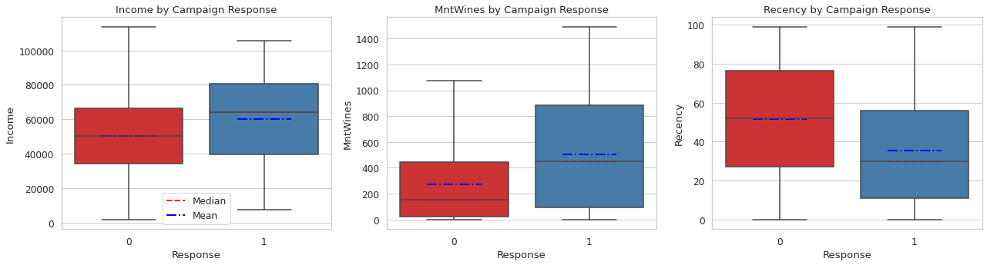

Numeric_Features_by_Response.png

### **H. Correlation Heat map**

# Correlation heatmap to visualize relationships among all numeric variables  
plt.figure(figsize=(18, 14))  
corr_matrix = df.select_dtypes(include=['int64', 'float64']).corr()  
sns.heatmap(  
 corr_matrix,  
 annot=True,  
 fmt=".2f",  
 cmap='coolwarm',  
 center=0,  
 annot_kws={"size": 8}  
)  
plt.title('Correlation Heatmap of Numeric Features', fontsize=16)  
plt.xticks(rotation=45, ha='right', fontsize=10)  
plt.yticks(fontsize=10)  
plt.tight_layout()  
plt.savefig(f'{plot_dir}/Correlation_Heatmap.png', bbox_inches='tight')  
plt.show()

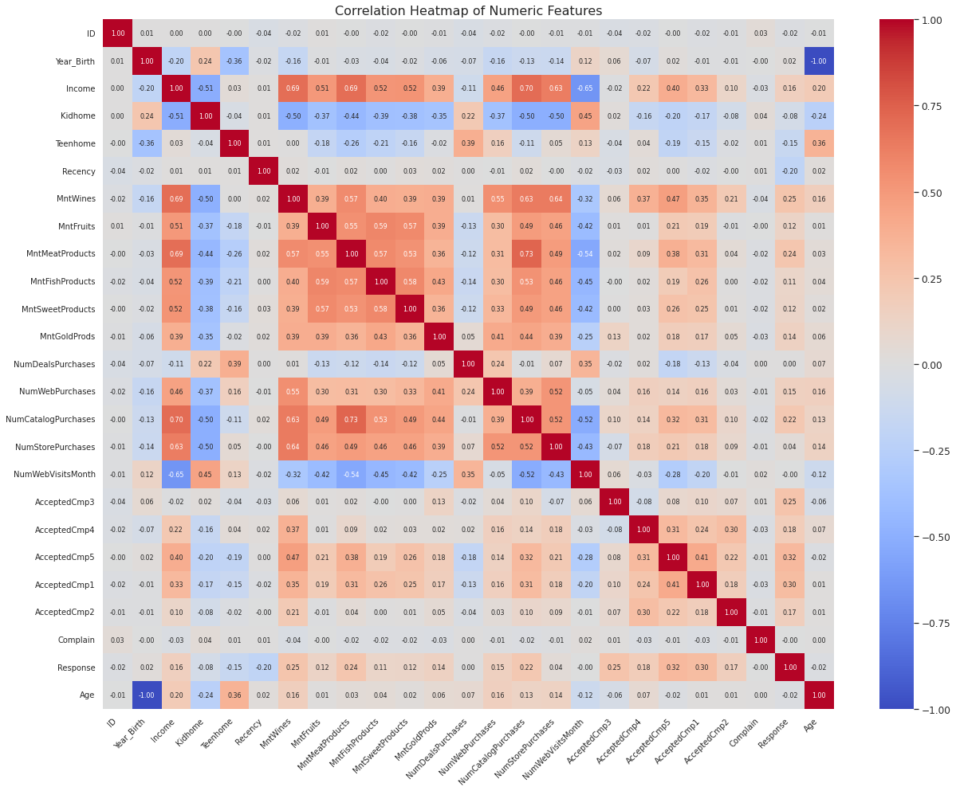

Correlation_Heatmap.png

### **I. Automated Insights Summary**

# Function auto-generates bullet-pointed analysis summary from key EDA findings  
def generate_insights(df):  
 insights = []  
 # Get number of customers (rows) and features (columns)  
 n_rows, n_cols = df.shape  
 insights.append(f"Dataset contains {n_rows:,} customers and {n_cols} features after cleaning.")  
  
 # Overall response rate  
 response_rate = df['Response'].mean() * 100  
 insights.append(f"Overall campaign response rate: {response_rate:.2f}%.")  
  
 # Correlation insights  
 corr = df.select_dtypes(include=['int64', 'float64']).corr()['Response'].drop('Response').sort_values(ascending=False)  
 top_positive = corr.head(3)  
 top_negative = corr.tail(3)  
 insights.append("Top positive correlations with Response: " +  
 ", ".join([f"{idx} ({val:.2f})" for idx, val in top_positive.items()]))  
 insights.append("Top negative correlations with Response: " +  
 ", ".join([f"{idx} ({val:.2f})" for idx, val in top_negative.items()]))  
  
 # Complaint rate  
 complaint_rate = df['Complain'].mean() * 100  
 insights.append(f"Complaint rate in dataset: {complaint_rate:.2f}% (very low, indicating high satisfaction or underreporting).")  
  
 # Impact of data cleaning  
 if df['Age'].max() <= 100 and df['Income'].max() <= 200000:  
 insights.append("Outliers for Age (>100) and Income (>200,000) were removed, improving analysis robustness.")  
  
 # Age group stats  
 age_counts = df['Age_Group'].value_counts(normalize=True) * 100  
 dominant_age_group = age_counts.idxmax()  
 smallest_age_group = age_counts.idxmin()  
 insights.append(f"Most common age group: {dominant_age_group} ({age_counts.max():.1f}%).")  
 insights.append(f"Smallest age group: {smallest_age_group} ({age_counts.min():.1f}%).")  
  
 # Income difference by response group  
 income_resp = df.groupby('Response')['Income'].median()  
 if 1 in income_resp and 0 in income_resp:  
 diff_income = income_resp[1] - income_resp[0]  
 insights.append(f"Median income for responders is {diff_income:.0f} higher than for non-responders.")  
  
 # Education and marital status with highest response  
 edu_rate = (df.groupby('Education')['Response'].mean() * 100).sort_values(ascending=False)  
 top_edu = edu_rate.index[0]  
 insights.append(f"Highest response rate by education: {top_edu} ({edu_rate.iloc[0]:.1f}%).")  
  
 ms_rate = (df.groupby('Marital_Status')['Response'].mean() * 100).sort_values(ascending=False)  
 top_ms = ms_rate.index[0]  
 insights.append(f"Highest response rate by marital status: {top_ms} ({ms_rate.iloc[0]:.1f}%).")  
  
 # Response rate for smallest age group  
 rare_category = smallest_age_group  
 rare_rate = df[df['Age_Group'] == rare_category]['Response'].mean() * 100  
 insights.append(f"Response rate for smallest age group ({rare_category}): {rare_rate:.1f}%.")  
  
 return insights  
  
# Usage:  
summary_points = generate_insights(df)  
print("\n=== Automated EDA Insights Summary ===\n")  
for point in summary_points:  
 print("-", point)

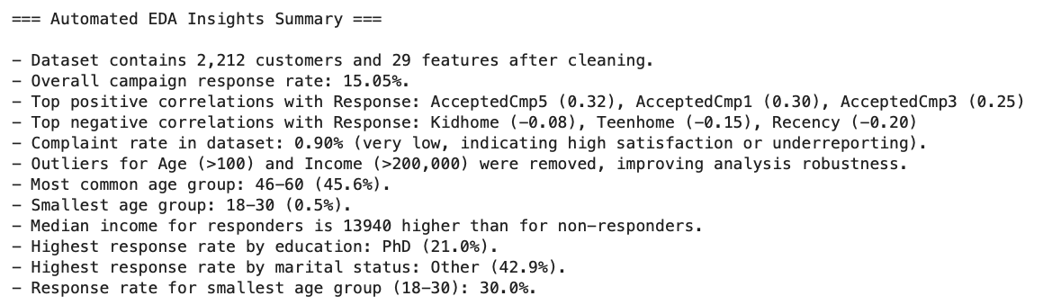

Screenshot 2025-08-16 at 09.47.59.png

## 4. Tableau Public Tasks (Interactive Dashboard)

### **A. Getting Started**

* Download and install Tableau Public for macOS.
* Connect to your cleaned data file (CSV or Excel) exported from previous steps.

### **B. Key Visualization Tasks in Tableau Public**

#### **1. Customer Income Distribution by Registration Year (Histogram)**

* Create a new worksheet.
* Drag Dt_Customer (or its extracted year) to Columns and set it to “Year”.
* Drag Income to Columns again, then use **Show Me → Histogram**.
* Y-axis will auto-populate with Number of Records (frequency).
* Adjust bin size for Income ([Income (bin)] → “Edit”).
* Add Education to Color for segment comparison.

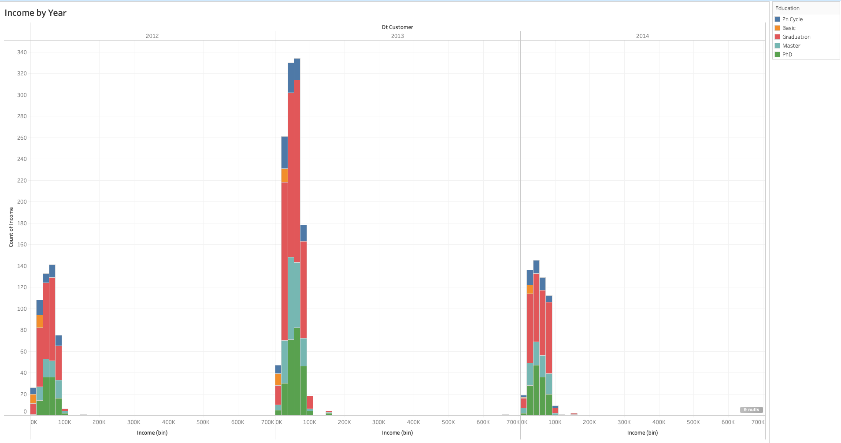

Screenshot 2025-08-16 at 10.34.29.png

#### **2. Education vs Marital Status (Clustered Bar Chart)**

* New worksheet: Drag Education to Columns.
* Drag Marital_Status to Columns next to Education (for side-by-side bars), or to Color for segmentation.
* Drag COUNTD(ID) to Rows.
* Use **Show Me → Side-by-Side Bars**; verify multiple bars per Education.
* Add labels by dragging the measure to Label in the Marks card.

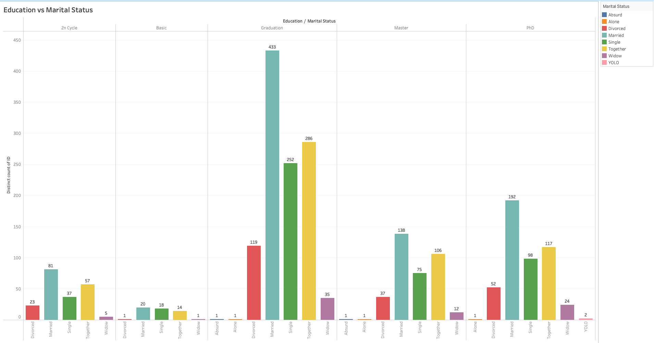

Screenshot 2025-08-16 at 10.34.42.png

#### **3. Normalized Wine Spending vs Income (Scatter Plot)**

* New worksheet: Drag Income to Columns, MntWines to Rows.
* For normalization, create two calculated fields:
  + **Normalized Income (Z-Score):**
  + ([Income] - { FIXED : AVG([Income]) }) / { FIXED : STDEV([Income]) }
  + **Normalized Wine Spend (Z-Score):**
  + ([MntWines] - { FIXED : AVG([MntWines]) }) / { FIXED : STDEV([MntWines]) }
* Use these fields as axes: Normalized Income (X), Normalized Wine Spend (Y).
* Add demographic Response to Color for more insights.
* Drag ID to Detail for tooltips on individual customers.

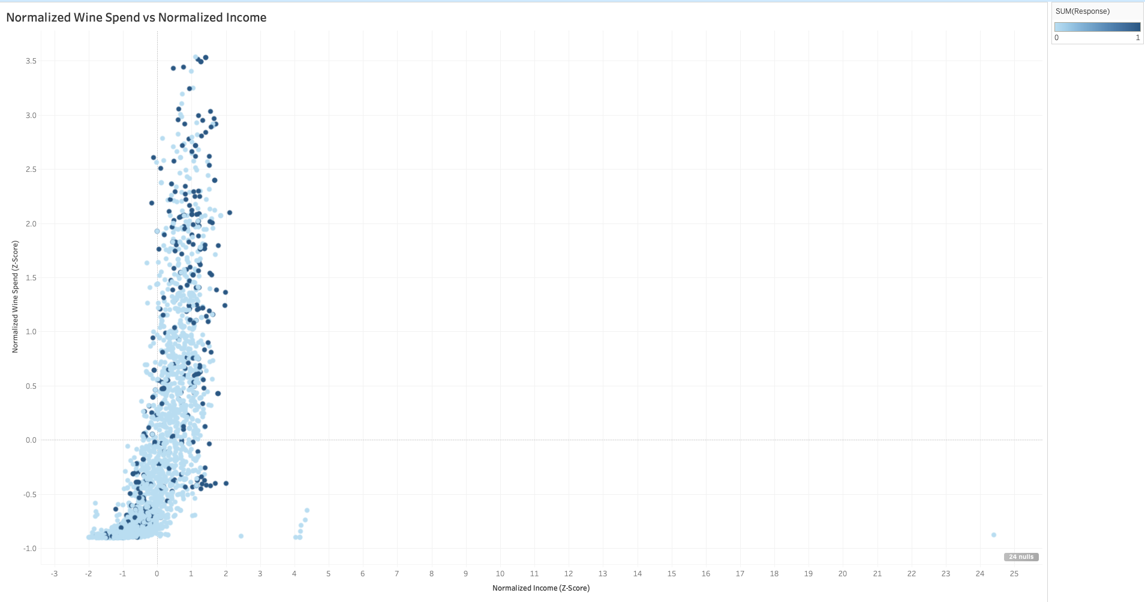

Screenshot 2025-08-16 at 10.34.56.png

#### **4. Top N Purchasers Across Spending Categories**

* For each spend category (e.g., Wines, Meats):
  + Create worksheet: Drag ID to Rows, measure (e.g., MntWines) to Columns.
  + Sort descending by spend amount.
  + Create a parameter (Top N Parameter) for N; set Data Type: Integer.
  + In Filter for ID, use the “Top” tab: By Field, set “Top N by SUM(Measure)” and connect to your parameter.
  + Display the parameter control for user interaction.
  + Duplicate worksheet for ‘MntMeatProducts’ categories as needed.

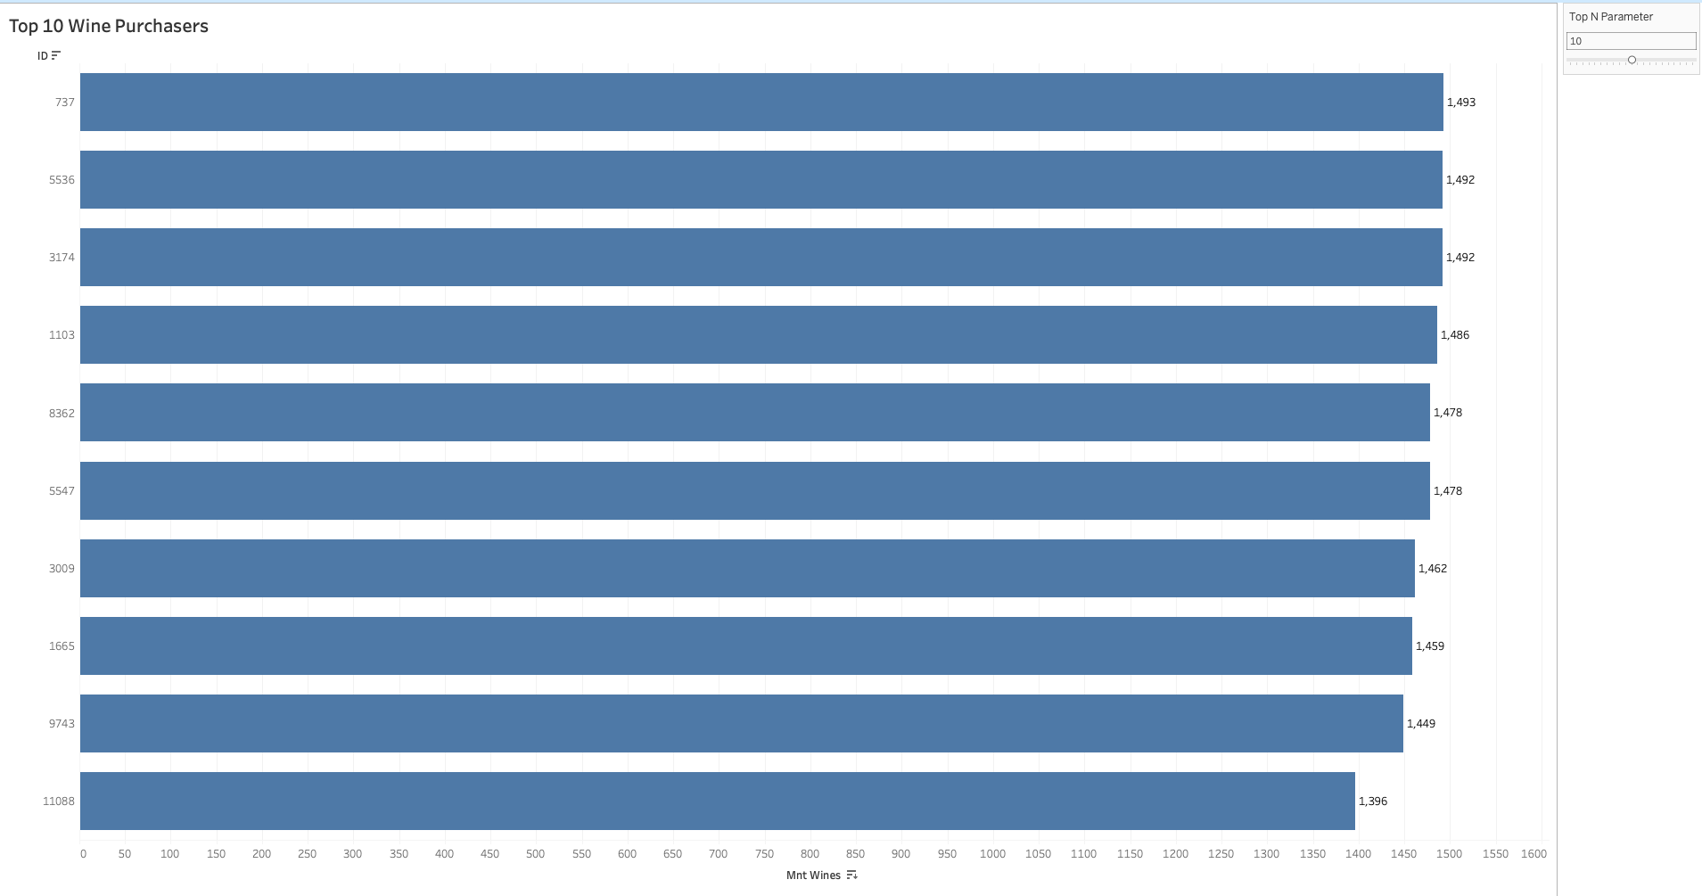 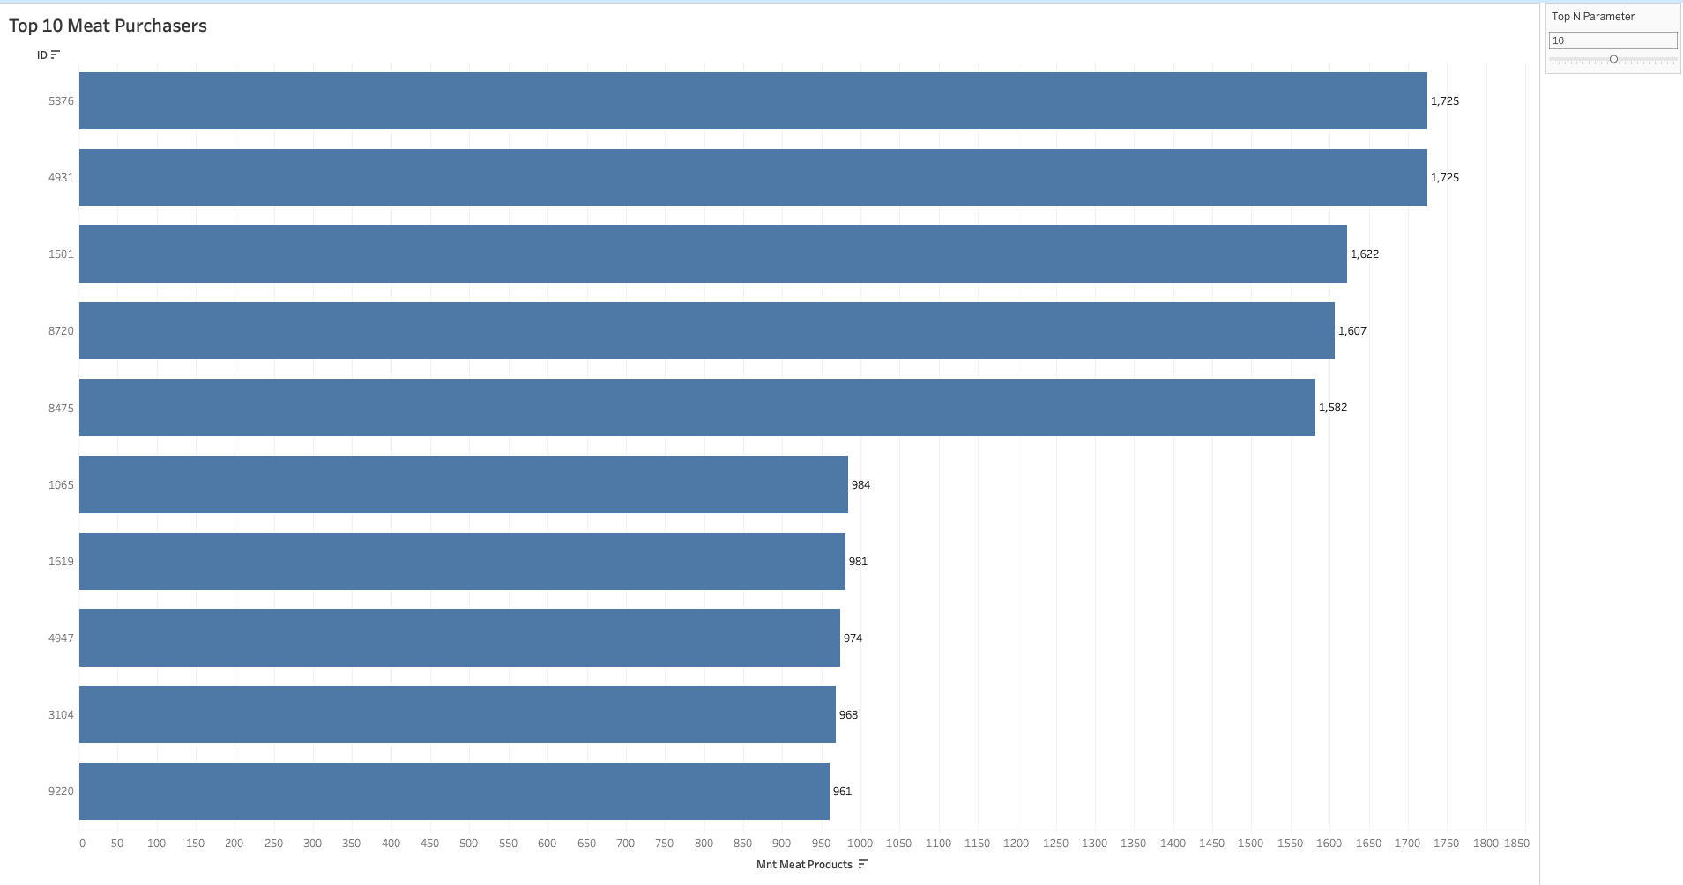

#### **5. Dashboard Compilation**

* Click Dashboard → New Dashboard.
* Set size: Fixed 1300x1600 px recommended for desktop viewing.
* **Layout suggestion (using vertical containers)**:
  + **Left Column**: (Customer Segments) “Income by Year”, “Education vs Marital Status”
  + **Right Column - Top**: (Spending Analysis) “Normalized Wine Spend vs Normalized Income”
  + **Right Column - Bottom**: (Top N Purchasers) “Top N Wine Purchases” (above), “Top N Meat Purchases” (below)
* Drag each worksheet onto the canvas; arrange and resize for clarity.
* Place filters and Top N parameters at the top/side for user interaction.
* Add section headings using Text objects (e.g., “Customer Segments”, “Spending Analysis”, “Top N Purchasers”).
* Ensure legends and color coding are visible and consistent.
* Test the dashboard layout with “Device Preview” to confirm readability across devices.
* Publish final dashboard to Tableau Public (File → Save to Tableau Public As…).

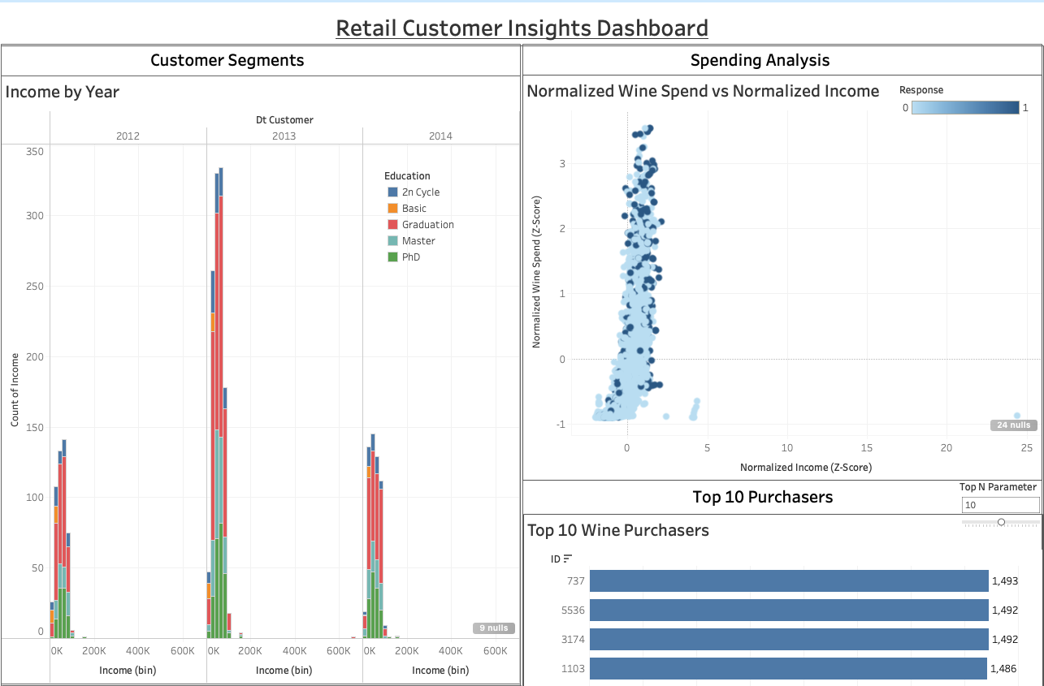 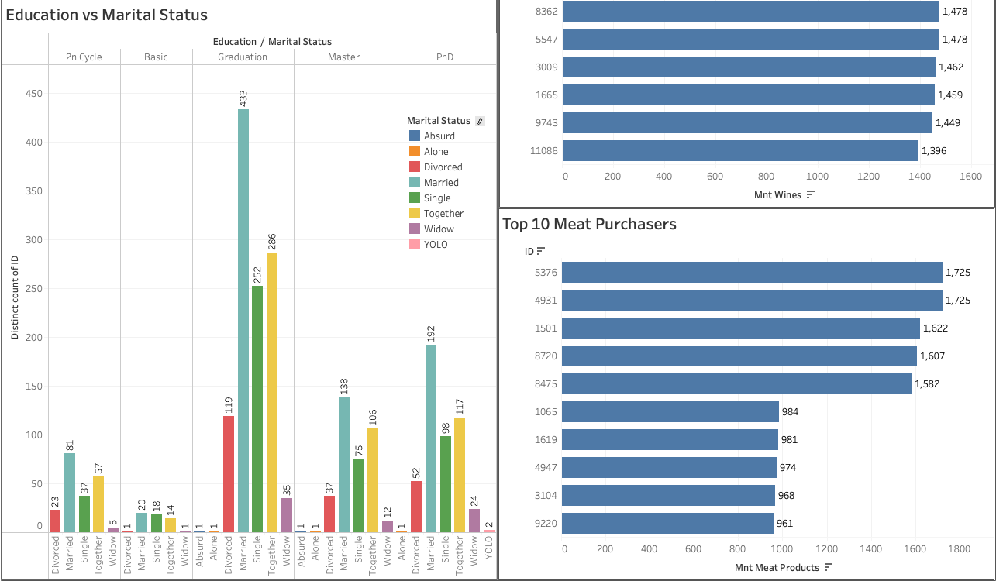

## 5. Conclusion & Summary

This workflow provides an end-to-end approach for retail marketing data analysis—starting from Excel and SQL-based exploration, moving through robust Python EDA, and culminating in interactive Tableau Public dashboards.

**Excel tasks** gave you quick exploration and visual summaries, helping identify basic trends and outliers.  
**SQL scripts** enabled structured data cleaning, type handling, demographic enrichment, and repeatable business queries.  
**Python and Jupyter** brought deeper, flexible analysis: systematic feature engineering, diagnostic visualizations, statistical summaries, and automated insight generation.

**Tableau Public** extended these insights into a powerful, interactive environment: - Histograms and demographic bar charts for segment overview - Scatter plots and normalized metrics for spend correlations and outlier detection - “Top N” purchasers visualizations surfaced customer value leaders - Dashboard compilation delivered an at-a-glance, customizable view for stakeholders

Throughout, best practices were applied for data cleaning, visual clarity, and reporting—making your analysis both insightful and accessible.

By following this comprehensive pipeline, you are now equipped to: - Detect and act on key customer trends - - Understand drivers of campaign response - Identify high-value customers for targeting - Share findings in executive-ready, interactive reports

**This unified process lays the foundation for advanced segmentation, predictive modeling, and data-driven marketing strategy. As your data or business needs grow, you can extend every step for ever more powerful insights.**