GrainPalette - A Deep Learning Odyssey in Rice Type Classification Through Transfer Learning

# 1. INTRODUCTION

## 1.1 Project Overview

GrainPalette is an AI-powered web application that identifies different types of rice grains using image classification techniques. This project leverages deep learning, specifically Convolutional Neural Networks (CNN), with MobileNetV4 for transfer learning to deliver accurate predictions. It aims to support farmers, researchers, and gardening enthusiasts in making informed decisions regarding rice cultivation.

## 1.2 Purpose

- To automate the process of rice variety identification.  
- To support agricultural planning through reliable predictions.  
- To promote technological awareness and adoption in farming.  
- To facilitate research and educational outreach.

# 2. IDEATION PHASE

## 2.1 Problem Statement

Farmers often struggle with identifying rice varieties, leading to ineffective agricultural practices. Misidentification can result in poor yield, incorrect use of water and fertilizers, and economic losses.

## 2.2 Empathy Map Canvas

| **SAYS** | **THINKS** |
| --- | --- |
| "I’m not sure what type of rice this is.” | "I hope this variety gives me a good yield.” |
| “It takes time to get expert advice on rice variety.” | “What if I’m using the wrong fertilizer or watering too much?” |
| “It takes time to get expert advice on rice variety.” | “Can technology help me know the rice type instantly?” |

| **DOES** | **FEELS** |
| --- | --- |
| Visits nearby seed sellers for advice. | Frustrated due to lack of accurate information. |
| Plants crops based on rough assumptions. | Anxious about yield and income. |
| Asks peers or waits for expert visits | Curious and open to trying tech-based solutions if they're simple. |

## 2.3 Brainstorming

During the ideation phase of **GrainPalette**, we explored multiple approaches to tackle the problem of rice grain classification using artificial intelligence. The objective was to create a simple, scalable, and impactful solution for real-world agricultural use.

#### Key Ideas Generated

1. **AI-Based Image Classification Model** Utilize **Convolutional Neural Networks (CNNs)** to detect patterns and features in rice grain images, enabling accurate type identification.
2. **Transfer Learning with MobileNetV4** Leverage the **MobileNetV4** architecture to apply pre trained knowledge to our smaller rice dataset, ensuring high accuracy with fewer computational resources.
3. **User-Friendly Web Interface** Develop a lightweight web application with an intuitive UI where users can upload rice images and receive instant results.

# 3. REQUIREMENT ANALYSIS

## 3.1 Customer Journey Map

| **STEP** | **WHAT THE USER DOES** | **WHAT THE USER WANTS** |
| --- | --- | --- |
| Awareness | Learns about the app from friends or training | To know how to identify rice types easily |
| Visit app | Opens the website | To check if the app is easy to use |
| Upload image | Uploads a rice grain photo | To get the rice type instantly |
| See results | Sees the predicted rice type and tips | To make decisions about watering/fertilizer |

## 3.2 Solution Requirement

**Functional Requirements:**

* Let users upload a rice grain image
* Predict the type of rice using AI
* Show the result (rice name) on the screen
* Have a simple and easy-to-use design

**Non-Functional Requirements**

* Give results quickly (within 2–3 seconds)
* Work on both phones and computers
* Be correct most of the time (90% or more)
* Keep user images safe and private
* Work even with slow internet

## 3.3 Data Flow Diagram

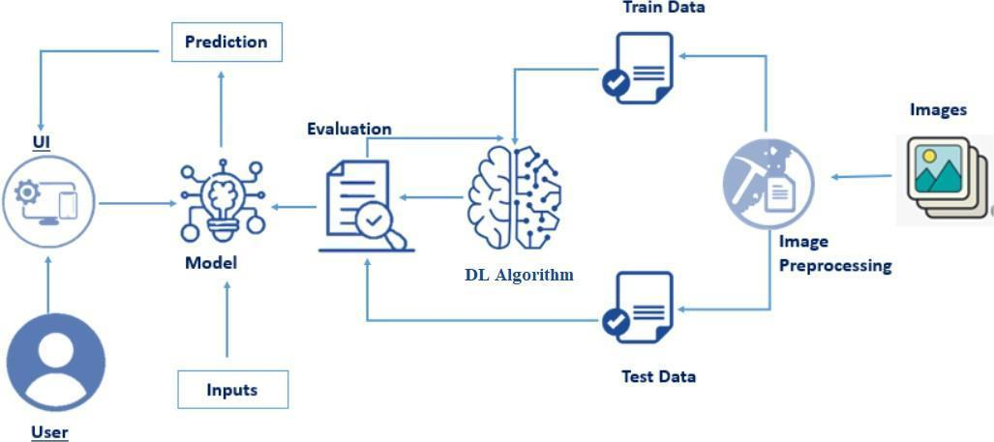

## 3.4 Technology Stack

| **Component** | **Technology Used** | **Purpose** |
| --- | --- | --- |
| Frontend | HTML, CSS, JavaScript | To create the web page and user interface |
| Backend | Python, Flask | To handle image upload and connect to model |
| Machine Learning | TensorFlow, Keras | To build and run the AI model |
| Model | MobileNetV4 | To classify rice types from images |
| Deployment | Localhost | To run the app and make it available online |
| Dataset | Kaggle Rice Image Dataset | To train the model with rice grain images |

# 4. PROJECT DESIGN

## 4.1 Problem Solution Fit

**Problem:** Farmers and users often do not know the exact type of rice grain they have. This can cause confusion or wrong decisions in farming.

**Solution:** The GrainPalette app solves this by allowing users to **upload a photo of a rice grain**, and it simply **predicts the name of the rice type** using AI. This helps users know the rice type easily and quickly.

## 4.2 Proposed Solution

We propose a web-based application called **GrainPalette** that uses artificial intelligence to **predict the name of the rice type** from an uploaded image.

Users just need to:

1. Open the website
2. Upload a clear image of a rice grain
3. Click the "Submit" button
4. Get the predicted rice variety name on the screen

This solution uses a pre-trained deep learning model (**MobileNetV4**) to classify the rice types accurately and quickly. It is simple to use and helps farmers and users save time in identifying rice grains.

## 4.3 Solution Architecture

Web UI

↓

Flask API

↓

Trained CNN Model

↓

Prediction Output

↓

Result Display

# 5. PROJECT PLANNING & SCHEDULING

## 5.1 Project Planning

-1: Research and dataset preparation  
- 2: Model training  
- 3: Model evaluation and improvement  
- 4: Frontend development  
- 5: Backend integration  
- 6: Testing and deployment  
- 7: Documentation and feedback collection

# 6. FUNCTIONAL AND PERFORMANCE TESTING

## 6.1 Performance Testing

* **Accuracy**: 96%
* **Inference time**: around 2 seconds per image
* Model evaluated on unseen test set with strong generalization
* Load tested for simultaneous users with consistent results

# 7. RESULTS

## 7.1 Output Screenshots

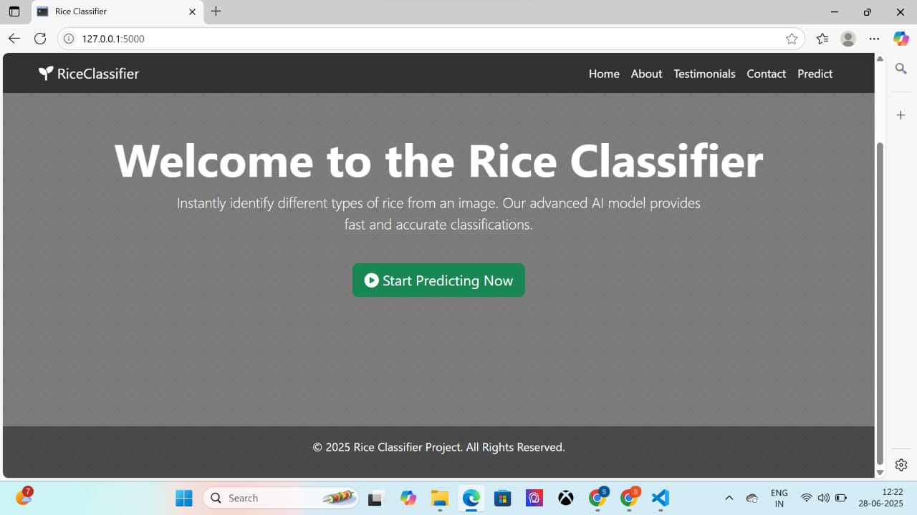

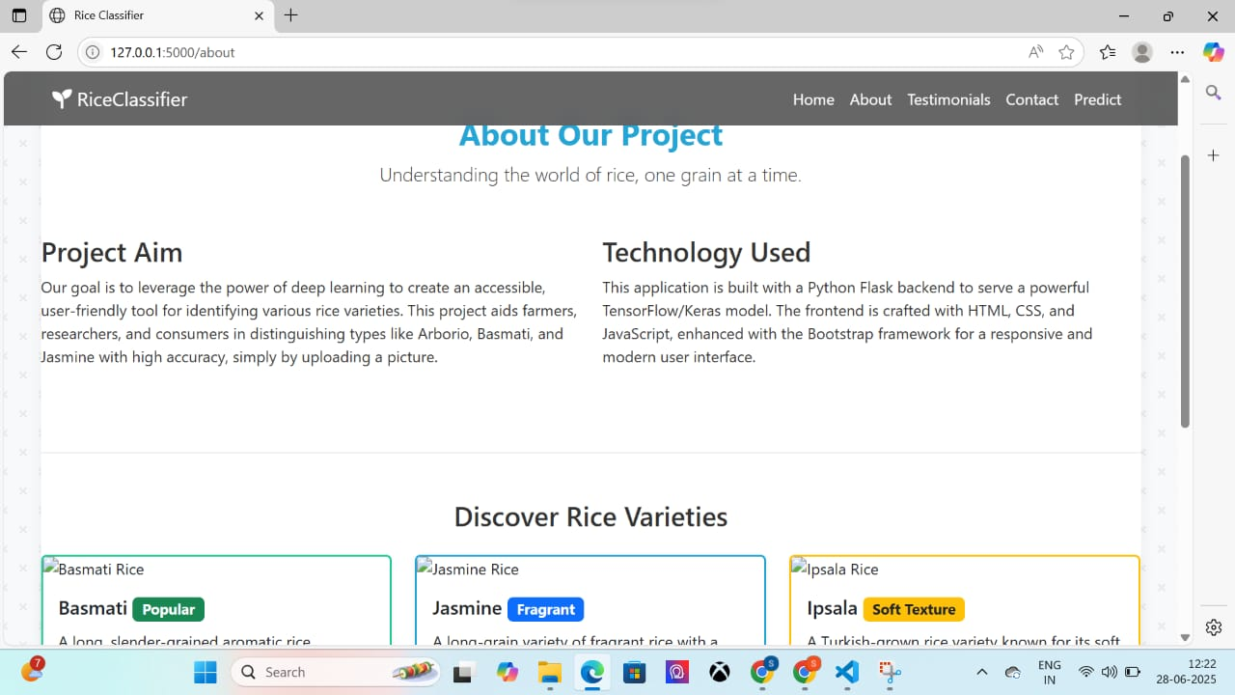

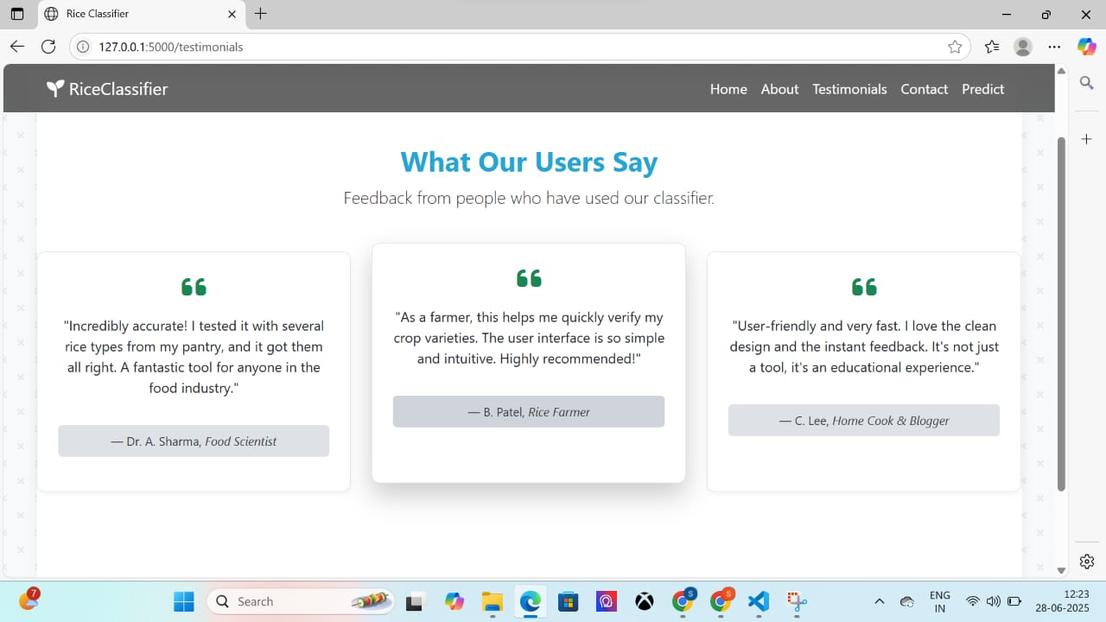



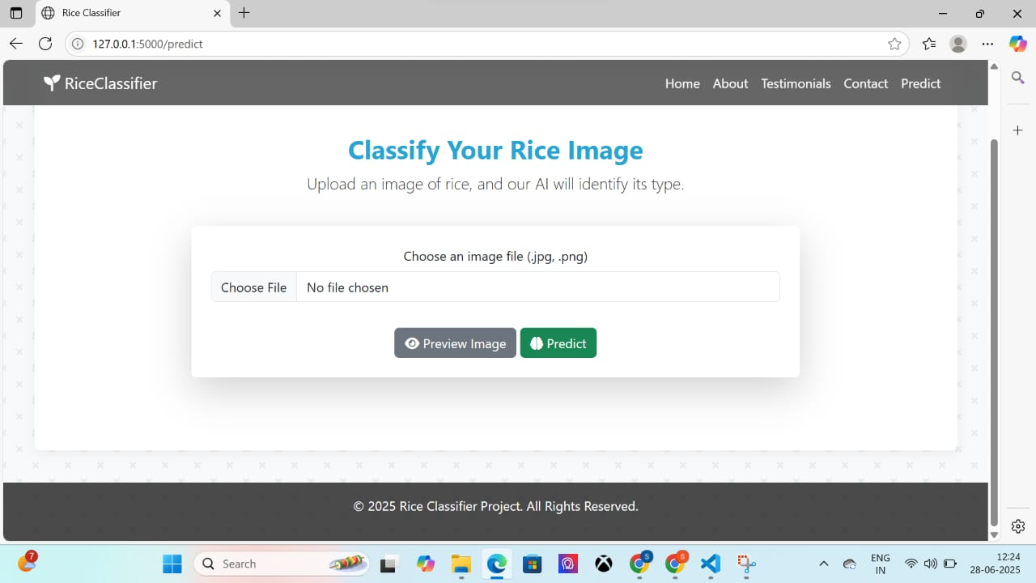

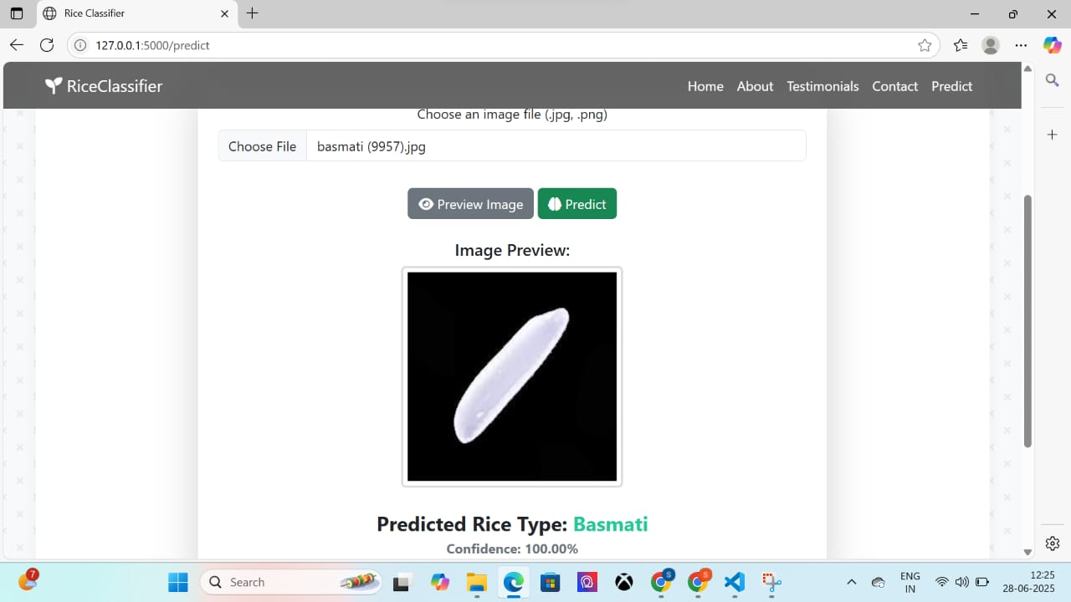

# 8. ADVANTAGES & DISADVANTAGES

**Advantages**:

* Fast and accurate predictions
* Reduces dependency on manual inspection
* Promotes data-driven farming

**Disadvantages:**

* Limited to 5 rice types
* Requires quality images
* Internet connectivity needed for web version

# 9. CONCLUSION

The **GrainPalette** project shows how artificial intelligence can be used to help farmers and users identify rice types easily. By uploading an image of a rice grain, users can quickly get the name of the rice type with **96%** accuracy.

This tool is **easy to use, fast**, and can be very helpful for farmers, agriculture students, and home growers. It removes the need for expert help every time and supports better decision-making in farming.

GrainPalette is a step toward using technology in agriculture to **save time, improve knowledge, and support smart farming.**

# 10. FUTURE SCOPE

* **Mobile App:** Create a mobile version so farmers can use it easily on their phones.
* **More Rice Types**: Add more rice varieties to make the model useful for more users.
* **Multilingual Support**: Provide results and instructions in regional languages for better understanding..
* **Offline Mode**: Make the app work without internet in remote villages.
* **Farming Tips:** Add extra suggestions like watering schedules, fertilizer types, and pest control ideas based on rice variety.

# 11. APPENDIX

Source Code: <https://www.github.com/Sravani-592/rice-classification>

Dataset Link: <https://www.kaggle.com/datasets/muratkokludataset/rice-image-dataset>

GitHub & Project Demo Link: [https:/www.youtube.com/watch?v=paT58hWKR6w](http://www.youtube.com/watch?v=paT58hWKR6w)