**AWS DAY-01**

**2) configure MFA for aws account**

* To configure MFA go to account (sravani) 🡪 from dropdown select ‘security credentials’
* Then ‘add MFA device’
* Install releavant app on mobile or computer (Google authenticator)
* Enter name and codes click on ‘add MFA’
* MFA device has been added.

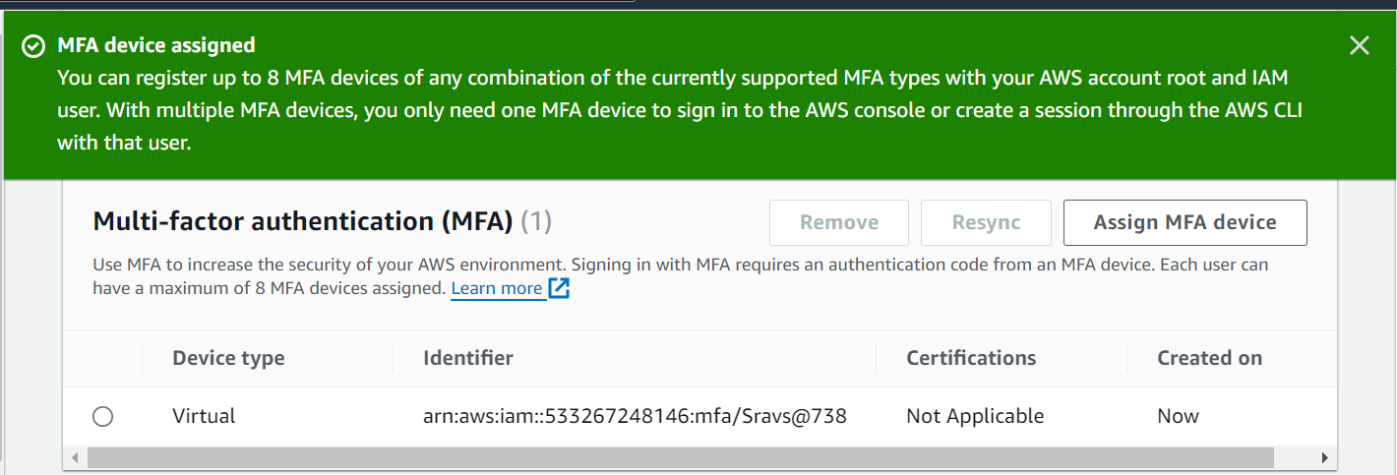

**3) Install aws cli in windows**

* Install aws cli go to browser 🡪aws cli 🡪install
* To check installed or not use aws --version

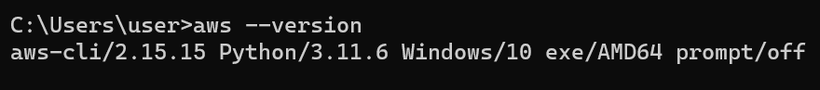

**4) Setup ec2 in N.virginia region using aws cli command**

* Configure aws by using ‘aws configure’
* Enter Accesskey,Secret key,region and format.
* We can create access key in console.

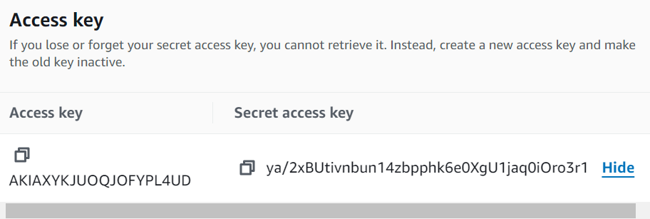

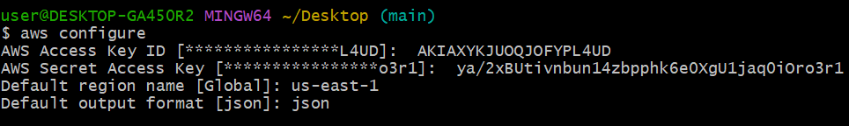

* Then run the below cmd to launch instance

aws ec2 run-instances --image-id ami-0a3c3a20c09d6f377 --instance-type t2.micro --region us-east-1

* It will give file which is in json format

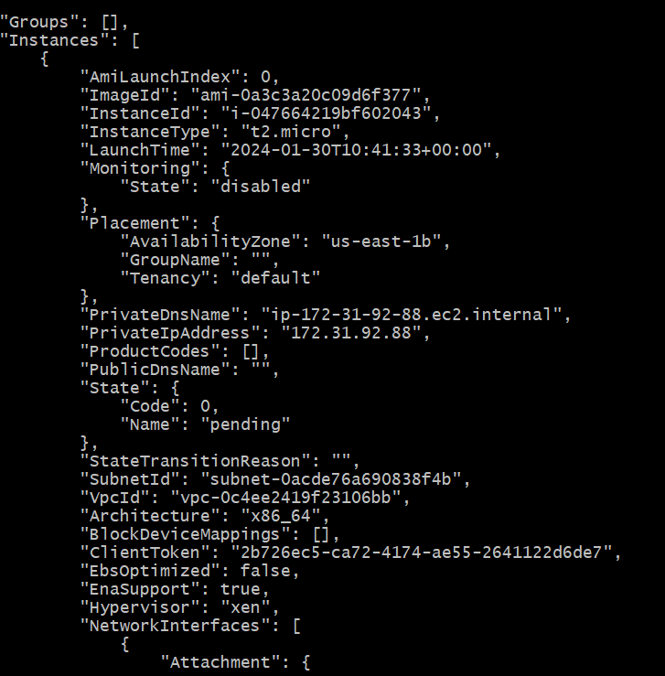

**5) Setup security group in ohio region with name - Techie-sg and open port 22**

* switch to ohio and go to security groups
* Add security group name as ‘Techie-sg’
* Edit inbound & outbound rules.
* The port default port no is 22.

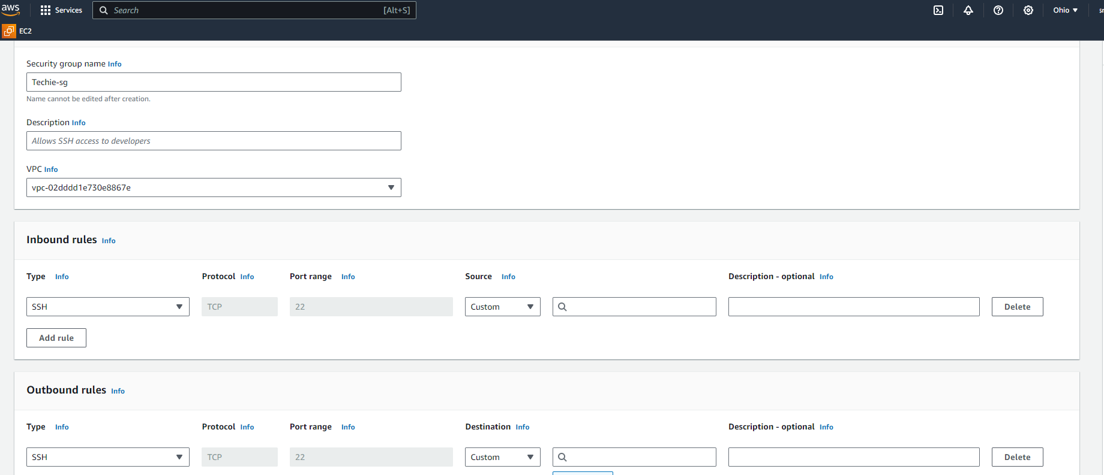

**6) setup ec2,security group in Mumbai region using single aws cli command**

* Create security group in console then run the below cmd

aws ec2 run-instances --image-id ami-00952f27cf14db9cd --security-group-ids sg-0c77faea515a95ddf --instance-type t2.micro --region ap-south-1

* Here the security group id is we created in console.

