JAVA SCRIPT
Introduction:
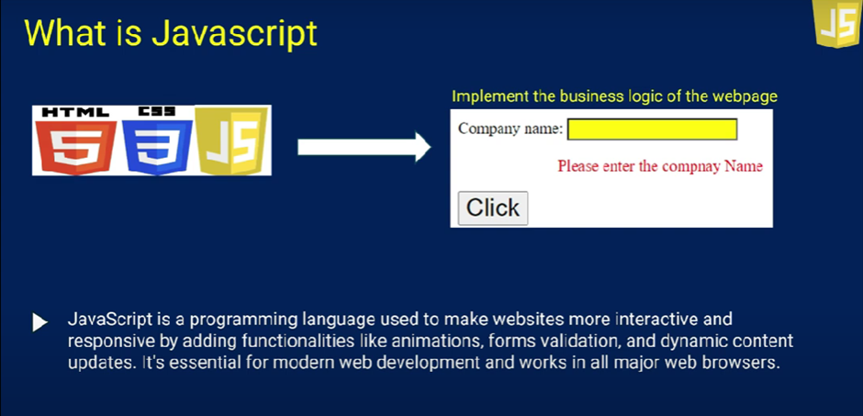
JavaScript is a versatile, dynamically typed programming language used for interactive web applications, supporting both client-side and server-side development, and integrating seamlessly with HTML, CSS, and a rich standard library.

Using html, we create elements.
Using CSS, we give styles to the elements.
Using JS, we give functionality(action) to that elements.
Uses:
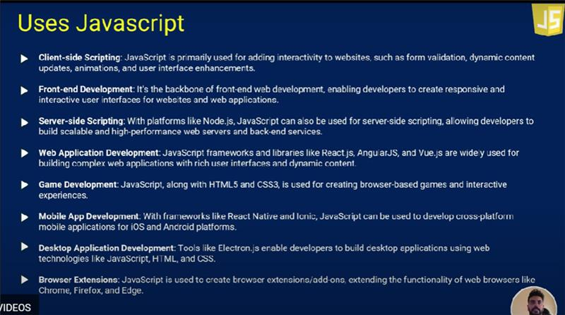
Console:
One action, or method, that is built into the console object is the .log() method. When we write console.log() what we put inside the parentheses will get printed, or logged, to the console.
It’s going to be very useful for us to print values to the console, so we can see the work that we’re doing.
Eg: console.log(10)
We see output in the console
document.write
We see output in the webpage.
windows.alert
We see output as a window alert.
Advantages:
- We can see the run time exception
- We can also see the compile time exception.

Var vs Let vs Const:
The above are the keywords we use in JavaScript regularly.
Variable is like a container that holds data that can be reused or updated later in the program. In JavaScript, variables are declared using the keywords var, let, or const.
- Var – we can redeclare and reassigned
- Let – we can reassigned but can’t redeclared let keyword
- Const – we cannot reassigned and redeclared
Eg: var a=10
var a=20
Eg: Let age=10
age=70
let age1 = 50
Eg: const a=90
Datatypes:
A datatype is a classification of data that determines the type of value that can be performed. There are two types of Datatypes.
1.Primitive Datatype: Holds a single value. Immutable i.e. it cannot be changed or created.
Eg: number, string, Boolean, undefined, null.
2.Non-primitive Datatype: Holds multiple (or) more complex values. Mutable i.e. allowing changes after creation.
Eg: objects, arrays, Functions.
Examples of Primitive Datatypes:
Number:
Let a=10
a=10.79
Console.log(a)
String:
Let name=”Sravani” or Let name=’Sravani’ or Let name=`Sravani`
Boolean:
Let Isadmin=true
Undefined:
Let place
Null:
Let city=null
Symbol:
Let sym1=Symabol(“JavaScript”)

