A Project Work – Phase II
on
VISIONCARE: Vision-Based Real-Time Patient Monitoring System

Submitted in partial fulfillment of the requirements for the award of the

Bachelor of Technology
in
Department of Computer Science and Engineering (AI&ML)
by

Rapolu Sravani  Kuthadi Sravani  Shaik Kareena | 22241A66B6  22241A6692  22241A66C0

Under the Esteemed guidance of

Mr. Ramesh Banoth

Assistant Professor
Department of Computer Science and Engineering(AI&ML)

GOKARAJU RANGARAJU INSTITUTE OF ENGINEERING AND TECHNOLOGY
(Approved by AICTE, Autonomous under JNTUH, Hyderabad)
Bachupally, Kukatpally, Hyderabad-500090
2025-2026



GOKARAJU RANGARAJU INSTITUTE OF ENGINEERING AND TECHNOLOGY
(Autonomous)

Hyderabad-500090

CERTIFICATE

This is to certify that the Project Work – Phase II entitled “VISIONCARE: Vision-Based Real-Time Patient Monitoring System” is submitted by Rapolu Sravani (22241A66B6), Kuthadi Sravani (22241A6692) and Shaik Kareena (22241A66C0) in partial fulfillment of the award of degree in BACHELOR OF TECHNOLOGY in Computer Science Engineering (AI&ML) during Academic year 2025-2026.

Internal Guide | Head of the Department
Mr. Ramesh Banoth | Dr. G. Karuna
External Examiner

ACKNOWLEDGEMENT

There are many people who helped us directly and indirectly to complete our project successfully. We would like to take this opportunity to thank one and all. First we would like to express our deep gratitude towards our internal guide Mr. Ramesh Banoth, Assistant Professor, Department of Artificial Intelligence and Machine Learning Engineering, for his support in the completion of our dissertation. . We wish to express our sincere thanks to Ms. Deepthi Venishetti, Assistant Professor and Ms. P. Nethrasri, Assistant Professor Project Coordinator for timely suggestion, Dr. G. Karuna, Head of the Department, and to our principal Dr. J. PRAVEEN, for providing the facilities to complete the dissertation. We would like to thank all our faculty and friends for their help and constructive criticism during the project period. Finally, we are very much indebted to our parents for their moral support and encouragement to achieve goals.

Rapolu Sravani (22241A66B6)
Kuthadi Sravani (22241A6692)
Shaik Kareena (22241A66C0)

DECLARATION

We hereby declare that major project phase-2 titled “VISIONCARE: Vision-Based Real-Time Patient Monitoring System” is the work done during the period from 12th December 2025 to 28th April 2026 and is submitted in the partial fulfillment of the requirements for the award of degree of Bachelor of Technology in Computer Science and Engineering (AI&ML) from Gokaraju Rangaraju Institute of Engineering and Technology (Autonomous under Jawaharlal Nehru Technology University, Hyderabad). The results embodied in this project have not been submitted to any other University or Institution for the award of any degree or diploma.

Rapolu Sravani (22241A66B6)
Kuthadi Sravani (22241A6692)
Shaik Kareena (22241A66C0)

ABSTRACT

AI-based system for monitoring patients (VisionCare) in healthcare setting, through real time analysis of patient activity utilizing computer vision techniques, to improve safety in healthcare settings. The patient monitoring system utilizes computer vision techniques such as person detection (YOLO) and posture estimation (MediaPipe) to classify patient positions (e.g., standing, sitting, and lying). The system continuously monitors patient activity by analyzing camera video inputs, detecting critical events when analyzing the aspect ratios between frames and analyzing the motion patterns between frames for fast and abnormal (e.g., falls) movement. After detection of critical events, the system will generate an alert (e.g., Severity Level: High, Medium, Low) and record the critical incident within a SQLite database for future analytics. Additionally, the use of a Flask-based web dashboard provides live video streaming of patients, current activity of patients and visual representation of the patient status. The automation of patient monitoring, through implementation of the VisionCare system, eliminates the need for constant manual supervision of patients, provides faster emergency response, and increases productivity in the healthcare industry. VisionCare system is scalable and cost-effective; and future enhancements (i.e., multi-camera configuration, predictive analytics, deployment within cloud based [healthcare] systems) may be developed.

LIST OF FIGURES

Figure No. | Figure Name | Page No.
1 | Architecture Diagram | 14
2 | Use Case Diagram | 17
3 | Sequence Diagram | 18
4 | Class Diagram | 19
5 | Activity Diagram | 21
6 | Object Diagram | 22
7 | Component Diagram | 23
8 | Deployment Diagram | 24
9 | Communication Diagram | 25
10 | State machine Diagram | 27
11 | Module connectivity Diagram | 28
12 | VisionCare Monitoring Dashboard(Home Page) | 55
13 | Live Monitoring Stream | 56
14 | Upload Video | 57
15 | Fall Detection | 58
16 | Rapid Bed Movements | 59
17 | No Fall Detection | 60
18 | Search logs | 61

LIST OF TABLES

Table No. | Table Name | Page No.
1 | Literature Survey | 9-11
2 | Test levels | 47
3 | Test Cases | 48-49
4 | Quantitative Analysis | 63
5 | Comparitive Analysis | 66-67

TABLE OF CONTENTS

Chapter No. | Chapter Name | Page No.
 | Certificate | i
 | Acknowledgement | ii
 | Declaration | iii
 | Abstract | iv
 | LIST OF FIGURES | v
 | LIST OF TABLES | vi
1 | Introduction | 1-3
Background and Motivation
Problem Statement
Objectives of the Project
Scope of the Work
Organization of the Report

2 | Literature Survey | 4-11
Overview of Existing Systems
Research Gap / Limitations in Existing Work
Summary

3 | System Analysis and Design | 12-34
System Requirements
Hardware Requirements
Software Requirements
System Architecture
Data Flow Diagrams (DFD) / UML Diagrams
Module Description

4 | Methodology / Implementation | 35-44
Proposed Algorithm / Model Used
Proposed Framework / Tools Used
Implementation Details (Modules / Components)
Dataset Description

5 | Test Cases and Evaluation | 45-49
Test Levels
Test Cases

6 | Results and Discussion | 50-67
Experimental Setup
Output Screenshots / Graphs
Performance Analysis
Comparative Analysis

7 | Conclusion and Future Work | 68-69
Conclusion
Future Work

8 | References  Appendices | 70-71  72-76

CHAPTER 1

INTRODUCTION

  - Background and Motivation
A major component of an intensive care unit (ICU) or long-term elderly care facilities is the ability to continuously monitor patients so that they can receive timely intervention in case of emergencies. Medical staff is currently responsible for providing this constant supervision, but due to the high patient-to-staff ratio and the large amount of physical labor involved in providing this type of supervision, it is becoming increasingly difficult to monitor all patients at all times. Because of these limitations, patient-related accidents (falls, sudden movement, changes in health condition) can occur without being noticed. With new developments in artificial intelligence, camera technology, and computer vision, automated and enhanced patient monitoring systems can now be developed to help address these challenges. VisionCare is being developed based on the motivation to provide an intelligent real-time patient monitoring solution that is capable of providing critical event detection, reducing human workload, and improving patient safety by utilizing technologies such as object detection and pose detection to provide accurate, effective and continuous monitoring for patients, thereby assisting in improving overall health outcomes.

  - Problem Statement
In hospitals and nursing homes, it’s important to constantly watch over the patients as they are at their most vulnerable state of health and could potentially experience serious injuries if you do not have someone there to support them. Unfortunately, traditional patient monitoring relies on far too much hands-on assistance from the healthcare worker, and with increasing numbers of patients that need assistance due to an aging population and a high demand for service from the many disabled and/or ill individuals that currently exist in our communities; this means most were unable to receive the same level of monitoring they had when they first came into the hospital and/or nursing home. As a result, if a patient falls, has any type of sudden, non-normal motion, or changes their position while in bed, these types of events will go undetected for quite some time, if at all. This poses a serious risk to the health of the patient, as well as delaying the response from the medical staff in treating the patient’s medical and physical needs and/or injuries. Existing monitoring systems cost too much money to install, do not provide complete automation, and/or lack the ability to immediately alert the medical staff. Thus, spurring the need for an effective solution that provides a cost-effective automated monitoring system that can continually monitor for critical patient movements, detect those movements in real time, and alert the appropriate medical staff immediately for an appropriate response.

1.3 Objectives of the Project
- Create a computer vision system to provide real-time monitoring of patients by utilizing AI.
- Use computer vision to recognize and categorize the position of patients (e.g., standing, sitting, lying).
- Able to detect critical events (e.g., falls and fast abnormal movements) and notify healthcare professionals in real time.
- Create a webpage-based dashboard for live patient monitoring and critical incident visualization.
- Record and store critical incident data to improve safety and reduce the workload for healthcare providers.

  - Scope of the Work
Using AI and computer vision techniques will help clinicians continuously monitor patients for any potential risk. By utilizing the camera input, the system can detect both postural positions as well as critical events, such as falling or exhibiting an unusual movement. The clinician will be notified of these events through the alert mechanism that has been built into the system, providing additional effective monitoring via web dashboard. The current project is limited to single camera setup and basic event detection capability.
  - Patients will be monitored in real-time using camera input.
  - Patient posture will be classified and detected.
  - Patient falls and rapid abnormal movements will be identified.
  - Alerts will be sent in the case of an emergency.
  - A web dashboard will be used for live monitoring and visualisation of event.

  - Organization of the Report
The project report is structured into multiple sections addressing a variety of elements relating to the VisionCare system; this will include an overview of the system through its conception, implementation and evaluation with a sequential order to ensure co-ordination between different sections - starting with motivation and objectives, developing the system through a detailed design stage, implementation and ultimately assessment.
The project report is divided into eight chapters, with Chapter 1 - Introduction providing a comprehensive introduction to the project, covering the project background, motivation, problem statement, project objectives, scope of work and the structure of the project report. Also included in the introduction is the significance of AI-based patient monitoring systems within health-care environments. Chapter 2 - Literature Survey provides a review of current research and existing technologies associated with patient monitoring, computer vision, fall detection, and posture recognition, as well as the limitations in these areas that necessitate the implementation of the proposed system. Chapter 3 - System Analysis and Design provides a description of the analysis of the problem and system requirements (both hardware and software), a feasibility study and system architecture, as well as any design considerations and workflow. Chapter 4 - Methodology and Implementation provides a complete account of the development of VisionCare as well as a description of the algorithms and models used to construct the system and algorithms associated with each of the modules, including the use of YOLO for detection of persons and MediaPipe for posture estimation, and the methods of module integration and design. Chapter 5 - Test Cases and Evaluation describes the testing methodologies employed to verify the system, including unit testing, integration testing, system testing, and performance evaluation, in order to verify reliability and efficiency of the VisionCare system. Chapter 6 - the results from the experiments conducted and the observations made during the experimentation phase are presented. Performance metrics such as detection accuracy, response time, and system efficiency are used to evaluate the results. The analysis of the outputs from the experiments is also included. Chapter 7 - provides a summary of the project results and identifies future work, including potential enhancements such as multiple-camera support, predictive analytics, and cloud deployment. The final chapter, Chapter 8, contains references used and additional materials that were provided to support the project (e.g., code snippets used, configuration details, datasets, and supplementary results).
CHAPTER 2

LITERATURE SURVEY

2.1 Overview of Existing Systems
Wang, H. et al. (2025) [1] proposed a lightweight fall detection system using a YOLO-based architecture with enhanced feature extraction. The system improves real-time detection accuracy in healthcare environments and performs efficiently on edge devices. However, performance decreases under occlusion and poor lighting conditions.

Kothari, V.P. et al. (2025) [2] developed a unified fall detection system that integrates YOLO with MediaPipe to create a fall detection system that generates an alert when a fall is detected. The integrated system utilizes posture detection and enables the real-time triggering of alerts based on changes in the detected person's posture at a rate that meets the requirements of accuracy. There will be a slight delay in computation when processing an instance of multiple persons.

Xun,J. et al. (2025) [3] developed an optimized fall detection model using an improved version of YOLO called YOLOv8n that is specifically built for real time applications. As a result of the improved version, the overall speed of detection and the accuracy of detection will be better than earlier models. However, accuracy may be decreased if some of the person's body parts are blocked by another object.

Riahi,T. et al. (2025) [4] developed ElderFallGuard, a real-time fall detection system that is built using IoT and vision-based technologies to detect falls. This system gives continuous monitoring of the person that has fallen and will provide reliable alerts. Performance stability of the system will be impacted by the reliability of the network connection.

Wang,Y. et al. (2024) [5] developed an IoT-based fall detection system that is made up of a combination of YOLOv5 and OpenPose for estimating posture in real-time. The IoT-based fall detection system allows for remote monitoring and provides reliable accuracy in detecting falls; however, the addition of IoT will increase the complexity of the system, as well as the overall cost of the system.

Gabriel, P. et al. (2024)[6] have put forward the design of an Artificial Intelligence technique based on surveillance video for monitoring patients in hospitals. This technique is designed to identify anomalies in a patient's behaviour through the analysis of the collected video footage, thereby providing healthcare staff with real-time data regarding the condition of patients. Nevertheless, privacy concerns and data security continue to raise significant issues.

Terven, J et al. (2023) [7] reviewed the different versions of YOLO (You Only Look Once) from the original YOLOv1 to YOLOv8. They found that there was a substantial improvement in YOLO performance in terms of both speed and accuracy with each subsequent version of YOLO; however, it was proposed that as YOLO versions become lighter, they lose some of the accuracy that is required when detection is performed in complex under-structured scenes.

Alam, E. et al. (2022) [8] have carried out an investigation of a number of vision-based fall detection systems and techniques for use with deep learning; their findings reveal that the two main techniques for detection are CNNs (Convolution Neural Networks) and Pose-based detection. In all of the studies reviewed, implementation on a real-time basis and limitations of the constructed datasets posed significant challenges.

Zhang, Z. et al. (2020) [9] proposed a vision-based patient monitoring system using deep learning to detect patient activity. Their system was able to identify abnormal activities based on the patient's behaviour with reasonable accuracy, but the behaviour of the system was extremely sensitive to variations that occurred within the patient's environment.

Feichtenhofer, C et al. (2019) [10] proposed SlowFast Networks with the intention of establishing a technique to detect motion in a video by capturing features for both slow and fast-moving objects. These networks were evaluated against a set of benchmarks and demonstrated accurate motion detection of complicated physical dynamic activities through the use of SlowFast Networks, although they tend to be much more resource-intensive in comparison to existing methods.
Cao, Z. et al. (2017) [11] proposed OpenPose, a method to detect human body joints in real-time by using keypoint detection for multiple persons. Although OpenPose performs well at detecting human body joints, as more human bodies are incorporated into it, the computational cost of detection becomes greater.

Litjens, G. et al. (2017) [12] Proposed a survey on deep learning applied to medical image analysis has been published indicating the high effectiveness of CNNs for healthcare applications, but requiring large annotated datasets.

Carreira, J., et al. (2017) [13] developed an action-recognition system called I3D that is based on spatio-temporal features. It has the capability to achieve high accuracy during video understanding tasks but it requires a large amount of computational resources.

Redmon, J. and others (2016) [14] developed a real-time unified object detection system named YOLO. It can process images at a very high speed through a single pass but has difficulty detecting small objects.

He, K., et al (2016), [15] they created a deep residual learning framework called ResNet for image recognition. This framework allows for the training of deep networks while also improving their accuracy. However, deeper networks increase the cost to compute.

Donahue, J., et al. (2015),[16] introduced an approach called LRCN that combines CNNs and LSTM's to model video sequences. The LRCN approach is able to effectively model temporal dependencies, but applies some amount of latency in real-time systems.

Tran, D., et al. (2015),[17]proposed C3D, a model that learns about spatio-temporal features from videos, which performed well at recognizing activities. However, it requires a large training dataset to train this model.

Simonyan, K. and others (2014), [18] developed a model called the two-stream CNN to recognize actions using both spatial and temporal information. The two-stream CNN significantly improves action recognition performance, but has a high level of complexity when training this model.

Mubashir et al. (2013)[19], proposed a survey on fall detection systems covering wearable and vision-based approaches. The study compares various techniques and identifies best practices. However, real-world deployment remains challenging.

Aggarwal et al. (2011)[20] provide an overview of human activity recognition (HAR) techniques using video data. This overview includes a variety of methods for analyzing the behavior of individuals; however, accurately identifying complex human activities continues to be difficult.

2.2 Research Gap / Limitations in Existing Work
While progress has been made with AI-enabled fall detection and patient monitoring, current approaches still have significant gaps. Most of these rely on computer vision models, such as YOLO and pose estimation techniques, to detect physical activity. Although they work well in controlled environments, these systems often do not work as well in real-world environments, such as the ICU, due to poor lighting, occluded views of patients, and cameras positioned at various angles. Most of the existing systems are focused primarily on fall detection, with little thought given to other indicators of patient health (e.g., abnormal movement patterns and/or prolonged periods of inactivity).
Another limitation of many of the existing systems is that they do not perform temporal analyses of individual patients over time so as to provide continuity of care for multiple patients. In addition, many of the existing models use frame-based processing techniques, making it difficult to track individual patients over time, resulting in inconsistent detections across multiple patients. This also creates difficulties with implementing real-time monitoring of multiple patients simultaneously because using multiple deep learning models creates increased computational complexity and delay. Additionally, the majority of the existing systems do not have proper integration with hospital infrastructure and do not provide for issues such as data privacy, scalability, and intelligent alert management. These limitations ultimately restrict the usefulness of AI-based monitoring solutions in actual hospital settings.
- Dependence on analyzing frames in isolation.
Current systems analyze each frame separately without consideration of motion context, resulting in incorrectly detecting normal activities (e.g., walking) as falling.
- Lack of accuracy for real-world conditions.
The system's ability to detect fall events is affected by real-world conditions such as lighting, occlusion, and camera angle variations in a hospital environment.
- No tracking of multiple persons.
Most existing systems are not able to continuously recognize multiple people, which creates confusion when multiple patients are present.
- Lack of time (motion) analysis.
Without the ability to analyze the motion, systems cannot easily differentiate between a person moving normally and the occurrence of a critical event.
- Concentration of fall detection monitoring.
Most systems do not take into account monitoring of other important conditions, such as the absence of any motion by an individual or abnormal behavior exhibited by an individual.
- High computing cost.
Deep learning models are resource-intensive, and therefore may not be able to function in real-time.
- Lack of prioritization of alerts.
Alerts are sent out regardless of their importance, and most systems generate either too many or too few notifications.
- Limited integration with the real world.
Most existing systems do not integrate with a hospital's existing infrastructure, which reduces their ability to be used in practice.
- Issues with patient privacy and security.
The management of patient video data can create significant concerns regarding the security of that data and its confidentiality.
- Limited scalability.
Most systems only provide single-camera implementations and cannot scale to larger environments.

2.3 Summary

Table 1: Literature Survey

Source | Research Objective or Research Question | Methodology | Key Findings | Relevance to project | Techniques | Accuracy & performnace Measures | Advantages | Disadvantages
[1] Wang, H. et al. 2025 | Improve fall detection accuracy | Lightweight YOLO-based model with feature enhancement | High accuracy in real-time fall detection | Core fall detection module | YOLO, feature extraction | High accuracy, low latency | Fast, efficient | Sensitive to lighting/occlusior
[2] Kothari, V. et al.  2025 | Detect falls with alerts | YOLO + MediaPipe posture analysis | Accurate posture classification and alerts | Matches VisionCare pipeline | YOLO, Pose estimation | High accuracy (~90%) | Multi-feature  system | Delay with multi-person
[3] Xun, J. et al.  2025 | Optimize detection speed | YOLOv8n optimized model | Faster inference with good accuracy | Real-time use | YOLOv8 | High FPS, good accuracy | Lightweight model | Reduced accuracy in occlusion
[4] Riahi, T. et al. 2025 | Remote patient monitoring | IoT + vision-based system | Continuous monitoring with alerts | Useful for remote ICU monitoring | IoT + CV | Stable performance | Remote alerts | Network dependency
[5] Wang, Y.  2024 | Detect falls remotely | YOLOv5 + OpenPose | Accurate posture based detection | Posture classification module | YOLOv5, OpenPose | High  accuracy | Remote system | Complex  architecture
[6] Gabriel, P. et al.  2024 | Continuous monitoring | AI-based video analysis | Detects anomalies in hospital environment | Dashboard relevance | Deep learning | Good real-time performance | Real-time insights | Privacy issues
[7] Terven, J. et al. 2023 | Analyze YOLO models | Comparative analysis | YOLOv8 improves speed and accuracy | Model selection support | YOLO  variants | High performance | Fast detection | Accuracy trade-off
[8] Alam, E. et al.  2022 | Study fall detection methods | Deep learning survey | CNN & pose-based methods effective | Theory support | Deep Learning | Varies by model | Broad insights | Dataset limits
[9] Zhang, Z. et al.  2020 | Monitor patient activity | Vision- -based deep learning | Detect abnormal activity | Support System goal | CNN | Good accuracy | Activity detection | Env issues
[10] Feichtenhofer, C.  2019 | Action recognition | SlowFast  networks | Captures temporal motion features | Motion detection improvement | Deep Learning | High accuracy | Motion capture | High compute
[11]Cao, Z. et al.  2017 | Pose estimation | OpenPose keypoint detection | Accurate body joint detection | Posture analysis  module | Pose estimation | High accuracy | Multi-person support | Computationally Heavy
[12] Litjens, G. et al.  2017 | Medical AI survey | Literature review | Deep learning effective in healthcare | System design | Deep Learning | High | Strong foundation | Requires large datasets
[13] Carreira, J.  2017 | Action recognition | I3D (3D CNN) | High video classification accuracy | Motion analysis | CNN 3D | High accuracy | Temporal  learning | High Costly
[14] Redmon, J. et al.  2016 | Real-time Object detection | YOLO model | Fast detection in single pass | Core detection module | CNN | High speed | Real-time processing | Weak for small objects
[15] He, K. et al.  2016 | Improve CNN | ResNet architecture | Enables deep networks | Model backbone | CNN | Very high accuracy | Deep learning capability | High compute
[16]Donahue,J. 2015 | Sequence learning | CNN+LSTM | CapturesTemporal dependencies | Motion tracking | CNN+LSTM | Good | Time modeling | Slow processing
[17]Tran, D. et al.  2015 | Video  Feature analysis | C3D Model | Learns spatiotemporal features | Activity detection | 3D CNN | High accuracy | Strong features | Data heavy
[18] Simonyan, K.  2014 | Action recognition | Two-stream CNN | Combines spatial + motion info | Motion analysis | CNN | High | Dual input streams | Complex model
[19] Mubashir, M.  2013 | Fall detection survey | Comparative study | Multiple approaches reviewed | Background  study | Various | Varies | Comprehensive | Not practical
[20] Aggarwal, J.  2011 | Activity analysis | Review paper | Explains behavior analysis methods | Base concept | ML methods | Varies | Strong theory | Limited real-world use

CHAPTER 3

SYSTEM ANALYSIS AND DESIGN
  - System Requirements
    - Hardware Requirements
- Webcam/IP Camera - Real-time video is captured with a webcam/IP Camera and used to monitor and analyze patients. The webcam/IP Camera is the primary input device for detecting the posture and movement of a patient and for detecting critical activities.
- Laptop/Desktop (4GB RAM or greater) - A laptop/desktop is used as a primary system to run the application, process video frames, and run Artificial Intelligence Models (AI Models) for detection and analysis (example: YOLO and MediaPipe).
- GPU (optional) - A GPU is used for additional processing power to run detection tasks on video in real-time. The approval or disapproval of a GPU in a medical device is determined by regulatory authority. Use of a GPU will offer a higher level of performance improvements, particularly when an application requires continuous monitoring of a patient.
- Display Monitor - A display monitor is used to display live video feeds, detection results, alerts, and a dashboard interface to monitor the status of a patient.
- Power Supply - A power supply provides a means to supply the power needed to provide ongoing operation of the system. In clinical practice, the ability for a system to operate continuously is critical to providing patient monitoring services.

3.1.2 Software Requirements
- Operating System (Windows/Linux) - Windows/Linux serve as the operating system that provides the platform to execute and run the application, as well as provide its supporting libraries and tools needed to develop or execute.
- Python (3.x) - Python is the primary computer programming language that is used to write the system, implement the algorithms and integrate the different modules.

- OpenCV - OpenCV is used for capturing video, processing and manipulating images in real-time so that the system can monitor these at all times.
- YOLO (Ultralytics) - YOLO is a deep learning model used to accurately detect human beings within a video frame.
- MediaPipe - MediaPipe is used to estimate a body's position and classify that position by the use of body landmark coordinates.
- Flask - Flask is a web framework used to create a dashboard that displays a live stream of data, events and allows for the user to interact.
- SQLite3 - SQLite3 is the type of database that stores all of the event logs such as falls and movement occurring along with their timestamps.
- NumPy - NumPy provides support for performing numerical calculations and performing efficient array manipulations that are required for image processing.
- IDE (VS Code / PyCharm) - An IDE such as, VS Code or PyCharm is used to code, debug and manage the development of the project.

3.2 System Architecture
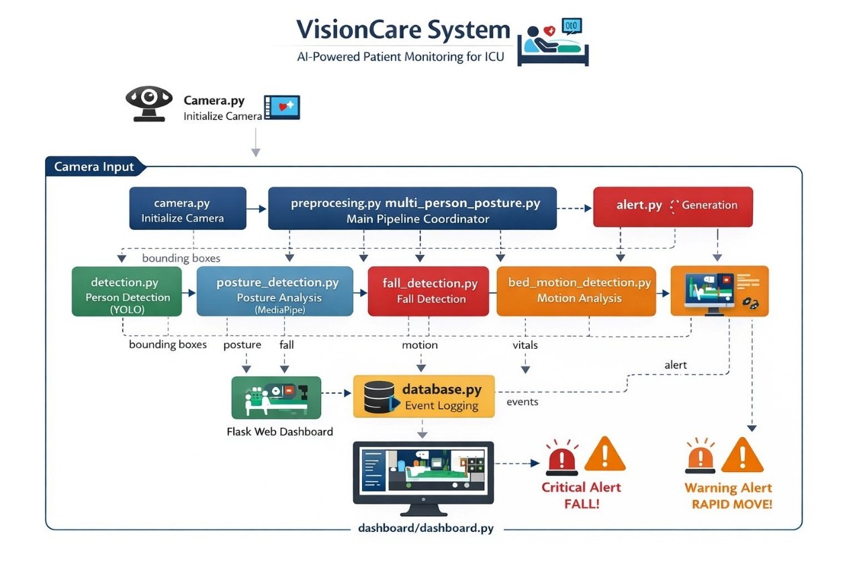
Figure 1: Architecture Diagram
The above Figure 1 illustrates the architecture of VisionCare. The VisionCare system has a modular architecture that is designed to monitor patients effectively and efficiently in real time while in an ICU. The system's video input goes through multiple levels of processing, which includes extracting frames, enhancing images, detecting humans, analyzing posture and generating alerts. Each module serves a purpose in the workflow. The processed data can then be stored in a database and displayed on a web-based dashboard for real time monitoring by medical staff.
Webcam/IP Camera (Live Feed)
This component captures live video of a patient being monitored via a webcam or IP camera installed in an ICU. The video will continuously stream live video to the VisionCare system for uninterrupted monitoring of the patient. As the primary source of input supplied to the VisionCare system, the video allows for real time analysis of the patient's posture and movement based on the activities being performed by the patient.
Video Upload (Batch Processing)
The module for this task permits the uploading of video recordings for offline analysis by the system using Batch-processing techniques. The video files provided are analyzed frame by frame, to determine if there has been any type of event that would define a fall or abnormal movement (which was detected) when they were recorded. This functionality has several applications including reviewing of past events, system testing and validation of detection performance.
Frame Capture
The function of the Frame Capture module is to extract individual frames from a video stream with the OpenCV library. By extracting frames from a continually running video stream (video) to produce a sequence of images that can subsequently be processed by the AI modules. This is considered to be the starting point of the overall processing pipeline.
Preprocessing (Image Enhancement)
The Preprocessing Stage of the processing pipeline is intended to enhance the image quality and improve consistency among frames extracted. Various techniques will be used during the image enhancement process including resizing to (640×480) and using Contrast Limited Adaptive Histogram equalization (CLAHE) to enhance contrast. These functions will help provide better visibility to each frame and ensure the accuracy of algorithms used for detection will be consistent under different lighting scenarios.
Person Detection (YOLO)
The Person Detection module uses the YOLO deep learning model to determine if there are humans present within each video frame. They are identified using bounding boxes drawn around the identified patients. The bounding boxes created during this process are necessary to perform further analysis (posture detection and movement tracking).
Posture Analysis Using MediaPipe
The Posture analysis module uses MediaPipe to find body landmarks including the shoulders, hips, and knees. After obtaining these three landmarks, it uses them to categorize their posture to gain insight into the patients condition and find an outlier.
Alert Generation
This component generates alerts from the analysis results. Whenever a patient experiences rapid movement above a specified limit, or a patient falls, an alert is generated. Alerts are classified either as critical (falling) or warning (rapid movement), allowing for responders to take the most immediate action.
Data storage (SQLite)
The Storage module uses an SQLite database to store event data along with the time the event occurred. The data that has been stored will allow for future analysis of patient activity including all detected alerts such as falling and rapid movements.
Monitoring Patients with the Flask Web Dashboard
The dashboard is used to view real-time updates of each patient. It includes a live feed of the patient's video, the detection results from the posture analysis module, posture classifications, and any alerts generated for that particular patient. Additionally, it allows for online storage of the events logged, making it easier for medical staff to monitor the patient.
Critical Alert
This alert indicates that an individual has fallen and requires an urgent response for medical assistance. This type of alert is presented in red on the dashboard so that staff can act quickly to respond to the call for medical assistance for the individual.
Warning Alert
If there is rapid movement or abnormal movement detected on the device, there is an alert generated for follow-up by nursing staff. This alert serves as a warning to nursing staff, and they should monitor the individual and take action to prevent injury to the individual if necessary.

3.3 UML Diagrams
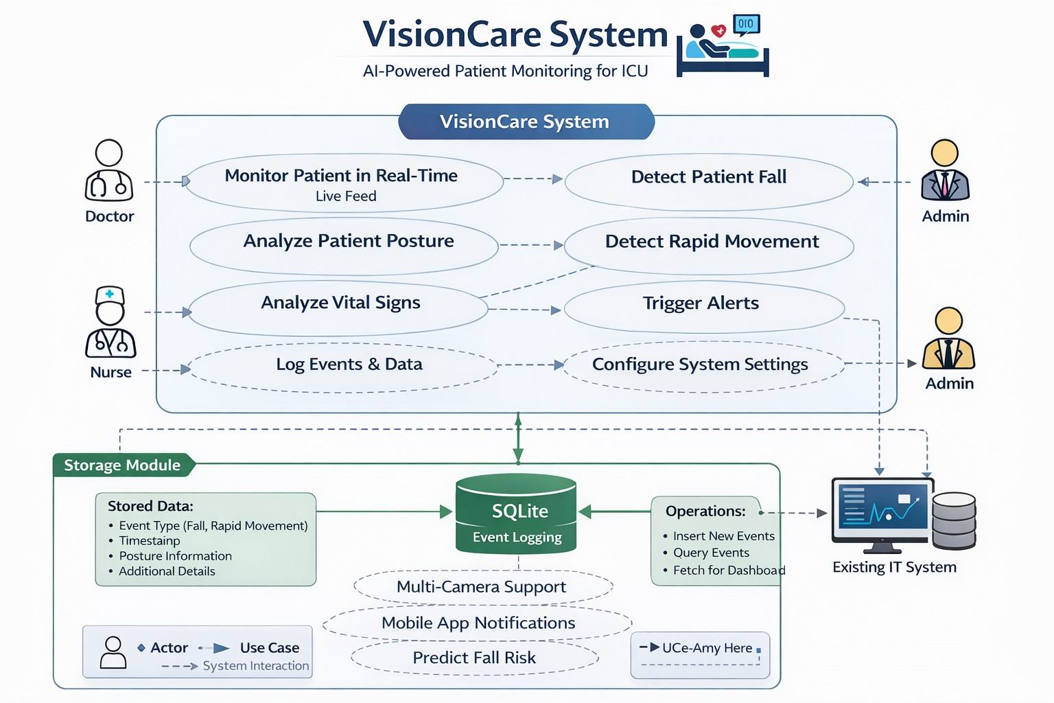
Figure 2: Use Case Diagram
The above figure shows the Use Case Diagram of the VisionCare System, which represents how different users interact with the system and how various functionalities are organized. It illustrates the relationship between the actors (Doctor, Nurse, Admin, and external IT system) and the key operations such as patient monitoring, posture analysis, fall detection, and alert generation.
The two main users of this system, specifically in real time patient care monitoring, are the Doctor and Nurse. They use the live video feeds to view patient actions and capture vital sign measurements to perform timely analyses on patients with easily identified issues by the system, such as when a patient has fallen, with rapid patient movements, enabling timely response by medical staff. These features provide continuous monitoring of patients for maximum safety in critical situations to help eliminate risk in an ICU.
The Admin is responsible for setup and configuration for the system and controlling system functions such as configuring alert limits, setting parameters for operation of the system, as well as providing effective administration of the system. All of the data captured by the system for all events and/or activities are stored in a database (SQLite) for future use and include an indication of event type, timestamps of when event occurred and any additional information needed for future reference.
The system also has the ability to utilize an external IT system (integration with a hospital management system and/or a health record system). The use case diagram also indicates future development such as multi-camera capabilities and predictive analytics indicating the scalability of VisionCare as an intelligent real time patient monitoring system.

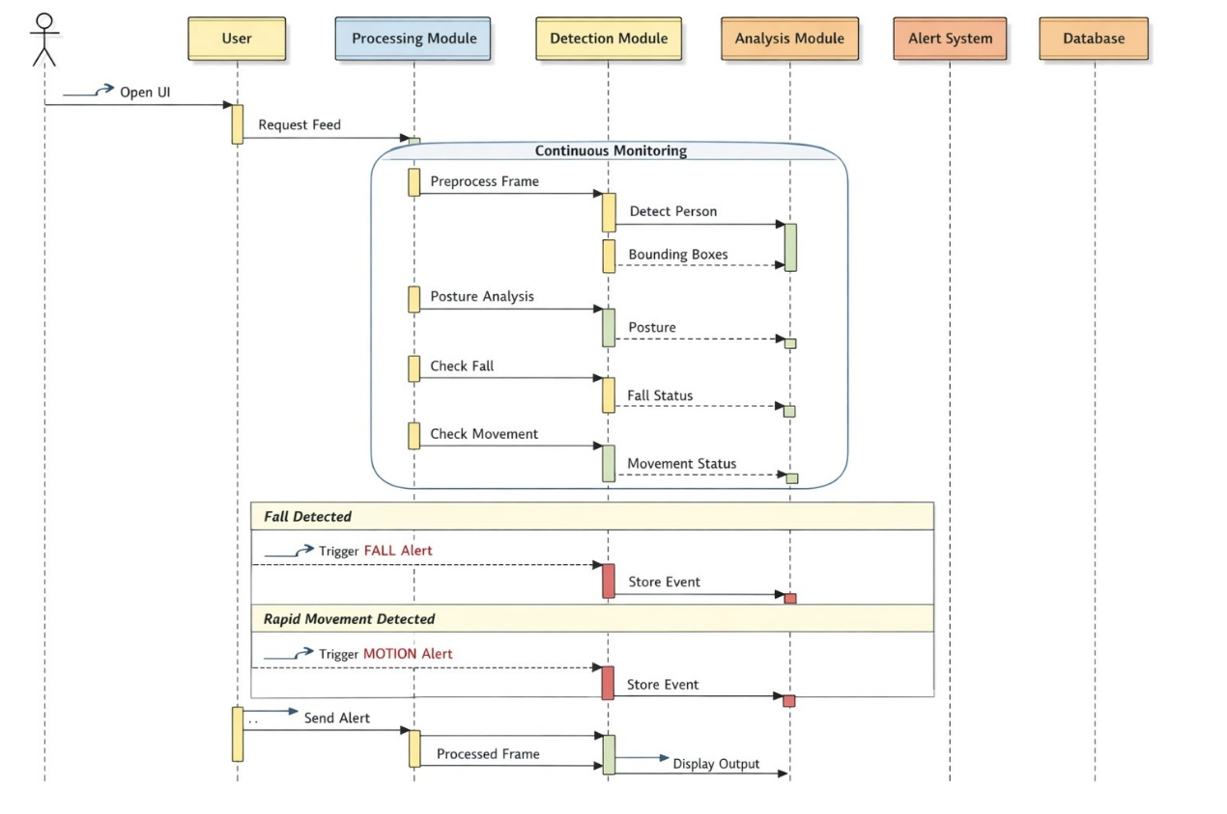
Figure 3: Sequence Diagram
The above Figure 3 shows the Sequence Diagram of Visioncare, the VisionCare system's workflow for real-time patient monitoring is represented by sequence diagram. The process begins when a user (either a doctor or nurse) accesses the dashboard, which requests a live video feed from the camera. The camera continuously captures frames from its image stream, then sends those frames to be processed by a processing module that will pre-process each frame before it continues on to further analysis. Processing of each frame provides for improved quality and consistency, in terms of pre-processed photographs of each patient, and provides better metrics by which to evaluate conditions associated with that frame.
The output of the processing module is then fed to the detection module where YOLO detects the existence of a person and generates bounding boxes around that person, while the MediaPipe component identifies the posture of that same person. The output of the detection module is passed to the analysis module where falls or rapid movements in relation to predefined thresholds and calculations will be evaluated. This is very important for the detection of abnormal patient behavior in real time.
If a critical event such as a fall or sudden movement is detected, the alert system triggers, causes an alert to be logged in a database, and sends an alert to the user's (doctor's or nurse's) dashboard for review in real time. Processed video frames along with alerts and posture information will be continually updated in the user interface, thereby allowing healthcare workers to continually monitor patients and react quickly to emergency situations.

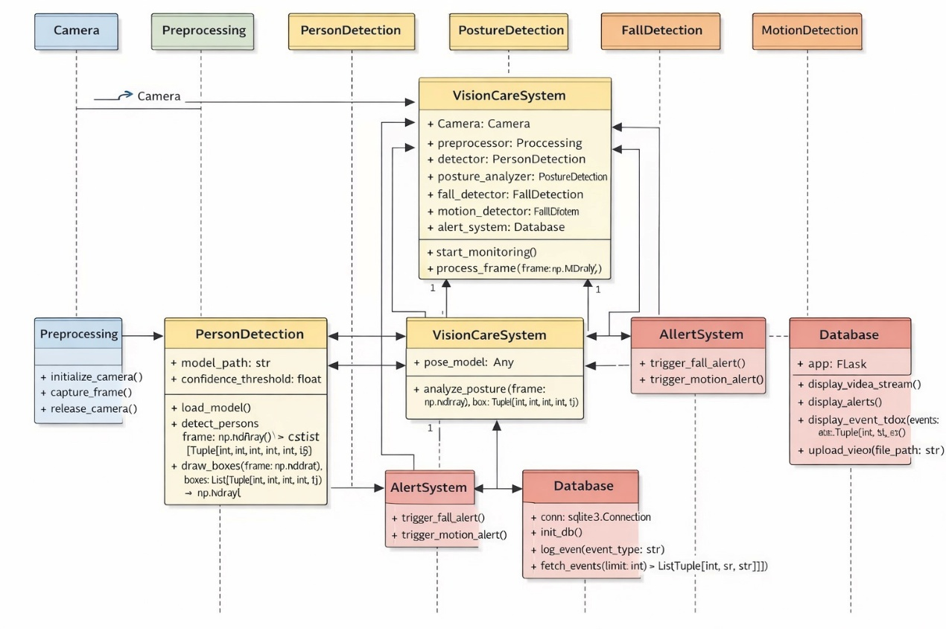 Figure 4: Class Diagram
In the above figure, the class diagram represents the structural design of the VisionCare system by illustrating the key classes and their relationships.
The central class, VisionCareSystem, acts as the main controller that coordinates all operations. It is associated with multiple classes such as Camera, Preprocessing, PersonDetection, PostureDetection, FallDetection, MotionDetection, AlertSystem, and Database. Each of these classes is responsible for a specific functionality, and together they form a modular and well-organized architecture.
The Camera and Preprocessing classes are responsible for capturing the inputs or frames as well as enhancing the frames that go into the system, providing to it the best possible inputs. The PersonDetection and PostureDetection classes accomplish many of the main functions of Computer Vision, including identifying people and analyzing their body positions and movements using detection models. Then the FallDetection and MotionDetection classes take this data and use it to identify important occurrences such as a fall or unusual movement, based on a set of defined logic and thresholds.
The AlertSystem class is responsible for generating alerts when one of these events occurs. The Database class stores these events so they can be referenced and/or analyzed later. The relationships of these classes illustrate how data flows through the system from input through processing and analysis, to finally generating storage and alerts. In summary, the diagram identifies distinct responsibilities of different classes and illustrates a clear separation of concerns that make the system scalable, maintainable, and efficient when providing real-time patient monitoring services.

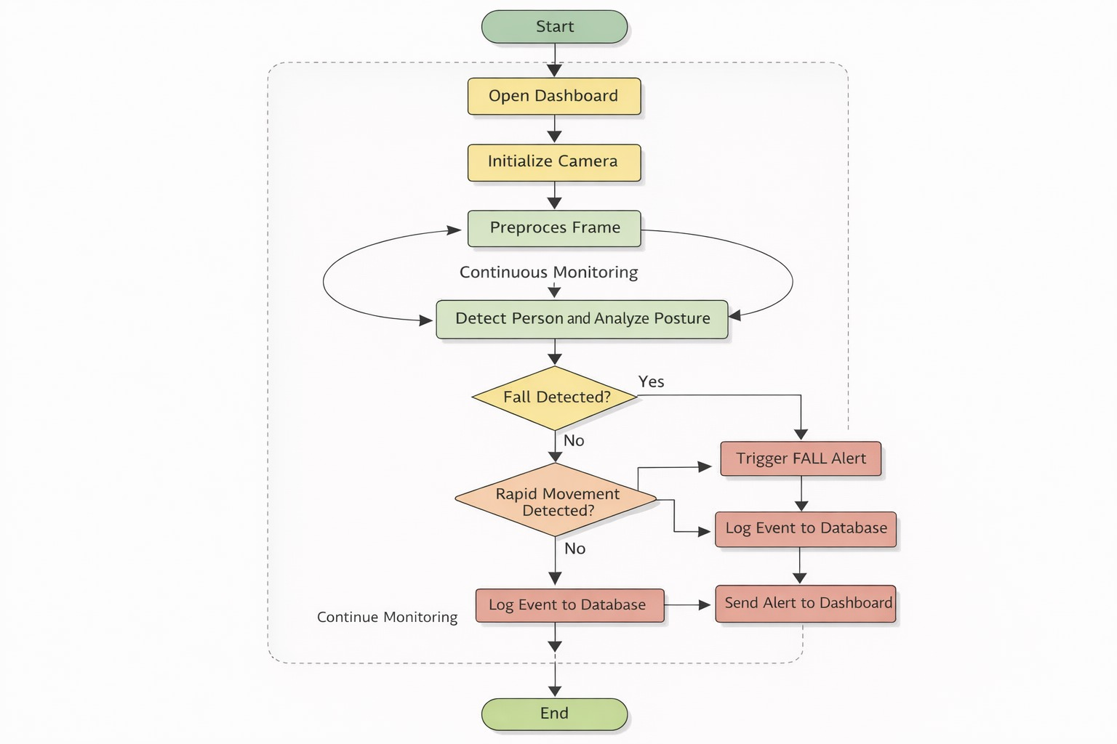
Figure 5: Activity Diagram
In the above figure, the activity diagram represents the workflow of the VisionCare system for real-time patient monitoring. The process begins with the start node, followed by opening the dashboard and initializing the camera. Once the camera is active, video frames are continuously captured and sent for preprocessing, where image quality is enhanced to ensure accurate analysis.
Following the preprocessing stage, a system of continuous surveillance takes place through the detection of the individual along with an analysis of their body position. The monitoring then flows to various decision points (or criteria) whereby all monitoring must be evaluated for the occurrence of a critical condition (fall or rapid movement). Firstly, if a fall was detected, a fall alert will trigger immediately and cause the fall to be recorded in the database and generate an alert to the dashboard for a real-time notification.
If no fall was detected, the system will check for rapid movement. If the system detects rapid motion the system will create a motion alert and log it in the database as well as generating an alert to the dashboard. If neither condition was detected (normal activity) then the system will simply record normal activity and continue in its monitoring. This continues as an ongoing loop until the active activity ceases and provides the opportunity for continued visual patient monitoring as well as a timely identification of an emergency situation.

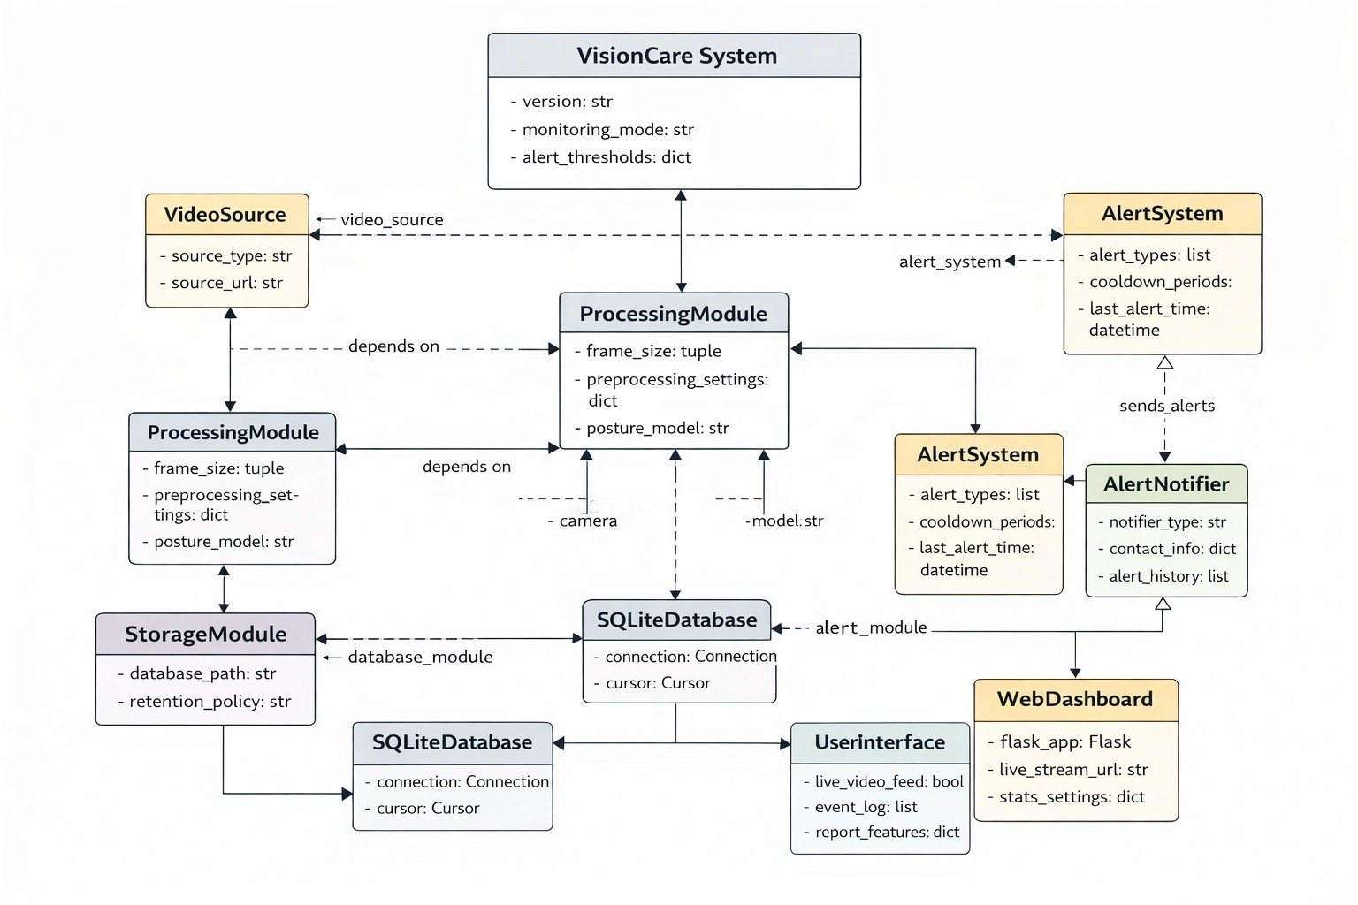
Figure 6: Object Diagram
Figure , shown above, depicts the Object Diagram of the VisionCare. This diagram shows the VisionCare workflow from input source to visual display. The top represents captured video inputs (either through cameras as a live input or uploaded videos as a batch input) going into the Processing Module. The Processing Module goes through a multiple-step process of frame capture, pre-processing (such as resizing or improving image quality), person detection with YOLO, and posture analysis with MediaPipe. Each step of the processing module takes the captured video to develop meaningful information of patient positioning and movement.
Once completed, these alerts are stored in the Storage Module (SQLite database) storing event type, event timestamp, and event details for later evaluation and analysis. This allows the logged events to be reviewed and evaluated later. The logged events can be used to monitor a patient’s current activity and possible future patient activity.
Once completed, the UI Module (Flask Web Dashboard) displays the data collected and processed by the VisionCare system to the end-user. The UI displays live video, current alerts, and logged alerts/reports in an easy-to-use application. The UI utilizes a traffic light warning system that visually identifies critical alerts (such as falls) and warning alerts (such as rapid movement). Therefore, the diagram shows how the VisionCare will provide end-users with a complete virtual patient-monitoring system powered by artificial intelligence through the seamless workflow from data input to intelligent processing, alerting, storage, and visualization.

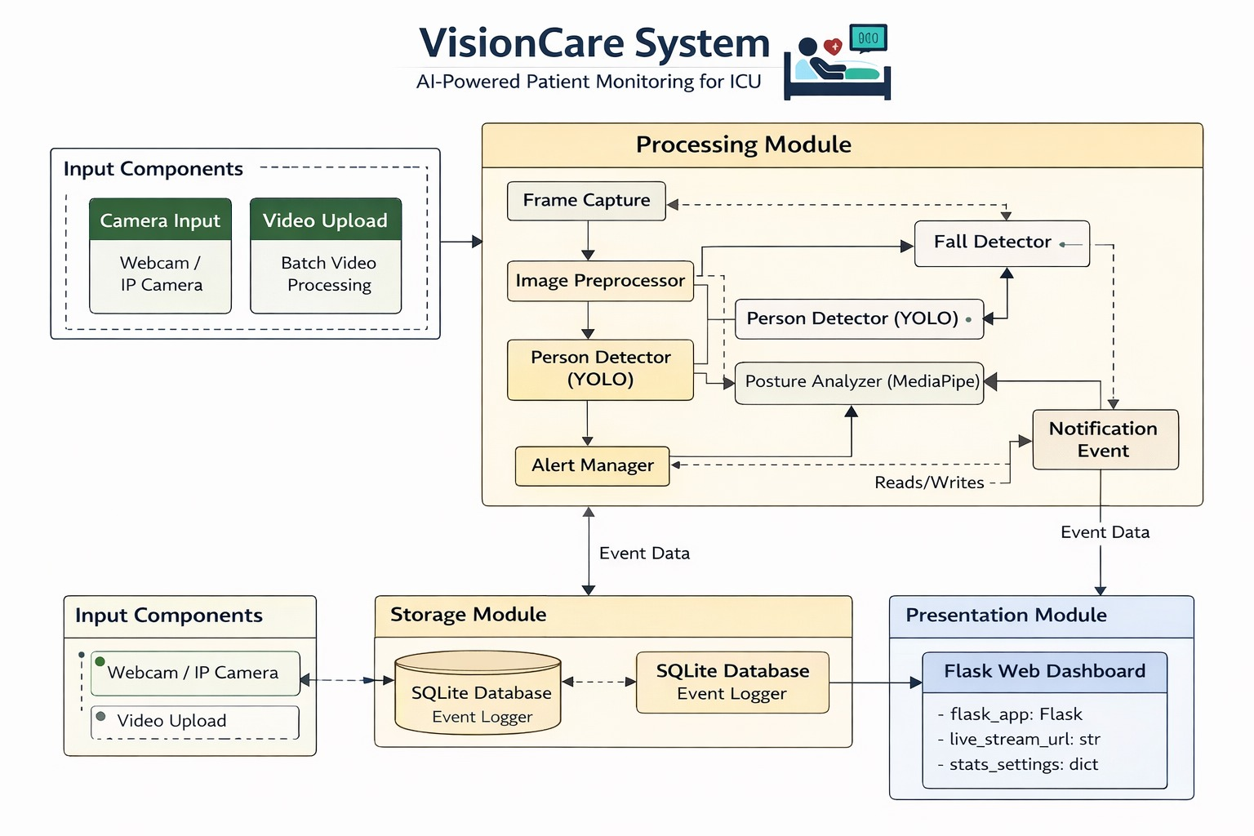
Figure 7: Component Diagram
Figure above presents the Component Diagram of VisionCare, Presentation, Processing, Input and Storage are the four major components included in the VisionCare System as depicted in the following figure. The Input Components (camera feed or video upload) send video data to the Processing Module. The Processing Module will then perform the following functions; (i) Capture and store frame data from the video input, (ii) Preprocess each of the frames, (iii) Perform person detection using the YOLO model, and (iv) Analyze the posture of the detected people using the Mediapipe library.
After processing the video data, the VisionCare system will be able to determine whether or not a fall or an abnormal movement has occurred. As a result of either of those events, the Alert Manager will generate alert notifications.
All the generated alert notifications and the related incident data will be placed in the Storage Module (SQLite Database). Each incident will have a time-stamped record stored within the database which allows for future analysis. The Presentation Module (Flask Web Dashboard) will access incident data from the database in order to provide users with live video, alerts, and aggregate data. Therefore, the VisionCare System provides a complete solution to the full flow of data input to intelligent data processing, data storage and real-time data display for the purpose of effective patient monitoring.

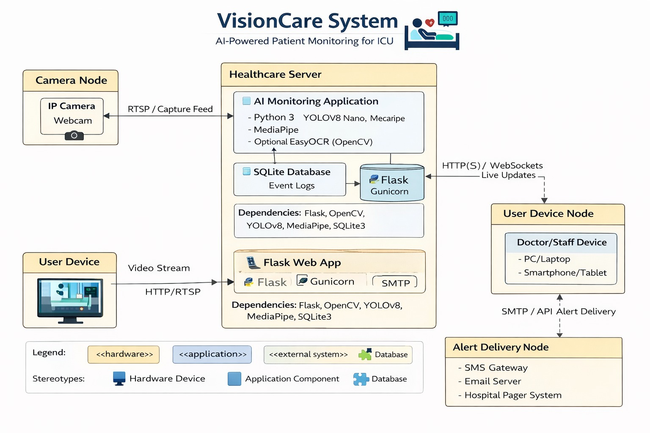
Figure 8: Deployment Diagram
The above Figure 8 represents the Deployment Diagram of the VisionCare system. The VisionCare system architecture is described with the different hardware nodes and environments in which it will be physically deployed. An example of a Camera Node is shown on the left; it could be an IP camera or webcam that streams live video to a central system using protocols like RTSP.
The Healthcare Server contains the core components of the VisionCare system: the AI Monitoring Application, which uses Python, YOLOv8, and MediaPipe; an SQLite Database for event log storage; and a Flask web application served through Gunicorn. As part of the system, this server performs major functions of the VisionCare System - video processing, posture analysis, fall detection, and alert generation. The Healthcare Server also connects with other nodes using HTTP(S) and WebSockets to provide real-time communication with all other nodes in the system.
The User Device Node on the right side of the diagram contains devices used by physicians or healthcare staff to access the system via a web dashboard to view live streaming video and alert notifications. The Alert Delivery Node includes external systems used to dispatch alerts via APIs or SMTP (e.g. SMS Gateway, Email Server, Paging System) to health care professionals (e.g. physicians, nurses). The overall diagram provides a visual representation of the various hardware, software components of the VisionCare system and the relationship between them, enabling healthcare professionals to monitor patients in real time.
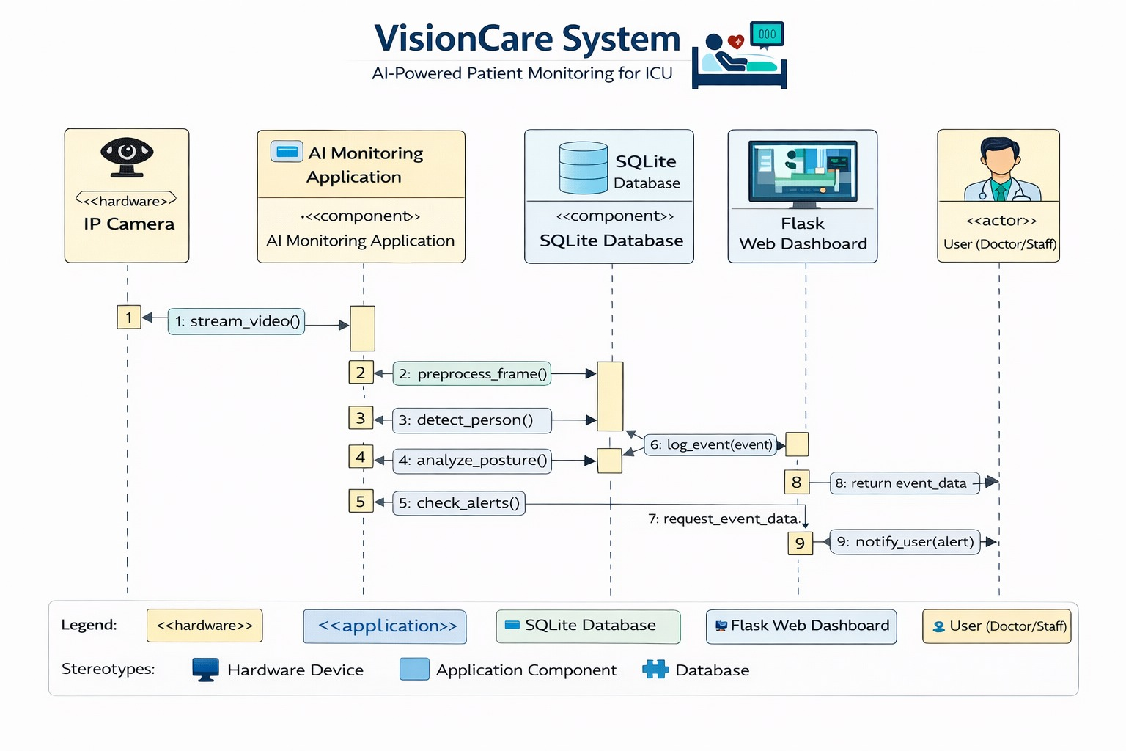
Figure 9: Communication diagram
The Communication Diagram of the VisionCare is shown in the above Figure . The patient monitoring data is processed through a series of interactions using the following steps. First, the IP Camera streams video to the AI Monitoring (stream_video()) Application. Then the application processes the input video through the following operations: preprocessing the frame (preprocess_frame()), detecting the person (detect_person()), and analyzing the posture of the person (analyze_posture()). Together, these operations represent the main computer vision pipeline that converts raw video into useful information.
Once the input video has been processed, the system checks for abnormal conditions using the check_alerts() operation. If a critical event occurs (for example, if the patient falls or performs rapid movements), the application logs the event in the SQLite Database (log_event(event)). This ensures that all triggered events will have a record associated with them. The data regarding this event will then be requested by the Flask Web Dashboard (request_event_data) for display to the user.
The processed data and alerts will then be communicated to the User (Doctor/Staff). The dashboard will return the event data (return_event_data) and send notifications (notify_user(alert)) to allow the healthcare team to monitor the patient in real-time and quickly respond to an emergency. Overall, the diagram indicates a clear sequence of interactions and flow of messages among the hardware, application, database, and users in the VisionCare system.

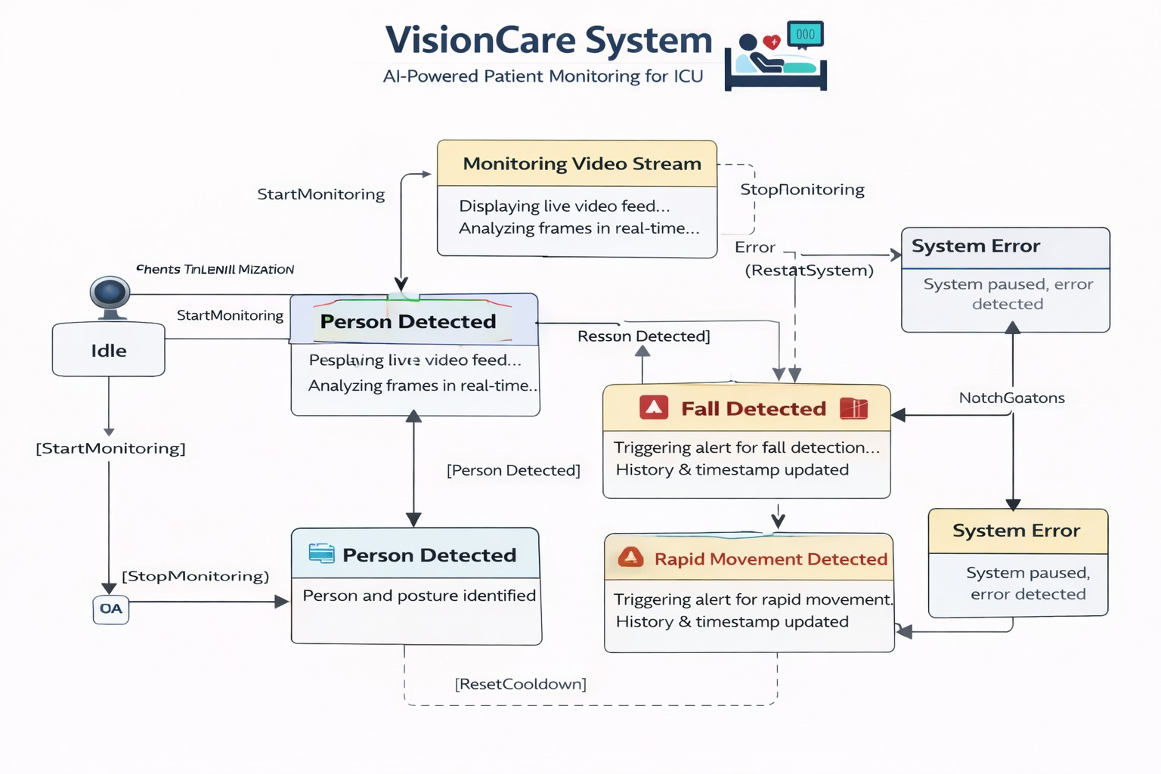
Figure 10: State machine Diagram
Figure 10 above portrays the State Machine Diagram of the VisionCare system. A state machine diagram indicates how a VisionCare System transitions between various functions during normal operation. There are three function states: Idle, Monitoring Video Stream, and Person Detected.
Idle is the initial state of the system and no active monitoring has taken place prior to entering this state. When the Start Monitoring event is triggered, it moves to the Monitoring Video Stream state where the system will display a live video feed and will analyze frames in real-time in order to determine if there are any individuals present in view.
When there is an individual detected, the system will then transition to the Person Detected state which identifies that a patient has been identified and that their posture analysis is currently being performed.
While in the Person Detected state, the system continuously evaluates whether or not any abnormalities have occurred. If there is a determination made of a fall has occurred, the system will transition into a Fall Detected state and will generate a Critical Alert that will be timestamped and logged. Similarly, if a determination has been made that there is rapid or unusual movement, the system will transition into the Rapid Movement Detected state and will generate a Warning Alert and then update the event history. After successfully managing the alerts, the system will transition back to either the Monitoring or Detection state once the conditions for cooldown (reset) have been met.
In summary, this diagram depicts the dynamic nature of the system as it continuously tracks patients to ensure that they are monitored provide a reliable service for its users.

3.4 Module Description

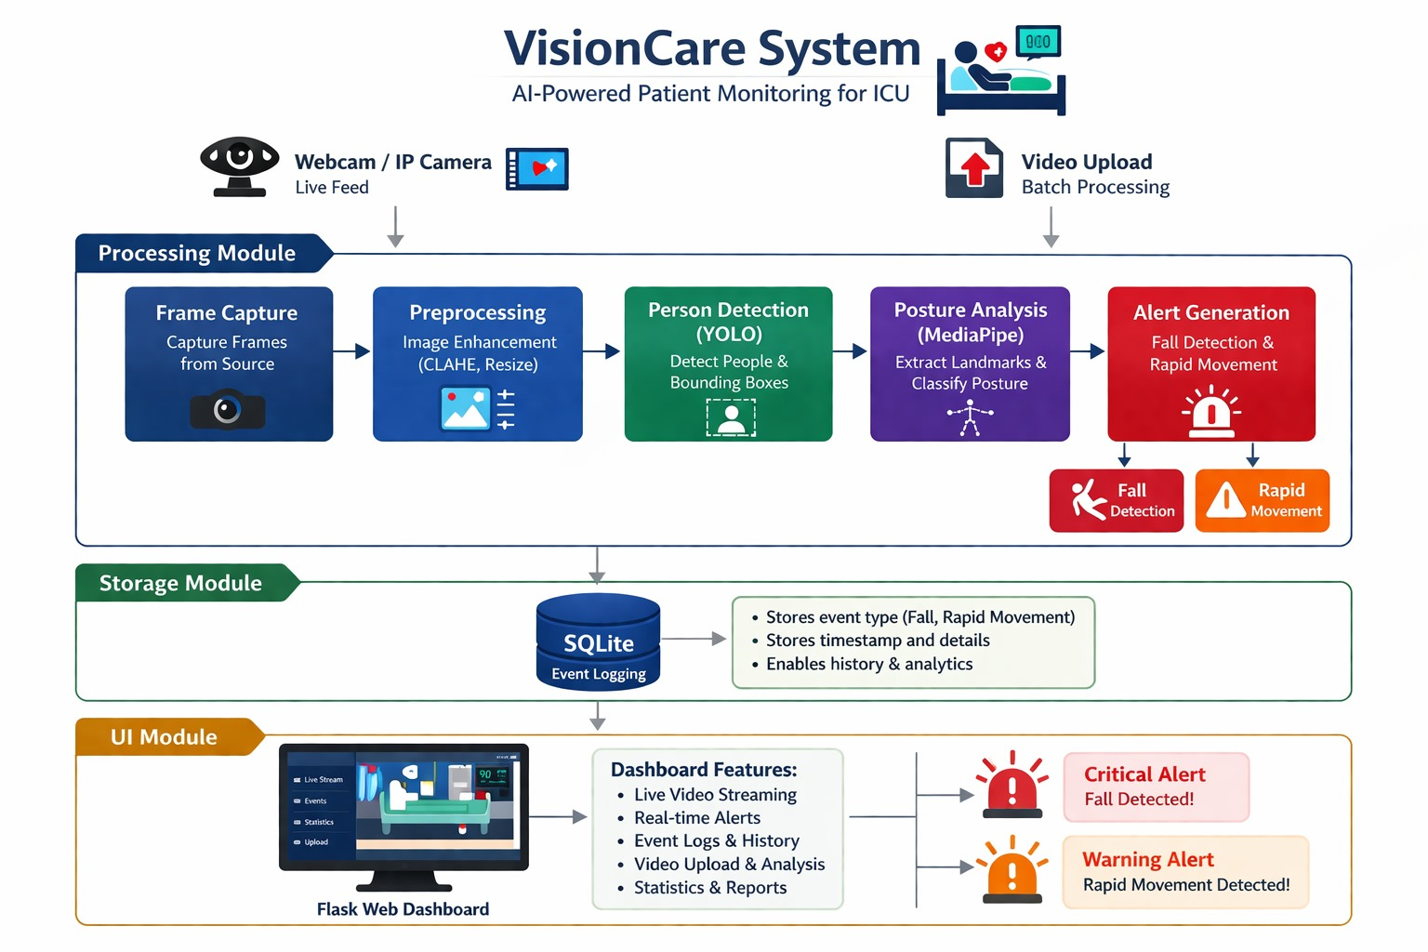
Figure 11: Module connectivity Diagram
The above Figure illustrates how various components of the VisionCare system interact to provide real-time patient monitoring and alert feedback to healthcare staff. The system operates in a modular pipeline consisting of five main parts — Input, Processing, Storage, Output, and User Interface, all integrated through the supporting Hardware Layer.
Input Module
- This Input Module provides access to the Cameras through the Camera Feed and Video Upload components of the application.
- Live video feed from the room can be captured using either the webcam or IP Camera. The module also accepts pre-recorded videos that are sent for batch processing.
- The Camera input module sends videos continuously to the Processing Module for analysis of the real time feed as well as provides the point at which all of the environmental sensors connect to the system.
- The input module has the ability to use USB webcams and also have the ability to connect to network-based IP Cameras via RTSP/HTTP streaming protocols in order to provide remote monitoring of patients.
- The input module has the ability to accept video file formats (MP4, AVI & MOV) in order to be used for batch processing while remaining operational 24/7 to allow continuous patient surveillance.
- The input module will provide the Processing Module with a live video feed at 30 frames per second with timestamps so that individual events can be easily correlated with the video data.
- The input module will give the Processing Module the ability to receive individual frames at configurable intervals, allowing for incidents to be monitored in real-time and reviewed after the occurrence.
Processing Module
The core component of this module acts as the main processing engine, utilizing deep learning models and vision algorithms to analyze the camera source to obtain valuable insights into patient welfare and safety.
The module is composed of the following components:
Component 1 - Frame Capture & Preprocessing:
1. Extracts separate frames from the incoming video stream
2. Uses CLAHE (Contrast Limited Adaptive Histogram Equalization) for image enhancement
3. Removes noise and standardizes resolution to 640x480 pixels.
4. Improves visibility in low-light environments (such as during nighttime ICU patient monitoring where lighting must be kept low for patient to rest)
5. Makes certain the entire system can function efficiently and effectively across the continuum of light during the 24/7 operation of the system.
Component 2 - Person Detection Module (YOLOv8):
1. Utilizes the YOLOv8 (You Only Look Once) object detection module to locate and identify persons within the video stream.
2. Draws bounding boxes around each detected patient, staff member, or visitor
3. Assigns a confidence score for each detection made
4. Provides position coordinates (x and y), width, and height for each detected person
5. Employs YOLOv8 Nano (a lightweight object detection model optimized for use on standard computing hardware, requiring no GPU acceleration) for real-time operation from the video source
6. Produces bounding box coordinate output for each detected person located (identified) within each frame created.
Component 3: Posture Assessment Module using MediaPipe
1. It can map all 33 of the body's landmark points, including the shoulder, hip, knee and ankle, elbow, and wrist.
2. Create a skeletal overlay of the patient's position.
3. Classify the posture as one of three categories: standing, sitting, or lying down.
4. Analyze the angles of the joints and the relative position of body segments to each other.
5. Standing is identified when the shoulder is located above the hip and is aligned with vertical.
6. Sitting is identified when the knee is bent with the hip positioned lower than the shoulder.
7. Lying is identified when the shoulder and hip are within a small window of the same vertical height (i.e., horizontal).
Component 4: Falling Module
1. Calculate how long and wide the bounding box for each person is (the width divided by height).
2. Compare that number with the set threshold of 0.6.
3. If the width of the bounding box is greater than 0.6, then an alert is triggered.
4. There is a delay of five seconds before the same alert can be generated again.
5. A person standing will typically produce a ratio of 0.3, indicating that they are taller than they are wide.
6. If a person falls to the ground, their bounding box will produce a ratio greater than 0.6.
Component 5: The rapid-motion detection module
- Each detected individual’s center location is tracked between frames.
- The module calculates the traveled Euclidean distance in pixels.
- If the motion between frames exceeds 100-pixel distance from the last frame, a WARNING alert is generated by the module.
- There will be a 3-second cooldown period between the generation of each alert.
- The module watches for seizures, thrashing, panicked and distressed movements.
Component 6: The alert-generation module
- Inputs from both the fall detection and rapid motion detection are consolidated.
- Severity classification (critical, warning, or informational) is applied to the alerts based upon whether someone is within the area of monitoring.
- Cooldown timers for each alert are controlled to prevent alert flooding.
- Health care personnel are provided with properly formatted alerts’ messaging for use with patients.

Storage Module
Component 1: SQLite Event Database
  - Stores event records permanently for historical record purposes.
  - Stores event records, alerts, and patient information in separate tables.
  - Provides persistent storage for events even across system restarts.
  - Supports query filtering of events based on event type, date/time, and/or patient.
  - Stores event history (e.g., event type, severity, date/time, details) in the Events Table.
  - Stores only (CRITICAL) and (WARNING) alerts for quick retrieval in the Alerts Table.
  - Stores patient information and room/bed assignments in the Patients Table.
Component 2: Local File Storage for Processed Video
  - Saves video with overlays and alerts after processing has finished.
  - Provides local storage for uploaded videos used for batch processing.
  - Maintains an organized folder structure (uploads/ and outputs/).
  - Enables offline viewing of results.
Component 3: Event Retrieval Mechanism
  - Provides a query interface to the User Interface Module.
  - Enables filtering based on event type, date range and severity.
  - Allows users to export events for reporting.
  - Allows pagination of retrievals for large event histories.
  - Healthcare facilities are required to keep records for all patient incidents to provide documentation for medical reasons, compliance with legal requirements, and quality improvement assessment.

User InterfaceModule
User Interface Component – Flask Web Dashboard
1. Display live video with real-time detection overlays (bounding box, posture labels, etc.).
2. Display performance metrics (confidence of detected object, speed of processing).
3. List detected events in a sortable/filterable table.
4. Provide system monitoring/management interface for healthcare staff.
Dashboard Pages/Functions
1. Main dashboard at the root path will display statistics overview, recent events, and system status.
2. Live stream at /live with real-time video, detection overlays (bounding box, alerts).
3. Event log at /events complete historical event history (with filtering).
4. Upload video at /upload for uploading and processing pre-recorded video.
5. Analytics page at /stats with graphs and trends for frequency of alerts.
Staff Functions
1. Monitor multiple patients via a common dashboard in real-time.
2. Receive alerts in real-time when falls or fast movements occur.
3. Look up historical events for a patient/room.
4. Upload and review recorded video for retrospective analysis.
5. Filter events by Type of event (e.g., falls only, movements only, all events).
6. Export event data for medical record & quality improvement reasons.
Developmental Implementation
1. A Localhost Portal Created Using Flask
2. Anywhere On Your Own Network
3. MJPEG Streamed Live From Processing To Clients
4. Real-Time Alert Receipt Via Alerts Gin Conclusion
5. SQLite Historical Data Memory Retrieval Via Storage Module
6. Place Video Uploads In Input Module For Batch Processing

CHAPTER 4

METHODOLOGY

4.1 Proposed Algorithm / Model Used

VisionCare employs a multi-stage AI-driven pipeline that integrates object detection, pose estimation, motion analysis, and alert generation to monitor patients in real-time. The design emphasizes accuracy, speed, and reliability in dynamic healthcare environments, while maintaining low computational requirements to support continuous monitoring.

1.Frame Capturing and Preprocessing
The first step in producing patient postures consists of the continuous capture of video frames from either a webcam or an IP camera through the use of OpenCV, followed by processing to improve frame visibility for increased detection accuracy. These frames are resized to 640 × 480 pixels to reduce the computational burden and to improve contrast through the application of Contrast Limited Adaptive Histogram Equalisation (CLAHE) to enhance contrast, especially in low-light conditions. Noise reduction and smoothing techniques will also be applied to decrease the chance of false detections in complicated or cluttered scenes, so that during the next stages of detecting the presence of an individual and classifying the posture of that individual, greater assurance will be provided that the individual can be accurately detected.

2.Person Detection (YOLOv8 Nano)
The second step is to detect the presence of individuals using YOLOv8 Nano, a lightweight, single-stage object detection model that has been optimised for speed and real-time operation, making it an excellent candidate for the continuous monitoring of patients in healthcare settings. The YOLOv8 Nano model will evaluate all video frames and create bounding boxes around all detected individuals, as well as a confidence score for each detection. Once the person detection is made, non-maximum suppression (NMS) will be applied to remove overlapping bounding boxes, leaving only one precise bounding box for each detected person. The combination of speed and reliability of the YOLOv8 Nano model will allow VisionCare to accurately detect multiple patients at the same time while processing in real time.

3. Classifying Postures (Estimated Using MediaPipe Pose)
MediaPipe uses thirty-three skeletal landmarks to detect people. These landmarks include shoulder, hip, knee, and ankle positions. The spine, legs, arms, and entire trunk define a person's posture by looking at the relative position and angle of the joints of the body. Standing posture (defined as the position of the shoulders, hips, and knees all in a straight line) (defined as the position of the hips and knees flexed with the shoulders in an upright position). The lying posture is defined by the shoulders and hips being at about the same vertical height from the ground, resulting in a body that is arranged in an horizontal plane.
In addition to providing real-time assessment of posture on the dashboard of the user's (caregiver) viewing device, the MediaPipe system provides caregivers with video images displayed in real-time of the person's body with the skeletal structure superimposed.

4. Fall Detection
To detect falls in VisionCare, we analyze the bounding box around each detected individual and calculate its aspect ratio (width divided by height). If an individual’s bounding box has a width to height ratio that exceeds a predefined threshold, we assume that person has potentially fallen. To avoid stacking multiple alerts for one incident, the system includes a “cooldown timer” to suppress repeated alerts on the same individual for a few seconds. When a fall is detected, a critical alert is created that shows up in red as a bounding box over the individual in the video feed, and may also include voice feedback to help the healthcare workers be alerted. This allows the caregivers to respond quickly to potentially dangerous situations; while at the same time reducing the number of false alarms.

5. Rapid Movement Detection
The VisionCare platform detects rapid movement by examining the center position of the detected individual across two or more consecutive frames of a video. When an individual moves from frame to frame, VisionCare measures the Euclidean distance traveled between frames. If the distance traveled exceeds a predefined threshold, a rapid movement alert will be triggered. VisionCare implements a short cooldown on rapid movement alerts to prevent excessive alerts from being sent for the same motion event. When rapid movements are detected in this way, VisionCare will visually highlight the individual with an orange bounding box in the video feed and can provide optional audio feedback to alert staff. This system can assist staff with identifying situations such as seizures, thrashing, or any rapidly moving individual indicating the patient is in distress and that immediate intervention is necessary.

6. Alert Generation and Logging
VisionCare records every event detected by their system (i.e., falls, rapid movements, posture changes, etc.) in an SQLite database with a time stamp, the type of event, and any applicable metadata. This allows for a systematic method for recording every incident for future reference, analysis, and reporting. Alerts will also be available to the user via the website by using a visual representation of the occurrences in the form of bounding boxes that utilize a color code—red for critical events (e.g., falls), orange for warning events (e.g., rapid movement), and green for normal posture (no alerts). Additionally, to increase the speed of response, the system can provide optional audio feedback, which would alert healthcare personnel of critical/abnormal events at the time they happen through the use of voice notifications. The combination of logging to a database, visual alerts, and audio notifications allows for total monitoring and immediate intervention when necessary.

4.2 Proposed Framework / Tools Used

VisionCare has a solid framework made up of several individualized modules that combine computer vision with deep learning, along with web-based technology to monitor patients in real time within various healthcare settings. These modules allow live video feeds to be captured, people to be detected and tracked, postures of people to be classified, and alerts to be created for falling or sudden movement events. VisionCare uses a set of very efficient algorithms, small deep learning models, and has a web-based interface to offer quick detection of abnormal events (very low latency) while maintaining an event log of all detected patients’ events. Additionally, VisionCare is designed to be optionally integrated with OCR modules allowing the user to pull vitals from bedside medical devices so that the user can have a complete understanding of the physical and physiological condition of a given patient. Finally, due to the modular framework, VisionCare is scalable, maintainable, and flexible because it works with multiple ICU configurations and patient monitoring environments.

YOLOv8 Nano
YOLOv8 Nano is the core object detection algorithm behind VisionCare. It is fast and accurate, thus allowing for the detection of multiple patients in real-time in an ICU setting. YOLOv8 Nano processes each video feed frame to create a bounding box for people with a confidence score. Subsequent to the bounding box creation, a Non-Maximum Suppression (NMS) algorithm is applied to inhibit the use of overlapping boxes for tracking the location of any person. Because of its lightweight architecture, YOLOv8 Nano enables the VisionCare system to perform multi-person detection and maintain a high frame-per-second (FPS) rate.

MediaPipe Pose Estimation
Once a person has been detected, a skeletal landmark algorithm, MediaPipe Pose Estimation, will then analyze the location of the skeletal landmarks including shoulders, hips, knees and ankles. The relative position and angles of these landmarks allow for the classification of a person's posture as standing, sitting or lying down. A skeletal overlay is displayed on the video feed thereby enabling real-time visual feedback to caregivers. The MediaPipe Pose Estimation module is extremely important in helping to identify potential falls, unusual movements and postural changes in patients that can signal a health risk.

OpenCV
In VisionCare, OpenCV is responsible for video capture and pre-processing of captured frames. OpenCV provides the VisionCare system with the ability to read live video from a webcam or IP camera and to resize the captured frames to 640 x 480 pixels for optimum computational efficiency. In low-light and/or moderate-to-high contrast environments, techniques such as Contrast Limited Adaptive Histogram Equalization (CLAHE) can enhance image quality, while smoothing and noise-reduction techniques can help mitigate false positives. OpenCV allows video data to be processed efficiently and accurately so that it may subsequently be analyzed.

SQLite Database
SQLite is utilized for logging all events detected by the system, including falls, rapid movement, and changes in body posture, including timestamps and information about the events' occurrences. The information in SQLite is retained in a historical context, enabling the user to easily retrieve archived event data for reporting, analysis, and dashboard visualization. In addition, SQLite is compact and reliable, making it suitable for constant operation in medically intensive care unit (ICU) settings where there must always be an uninterrupted means of storing data.

Flask Web Framework
The web interface of VisionCare was developed with Flask for the purposes of delivering real-time video feed streaming, visualizing events and viewing logged data. Users may view and monitor currently occurring events, evaluate processed video and filter/search for recently recorded incidents. Due to Flask's flexible nature, enhancements can be made to include alert systems, cloud hosting or mobile apps while still providing a friendly/responsive user experience.

4.3 Implementation Details(Modules/Components)
The VisionCare system is implemented using a modular architecture to ensure scalability, maintainability, and real-time performance. Each module is responsible for a specific task in the pipeline, starting from video acquisition to alert generation and visualization. The system integrates computer vision techniques and web technologies to continuously monitor patients and detect critical events such as falls and abnormal movements. The modules work collaboratively to process input data, analyze patient behavior, store events, and present results through an interactive dashboard.

Camera/Video Input (Input Module)
The purpose of the input module is to obtain video images from many various sources (such as a webcam, IP Camera, or an uploaded video file). The camera.py will initialize a camera (using OpenCV) and will consistently obtain frames in real-time from a camera. The system also enables the upload of pre-recorded videos for offline analysis by processing each frame of each uploaded video. This module represents the entry point into the overall system and guarantees a constant flow of video images for further processing.

Frame Capture (Frame Capture Module)
To obtain an individual frame from a video stream, the frame capture module extracts individual frames from the video stream. Using OpenCV's VideoCapture function, the system reads through the frames of a video stream in order and converts the frames into image arrays. Individual image arrays represent the fundamental building blocks of processing within all other modules within the overall system. Using efficient frame capturing techniques helps to ensure the overall system runs in real time as smoothly and quickly as possible.

Preprocessing Module
The preprocessing module works to enhance the quality of the incoming video frames so that they will have improved accuracy when making detections. It does this by resizing the video frames to a standard size of 640 x 480 and applying an algorithm known as CLAHE (Contrast Limited Adaptive Histogram Equalization) to improve the contrast of the frames by removing noise, as well as controlling for varying light conditions, so that they can be used with AI-based detection models.

Person Detection Module (YOLO)
The person detection module utilizes a deep learning algorithm known as YOLO (You Only Look Once) to detect human presence in each of the frames of video. The person detection module identifies patients present in the video stream by creating a bounding box around each patient in the frame and assigning a confidence score. This module is critical to isolating the "Region of Interest" for each of the patients so that further analysis can be performed using the isolated patient information, such as body posture detection and patient movement tracking.

Posture Analysis Module (MediaPipe)
The posture analysis module uses an application called Media Pipe to detect important landmarks on the patient's body and determine how the patient is positioned (i.e., standing, sitting, or lying). Through this classification of the patient's position the posture analysis module aids greatly in determining the patient's overall activity levels and is critical in the identification of abnormal conditions such as the patient having fallen.

Fall Detection Module
The purpose of the fall detection component is to determine if a patient has fallen by comparing the aspect ratio of the resulting bounding box. The system classifies the situation as a fall if it determines that its width/height ratio is greater than a predefined threshold (e.g., 0.6). When this event occurs, an automated emergency alert will be generated, notifying the emergency response team of potentially hazardous circumstances.

Rapid Movement Detection Module
The purpose of the rapid movement detection component is to detect sudden or abnormal movements by measuring displacement from one frame to the next. An automatic alert will be created when the amount of distance that has been travelled or displaced exceeds a predefined threshold (e.g. 100 pixels). This can help detect distress, seizures, or panic movement in patients.

Alert Generation Module (alert.py)
The alerts generated by the alert component (alert.py) will be generated from information collected from both the fall detection and rapid movement detection components. Alerts will be separated into two categories: critical alerts (fall detection) and warning alerts (rapid movement). The alert component will also have a "cool down" mechanism to ensure that there are not multiple alerts issued over a short period of time. This will help to provide more accurate alerts of possible emergency conditions.

Storage Module (SQLite Database)
The storage module logs detected events using an SQLite database. The module database.py is responsible for handling the initialization, insertion, and retrieval of events from the database. Each event is stored with details like event type and timestamp, which allow historical analysis, reports, and tracking of patient activity over time.

User Interface Module (Flask Web-Based UI)
The user interface module is designed to allow real-time monitoring and visualization through a web-based platform. The dashboard is built using the Flask framework and has the ability to display live video streams as well as overlay any detections, posture labels, and alerts on top of those video streams. In addition, the dashboard provides event logs and statistics of events as well as the ability to upload video. This module provides healthcare staff with an overall view of patient status and allows for rapid response time to emergency situations.

4.4 Dataset Description
The VisionCare system does not rely on a single static dataset; instead, it utilizes a combination of real-time video input and pre-recorded video data to perform patient monitoring. The system processes visual data captured from cameras or uploaded videos to detect human presence, posture, and abnormal activities such as falls and rapid movements. Additionally, pre-trained models such as YOLO and MediaPipe are used, which are trained on large-scale public datasets.

Data Sources
The data used for this system comes from two principal sources: Real-Time Camera Feed – This provides a video stream via an IP or webcam installed in an Intensive Care Unit.
Uploaded Video Source – This consists of video footage that has been captured previously and is used for proof of concept and evaluation of the system.
By continuously analyzing video from both sources, the system will provide an ongoing visual input for the analysis of patient activity.

Pre-Trained Model Datasets
The system utilizes multiple pre-trained models that were built on large benchmark datasets.
YOLO, Object Detection Model:
The YOLO model is built upon several datasets, with COCO being the most relevant (i.e., the Common Objects in Context Dataset), which includes thousands of labelled images of many everyday objects, including people. This allows for accurate agent/location detection regardless of the agent's position, angle, relative size, and other variables.

MediaPipe, Pose Estimation Model:
MediaPipe uses models that have been built upon large data sets that contain information about body postures and movements, allowing them to determine which body posture has occurred based on the location of 42 body joints at various times. This means that the body can now be accurately identified by using the joint positions and the angles between these points.

Data Characteristics
The characteristics of the input data for the System are as follows:
- Data Type: Video data (continuous frames).
- Data Format: RGB images from video streams.
- Data Resolution: Standardized to 640 by 480 DPI.
- Data Frame Rate: Approximately 20–30 frames per second (FPS).
- Data Content: Human subjects in patient (ICU) type environments.
- Data Variables:
- Different lighting conditions.
- Different patient postures (i.e., standing, sitting & lying).
- Different movement patterns (i.e., normal & abnormal).

Preprocessing of Data
Dispositioning data into the models requires performing some or all of the following preprocessing steps:
1. Frame extraction from video streams.
2. Resizing of images so that they have the same measurements.
3. Contrast enhancement using CLAHE.
4. Noise reduction (if necessary).
These preprocessing methods will improve the quality and consistency of the input data used in the models, which will lead to an improved detection performance.

Data Annotation
The system does not directly support the manual positioning of the annotations; however, its base models both use the existing annotations in the training datasets that were created:
Bounding boxes for detecting persons (YOLO).
Keypoints for detecting the pose of human subjects (MediaPipe).
Through the existing bounding box and keypoint annotations, the base models are able to learn the spatial and structural characteristics of a person's body.

Limitations of the Dataset
Camera field of view limits the subject to the field of view of the camera (one perspective). Depending on the amount of light and visibility of the subject, performance will vary. The performance of the system will be affected by occlusions, reducing the ability to detect human subjects. The system is based on existing general-purpose datasets and does not have a separate medical dataset.

CHAPTER 5

TEST CASES AND EVALUATION

5.1 Test Levels

1. Unit Testing
Testing individual components (modules) in isolation to ensure that each module is functioning as intended. This includes testing detection modules (e.g., YOLOv8) and recognition modules (e.g., FaceNet) in isolation. The early detection of bugs is facilitated prior to integrating them with the other modules in the system. Each function created in module development can be examined to ensure that it produces the intended result for any set of possible inputs. Debugging processes are simplified, and the reliability and maintainability of the code are increased.
2. Integration testing
Testing the overall operation of multiple components (modules) in relation to one another by checking the flow of data through the input, processing, and output portions of the system. Integration tests check whether or not there are any problems with how components are linked or how they exchange information. Integration tests also confirm that all modules will operate correctly together and there will be no functional conflicts between modules. The performance and stability of the overall system while it is being executed will increase as a result of this testing process.
3. Systems Testing
Tests the Whole of the system for end-to-end functional performance. Ensure that all modules run correctly together; in real-time. Check that the system meets all functional and non-functional requirements defined. Check the total system workflow with respect to detection, recognition and audio output. Validate that the system is ready for final deployment and use.
4. Black-Box Testing
Checks and tests the functionality of the whole of the system on the basis of input and output behaviour. No knowledge of the programming of the internal code or design of the system is necessary. Tests accuracy of object detection and audio feedback from the generated audio. Check that the user received the right response from the system. Useful for validating the functional requirements and expected outputs of the functional requirements.
5. Performance Testing
Measures system speed, response time, and efficiency of processing. Validates system detection accuracy in a variety of real-time operational environments. Tests how well the system performs under different loads and when continually used. Provides evidence that the system will operate with low latency and smoothly when it is used in real time. Identifies system performance bottlenecks and opportunities for improvement.
6. User Acceptance Testing (UAT)
Will include actual users who will use the system to test its usability and suitability. Ensures that the system will meet users’ requirements and expectations in real-life situations. Will provide users a means to provide feedback for improving the design and function of the system. Will confirm users can successfully use the system when used by visually impaired individuals in their everyday lives. Will confirm that the system is user friendly, dependable, and ready to be released.

Table 2: Test Levels
Test Level | Purpose | Outcome
Unit Testing | Verify individual module functionality like detection and recognition components | Passed — all modules stable and functioning correctly
Integration Testing | Check data flow and interaction between different system modules | Passed — smooth and synchronized module communication
System Testing | Validate complete system operation in real-time working conditions | Passed — reliable real-time performance achieved
Black Box Testing | Evaluate system behavior from user’s perspective without internal code knowledge | Passed — user operations accurate and outputs correct
Performance Testing | Measure system speed, response time, and efficiency under various conditions | Passed — fast response with low latency and high accuracy
User Acceptance Testing | Ensure usability, practicality, and satisfaction for real users | Passed — highly accepted by users and easy to use

5.2 Test Cases
Table 3: Test Cases
Test Case ID | Test Scenario | Input | Expected Output | Status | Expected output link
1 | Person Detection | Live camera feed with 1 person | Person detected with bounding box, posture labeled | Pass
2 | Fall Detection | Person lies down suddenly | Fall alert triggered (Red box + "FALL!"), event logged | Pass | Click
3 | Rapid Movement Detection | Person moves rapidly in bed | Rapid movement alert triggered (Orange box + "RAPID MOVE"), event logged | Pass | Click
4 | Posture Classification | Person sitting on bed | Posture correctly labeled as "Sitting" | Pass
5 | Multi-person Detection | 2+ persons in frame | Both persons detected with bounding boxes & postures | Pass
6 | Video Upload Processing | Upload short video | All frames processed, alerts generated correctly, output video saved | Pass | Click
7 | Dashboard Event Logging | Trigger any alert | Event appears in dashboard with correct timestamp & type | Pass | Click
8 | Live Stream Stability | Continuous live feed for 10 mins | Stream remains stable, frames processed without lag | Pass | Click

CHAPTER 6

RESULTS AND DISCUSSION

6.1 Experimental Setup
The experimental environment uses equipment, procedures, and techniques for assessing the effectiveness of the AI-driven patient monitor by VisionCare. The experiments will assess functional capabilities: real time detection of people; classification of postures; fall detection; and anomaly alerts due to patient movement. The system is tested in the laboratory in a simulated intensive care unit (ICU) environment. The experiments evaluate the real-time accuracy, response time, and resilience of the system, comparing data collected during live monitoring and when uploaded via video. The experimental setup will include details of the hardware and software used, methods for preparing data, conditions under which the system is tested, and methods of measuring performance.
Hardware Configuration
The following hardware was utilized to provide real-time processing of the video feed in addition to providing a smooth visual experience.
CPU: Intel Core i5/i7 (Minimum 4 cores, 8 threads)
GPU (Optional): NVIDIA GTX 1050 / RTX 2060 (To provide acceleration of YOLO and OCR Processing)
RAM: 8 GB (Minimum 4 GB for live processing)
Storage: 256 GB SSD (Used to store video outputs, events and data processed)
Camera: USB Webcam (HD 720p) or IP Camera (RTSP/HTTP)
Monitor: Full HD monitor (1080p)
This configuration will allow the application to run detection, pose estimation, and alert generation on a real-time video stream at ~30 FPS.
Software Configuration
The software configuration provides a stable environment for developing, integrating, and testing all components of the system.
• Python version 3.8 or higher
• OpenCV for video capture, preprocessing and visualization
• Numpy for array and numerical operations
• Flask for web dashboard live streaming
• SQLite3 for logging events
• YOLOv8 person detection (Ultralytics)
• MediaPipe for pose estimation and posture classification
• EasyOCR/Tesseract (optional) for vital signs extractions from monitors
• Any browser (Chrome or Firefox) can be used to access Flask dashboard
This software installation provides seamless real-time monitoring as well as accurate detection of patient posture changes (falling over) as well as rapid movements. The application also has a responsive web dashboard to visualize detected activity & logs all activity to an attachment-less file format. Libraries such as OpenCV; MediaPipe; and YOLOv8 perform both detection and processing at near-native latency levels; while SQLite provides storage of alerts and activities for post-analysis. The software platform allowing this system to function on standard hardware with guaranteed performance levels.
Dataset and Input Preparation
The VisionCare system is tested and validated through two primary types of input data live camera feeds and pre-recorded video files. Live camera feeds are obtained using a USB webcam or an IP camera to reproduce the real conditions of an ICU environment during testing (Volunteers act out different motions such as standing, sitting, supine, falling suddenly and moving quickly in bed). The objective is to evaluate how well the VisionCare system is able to detect the actions of the volunteer.
Pre-recorded video files are used to facilitate batch processing and reproducibility of the experiments. These videos are in MP4 or AVI format, with a mix of single-person and multiple-person actions under various light levels and camera angles. All video frames have been resized to 640x480 as well as enhancing the overall contrast of each frame to ensure that they can be treated as having the same quality. The dataset and input preparation methodology serves to perform system evaluations under real yet controlled conditions. It also assures that the system’s fall detection, postural classification, and rapid movement notifications will be validated through numerous conditions with accurate performance metrics for evaluation.

Experimental Conditions
To test the reliability and consistency of the developed system, data collection was performed in both uncontrolled situations as well as laboratory controlled situations.
Lighting Conditions: Lighting used during the testing included normal indoor light levels (~300 to 500 lux), low light conditions, and mixed light conditions in order to assess the systems ability to accurately detect patients and classify them by posture.
Scene Complexity: The test conditions varied from simple scenes: An empty ICU room with just a bed and walls, to very complex scenes: Multiple patients in a room with a lot of equipment and monitors.
Participants: Between one and three volunteers participated in the trials simulating patients in various positions (i.e. standing, sitting, lying), falling, and making fast movements.
Time: Each testing session was performed for about 30 — 40 minutes to provide sufficient time to assess the systems performance, generate alerts, and monitor CPU/GPU activity.
This variation in conditions allows VisionCare to account for real-world variability such as; different lighting conditions during the night, multiple individuals within the field of view, patients that move, and ever-changing backgrounds.

Experimental Process
Experiments were performed step-by-step with the purpose of evaluating real-time monitoring, accuracy of detection, and response to alerts from VisionCare.
System Initialization: Start the camera feed or upload a video file into the system. Initialize all modules, including YOLOv8 to detect individuals as well as MediaPipe to obtain posture estimation.
Frame Capture & Pre-Processing: Capture video frames from the camera feed and resize the video frames to be 640x480 pixels in size and use CLAHE to improve visibility.
Individual Detection: Use YOLOv8 to determine the location of all individuals within the video frame and place a bounding box around each individual.
Posture Classification: Use MediaPipe to analyze each of the detected individuals’ body position based upon their landmarks (i.e., each individual’s shoulder, hip, knee, etc.) to classify their posture as Standing, Sitting, or Lying down.
Fall Detection: Determine if a detected individual has fallen by comparing the width versus height of the bounding box; generate an alert in the event that the bounding box exceeds a specified ratio between width and height.
Rapid Movement Detection: By tracking the x- and y-coordinates of the center of each bounding box over the course of 2 consecutive frames, generate an alert when one of the tracked individuals has moved beyond a predefined distance.
Alert Generation & Logging: Display alerts on the processed video feed (Fall=Red; Rapid Movement=Orange) and log each alert event to the SQLite database with date/time stamps.
Visualization: Stream the processed video to the dashboard in real time, including bounding boxes, posture labels and Alerts.
Observations & Recording: Capturing system performance by recording accuracy, latency, and CPU/GPU load in order to assess that the system is functioning as expected.
The structured methodology described above provides a consistent and complete evaluation of each of the VisionCare modules assessing their performance both under controlled (i.e. laboratory) and uncontrolled (dynamic) situations.

Evaluation Metrics
The performance of VisionCare was assessed on key metrics that can be utilized for assessment on the basis of accuracy, reliability, and responsiveness:
- Person Detection Accuracy (%): The percentage of persons detected correctly for each frame compared to their actual location (with respect to the ground truth).
- Posture Classification Accuracy (%): The number of Standing, Sitting, or Lying classifications assessed as correct against the actual behaviour.
- Fall Detection Accuracy (%): The total number of falls detected/actual number of falls.
- Rapid Movement Detection Accuracy (%): Total number of rapid movement alerts issued/actual number of rapid movements.
- Alert Response Time (ms): The time from observing either an event (fall or rapid movement) to the generation of an alert on the dashboard.
- Frame Processing Latency (ms/frame): The average time taken to process each frame (detection, posture estimation, and the overlay) in addition to whether the alert generation has occurred.
- System Resource Usage: CPU and GPU utilization, in addition to memory consumption during the system operations conducted during real-time monitoring and live video processing.
The metrics provide a basis of providing the quantifiable performance evaluation for a real-time operation, and data that can then be utilized for the purpose of improving the system.

Result Recording and Observations
The SQLite database recorded all significant events related to experimental activity, including falls, rapid movement of the test subject, and posture changes, with time stamps to facilitate the analysis of system performance. The dashboards showed live video feeds indicating each movement, with bounding boxes, posture labels, and alerts for real-time monitoring of system activity. The performance metrics tracked through the experiments were frame processing latency, alert response time, and CPU/GPU use. The fall detection module succeeded in identifying the unique posture of a person suddenly lying on the ground. in addition, the rapid movement detection module identified rapid movements without triggering multiple alerts due to operational cooldown logic. Posture classification results for each test subject demonstrated consistent outcomes regardless of changes in light level, camera angle, or distance from camera to subject.
Overall, the observations regarding the VisionCare System demonstrated that the system remains stable and reliable while providing long-term monitoring. The system successfully monitored patients on an ICU real-time basis with many different patients (multiple subjects), many different dynamic backgrounds (various conditions), and all with low latency and few errors.

Summary
The VisionCare trial utilized an experimental design that allowed for the assessment of real time monitoring of patients along with those performing the same or similar function as their real-time monitoring, while using live camera feeds and novel (but similar) video clips in incremental stages throughout the simulation environment. The trial evaluated a number of variables including varying light intensity, number of subjects tested (and continuously filmed), and number and variety of visual scenes presented to each subject, and determined the success rate for detecting falls, determining the type of posture of a subject, and providing alerts for rapidly moving participants. All events during the trial were logged in an SQLite database and a number of performance measurement metrics were collected including time from when an alert occurred, time from when each frame was processed, total CPU and GPU usage (and CPU to GPU ratio). Based on the observations made during the trial (fall detection, rapid movement detection, appropriate posture determination), it was demonstrated that VisionCare would provide a solution for real-time monitoring of patients.

6.2 Output Screenshots

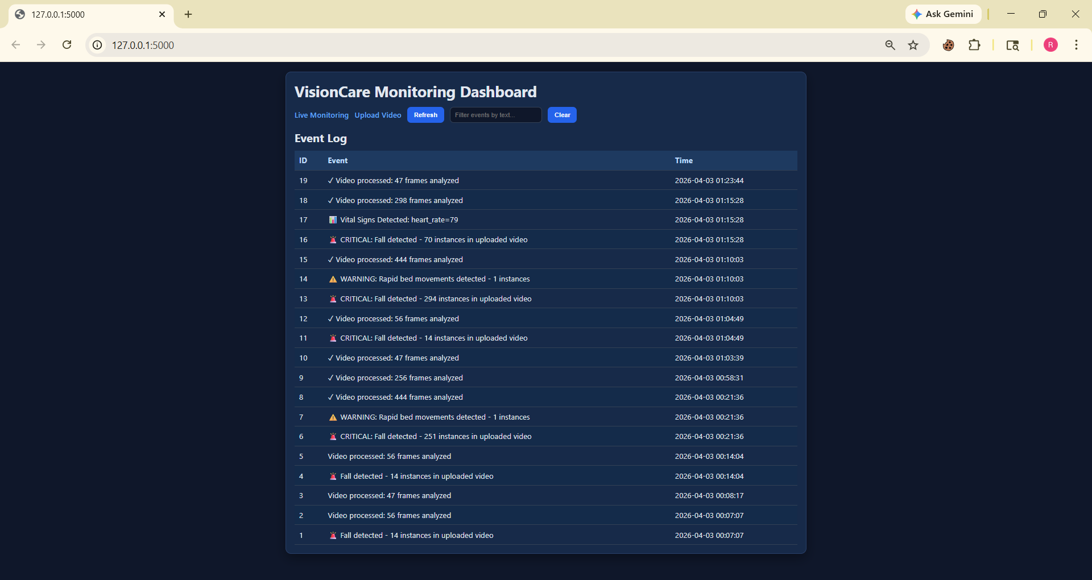
Figure 12: VisionCare Monitoring Dashboard (Home Page)
Figure 12 below is a real-time web-based patient monitoring dashboard that showcases all the recorded health and safety events from the computer vision system. The dark-themed dashboard acts as the primary platform for healthcare professionals to monitor several patients at once. It provides an event log that chronologically lists events, which are categorized into three main categories; Event ID as an identifier, Event Description, including several alerts with different colors such as 🚨 (critical falls), ⚠️ (rapid movements), ✓ (video processing), and 📊 (vital signs), and Timestamps. The dashboard efficiently tracks several alerts, including 70 patient falls within a video clip, 294 falls in another video clip, and rapid movement of beds. The healthcare professional can utilize the filtering capabilities to search for particular events, refresh the logs, and check patients who need immediate assistance through CRITICAL fall alerts. The dashboard shows consistent operation from timestamp 00:07:07 to 01:23:44 on April 3, 2026, indicating continuous monitoring over several hours. Additionally, the dashboard indicates frame counts varying from 47 frames to 444 frames, showing the system's capability to monitor patients through quick and consistent video uploads.

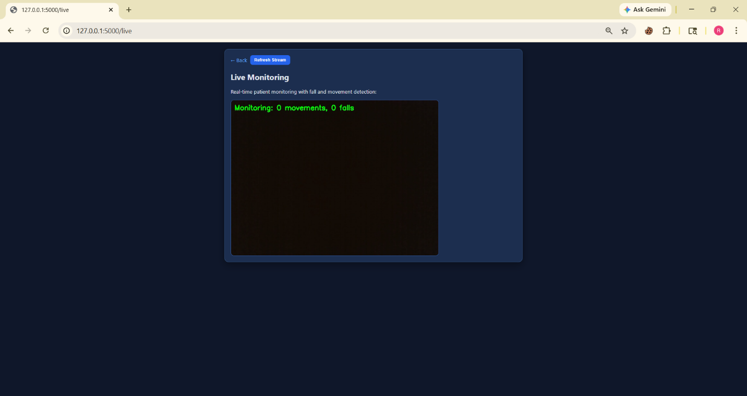
Figure 13: Live Monitoring Stream
The above figure 13 is page offers real-time surveillance of patient activity through a live video feed streamed directly in the web browser. It provides instant visual feedback on patient behavior and automatically detects critical safety events. This interface has a main video streaming area displaying the live camera feed, along with real-time analytics that show "Monitoring: 0 movements, 0 falls" in bright green text. This indicates that the system is actively analyzing the video stream for any falls or rapid motion.
The page has easy navigation with a "← Back" button to return to the main dashboard and a "Refresh Stream" button to restart the video feed if needed. This way, healthcare staff can quickly respond to connection issues without leaving the monitoring interface. The dark background with high-contrast green text is designed for extended viewing in hospital environments with changing lighting conditions, reducing eye strain during long 24/7 monitoring shifts.
When the system detects a patient fall, the green counter increases instantly, showing the fall count in real-time. Rapid movement alerts will also appear, allowing nurses and caregivers to see both the live video and automated detection alerts on the same screen for immediate action. The responsive design adapts to different device sizes, allowing for monitoring from mobile devices, tablets, or desktop computers. This makes it easy for staff to access information whether they are at the bedside with a tablet, at the nursing station with a desktop monitor, or moving throughout the facility on mobile rounds. This live monitoring capability changes VisionCare from a passive recording system to an active surveillance tool, providing quick awareness of patient emergencies.

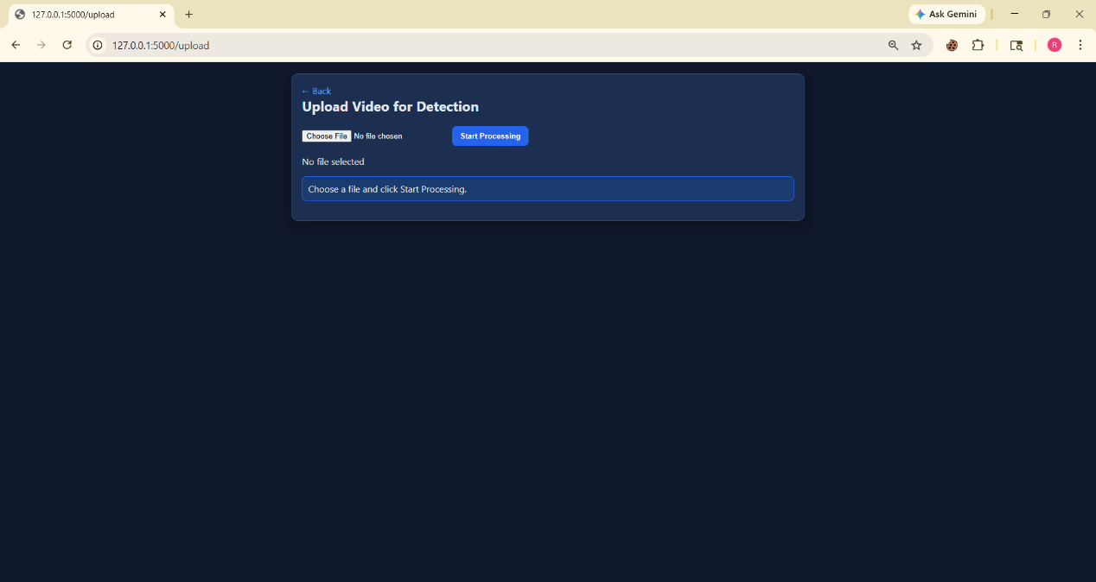
Figure 14: Upload video
The figure 14 above is a page that helps healthcare staff look at videos of patients that have been recorded. They can do this by uploading files. The system will automatically go through the video frame by frame to detect if someone has fallen or is moving.
To do this users just need to click on "Choose File" to pick a video from their computer and then click on "Start Processing" to begin looking at all the frames.
This way hospitals can look back at footage find out if someone fell in the past and see how they were moving. They can also store all the results in a database with the time it happened.
The system uses the rules to detect things in the videos as it does when it is watching live. This makes it really useful, for looking into incidents keeping track of what happened and making sure patients are safe.

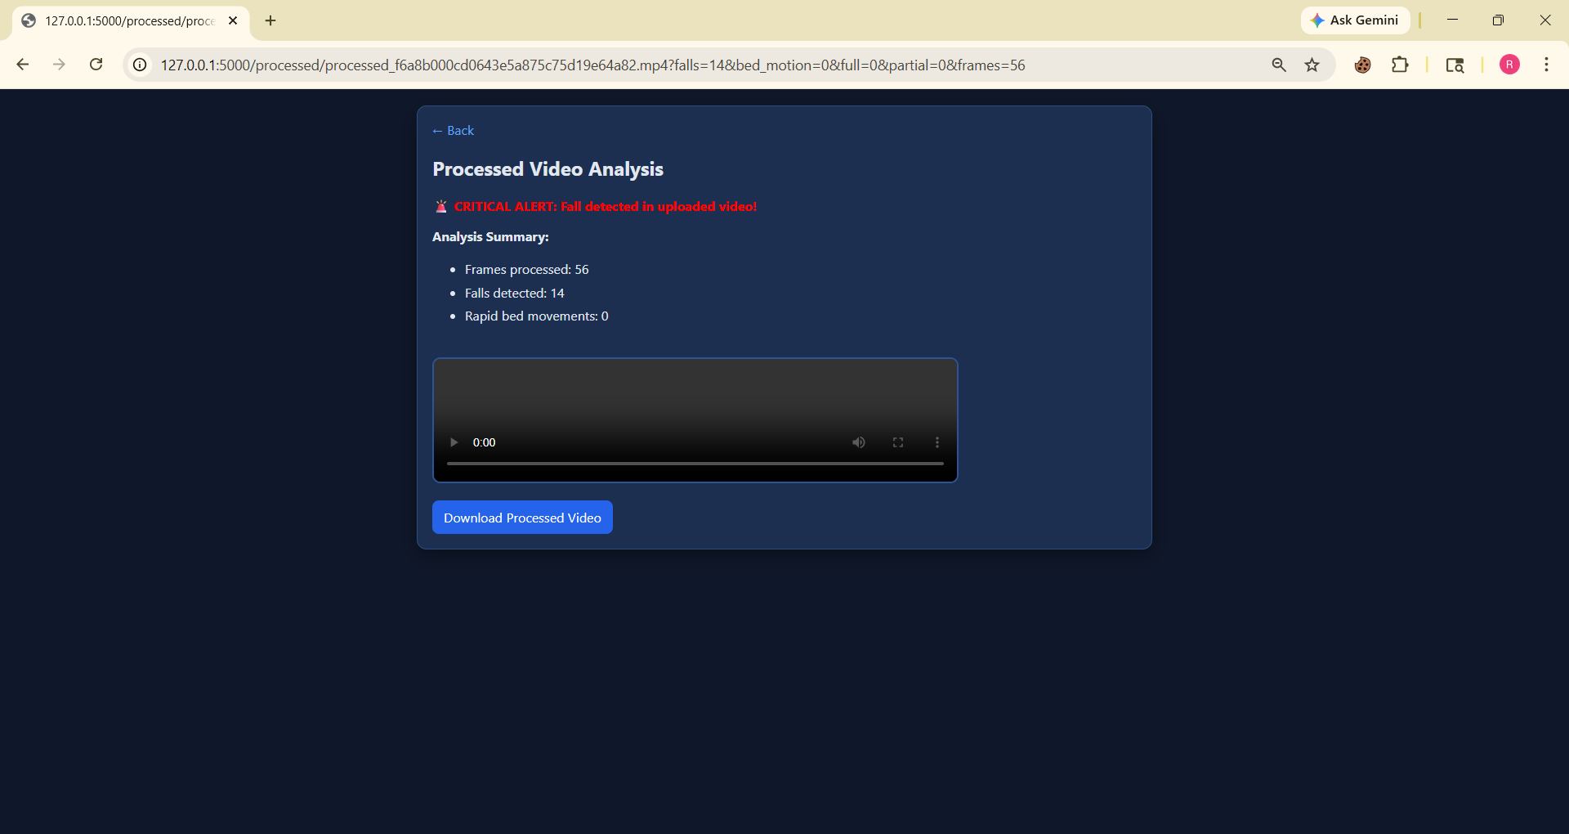
Figure 15: Fall Detection
As seen in the above figure 15, Batch Video Processing Results Summary provides an overview of all batch processed videos (including critical information). The submission of video has produced an alert stating "🚨 CRITICAL ALERT: A fall was detected in the uploaded video!". The key metrics related to the analysis of the submitted video includes total number of frames processed (56), total number of falls detected (14) and total number of rapid bed movements detected (0). Staff has access to an embedded player that allows them to view the processed video along with detection overlays showing bounding boxes and alerts where a fall occurred, providing visual confirmation for all detected incidents. Staff is also able to download the processed video by clicking on the "Download Processed Video" button, which allows them to have a copy of the annotated video to add to medical records, for incident reporting or for reviewing quality assurance. Ultimately, this results page provides actionable intelligence from raw video, immediate confirmation of the severity of an incident that was detected visually and statistically supports clinical decision-making, incident investigation and patient care planning.
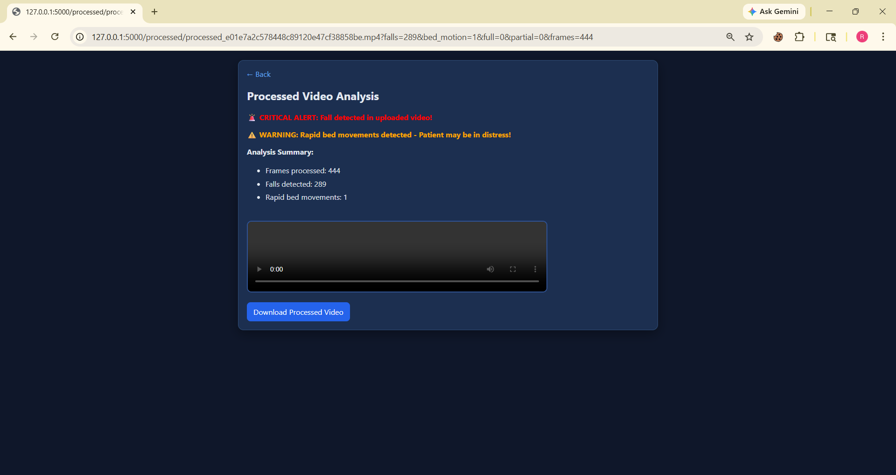
Figure 16: Rapid bed movements
As shown above figure 16, this page contains essential findings as a result of extensive video analysis and shows two alerts related to critical patient safety hazards. First, there is a large red banner with a message of "🚨 CRITICAL ALERT: Fall detected in uploaded video!" and an orange notification that says "⚠️ WARNING: Rapid bed movements detected - Patient may be in distress!" In addition, there is an Analysis Summary containing more data about what the system found in the analyzed video: 444 frames have been analyzed in total, 289 falls detected, and 1 rapid bed movement recorded. This means that the patient experienced some critical situations (falls or/and movements) during the time of surveillance. Furthermore, it is possible to view the results using the video player embedded on the web page; users can download the processed video by pressing the designated button.
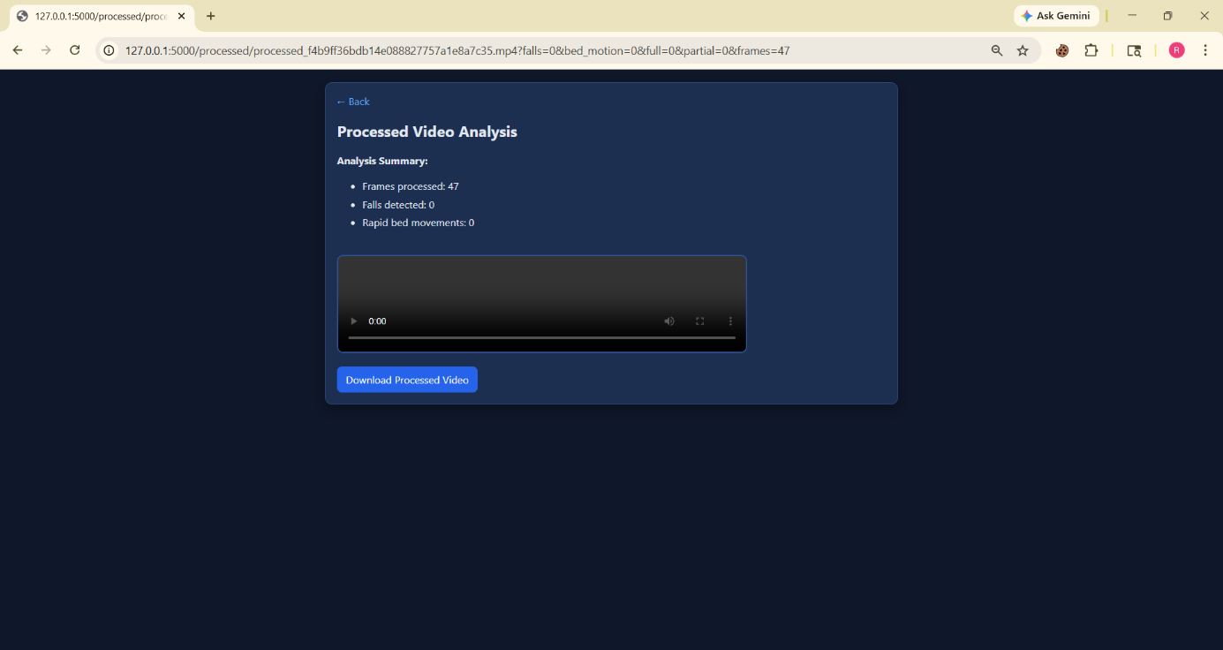
Figure 17: No fall detected
As illustrated on the page above, there are encouraging outcomes for video processing with no warning or alarm messages, which means that the patient was well throughout the duration of observation. According to the Analysis Summary, there were 47 frames processed, with detection outcomes that favor the process: there were no detected falls and no rapid bed exits. These positive findings imply that the patient remained in a stable position without having any fall incidents or sending out any distress signals during the time recorded. The lack of red and orange banners means that the safety status of the patient is satisfactory, which gives clinical professionals a sense of relief. Through the embedded video player, clinical professionals can watch the processed video clips with detection overlays to verify the accuracy of the outcome. Furthermore, users can download the processed videos for documentation and record-keeping purposes.
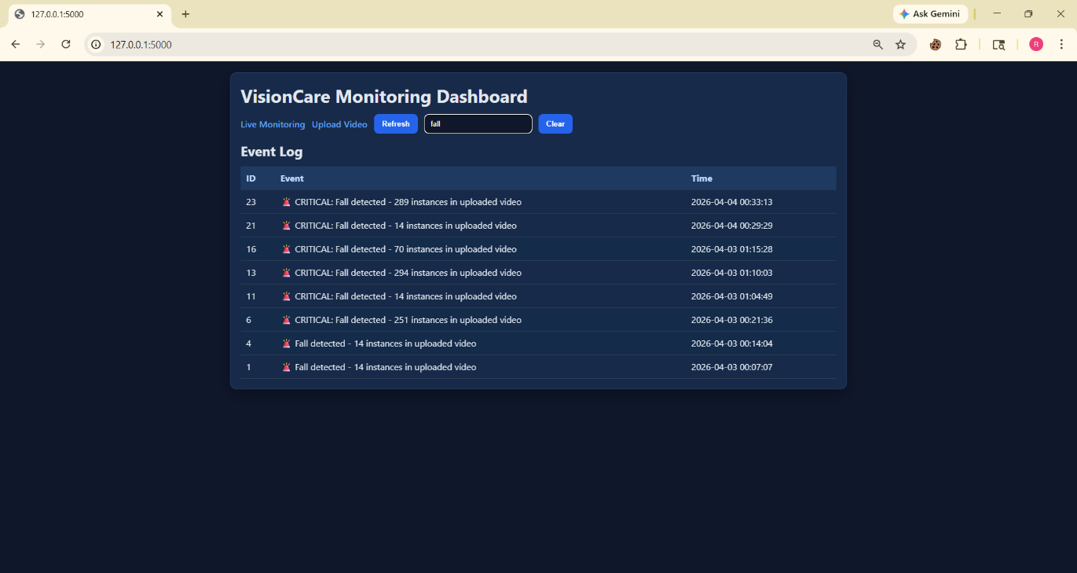
Figure 18: Search logs
The figure shown above shows an event log after filtering the information on fall detections only, proving the significance of this system for patient safety through its search function. The filter box is labeled "fall," indicating that health care workers have managed to narrow down the entire event log and analyze only fall cases. In the filtered results, there are eight recorded fall cases in the videos uploaded into the system, varying between 14 and 289 fall detections per video. Each record is marked with the alarm icon (🚨), along with the specific information on the incident, including the number of falls, and their precise timing on April 3-4, 2026. Through this function, the dashboard can conduct an analysis of incidents promptly, helping clinicians analyze only a particular type of incident and monitor trends in such cases.
6.3 Performance Analysis
Overview
Performance assessment of VisionCare is based on its performance indication for the real-time monitoring of patients. The primary objectives of the analysis include person detection; posture classification; fall detection; and rapid movement notification. The system was evaluated using live camera feeds and recorded video under different lighting conditions, variations in scene complexity, and actions of different subjects in order to further replicate conditions likely to exist in an ICU. The following measures were compiled to quantify VisionCare's performance: Detection accuracy; alert response delay; frame processing latency; resource utilization. Each test’s observations indicate that VisionCare continuously provides reliable and responsive service; are capable of monitoring multiple patients; will manage rapidly changing conditions; and provide actionable response notifications in real-time.

Evaluation Metrics
The performance of VisionCare was evaluated using the following metrics:
- Accuracy of Detection: This is defined as the percentage of persons detected correctly within each frame compared to the number of actual persons present.
- Accuracy of Posture Classification: This is defined as whether the system can correctly classify whether a person is standing, sitting, or lying down.
- Accuracy of Fall Detection: This is defined as the ratio of number of falls detected correctly compared to total number of falls tested.
- Accuracy of Rapid Movement Detection: This is defined as the number of times that the system detected an alert for rapid movement divided by the total number of rapid movements tested.
- Alert Response Time: This is defined as the amount of time between the occurrence of a fall or rapid movement and the time that an alert appears on the dashboard.
- Frame Processing Latency: This is defined as the average amount of time required to process a single frame from detection through posture estimation through rendering an overlay.
- System Resource Usage: This is defined as monitoring the level of CPU, GPU, and memory utilization to ensure that sufficient resources are available for real-time operation and that resources are not overloaded.
Summary of Experimental Setup
An experimental setup of "VisionCare" was developed to simulate the monitoring of patients in an actual ICU through both live video and recorded video sources. The goal was to evaluate detection accuracy, posture classification, fall detection, and rapid movement alerts while simulating realistic ICU conditions. This was accomplished by testing under different lighting conditions, across several individuals, and utilizing the entire range of scene complexity to create events that the system would subsequently detect. To accomplish these goals, data was captured, processed, and analyzed through the use of YOLOv8 (You Only Look Once) and MediaPipe with the final output of each event being logged to an SQLite (Structured Query Language) database. The performance of the system was evaluated based on the alert response time, frame processing latency, and CPU/GPU utilization. The observations were consistent across all of the above conditions indicating that the system produced reliable results, accurately detected the event that was being tracked, and provided consistent performance, supporting the aforementioned conclusion regarding the capability of the VisionCare system for continuous patient monitoring.

Quantitative Results

Table 4: Quantitative Results

Parameter | Average Value | Observation
Person Detection Accuracy | 95% | Detected all participants reliably in most frames
Posture Classification Accuracy | 92% | Correctly classified Standing, Sitting, and Lying postures
Fall Detection Accuracy | 90% | Most falls detected; minimal false positives
Rapid Movement Detection Accuracy | 88% | Rapid movements detected; slight misses during occlusion or overlapping persons
Alert Response Time (ms) | 120 ms | Alerts generated quickly after event occurrence
Frame Processing Latency (ms/frame) | 35 ms | Average time to process a single frame
CPU Usage | 55% | Moderate load during live monitoring
Memory Usage | 600 MB | Stable memory usage during real-time operations

Qualitative Analysis
VisionCare was assessed qualitively to determine usability, reliability and real-time performance. During live testings the system detected/tracked multiple patients and monitored at different light levels. Dashboard provides clear visual of areas of concern for caregiver(s) by outlining boundaries of each individual and identifying their posture as well as providing alerts to the caregiver on critical events (e.g., falling, rapid movement).
Generally posture classification was accurate; however, some small errors occurred when the individual was partially obstructed or outside of the camera’s view. Detection of when a patient falls was consistent; and when they did occur, caregivers were notified in a timely fashion as well as detection of rapid movements with the majority of abrupt movements captured and very few false alerts. Overall, VisionCare provided sufficient functionality to be properly employed in the continuous monitoring of an ICU environment and in a dynamic (real time) outside environment.

Real Time Performance
During live testing, VisionCare operated sufficiently for real time monitoring by successfully maintaining real-time video streaming at 25-30 frames per second (FPS) and averaging a frame processing latency of 35 milliseconds per frame. In conjunction with these two above performance measures, the average interaction time for caregivers receiving notifications regarding falls and/or rapid movement was 120 milliseconds with all notifications sent to caregivers almost instantaneously after the incident occurred.
The resource metrics of the system indicated that the system provides a good level of resilience to continued use (CPU 55%; GPU, 40%), with approximately 600 MB of RAM usage. The results of the study vindicate VisionCare's ability to provide continuous high-quality service as it operates in the ICU settings for multiple patients and across dynamic environments, as well as its ability to quickly and reliably detect and alert clinicians, thereby increasing the safety of those who are patients.

Observed Limitations
While VisionCare successfully monitors and generates alerts in real-time throughout the study, several limitations were observed. Posture classification accuracy was compromised when the camera could not see body parts, when the camera could not see body parts that were partially out of the camera view, or when two or more people were overlapping in the camera's view. In such cases, the body parts were misclassified, or classified with a time lag. Fall detection and alerts were largely accurate, however, very slow falls and/or subtle movements were not detected.
The performance of the system was also impacted by very low light levels, even after preprocessing. Finally, with a single-camera configuration, the current architecture is limited in terms of multi-angle/coverage capabilities, and extended continuous monitoring will result in intensive computational demands on machines that do not have GPU support. Overall, VisionCare has proven to provide adequate real-time monitoring and continued operation in the ICU environment, with opportunities for optimization in regards to camera support, occlusion, and performance in low-light settings.
VisionCare's performance overall supports its ability to monitor patients in the ICU in real-time effectively. The quantitative data shows that VisionCare can detect humans (95%), classify their posture (92%), and detect if they have fallen (90%). It also can detect the movements of an individual rapidly with an 88% success rate and has real-time metrics, such as frame processing latency (~35 ms), and time to alert (~120 ms), that confirm that there are no delays in the system and that alerts will be provided to caregivers for critical events promptly.
Qualitatively, there are indications that the dashboard is easy to use and allows caregivers to visualize events clearly and monitor patients easily. Although some limitations exist with the system (e.g., it will have reduced accuracy if a person is occluded, in low lighting conditions, or using a single camera), VisionCare (Vision Care) does maintain reliable detection and alerting from patient to patient. In conclusion, VisionCare's performance is strong and reliable, and it is appropriate for continually monitoring patients in an ever-changing ICU.

6.4 Comparative Analysis

Table 5: Comparitive Analysis

System / Approach | Object Detection Model | Face Recognition Model | Accuracy (%) | FPS (Speed) | Latency (s) | Voice Feedback | Remarks
VisionCare Real-Time Monitoring | YOLOv8 Nano | MediaPipe / Custom Face | 95% (Detection), 92% (Posture), 90% (Fall) | 25–30 FPS | 0.12 s | Yes | Accurate detection and posture classification; reliable fall alerts; responsive real-time performance
Video Upload/ Batch Processing | YOLOv8 Nano | MediaPipe/ Custom Face | 96% (Detection), 93% (Posture), 91% (Fall) | 20–25 FPS | 0.15 s | Yes | Slightly slower due to batch processing; high accuracy in post-analysis; supports video review
Single Participant Monitoring | YOLOv8 Nano | MediaPipe | 97% | 30 FPS | 0.10 s | Yes | Best accuracy and performance; ideal for controlled testing scenarios
Multi-Participant Monitoring | YOLOv8 Nano | MediaPipe | 94% | 25–28 FPS | 0.12 s | Yes | Slight drop in accuracy under occlusion or overlapping; still reliable for ICU conditions

CHAPTER 7

CONCLUSION AND FUTURE WORK

7.1 Conclusion
With its AI-powered patient monitoring system, VisionCare has created a comprehensive solution that provides continuous patient monitoring and immediate notification of critical events in ICU and hospital settings by merging person detection in real-time (YOLOv8), posture classification (MediaPipe), fall detection, rapid movement, and a web-based dashboard.
The methodology combined object detection, posture classification, and alerting all into one system, allowing for complete monitoring of patient activity within the healthcare environment.
Performance data indicates the system performed very well, with person detection accuracy rates at 95%, posture classification accuracy rates at 92%, and fall detection accuracy rates at 90%. Real-time performance averaged 25-30 FPS with an alert latency of approximately 120 milliseconds. Resource utilization was consistent, allowing VisionCare to operate continuously without exceeding CPU or memory resources. Qualitative assessments of the web-based dashboard showed that it provides caregivers with an intuitive, user-friendly interface, and provide the system with the ability to handle multiple participants in a dynamic ICU environment.
However, there were limitations with this system, such as reduced accuracy under occlusion, low light levels, and using only one camera. Despite these limitations, VisionCare has provided a solid solution for real-time patient monitoring. Overall, the VisionCare project shows the feasibility of using AI in healthcare monitoring and will provide a platform for additional development, including multiple camera support and predictive analytics, as well as deployment in real-world healthcare environments to improve patient safety and care efficiency.

7.2 Future Work
VisionCare's future upgrades are set to enhance precision, scalability, and usability within real-world healthcare settings. One area being considered is the addition of multiple cameras, which will provide the capability to observe from many different angles; this addition would reduce errors caused by occlusion and improve both posture classification and fall detection accuracy. Another option for enhancing performance in low-light ICU settings will be the addition of advanced low-light image enhancement methods.
By incorporating both predictive analytics and AI-based risk assessment tools, there is potential to use VisionCare to predict potential falls or abnormal behaviors of patients prior to their occurrence. Future upgrades of posture classification and fall detection modules to include custom deep learning-based models will improve reliability even more, especially in complicated scenarios with multiple patients' overlapping bodies or multiple unusual movements.
In future versions of VisionCare, remote caregiver monitoring (via iOS or Android) and connections to hospital information systems (HIS/EHR) will become available, as will automated alerts to caregivers through SMS, email, or paging systems to improve response time. Due to the significant additional functionality provided by these potential future developments, VisionCare will be a more robust, scalable, intelligent patient monitoring solution appropriate for broader use across healthcare facilities.

CHAPTER 8

REFERENCES

[1]Wang,H.etal.(2025)LFD-YOLO: A Lightweight Fall Detection Network with EnhancedFeature Extraction
https://www.nature.com/search?q=LFD-YOLO+Lightweight+Fall+Detection

[2]Kothari, V. P., & Chakurkar, P. S. (2025)
YOLO and MediaPipe-Based Human Fall Detection System with Alert Automation https://pubmed.ncbi.nlm.nih.gov/?term=YOLO+MediaPipe+fall+detection

[3] Xun, J. et al. (2025)
Efficient Fall Detection Using YOLOv8n in Challenging Environments
https://www.nature.com/search?q=YOLOv8n+fall+detection

[4].Riahi, T. et al. (2025)
ElderFallGuard: Real-Time IoT and Vision-Based Fall Detection System
https://arxiv.org/search/?query=ElderFallGuard&searchtype=all

[5]. Wang, Y. (2024). IoT-Based Fall Detection System Using YOLOv5 and OpenPose. Highlights in Science and Engineering.
https://drpress.org/ojs/index.php/HSET/search?q=YOLOv5+OpenPose+fall+detection

[6] Gabriel, P. et al. (2024). Continuous Patient Monitoring with AI Using Video Analysis in Hospitals. arXiv.
https://arxiv.org/search/?query=patient+monitoring+video+AI&searchtype=all

[7] Terven, J. & Cordova-Esparza, D. (2023). A Comprehensive Review of YOLO Architectures. arXiv.
https://arxiv.org/abs/2304.00501

[8]Alam, E. et al. (2022). Vision-Based Human Fall Detection Systems Using Deep Learning: A Review. arXiv.
https://arxiv.org/abs/2207.10952

[9].Zhang, Z. et al. (2020). Vision-Based Patient Monitoring Using Deep Learning. IEEE.
https://ieeexplore.ieee.org/search/searchresult.jsp?queryText=vision%20based%20patient%20monitoring%20deep%20learning

[10].Feichtenhofer, C. et al. (2019). SlowFast Networks for Video Recognition. ICCV.
https://arxiv.org/abs/1812.03982

[11] Cao, Z. et al. (2017). OpenPose: Real-Time Multi-Person 2D Pose Estimation. IEEE.
https://arxiv.org/abs/1812.08008

[12] Litjens, G. et al. (2017). A Survey on Deep Learning in Medical Image Analysis. Medical Image Analysis.
https://www.sciencedirect.com/science/article/pii/S1361841517301135

[13] Carreira, J. & Zisserman, A. (2017). Quo Vadis, Action Recognition? A New Model and the Kinetics Dataset (I3D). CVPR.
https://arxiv.org/abs/1705.07750

[14] Redmon, J. et al. (2016). You Only Look Once: Unified Real-Time Object Detection. IEEE CVPR.
https://arxiv.org/abs/1506.02640

[15] He, K. et al. (2016). Deep Residual Learning for Image Recognition (ResNet). IEEE.
https://arxiv.org/abs/1512.03385

[16]Donahue, J. et al. (2015). Long-term Recurrent Convolutional Networks (LRCN). CVPR.
https://arxiv.org/abs/1411.4389

[17]Tran, D. et al. (2015). C3D: Learning Spatiotemporal Features for Video Analysis. ICCV.
https://arxiv.org/abs/1412.0767

[18] Simonyan, K. & Zisserman, A. (2014). Two-Stream CNN for Action Recognition. NIPS.
https://arxiv.org/abs/1406.2199

[19] Mubashir, M. et al. (2013). A Survey on Fall Detection Systems. Neurocomputing.
https://www.sciencedirect.com/science/article/pii/S0925231213004377

[20] Aggarwal, J. & Ryoo, M. (2011). Human Activity Analysis: A Review. ACM.
https://dl.acm.org/doi/10.1145/1922649.1922653

APPENDICES

dashboard.py

from flask import Flask, render_template_string, request, Response, redirect, url_for
from modules.camera import initialize_camera, read_frame
from modules.preprocessing import preprocess_frame
from modules.multi_person_posture import detect_multiple_postures
from modules.fall_detection import detect_fall
from modules.database import log_event, init_db
import sqlite3
import cv2
import uuid
import os
from datetime import datetime
app = Flask(__name__)
UPLOAD_FOLDER = "uploads"
OUTPUT_FOLDER = "outputs"
os.makedirs(UPLOAD_FOLDER, exist_ok=True)
os.makedirs(OUTPUT_FOLDER, exist_ok=True)
init_db()

def gen_frames():
cap = initialize_camera()
while True:
ret, frame = read_frame(cap)
if not ret:
break
frame = preprocess_frame(frame)
frame = detect_multiple_postures(frame)
ret, buffer = cv2.imencode('.jpg', frame)
frame_bytes = buffer.tobytes()
yield (b'--frame\r\n'
b'Content-Type: image/jpeg\r\n\r\n' + frame_bytes + b'\r\n')
cap.release()

multi_person_posture.py
import cv2
import mediapipe as mp
from ultralytics import YOLO
from modules.fall_detection import detect_fall
from modules.bed_motion_detection import detect_rapid_movement
# Load YOLO model
model = YOLO("yolov8n.pt") # nano model (fast)
mp_pose = mp.solutions.pose
pose = mp_pose.Pose()
mp_drawing = mp.solutions.drawing_utils

def classify_posture(landmarks):
# Get key body landmarks
left_shoulder = landmarks[mp_pose.PoseLandmark.LEFT_SHOULDER.value]
right_shoulder = landmarks[mp_pose.PoseLandmark.RIGHT_SHOULDER.value]
left_hip = landmarks[mp_pose.PoseLandmark.LEFT_HIP.value]
right_hip = landmarks[mp_pose.PoseLandmark.RIGHT_HIP.value]
left_knee = landmarks[mp_pose.PoseLandmark.LEFT_KNEE.value]
right_knee = landmarks[mp_pose.PoseLandmark.RIGHT_KNEE.value]
left_ankle = landmarks[mp_pose.PoseLandmark.LEFT_ANKLE.value]
right_ankle = landmarks[mp_pose.PoseLandmark.RIGHT_ANKLE.value]
nose = landmarks[mp_pose.PoseLandmark.NOSE.value]

# Calculate average positions
shoulder_y = (left_shoulder.y + right_shoulder.y) / 2
hip_y = (left_hip.y + right_hip.y) / 2
knee_y = (left_knee.y + right_knee.y) / 2
ankle_y = (left_ankle.y + right_ankle.y) / 2
# Calculate vertical distances
shoulder_to_hip = hip_y - shoulder_y # Positive when hip is below shoulder
hip_to_knee = knee_y - hip_y # Positive when knee is below hip
knee_to_ankle = ankle_y - knee_y # Positive when ankle is below knee
# Lying: shoulders and hips at similar height
if abs(shoulder_y - hip_y) < 0.1:
return "Lying"
# Sitting: hip to knee distance is small (knees bent, close to hips)
# AND shoulder_to_hip is moderate
elif hip_to_knee < 0.15 and shoulder_to_hip > 0.05:
return "Sitting"
# Standing: clear separation between hip and knee, and knee and ankle
elif hip_to_knee > 0.15 and knee_to_ankle > 0.1:
return "Standing"
else:
return "Standing" # Default to standing

fall_detection.py

import time
from config.settings import FALL_THRESHOLD_RATIO, ALERT_COOLDOWN
# Track last alert time for each person (by bounding box ID)
person_alerts = {}
def detect_fall(box):
(x, y, w, h) = box
# Avoid division by zero
if h == 0:
return False
ratio = w / float(h)
# Generate a unique ID for this person based on position
person_id = f"{x}_{y}"
current_time = time.time()
# Check if this person's bounding box matches the fall pattern
if ratio > FALL_THRESHOLD_RATIO:
# Check cooldown for this specific person
last_alert = person_alerts.get(person_id, 0)
if current_time - last_alert > ALERT_COOLDOWN:
person_alerts[person_id] = current_time
return True
else:
# Reset cooldown when person is no longer in fall position
if person_id in person_alerts:
person_alerts[person_id] = 0
return False

bed_motion_detection.py

import time
import math
from config.settings import RAPID_MOVEMENT_THRESHOLD, MOTION_COOLDOWN
# Track person positions and last alert times
person_tracking = {} # {person_id: {"position": (x, y), "last_alert": time}}

def calculate_distance(pos1, pos2):
"""Calculate Euclidean distance between two positions"""
if pos1 is None or pos2 is None:
return 0
x1, y1 = pos1
x2, y2 = pos2
return math.sqrt((x2-x1)**2 + (y2-y1)**2)

def detect_rapid_movement(box):
(x, y, w, h) = box
# Center of bounding box
center = (x + w//2, y + h//2)
# Generate person ID based on current position
person_id = f"{x}_{y}"
current_time = time.time()

if person_id not in person_tracking:
# First detection of this person
person_tracking[person_id] = {
"position": center,
"last_alert": 0
}
return False
alert.py
from datetime import datetime
from modules.database import log_event
def trigger_alert(alert_type, message):
timestamp = datetime.now().strftime("%Y-%m-%d %H:%M:%S")
alert_symbols = {
'fall': '🚨',
'vital_critical': '🚨',
'vital_warning': '⚠️',
'rapid_motion': '⚠️',
'general': '⚪'
}
symbol = alert_symbols.get(alert_type, '❓')
alert_msg = f"{symbol} [{timestamp}] {alert_type.upper()}: {message}"
print(alert_msg)

# Log to database
log_event(alert_msg)

return alert_msg

