**Java Full Stack Development**

**Skilling-2**

**ID NO: 190030677 Name: K. Sravani**

1. a) Pranathi is a Student in KL University, as situations are not good, she does not want to travel, so she wants to stay in Hostel from this year. There are many more students who are facing the same issue, so our KL University Hostel Management Came to a decision to create a table which includes KL ID Number (Primary Key), First Name, Last Name, Year of Study, Gender, Department, Mobile Number, Date of Birth (Must use “Date” data type), Parent Name, Parent Mobile Number, Address, proof (Photo of KL ID Card) and the Payment Receipt (PDF). Help the K L Hostel Management to Manage Database with their requirements.

b) Assume you are a student who opted to stay in Hostel at the time of registrations and fill the details that are required to book a room in a hostel.

**Note: Use Statement and PreparedStatement**

**Code Screenshots:**

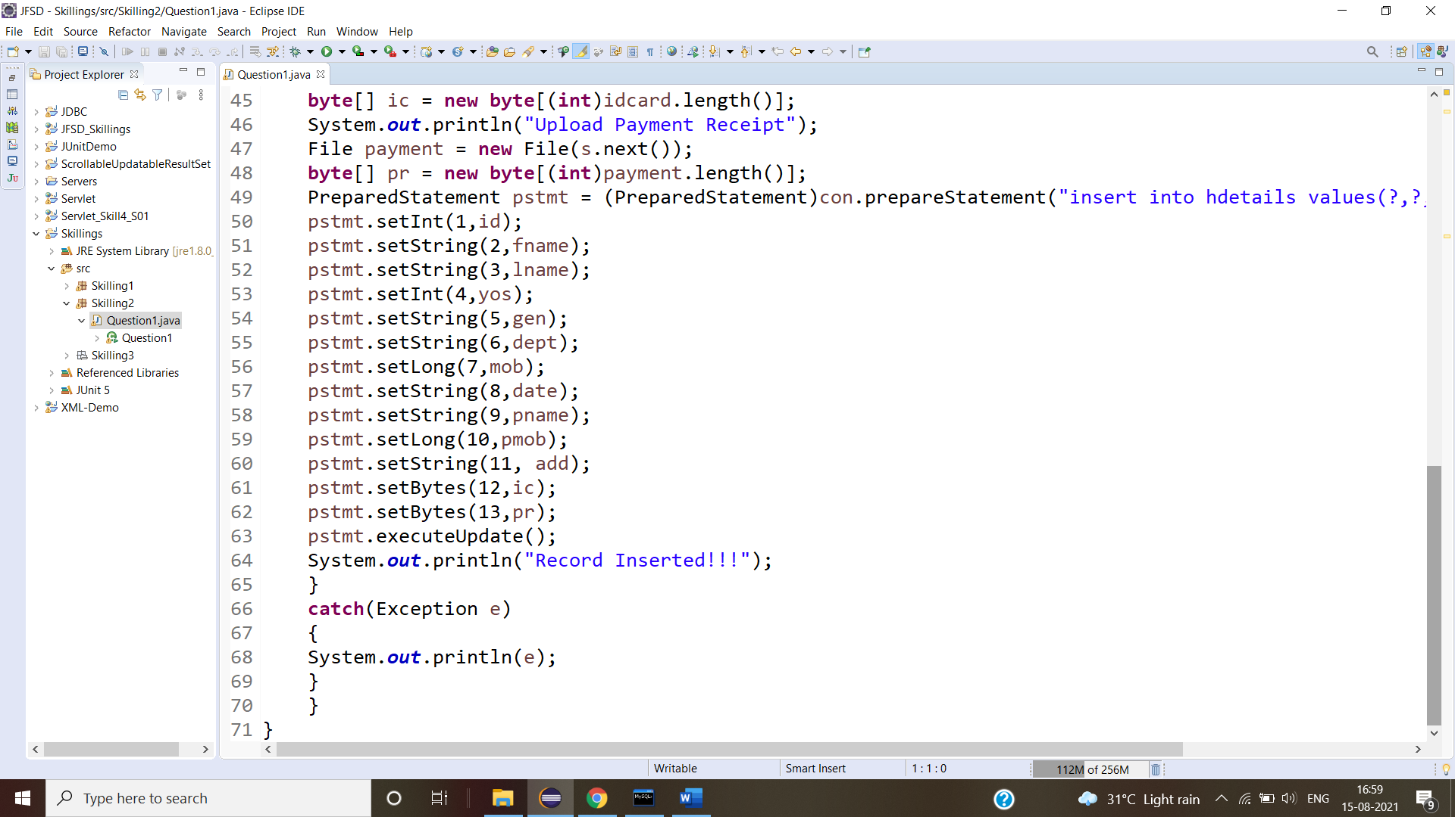

**Output Screenshots:**

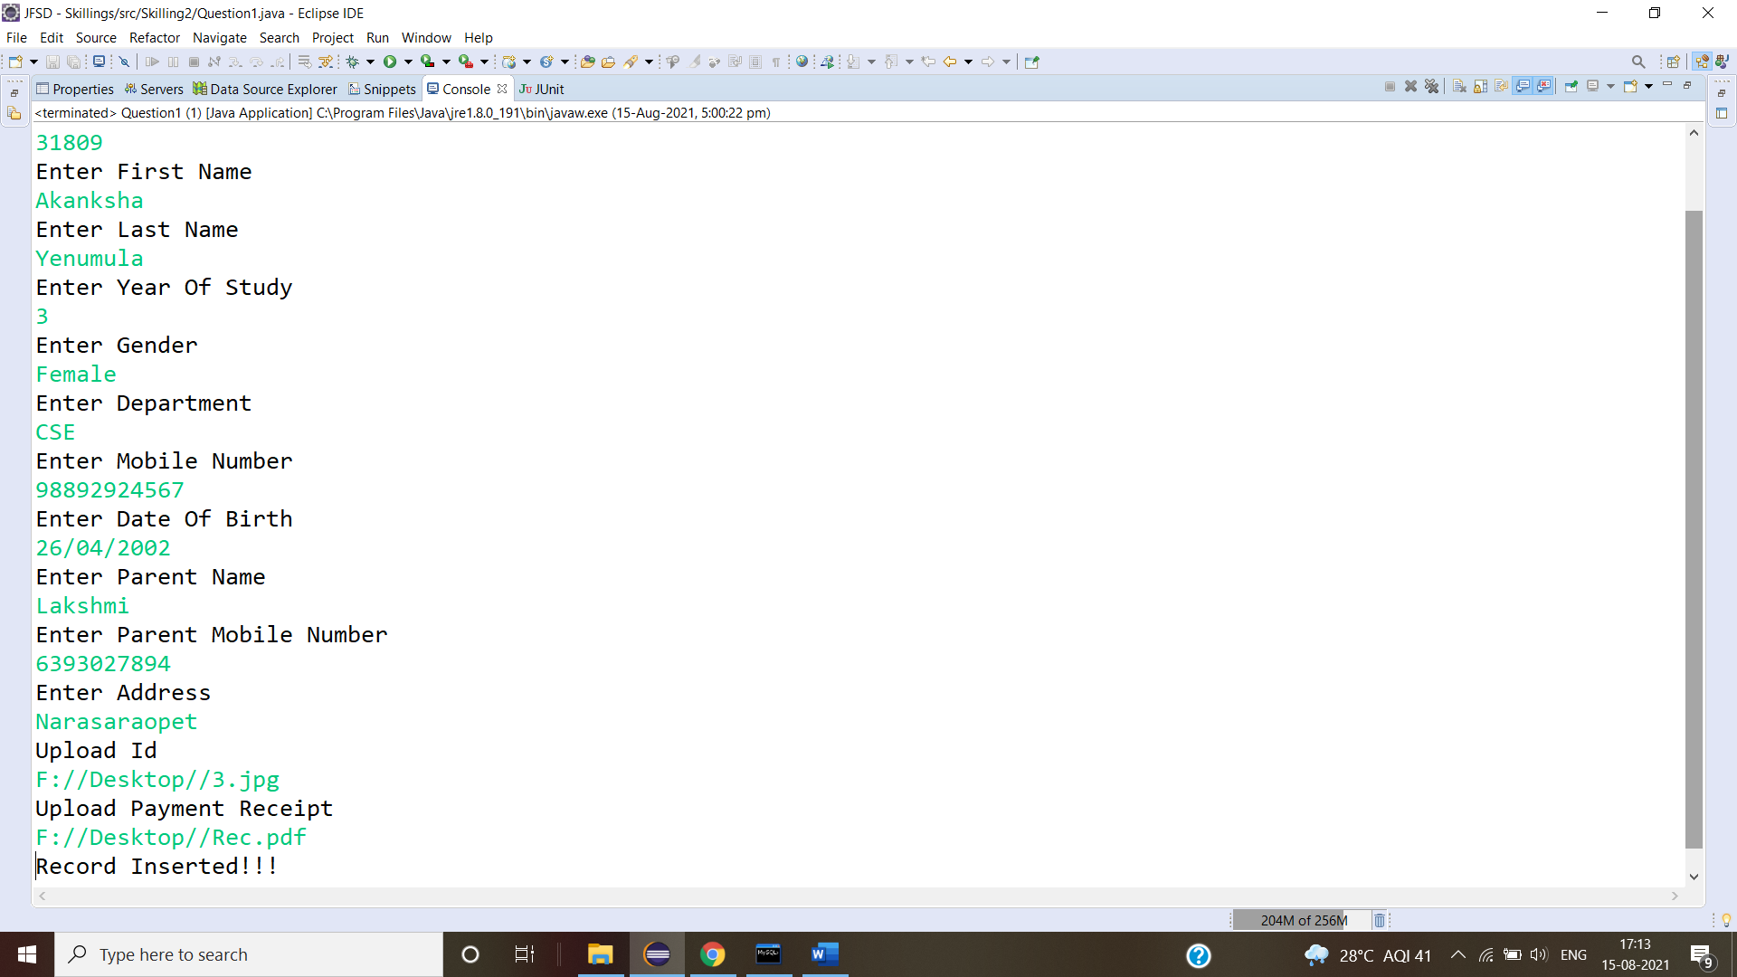

**Database Screenshot:**