**Java Full Stack Development**

**Skilling-4**

**ID NO: 190030677 Name: K. Sravani**

Shanmukh has 10 theatres in AP. Every theatre is managed by a manager. Due to covid19 the risk of virus spread may increase among the customers and theatre staff. So, Shanmukh wants to digitalize the ticket booking process so that there will be no rush at the ticket counter and the risk of spread was minimal.

As you are a computer science student, he approached you to help him out to build a web application where customers can book tickets online.

Shanmukh’s requirements are as below:

a. Shanmukh (super admin) can add the managers of his theatres(admin)

b. Admin can login with their own credentials and add movie details into database

c. Customer should login with his registered credentials.

d. Customers must have a provision to book the ticket(s) (He can update no of tickets) for a respective movie. At the last moment, if customer is not willing to go to theatre, he should have a provision to cancel the ticket he booked

e. Shanmukh must have a provision to view how many tickets are sold and how much money earned.

Create a web application as per his requirements by using servlets.

**Screenshots:**

**index.html**

**Superadminlogin.html**

**managerlogin.html**

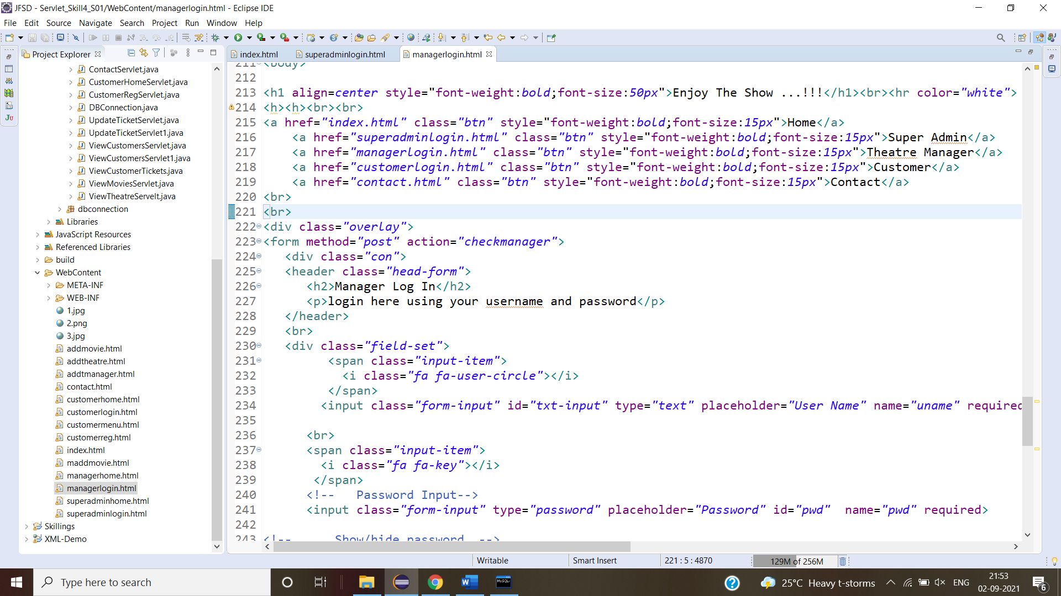

**Customerlogin.html**



**Customerregister.html**

**Contact.html**

**Main Page**

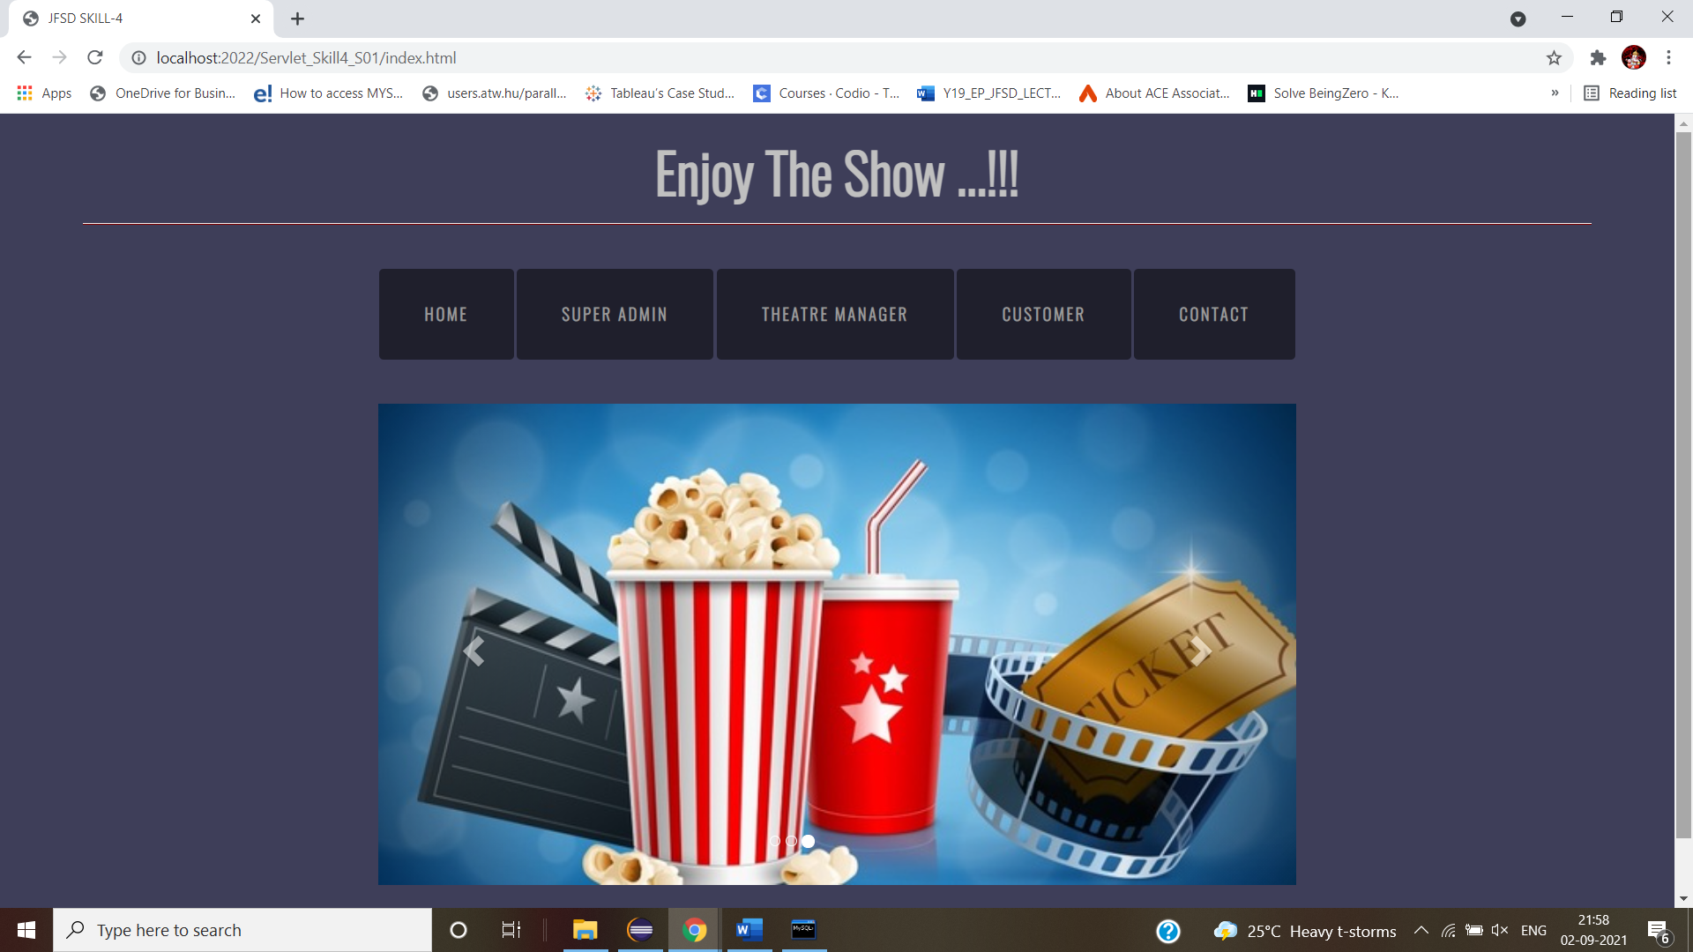

**Superadminlogin Page**

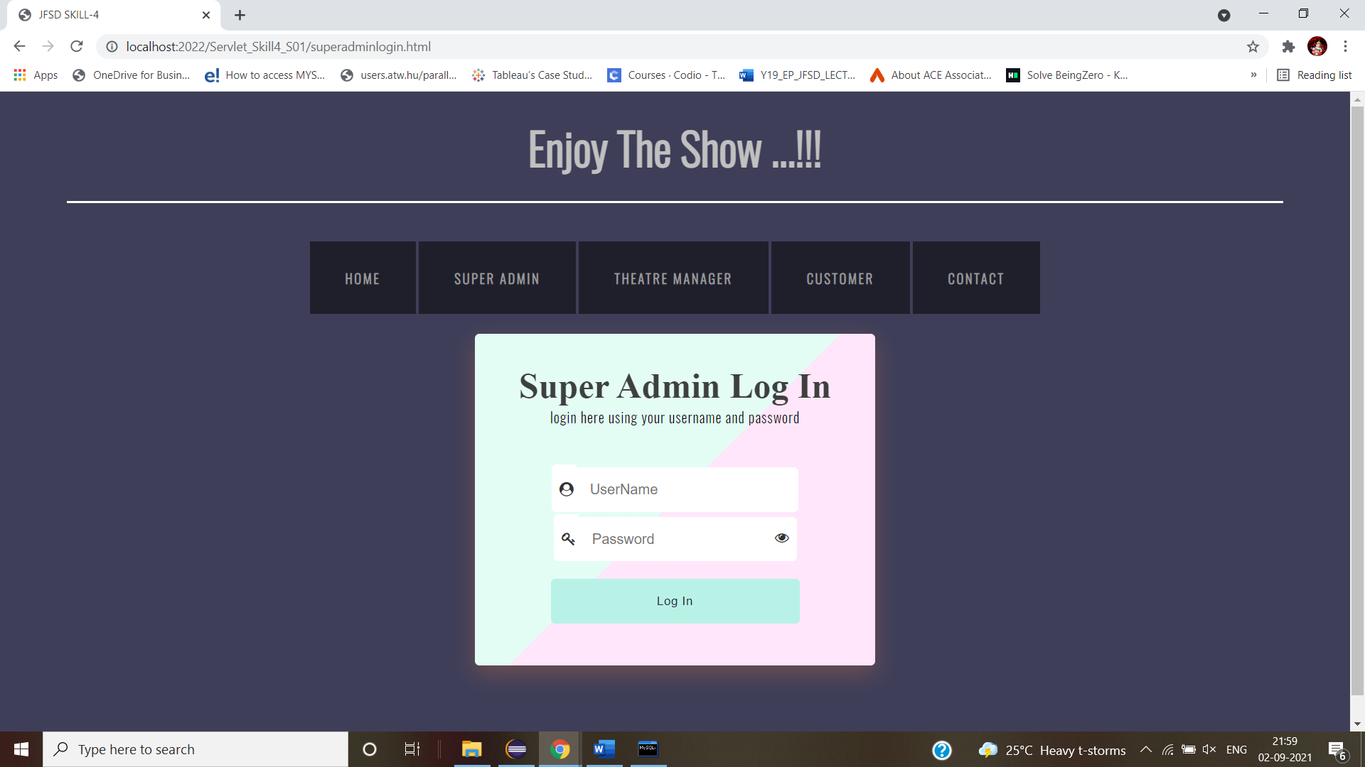

**Managerlogin**

**Customerlogin**

**Customerregister**

**Contactpage**

**Database data Screenshots:**

