**Java Full Stack Development**

**Skilling-4_Part-2**

**ID NO: 190030677 Name: K. Sravani**

**Admin Module:**

**Superadminhome.html**

**Addtheatre.html**

**Addmanager.html**

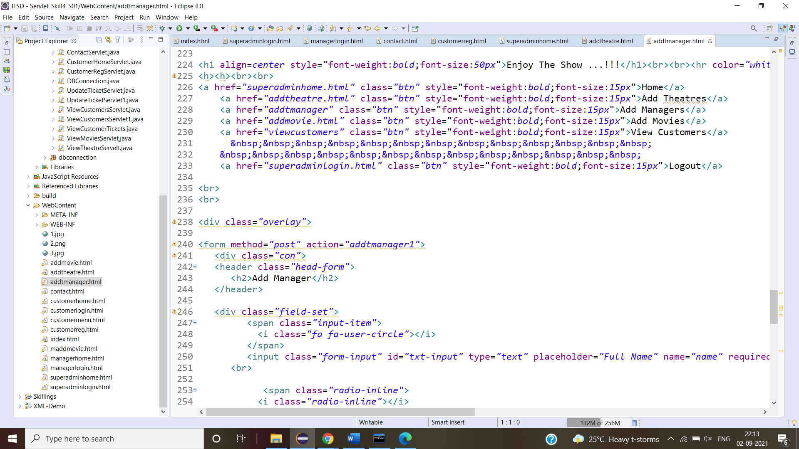

**Addmovie.html**

**viewcustomer Servlet**

**Superadminhome page:**

**Addtheatres page:**

**Addmanagers page:**

**Addmovies page:**

**Viewcustomers page:**

**Database screenshots:**

